Text script

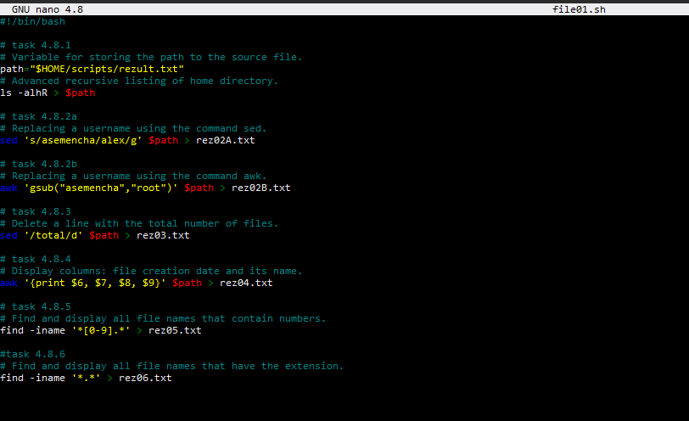

1. Create a file with the result of extended recursive listing of the home folder.

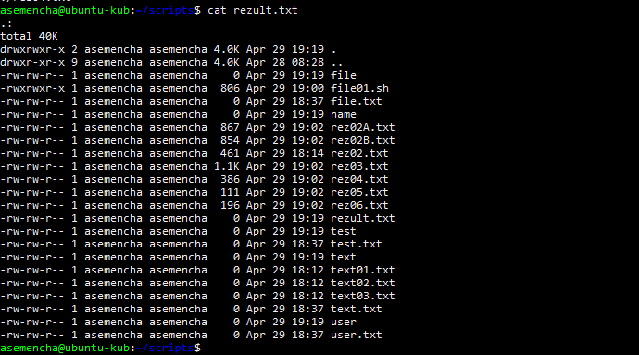

1. Replace Username with any other name
   1. Replace username with any other with sed

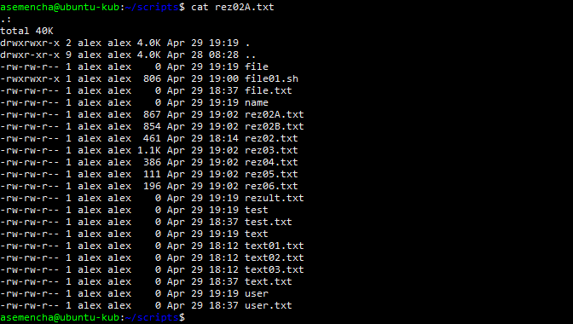

* 1. Replace Username any other with awk

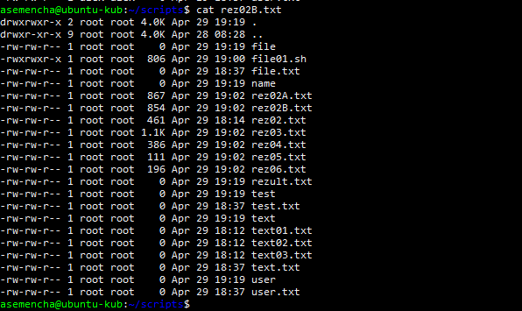

1. Delete the line with the total number of files.

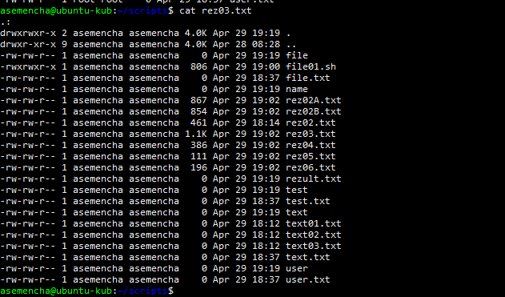

1. Display columns: file creation date and its name.

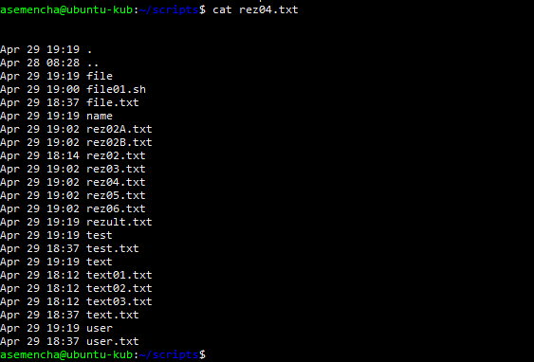

1. Find and display all file names that contain numbers.

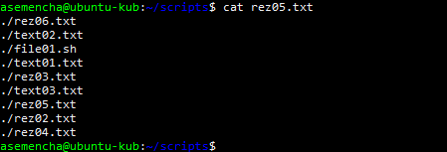

1. Find and display all file names that have the extension.

