1. Write a script that displays prompts for data entry until quit is entered.

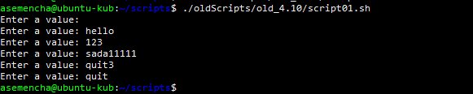

1. Write a script that writes the current time and date and the number of processes to the file every minute. In this case, the file should be created in the directory / home/user/tmp regardless of the user and the system. Run it in the background.

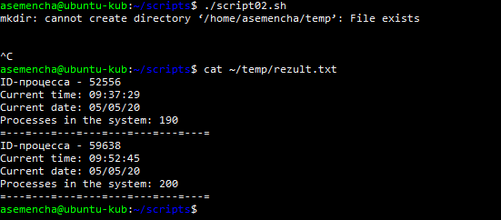

1. Transfer the script from item 2 from the background to priority, then to the background with a pause, resume its work in the background, obtain information about the process and terminate the script by transmitting the corresponding signal.
2. View processes in real time and display the ones that use the most memory. Lower the priority of the most resource-intensive process by 2.
3. Create a script that displays a square of the numbers entered as arguments (positional parameters), regardless of their number.

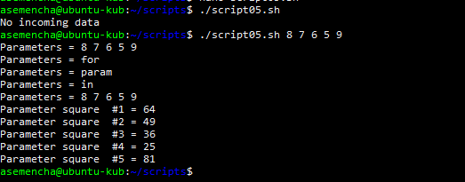

1. Create a script to solve a linear equation using a function.

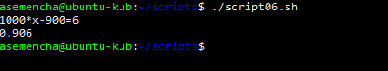

1. Create a script that regularly monitors the appearance of new users in /etc/passwd and writes their logins and UIDs to a file.