1. Find and display paths to files from the / usr directory (including subdirectories) that are larger than 20 MB in size.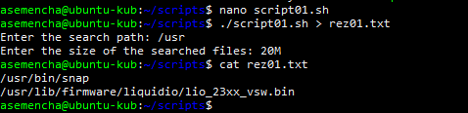
2. Count the number of files, the number of hidden files in the current user's home directory and display the result in the format:

User home directory

<User>

contains regular files:

XX

hidden files:

Yy

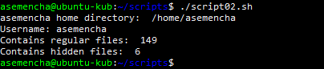

1. Display the date, time, list of registered users, uptime systems.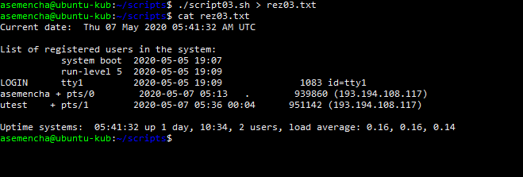
2. Print the number of processes running as current and as root in the format:

User Processes:

<User>

XX

Root user processes:

Yy

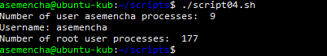

1. Find and display 5 processes that consume the most memory in the system.

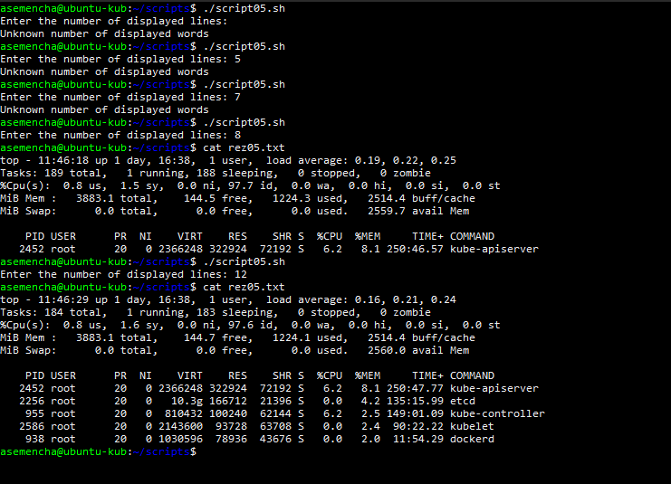

1. Develop a script that invokes the grep command and takes the following arguments:

* The text to find
* file in which to find this text;
* The maximum number of lines to display.

1. Run 4.11.6 in restricted mode for the /home/user directory