# Install and set up linux virtual machine

1. Create new virtual machine in hyper-v. 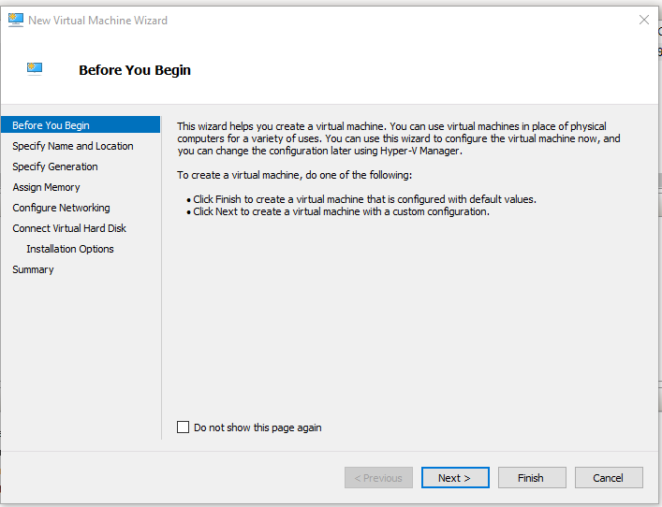
2. Select name virtual machine and location virtual machine’s files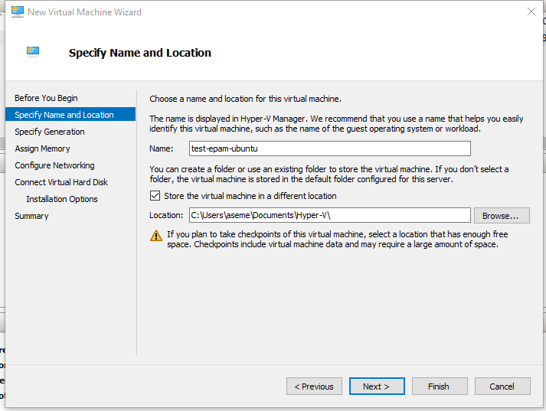
3. Choose the generation of virtual machine. 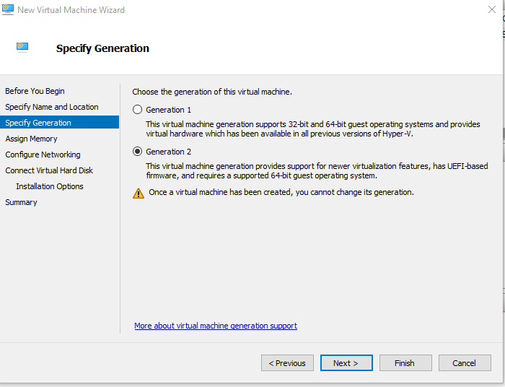
4. Assign memory. 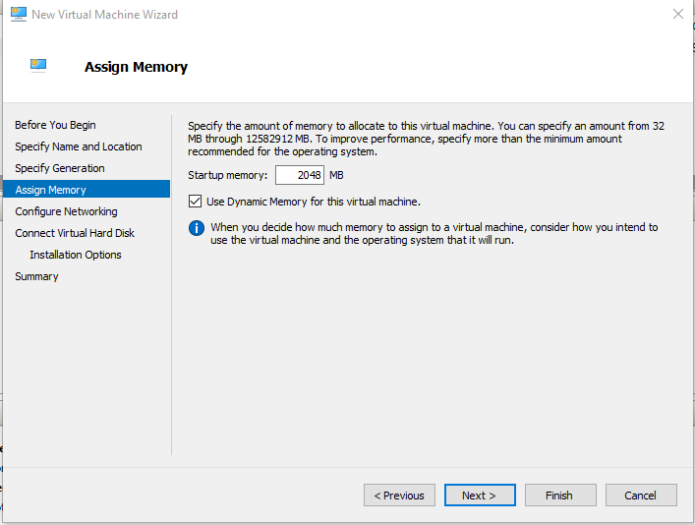
5. Configure networking. 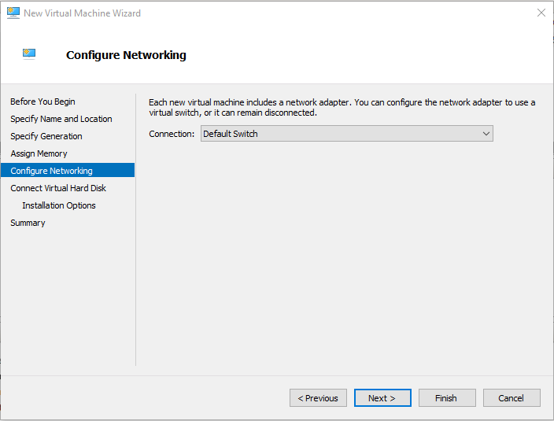
6. Create or select virtual hard disk and select location 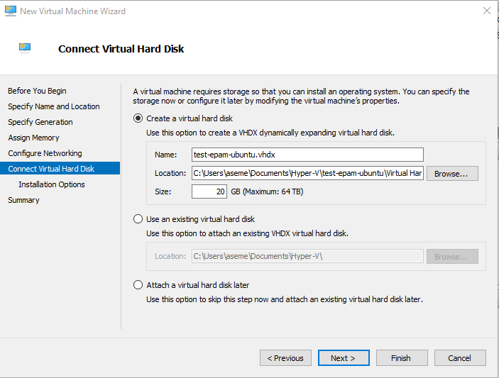
7. Select installation image. 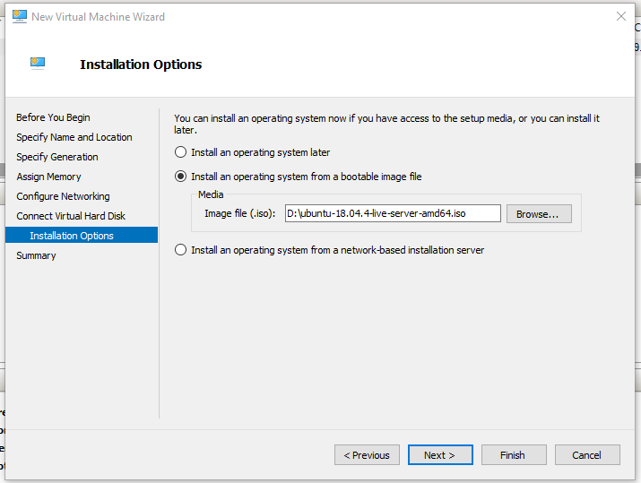
8. Completiong the wizard. 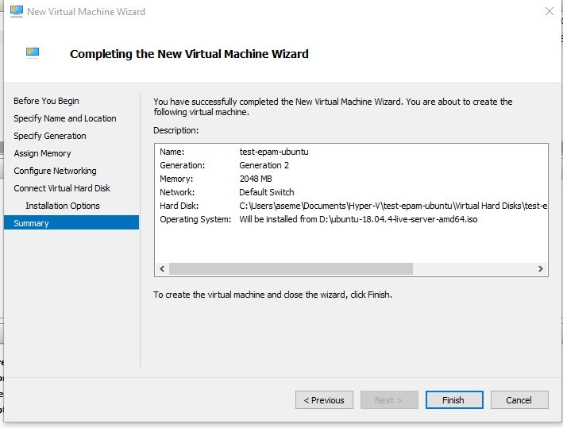

# Change setting virtual machine

1. Change boot order 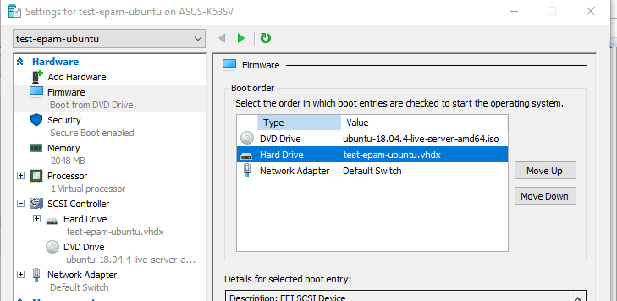
2. Change security settings 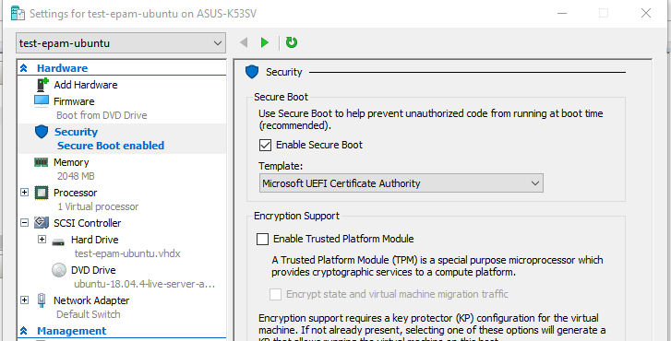
3. Configure dynamic memory 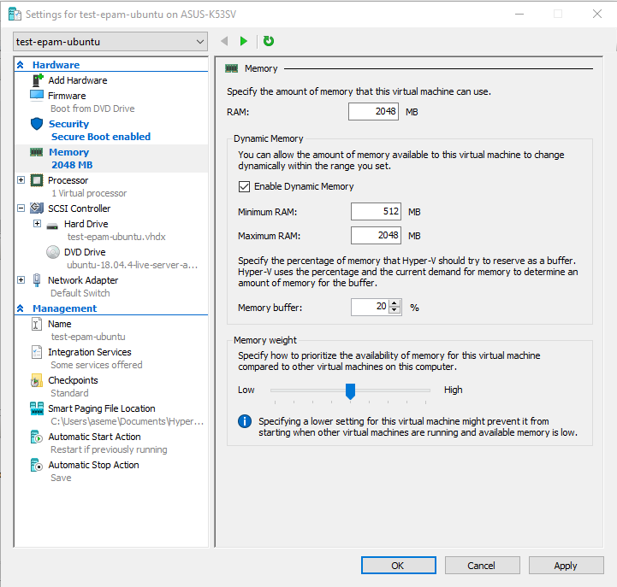
4. Select processors core 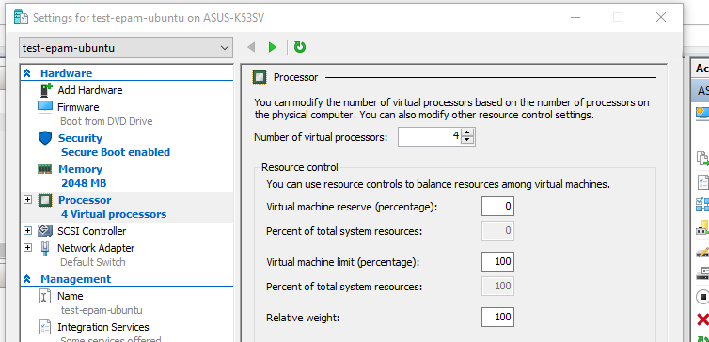

# Installation OS

1. Select installation options 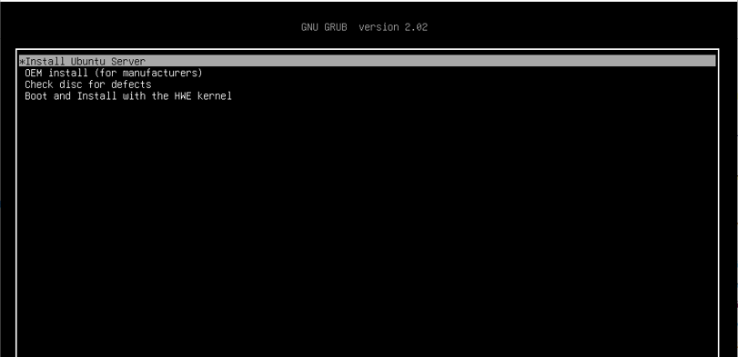
2. Choose language OS 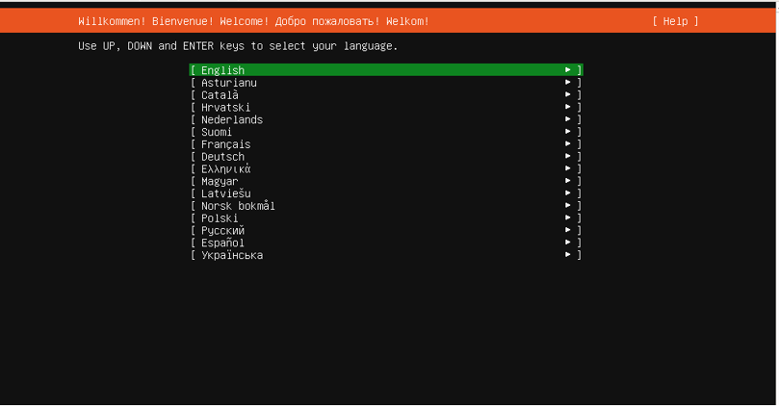
3. Chooce keyboard input 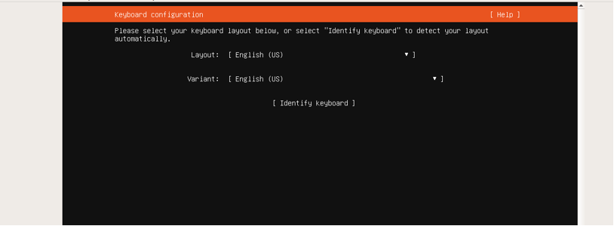
4. Configure network settings 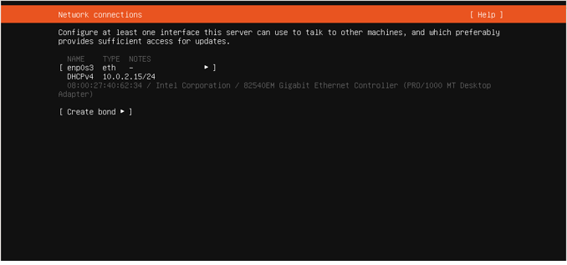
5. Configure archive mirror 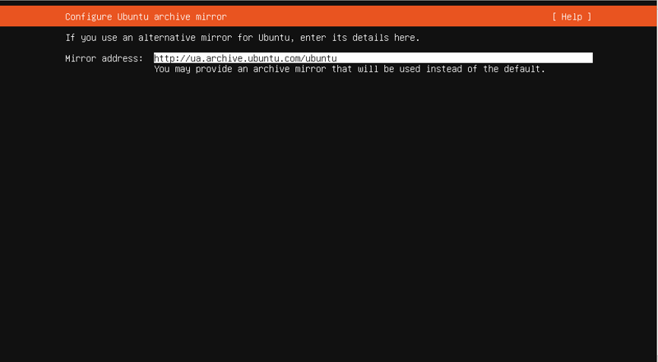
6. Configure proxy settings 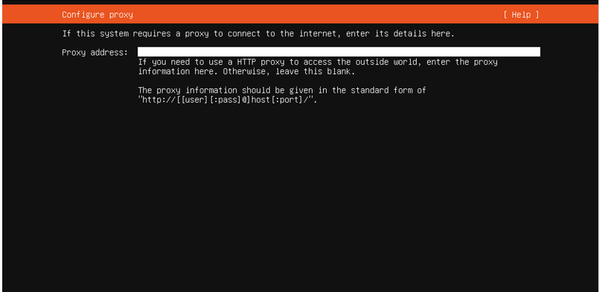
7. Configure storage 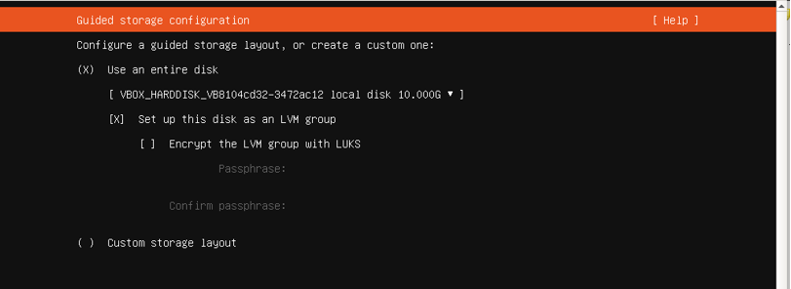 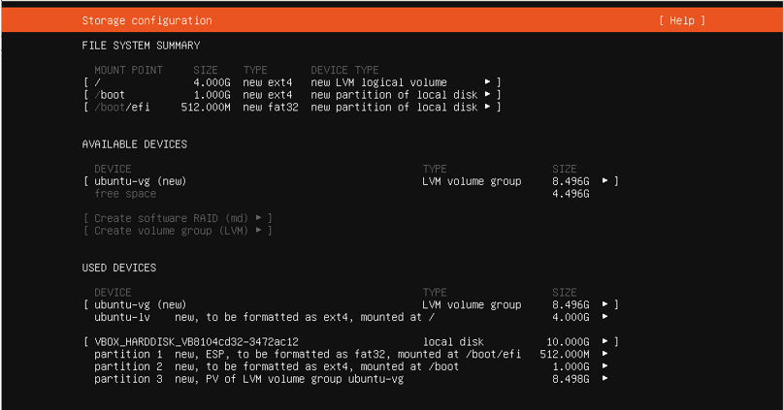
8. Create system users and name server 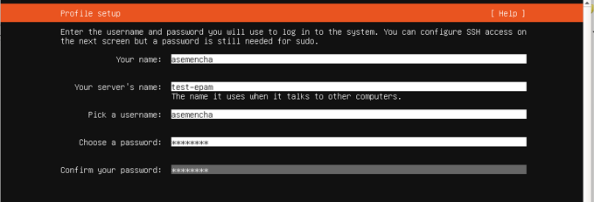
9. Install and configure OpenSSH Server 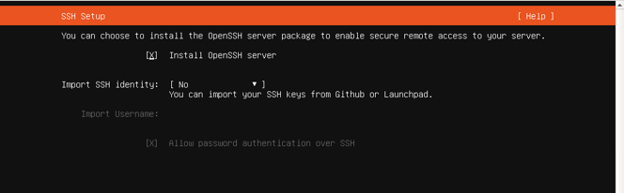
10. Chooce feature 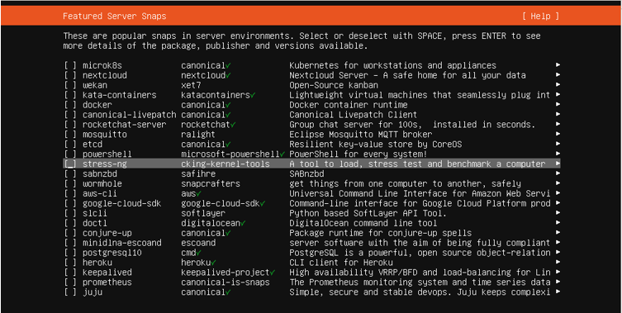
11. Progress installation 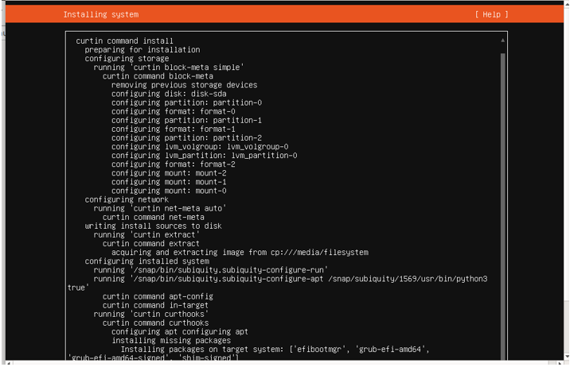
12. First launch in OS 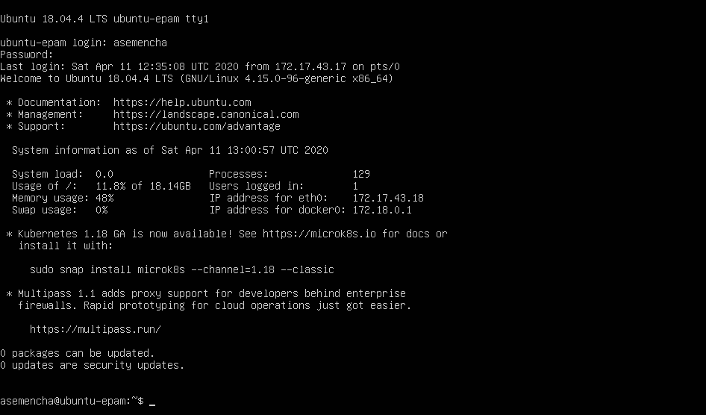

# Familiarize with the commands and utilities

tty - print the file name of the terminal connected to standard input 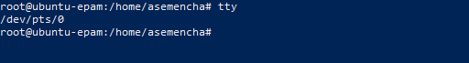

who - show who is logged on

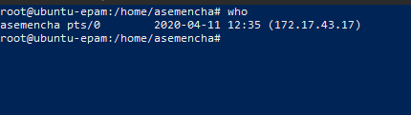

printenv - print all or part of environment 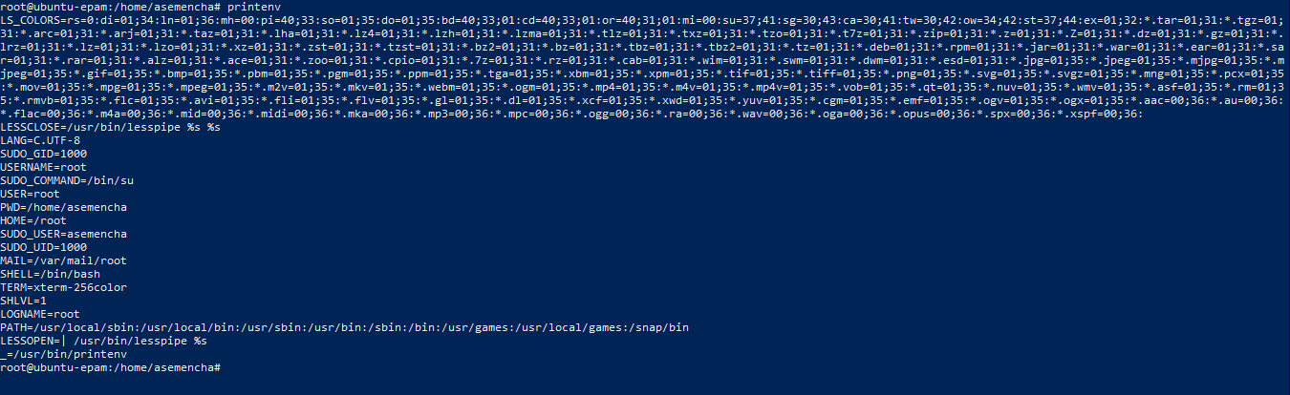

w - Show who is logged on and what they are doing. 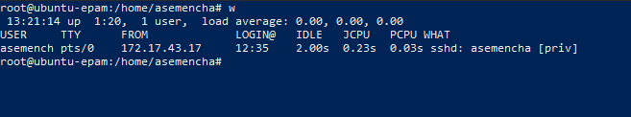

whoami - print effective userid



id - print real and effective user and group IDs 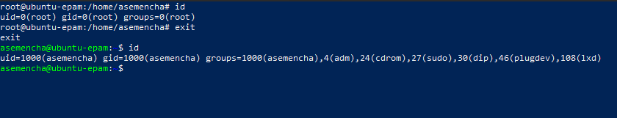

uname - print system information

|  |  |  |
| --- | --- | --- |
| Short key | Full key | Description |
| -a | --all | print all information, in the following order, except omit -p and -i if unknown |
| -s | --kernel-name | print the kernel name |
| -n | --nodename | print the network node hostname |
| -r | --kernel-release | print the kernel release |
| -v | --kernel-version | print the kernel version |
| -m | --machine | print the machine hardware name |
| -p | --processor | print the processor type (non-portable) |
| -i | --hardware-platform | print the hardware platform (non-portable) |
| -o | --operating-system | print the operating system |
|  | --help | display this help and exit |
|  | --version | output version information and exit |

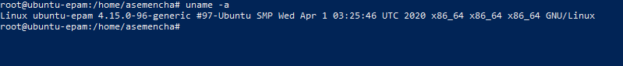

hostname - show or set the system's host name

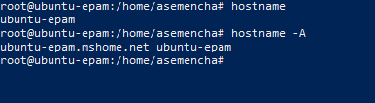 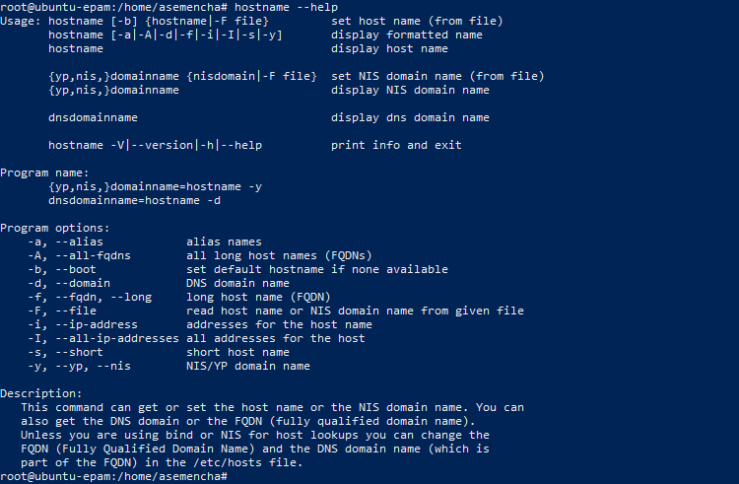

uptime - Tell how long the system has been running. 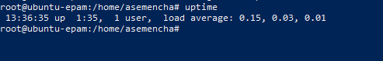

shutdown - Halt, power-off or reboot the machine 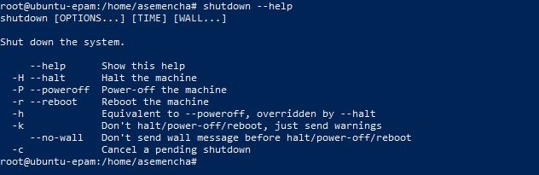

halt, poweroff, reboot - Halt, power-off or reboot the machine 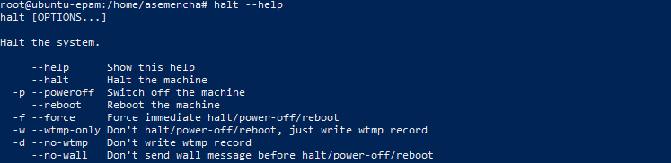 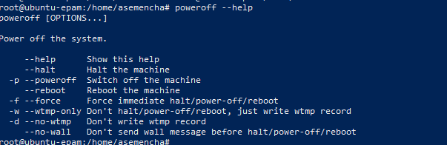 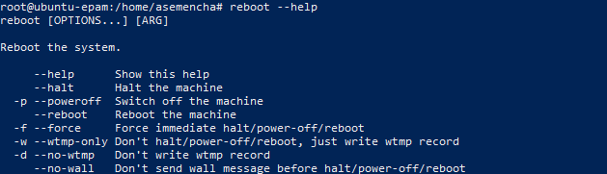

systemd, init - systemd system and service manager 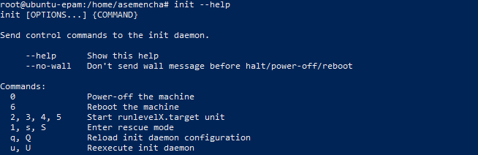 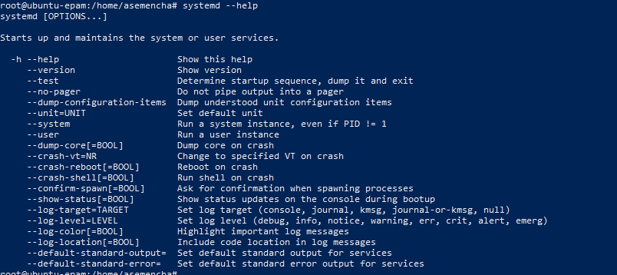

man - an interface to the on-line reference manuals 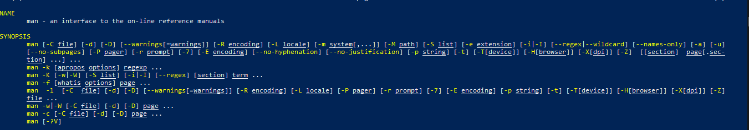

info - read Info documents 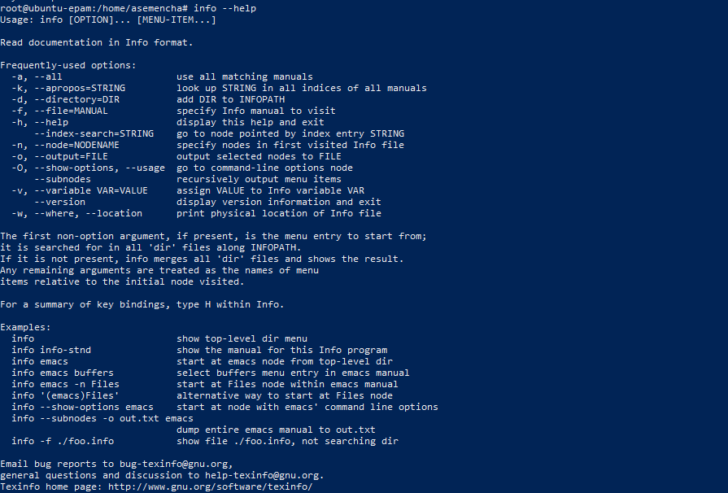

find - search for files in a directory hierarchy 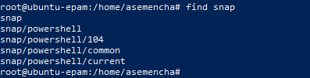

locate - find files by name 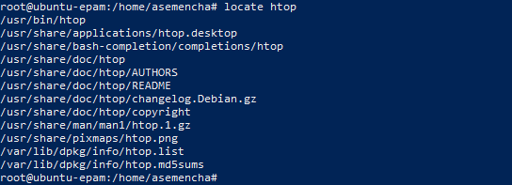

whereis - locate the binary, source, and manual page files for a command 

less - opposite of more

less /usr/share/doc/acl/README