1. Check the location of the bash shell and use this path in scripts #! / Full_path_to_program program_option

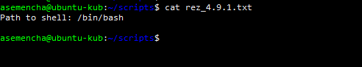

I did not quite understand the correct solution. Or there was something else in mind.

1. We verify that bash is running using a special built-in variable.

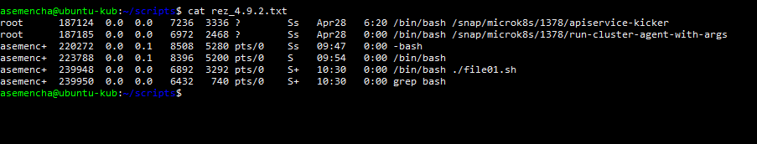

1. Create a directory where your scripts will be stored, for example ... /tmp/scripts.



1. Create a script that displays the following message: “In my home directory <n> subdirectory: <name>”. n - quantity, name - the name of the directory.

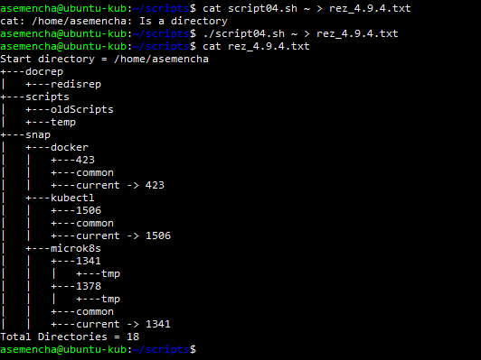

1. Create a script that reads a word from the screen and displays the number of characters in that word.

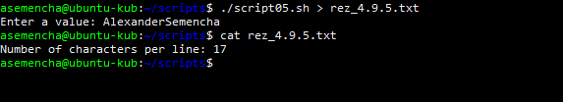

1. Write a script that sequentially (using positional parameters) takes three arguments a, b and c and displays the value (a + b) / c as a simple fraction.

I could not figure out how to work with positioning in a file

1. Write a script that sequentially takes two arguments and displays the larger one. If there are more than two arguments, display an error message.

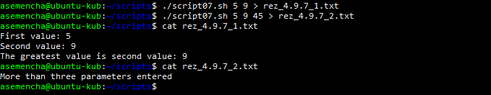

1. Check what position the 'a' character is in path.

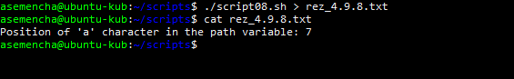

1. Remove the time zone name (EEST) from date. Rearrange the day and month.

I do not quite understand how to change the date settings

1. Print a line containing the sentence: I went to the <current directory> at <time> using the identifier <UID>.

I did not understand how to get the necessary data for this task.

1. Withdraw from the $ PATH path to the last in the directory list (3 ways).

I did not understand how to get the necessary data for this task.

1. Try to display the value of a variable not previously declared and get the error message you specified.

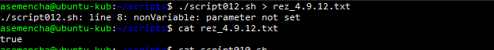

1. In the script using wget, download the document from the mail.ru server head page and redirect the received document to the links (lynx) input.

I did not understand how to get the necessary data for this task.