pwd - print name of current/working directory



ls - list directory contents

ls -l /

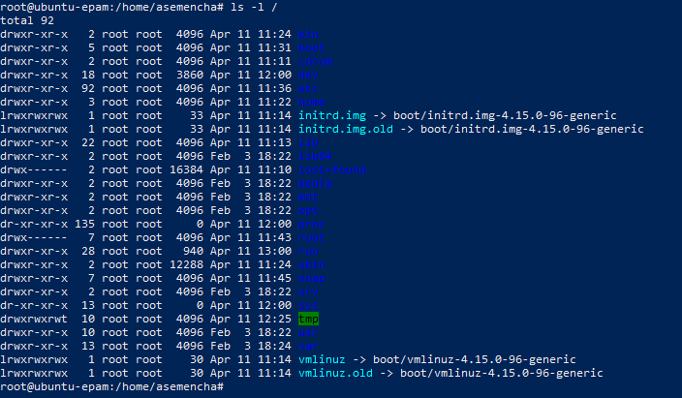

ls

ls ~

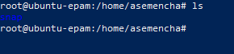

ls -l

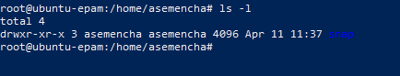

ls -a



ls -la

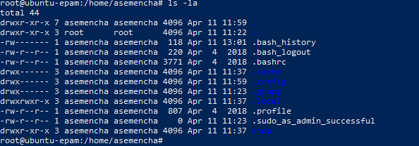

ls -lda ~

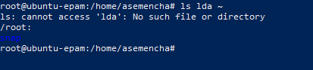

mkdir - make directories

mkdir test

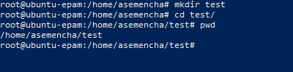

touch - change file timestamps

touch test1.txt

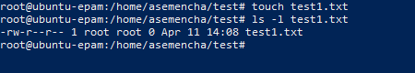

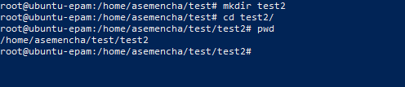

mv - move (rename) files

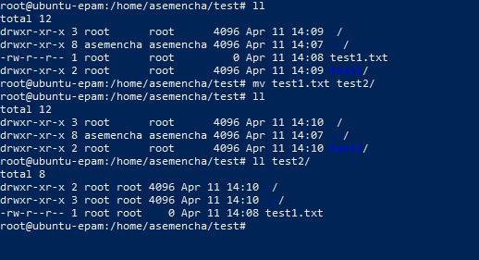

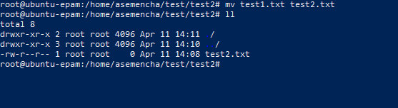

cp - copy files and directories

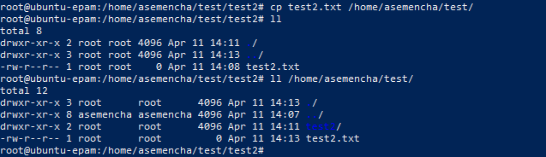

rm - remove files or directories

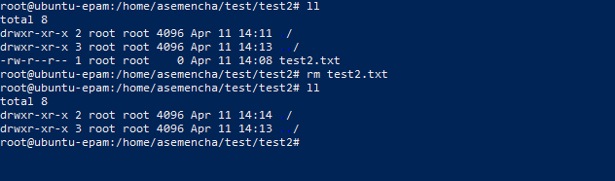

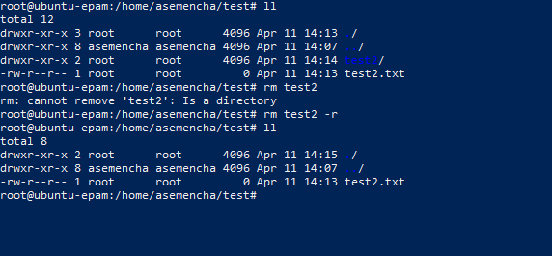

rmdir - remove empty directories

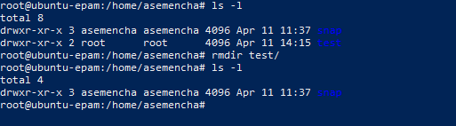

cat - concatenate files and print on the standard output

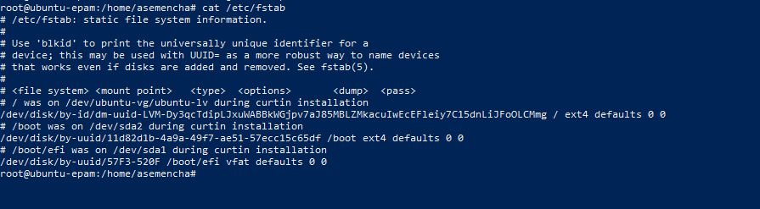

tar - an archiving utility

