# E9633协议说明

1. 开机协议通信图

终端开机网络初始化完成后，TCP连接上服务器首先发送“连接指令”（见协议文档2.5 B2类终端报告的80指令说明部分）；

得到平台端正确应答后（见协议文档2.5 A2类平台控制的80说明部分）；

连接指令执行成功后就可以根据文档要求上传相关数据，注意“心跳指令”只在通讯空闲时才会发送，也就是没有其它数据包通讯时才定时发送“心跳指令”测试连接是否正常。

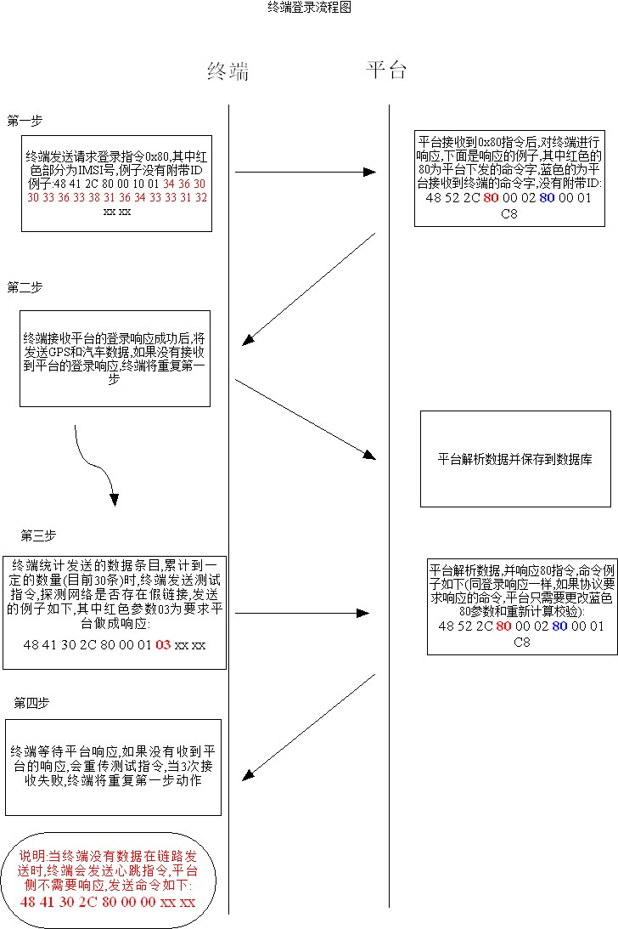

1. 二进制协议

终端往平台发送的指令在协议文档2.5 B2类终端报告部分说明，协议包以“HA”开头；

平台往终端发送的指令在协议文档2.5 A2类平台控制部分说明，协议包以“HR”开头；

1. 字符串协议

包含平台对终端参数的设置和对终端的查询；

见协议文档的A、B、C、D类说明部分；

这四种是纯字符串协议，协议包中的CMD字段也是字符，例如“设置IP指令”的CMD是字符‘0’，即0x30;

1. 测试平台

TCP连接

IP: **139.217.202.73**

PORT： **6699**

1. 部分协议包抓包

连接指令 登入指令

CMD:80

---------------------------------------------------------------

48 41 32 30 31 37 31 32 30 34 30 30 30 32 2c 80 0 10 1 34 36 30 30 30 32 39 37 31 31 34 33 33 30 31 6 92

----------------------------------------------------------------

protocol:HA

id:201712040002

CMD:80

dataLength:16

插拔报警

CMD:a8

---------------------------------------------------------------

48 41 32 30 31 37 31 32 30 34 30 30 30 32 2c a8 0 19 0 1 5a 7b a3 2d 6f 1 54 c2 d1 6 c4 83 2e fe 0 26 16 f 5 0 1 d9 e0 c 49

----------------------------------------------------------------

protocol:HA

id:201712040002

CMD:a8

dataLength:25

高速报告

CMD:97

---------------------------------------------------------------

48 41 32 30 31 37 31 32 30 34 30 30 30 32 2c 97 0 10 5a 7b a3 49 ff 4a 8e 7f b7 8e fe df 4b 34 30 45 b dc

----------------------------------------------------------------

protocol:HA

id:201712040002

CMD:97

dataLength:16

历史故障码 主动上报

CMD:d0

---------------------------------------------------------------

48 41 32 30 31 37 31 32 30 34 30 30 30 32 2c d0 0 1 0 3 d9

----------------------------------------------------------------

protocol:HA

id:201712040002

CMD:d0

dataLength:1

当前故障码 主动上报

CMD:d1

---------------------------------------------------------------

48 41 32 30 31 37 31 32 30 34 30 30 30 32 2c d1 0 1 0 3 da

----------------------------------------------------------------

protocol:HA

id:201712040002

CMD:d1

dataLength:1

RPM 报警

CMD:a2

---------------------------------------------------------------

48 41 32 30 31 37 31 32 30 34 30 30 30 32 2c a2 0 19 1f e9 5a 7b a3 1d 3f 1 54 c2 d1 6 c4 83 2e 0 0 0 0 0 0 0 1 d9 cd b a9

----------------------------------------------------------------

protocol:HA

id:201712040002

CMD:a2

dataLength:25

超速报警

CMD:a1

---------------------------------------------------------------

48 41 32 30 31 37 31 32 30 34 30 30 30 32 2c a1 0 19 0 7f 5a 7b a3 1d 2f 1 54 c2 d1 6 c4 83 2e fe 0 0 0 0 0 0 1 d9 cd c d

----------------------------------------------------------------

protocol:HA

id:201712040002

CMD:a1

dataLength:25

连接指令 测试指令

CMD:80

---------------------------------------------------------------

48 41 32 30 31 37 31 32 30 34 30 30 30 32 2c 80 0 1 3 3 8c

----------------------------------------------------------------

protocol:HA

id:201712040002

CMD:80

dataLength:1

行 程 开 始 GPS 报告

CMD:b0

---------------------------------------------------------------

48 41 32 30 31 37 31 32 30 34 30 30 30 32 2c b0 0 17 5a 7b a3 1d 2f 1 54 c2 d1 6 c4 83 2e fe 0 0 0 0 0 0 1 d9 cd b 9b

----------------------------------------------------------------

protocol:HA

id:201712040002

CMD:b0

dataLength:23

GPS 定位信 息报告

CMD:90

---------------------------------------------------------------

48 41 32 30 31 37 31 32 30 34 30 30 30 32 2c 90 0 17 5a 7b a3 3b 6f 1 54 c2 d1 6 c4 83 2e fe 0 26 16 f 5 0 1 d9 e1 c 3d

----------------------------------------------------------------

protocol:HA

id:201712040002

CMD:90

dataLength:23

急减速报警

CMD:aa

---------------------------------------------------------------

48 41 32 30 31 37 31 32 30 34 30 30 30 32 2c aa 0 19 0 99 5a 7b a4 1e 6f 1 54 c2 d1 6 c4 83 2e 65 0 26 16 f 5 0 1 da 89 b e6

----------------------------------------------------------------

protocol:HA

id:201712040002

CMD:aa

dataLength:25

低速报告

CMD:95

---------------------------------------------------------------

48 41 32 30 31 37 31 32 30 34 30 30 30 32 2c 95 0 10 5a 7b a4 2e ff 4a 8e 82 b7 8e 0 df 4b 24 30 45 a b5

----------------------------------------------------------------

protocol:HA

id:201712040002

CMD:95

dataLength:16

怠速报告

CMD:93

---------------------------------------------------------------

48 41 32 30 31 37 31 32 30 34 30 30 30 32 2c 93 0 10 5a 7b a4 56 ff 4a 8e 82 b7 8e 0 df 4b 24 30 4d a e3

----------------------------------------------------------------

protocol:HA

id:201712040002

CMD:93

dataLength:16

行 程 结 束 GPS 报告

CMD:b1

---------------------------------------------------------------

48 41 32 30 31 37 31 32 30 34 30 30 30 32 2c b1 0 17 5a 7b a7 bf 7f 1 54 c2 d1 6 c4 83 2e 0 0 26 16 f 5 0 1 da 93 b ab

----------------------------------------------------------------

protocol:HA

id:201712040002

CMD:b1

dataLength:23

行 程 结 束 OBD 工况报 告

CMD:b2

---------------------------------------------------------------

48 41 32 30 31 37 31 32 30 34 30 30 30 32 2c b2 0 14 ff fe 3f fb 1 19 0 a1 5a 7b a4 27 5a 7b a7 bf 0 63 0 39 c 37

----------------------------------------------------------------

protocol:HA

id:201712040002

CMD:b2

dataLength:20

ETC 高温报 警

CMD:a4

---------------------------------------------------------------

48 41 32 30 31 37 31 32 30 34 30 30 30 32 2c a4 0 19 0 91 5a 7b a3 20 2f 1 54 c2 d1 6 c4 83 2e 52 0 0 0 0 0 0 1 da 93 b 40

----------------------------------------------------------------

protocol:HA

id:201712040002

CMD:a4

dataLength:25

急加速报警

CMD:a9

---------------------------------------------------------------

48 41 32 30 31 37 31 32 30 34 30 30 30 32 2c a9 0 19 0 35 5a 72 fd 92 6f 1 54 c2 18 6 c4 82 a0 78 0 25 41 10 e6 0 1 90 59 c a2

---------------------------------------------------------------

protocol:HA

id:201712040002

CMD:a9

dataLength:25

版 本 查 询指令

CMD:59

---------------------------------------------------------------

53 41 32 30 31 37 31 32 30 34 30 30 30 32 2c 35 39 3d 47 4d 36 36 30 42 5f 55 42 4c 4f 58 38 5f 48 5a 53 5a 5f 48 56 31 30 5f 53 56 31 33 5f 43 41 52 5f 4f 42 44 2e 45 43 53 20 44 45 43 2d 32 35 2d 32 30 31 37 20 31 38 3a 34 30 3a 31 31 d a

----------------------------------------------------------------

protocol:SA

ID:201712040002

CMD:59

param0:GM660B_UBLOX8_HZSZ_HV10_SV13_CAR_OBD.ECS DEC-25-2017 18:40:11

网 络参数 查询

CMD:2

---------------------------------------------------------------

53 41 32 30 31 37 31 32 30 34 30 30 30 32 2c 32 3d 78 75 6e 6c 65 2c 78 75 6e 6c 65 2c 31 32 33 34 35 36 d a

---------------------------------------------------------------

protocol:SA

ID:201712040002

CMD:2

param0:xunle

param1:xunle

param2:123456

ID查询

CMD3

---------------------------------------------------------------

53 41 32 30 31 37 31 32 30 34 30 30 30 32 2c 33 3d 30 2c 32 30 31 37 31 32 30 34 30 30 30 32 d a

----------------------------------------------------------------

protocol:SA

ID:201712040002

CMD:3

param0:0

param1:201712040002

心 跳 查询

CMD:6

---------------------------------------------------------------

53 41 32 30 31 37 31 32 30 34 30 30 30 32 2c 36 3d 30 2c 30 2c 30 2c 33 30 30 d a

----------------------------------------------------------------

protocol:SA

ID:201712040002

CMD:6

param0:0

param1:0

param2:0

param3:300

GPS 功 能参数查询

CMD:31

---------------------------------------------------------------

53 41 32 30 31 37 31 32 30 34 30 30 30 32 2c 33 31 3d 31 2c 31 2c 36 30 30 30 30 2c 31 d a

----------------------------------------------------------------

protocol:SA

ID:201712040002

CMD:31

param0:1

param1:1

param2:60000

param3:1

低 压 报 警 参数查询

CMD:33

---------------------------------------------------------------

53 41 32 30 31 37 31 32 30 34 30 30 30 32 2c 33 33 3d 31 2c 31 31 35 d a

----------------------------------------------------------------

protocol:SA

ID:201712040002

CMD:33

param0:1

param1:115

超速 报 警 参数查询

CMD:34

---------------------------------------------------------------

53 41 32 30 31 37 31 32 30 34 30 30 30 32 2c 33 34 3d 31 2c 31 32 35 d a

----------------------------------------------------------------

protocol:SA

ID:201712040002

CMD:34

param0:1

param1:125

RPM 报 警信息查询

CMD:35

---------------------------------------------------------------

53 41 32 30 31 37 31 32 30 34 30 30 30 32 2c 33 35 3d 31 2c 33 32 30 30 d a

----------------------------------------------------------------

protocol:SA

ID:201712040002

CMD:35

param0:1

param1:3200

ECT 低 温 报 警信息查询

CMD:36

---------------------------------------------------------------

53 41 32 30 31 37 31 32 30 34 30 30 30 32 2c 33 36 3d 31 2c 34 30 d a

----------------------------------------------------------------

protocol:SA

ID:201712040002

CMD:36

param0:1

param1:40

ECT 高 温 报 警信息查询

CMD:37

---------------------------------------------------------------

53 41 32 30 31 37 31 32 30 34 30 30 30 32 2c 33 37 3d 31 2c 31 34 33 d a

----------------------------------------------------------------

protocol:SA

ID:201712040002

CMD:37

param0:1

param1:143

碰 撞 报 警信息查询

---------------------------------------------------------------

53 41 32 30 31 37 31 32 30 34 30 30 30 32 2c 33 38 3d 31 2c 31 30 d a

----------------------------------------------------------------

protocol:SA

ID:201712040002

CMD:38

param0:1

param1:10

历 史 故 障 码 报 警信息查询

CMD:39

---------------------------------------------------------------

53 41 32 30 31 37 31 32 30 34 30 30 30 32 2c 33 39 3d 31 31 38 34 37 d a

----------------------------------------------------------------

protocol:SA

ID:201712040002

CMD:39

param0:11847

插 拔 报 警 信息查询

CMD:41

---------------------------------------------------------------

53 41 32 30 31 37 31 32 30 34 30 30 30 32 2c 34 31 3d 31 d a

----------------------------------------------------------------

protocol:SA

ID:201712040002

CMD:41

param0:1

急 加 速 功 能 信息查询

CMD:42

---------------------------------------------------------------

53 41 32 30 31 37 31 32 30 34 30 30 30 32 2c 34 32 3d 31 2c 32 30 2c 35 2c 36 30 d a

----------------------------------------------------------------

protocol:SA

ID:201712040002

CMD:42

param0:1

param1:20

param2:5

param3:60

急 减 速 功 能 信息查询

CMD:43

---------------------------------------------------------------

53 41 32 30 31 37 31 32 30 34 30 30 30 32 2c 34 33 3d 31 2c 33 30 2c 35 2c 36 30 d a

----------------------------------------------------------------

protocol:SA

ID:201712040002

CMD:43

param0:1

param1:30

param2:5

param3:60

急 转 弯 功 能 信息查询

CMD:44

---------------------------------------------------------------

53 41 32 30 31 37 31 32 30 34 30 30 30 32 2c 34 34 3d 31 2c 36 30 2c 33 2c 36 30 d a

----------------------------------------------------------------

protocol:SA

ID:201712040002

CMD:44

param0:1

param1:60

param2:3

param3:60

转 速 失 调 信息查询

CMD:45

---------------------------------------------------------------

53 41 32 30 31 37 31 32 30 34 30 30 30 32 2c 34 35 3d 30 2c 30 2c 30 2c 30 d a

----------------------------------------------------------------

protocol:SA

ID:201712040002

CMD:45

param0:0

param1:0

param2:0

param3:0

超 怠 速 设置信息查询

CMD:46

---------------------------------------------------------------

53 41 32 30 31 37 31 32 30 34 30 30 30 32 2c 34 36 3d 31 2c 36 30 30 2c 33 30 30 d a

----------------------------------------------------------------

protocol:SA

ID:201712040002

CMD:46

param0:1

param1:600

param2:300

保 养 提 醒功能信息查询

CMD:51

---------------------------------------------------------------

53 41 32 30 31 37 31 32 30 34 30 30 30 32 2c 35 31 3d 31 32 31 35 33 36 2c 30 2c 30 2c 30 d a

----------------------------------------------------------------

protocol:SA

ID:201712040002

CMD:51

param0:121536

param1:0

param2:0

param3:0

终端时间查询

CMD:58

---------------------------------------------------------------

53 41 32 30 31 37 31 32 30 34 30 30 30 32 2c 35 38 3d 35 41 37 42 41 43 37 41 d a

----------------------------------------------------------------

protocol:SA

ID:201712040002

CMD:58

param0:5A7BAC7A

平 台 侧 预 留 接口参数查询

CMD:61

---------------------------------------------------------------

53 41 32 30 31 37 31 32 30 34 30 30 30 32 2c 36 31 3d 31 30 30 2c 36 35 30 30 2c 33 32 2c 37 35 2c 31 30 d a

----------------------------------------------------------------

protocol:SA

ID:201712040002

CMD:61

param0:100

param1:6500

param2:32

param3:75

param4:10

设 置 汽 车 上 报 时间参数查询

CMD:62

---------------------------------------------------------------

53 41 32 30 31 37 31 32 30 34 30 30 30 32 2c 36 32 3d 33 30 2c 33 30 2c 33 30 2c 33 30 d a

----------------------------------------------------------------

protocol:SA

ID:201712040002

CMD:62

param0:30

param1:30

param2:30

param3:30

RTD IP 地址参数查询

CMD:77

---------------------------------------------------------------

53 41 32 30 31 37 31 32 30 34 30 30 30 32 2c 37 37 3d 31 2c 30 2c 31 32 33 2e 31 32 33 2e 31 32 33 2e 31 32 33 3a 36 36 39 39 2c 31 32 33 2e 31 32 33 2e 31 32 33 2e 31 32 33 3a 36 36 39 39 d a

----------------------------------------------------------------

protocol:SA

ID:201712040002

CMD:77

param0:1

param1:0

param2:123.123.123.123:6699

param3:123.123.123.123:6699

corss\ 用 户名、密 码参数查询

CMD:78

---------------------------------------------------------------

53 41 32 30 31 37 31 32 30 34 30 30 30 32 2c 37 38 3d 58 55 4e 4c 45 2c 58 55 4e 4c 45 2c 31 32 33 34 35 36 37 38 39 d a

----------------------------------------------------------------

protocol:SA

ID:201712040002

CMD:78

param0:XUNLE

param1:XUNLE

param2:123456789

RTD 使 用配置查询

CMD:79

---------------------------------------------------------------

53 41 32 30 31 37 31 32 30 34 30 30 30 32 2c 37 39 3d 30 d a

----------------------------------------------------------------

protocol:SA

ID:201712040002

CMD:79

param0:0

GPS 角 度查询

CMD:80

---------------------------------------------------------------

53 41 32 30 31 37 31 32 30 34 30 30 30 32 2c 38 30 3d 31 35 d a

----------------------------------------------------------------

protocol:SA

ID:201712040002

CMD:80

param0:15

复位终端

CMD:53

---------------------------------------------------------------

53 41 32 30 31 37 31 32 30 34 30 30 30 32 2c 35 33 2c 30 d a

----------------------------------------------------------------

protocol:SA

ID:201712040002

CMD:53

Result:0

恢复默认值

CMD:52

---------------------------------------------------------------

53 41 32 30 31 37 31 32 30 34 30 30 30 32 2c 35 32 2c 30 d a

----------------------------------------------------------------

protocol:SA

ID:201712040002

CMD:52

Result:0

删 除 历 史记录

CMD:54

---------------------------------------------------------------

53 41 32 30 31 37 31 32 30 34 30 30 30 32 2c 35 34 2c 30 d a

----------------------------------------------------------------

protocol:SA

ID:201712040002

CMD:54

Result:0

网络参数设置

CMD:2

---------------------------------------------------------------

53 41 32 30 31 37 31 32 30 34 30 30 30 32 2c 32 2c 30 d a

----------------------------------------------------------------

protocol:SA

ID:201712040002

CMD:2

Result:0