Question 5

For commercial places like coffee bars or supermarkets, some of them provide free charging service. However, the dramatical increase of energy consumption will cost a lot. Therefore, it is impossible for them to provide this service for free forever. One way to solve this problem is to raise the price of goods. In this case, consumers are actually paying for this service without noticing. However, according to the basic principle of demand, when the price of a commodity increases, the demand for it will decrease because the consumer becomes less willing to buy it. Therefore, we build a model to find the adaptive price increment for shop keepers.

First of all, we can describe the revenue as:

$$R = P×C×d$$

Whereas the $P$ represents the revenue per commodity, C means the number of consumers per day and $d$ means the number of the day. For the revenue that before the shop builds the charging devices, the revenue function is:

$$R_{before}=P_{origin}×C_{origin}×d$$

However, after the shop starts to build free charging devices and began to increase the price of their commodity, the revenue model will become like:

$$R_{after}=P_{after}×C_{after}×d-Cost \\ =P_{after}×C_{after}×d-Cost_{fixed}-Cost_{variable}$$

Whereas the $Cost$ represents the cost for building the charging devices (include E-car charging station and plug-in). $Cost_{fixed}$ means the fixed cost and $Cost_{variable}$ means variable cost.

In economics, it is known to us that when the price of a good increased, the demand for this goodwill decrease by a linear relationship. This kind of correlation is called price elastic, which is shown below:

$$ϵ=\frac{ΔQ}{ΔP}$$

Whereas the $Q$ above means the quantity of demand, and $P_{origin}$ means the price. We also define a variable $σ$ to represent the change ratio of demand as the price changes.

$$σ=1-\frac{ΔP}{P_{origin}}×PE$$

For the $P_{after} and C_{after}$ in $R_{after}$ function, each of them also equal to:

$$P_{after}=P_{origin}+ΔP$$

$$C_{after}=C_{origin}× σ$$

For the $Cost_{fixed}$, and $Cost_{variable}$, according to the Energy model in question 2. Both of them $∝ C$. Therefore, for $Cost$, which equal to $Cost_{fixed}+ Cost_{variable}$, also $∝C$

Finally, we can build the $R_{after}$ model as below:

$$R_{after}=\left(P_{origin}+ΔP\right)×\left(C_{origin}×σ\right)×d-Cost_{fix-origin}×σ-Cost_{variable-origin}×σ×d$$

$$ΔR=R_{after}-R_{before}$$

For the $ΔR$ function, it means the revenue after shop builds charging devices. To achieve their goal that making money by providing free charging service, we should find the $ΔP$ when the $ΔR$ function reaches the max value.

Application

We will still use the example of the coffee bar we mentioned in question 2 to calculate the price that the shop should increase to make up their price for free charging,

Assume all the commodity in this shop cost $P_{origin}=3$ and the revenue for every single commodity are $P = 1$. For the coffee shop, they hope that they can begin to make money from their charging service after one year. The data below shows the information about this shop:

*Table1: Basic information before offering ‘free’ charging service*

|  |  |  |  |  |
| --- | --- | --- | --- | --- |
| $$P_{origin}$$ | $$P$$ | $$C$$ | Cost | |
| Fixed | Variable |
| 3 | 1 | 363 | 1740 | 228 |

*Table2: Basic information after offering ‘free’ charging service*

|  |  |  |  |  |
| --- | --- | --- | --- | --- |
| $$P_{origin}$$ | $$P$$ | $$C$$ | Cost | |
| Fixed | Variable |
| 3+ $ΔP$ | 1+ $ΔP$ | 363 $×σ$ | 1740 $×σ$ | $$228×σ$$ |

By applying the model, we can get two functions:

$$ΔR=\left(1+ΔP\right)×\left(363σ\right)×100-1740σ-22863.816σ-36300$$

$$σ=1-\frac{ΔP×0.03}{3×0.1}$$

Assuming that the shop keeper wants to recover their investment in one year, the $ΔR$ vs $ΔP$ is shown below:

*Pricing curve*

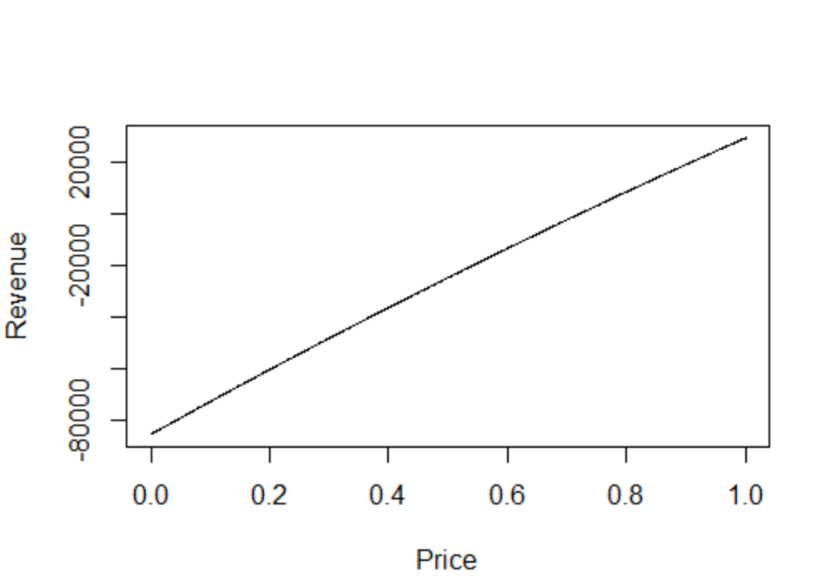

Considered it is a Quadratic function when $ΔP$ lays between 0.72 and 0.73, $ΔR=0$. Therefore, to ensure the coffee shop start making money after one year, the price should be added by 0.73. In this situation, this coffee shop can get back revenue after 224.06 days.