**SMART TRASH-KUN**

**Submitted by:**

Dhyan <<20BCE7648>>

Khushi Sharma <<20BCN7001>>

Twinkle Kumari <<20BCN7023>>

Venkata Karthik <<20BCN7028>>

Adusumilli Serishma <<20BES7039>>

L Shanmukha Sai Srivalli <<20BES7054>>

**Under the guidance of Prof. Somya Ranjan Sahoo**

**Abstract:**

**Index**

Section 1 : Introduction

Section 2: Background

Section 3: Problem Definition

Section 4: Objectives

Section 5: Methodology/Procedure

1. Planning the required components for project
2. Design the working of project
3. Individual Sensor connection and testing to Arduino
4. Multiple sensors connections and testing to Arduino
5. Making of Conveyor
6. Making of Rotatory disk
7. Overall working of the Project
8. Outputs we obtained.

**A list of figures and tables and abbrevation**

**Introduction**

**Background**

**Problem Definition:**

Throwing garbage all over the place will not only dirty our surroundings and pollute

the environment, making it very unhygienic, but also causes bad odors

and encourages the infestation of cockroaches, flies, and other insects.

There are various diseases caused due to poor maintenance of hygienic

conditions.

We don't need to do something to open it without touching it without

stepping on it, just approaching it or bringing our hands closer, we are

hygienic without touching the garbage can to dispose of the trash.

It is sometimes difficult to know where to put the different types of

waste (wet and dry).

But if the people have this much of awareness, they already have done

this, to make this more interesting we are offering Credit system which

they can use later as a discount or offer.

This project is to design a smart automatic recycling trash bin, and it is

an interesting solution to a before-mentioned inconvenience that comes

from recycling Dry and other types of waste. By using this, we hope that

the convenience of a recycling trash bin that helps users to sort the

trash will inspire more people to recycle.

**Objectives**

**Methodology/Procedure**

**Procedure:**

1. Planning the required components for project
2. Design the working of project
3. Individual Sensor connection and testing to Arduino
4. Multiple sensors connections and testing to Arduino
5. Making of Conveyor
6. Making of Rotatory disk
7. Overall working of the Project.
8. Outputs we obtained.
9. **Planning the required components for project.**

Based on the availability we used the set of components listed below:

<https://docs.google.com/spreadsheets/d/1JDUzl5MHy6ydJADFMe42LQ0IFeCBZJEz/edit?usp=share_link&ouid=118388293117458898079&rtpof=true&sd=true>

1. **Design and working of project.**

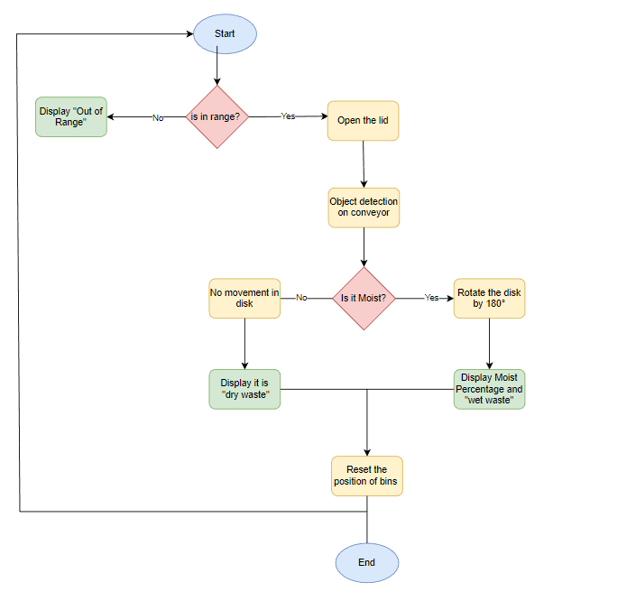

1. **Individual Sensor Testing**

Before, we have tested individual components of the sensors by demonstrating the individual output sensors and their working, This time we extended our procedure from individual working to multi testing the sensors, The individual Testing are listed below:

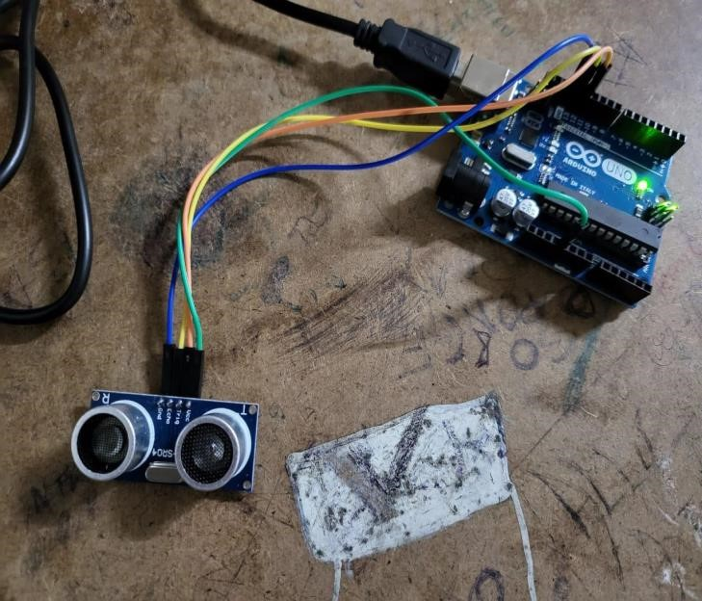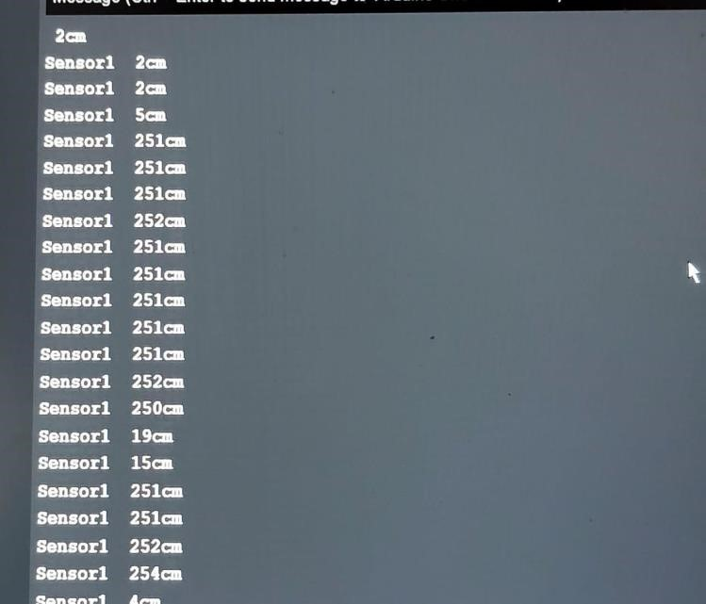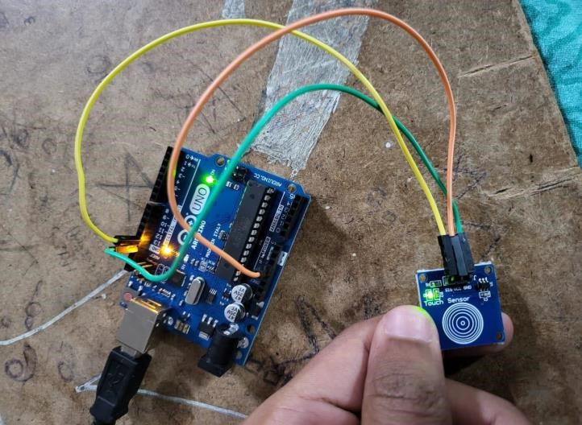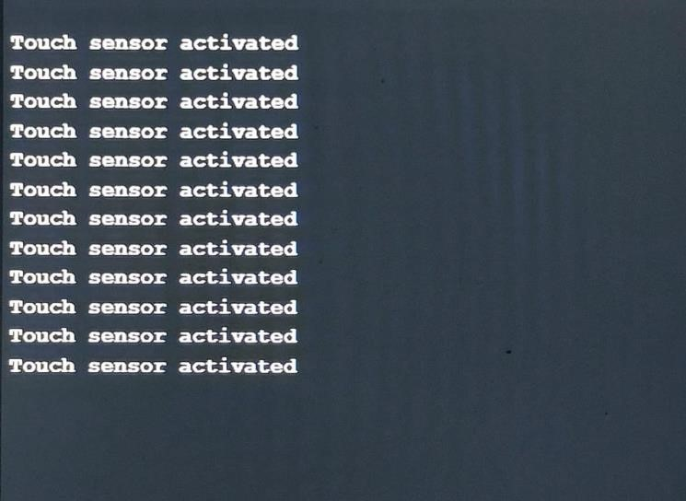

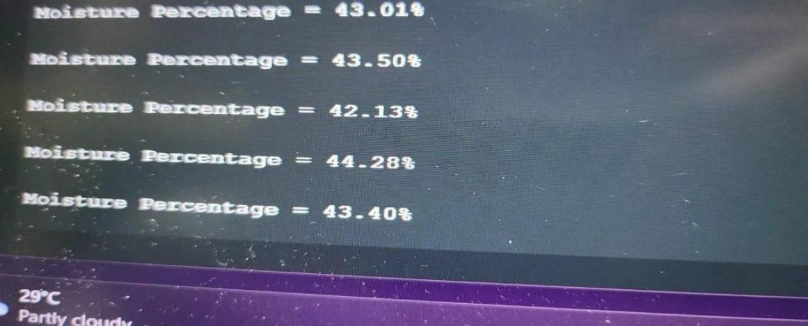

1. **Multi sensors and testing with respective to project**

‘

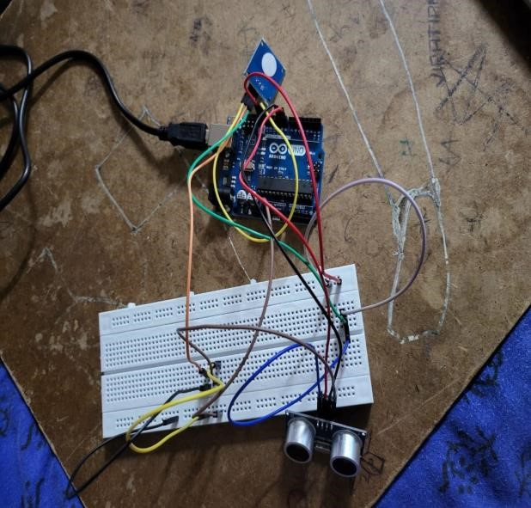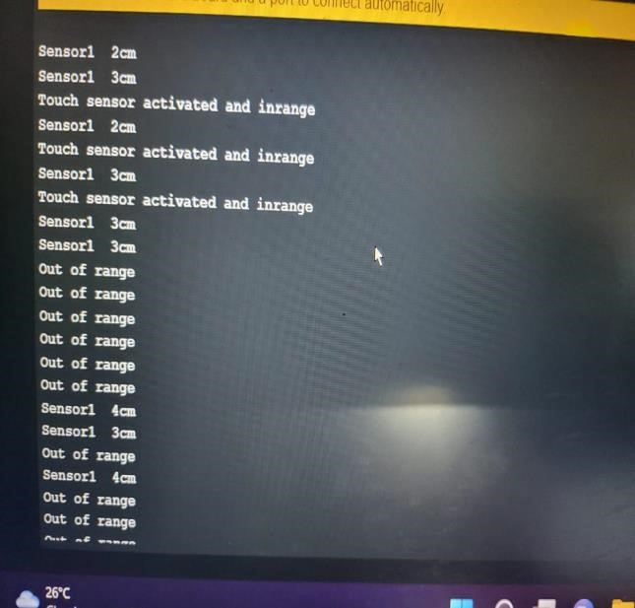

We connected our sensors in such a way that it segregates the dry and wet waste and display what type of waste, if it wet waste then the LCD shows how much moisture percentage is and displays if a person approaches or not. If a person is in range, then it displays the range if not it displays out of range. The working is shown in the below pictures and respective video links at the end.

1. **Making of Conveyor**
2. **Making of Disk**
3. **Overall working of Project**

Conveyor working:

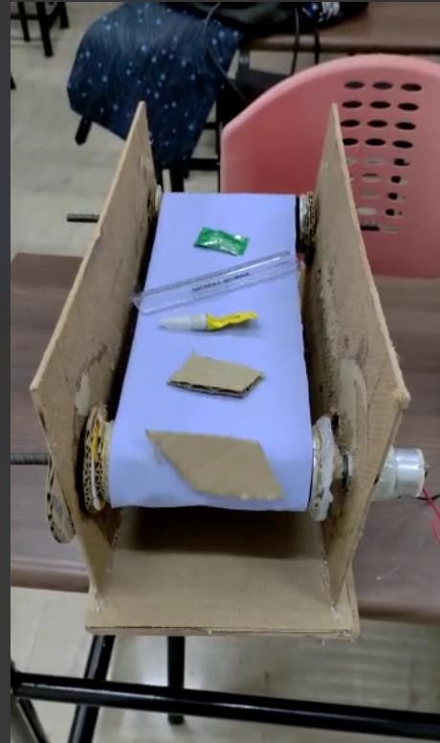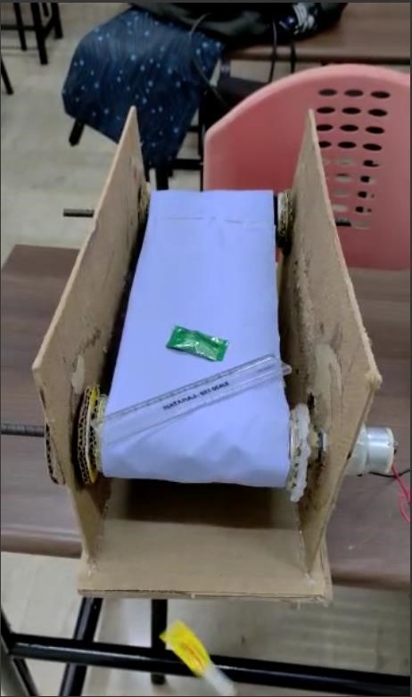

Working of rotatory disk:

If the Ultrasonic ranger is in range and detects wet waste, then the bin rotates to 180 degrees. If it is dry waste, then it won’t move as it is the default position.

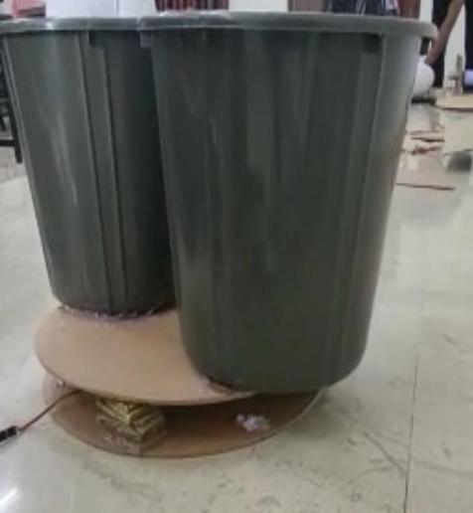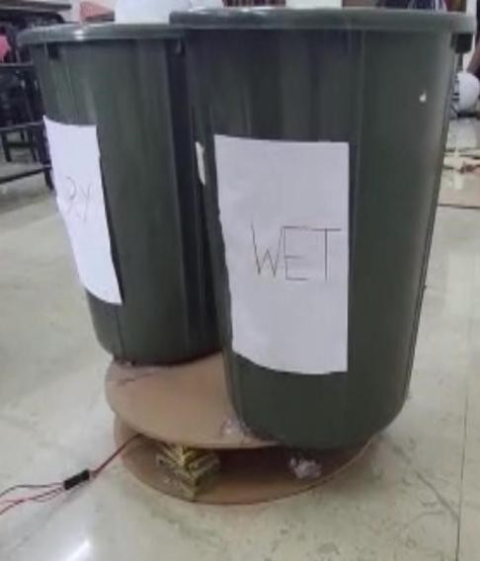

Conveyor will be moving making the waste move which are fallen at a place. It is a place where sensor determines it is whether it is a dry waste or wet waste.

After it has been determined, based on the type of the waste, it segregates.

1. **Setup and output:**

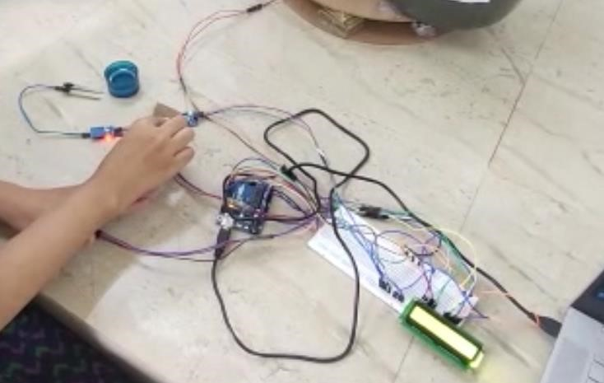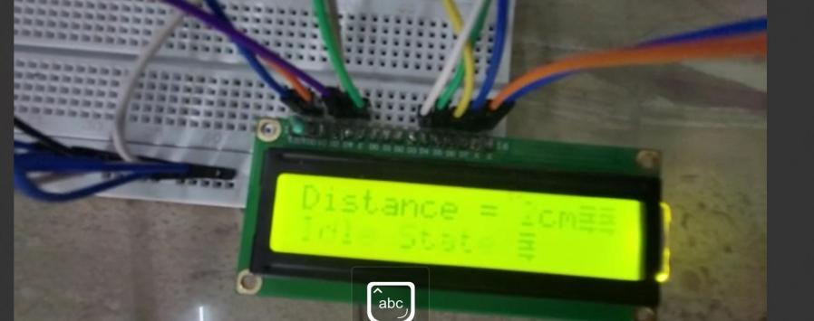

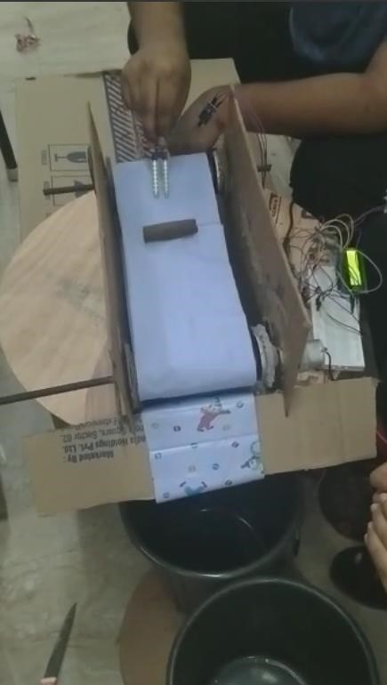

**Result and Discussion**

After throwing an object, Ultrasonic ranger detects the presence of an object and the lid will open. The objects which are thrown inside will fall on conveyor where the moisture sensor categorizes if it is dry waste or wet waste. Finally, the rotatory disk moves accordingly with respective to sensor and segregates the waste.

[https://drive.google.com/file/d/1Xu8dHL4iJIeK2jE4BpQ8zdSRWe9MUrnN/view?u sp=share_link](https://drive.google.com/file/d/1Xu8dHL4iJIeK2jE4BpQ8zdSRWe9MUrnN/view?usp=share_link)

[https://drive.google.com/file/d/1ICHIY8X8RKUhoIaOggTR2tMsGLQl2PEc/view?us p=share_link](https://drive.google.com/file/d/1ICHIY8X8RKUhoIaOggTR2tMsGLQl2PEc/view?usp=share_link)

**Conclusion and Future Scope**

A person comes to a trash bin with some amount of waste with him. An ultrasonic sensor detects the person nearby to him such a way that, It will detect and automatically opens the outer lid, allowing the trash to fall on a conveyor belt. Conveyor will be in ideal state initially. Outer lid is closed after the person leaves the waste bin surroundings. Thereafter, conveyor takes the action in which the sequential detection takes place using soil moisture sensor. The two sensors are placed within a uniform distance such a way that giving enough time to segregate the waste and for rotation of two bins.

After outer lid is closed, the conveyor is on a move. The soil moisture sensor will detect the wet material. Based on the FIFO (First In First Out), The inputs are taken, and the bins are rotated accordingly for segregation. The moisture content and the type of waste will be displayed in the LCD.

**References**

**Codes in Appendix**