1. Download the data in C:\temp or wherever your want your csv file to be available.

This example, I created csv file C:\temp directory.

I have already created table called empdata.

1. Open a Workbench and follow the direction below.

Click on Database Menu in Workbench.

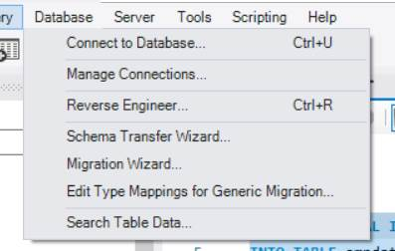

Click on Local Instance MySQL 8.0

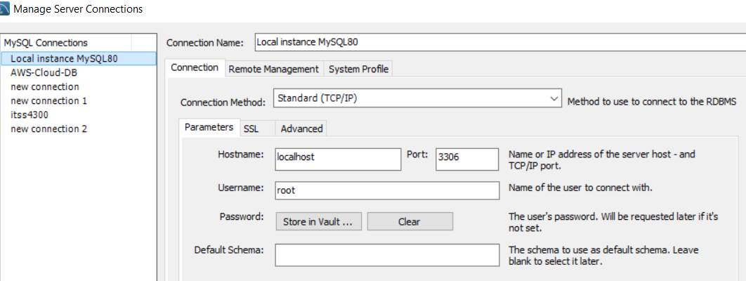

Click on Advanced ,  on others tab,  add OPT_LOCAL_INFILE=1  as you can see below.

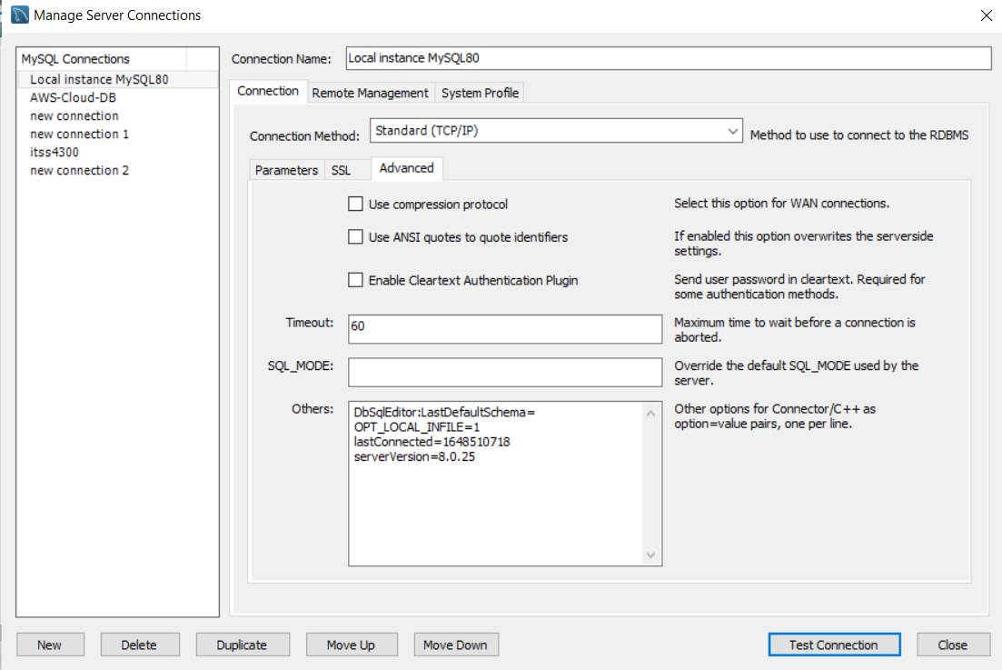

Click on Test Connection to make sure the connection setup is fine.

Then restart the workbench.

Use the SQL editor and run following

**set global local_infile=on;**

use payroll;

CREATE TABLE `empdata` (

`emp_no` int NOT NULL,

`birth_date` date NOT NULL,

`first_name` varchar(14) NOT NULL,

`last_name` varchar(16) NOT NULL,

`gender` enum('M','F') NOT NULL,

`hire_date` date NOT NULL,

`job_category` int DEFAULT NULL,

`health_plan_id` int DEFAULT NULL,

`retirement_saving` decimal(9,2) DEFAULT NULL,

`deposit_bankrouting_number` int DEFAULT NULL,

`deposit_bankaccount_number` int DEFAULT NULL,

`dept_no` varchar(4) DEFAULT NULL,

`payroll_common_deduction_id` int DEFAULT NULL,

`salary` double DEFAULT NULL

) ENGINE=InnoDB DEFAULT CHARSET=utf8mb4 COLLATE=utf8mb4_0900_ai_ci;

Make sure you have file exist in the C:\temp\ directory

LOAD DATA LOCAL INFILE '\\temp\\empdata.csv'

INTO TABLE empdata

FIELDS TERMINATED BY ',' ENCLOSED BY '"'

LINES TERMINATED BY '\r\n'

IGNORE 1 ROWS;

IF it is MAC

Note down where you have downloaded, and replace YOURDIRECTORY with where you have downloaded the file in mac.

LOAD DATA LOCAL INFILE '/YOURDIRECTORY/empdata.csv'

INTO TABLE empdata

FIELDS TERMINATED BY ',' ENCLOSED BY '"'

LINES TERMINATED BY '\r\n'

IGNORE 1 ROWS;

This works fine for WINDOWS. Use MAC directory structure for running in MAC environment.

