NAME : PINKI KUMARI
ROLL NO : CSC/21/25
COURSE : BSC COMPUTER SCIENCE (HONS.)
PAPER : DATABASE MANAGEMENT SYSTEM
SUBMITTED TO : MRS. NEHA KUMARI

PRACTICAL 1

create database pinki25;

DEPARTMENT SCHEMA

create table Department(
Dno int(5),
Dname varchar(50),
Location varchar(50) default 'NEW DELHI',
primary key(Dno)
);


INSERT VALUES

INSERT INTO DEPARTMENT VALUES (10,"Purchase","New Delhi");
Query OK, 1 row affected (0.09 sec)

INSERT INTO DEPARTMENT VALUES (11,"Sales","New Work");
Query OK, 1 row affected (0.12 sec)

INSERT INTO DEPARTMENT VALUES (20,"Design","Seol");
Query OK, 1 row affected (0.10 sec)

INSERT INTO DEPARTMENT VALUES (30,"Media Management","New Delhi");
Query OK, 1 row affected (0.11 sec)

INSERT INTO DEPARTMENT VALUES (35,"Marketing","ITLAY");
Query OK, 1 row affected (0.11 sec)

INSERT INTO DEPARTMENT VALUES (40,"Account","JAPAN");
Query OK, 1 row affected (0.11 sec)

select * from DEPARTMENT;

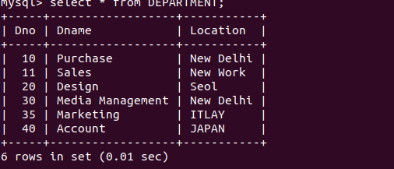

EMPLOYEE SCHEMA

Create table EMPLOYEE(
Eno char(4) not null,
Ename varchar(50) not null,
job_type varchar(50) not null,
Hire_date date not null,
Dno int(11) default null,
Commission decimal(10,2) default null,
Salary decimal(7,2),
primary key(Eno)
);

Query OK, 0 rows affected, 1 warning (1.42 sec)
Query OK, 0 rows affected, 1 warning (0.84 sec)

alter table EMPLOYEE add column SupervisonENO CHAR(04);
Query OK, 0 rows affected (0.42 sec)
Records: 0 Duplicates: 0 Warnings: 0

ALTER TABLE EMPLOYEE ADD FOREIGN KEY(Dno) REFERENCES DEPARTMENT(Dno);
Query OK, 0 rows affected (2.05 sec)
Records: 0 Duplicates: 0 Warnings: 0

ALTER TABLE EMPLOYEE ADD CONSTRAINT SupervisonENO FOREIGN KEY(SupervisonENO) REFERENCES EMPLOYEE(Eno);
Query OK, 4 rows affected (2.43 sec)
Records: 4 Duplicates: 0 Warnings: 0

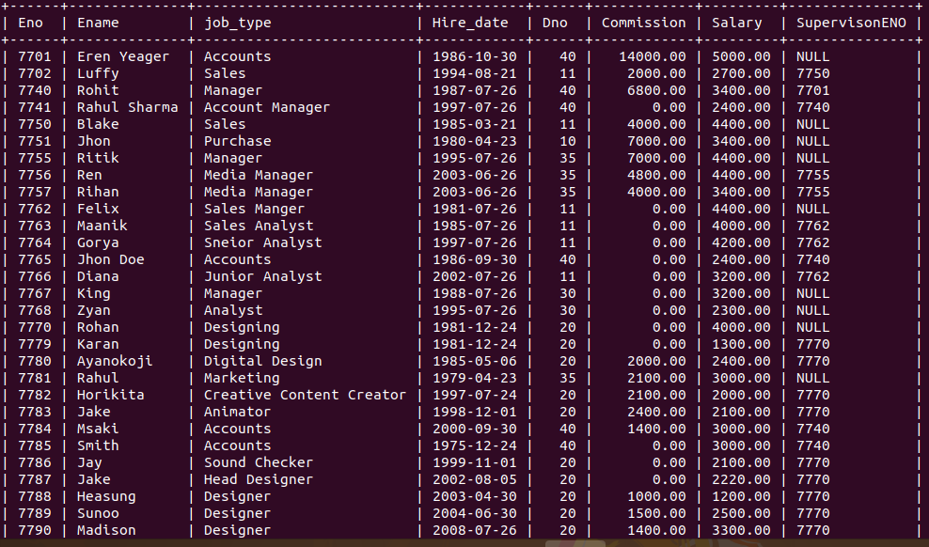
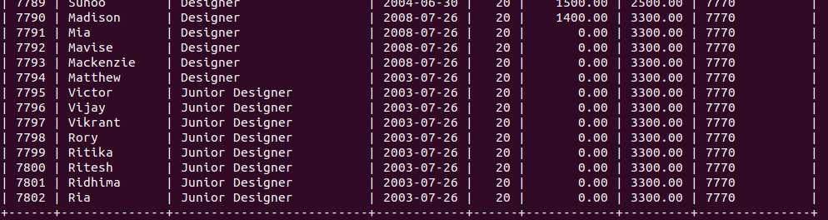

1. Query to display Employee Name, Job, Hire Date, Employee Number; for each employee with the Employee Number appearing first.

SELECT Eno,Ename,job_type,Hire_date FROM EMPLOYEE;

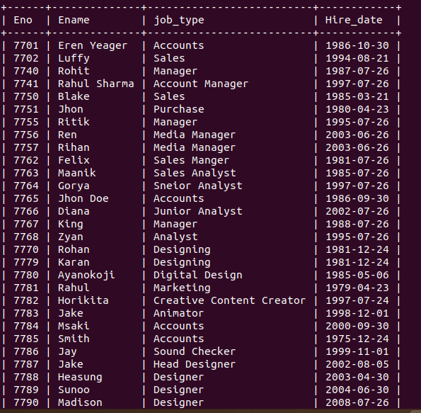
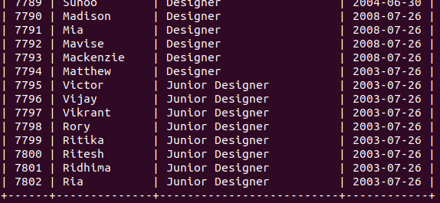

2. Query to display unique Jobs from the Employee Table.
SELECT distinct JOB_TYPE FROM EMPLOYEE;

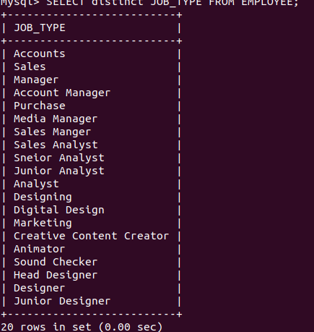

3. Query to display the Employee Name concatenated by a Job separated by a comma.
SELECT CONCAT(Ename,',',job_type)as Name from EMPLOYEE;

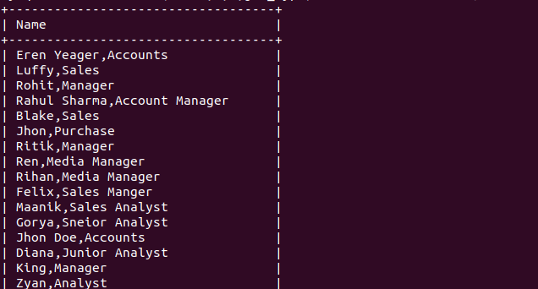
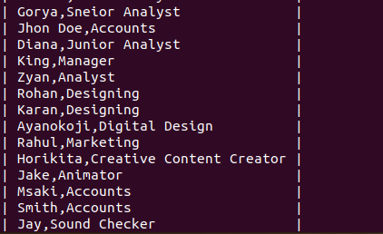

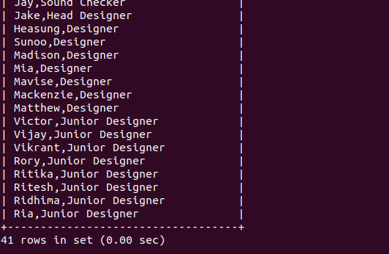
4. Query to display all the data from the Employee Table. Separate each Column by a comma and name the said column as THE_OUTPUT.
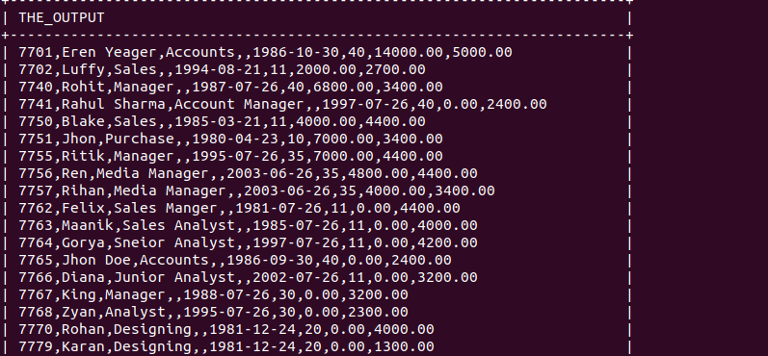
SELECT CONCAT(Eno,',',Ename,',',job_type,',',',',Hire_date,',',Dno,',',Commission,',',Salary) AS THE_OUTPUT FROM EMPLOYEE;

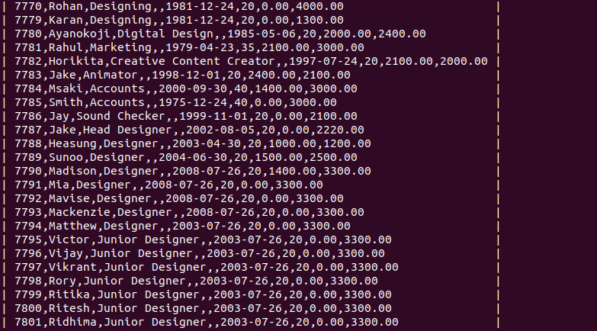
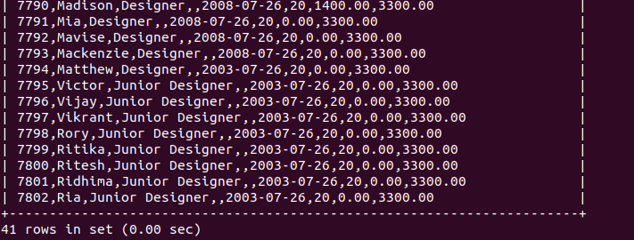

5. Query to display the Employee Name and Salary of all the employees earning more than $2850.
SELECT Ename, Salary FROM EMPLOYEE WHERE ( Salary + Commission ) > 2850;
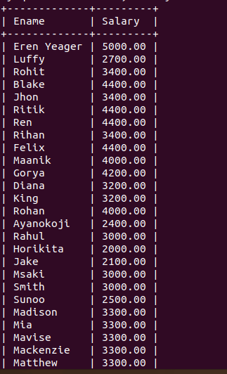
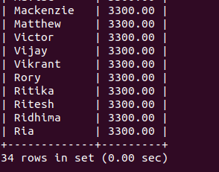

6. Query to display Employee Name and Department Number for the Employee No= 79.
SELECT Ename,Dno FROM EMPLOYEE WHERE Eno='7779';
7. Query to display Employee Name and Salary for all employees whose salary is not in the range of $1500 and $2850.
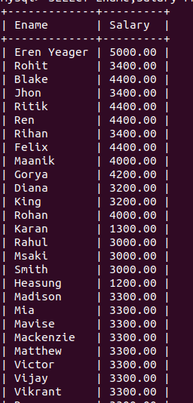
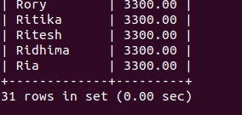

8. Query to display Employee Name and Department No. of all the employees in Dept 10 and Dept 30 in the alphabetical order by name.

SELECT Ename,Dno FROM EMPLOYEE WHERE Dno=10 OR DNO=30 ORDER BY Ename;

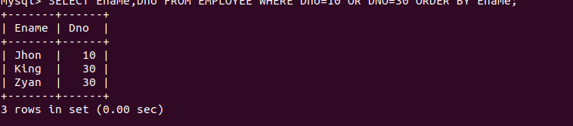

9. Query to display Name and Hire Date of every Employee who was hired in 1981.

SELECT Ename,Hire_date FROM EMPLOYEE WHERE Hire_date LIKE '1981%';

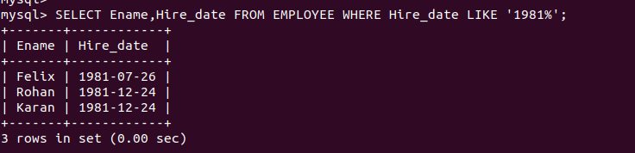

10. Query to display Name and Job of all employees who have not assigned a supervisor.

SELECT Ename,Job_type FROM EMPLOYEE WHERE SupervisonENO IS NULL;
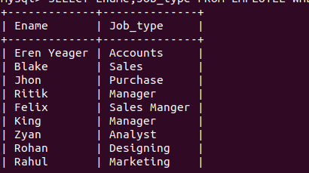

11. Query to display the Name, Salary and Commission for all the employees who earn
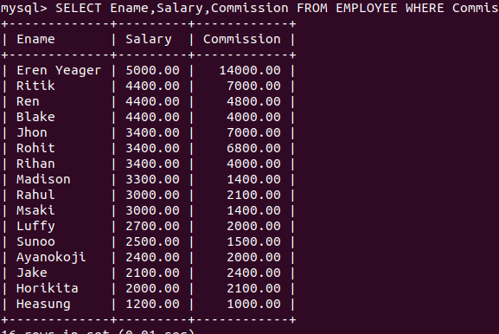
commission.
SELECT Ename,Salary,Commission FROM EMPLOYEE WHERE Commission > 0.00 ORDER BY Salary DESC,Commission DESC;

12. Sort the data in descending order of Salary and Commission.

SELECT Ename, Salary, Commission from EMPLOYEE ORDER BY Salary desc,Commission desc;
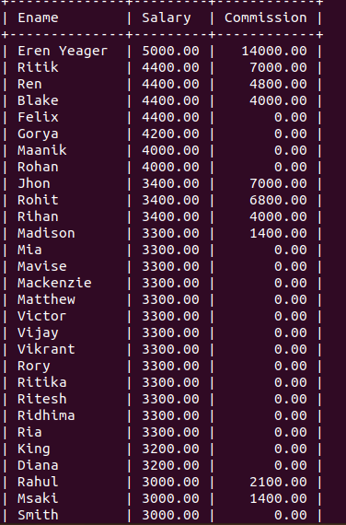

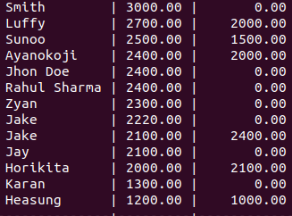

13. Sort the data in descending order of Salary and Commission.

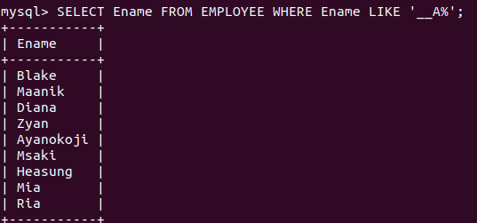
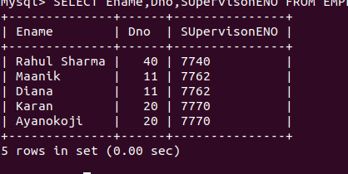
SELECT Ename FROM EMPLOYEE WHERE Ename LIKE '__A%';
14. Query to display Name of all the employees where the third letter of their name is ‘A’.
SELECT Ename,Dno,SUpervisonENO FROM EMPLOYEE WHERE Ename LIKE '%A%A%' OR Ename LIKE '%R%R%' AND Dno=30 OR SupervisonENO='7778';

15. Query to display Name, Salary and Commission for all employees whose Commission amount is greater than their Salary increased by 5%.

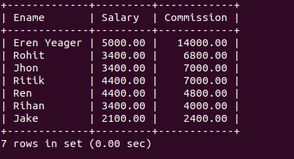

16. Query to display the Current Date along with the day name.
SELECT date_format(CURDATE(),'%W %D %M %Y %T');

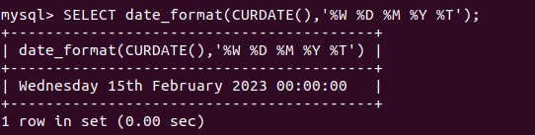

17. Query to display Name, Hire Date and Salary Review Date which is the 1st Monday after six months of employment.
SELECT Ename,Hire_date,date_add(date_add(Hire_date,INTERVAL 6 MONTH),INTERVAL (7-WEEKDAY(date_add(Hire_date,INTERVAL 6 MONTH))) DAY) AS REVIEW_DATE FROM EMPLOYEE;
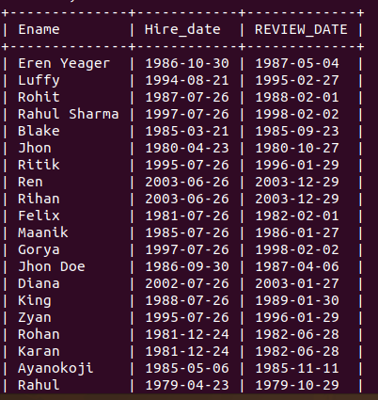
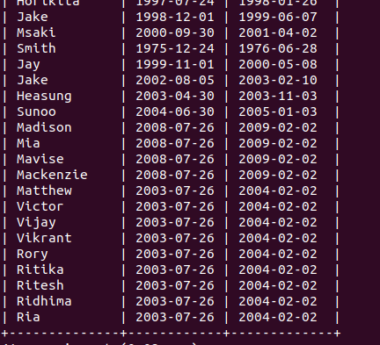

18. Query to display Name and calculate the number of months between today and the date on which employee was hired of department ‘Purchase’.

SELECT Ename,12 * (YEAR(curdate())-YEAR(Hire_date)) + (MONTH(CURDATE())-MONTH(Hire_date)) AS MONTHS FROM EMPLOYEE where Dno =10;

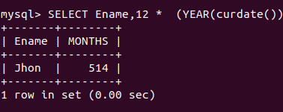
19. Query to display the following for each employee <E-Name> earns < Salary> monthly but wants < 3 * Current Salary >. Label the Column as Dream Salary.
SELECT CONCAT(Ename,' Earns ',Salary,' Wants ',3*Salary) AS DREAM_SALARY from EMPLOYEE;
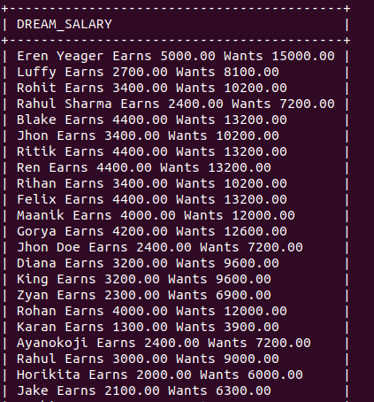
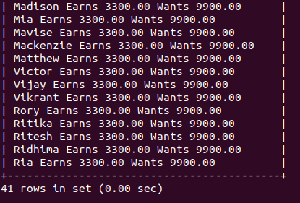
20. Query to display Name with the 1st letter capitalized and all other letter lower case and length of their name of all the employees whose name starts with ‘J’, ’A’ and ‘M’.
SELECT
CONCAT(UPPER(SUBSTRING(Ename,1,1)),LOWER(SUBSTRING(Ename,2,50)))
AS
NAME,LENGTH(Ename) AS LENGTH FROM EMPLOYEE WHERE Ename LIKE 'J%' OR Ename LIKE 'A%' OR Ename LIKE 'M%';

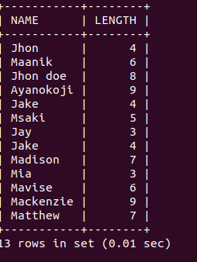
21. Query to display Name, Hire Date and Day of the week on which the employee started.
SELECT e.Ename,e.Hire_Date,DAYNAME(Hire_date) as WEEK_DAY FROM EMPLOYEE AS e;
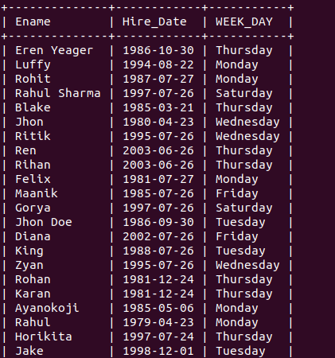
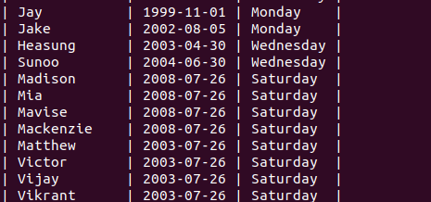

22. Query to display Name, Department Name and Department No for all the employees.
select e.Ename,d.Dno,d.Dname FROM EMPLOYEE AS e,DEPARTMENT AS d WHERE d.Dno=e.Dno;

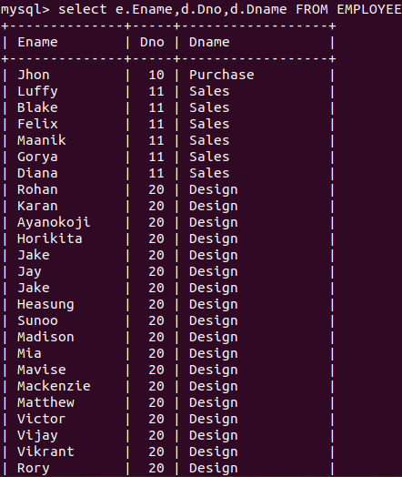
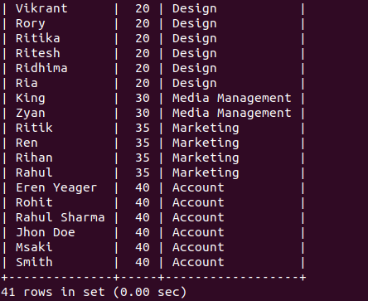

23. Query to display Unique Listing of all Jobs that are in Department number 30.

select DISTINCT e.job_type from EMPLOYEE AS e,DEPARTMENT AS d WHERE d.Dno = 30;

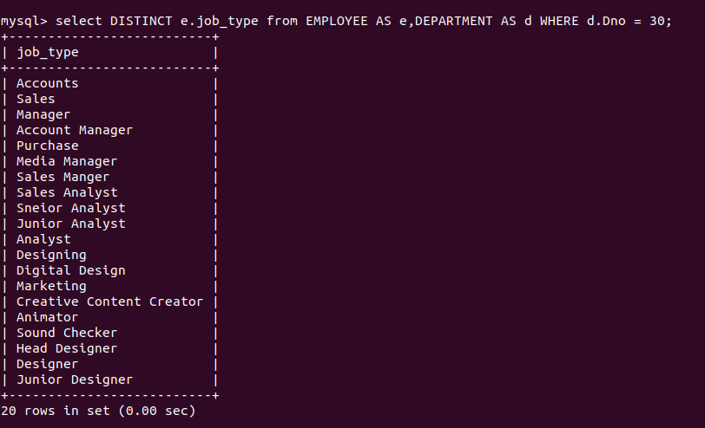
24. Query to display Name, Dept Name of all employees who have an ‘A’ in their name.
select e.Ename,d.Dname FROM EMPLOYEE AS e,DEPARTMENT AS d WHERE d.Dno=e.Dno AND e.Ename LIKE '%a%';

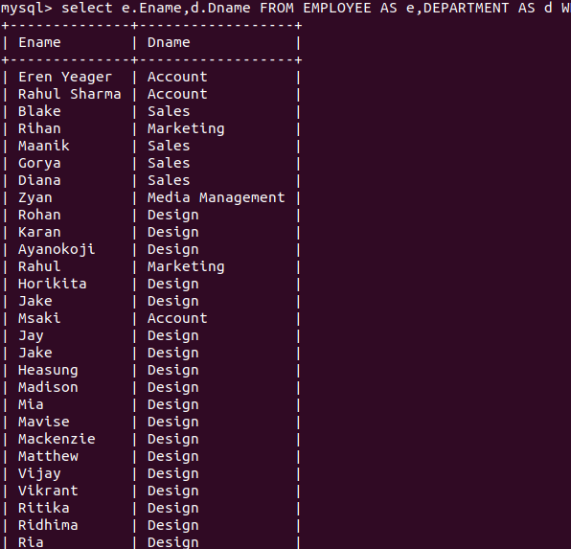
25. Query to display Name, Job, Department No. And Department Name for all the
employees working at the Dallas location.

select e.Ename,e.job_type,d.Dno,d.Dname FROM EMPLOYEE AS e,DEPARTMENT AS d WHERE d.Dno=e.Dno AND d.Location='DALLAS';

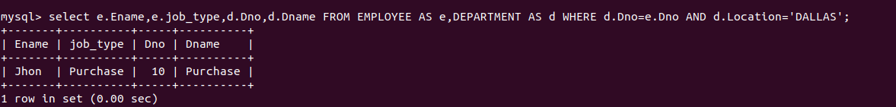
26. Query to display Name and Employee no. Along with their supervisor’s Name and the supervisor’s employee no along with the Employees’ Name who do not have a supervisor.

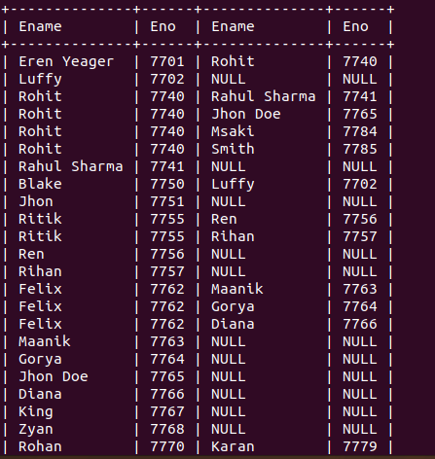
SELECT e.Ename,e.Eno,d.Ename,d.Eno FROM EMPLOYEE AS e LEFT OUTER JOIN EMPLOYEE as d ON e.Eno=d.SupervisonENO;
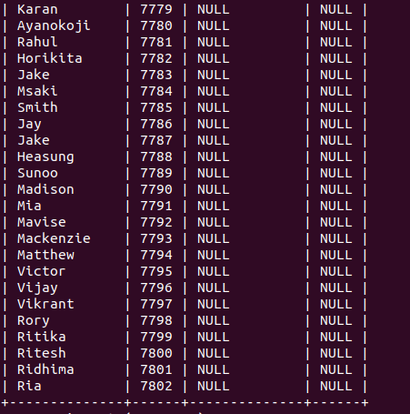
27. Query to display Name, Dept No. And Salary of any employee whose department No. and salary matches both the department no. And the salary of any employee who earns a commission.
SELECT Ename,Dno,Salary FROM EMPLOYEE WHERE (Dno,Salary) IN (SELECT Dno,Salary FROM EMPLOYEE WHERE Commission>0);

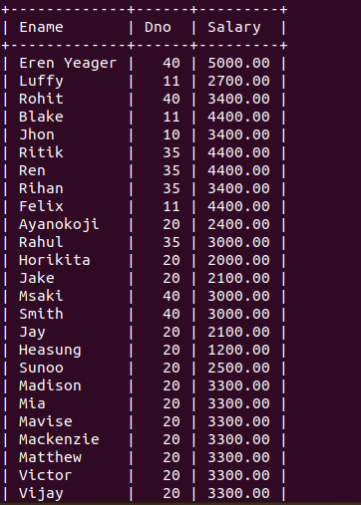
28. Query to display Name and Salaries represented by asterisks, where each asterisk (*)signifies $100.

select EName,Repeat('*',(Salary/100))AS Salary From EMPLOYEE;

