Bisection Method:

f[x_] := x^3 -x -1
a[0] = 1;
b[0] = 2;
Do[p[n+1] = N[(a[n] + b[n] ) /2];
If [N[f[p[n+1]]] > 0 , a[n+1] = a[n];
b[n+1] = p[n+1] , a[n+1] = p[n+1];
b[n+1] = b[n] ] , {n,0,20} ]
TableForm[Table[{n,a[n],b[n],p[n+1] , f[p[n+1] ] } , {n,0,20}]]

Regula Falsi:

f[x_] := x^ 3 - 5 x + 1
a[0] = 0.0;
b[0] = 1.0;
Do[p[n + 1] = b[n] - ((b[n] - a[n]) / (f[b[n]] - f[a[n]])) * f[b[n]];
If[N[f[a[n]] * f[p[n + 1]]] < 0, a[n + 1] = a[n];
b[n + 1] = p[n + 1], a[n + 1] = p[n + 1];
b[n + 1] = b[n]], {n, 0, 20}]
TableForm[Table[{n, a[n], b[n], p[n + 1], f[p[n + 1]]}, {n, 0, 20}]]

Secant:

f[x_] := x^ 3 - 5 x + 1;
a[0] = - 3.0
a[1] = -2.0
Do[a[n+2] =a[n+1]-((a[n+1]-a[n])/(f[a[n+1]]-f[a[n]])) * f[a[n+1]] ,{n,0,9}]
TableForm[Table[{n,a[n],f[a[n]]},{n,0,9}]]

Newton Raphson:

f[x_] := x^3 -5 x + 1
a[0] = -2.5;
Do[a[n+1] = a[n] - (f[a[n]] / f' [a[n]]) , {n,0,9}]
TableForm[Table[{n,a[n],f[a[n]]} , {n,0,9} ]]

Gauss Elimination:

R={{8.0,5.0,1.0},{1.0,12.0,8.0},{10.0,8.0,2.0}};
S= {1.0, 6.0, 10.0};
MatrixForm[eq3=Transpose[Join[Transpose[R],{S}]]]
MatrixForm[r=RowReduce[eq3]]
x=r[[All, 4]]

Gauss Jordan:

A= {{4.0,3.0,2.0},{2.0,11.0,6.0},{1.0,2.0,10.0}}
RowReduce[A] // MatrixForm

Gauss Jacobi:

A = {{4.0, 1.0, 2.0},{3.0,5.0,1.0},{1.0,1.0,3.0}};
d = {{4.0, 0, 0}, {0, 5.0, 0}, {0, 0, 3.0}};
u = {{0, 1.0, 2.0}, {0, 0, 1.0}, {0, 0, 0}};
l = {{0, 0, 0}, {- 3.0, 0, 0}, {1.0, 1.0, 0}};
b = Transpose[{{4.0, 7.0, 3.0}}];
x[1] = Transpose[{{0, 0, 0}}]
Do[x[n + 1] = LinearSolve[d, -(l + u).x[n] + b];
Print[x^ n, "=", MatrixForm[x[n]]], {n, 1, 15}]

Gauss Seidel:

A = {{4.0,1.0,2.0},{3.0,5.0,1.0},{1.0,1.0,3.0}};
d = {{4.0,0,0},{0,5.0,0},{0,0,3.0}};
u={{0,1.0,2},{0,0,1.0},{0,0,0}};
l={{0,0,0},{-3.0,0,0},{1.0,1.0,0}};
b=Transpose[{{4.0,7.0,3.0}}]
x[1] = Transpose[{{0,0,0}}]
Do[x[n+1] = LinearSolve[d+l,-u.x[n]+b;
Print[x^n,"=",MatrixForm[x[n]]],{n,1,15}]

Lagrange:
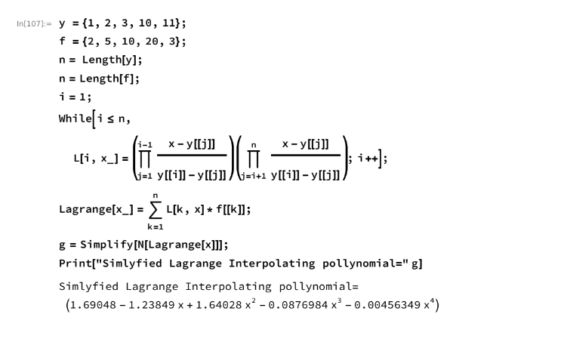

Newton Interpolation:

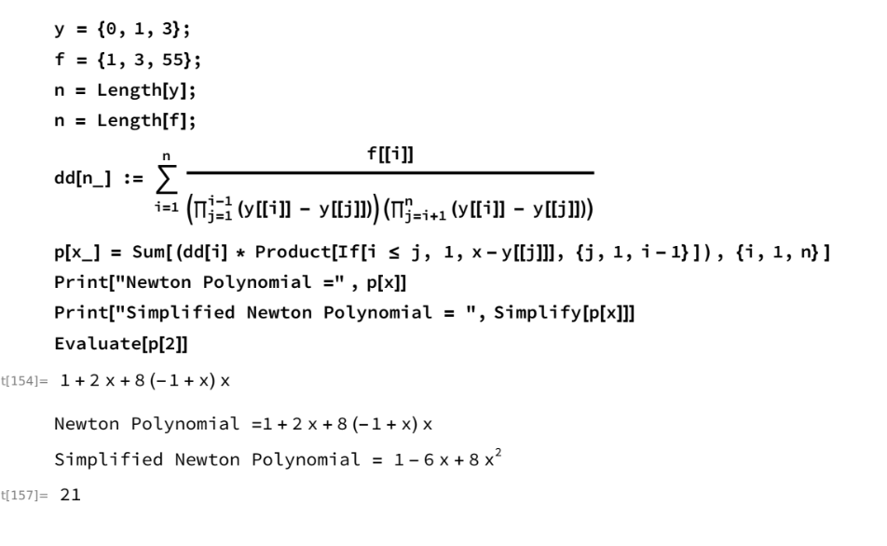

Euler:
f[x_,y_] := x+y
a=0.0;
b=1.0;
n=10.0;
h = (b-a)/n;
y[0] = 1.0;
Int = y[0];
For[i=0,i<=n-1,i++,x[i] = a+i*h;
y[i] = Int;
y[i+1] = y[i] + h * f[x[i],y[i]];
Print["Approx Value ",i+1," is : ",y[i+1]];
Int =y[i+1]];

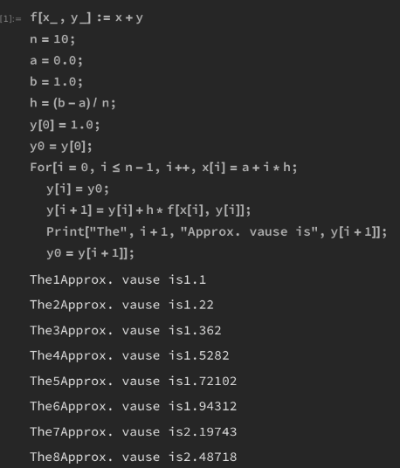

Trapezoidal:

f[x_] := 1 / (1 + x)
a = 0.0;
b = 1.0;
h = b - a;
AprInt = (h / 2) * (f[a] + f[b])
ExactInt = Integrate[f[x], {x, 0.0, 1.0}]
Err = Abs[ExactInt - AprInt]

Simpson:
Simple:

f[x_] := 1/(1+x);
a = 0.0;
b = 1.0;
h= (b-a)/2
APPINT = h/3 (f[a]+4*f[a+h]+f[b])
EXACTINT = N[Integrate[f[x],{x,0,1}]];
Error = Abs[APPINT-EXACTINT];
Print["APPINT = ",APPINT]
Print["EXACTINT = ",EXACTINT]
Print["Error = ",Error]

Composite:
