

170473107004



TWINKLE DESAI

170473107004

Table of Contents

AIM : Introduction to c# 2

AIM: Inheritance 12

Program 1 12

Program 2 14

Program 3 15

Program 4 17

AIM: Method & constructor overloading 19

Program 1 19

Program 2 23

AIM: Reflection 26

Program 1 26

# AIM : Introduction to c#

Variables:

Initialization

Scope

Constant

Predefined Data Types

Value Types

Reference TYpes

Flow Control

Conditional Statements(if, switch)

Loop(for, while, dowhile, foreach)

Jump(goto, break, continue, return)

Eumerations

Passing Arguments

using System;

using System.Collections.Generic;

using System.Linq;

using System.Text;

using System.Threading.Tasks;

namespace aim

{

class Program

{

static int newint=100;

public enum TimeOfDay

{

Morning = 0,

Afternoon = 1,

Evening = 2

}

public static void Main(string[] args)

{

Console.WriteLine("\n integer types");

sbyte sb = 10;

short s = 33;

int i = 10;

long l = 33L;

byte b = 22;

ushort us = 33;

uint ul = 33u;

ulong ulo = 33ul;

Console.WriteLine("{0},{1},{2},{3},{4},{5},{6},{7}", sb, s, i, l, b, us, ul, ulo);

float f = 1.122345656767f;

double d = 12.1234455657878797;

Console.Write("\nFloat and Double:\n");

Console.WriteLine("{0} and \n{1}", f, d);

decimal dec=111.666666666666666666666M;

Console.WriteLine("decimal:\n{0} ",dec);

Console.WriteLine("\nBoolean:");

bool boolean =true;

Console.WriteLine("Status: " + boolean);

// Console.ReadLine();

char character ='d';

Console.WriteLine(character);

character = '\0';

Console.WriteLine("Now null: " + character);

object o1 = "Hi, I am ALICE";

object o2 = 15.3454365;

string strObj = o1 as string;

Console.WriteLine(strObj);

Console.WriteLine(o1.GetHashCode() + " " + o1.GetType());

Console.WriteLine(o2.GetHashCode() + " " + o2.GetType());

Console.WriteLine(o1.Equals(o2));

string s1, s2;

s1 = "this is string";

s2 = s1;

Console.WriteLine("S1 is: {0} and s2 is {1}", s1, s2);

s2 = "other string";

Console.WriteLine("S1 is: {0} and s2 is {1}", s1, s2);

s1 = "c:C:\\Users\\Dell\\source\\repos\\aim";

Console.WriteLine(s1);

s1 = @"c:C:\Users\Dell\source\repos\aim\aim";

Console.WriteLine(s1);

s1 = @"We can also write

like this";

Console.WriteLine(s1);

bool isZero;

Console.WriteLine("\nFlow Control: (if)\ni is " + i);

if (i == 10)

{

isZero = true;

Console.WriteLine("i is Zero {0}",isZero);

}

else

{

isZero = false;

Console.WriteLine("i is Non - zero");

}

int integerA = 1;

Console.WriteLine("\nSwitch:");

switch (integerA)

{

case 1:

Console.WriteLine("integerA = 1");

break;

case 2:

Console.WriteLine("integerA = 2");

//goto case 3;

break;

case 3:

Console.WriteLine("integerA = 3");

break;

default:

Console.WriteLine("integerA is not 1, 2, or 3");

break;}

WriteGreeting(TimeOfDay.Morning);

Console.WriteLine("Argument is: {0}",args[1]);

void WriteGreeting(TimeOfDay timeOfDay)

{

switch (timeOfDay)

{

case TimeOfDay.Morning:

Console.WriteLine("Good morning!");

break;

case TimeOfDay.Afternoon:

Console.WriteLine("Good afternoon!");

break;

case TimeOfDay.Evening:

Console.WriteLine("Good evening!");

break;

default:

Console.WriteLine("Hello!");

break;

}}

Console.WriteLine("Scope of Variables.\n1:");

int newint=0;

int j;

for (/*int*/ j = 0; j < 2; j++) //removing comment from for loop will raise error

{

//int j;

//uncomment above line to error "A local variable named 'j' cannot be declared in this

//scope because it would give a different meaning to 'j', which is already

//used in a 'parent or current' scope to denote something else"

Console.Write("{0} {1}\n", newint, Program.newint);

}

Console.WriteLine("2:");

for (int k = 0; k < 3; k++)

{

Console.Write("{0} ", k);

}//Scope of k ends here

Console.Write("\n");

//Console.Write(k);

//uncomment above line to see error "The name 'k' does not exist in the current context"

for (int k = 3; k > 0; k--)

{

Console.Write("{0} ", k);

}//scope of k ends here again

Console.WriteLine("Constants");

const int valConst = 100; // This value cannot be changed.

Console.WriteLine("{0} is constant value", valConst);

//valConst = 45;

//uncomment above line to see error "The left-hand side of an assignment must be a variable, property or indexer"

//const only allow constant variables into the expression

const int valConst2 = valConst + 9 /* + j*/;

//remove comments from the above line to see error "The expression being assigned to 'valConst2' must be constant"

Console.WriteLine("Another Constant: {0}", valConst2);

Console.WriteLine("\nPredefined Data Types\n\nValue Types and Reference Types");

//Value Types

int vali = 2, valj = vali;

Console.WriteLine("vali is: {0} and valj is: {1}", vali, valj);

valj = 90;

Console.WriteLine("vali is: {0} and valj is: {1}", vali, valj);

//Referece Types

Vector x, y;

x = new Vector();

x.value = 3;

y = x;

Console.WriteLine("x is: {0} and y is:{1}", x.value, y.value);

y.value = 234;

Console.WriteLine("x is: {0} and y is:{1}", x.value, y.value);

//If a variable is a reference, it is possible to indicate that it does not refer to any object by setting its value to null:

y = null;

//Console.Write("Value for y is: " + y.value);

//uncomment above line to see runtime exception "System.NullReferenceException: Object reference not set to an instance of an object."

//CTS

}

public class Vector

{

public int value;

}

}

}

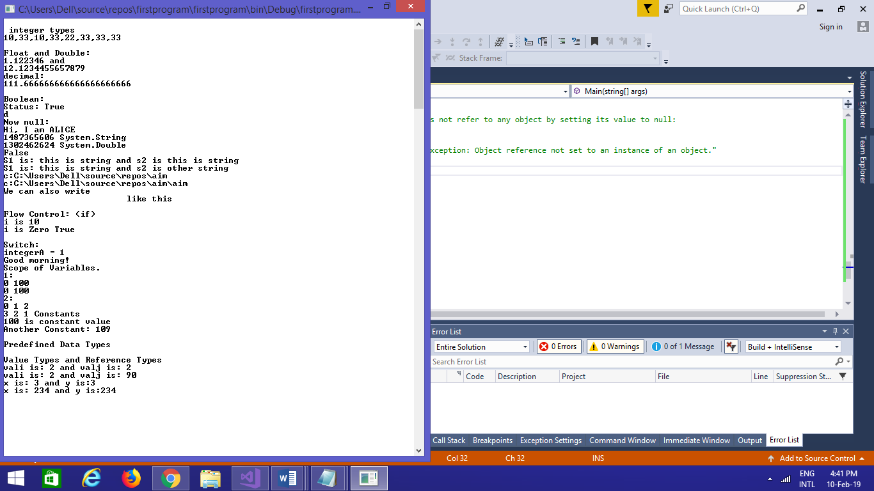

# AIM: Inheritance

## Program 1

Perform following programs in c#.

1. Write console based program in code behind language VB or C# to print following pattern.

@ @ @ @ @

@ @ @ @

@ @ @

@ @

@

using System;

using System.Collections.Generic;

using System.Linq;

using System.Text;

using System.Threading.Tasks;

namespace practical2

{

class Program

{

static void Main(string[] args)

{

for(int i=5;i>0;i--)

{

for (int j = i; j > 0; j--)

{

Console.Write("@");

}

Console.WriteLine(" ");

}

Console.ReadKey();

}

}

}

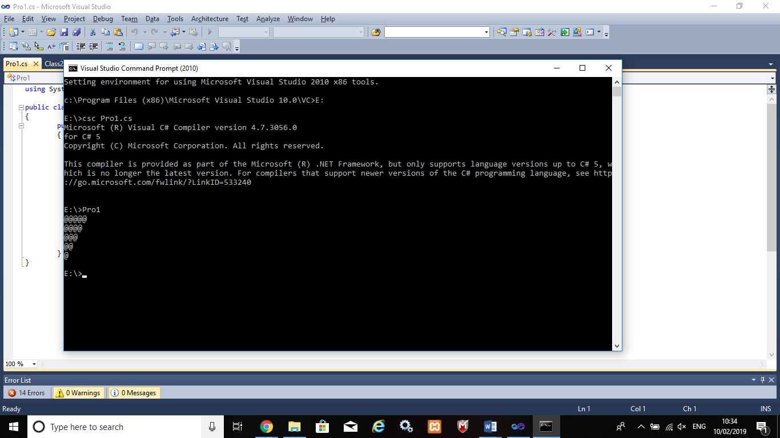

## Program 2

2. Write console based program in code behind language VB or C# to print following pattern.

1

1 2

1 2 3

1 2 3 4

using System;

using System.Collections.Generic;

using System.Linq;

using System.Text;

using System.Threading.Tasks;

namespace practical2._1

{

class Program

{

static void Main(string[] args)

{

for(int i=1;i<=5;i++)

{

for(int j=i;j>0;j--)

{

Console.Write("{0}",i);

}

Console.WriteLine("");

}

Console.ReadKey();

}

}

}

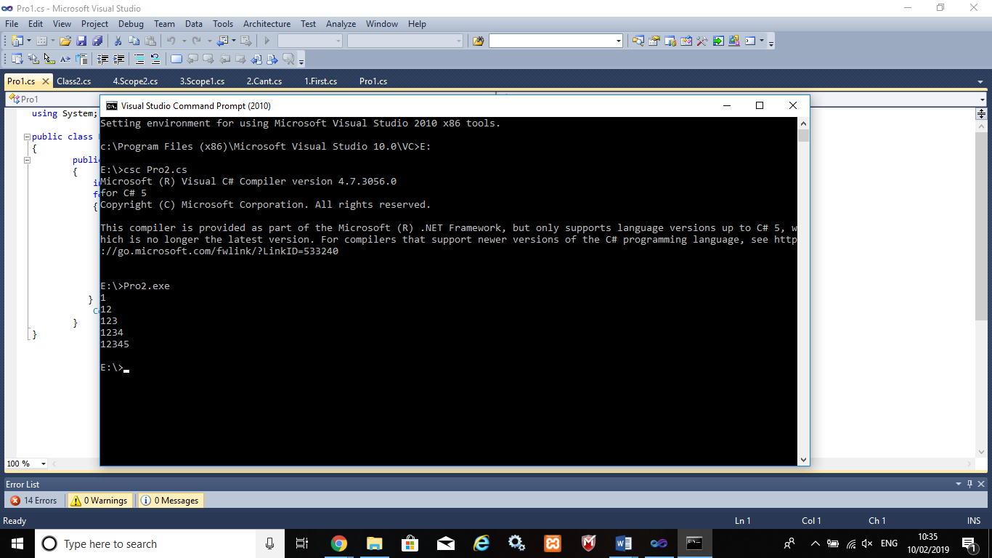

## Program 3

3. Write C# code to prompt a user to input his/her name and country name and then the output will be shown as an example below:

Hello Ram from country India

using System;

using System.Collections.Generic;

using System.Linq;

using System.Text;

using System.Threading.Tasks;

namespace practical2._2

{

class Program

{

static void Main(string[] args)

{

string name;

string country;

Console.WriteLine("enter your name:");

name=Console.ReadLine();

Console.WriteLine("enter your country:");

country = Console.ReadLine();

Console.WriteLine("hello {0} from country {1}",name,country);

Console.ReadKey();

}

}

}

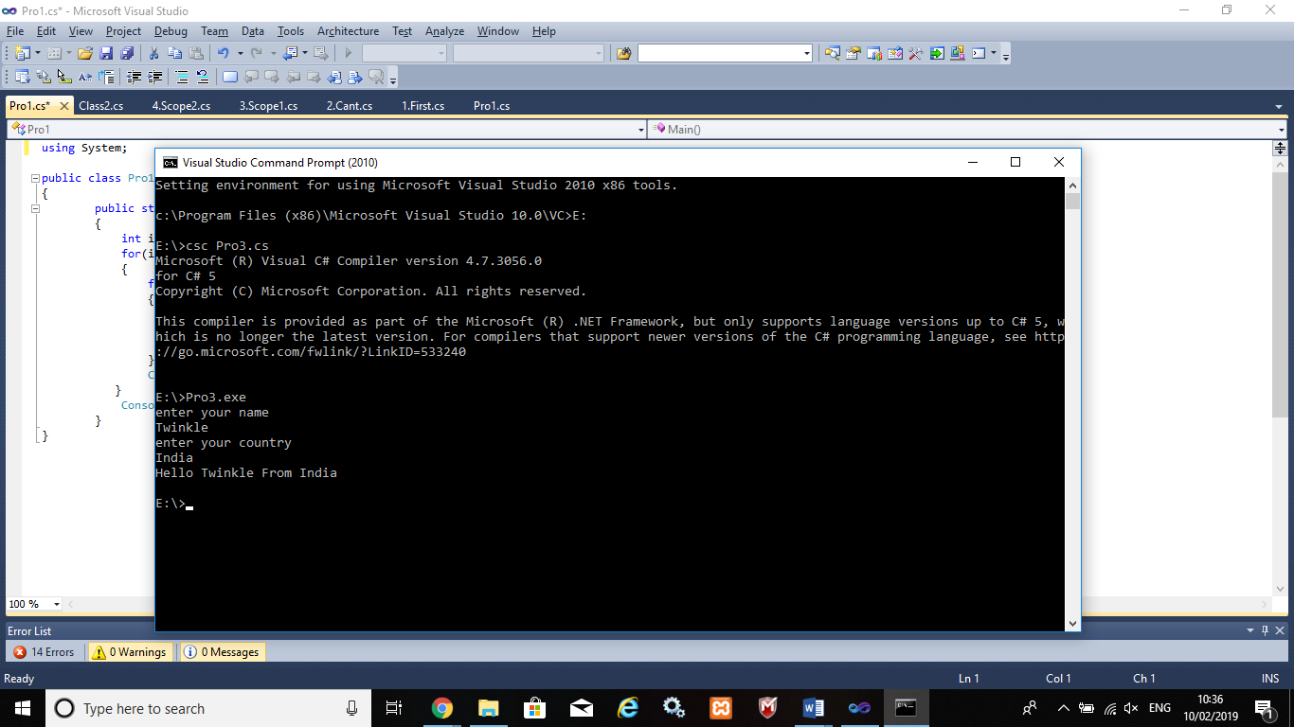

## Program 4

4. What is inheritance? Create C# console application to define Car class and derive Maruti and Mahindra from it to demonstrate inheritance.

using System;

using System.Collections.Generic;

using System.Linq;

using System.Text;

using System.Threading.Tasks;

namespace practical2._3

{

class car

{

public void Method1()

{

Console.WriteLine("this is the method of car class");

}

}

class maruti:car

{

public void method2()

{

Console.WriteLine("this is the method of maruti");

Console.ReadKey();

}

}

class mahindra:car

{

public void method3()

{

Console.WriteLine("this is the method of mahindra");

}

}

class Program

{

static void Main(string[] args)

{

mahindra m = new mahindra();

maruti m1 = new maruti();

m.Method1();

m1.Method1();

Console.ReadKey();

}

}

}

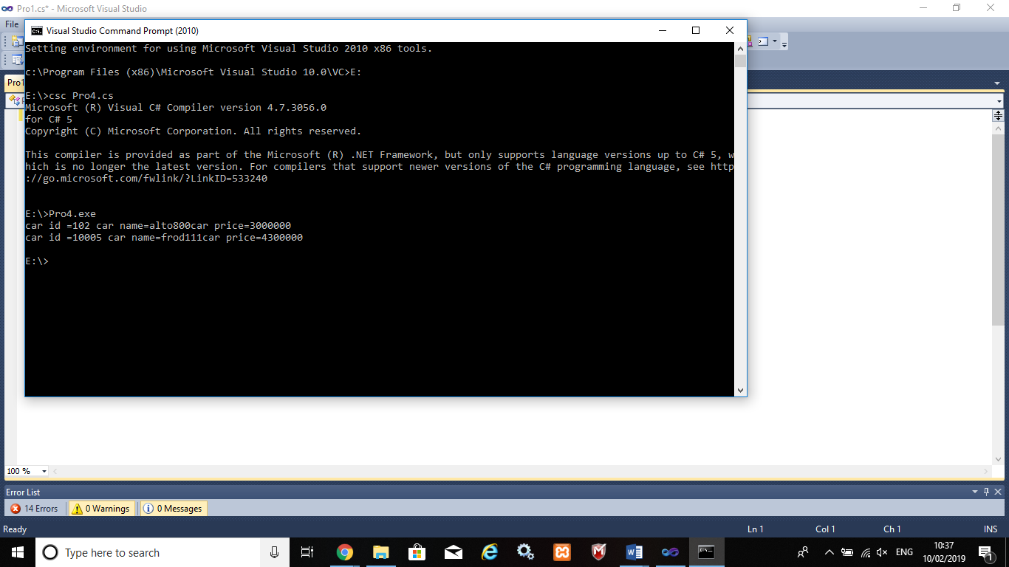

# AIM: Method & constructor overloading

## Program 1

1.Write a c# program to add two integers, two vectors and two metric using method overloading.

using System;

using System.Collections.Generic;

using System.Linq;

using System.Text;

using System.Threading.Tasks;

namespace p3

{

public class Add

{

public void add()

{

int[,] m1 = new int[50, 50];

int[,] m2 = new int[50, 50];

int[,] m3 = new int[50, 50];

Console.WriteLine("enter size of array:");

int size = Convert.ToInt32(Console.ReadLine());

Console.WriteLine("enter first array:");

for (int i = 0; i < size; i++)

{

for (int j = 0; j < size; j++)

{

m1[i, j] = Convert.ToInt32(Console.ReadLine());

}

}

Console.WriteLine("enter second array:");

for (int i = 0; i < size; i++)

{

for (int j = 0; j < size; j++)

{

m2[i, j] = Convert.ToInt32(Console.ReadLine());

}

}

for (int i = 0; i < size; i++)

{

for (int j = 0; j < size; j++)

{

m3[i, j] = m1[i, j] + m2[i, j];

}

}

Console.WriteLine("addition array:");

for (int i = 0; i < size; i++)

{

Console.Write("\n");

for (int j = 0; j < size; j++)

{

Console.Write("{0}\t", m3[i, j]);

}

Console.Write("\n");

}

}

public int add(int a, int b)

{

return (a + b);

}

}

public class Vector

{

public void add()

{

Console.WriteLine("enter first vector");

int x = Convert.ToInt32(Console.ReadLine());

int y = Convert.ToInt32(Console.ReadLine());

int z = Convert.ToInt32(Console.ReadLine());

Console.WriteLine("enter second vector");

int x1 = Convert.ToInt32(Console.ReadLine());

int y1 = Convert.ToInt32(Console.ReadLine());

int z1 = Convert.ToInt32(Console.ReadLine());

int x2 = x + x1;

int y2 = y + y1;

int z2 = z + z1;

Console.WriteLine("<" + x2 + "," + y2 + "," + z2 + ">");

}

}

class Program

{

static void Main(string[] args)

{

Add a1 = new Add();

Vector v1 = new Vector();

v1.add();

a1.add();

int res=a1.add(1, 2);

Console.Write("method overloading for addtion{0}",res);

Console.ReadLine();

}

}

}

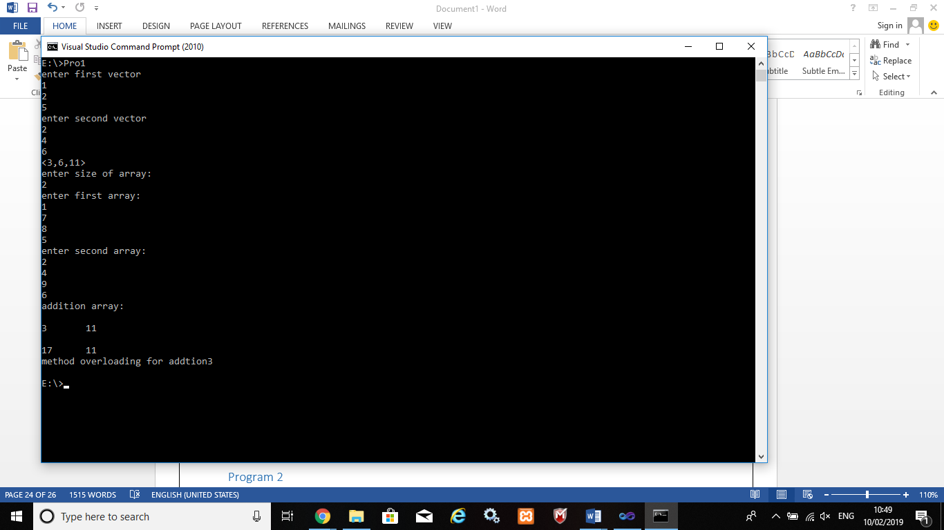

## Program 2

2.Write a c# program that create student object. Overload constror to create new instant with following details.

1. Name

2. Name, Enrollment

3. Name, Enrollment, Branch

using System;

using System.Collections.Generic;

using System.Linq;

using System.Text;

using System.Threading.Tasks;

using System.Reflection;

namespace p3a1

{

class Program

{

public int ID { get; set; }

public string Name { get; set; }

String name, branch;

int enrol;

public Program(String name)

{

this.name = name;

Console.WriteLine("constructor 1:" + name);

}

public Program(String name, int enrol)

{

this.name = name;

this.enrol = enrol;

Console.WriteLine("constructor 2:" + name + " " + enrol);

}

public Program(String name, int enrol, String branch)

{

this.name = name;

this.enrol = enrol;

this.branch = branch;

Console.WriteLine("constructor 3:" + name + " " + enrol + " " + branch);

}

static void Main(string[] args)

{

Program p1 = new Program("bob");

Program p2 = new Program("bob", 1);

Program p3 = new Program("bob", 1, "computer");

Console.ReadLine();

}

}

}

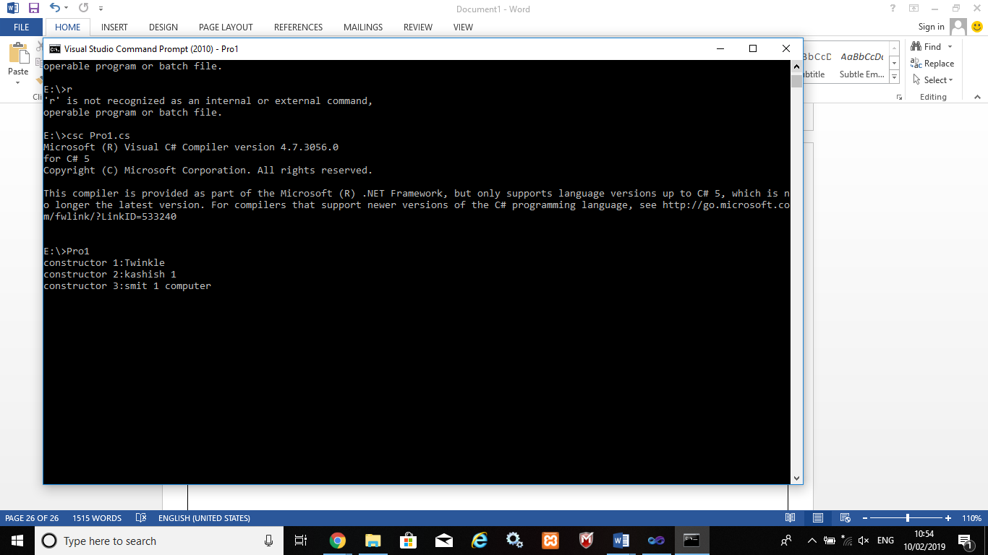

# AIM: Reflection

## Program 1

Create a c# program to find Methods, Properties and Constructors from class of running program.(Use Class from previous practical)

using System;

using System.Reflection;

namespace ReflectionDemo

{

public class mainClass

{

public static void Main()

{

Type T = Type.GetType("ReflectionDemo.StudentInfo");

MethodInfo[] methods = T.GetMethods();

foreach (MethodInfo method in methods)

{

Console.WriteLine(method.ReturnType + " " + method.Name);

}

PropertyInfo[] properties = T.GetProperties();

Console.WriteLine("\nProperties");

foreach (PropertyInfo property in properties)

{

Console.WriteLine(property.PropertyType + " " + property.Name);

}

Console.WriteLine("\nConstructors");

ConstructorInfo[] constructors = T.GetConstructors();

foreach (ConstructorInfo constructor in constructors)

{

Console.WriteLine(constructor.ToString());

}

}

}

class StudentInfo

{

int id { get; set; }

int age { get; set; }

String name { get; set; }

public StudentInfo()

{

id = 1;

age = 1;

name = "Twinkle";

}

public StudentInfo(int id, int age, String name)

{

this.id = id;

this.age = age;

this.name = name;

}

public void showId()

{

Console.WriteLine("ID is: {0}", this.id);

}

public void showName()

{

Console.WriteLine("NAME is: {0}", this.name);

}

public void showAge()

{

Console.WriteLine("AGE is: {0}", this.age);

}

}

}

