Conestoga College - ACS & IT
Microsoft Web Technologies – PROG8551
Assignment #2: More Data-driven ASP.NET Core MVC Web Apps
Due: Sunday Nov 10, 2024 (by Midnight)
Total marks: 40 Worth: 10%

Introduction
The goal of this assignment is to build on the skills you have been developing around database-driven ASP.NET Core MVC web apps. This app is somewhat more complex than what you built in assignment #1 in that it has more links and connections between pages and there is a more significant flow of pages. It also has a slightly richer 1-to-many data model in the sense that both entities are dynamic, i.e. the number of child entities the primary entity has can fluctuate at any moment. A key point of this assignment is that you have some freedom to develop the app as you think is best given that we have been exploring some different ways of building ASP.NET Core MVC web apps. Some highlights of this assignment are:
- View models and attribute routing, while not strictly required, are likely going to be helpful.
- Similarly, you don’t need to implement your core business logic in a service but doing so would adhere to some well-established best practices.
- The app will send out emails but you will be provided with a hint solution that will help you to make that work.
  - A tip for this: use a test Gmail account with generated password and delete the app after you receive your grade
- You will also make use of cookies in a very simple way in this app to store the date the given user first used the app and present a message accordingly in the footer.
- The data model is a little bit richer than what we have seen so far and you will see how you can configure EF Core to map C# enums to strings in the DB.
- You will learn how to post child resources associated with a specific parent resource.
- The solution also requires our first use of radio buttons in a form in this course.

First, a word of caution
I remind you to make sure you do your own work on this assignment and resist any urge to copy code from any other source - e.g. your classmates, the web, etc. Not only is this the only way to learn how to program but also everyone’s solution will be run through MOSS to check for academic integrity violations. There is zero-tolerance for such violations and any encountered with be dealt with in accordance with Conestoga’s policy. I also remind you that if you are not typing syntactically correct code in yourself you are not learning to program! Finally, I’ll note that these assignments are very representative of what will be expected of you on exams so it is very much in your interest to ensure that you are capable of doing them on your own.

Hints
The general idea is that there will be some time to work on these assignments in class and, if necessary, I can offer hints if I see that you are struggling with certain parts. Also, you should try to pace out your work on this assignment over the coming weeks.

How will it be graded?
I’ll say from the outset that there is absolutely no reason to not get 100% - the emphasis here is simple: get your hands dirty coding to solve basic problems and, if needed, I will do what I can to help steer you towards a working and complete solution.

Accompanying each assignment will be an Excel marking sheet that details how your grade will be calculated so you obviously want to make sure that you are doing everything as it’s laid out there.

What/how to submit?
Zip up your entire solution into one zip file and submit that file to the eConestoga dropbox for the assignment.You can submit multiple solutions but only the latest (i.e. most recent) one will be looked at and evaluated.

What will you build?
The app you will build for this assignment is intended to be a basic app to help an organization that offers courses a way to manage their courses, the students in each course, and the confirmation of enrollment messages they send out to students, and to see who among them has responded and, if so, whether the student has confirmed or declined their enrollment. The basic features are as follows
- Users can create and edit courses.
- Once created they can create students for the course and ultimately send those students an email to confirm their enrollment.
- From the email the recipients can click on a link that takes them to a page that allows them to respond and indicate whether or not they want to be enrolled.
- As users submit their responses the creator of the course will be able to see updated statistics on responses - i.e. who has said yes, who has said no, and who still has a response pending.
- All the details pertaining to courses, students, and responses are stored in the database
- A cookie will be used to store when a user has first visited (or used) the app.
  - If it’s their first visit, a cookie will be created with that timestamp but the message in the footer will welcome them to their first visit
  - Afterwards the welcome message will state when they first started using the app because that date will be stored in the cookie.

The entity (or data) model is fairly basic but a tiny bit more complex than what you have worked with so far. The basic idea is a follows:
- There are 2 main entities:
  - Course - which has the following properties:
    - Name (required)
    - Instructor (required)
    - Start date (required)
    - Room number (required) - and must be in the format: a single digit, a single capital letter, and 2 digits, e.g. 3G15, 1C07
  - Student - which has the following properties:
    - Name (required)
    - Email (required - and must be in valid email address format)
    - Status (required)
      - It should have to following possible states:
        - ConfirmationMessageNotSent (Default to this)
        - ConfirmationMessageSent
        - EnrollmentConfirmed
        - EnrollmentDeclined
      - These are likely best implemented as an enum. You might want to look at this blog entry that discusses how EF Core can be easily configured to map enum values in C# to strings in the DB based on their name.
- As for the relationship, each Course can have (or be associated with) any number of Students - i.e. they are in a 1-to-many relationship. For simplicity here, we’ll assume that each Student belongs to only 1 Course. Microsoft’s own documentation on EF Core relationships uses an example that is effectively identical to the one you need to implement for this assignment. In this example, a Blog is an entity that can have any number of Post objects - thus a Blog is like the Course object in this assignment whereas Posts are like our Students.

Your solution should be able to email out enrollment confirmations to the students. Sample code has been provided in the eConestoga folder for the assignment but this Stack Overflow article not only has sample code as well but also some excellent guidance on how to make the sending of an email using Gmail work as there are a few hurdles that you have to overcome. Also, sending emails can be quite slow so should likely never be done synchronously inside an HTTP request handler but for simplicity in this assignment don’t worry about kicking them off asynchronously.

Also, for the Razor view that allows users to submit their response on whether or not to attend the party, you will likely want to make use of radio buttons for the Yes and No options. Even though the code is making use of the Razor Pages approach (as opposed to MVC), this blog entry shows how you make use of radio buttons in an ASP.NET Core app.

Where to start?
The hardest problem is always where to start and this assignment is no exception. Many hints will be provided in class but also we can step through a process that will help guide you when it comes to developing any web app. In my humble opinion, the secret lies in developing a really good sketch of how the app will work!

Screenshots and demo video of the Final Web App
The following are screenshots of the final Web App to help give you guidance and, included in the assignment folder in eConestoga, a video that demonstrates a working solution so that you have a final solution to visualize.

First, the home page for the app which highlights 2 entry points into the main app via the 2 links on the page and the message in the footer reflects the fact that this is this user’s first visit to the app:

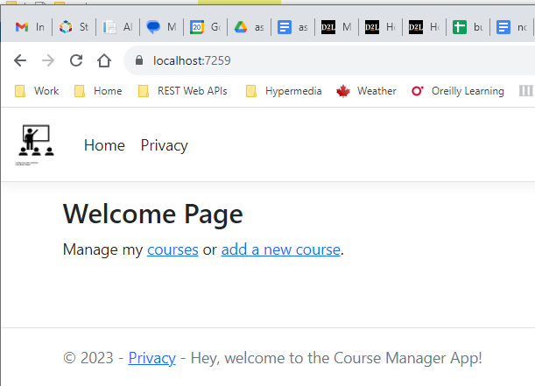

And the page that shows all the courses:

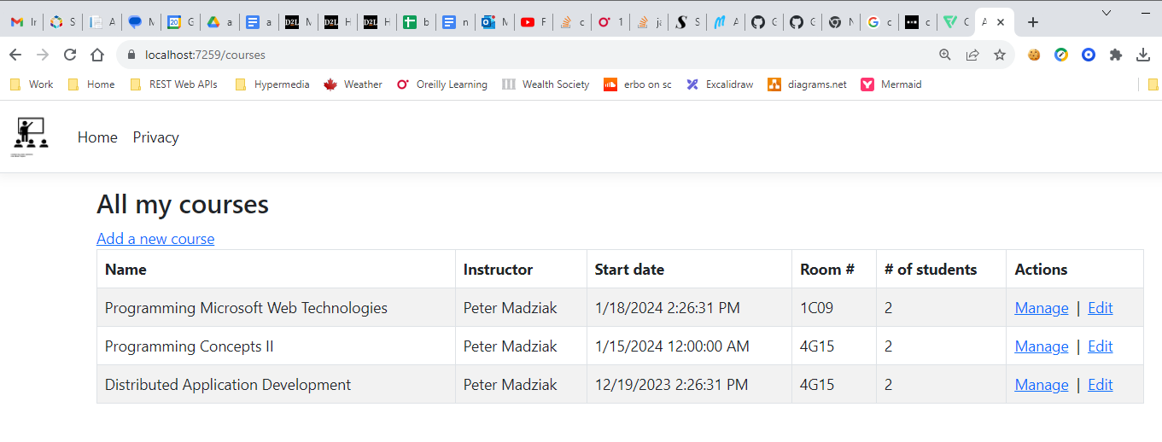

And the pages to add a new course and to edit an existing one:

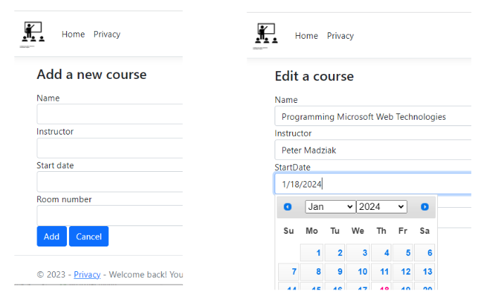

And then the page that allows the user to see all the details and manage a course by adding new students and sending out enrollment confirmation messages to them. Also note that the footer message now indicates when they first visited/used the app:

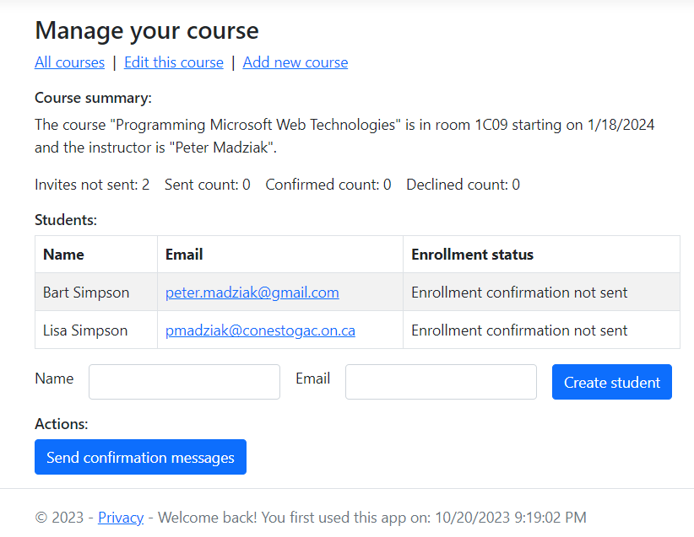

And next, the following shows the nature of the enrollment confirmation emails students will receive:

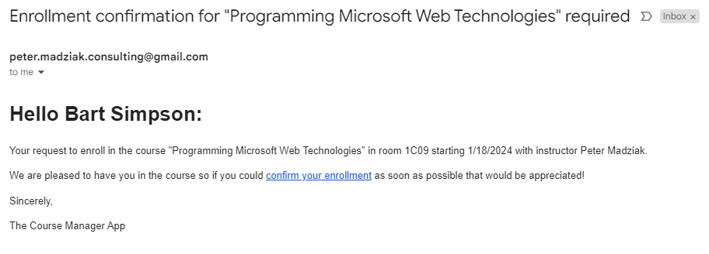

And what happens when they click on the link:

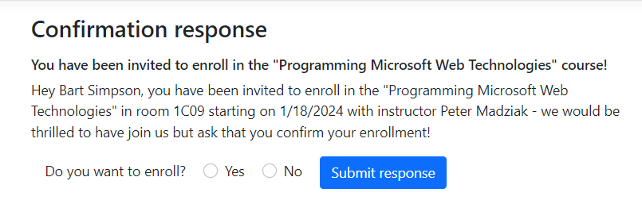

And what happens when they submit their response:

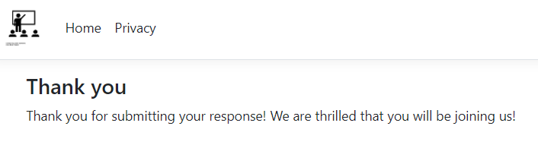

And finally how this would look when we return to the details/manage course page after the student “Bart Simpson” submitted his response confirming his enrollment:

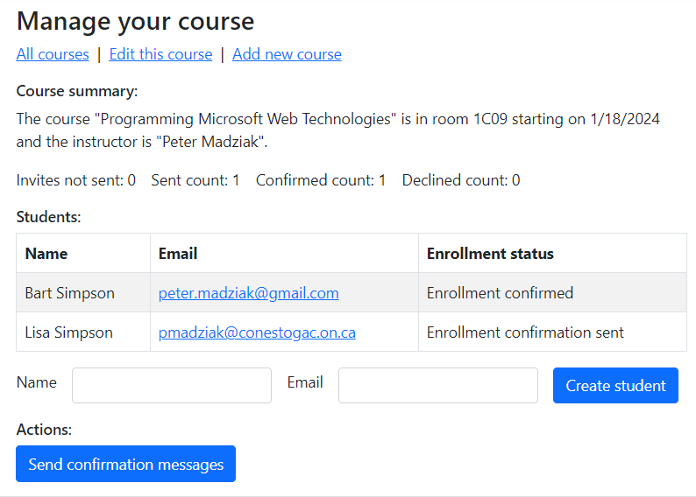

References
https://thecodeblogger.com/2021/07/08/net-ef-core-how-to-store-enum-to-the-database/
https://www.learnrazorpages.com/razor-pages/forms/radios
https://stackoverflow.com/questions/32260/sending-email-in-net-through-gmail
https://learn.microsoft.com/en-us/ef/core/modeling/relationships?tabs=fluent-api%2Cfluent-api-simple-key%2Csimple-key

