- Write a SQL query to add a new record to the Movies table for a movie titled "The Great Adventure" directed by "John Smith" with a release year of 2023 and a duration of 150 minutes.
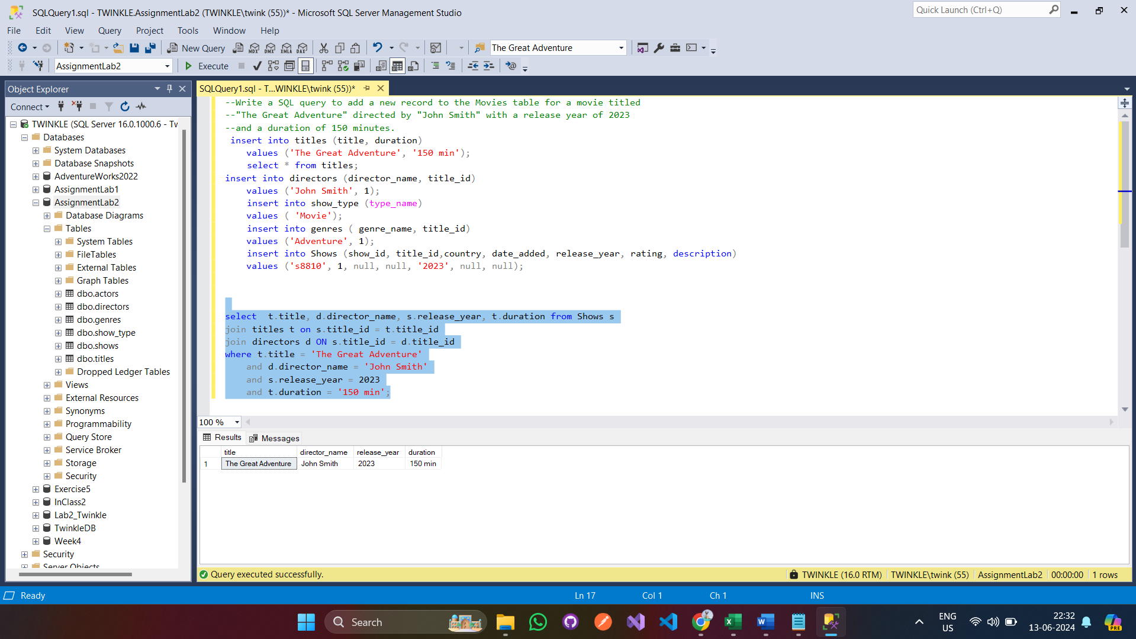
2.Write a SQL query to retrieve all movies from the Movies table released in the year 2020.
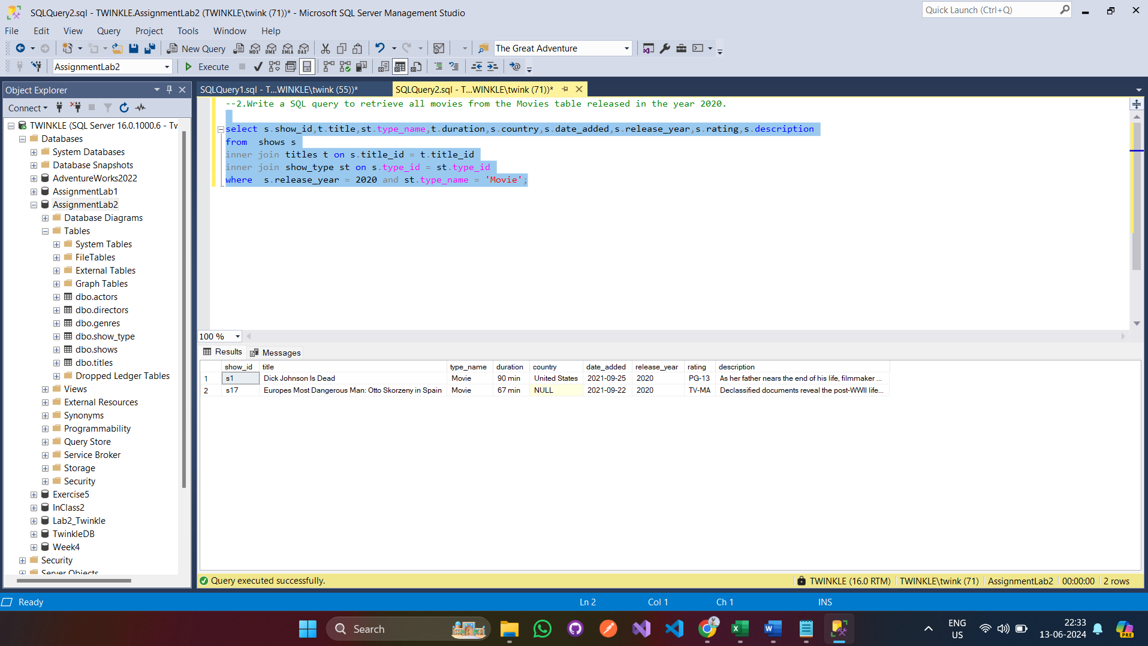
3.Write a SQL query to update the duration of the movie with show_id 12345 in the Movies table to 120 minutes 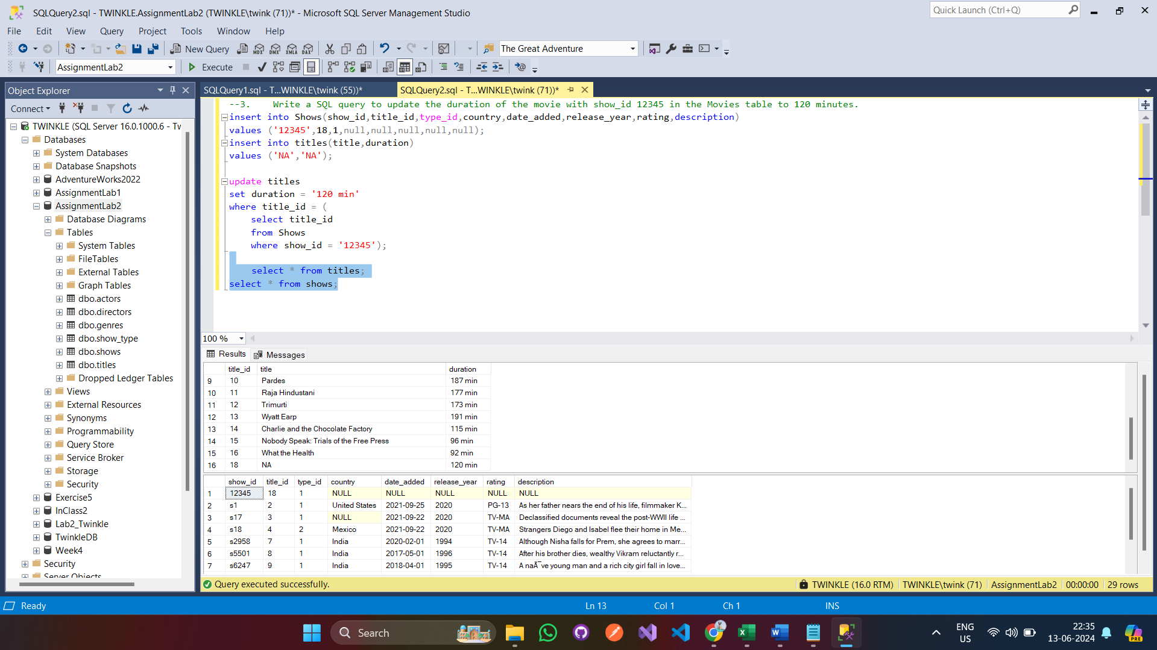
4.Write a SQL query to delete all records from the Movies table where the release_year is before 2000.
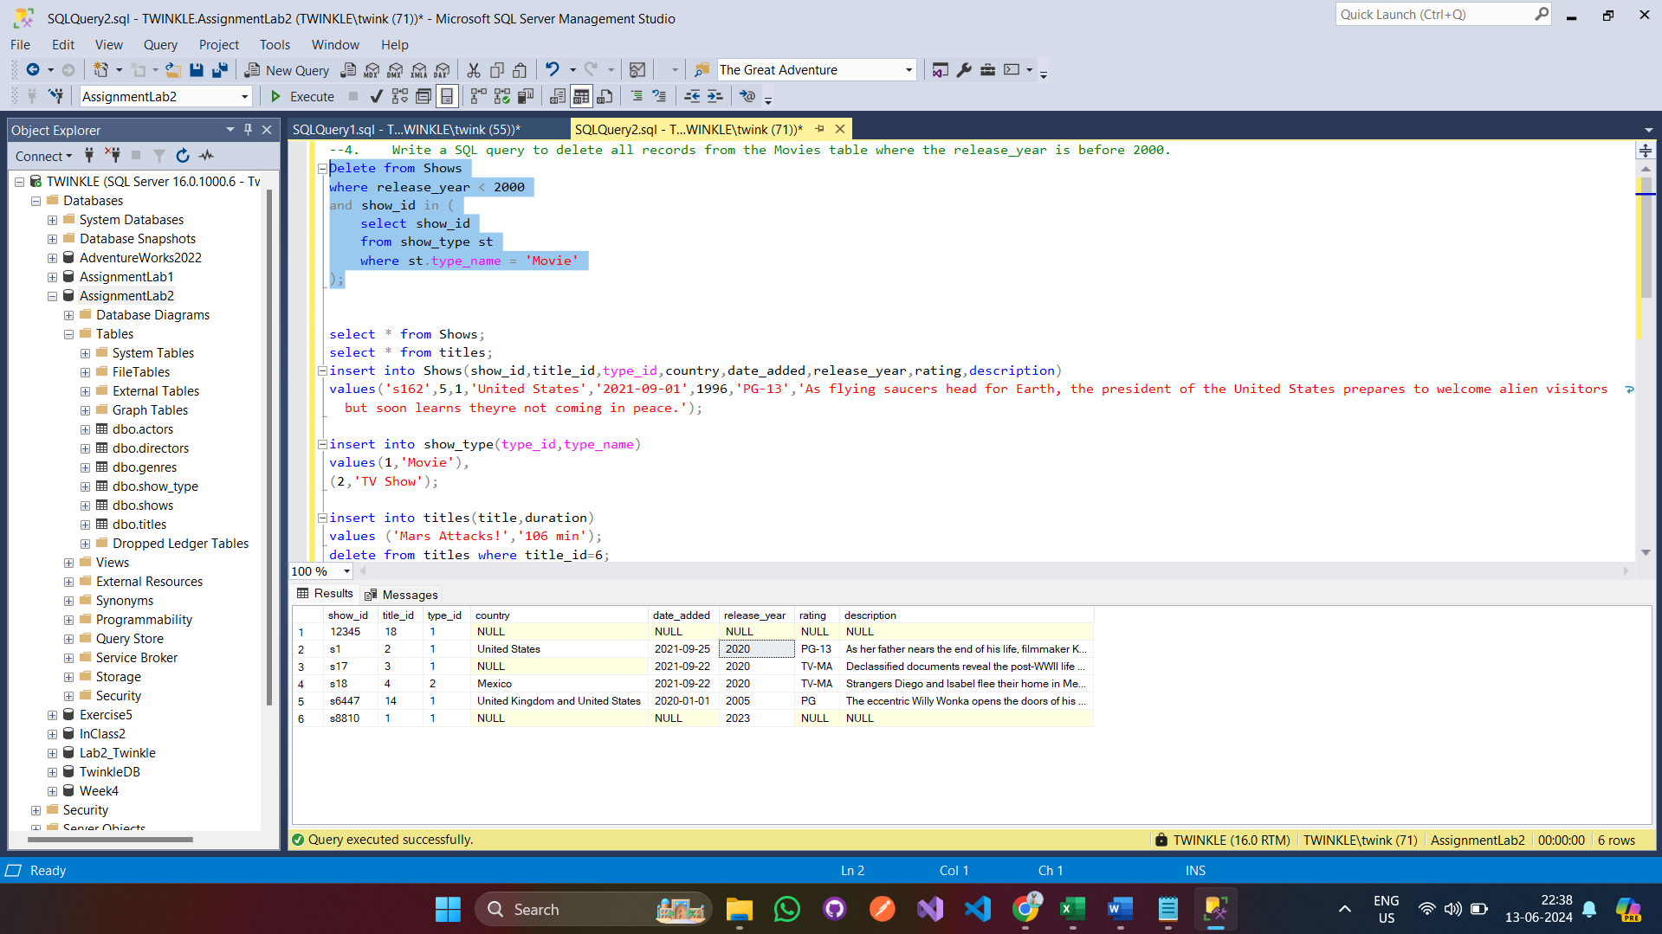
5.Create a View named LongestMovies that displays the top 10 longest movies from the Titles table, including the title and duration in minutes.
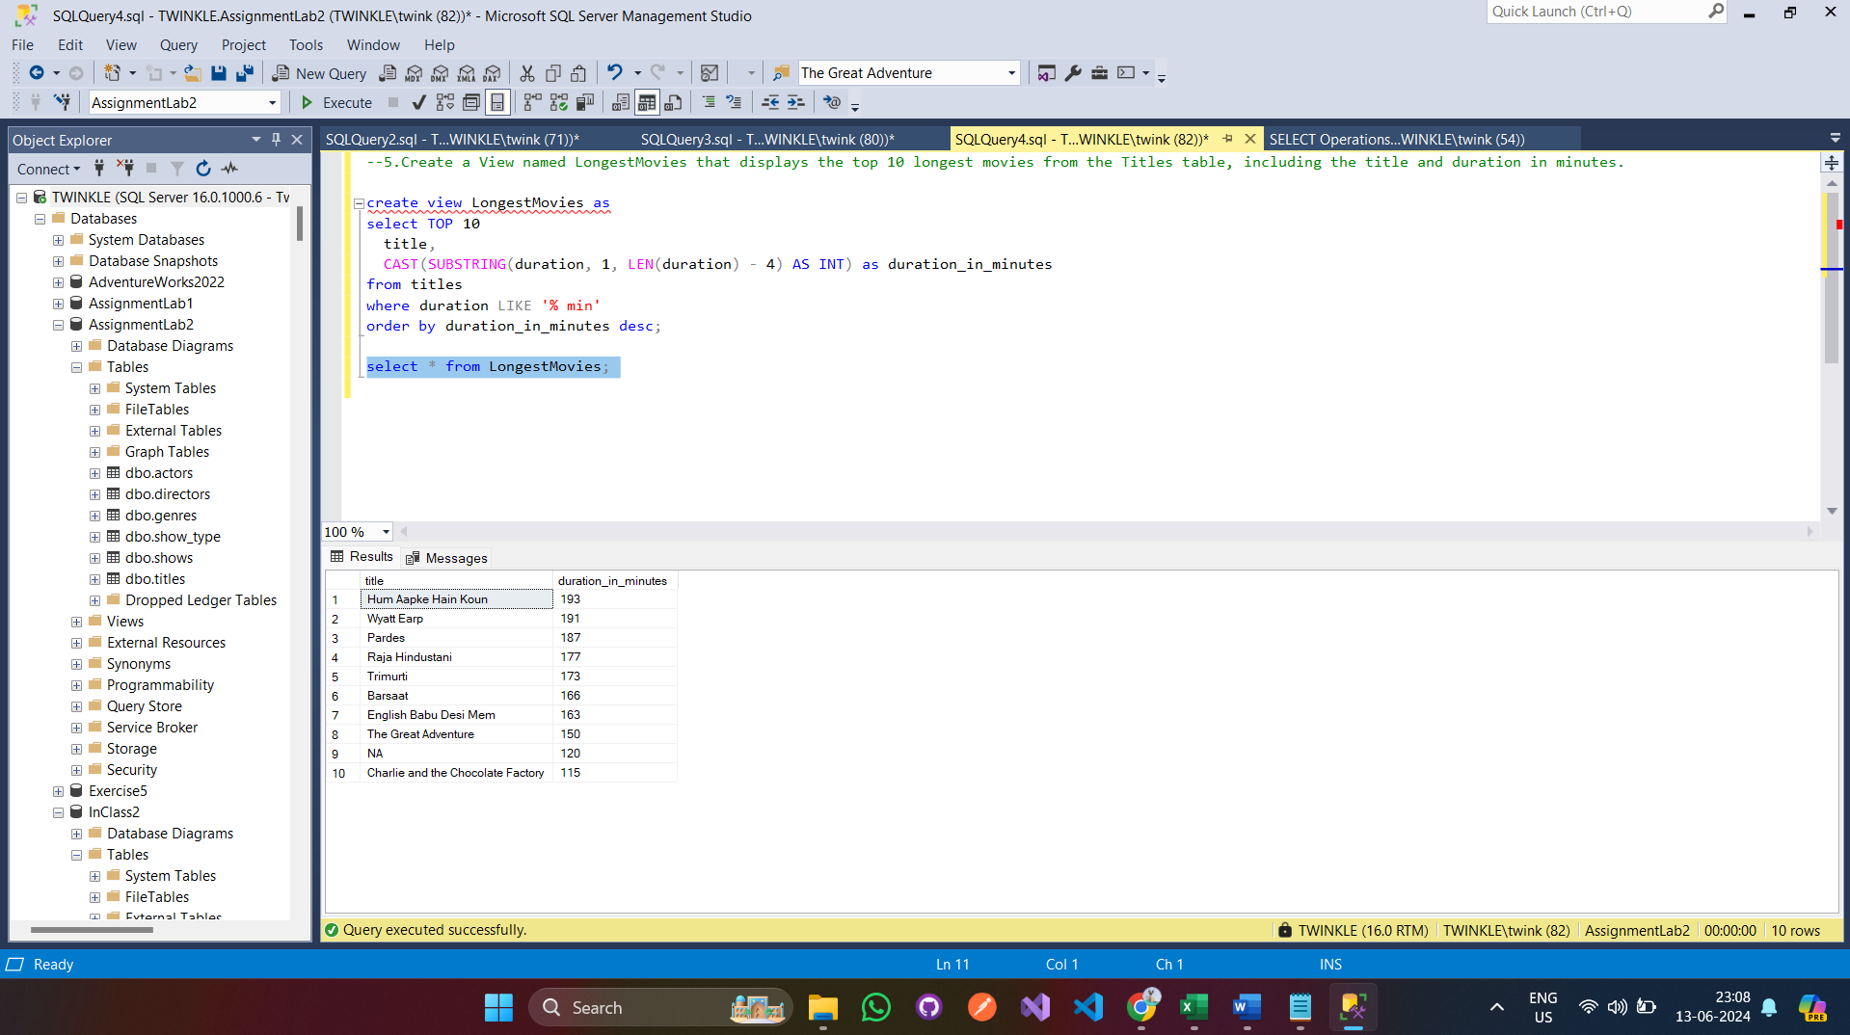
- Write a SQL queries to extract Total number of TV shows.
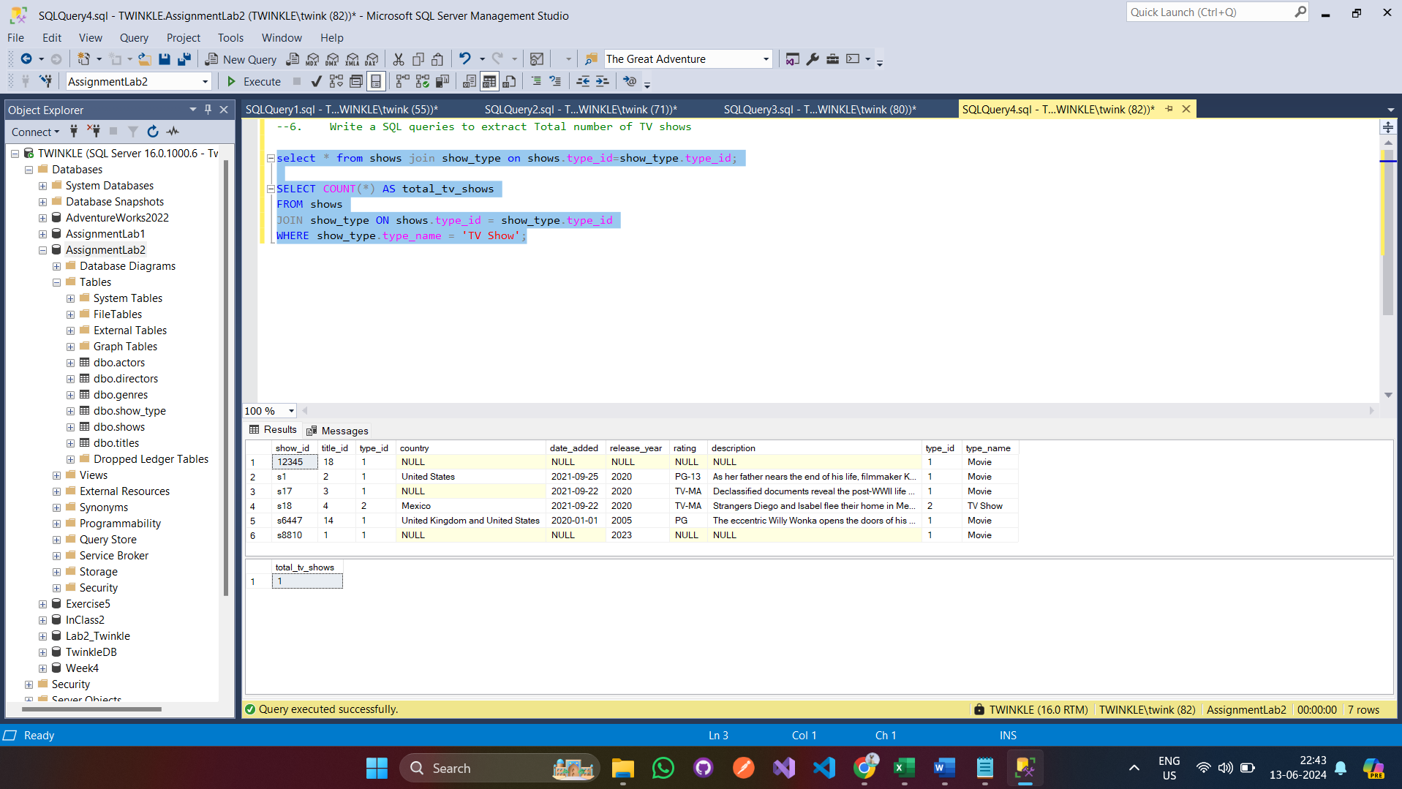

7.Write a SQL queries to find Number of movies released in a specific year.
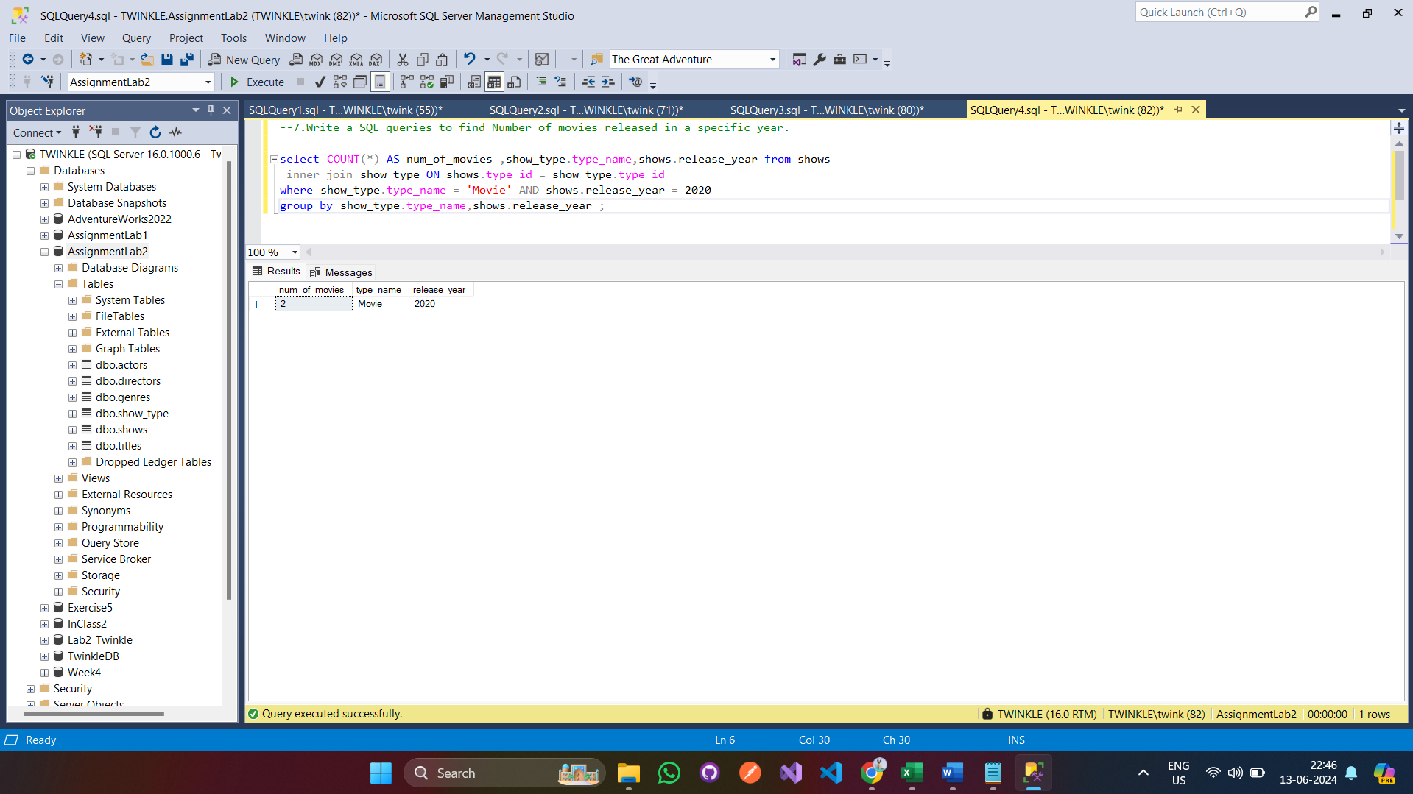
8.Write a SQL queries to List of directors and the number of movies/TV shows they have directed.
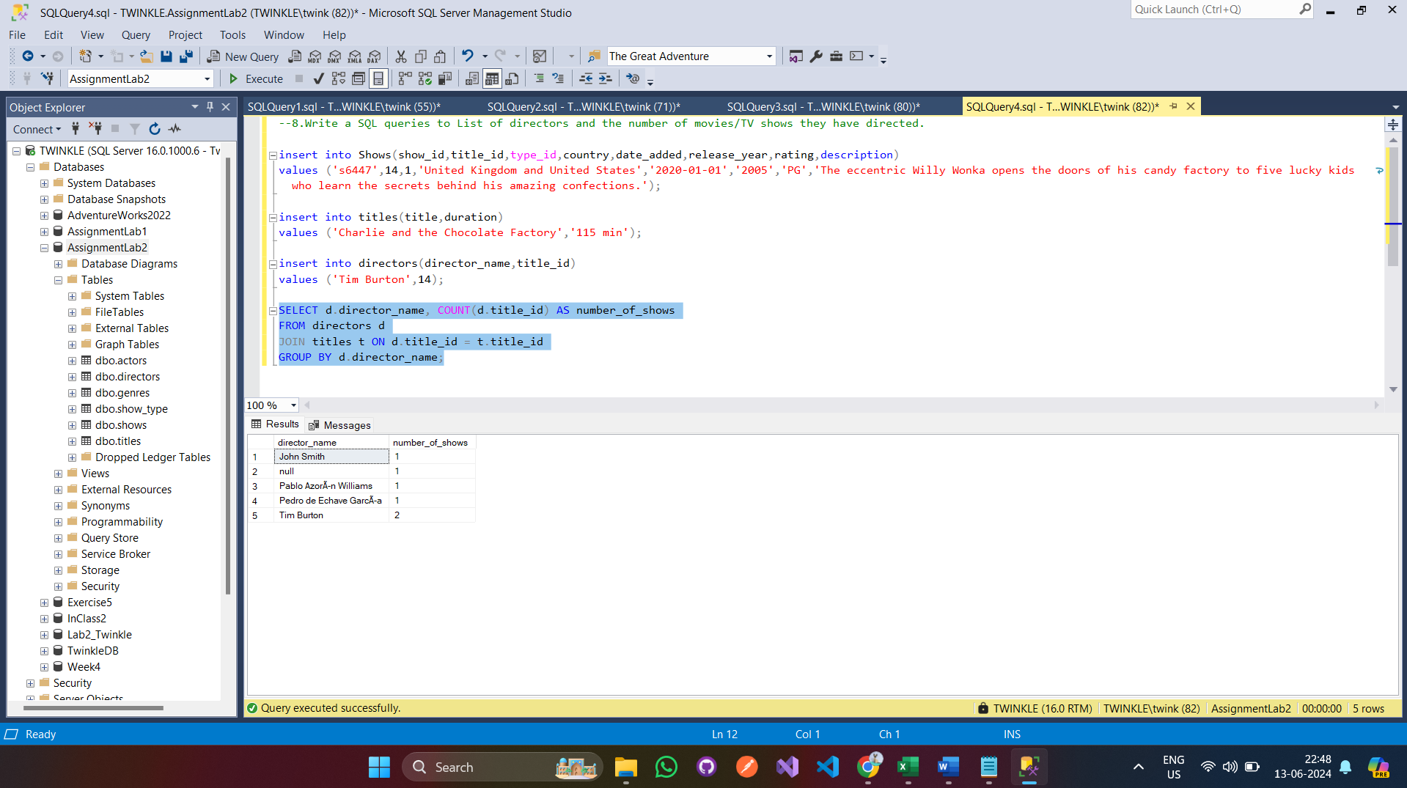

9.Write a SQL queries to get the Average duration of movies

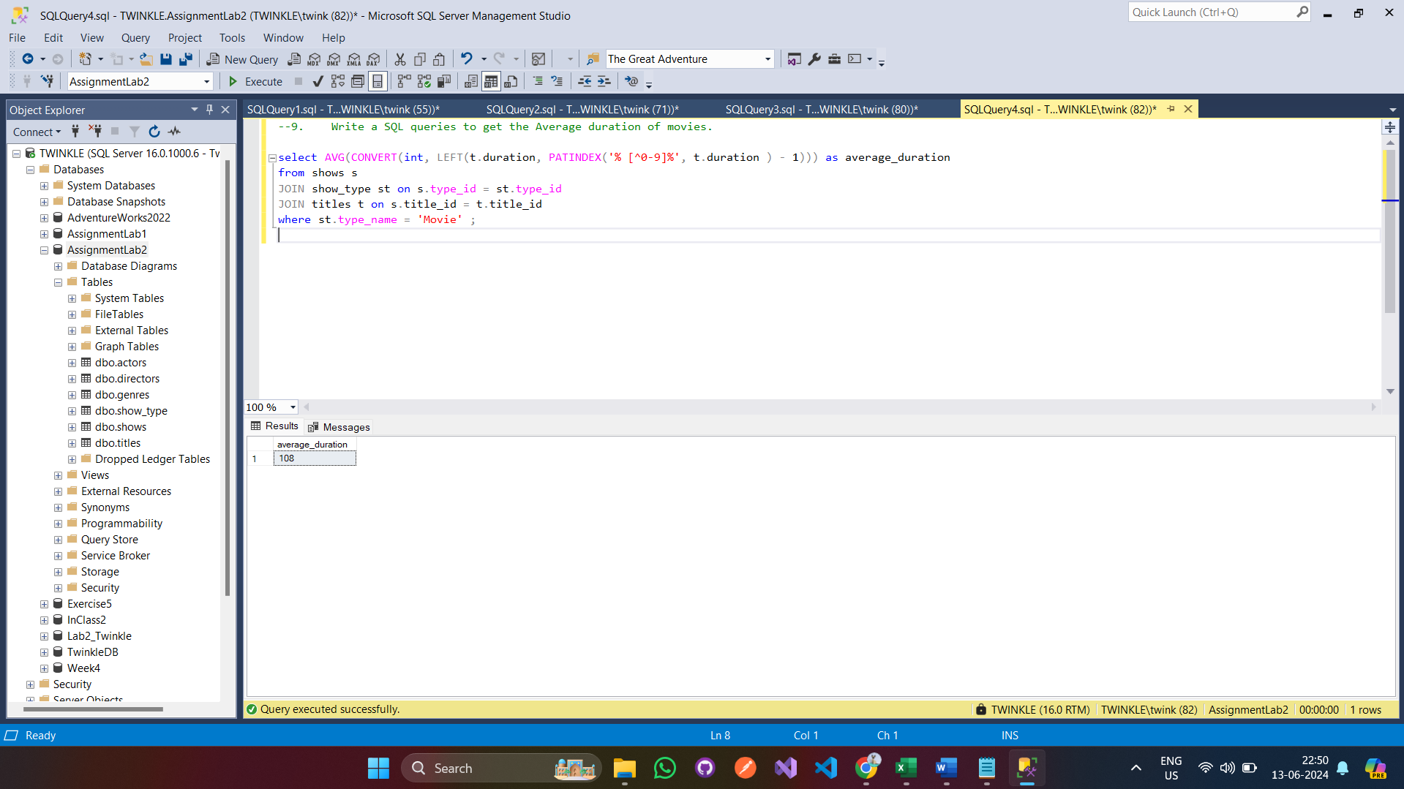
- Write a SQL queries to get the List of genres with the highest number of titles.
