GitHub Repository: https://github.com/TwinkleM97/Final-Project-IAC

INSTRUCTOR: PROF.VIKAS Vattikonda  | Twinkle Mishra -8894858

PROG 8870 - Final Project: Deploying AWS Infrastructure with Terraform and CloudFormation

## Introduction

This project demonstrates the end-to-end deployment of a multi-service AWS infrastructure using two Infrastructure-as-Code (IaC) tools: Terraform and AWS CloudFormation. The goal is to provision secure, scalable, and reusable cloud resources while following IaC best practices such as modular code design, dynamic configuration, and state management.

The deployed infrastructure includes:

* Amazon S3 for private object storage with versioning enabled.
* Amazon EC2 instances within custom VPCs, configured for SSH access.
* Amazon RDS (MySQL) instances deployed in public subnets for demonstration purposes.

The project is divided into two parts:

* Terraform Deployment: Automated provisioning of S3 buckets, a custom VPC, an EC2 instance, and an RDS instance.
* CloudFormation Deployment : Creation of similar resources using YAML templates and the AWS CLI.

Each step in this report is supported by:

* Screenshots of the AWS Console or CLI output.
* Commands used to deploy and verify resources.
* Short descriptions explaining the purpose of each step

## Terraform - S3 Buckets Created

This screenshot shows the S3 buckets created via Terraform with versioning enabled for each bucket.

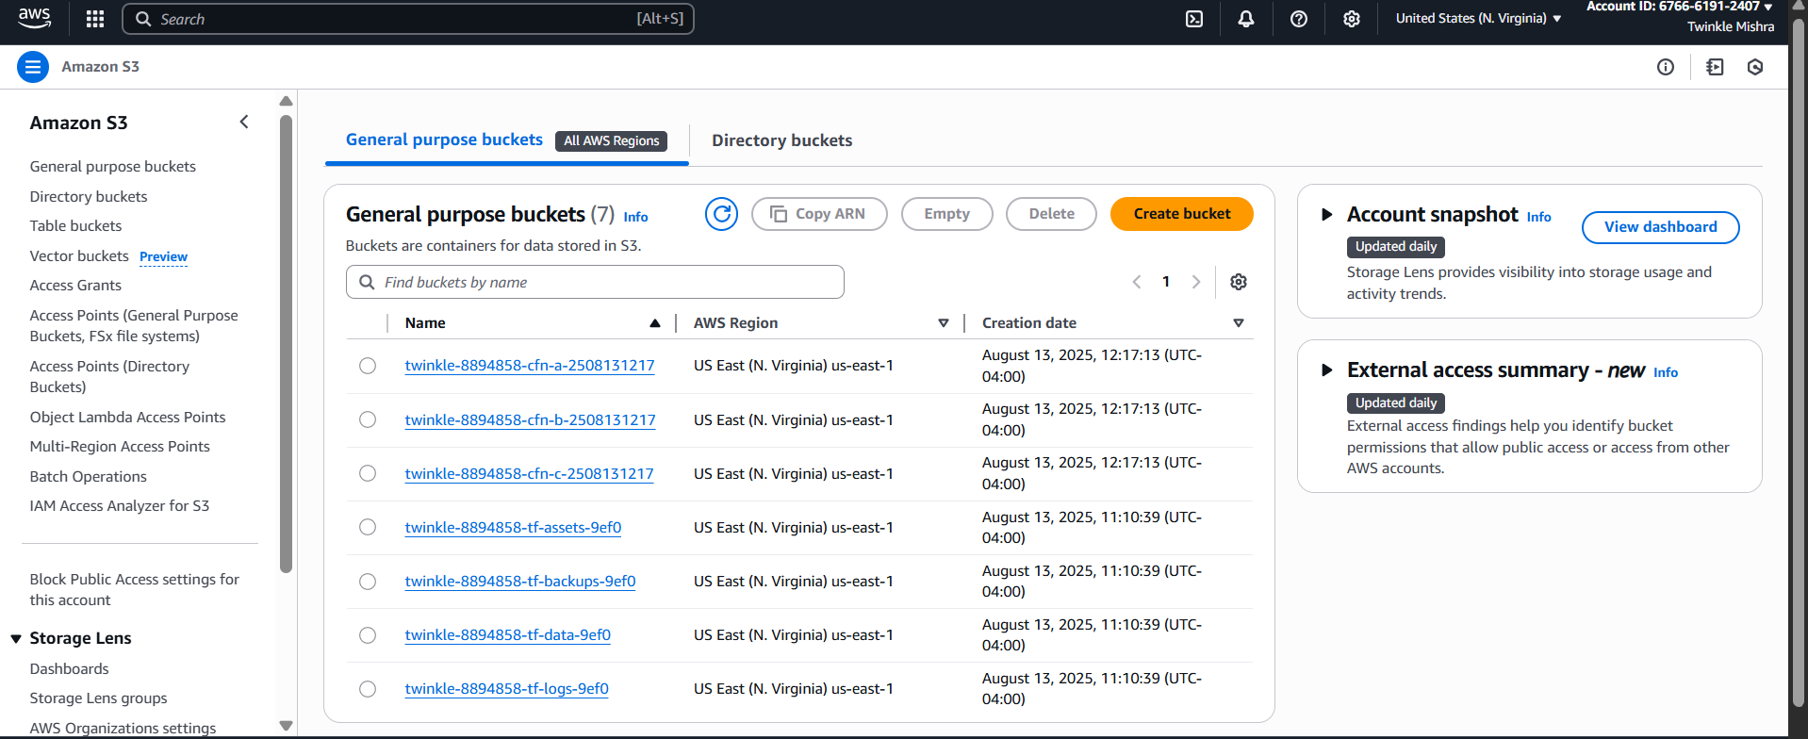

## Terraform - S3 Buckets in AWS Console

This view confirms the S3 buckets in the AWS Console.

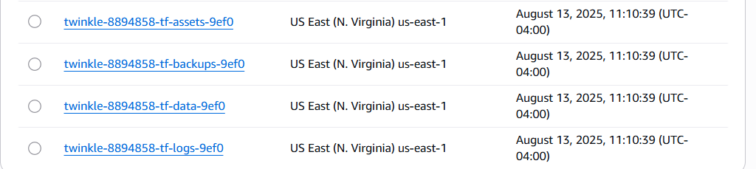

## Terraform - S3 Versioning Enabled

Shows that bucket versioning is enabled in all buckets.

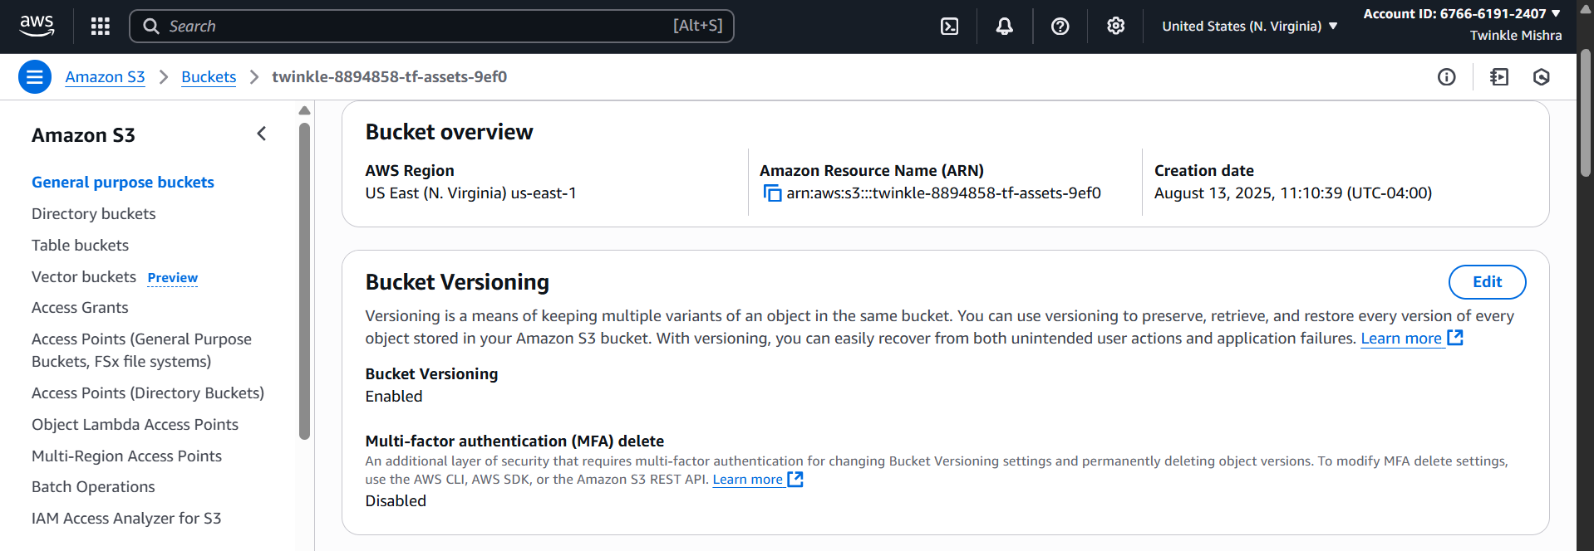

## Terraform - EC2 Instance

The EC2 instance provisioned via Terraform, showing its details.

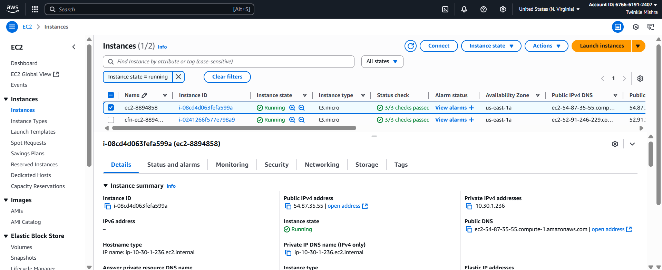

## Terraform - RDS Instance

The RDS instance deployed with Terraform and its details.

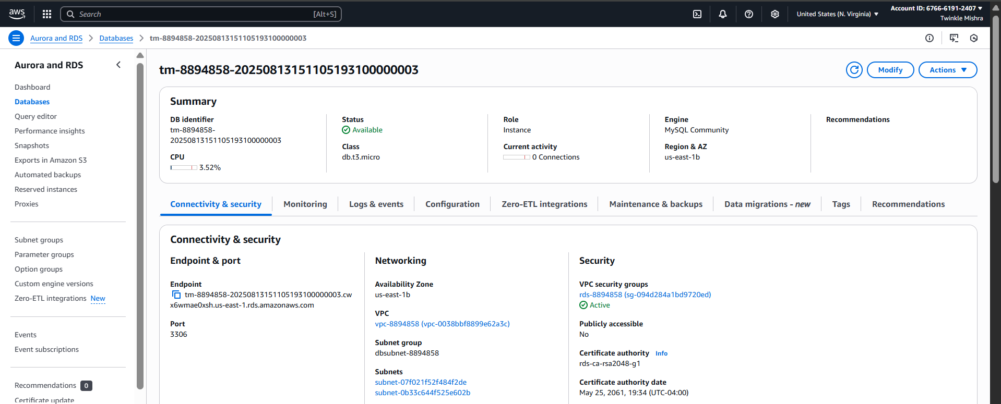

## Terraform Apply Output

The output after running 'terraform apply', confirming successful creation of resources.

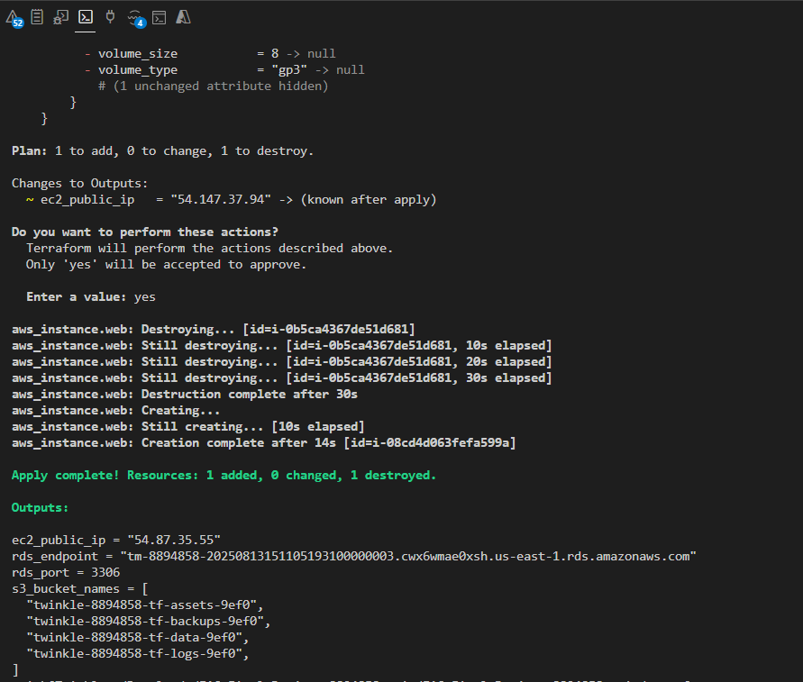

## CloudFormation - S3 Stack Creation

CloudFormation stack creation for S3 buckets with versioning.

## CloudFormation - S3 Buckets in Console

S3 buckets created via CloudFormation as seen in the AWS Console.

## CloudFormation - S3 Versioning Enabled

Verification that versioning is enabled on all CloudFormation S3 buckets.

## CloudFormation - EC2 Stack Creation

CloudFormation stack creation for EC2 instance with networking components.

## CloudFormation - EC2 Instance in Console

Details of the EC2 instance deployed by CloudFormation.

## CloudFormation - EC2 Outputs

Outputs of the EC2 CloudFormation stack showing Public IP and VPC ID.

## CloudFormation - RDS Stack Creation

CloudFormation stack creation for RDS instance.

## CloudFormation - RDS Instance in Console

RDS instance details from AWS Console.

## CloudFormation - RDS Outputs

Outputs from RDS CloudFormation stack including endpoint and port.

## Terraform Provider Config

Terraform provider.tf configuration defining AWS provider settings.

## Terraform Main Config

Terraform main.tf showing resource linking and module use.

## Terraform Variables File

Terraform tfvars file holding variable values for the project.

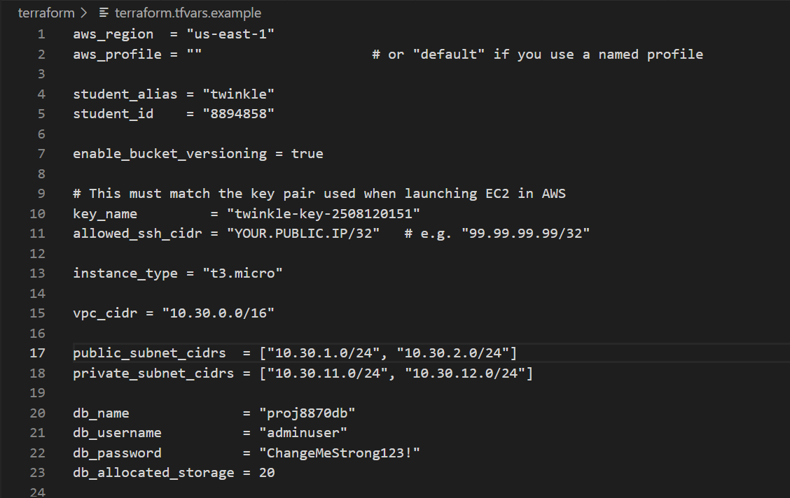

## Terraform Variables Definition

Terraform variables.tf file defining input variables.

## Terraform VPC Configuration

Terraform vpc.tf showing VPC and networking setup.

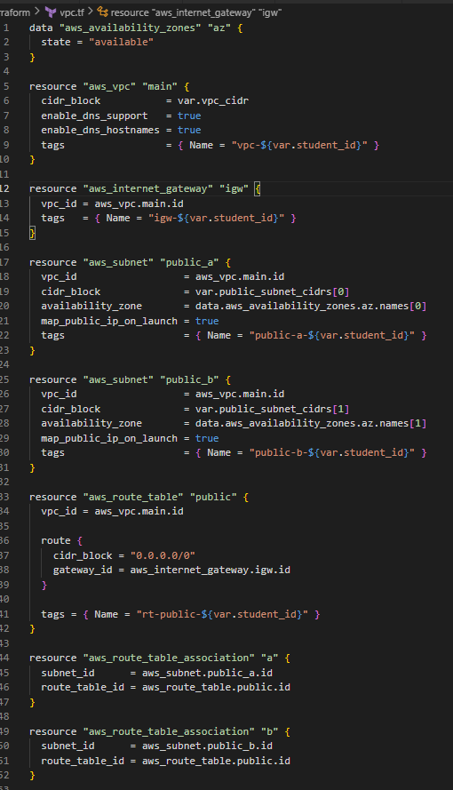

## Terraform EC2 Configuration

Terraform ec2.tf file with EC2 instance details.

## Terraform S3 Configuration

Terraform s3.tf file creating S3 buckets.

## Terraform RDS Configuration

Terraform rds.tf file creating RDS instance.

