Spring Breaks ‘R’ Us (SBRU)

Task 2:
- Use the event decomposition technique for each event you can identify in the description of the Student Booking subsystem.

  - Name the event
  - State the type of event
  - Name the resulting use case.

Event (Student Booking subsystem) | Type | Use Case
Browsing through the resorts. | External | Display available Resorts
Student books the resort | External | Booking Trip
To add additional student to the existing group  To delete/remove any student from the existing group | External | Modify Group Booking
Changing the sorts of rooms allocated according to the requirements of the students | External | Change/Update Room Type
Time to send payment notice for the bookings | Temporal | Send Final payment Invoice
Students may cancel their reservation. | External | Cancel Booking
Students can make payments once their trip is finalized. | External | Pay Final Bills
Sends booking confirmation mail to students, once payment is successful | Temporal | Booking Confirmation Email
Student wants to check the booking status | External | To Produce Booking Status
Students wants to check the resort details | External | Check Resort Details
Student Checks In at the Resort | External | Resort Check -in
Student Checks Out of the Resort | External | Resort Check-out
SBRU registers Check-in and Check-out during arrival and departure | External | Registering the time

Use Case Diagram
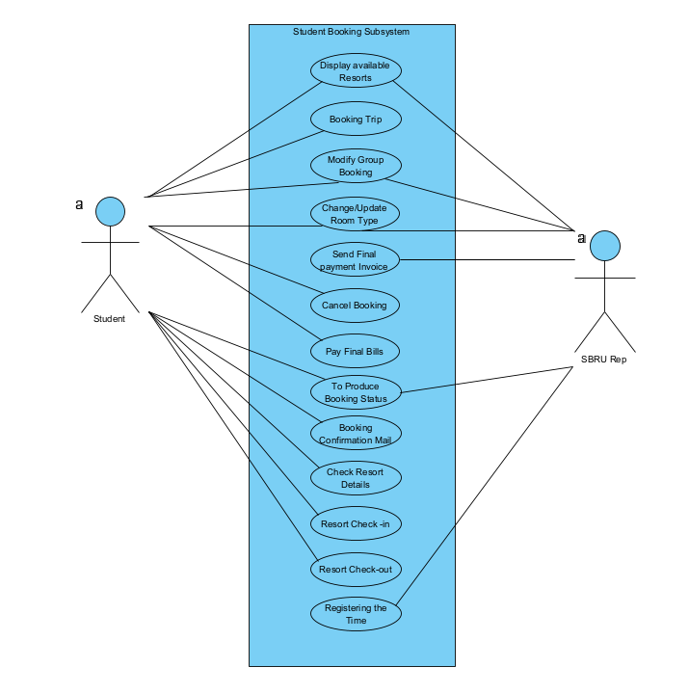

- Consider the new Social Networking subsystem that SBRU is researching. Think in terms of the user goal technique to identify as many use cases as you can think of that you would like to have in the system. SBRU is guessing you might want to join, send messages, and so forth, but there must be many interesting and useful things the system could do before, during, and after the trip.

- Setup a social networking account.
- Create a group to add students and members to the group for the spring break and resort finds.
- Students can join the group and make friends.
- Editing or updating social media profiles.
- Group members can be added or removed.
- Planning Activities for Groups
- To post images and videos in groups about the vacation, resort, and its unique features.
- Sending trip invitations to student’s group and informing them about the timelines.
- To contact a person of the group via private message
- Students can Like/ Share/React on photos and videos also they can mention or tagging other members to the post so they would be notified.
- Students can provide reviews or feedback and comments
- Students can share their experience and rate the resort once the trip is completed.

Use Case Diagram

