# ****INFO8985 - Task 3: Monolithic Flask App with OpenTelemetry + SigNoz****

Name: Twinkle Mishra -8894858

Course: INFO8985-Monitoring and Logging

Instructor: Prof. Richard Hildred

## GitHub Repository:

<https://github.com/TwinkleM97/Task3-INFO8985_monolith_analysis>

## Objective:

1. Log, trace, and collect metrics using SigNoz

2. Add an exception to the roll function and log it in SigNoz

3. Ensure the application doesn't 'swallow' the exception

## What I Did:

* **Instrumented the Flask app with:**
* Logs (including exceptions using `logging.error`)
* Metrics (using OpenTelemetry `meter.create_counter`)
* Traces (using OpenTelemetry `tracer.start_as_current_span`)
* **Created a dice roll function that throws a ValueError when the roll equals 6**:

* **Used a Bash script to run the app with all OpenTelemetry exporters configured.**

* Ran the SigNoz monitoring stack via Docker Compose:

* Tested the `/rolldice` endpoint on Codespaces to verify behavior.

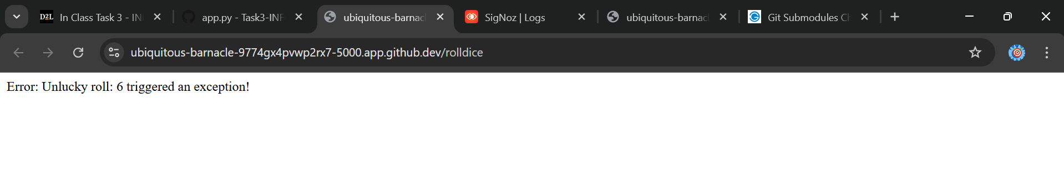

Screenshots & Evidence:

* SigNoz detecting monolith-analysis with traces and metrics:

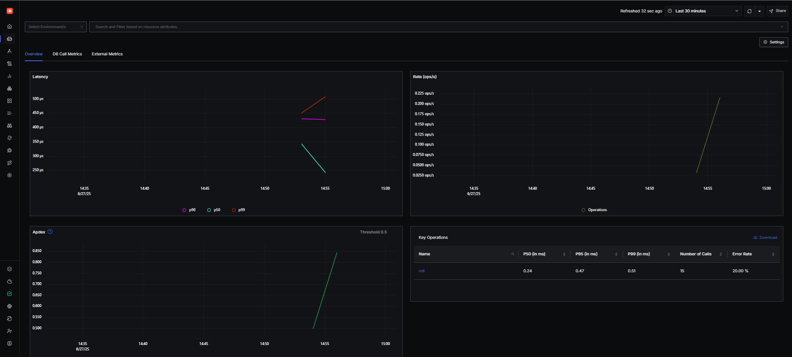

* Registered metric dice.rolls from app:

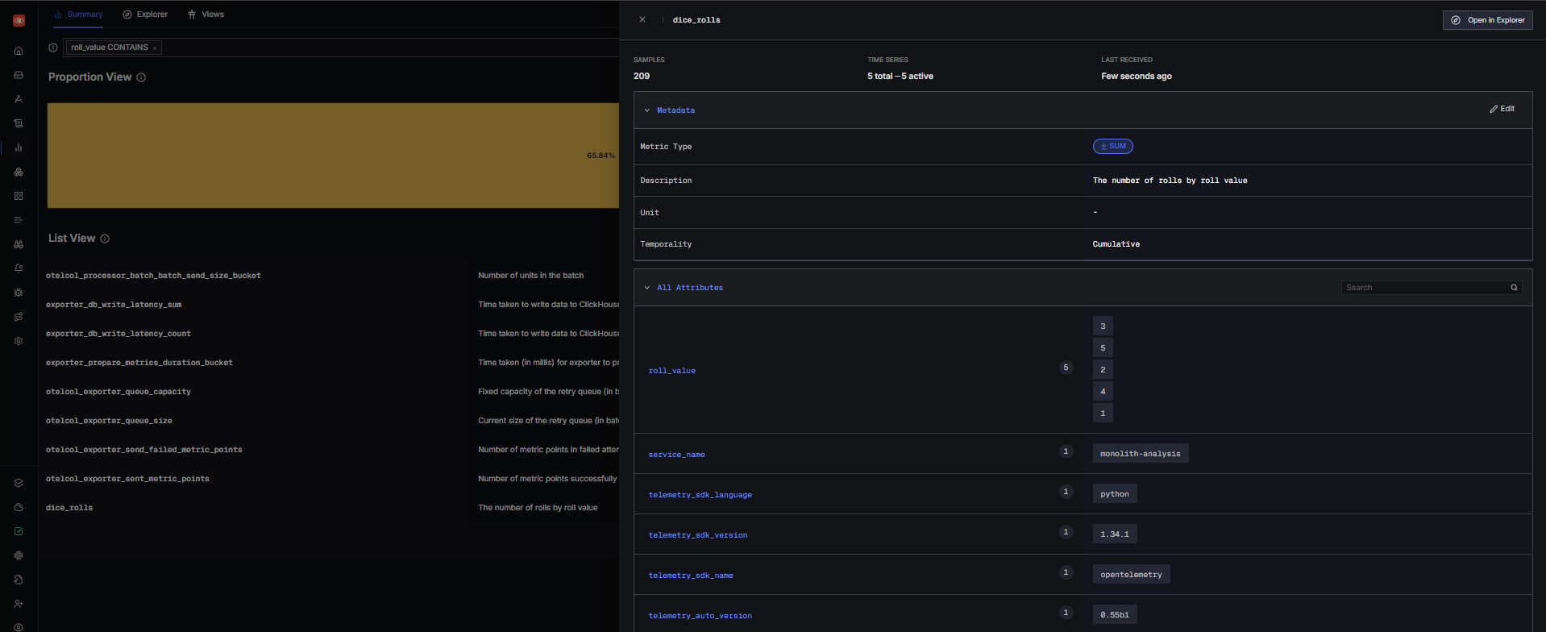

* Graph showing dice roll frequency over time:

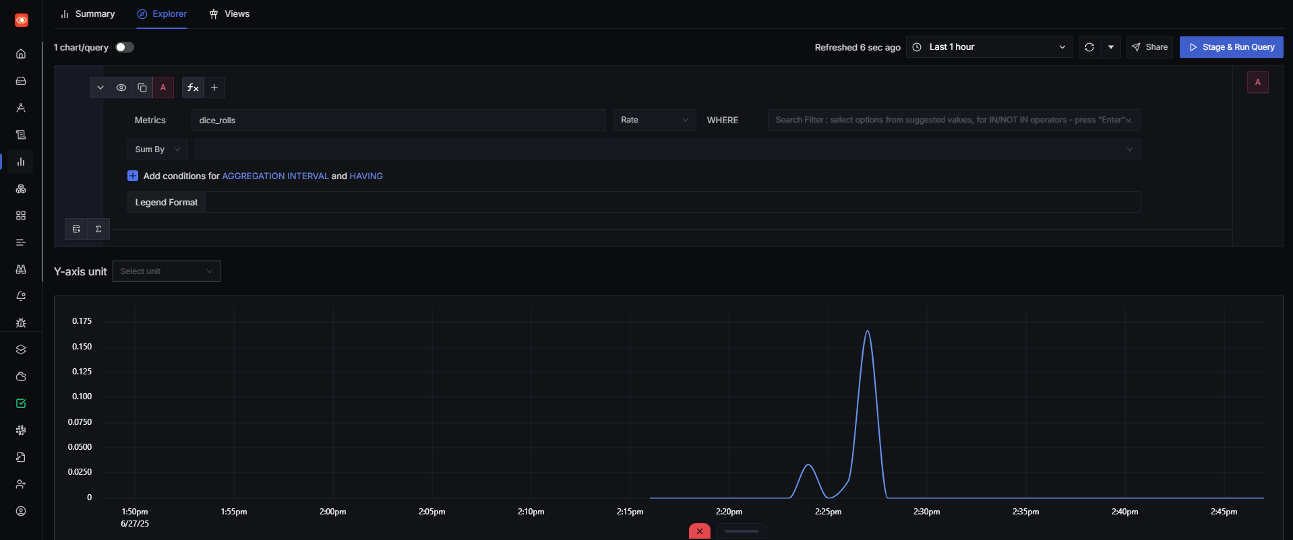

* Tabular breakdown of roll values and their count:

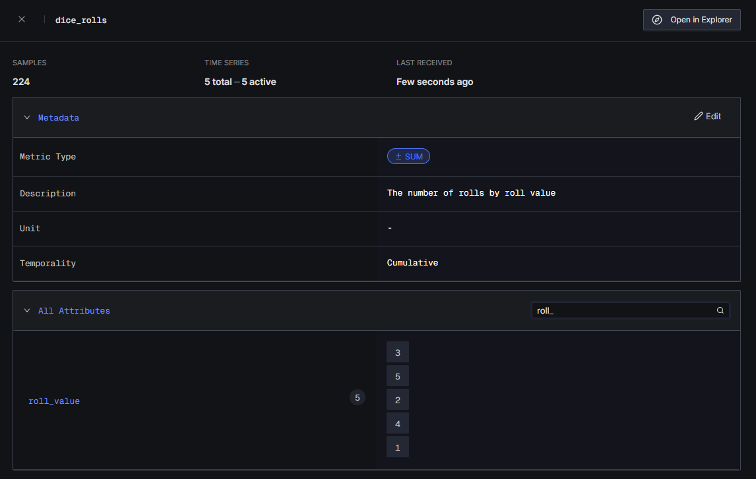

* General logs including INFO and WARNING:

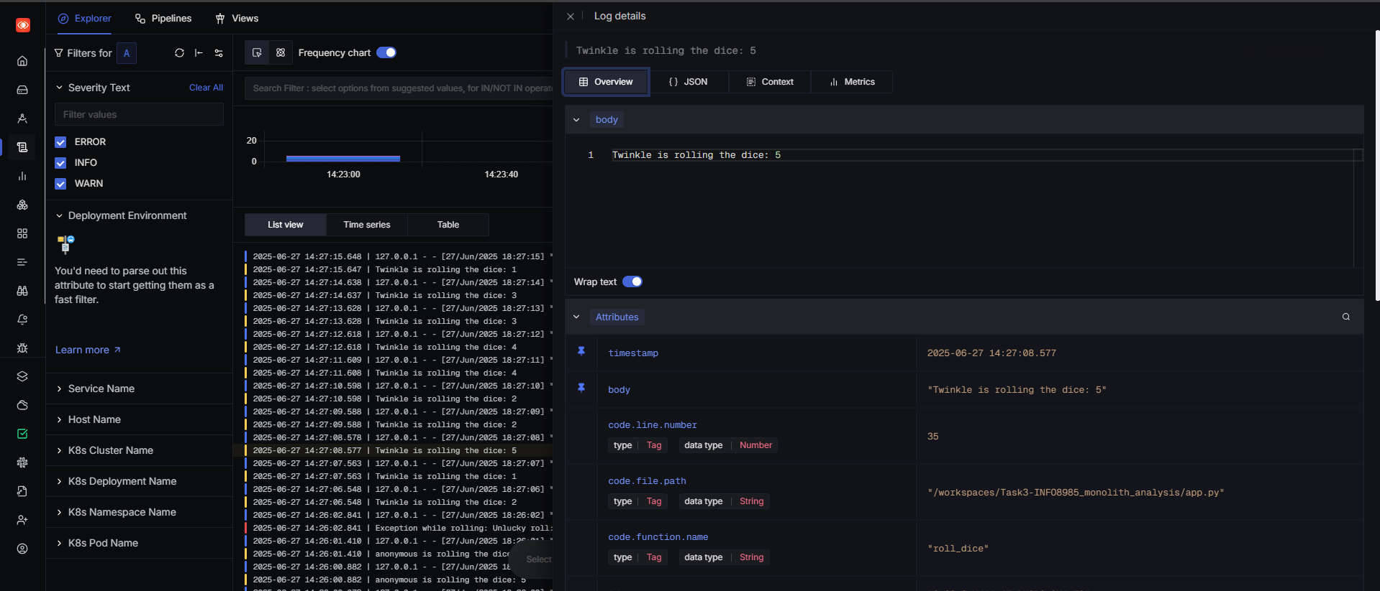

* Filtered logs showing ERROR level logs:

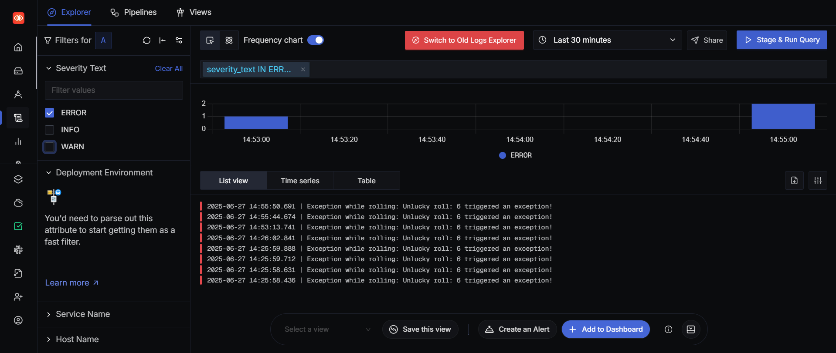

* Captured ValueError exceptions in logs:

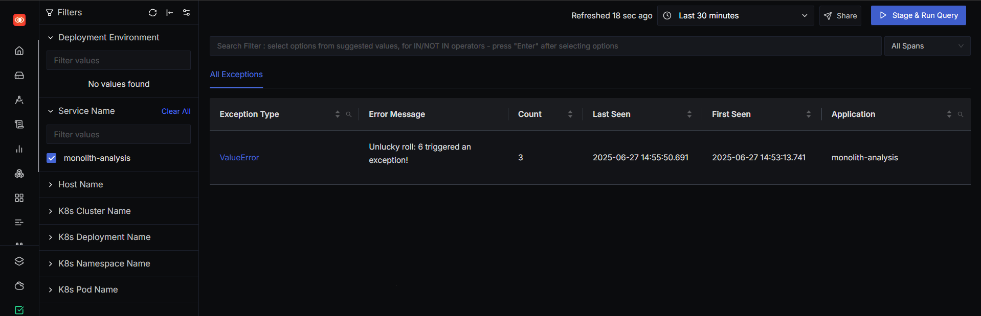

* 500 error page shown to user (proving exception not swallowed):



* Terminal output showing exception and OpenTelemetry trace export:

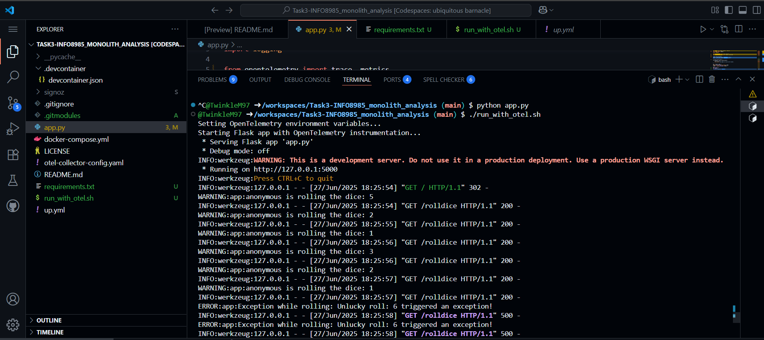

## Validation Checklist:

* dice.rolls metric appears in SigNoz Metrics Explorer
* ValueError exception is logged and traced
* User sees HTTP 500 error, confirming exception is not swallowed

## Notes:

All telemetry data is exported using OTLP HTTP (http://localhost:4318).  
App was tested on GitHub Codespaces, port 5000.  
Used OpenTelemetry Python SDK and SigNoz for observability.