 

**INSTITUTE FOR ADVANCED COMPUTING AND SOFTWARE DEVELOPMENT (IACSD), AKURDI,**

**PUNE**

Documentation On

**Online Tiffin Ordering System**

PG-DAC September 2023

**Submitted By:**

Group No:36

**Roll No. : Name:**

**239050 Mrunali Madhav Dhote**

**239107 Twinkle Pramod Nemade**

**Mrs. Megha Mane Mr. Rohit Puranik**

**Project Guide Centre Coordinator**

**ABSTRACT**

In the modern hustle and bustle of daily life, the traditional practice of cooking meals at home is gradually being replaced by convenient alternatives. Among these, the Online Tiffin Ordering System (OTOS) emerges as a novel solution, catering to the needs of individuals seeking hassle-free, nutritious meals. This abstract outlines the key components and benefits of such a system.

The Online Tiffin Ordering System (OTOS) facilitates the seamless ordering and delivery of freshly prepared meals through a user-friendly digital platform. Users can browse through a diverse menu of dishes, customize their orders according to dietary preferences, and schedule deliveries at their convenience. Behind the scenes, a sophisticated backend system manages inventory, tracks orders, and coordinates delivery logistics to ensure timely and efficient service.

OTOS offers several advantages over traditional meal preparation methods. Firstly, it saves users valuable time and effort by eliminating the need for grocery shopping, meal planning, and cooking. This is particularly beneficial for busy professionals, students, and individuals with hectic schedules. Additionally, OTOS promotes healthier eating habits by offering nutritious meal options prepared by professional chefs, thus reducing reliance on fast food and processed meals.

Moreover, OTOS fosters economic growth by providing opportunities for local culinary entrepreneurs to showcase their culinary skills and reach a wider audience. By connecting consumers with small-scale food businesses, OTOS contributes to the vitality of the local food ecosystem.

Furthermore, OTOS enhances user experience through features such as personalized recommendations based on past orders, loyalty programs, and feedback mechanisms to ensure continuous improvement in service quality. Data analytics tools enable OTOS to gather insights into user preferences and market trends, enabling targeted marketing strategies and menu optimization.

In conclusion, the Online Tiffin Ordering System (OTOS) represents a convenient, efficient, and innovative solution for modern meal management. By leveraging technology to streamline the process of ordering and delivering fresh, homemade meals, OTOS addresses the evolving needs and preferences of today's consumers while promoting healthy eating habits and supporting local food businesses.

**ACKNOWLEDGEMENT**

I take this occasion to thank God, almighty for blessing us with his grace and taking our endeavor to a successful culmination. I extend my sincere and heartfelt thanks to our esteemed guide, Mrs. Megha Mane for providing me with the right guidance and advice at the crucial juncture sand for showing me the right way. I extend my sincere thanks to our respected Centre Co-Ordinator Mr. Rohit Puranik, for allowing us to use the facilities available. I would like to thank the other faculty members also, at this occasion. Last but not the least, I would like to thank my friends and family for the support and encouragement they have given me during the course of our work.

Mrunali Madhav Dhote (230941220101)

Twinkle Pramod Nemade (230941220201)

# 

**INDEX**

|  |  |  |
| --- | --- | --- |
| **Sr. No.** | **Title** | **Pg. No.** |
| 1 | INTRODUCTION | 5 |
| 1.1 | PURPOSE | 6 |
| 1.2 | SCOPE | 6 |
| 1.3 | OBJECTIVE OF PROJECT ON ONLINE  TIFFIN ORDERING SYSTEM | 6 |
| 1.4 | FUNCTIONALITIES PROVIDED BY ONLINE  TIFFIN ORDERING SYSTEM ARE AS FOLLOWS | 6 |
| 2 | REQUIREMENT | 8 |
| 3 | DATABASE DESIGN | 14 |
| 4 | PROJECT MANAGEMENT RELATED STATISTICS | 18 |
| 5 | APPENDIX A | 20 |
| 6 | APPENDIX B | 26 |
| 7 | REFERENCES | 31 |

1. **INTRODUCTION**

In our fast-paced world, where time is of the essence, managing meals can often be a daunting task. Whether it's juggling busy work schedules, catering to diverse dietary needs, or simply seeking convenience, the demand for efficient meal solutions is ever-present. Enter the Tiffin Ordering System, a modern approach to revolutionizing meal management.

The Tiffin Ordering System offers a seamless and hassle-free way for individuals to order and enjoy freshly prepared meals delivered straight to their doorstep. Rooted in the rich culinary traditions of tiffin services prevalent in many cultures, this system combines technology with the age-old concept of home-cooked meals, providing a convenient and personalized dining experience.

At its core, the Tiffin Ordering System operates through an intuitive online platform or mobile application, offering users a diverse selection of menu options tailored to their preferences. Whether craving traditional cuisines, healthy alternatives, or specialty diets, customers can easily browse through a variety of meal choices curated by local chefs and culinary experts.

## Purpose

The purpose of this document is to provide a detailed specification of the features and functionalities of the "Online Tiffin Ordering System" It outlines the requirements, system architecture, and user interactions.

**1.2 Scope**

The scope of a Tiffin Ordering System encompasses the development and implementation of an online platform or mobile application that facilitates the ordering, management, and delivery of freshly prepared meals, commonly referred to as "Tiffins."

## 1.3 Objective of Project on Online Tiffin Ordering System :

The objective of an online Tiffin ordering system is to provide customers with a convenient and efficient way to access freshly prepared meals. It aims to streamline the meal ordering and delivery process, offering a wide variety of menu options to cater to different tastes and dietary preferences. Additionally, the system seeks to promote healthy eating habits, ensure customer satisfaction through timely delivery and responsive service, and support the growth and scalability of the business.

## 1.4 Functionalities provided by Online Tiffin Ordering System are as follows:

1. **User Registration and Authentication**: Allow users to create accounts securely and authenticate their identities to access the platform.
2. **Menu Management**: Enable admins to add, edit, and delete menu items, including descriptions, prices, and images.
3. **Order Placement**: Allow users to browse the menu, select items, add them to their cart, and place orders for delivery.
4. **Payment Processing**: Support various payment methods, such as credit/debit cards, digital wallets, and cash on delivery.
5. **Order Tracking**: Provide users with real-time updates on the status of their orders, from confirmation to delivery.
6. **Delivery Management**: Assign delivery personnel to orders, optimize delivery routes, and track delivery status for efficient and timely service.
7. **Feedback and Rating**: Allow users to provide feedback and ratings for meals and delivery services, with admins able to view and respond to feedback.
8. **Account Management**: Enable users to update their profiles, view order history, and manage subscription settings.
9. **Admin Dashboard**: Provide admins with a centralized dashboard to manage orders, track sales, analyze customer data, and monitor performance metrics.
10. **Customer Support**: Offer responsive customer support channels, such as live chat, email, or phone support, to address inquiries and resolve issues promptly.

These functionalities collectively ensure a seamless and satisfying experience for both customers and administrators, enhancing the efficiency, convenience, and reliability of the Tiffin ordering process.

**2.** **REQUIREMENTS**

**Functional Requirements**

**FR 1. User Registration and Authentication**

* Users should be able to register for an account on the platform.
* The system must authenticate users securely to ensure data privacy and security.

**FR 2. Menu Management**

* The system should allow admins to add, edit, and delete menu items.
* Users should be able to browse the menu, filter options based on dietary preferences, and view detailed descriptions of each dish.

**FR 3. Order Placement**

* Users must be able to select items from the menu and add them to their cart.
* The system should support multiple payment methods, including credit/debit cards, digital wallets, and cash on delivery.
* Users should have the option to schedule orders for specific dates and times.

**FR 4. Order Tracking**

* Users should be able to track the status of their orders in real-time, from confirmation to delivery.
* Notifications should be sent to users at key stages of the order process, such as order confirmation, dispatch, and delivery.

**FR 5. Delivery Management**

* Admins should be able to assign delivery personnel to orders and track their delivery status.
* The system should optimize delivery routes and schedules to ensure efficient and timely deliveries.

**Non-Functional Requirements :**

**NFR 1. Performance**

* The system should be able to handle a large number of concurrent users without significant performance degradation.
* Response times for user interactions, such as browsing the menu and placing orders, should be minimal.

**NFR 2. Security**

* The system must implement robust security measures to protect user data and payment information.
* Secure encryption protocols should be used for data transmission and storage.

**NFR 3. Scalability**

* The system should be designed to accommodate future growth and expansion, with scalability built into its architecture.

**NFR 4. Usability**

* The user interface should be intuitive and user-friendly, catering to users of all technical proficiencies.
* Accessibility features should be incorporated to ensure usability for users with disabilities.

**NFR 5. User Interface Design**

The user interface should feature:

* Clear navigation menus and intuitive layout.
* Visual cues to guide users through the ordering process.
* Responsive design for seamless access across devices, including desktops, tablets, and smartphones.

**NFR 6. Reliability**

* The system should be available and operational 24/7 with minimal downtime..

**NFR 7. Data Integrity**

* Data Integrity and consistency are maintained through proper validation and database design.

**NFR 8. Data Privacy**

* User data , especially personal and sensitive information, should be stored securely.

**NFR 6. Glossary**

* Tiffin: A freshly prepared meal, typically consisting of a main course and accompaniments, delivered to the customer's doorstep.
* Admin: A user with administrative privileges, responsible for managing menu items, orders, and other system settings.

This Software Requirements Specification outlines the key requirements and specifications for the development of the Tiffin Ordering System, ensuring a comprehensive understanding of the system's functionality and user experience.

**Other Requirements:**

**Hardware and Network Interfaces:**

Back-end Server Configuration:

* Intel Pentium-IV Processor
* 128 MB RAM33
* 1 Raid Controller Card
* 32-bit Ethernet Controller (100 Base-T)
* 8 x 2.0 GB Fast SCSI/2 with Raid Support
* 2.88 MB FDD
* 48x CD ROM Drive
* SVGA Colour Monitor on PCI with 1MB RAM
* 101 Keys Keyboard
* 1 Microsoft Mouse with pad
* 4/8 GB DAT
* One Serial & Two Parallel Ports
* Internet Information Server (IIS)
* Microsoft Transaction Server (MTS)

Front-end Client Configuration:

* Intel Pentium-III @ 650 MHz Processor
* 128 MB SDRAM
* 10 GB Hard Disk Drive
* 1.44 MB Floppy Disk Drive
* 15” SVGA Digital Color Monitor
* One Serial, One Parallel port, and One USB port
* 104 Keys Keyboard
* PS2 Mouse with pad
* 32-bit PCI Ethernet Card
* 48X CD Drive

**Software Interfaces:**

Software configuration for back-end Services:

* Windows NT – Server 4.0
* SQL Server 7.0

Software configuration for front-end Services:

* Virus Protection Software
* Client Workstation
* Office 2000

-**Web Browser** – Internet Explorer/N

# 

# 

# **3. DATABASE DESIGN**

# **Database Design**

The following table structures depict the database design.

Table 1: user:

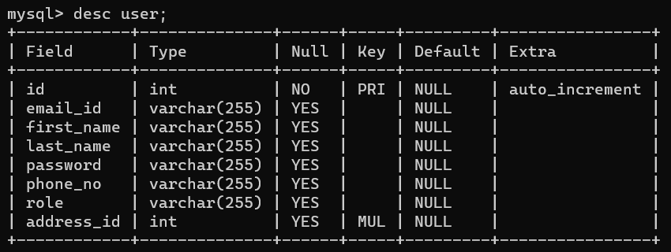

Table 2:category:

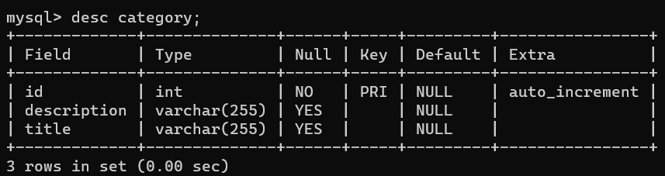

Table 3:product:

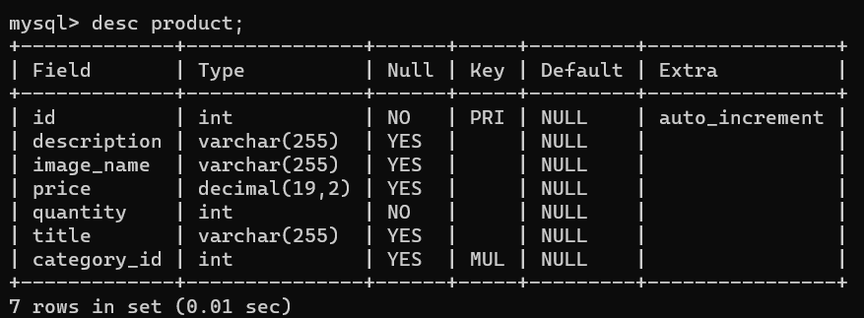

Table 4:orders:

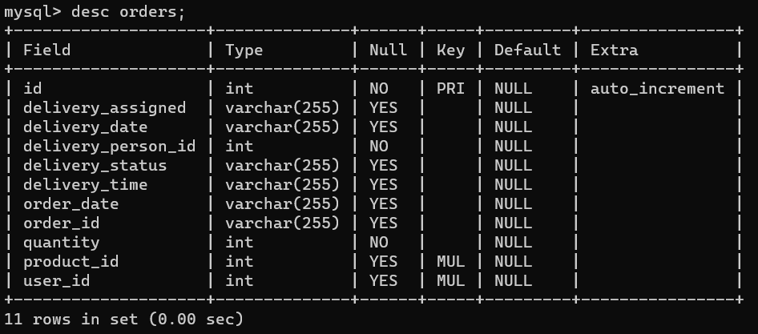

Table 5:address:

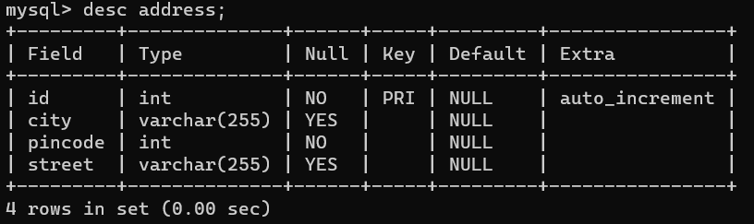

Table 6:cart:

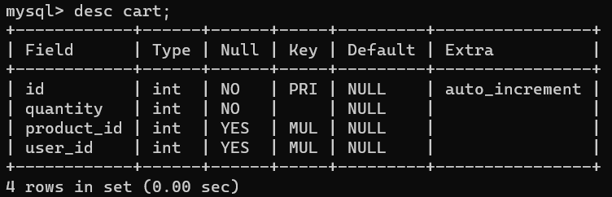 **4**. **PROJECT MANAGEMENT RELATED STATISTICS**

|  |  |  |  |
| --- | --- | --- | --- |
| **DATE** | **WORK PERFORMED** | ***SLC Phase*** | **Additional Notes** |
| 15 Nov  2023 | Project Allotment and User Requirements Gathering | Feasibility Study | ---------------------- |
| 1 Dec  2023 | Initial SRS Document Validation and Team Structure Decided | Requirement Analysis (Elicitation) | The initial SRS was presented to the client to understand his requirements better |
| 10 Dec  2023 | Designing the use- cases, Class Diagram, Collaboration Diagram, E-R Diagram and  User Interfaces | Requirement Analysis & Design Phase | Database Design completed |
| 20 Dec  2023 | Business Logic Component design  Started | Design Phase | ---------------------- |
| 27 Dec  2023 | Coding Phase Started | Coding Phase | 70% of Class Library  implemented. |
| 11 Jan  2024 | Implementation of Web Application and Window Application Started | Coding Phase | Class Library Development going on. |
| 15 Jan 2023 | Implementation of Web Application and Window Application Continued | Coding Phase and Unit Testing | Class Library Modified as per the need. |
| 27 Jan  2024 | Implementation of Web Application and  Window Application Continued | Coding Phase and Unit Testing | -- |
| 28 Jan  2024 | After Ensuring Proper Functioning the Required Validations were  Implemented | Coding Phase and Unit Testing | Module Integration was done by the Project Manager |

|  |  |  |  |
| --- | --- | --- | --- |
| 8 Feb  2024 | The Project was Tested by the respective Team and the  Project Guide | Testing Phase (Module Testing) | -- |
| 18 Feb  2024 | The Project was Submitted to Other Project Leader of Other Project Group for Testing | Testing Phase (Acceptance Testing) | The Project of Other Team was Taken up by the Team for Testing |
| 20 Feb  2024 | The Errors Found were Removed | Debugging | The Project was complete for submission |
| 21 Feb  2024 | Final Submission of Project |  |  |

**5. APPENDIX A**

**Entity Relationship Diagram:**

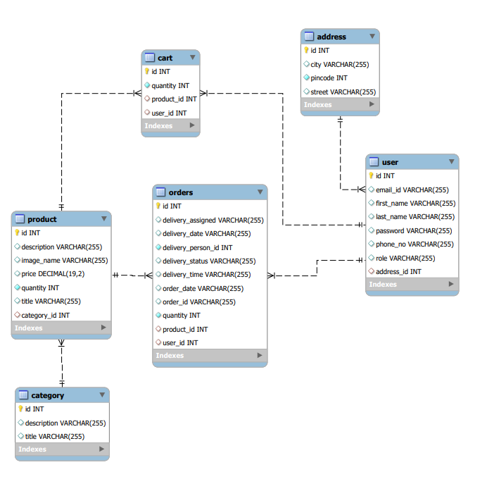

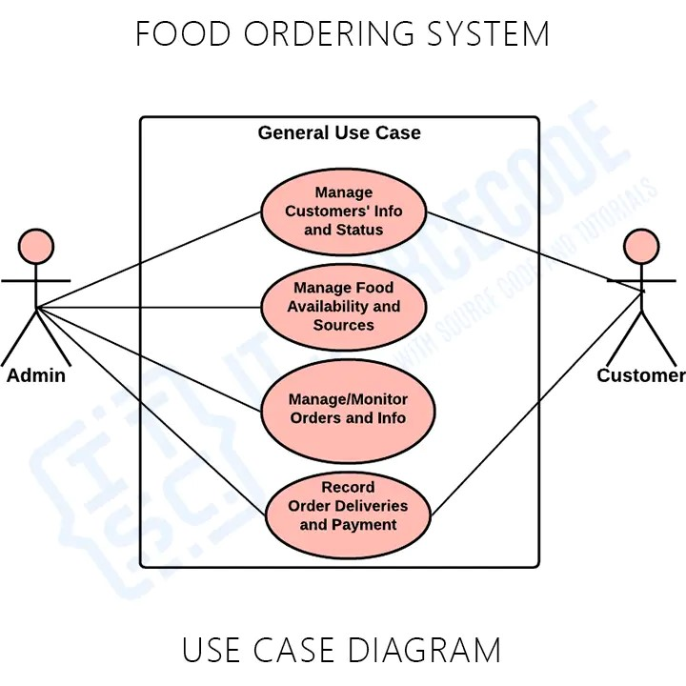

**Data Flow Diagram:**

**Level 0 :**

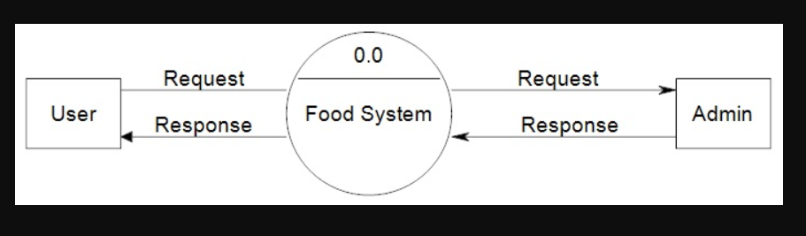

**Level 1 :**

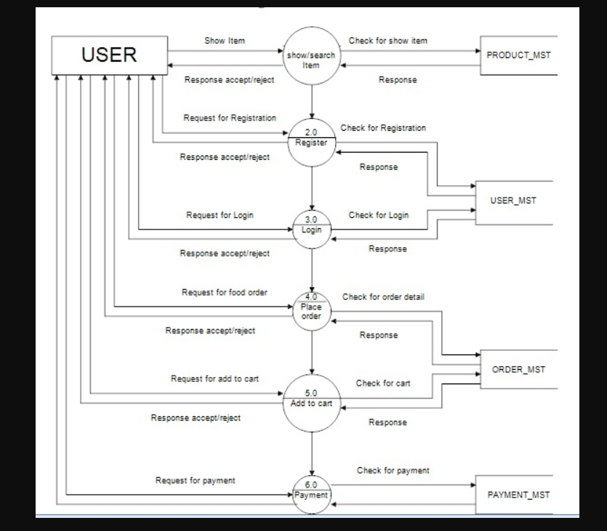

**Class diagram :**

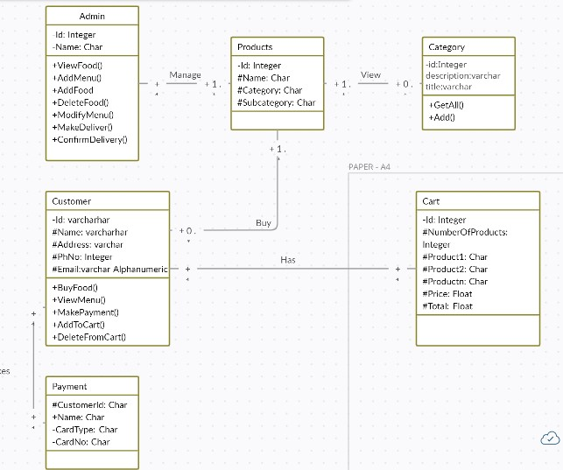

**Sequence Diagram :**

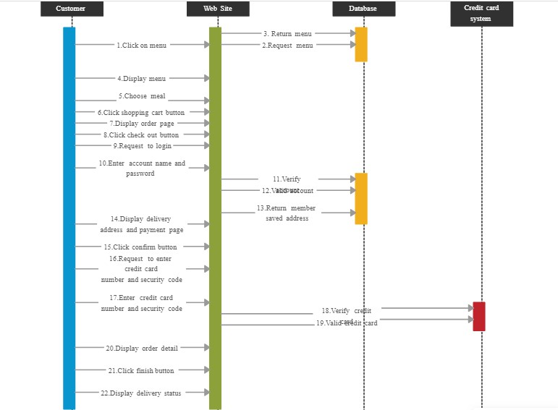

**6. APPENDIX B**

**Homepage:**

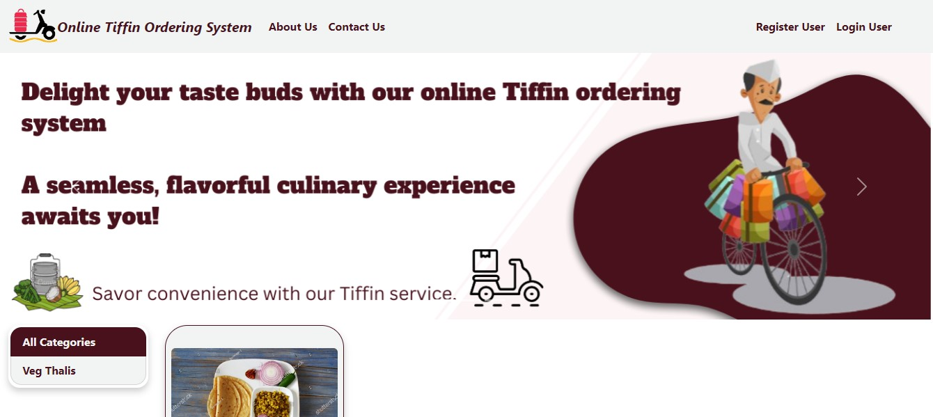

**Login :**

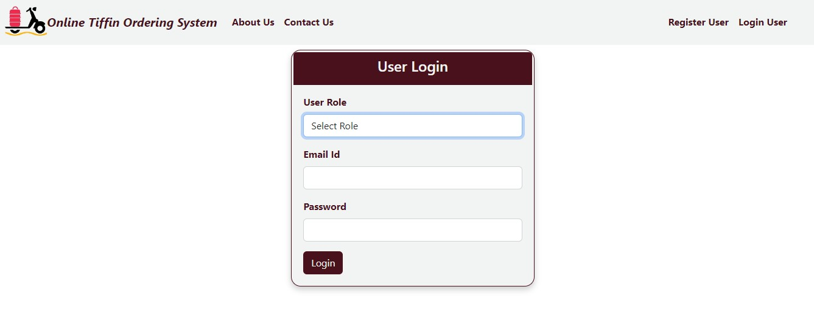

**Registration:**

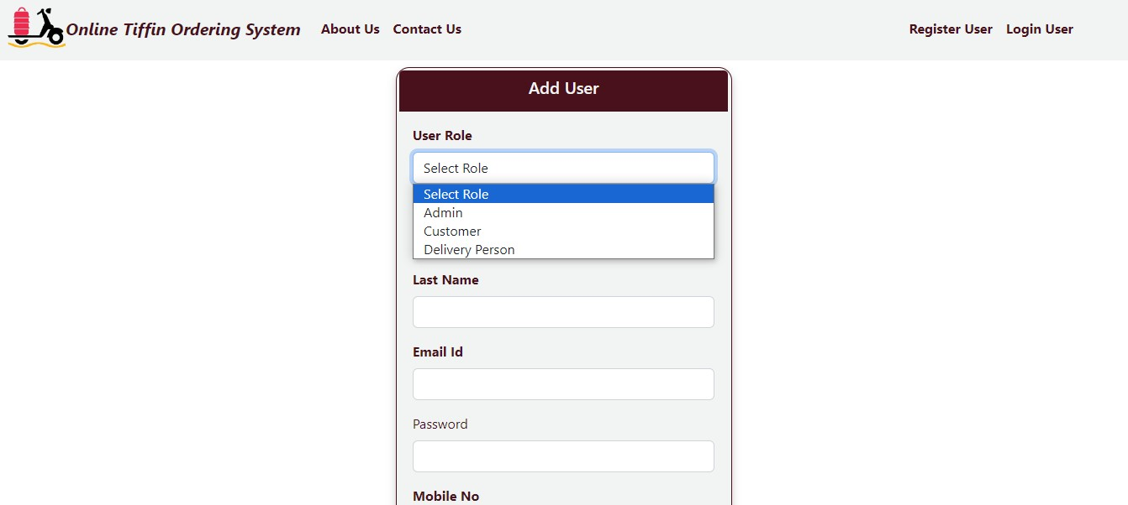

**Add Category :**

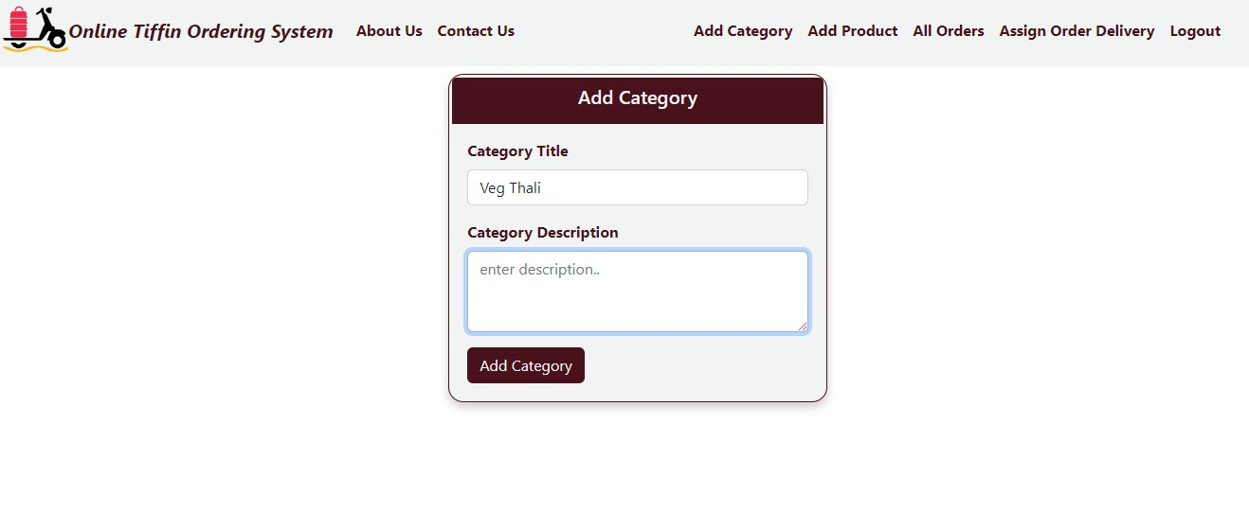

**Add Product :**

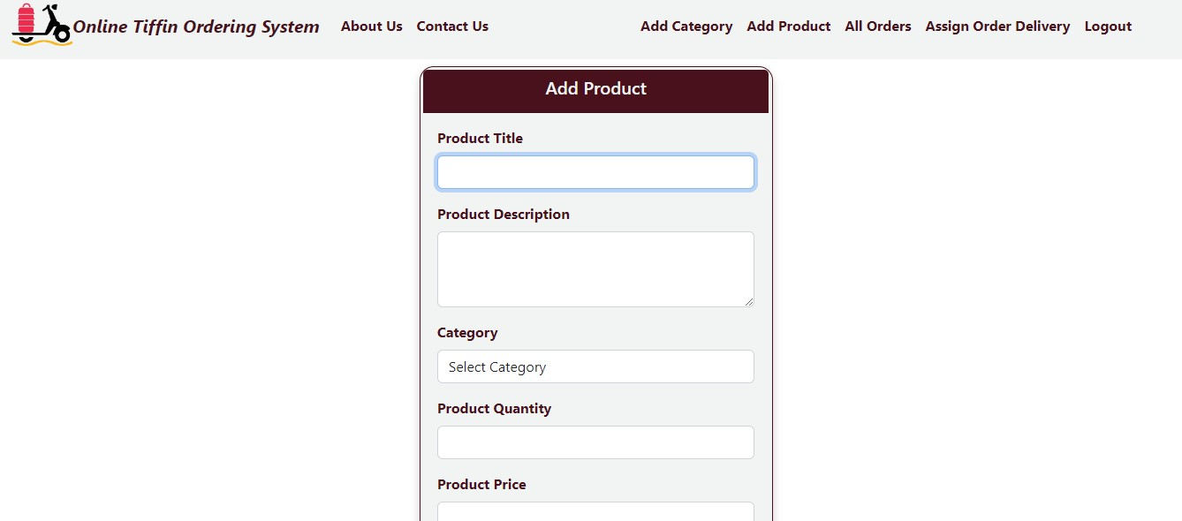

**Add To Cart** :

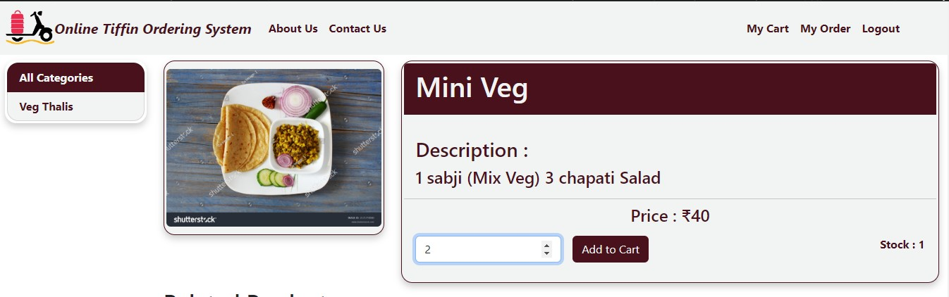

**Delivery Person Details :**

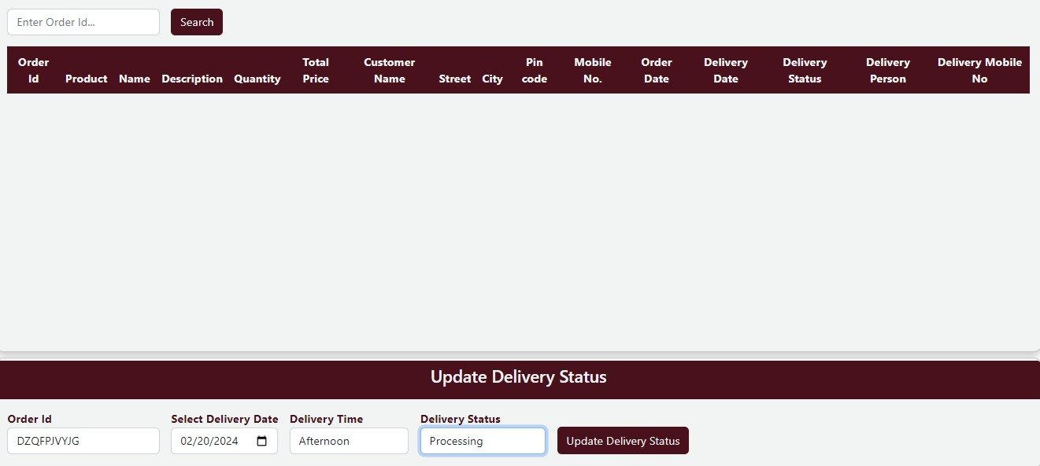

**Assign Delivery Person :**

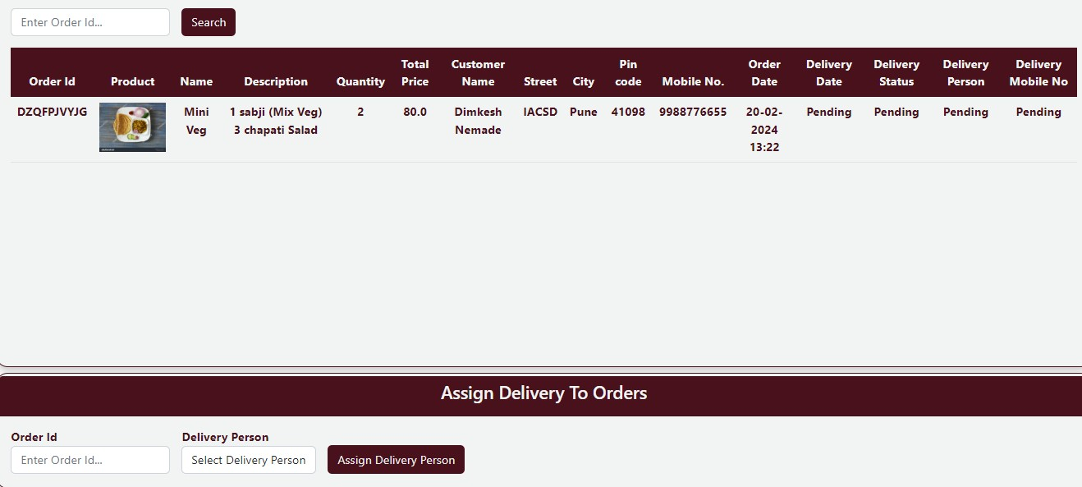

**Placed Order :**

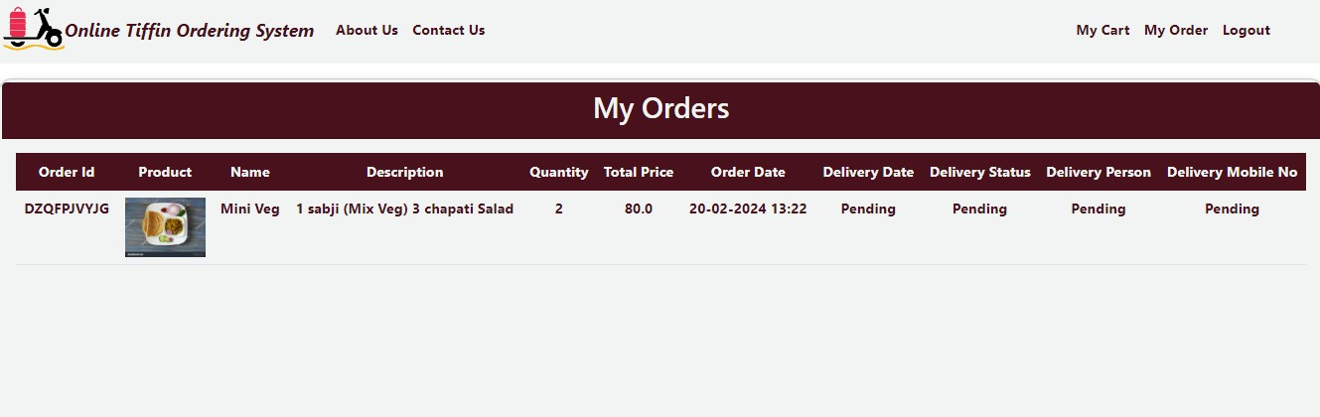

**Payment :**

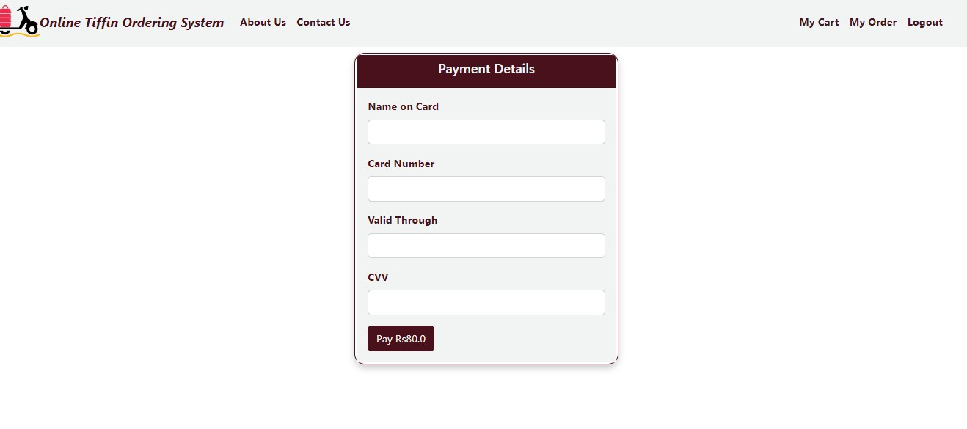

**7. REFERENCES**

<http://www.javatpoint.com/java->

tutorial [http://www.w3.org](http://www.w3.org/)

<http://www.wikipedia.org>

https://[www.tutorialspoint.com/java](http://www.tutorialspoint.com/java)