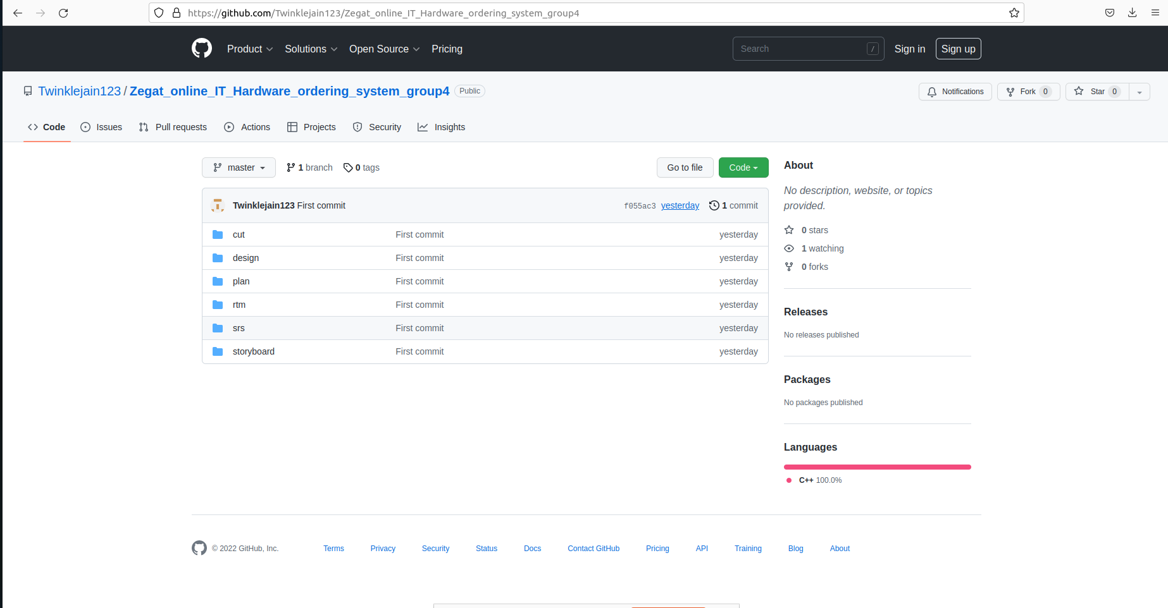

github link:https://github.com/Twinklejain123/Zegat_online_IT_Hardware_ordering_system_group4