Game Design Document

Fill up the following document

1. Write the title of your project.

Ans: “Kill your fears before it kills you”

1. What is the goal of the game?

Ans: The goal of this game is to kill the zombies (fears) that are coming in your way before you run out of bullets or before the zombie (fear) catches you.

1. Write a brief story of your game.

Ans: In the game there will be a player and there will be zombies (fears). The player by pressing space bar key will release the bullets and kill the zombies (fears). The reason why this game is unique is because a lot of people would be able to relate to it (the fears). The game would have common fears such as Social fobias, Fomo issues, Claustrophobia, etc.

1. Which are the playing characters of this game?

* Playing characters are the ones who respond to the user based on the input from the user.
* Cars, monkeys, dinos, wizards, etc., are the playing characters in the game.

|  |  |  |
| --- | --- | --- |
| Number | Character Name | What can this character do? |
| 1 | Player | This character can shoot bullets by pressing the space bar key and killing the zombies (fears) coming its way; It can also move by the up and the down arrow key to kill the zombies (fear). |
| 2 | Bullet | This element in the game can kill the zombies (fears) if the user presses the space bar key. Hence, winning the game after reaching a particular score. |
| 3 |  |  |
| 4 |  |  |
| 5 |  |  |
| 6 |  |  |
| 7 |  |  |
| 8 |  |  |

1. Which are the Non-Playing Characters of this game?

* Non-Playing characters are the ones that don't have an action or behavior when the user interacts with the game.
* Hurdles, stones, bananas, coins, etc., are non-playing characters in the game.

|  |  |  |
| --- | --- | --- |
| Number | Character Name | What can this character do? |
| 1 | Zombies (fears) | This character(s) spawns after every 60 frames, it moves with a velocity towards the player. If it touches the player more than 2 times, the player will lose the game. |
| 2 |  |  |
| 3 |  |  |
| 4 |  |  |
| 5 |  |  |
| 6 |  |  |
| 7 |  |  |
| 8 |  |  |

Draw your imagination of this game. What does this game look like?

* Draw the game either on your computer or on paper.
* Add images of the game scenes to show each of the playing and non-playing characters at least once.

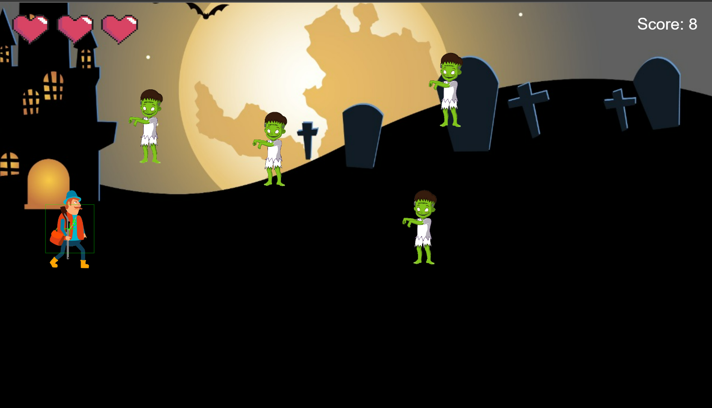 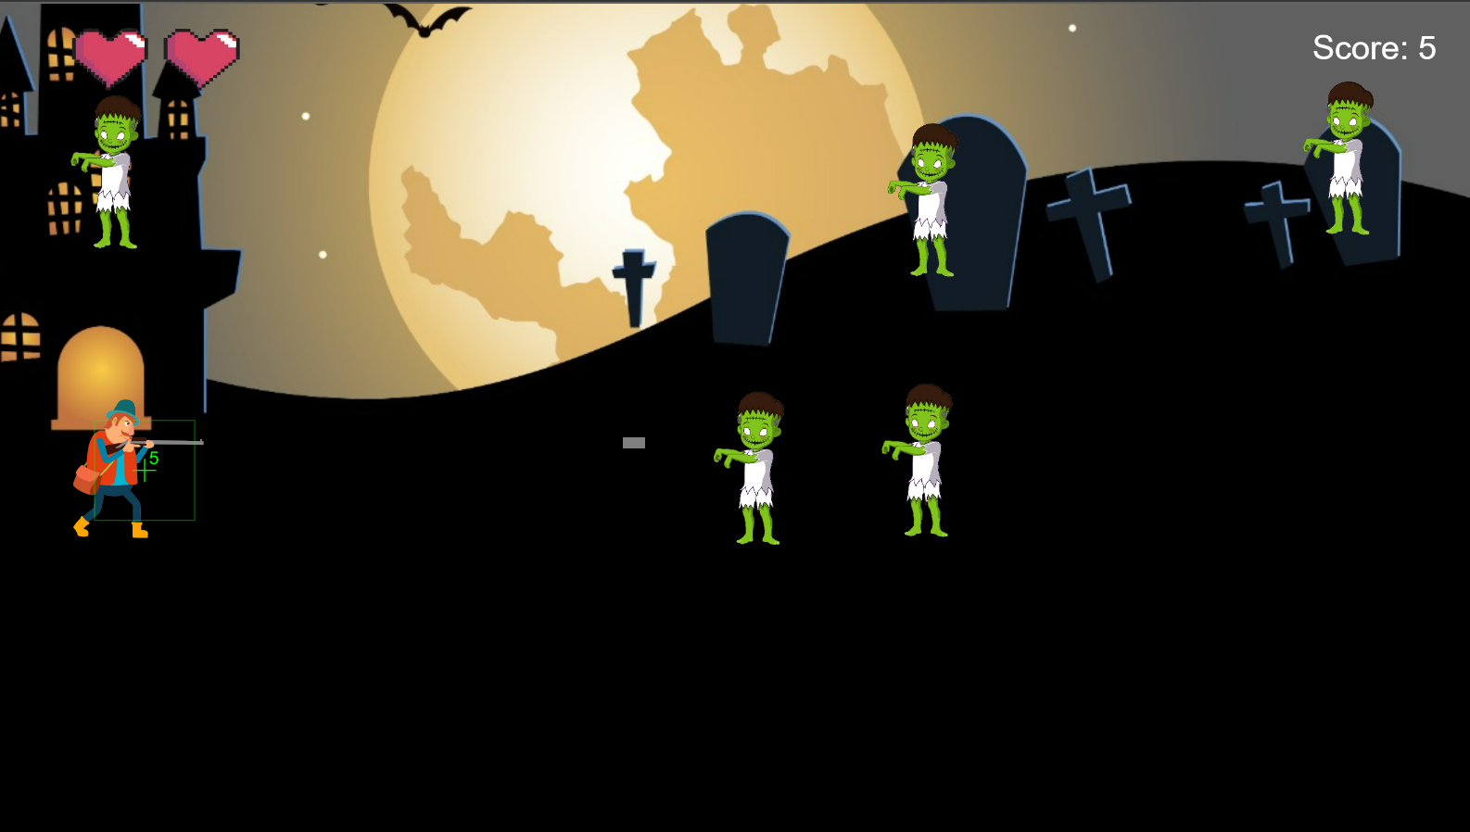

How do you plan to make your game engaging?

Ans: I plan on making the game engaging by:

1. Spwaning the zombies (fears) at random x and y position.2. By making the bullets a particular number so that the player needs to be mindful while using it, as if the user runs out of bullets before reaching the score that is needed to win the game, the user will lose.

3. By changing the velocity of the zombies (fears) over the time.

4. By naming the zombies fears that people can actually relate to.