BiblioGuard: Selective bibliographic metadata intervention for multi-domain scientific retrieval-augmented generation

Abstract
Bibliographic metadata can improve scientific retrieval, but fixed citation or recency priors can also displace relevant evidence. We formulate metadata use as a selective intervention problem and introduce BiblioGuard, a lightweight decision layer for scientific retrieval-augmented generation. For each query, BiblioGuard retrieves similar historical queries, estimates paired NDCG@10 effects for nine atomic metadata actions, and intervenes only when the best Bonferroni-corrected pessimistic decision score is positive. Every action preserves the selected content retriever's scores, fusion rule, and candidate set, removing a confound in earlier metadata comparisons. Across four scientific benchmarks, the method raises SCIDOCS from 0.2164 to 0.2343 (gain 0.0179; paired-bootstrap 95% interval [0.0139, 0.0218]) against a strong SBERT-Dense fallback, while conservatively abstaining on the other domains. Ten fold seeds give a mean gain of 0.0180 ± 0.0009. Official train-to-test evaluations on SciFact and NFCorpus show near-complete abstention and no mean improvement, exposing limited transfer rather than hiding it. Risk–coverage analysis shows that conservative gating reduces harmed queries relative to unconstrained local or global routing. The contribution is a metadata-specific selective intervention policy, not a formal distribution-free safety guarantee.
Keywords: scientific information retrieval; retrieval-augmented generation; bibliographic metadata; selective prediction; query routing; abstention

1. Introduction
Scientific retrieval-augmented generation (RAG) systems must select evidence from collections in which lexical match, semantic relevance, citation impact, publication time, and venue quality are only partly aligned. Content encoders directly address topical relevance. Bibliographic signals provide a different kind of evidence: they can favour influential or recent work, but they can also encode age, field, and popularity biases. A fixed metadata prior therefore creates a decision problem rather than a universally beneficial ranking feature.
The central question is not whether citations are correlated with relevance on average. It is whether a system should alter a strong content ranking for the current query. This distinction matters in deployed writing assistants: an unhelpful intervention changes the evidence exposed to the generator, whereas abstention retains a known content-only ranking.
We address this problem with BiblioGuard. The method treats citation and recency weights as atomic actions relative to the same underlying content retriever. It uses cross-fitted query similarity to estimate local paired effects, penalises uncertain actions and multiplicity, and otherwise selects the content fallback. The design borrows the useful non-parametric intuition of retrieval-based routers but changes the target from absolute model performance to the incremental effect of a metadata intervention.
The paper makes four bounded contributions:
- A confound-free action construction in which metadata is the only ranking component that changes relative to a strong content fallback.
- BiblioGuard, a metadata-specific local paired-effect policy with a multiplicity-corrected pessimistic gate and explicit abstention.
- A four-domain evaluation with local/global routing baselines, gate and representation ablations, risk–coverage analysis, query-level harm counts, paired bootstrap intervals, and repeated folds.
- An official train-to-test evaluation on two domains that documents both conservative transfer and the method's limited coverage.

2. Related work and novelty boundary

2.1. Scientific retrieval and bibliographic signals
Sparse and dense retrieval capture complementary matching signals, and hybrid fusion is a standard strategy on heterogeneous corpora (Thakur et al., 2021; Reimers and Gurevych, 2019; Xiao et al., 2023). Scientific search additionally exposes citation, publication-year, and venue metadata. Prior systems use metadata for filtering, reranking, source reliability, or citation-aware synthesis (Hwang et al., 2025; Yousuf et al., 2026; Ding et al., 2026). These studies motivate metadata-aware retrieval but do not imply that a fixed prior is safe for every query or corpus.

2.2. Query routing and selective prediction
Adaptive RAG increasingly routes queries among retrievers or evidence sources. R3AG learns query-specific retriever capability from retrieval and generation supervision (Zhao et al., 2026), while RouteRAG jointly learns graph/text retrieval decisions (Guo et al., 2026). ContextualRouter estimates candidate performance from similar historical queries and reports that a simple k-nearest-neighbour mean is highly competitive (Varangot-Reille et al., 2026). We therefore include that simple local-mean rule as a direct experimental baseline.
Abstention and conservative policy improvement offer a second foundation. Selective prediction studies risk as coverage changes (Geifman and El-Yaniv, 2019), and high-confidence policy improvement compares a proposed policy with a baseline (Thomas et al., 2015). Recent conformal routing provides distribution-free violation-rate guarantees under explicit calibration assumptions (Uddin and Bauer, 2026). BiblioGuard does not provide that guarantee. Its weighted neighbours are dependent and similarity-selected; its score must be read as an operational pessimistic decision score; it is not a formal confidence bound.

2.3. What is new here
Method family | Prediction target | Uncertainty/abstention | Our distinction
ContextualRouter-style kNN | Absolute candidate performance | Optional cost rule | Paired metadata effect, same-content fallback
Safe policy improvement | Policy return vs baseline | Formal bounds under assumptions | Offline retrieval action; no formal safety claim
Selective prediction | Prediction correctness/risk | Reject option | Intervention coverage and retrieval harm
BiblioGuard | Incremental NDCG@10 effect | Pessimistic score; fallback | Bibliographic intervention for scientific retrieval

The novelty is consequently application-methodological: the action definition, paired-effect target, multiplicity-aware gate, and same-content fallback are integrated for bibliographic intervention. We do not claim a new general statistical theory or use “first”.

3. Problem formulation
Let q be a query, D a corpus, s₀(q,d) the score produced by a content-only retriever, and zₘ(d) a normalised metadata signal m ∈ {citation, recency}. The fallback ranking uses s₀. An atomic action a=(m,λ) reranks only the top-100 fallback candidates with sₐ(q,d) = s₀(q,d) + λzₘ(d). The action does not change the content retriever, its sparse/dense fusion, or its candidate set. Citation actions use λ ∈ {.05,.10,.15,.20,.30}; recency actions use λ ∈ {.05,.10,.15,.20}.
For historical query i, the paired action effect is Δᵢ(a) = NDCG@10ᵢ(a) − NDCG@10ᵢ(0), where 0 denotes fallback. The policy observes query text and historical paired effects, but not the relevance judgements of the query being routed. Its output is either one atomic action or fallback.

4. BiblioGuard

4.1. Training-fold content fallback
Within each outer fold, BiblioGuard selects the content-only candidate with the highest training-fold mean NDCG@10 among the candidates for which same-content actions are available. Candidates include SBERT-Dense, BGE-Dense, Neural-Hybrid, and BGE-Hybrid where document scores are available. The held-out fold does not influence this selection. This directly answers why the method should not be compared only with an arbitrary 0.5/0.5 hybrid.

4.2. Local paired-effect estimation
Word TF-IDF (1–2 grams) and character TF-IDF (3–5 grams) are fitted only on training queries. For a held-out query, cosine similarity selects k = ⌈√nₜʳₐᶢₙ⌉ neighbours. Non-negative similarities plus 0.001 are normalised to weights wᵢ. For every action, the weighted mean effect is μ̂ₐ = ∑ᵢ wᵢΔᵢ(a). We use the unbiased weighted variance vₐ = ∑ᵢ wᵢ(Δᵢ(a) − μ̂ₐ)² / (1 − ∑ᵢ wᵢ²), effective sample size nₑ = 1 / ∑ᵢ wᵢ², and SEₐ = √(vₐ ∑ᵢ wᵢ²).

4.3. Pessimistic decision score and abstention
For nine actions and family α=.05, the decision score is PDSₐ = μ̂ₐ − t(1 − α/9, ⌊nₑ⌋ − 1)SEₐ. BiblioGuard selects the action with maximal PDS only if that maximum is positive; otherwise it returns the content fallback. The Bonferroni term addresses the within-query action search. Because retrieved neighbours are similarity-selected rather than independent observations, PDS is not labelled a confidence bound.
Algorithm 1. Cross-fitted BiblioGuard
Step | Operation
1 | Split queries; select the strongest content fallback on outer-training labels.
2 | Construct nine same-content atomic metadata outcomes for training and held-out queries.
3 | Fit word/character TF-IDF on training text; retrieve k similar training queries.
4 | Estimate weighted paired effects, variance, effective sample size, and PDS per action.
5 | Apply argmax action if max PDS>0; otherwise return the content-only fallback.

4.4. Computational complexity
After content retrieval, an intervention reranks at most 100 documents. Routing requires one sparse query projection and a similarity search over historical query vectors. The reference code uses exact cosine search; approximate nearest-neighbour indexing can replace it without changing the decision rule.

5. Experimental design

5.1. Datasets and frozen metadata
Dataset | Domain | Documents | Test queries | Citation coverage | Year coverage
SCIDOCS | computer science | 25,657 | 1,000 | 99.7% | 98.7%
SciFact | biomedical claims | 5,183 | 300 | 94.1% | 93.8%
NFCorpus | nutrition / medicine | 3,633 | 323 | 94.0% | 94.0%
TREC-COVID | COVID-19 biomedicine | 171,332 | 50 | 69.8% | 96.4%

SCIDOCS covers computer science; SciFact contains biomedical claims; NFCorpus covers nutrition and medicine; TREC-COVID is a temporal biomedical search collection. Citation/year/venue metadata come from the frozen repository snapshot collected from Semantic Scholar and OpenAlex during 2025–2026. No live API values are used at evaluation time. The recency reference year remains 2024 to reproduce the frozen experimental protocol.

5.2. Main and independent protocols
The main protocol is five-fold cross-fitting with seed 42. Held-out qrels never enter content-base selection, TF-IDF fitting, neighbour retrieval, effect estimation, or action selection. We repeat the complete procedure for seeds 0–9. For independent validation, official SciFact and NFCorpus train queries determine the base, representation, neighbours, and actions; test qrels are opened only after decisions are frozen. We call this train-to-test transfer, not external-dataset validation.

5.3. Baselines and ablations
Content candidates are SBERT-Dense, BGE-Dense, and their 0.5 BM25 hybrids. Routing baselines are: (i) the global training-fold best action; (ii) a ContextualRouter-style kNN local mean without an uncertainty penalty; (iii) an uncorrected one-sided t penalty; (iv) a bounded-effect empirical Bernstein penalty; and (v) BiblioGuard. The legacy PAV feature router is retained as a historical baseline. Mechanism ablations compare word-only, character-only, half-k, and double-k settings. Hyperparameters are not selected on test outcomes.

5.4. Statistical analysis
The primary comparison uses paired, two-sided Wilcoxon signed-rank tests, with Holm correction across four datasets. Mean paired gains receive 10,000-resample query-level bootstrap 95% intervals (seed 2026). We report improved, unchanged, and harmed queries both overall and among active interventions. A penalty multiplier from 0 to 1.5 produces the risk–coverage analysis. Exact per-query arrays are released.

6. Results

6.1. Primary comparison with strong fallbacks
Table 2. Cross-fitted BiblioGuard against a training-fold-selected content fallback. CI is the paired-query bootstrap interval; p is two-sided and Holm-adjusted.
Dataset | Fallback | BiblioGuard | Gain | 95% CI | Active | Holm p | Fold bases (queries)
SCIDOCS | 0.2164 | 0.2343 | +0.0179 | [0.0139, 0.0218] | 49.3% | 2.75e-19 | SBERT-Dense:1000
SciFact | 0.6998 | 0.6998 | +0.0000 | [0.0000, 0.0000] | 0.0% | 1.000 | BGE-Dense:240, Neural-Hybrid:60
NFCorpus | 0.3487 | 0.3487 | +0.0000 | [0.0000, 0.0000] | 0.0% | 1.000 | BGE-Hybrid:323
TREC-COVID | 0.7578 | 0.7578 | +0.0000 | [0.0000, 0.0000] | 0.0% | 1.000 | BGE-Dense:50

On SCIDOCS, every outer fold selects SBERT-Dense, and BiblioGuard improves mean NDCG@10 by 0.0179. This result exceeds the strongest content-only score rather than only a weaker hybrid. The policy abstains on the other domains under the corrected gate. The result therefore supports selective utility on one domain, not universal metadata benefit.
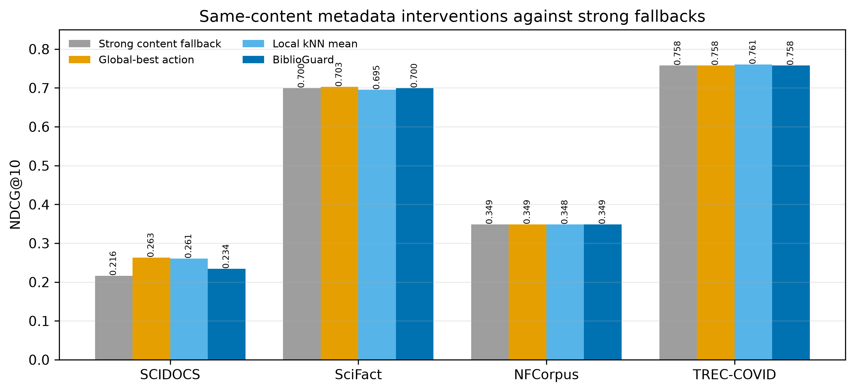
Fig. 1. Same-content interventions compared with strong fallbacks and routing baselines.

6.2. What the gate changes
Dataset | Policy | NDCG@10 | Gain | Active | Improved | Unchanged | Harmed
SCIDOCS | Global-best | 0.2633 | +0.0469 | 100.0% | 474 | 380 | 146
SCIDOCS | Local kNN mean | 0.2607 | +0.0443 | 100.0% | 461 | 401 | 138
SCIDOCS | Uncorrected PDS | 0.2530 | +0.0366 | 88.5% | 404 | 362 | 119
SCIDOCS | Empirical Bernstein | 0.2164 | +0.0000 | 0.0% | 0 | 0 | 0
SCIDOCS | BiblioGuard | 0.2343 | +0.0179 | 49.3% | 214 | 217 | 62
SciFact | Global-best | 0.7030 | +0.0032 | 40.0% | 5 | 113 | 2
SciFact | Local kNN mean | 0.6954 | -0.0044 | 76.0% | 18 | 189 | 21
SciFact | Uncorrected PDS | 0.6998 | +0.0000 | 0.3% | 0 | 1 | 0
SciFact | Empirical Bernstein | 0.6998 | +0.0000 | 0.0% | 0 | 0 | 0
SciFact | BiblioGuard | 0.6998 | +0.0000 | 0.0% | 0 | 0 | 0
NFCorpus | Global-best | 0.3487 | +0.0000 | 100.0% | 4 | 316 | 3
NFCorpus | Local kNN mean | 0.3483 | -0.0004 | 71.8% | 41 | 157 | 34
NFCorpus | Uncorrected PDS | 0.3493 | +0.0005 | 2.2% | 3 | 3 | 1
NFCorpus | Empirical Bernstein | 0.3487 | +0.0000 | 0.0% | 0 | 0 | 0
NFCorpus | BiblioGuard | 0.3487 | +0.0000 | 0.0% | 0 | 0 | 0
TREC-COVID | Global-best | 0.7577 | -0.0001 | 100.0% | 13 | 25 | 12
TREC-COVID | Local kNN mean | 0.7608 | +0.0029 | 100.0% | 16 | 19 | 15
TREC-COVID | Uncorrected PDS | 0.7583 | +0.0005 | 12.0% | 3 | 2 | 1
TREC-COVID | Empirical Bernstein | 0.7578 | +0.0000 | 0.0% | 0 | 0 | 0
TREC-COVID | BiblioGuard | 0.7578 | +0.0000 | 0.0% | 0 | 0 | 0

The SCIDOCS global-best action obtains a larger average gain (+0.0469) but harms 146 active queries. The local mean harms 138; BiblioGuard reduces that count to 62 while intervening on fewer queries. This is the central trade-off: the gate sacrifices some mean upside for lower exposure to query-level harm. It does not eliminate harm. The empirical Bernstein comparator abstains throughout the evaluated domains, illustrating that a bounded-effect penalty can be too conservative at these local sample sizes.
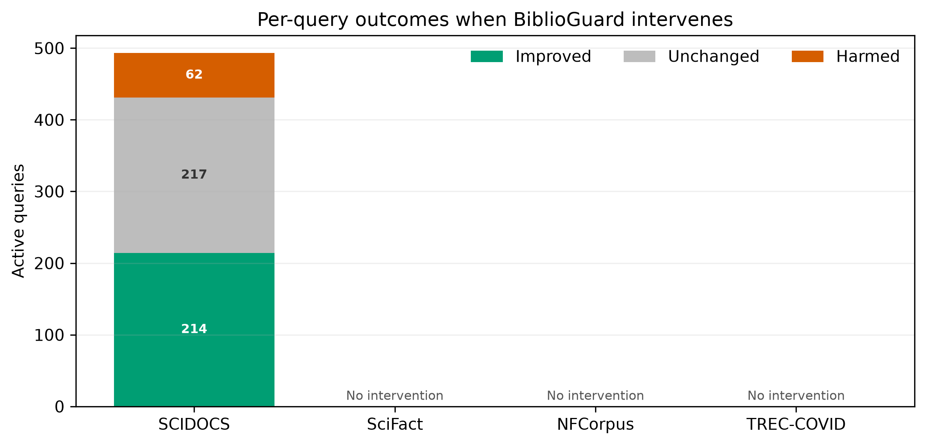
Fig. 2. Improved, unchanged, and harmed queries among active BiblioGuard decisions.

6.3. Risk–coverage and repeated folds
Penalty multiplier | Coverage | Mean gain | Harmed active queries
0.00 | 100.0% | +0.0443 | 138
0.25 | 99.2% | +0.0433 | 133
0.50 | 94.4% | +0.0403 | 129
0.75 | 80.3% | +0.0326 | 109
1.00 | 49.3% | +0.0179 | 62
1.25 | 18.3% | +0.0056 | 28
1.50 | 5.2% | +0.0011 | 9

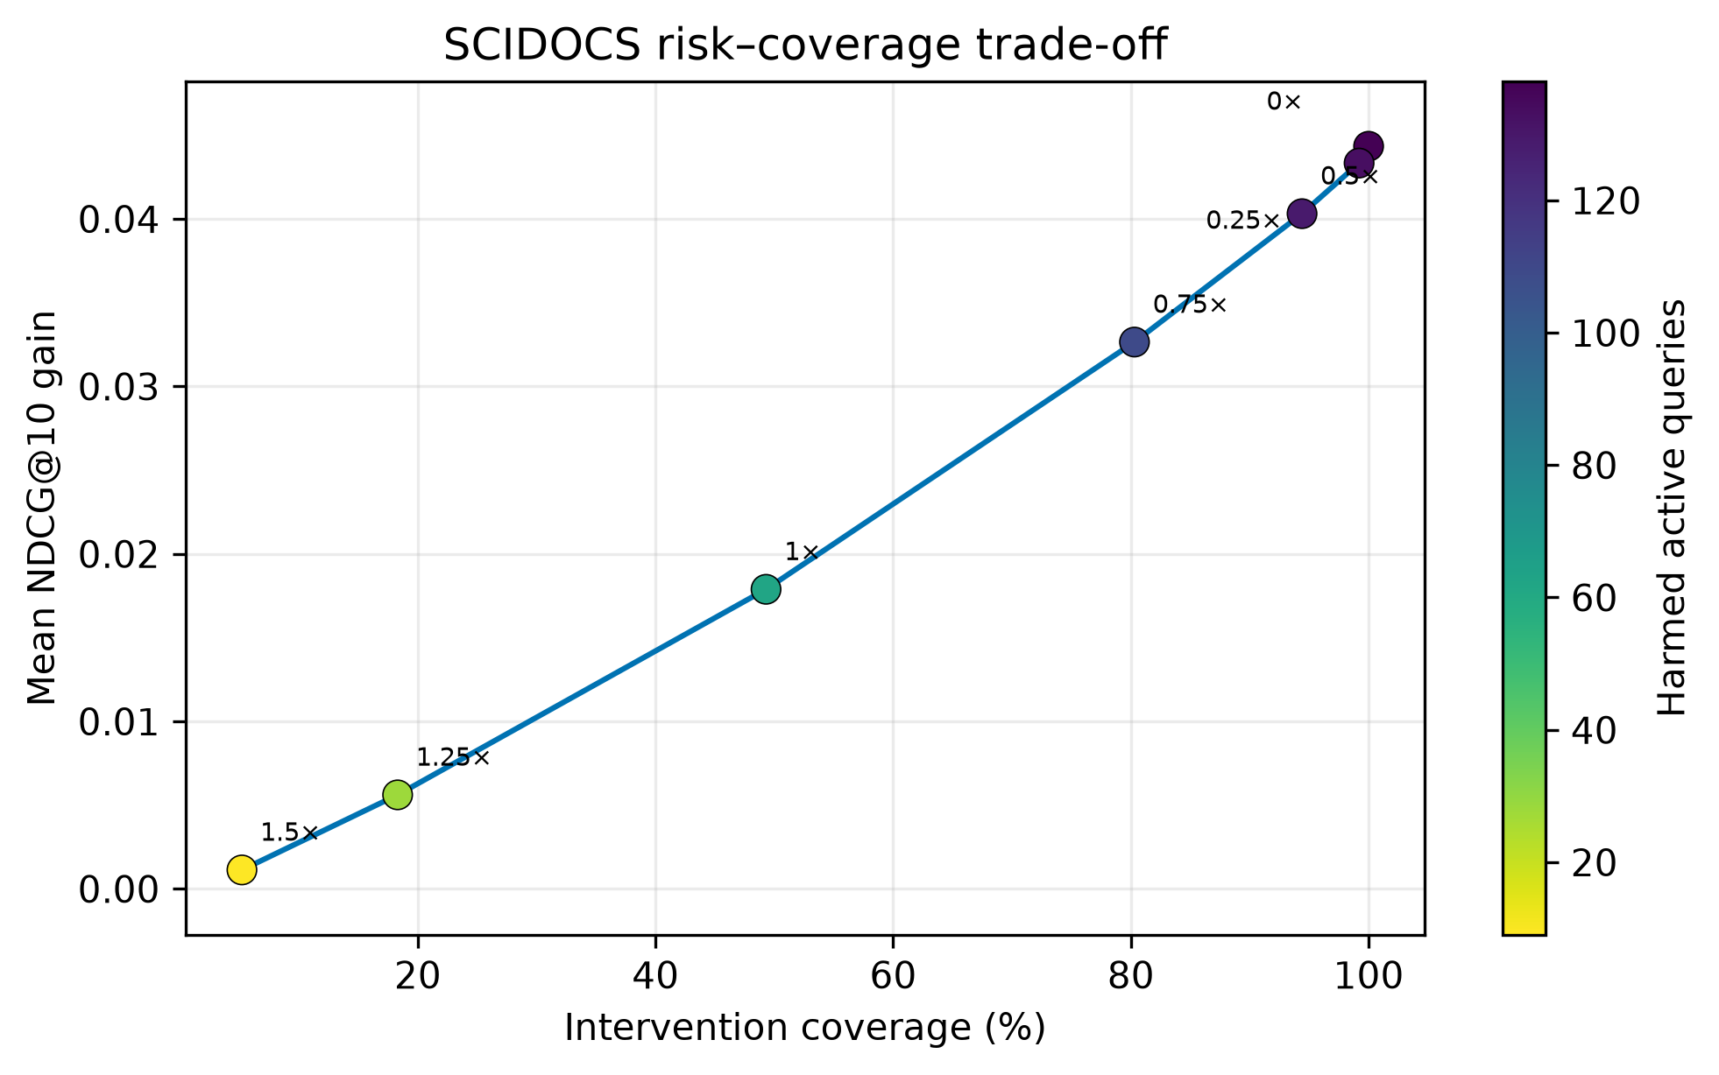
Fig. 3. SCIDOCS intervention coverage and gain as the pessimism penalty changes.
Dataset | BiblioGuard NDCG@10 | Gain | Active rate
SCIDOCS | 0.2344 ± 0.0009 | +0.0180 ± 0.0009 | 50.1% ± 1.3%
SciFact | 0.6965 ± 0.0051 | +0.0000 ± 0.0000 | 0.0% ± 0.0%
NFCorpus | 0.3436 ± 0.0046 | +0.0000 ± 0.0000 | 0.0% ± 0.0%
TREC-COVID | 0.7578 ± 0.0000 | +0.0000 ± 0.0000 | 0.2% ± 0.6%

SCIDOCS remains positive across all ten repeated seeds. The other datasets remain conservative, showing that the null activation is not a peculiarity of seed 42.

6.4. Feature and neighbourhood ablations
SCIDOCS setting | NDCG@10 | Gain | Active
Default word+char, k | 0.2343 | +0.0179 | 49.3%
Word only | 0.2327 | +0.0163 | 43.5%
Character only | 0.2367 | +0.0203 | 51.5%
Half k | 0.2217 | +0.0053 | 14.5%
Double k | 0.2518 | +0.0354 | 85.4%

Character-only and double-k variants are stronger on SCIDOCS, but they are reported as post-specified ablations and are not promoted to the primary method. Choosing them after viewing these test outcomes would inflate the result. Future work should tune representation and coverage on a separate development collection.

6.5. Official train-to-test transfer
Dataset | Train | Test | Base | Fallback | BiblioGuard | Active | I/U/H active
SciFact | 809 | 300 | BGE-Dense | 0.7127 | 0.7127 | 0.0% | 0/0/0
NFCorpus | 2590 | 323 | BGE-Hybrid | 0.3487 | 0.3487 | 0.3% | 0/1/0

The strict gate activates on 0.0% of SciFact and 0.3% of NFCorpus test queries, with zero mean gain in both. The uncorrected gate activates more often, and the local mean can transfer negatively on NFCorpus. These findings support abstention under weak evidence but also show that the learned intervention does not yet generalise broadly.

6.6. Legacy PAV routing baseline
Dataset | Best fixed | PAV routed | Macro-F1 | Kappa
SCIDOCS | 0.1974 | 0.1896 | 0.303 | 0.027
SciFact | 0.7081 | 0.7042 | 0.318 | -0.005
NFCorpus | 0.3391 | 0.3326 | 0.293 | 0.003
TREC-COVID | 0.6743 | 0.6702 | 0.285 | -0.108

The legacy surface-feature classifier does not reliably beat its best fixed method and has near-zero agreement beyond class imbalance. BiblioGuard differs by estimating paired intervention effects rather than predicting an absolute winning retriever label.

6.7. Metadata association diagnostics
Dataset | Positive docs | Background docs | Citation AUC (95% CI) | Median cites P/B | Snapshot
SCIDOCS | 4008 | 21574 | 0.804 [0.795, 0.812] | 566/68 | frozen repository snapshot collected during 2025-2026
SciFact | 264 | 2640 | 0.589 [0.551, 0.626] | 254/173 | frozen repository snapshot collected during 2025-2026
NFCorpus | 2943 | 473 | 0.498 [0.470, 0.526] | 6/5 | frozen repository snapshot collected during 2025-2026
TREC-COVID | 17537 | 25000 | 0.499 [0.493, 0.505] | 6/10 | frozen repository snapshot collected during 2025-2026

The diagnostic is document-level and associative. Positive and background IDs are deduplicated; every dataset uses the same seeded background rule (up to 10:1, capped at 25,000; seed 7). SCIDOCS has a strong citation–relevance association, whereas NFCorpus and TREC-COVID are near chance. This pattern is consistent with, but does not causally explain, where citation intervention is useful. The AUC interval uses the stated Hanley–McNeil large-sample approximation.

7. Discussion

7.1. Practical interpretation
BiblioGuard should be interpreted as a selective decision layer, not as evidence that conservative routing maximises average NDCG. On SCIDOCS, the global action is stronger in mean but exposes more queries to harm. A deployment can choose a penalty multiplier based on its tolerance for coverage and query-level regressions. The default is deliberately conservative.
The train-to-test results are equally important. Near-total abstention protects the content baseline, but a system that almost never acts has limited added value. This failure boundary motivates better calibrated representations, domain-conditioned action spaces, and development collections with sufficient intervention signal.

7.2. Relation to end-to-end RAG
An earlier feasibility experiment generated 200 paired answers with two fixed MiniLM retrieval backends. It found no significant relevance, faithfulness, or citation-precision difference between them. That experiment predates BiblioGuard and does not test the new policy. It is therefore not used as evidence of an end-to-end generation gain and is retained only in the repository as secondary feasibility material. The same qualification applies to the earlier small deployment pilot.

7.3. Limitations
First, the main gain occurs on one of four domains. Second, official train-to-test transfer yields abstention rather than improvement. Third, PDS is not a calibrated or distribution-free confidence bound. Fourth, the metadata snapshot is time-dependent, incomplete, and may encode popularity and age bias. Fifth, SCIDOCS representation and k ablations show meaningful sensitivity; they require independent tuning. Sixth, NDCG@10 is a retrieval surrogate and the paper does not establish a BiblioGuard generation gain. Seventh, candidate retrieval models are compact encoders rather than current large rerankers. Eighth, query-level improvements do not prevent individual harms.

7.4. Responsible use
Citation counts should not be treated as scientific quality. They are affected by field size, publication age, language, venue, and social visibility. The fallback and abstention mechanism reduce unnecessary use but do not remove these biases. Interfaces should expose why a metadata action was used and allow users to disable it.

8. Conclusion
We introduced BiblioGuard, a selective bibliographic intervention algorithm that compares atomic citation and recency actions with an unchanged strong content ranking. The method combines local paired effects, a multiplicity-corrected pessimistic score, and explicit fallback. It produces a stable improvement over SBERT-Dense on SCIDOCS while reducing harmed-query exposure relative to aggressive routing; on the remaining domains and official transfer tests it largely abstains. The negative transfer evidence sets a clear research agenda: independent calibration, broader development collections, and direct generation evaluation are required before bibliographic intervention can be considered broadly reliable.

References
Asai, A., Wu, Z., Wang, Y., Sil, A., & Hajishirzi, H. (2024). Self-RAG: Learning to retrieve, generate, and critique through self-reflection. ICLR.
Ding, H., Zhao, Y., Hu, T., Wang, Z., Patwardhan, M., & Cohan, A. (2026). SciRAG: Adaptive, citation-aware, and outline-guided retrieval and synthesis for scientific literature. EACL, 6440–6460.
Geifman, Y., & El-Yaniv, R. (2019). SelectiveNet: A deep neural network with an integrated reject option. ICML, 2151–2159.
Guo, Y., Su, M., Guan, S., Sun, Z., Jin, X., Guo, J., & Cheng, X. (2026). RouteRAG: Efficient retrieval-augmented generation from text and graph via reinforcement learning. Findings of ACL, 30042–30059. https://doi.org/10.18653/v1/2026.findings-acl.1502
Hwang, J., Park, J., Park, H., Kim, D., Park, S., & Ok, J. (2025). Retrieval-augmented generation with estimation of source reliability. EMNLP, 34279–34303.
Priem, J., Piwowar, H., & Orr, R. (2022). OpenAlex: A fully-open index of scholarly works, authors, venues, institutions, and concepts. arXiv:2205.01833.
Reimers, N., & Gurevych, I. (2019). Sentence-BERT: Sentence embeddings using Siamese BERT-networks. EMNLP-IJCNLP, 3982–3992.
Thakur, N., Reimers, N., Rücklé, A., Srivastava, A., & Gurevych, I. (2021). BEIR: A heterogeneous benchmark for zero-shot evaluation of information retrieval models. NeurIPS Datasets and Benchmarks.
Thomas, P. S., Theocharous, G., & Ghavamzadeh, M. (2015). High confidence policy improvement. ICML, 2380–2388.
Uddin, I., & Bauer, A. (2026). Conformal LLM routing with distribution-free safety guarantees. ACL Student Research Workshop, 791–799. https://doi.org/10.18653/v1/2026.acl-srw.70
Varangot-Reille, C., Bouvard, C., & Gourru, A. (2026). Generalising LLM routing using past performance retrieval: A few-shot router is sufficient. EACL Student Research Workshop, 304–319. https://doi.org/10.18653/v1/2026.eacl-srw.22
Xiao, S., Liu, Z., Zhang, P., & Muennighoff, N. (2023). C-Pack: Packaged resources to advance general Chinese embedding. arXiv:2309.07597.
Yousuf, R. B., Xu, S., Sharma, M., Neeser, A., Latimer, C., & Ramakrishnan, N. (2026). Utilizing metadata for better retrieval-augmented generation. ECIR, 305–319.
Zhao, T., Zhu, Y., Tian, Y., & Dou, Z. (2026). R3AG: Retriever routing for retrieval-augmented generation. ACL, 20506–20522. https://doi.org/10.18653/v1/2026.acl-long.939

Data and code availability
The full pipeline, frozen metadata, per-query outcomes, action archives, and verification scripts are available at https://github.com/TwistXXF/PaperPilot-Reproduction. The exact revised commit and archival DOI will be inserted after the revision is released; no DOI from an earlier manuscript version is claimed here.

