

Bio-BELT
Tag Number/Serial Number/Customer Provided #

Operations and Maintenance Manual

PLANT NAME

LOCATION

Specification Section XX XX XX

Engineer of Record: XXX

Revision X
MONTH YEAR
Table of Contents
Contact Information 4
1. Scope of Supply 5
1.1 Equipment Data 5
1.2 Special Tools 5
1.3 Field Service 5
1.4 Scope Exclusions 5
1.5 Spare Parts 5
2. Safety Precautions 7
2.1 Equipment-Specific Safety 7
3. Delivery, Handling, and Storage 9
3.1 Upon Equipment Arrival 9
3.2 General Handling and Storage Information 11
3.2.1 Belt Handling and Storage 11
3.2.2 Avoiding Cross-Contamination Between Materials 12
3.3 Storage 13
3.3.1 General Requirements for Indoor Storage 14
3.3.2 General Requirements for Outdoor Storage 15
3.3.3 Gear Units 15
3.3.4 Electric Motors and Actuators 16
4. Installation Instructions 18
4.1 Before Installation 18
4.2 Detailed Installation Instructions 20
5. Operating Procedures 26
5.1 General Equipment Operation 26
5.2 Initial Startup 27
5.3 Startup 28
5.4 Shutdown 29
5.5 Shutdown (Alarm Condition) 29
6. Maintenance, Lubrication, & Troubleshooting 31
6.1 Preventative Maintenance 31
6.2 Corrective Maintenance 35
6.2.1 [Belt Tensioning 35
6.2.2 Belt Tracking 35
6.3 Lubrication 36
6.4 Troubleshooting 40
7. Policies 43
7.1 Warranty 43
7.2 Liability 43
7.3 Returns 43
7.4 Delivery 43
7.5 Thread Lubricant Information 44
7.6 Standard Erecting Practices 44

Table of Figures
Figure 1. Fully Assembled Bio-BELT Prepared for Shipment 10
Figure 2. Breather Valve with Protective Band (in Black)] 25
Figure 3. SEW Eurodrive Gear Reducer Mounting Position “XX” and Location of Lubrication Components 36
Figure 4. Oil Level Plug (Painted Red) and Breather Valve (Protective Band Removed) (FOR REFERENCE ONLY) 36
Figure 5. Example Sight Glass in Lieu of Oil Level Plug (If Applicable) (FOR REFERENCE ONLY)] 37
Figure 6. SEW Eurodrive Diagram for Checking Oil Level at the Gear Reducer 39

List of Tables
Table 1. Typical Bolt Torque Chart 20
Table 2. Bio-BELT Preventative Maintenance 32
Table 3. Bio-BELT Component Lubrication Requirements 37
Table 4. Bio-BELT Troubleshooting 40

List of Appendices
Appendix A: Catalog Cuts
Appendix B: Equipment Drawings
Appendix C: Calculations
Appendix D: Startup Reports
Appendix E: Controls
Appendix F: O&M Revision History


Contact Information
Local JMS Representative:
Rep Name
Company Name
Company Address
City, State Zip
(XXX)XXX-XXXX
JMS Project Manager:
PM Name Here
Jim Myers & Sons, Inc.
PO Box 38778
Charlotte, NC 28278
Phone: (704)554-8397
Fax: (704)554-9113

For general inquiries regarding field services, contact custsvc@jmsequipment.com.
For general inquiries regarding aftermarket parts, contact AMP@jmsequipment.com.

Scope of Supply
JMS supplied X (Number) belt conveyor[s], also referred to herein as (a) “Bio-BELT”[s]. The dimensions of each Bio-BELT are as follows:
- [Bio-BELT 1], [WIDTH] x [LENGTH]

Each conveyor included:
- INCLUDE LIST FROM APPROVED SUBMITTAL.

[INCLUDE ANYTHING ELSE FROM SCOPE NOT ALREADY LISTED ABOVE.]

Equipment Data
Please refer to the drawings, Appendix A: Catalog Cuts, and Appendix E: Controls (if applicable) for Bio-BELT equipment parameters.

Special Tools
[Note that a chain hoist or similar device capable of supporting the full weight of the gravity take-up assembly, weight box, AND all weights is required during installation or maintenance of the gravity take-up assembly.

Care should be taken to avoid cross-contamination between carbon steel and stainless-steel components when installing, maintaining, or otherwise working with the equipment or components. Please refer to the additional information about carbon steel contamination provided in Section 3.2.2 - Avoiding Cross-Contamination Between Materials.]

[While no special tools are required for working with the Bio-BELT, care should be taken to avoid cross-contamination between carbon steel and stainless-steel components when installing, maintaining, or otherwise working with the equipment or components. Please refer to the additional information about carbon steel contamination provided in Section 3.2.2 - Avoiding Cross-Contamination Between Materials.]

Field Service
The JMS scope of supply xxxxx

Additional service trips and service days are available at an additional cost. Compensation is required for any additional visits caused by site delays that result in the inability to complete field services during scheduled site visits.

Before beginning equipment installation, schedule JMS field service site visits in advance using the contact information provided in this O&M manual. Site visits should be scheduled at least four weeks in advance.

Scope Exclusions
The following items are excluded from the JMS scope of supply:
- Xxxx

Spare Parts
The JMS scope of supply includes the following spare parts. Please note that a complete table of spare parts is also included on the GA drawings.
- Insert as necessary, otherwise can simply say spare parts aren’t included for this project and remove all this text

Safety Precautions
Safety must always be considered a basic factor in machinery operation. Most accidents are the result of carelessness or negligence. The following safety instructions are basic guidelines and should be considered as minimum provisions. Please note that not all precautions are applicable to all equipment components. Additional information should be obtained by the purchaser from other sources, including the latest editions of American Society of Mechanical Engineers Standards ANSI B20.1, ANSI B11.0, and ANSI A1264.1, as well as ANSI/ASSP Z244.1-2016.

It is the responsibility of the Contractor, installer, Owner, and user to install, maintain, and operate the equipment components and assemblies manufactured and supplied by JMS in such a manner as to comply with the Williams-Steiger Occupational Safety and Health Act. Furthermore, all parties should comply with all state and local laws and ordinances, as well as the American National Standards Institute Safety Code.

It is extremely important to follow the below precautions to prevent personal injury or property damage:

- Only persons properly trained and familiar with JMS equipment should be permitted to operate or maintain the unit.
- LOCK OUT/TAG OUT ALL POWER prior to any inspection or maintenance.
- Periodically run the equipment for a few minutes to check for excessive vibration, loose fasteners, security of covers and guards, noise, and bearing and drive temperature.
- ALWAYS operate the equipment with covers, guards, and safety labels in place.
- NEVER walk on or across equipment covers, guards, or grating.
- DO NOT place hands, feet, or clothing in equipment openings.
- DO NOT poke or prod the equipment or material in the equipment.
- ALWAYS practice good housekeeping to maintain a clear view of the equipment and all safety devices.

Equipment-Specific Safety
Please follow all local safety regulations when working around the Bio-BELT. Additional safety requirements are outlined below.

- Follow all plant and industry LOCK OUT/TAG OUT (LOTO) procedures and practices throughout the handling, installation, commissioning, startup, and maintenance of the Bio-BELT. This protects installation personnel from the unexpected release of all forms of potential energy. Equipment should be locked out in such a manner that the equipment cannot be restarted by anyone, including employees that are remote from the area. Other secondary devices should not be used as a substitute for locking out equipment power.
- Follow all plant and industry confined space procedures and practices throughout the handling, installation, commissioning, and startup of the Bio-BELT.
- Observe all posted safety labels while working on or around the Bio-BELT.
- The exposed belt and moving parts can cause severe injury; follow all plant and industry LOTO procedures and practices while working on or around the Bio-BELT and its components, including prior to the removal of any guards, railings, or covers for inspection or service.
- Operate the Bio-BELT only when all approved covers, railings, and guards are in place.
- Keep clothing, body parts, and hair away from the Bio-BELT.
- Block any gravity loads prior to performing inspections or maintenance procedures.
- Clean up spillage or adhered solids near or on moving parts only when the equipment is locked out and all necessary covers, railings, and guards are in place.
- Do not modify the controls unless explicitly directed.
- Verify that all controls are visible and accessible at all times.
- Report any unsafe conditions.
- Do not use the Bio-BELT or any of its components for a purpose other than that for which it was intended. Do not attempt field modification of the Bio-BELT or any of its components.
- Do not attempt to clear a jammed conveyor until the equipment has undergone appropriate LOTO procedures.
- Do not overload the Bio-BELT or otherwise exceed the equipment speed, capacity, volume, material density, or rate of flow for which the Bio-BELT and gearmotor were designed.

Delivery, Handling, and Storage

Upon Equipment Arrival
Although all possible precautions are taken to protect equipment against damage or losses during shipment, before accepting the shipment, check all items against the packing list for shortages and inspect for evidence of physical damage. In either case, immediately notify JMS using the contact information included herein. Keep a record of all claims and correspondence. Photographs are recommended.

As detailed and agreed upon in the original contract and purchase order, all equipment and components delivered to the receiving location should be inspected immediately. A full and complete inspection report noting any visible damage must be transmitted to JMS within ten (10) days of the delivery date. If a written report is not received by JMS within this period, it will be conclusively assumed that the equipment was received in good condition and meets the requirements of the purchase order and/or equipment specification. Failure to submit a full and complete inspection report in the time constraints dictated herein constitutes unqualified acceptance by the buyer or customer, and the buyer or customer waives any rights to rejection or remediation of the delivered equipment.

Do not remove protective covers unless there are indications of damage. Boxes opened for inspection and inventory should be carefully repackaged to ensure protection of the contents, or the parts should be stored in a safe place. Refer to Section 3.3 - Storage. Examine all packing boxes, wrappings, and covers for items that may be attached to them, especially if these items are to be discarded.

If Bio-BELT length does not exceed shipping restrictions (greater than 48’), Bio-BELTs are generally shipped fully assembled for ease of installation. Refer to Figure 1 for an example of a fully assembled Bio-BELT loaded onto a shipping trailer.

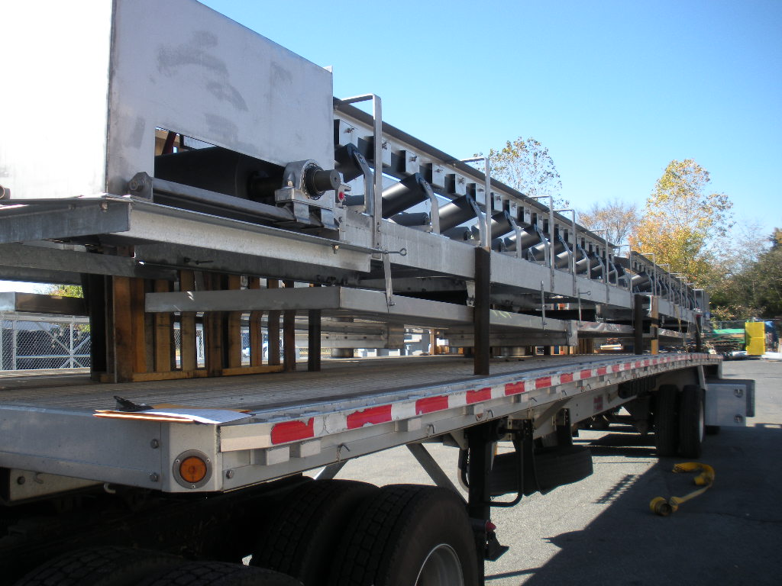
Figure 1. Fully Assembled Bio-BELT Prepared for Shipment

In instances where a Bio-BELT is longer than that which is allowed by shipping constraints or if required for other reasons, the Bio-BELT is shipped in sections. Each section of Bio-BELT is fully assembled and clearly labeled to assist in site assembly. Temporary shipping legs are added as required to securely load and safely ship all Bio-BELT sections.

General Handling and Storage Information
Upon completion of the initial inspection, the equipment should be moved from the delivery truck to temporary storage (see the Storage section within this O&M manual) or immediately installed (see the Installation Instructions section within this O&M manual). When maneuvering the equipment, go slowly and use extreme caution. Watch for accidental damage caused during handling and document any issues. It is the responsibility of the handler and installer to ensure that appropriate measures are taken to prevent damage to the equipment during handling and installation.

Provided in the following sections are instructions for handling and storing the equipment. These instructions are intended to cover the basics but will not cover every conceivable situation. Use good judgment when handling and working with the equipment.

Lifting lugs or spreader bars with slings are the recommended support method for lifting all equipment. When utilized, the unsupported span of spreader bars should be no longer than 12 feet. Do not attempt to lift any equipment from only one support point. When support locations or lifting lugs are not specified on the drawings, support locations must be carefully selected with consideration to the overall equipment weight distribution (i.e. consider the positioning of unusually heavy items such as gearmotors or gates). Support points should be selected such that optimal load balance is achieved to avoid bending or other damage to the equipment.

Please refer and adhere to any additional best practices for belt conveyors as detailed in all applicable CEMA standards, including the most recent edition of the ANSI/CEMA document titled “Belt Conveyors for Bulk Materials”.

Belt Handling and Storage
Belts generally arrive in rolls and should be kept in their original packaging until installation. During short-term storage, belts should be kept in an upright position and not on their sides (the edges of the belt). Belts should be covered with a tarp or dark plastic and stored on a smooth and level floor in an ambient temperature between approximately 40ºF and 90ºF. During long-term storage, rolls should be kept on stands supported by a strong steel bar or similar component through the core of the roll.

Depending on the belt width and roll weight, packaged belt can be moved by rolling it, moving it on skids, or hoisting and placing it according to the following procedures:
- Rolling the belt
  - The belt must be rolled such that rotation is in the same direction that the belt is wound on the core. This is the only correct direction of rotation. Packaged rolls of belt are generally marked on the roll ends with arrows indicating the direction in which they should be rotated to assist with this.
  - Avoid rolling the belt over long distances to prevent damage.
- Moving the belt on skids
  - Avoid moving rolls directly with lift truck forks; instead, place the belt on a skid and use the lift truck forks to move the skid.
- Hoisting the belt
  - Insert a strong steel bar or similar component through the center core of the belt. Hoist the belt by attaching chains or slings to the bar on each side of the roll via a spreader bar. Never lift belt rolls with slings around the circumference of the roll.

Avoiding Cross-Contamination Between Materials
This equipment is partially or wholly constructed from corrosion-resistant stainless steel. The Owner and/or installer must protect the equipment against damage to and/or contamination of the stainless steel’s protective oxide layer by taking all necessary precautions to prevent stainless steel equipment from coming in contact with any carbon steel or carbon steel dust throughout the handling, installation, commissioning, and startup of the system. Failure to protect stainless steel equipment from damage to and/or contamination of its protective oxide layer will void the manufacturer’s material warranty.

As a general practice, keep carbon steel components separate from stainless steel components. Avoid stacking components in a manner such that carbon steel and stainless steel will be in contact. While not an exhaustive list, protect stainless steel equipment from the following forms of carbon steel:

- Truck beds
- Forklifts
- Cables
- Chains
- Tools
- Wire brushes
- Grinding wheels
- Grinding dust
- Nylon lifting straps

If work on any carbon steel components is being performed on site near the storage area for this project, cover stainless steel components with tarps or paper to protect them from coming in contact with carbon dust particles. If work is being performed indoors, fans should be used to keep carbon steel dust from falling onto stainless steel components. If work is being performed outdoors, position the work involving carbon steel such that it is located downwind of the stainless-steel component storage area.

Select tools for installation and maintenance of the stainless-steel equipment that are stainless or non-magnetic. Tools made of aluminum bronze, chrome alloys, or stainless alloys are examples of acceptable tool materials. Ensure the tools selected meet the torque requirements for the equipment as detailed on Table 1 in Section 4.1 - Before Installation and the drawings.

Lifting straps previously used for handling carbon steel should not be used to handle stainless steel equipment components. If there is no method for tracking which material the lifting straps may have handled previously, new lifting straps should be used.

Because a thin layer of chrome oxide naturally forms on the surface of stainless-steel, stainless steel resists corrosion. During welding and machining operations, the chrome oxide layer can be damaged. To rebuild this corrosion-resistant layer, pickling and passivation in accordance with ASTM A380 and A967 are conducted on necessary parts of the equipment before it leaves JMS. However, if the corrosion-resistant layer is further breached by installation and/or handling practices, iron particles may be introduced. The introduction of these particles may lead to the appearance of surface corrosion on the stainless-steel component. In the majority of JMS equipment, the surface corrosion is merely aesthetic in nature and does not have any impact on equipment performance. However, these issues can be mitigated or prevented entirely during installation by following the guidance included in this O&M manual.

Some surface corrosion is practically unavoidable over time for most plants due to the environment in which the equipment will be used. Chemicals such as chlorine can introduce corrosion to stainless steel components without the presence of iron particles, and a damp environment can propagate surface corrosion over time. Most corrosion does not have a performance impact on the equipment over its operational life assuming suitable performance characteristics have been specified. Contact JMS using the contact information provided in this O&M manual if concerns arise about the presence of surface corrosion on JMS equipment.

If surface corrosion is noted on stainless steel and needs to be removed, perform the following steps:
- Clean the affected area thoroughly with a clean rag to remove any moisture on the surface.
- Remove the corrosion from the contaminated area with an abrasive pad that is appropriate for working with stainless steel.
- Treat the abraded area with a local passivation chemical. JMS recommends the use of CitriSurf 2310.

Storage
Please note that the equipment storage instructions provided herein are the JMS standard requirements for all equipment and cover a variety of components comprehensively. Some instructions may not apply to the equipment covered in this O&M manual. Please disregard any instructions that clearly do not apply. In the case where a vendor O&M manual has been attached to this O&M manual and includes more stringent and/or differing equipment storage requirements, please adhere to the vendor O&M manual instructions. Failure to comply with these equipment storage instructions may void any and all warranties for the equipment.

After the equipment has been checked for any transit damage, JMS recommends the following procedures for equipment storage. Storage refers to the period of time following shipment but prior to installation in which the equipment or component must be protected from damage. For the purposes of this O&M manual, the following requirements are intended to apply when equipment is stored for 30 days or longer on site prior to installation. Requirements may vary based on the duration of the equipment storage.

It is preferred that all equipment be warehoused to protect against inclement weather, dust, and/or damage by vehicles. Similarly, all spare parts should be warehoused until ready for use. Storage inside a building is preferred but covering the equipment or component with a canvas tarp is acceptable unless otherwise indicated. Do not cover the equipment or component with a polyethylene sheet, as this will cause and trap condensation. Additional recommendations for indoor and outdoor storage of various components are highlighted below.

Please refer and adhere to any additional best practices for belt conveyors as detailed in all applicable CEMA standards, including the most recent edition of the ANSI/CEMA document titled “Belt Conveyors for Bulk Materials”.

General Requirements for Indoor Storage
The following general requirements are applicable to all equipment or components stored indoors.
- Store the components in a cool, dry area that is not subject to extreme temperature fluctuations. Protect components from heat and flame, as well as from dirt, mud, and flying debris.
- Ensure the area for storage has adequate ventilation.
- Ensure the storage area ground surface is level.
- Provide space heaters for heating and drying.
- Provide adequate support under all equipment to prevent distortion and to raise equipment off of the ground above any undesirable ground or floor conditions. All supports should be placed directly below the equipment’s vertical upright supports (where applicable) to prevent damage to the equipment.
- Ensure tenting and/or tarpaulins (if any) are well supported to provide sufficient ventilation.
- Re-coat parts which may have been scratched or wiped clean of their protective coating in shipment with paint, primer, or grease.
- Shield painted surfaces, including bitumastic coatings, from direct sunlight, which can lead to warping, damage, or chipping.
- Check the equipment periodically for accumulations of moisture and/or surface rusting and remove. If rusting is present, prepare the surface and re-coat with the proper material. Increase ventilation and reduce humidity.
- In equipment containing rotating parts, rotate the equipment one and a half (1.5) rotations every two weeks. Rotation can be performed by bumping the motor (if applicable) or disengaging the motor (if applicable) and rotating by hand.

General Requirements for Outdoor Storage
The following general requirements are applicable to all equipment or components stored outdoors. It is the responsibility of the Contractor to protect JMS equipment from damage to equipment due to outside storage.
- If warehousing is not possible, choose a site that has adequate drainage, ventilation, and size to maintain space for air circulation and access by inspecting personnel.
- Shield the materials from direct sunlight, rain, snow, dust, etc. with tenting if possible or well-supported tarpaulins at a minimum. Ensure good cover is provided at all times. Ensure that the equipment is protected from contact with other machinery, equipment, etc.
- Provide space heaters for heating and drying in cold or wet weather.
- Use blocks to raise all material off the ground a minimum of 6” higher than any expected level of rain, snow, etc. Components should be stored a minimum of 6” off the ground, and no portion of the component should contact the ground while stored. Always support the components directly below their vertical upright supports (where applicable) to prevent damage to the component.
- Provide adequate support of all fabricated steelwork to prevent warping.
- Perform frequent checks to locate rusting surfaces and accumulations of condensation. It is the responsibility of the Contractor to protect JMS equipment from rusting and corrosion due to outside storage, including corrosion occurring after the equipment is delivered to the job site but before final finish painting. If rust is found on painted surfaces, remove the rust, re-prime, and re-paint the surface. If the surface was originally grease-coated, remove the rust and re-coat the surface with waterproof grease.
- Block or prop open any open inspection doors, etc. slightly to increase ventilation in housings.
- In equipment containing rotating parts, rotate the equipment one and a half (1.5) rotations every two weeks. Rotation can be performed by bumping the motor (if applicable) or disengaging the motor (if applicable) and rotating by hand.

Gear Units
In addition to the general requirements, adhere to the following additional requirements for storage of gear units.
- In the event of expected extended storage lasting nine (9) months or longer, contact the equipment manufacturer to inquire about the usefulness of adding an anti-corrosion agent to the lubricant and on flange contact surfaces. The agent will protect internal gearing for an extended period (see subsequent bullets) under good storage conditions. Verify that the unit is prepared for extended storage with the equipment manufacturer.
- The gear units should remain tightly sealed until startup.
- Store gear units according to the mounting position.
- If the gear unit is packed in containers and shipped with desiccant and a moisture indicator sealed in the plastic wrap, regularly inspect the packaging and humidity indicator. Relative humidity should be less than 50% at all times. The gear unit should be stored under a roof and protected against rain and snow. The unit can be stored for up to 3 years if all conditions described herein are maintained.
- If the gear unit is received open (no packaging), perform regular inspections. Check for cleanness and mechanical damage and inspect the corrosion protection. The gear unit should be stored under a roof and enclosed at a constant temperature and atmospheric humidity (between 41 and 122 degrees F; less than 50% relative humidity). Ensure there are no sudden temperature variations, aggressive vapors, or shocks, and control ventilation with a filter free from dust and dirt. The unit can be stored for 2 years or more if all conditions described herein are maintained.

Electric Motors and Actuators
- In addition to the general requirements, adhere to the following additional requirements for storage of electric motors and actuators.
- Do not remove electrical compartment covers unless specifically instructed in the vendor O&M manual.
- Block open control panel covers or doors so air can circulate.
- Open all cartons and remove all sealing films unless the carton specifically states otherwise. Remove moisture-absorbing materials if found in the cartons. Remove any plastic shock-absorbing particles surrounding the cartons and/or films.
- Store small apparatuses in the original containers (if received dry).
- If not mounted, store motors in the original containers in a clean, dry, and protected warehouse.
- Ensure the storage area is free from vibration and extreme fluctuations in temperature.
- Ensure motors/gearmotors are properly lubricated.
- Ensure all drains remain fully operable while in storage, and/or remove the drain plugs. The motors must be stored so that the drain is at the lowest point. All breathers and automatic “T” drains must be operable to allow breathing at locations other than through the bearing fits. Motors should be stored in their proper mounting position.
- Where motors are not in the original containers but are instead mounted on other pieces of machinery, the mounting must be such that the drains and breathers are fully operable. The drains must be kept at the lowest point on the motor and/or the drain plugs removed so that all condensation can drain freely.
- Apply corrosion resistant coating to external motor parts when the motor is stored in a corrosive environment.
- Coat all machined parts with Cosmoline (or similar preservative material) if not already coated.
- Connect all units equipped with heaters (if storage conditions in any way simulate or approach operational conditions).
- Keep the motors warm. If the motors are equipped with space heaters, energize them at all times. If space heaters were not supplied, auxiliary heat must be used to keep the motor windings warm and free of condensation.
- If the motor or actuator is installed but not cabled, it is recommended that any plastic transit cable entry plugs are replaced with metal plugs (which are sealed with PTFE tape).
- Check windings for resistance with a megohm meter at the time equipment is put in storage. At termination of storage, repeat this resistance check prior to applying power. The minimum reading should be 1 megohm for motors rated 600 volts or less. Any drop below this point indicates the need for electrical or mechanical drying. When storing a large quantity of motors, perform an inspection of a sample size of the motors by removing the end brackets and visually inspecting for the presence of water in the grease or surface corrosion on the bearing. If water or surface corrosion is present, replace the bearings and re-lubricate.
- Purge grease in the motors at the time of removal from storage, ensuring that an ample supply of fresh grease is in each grease cavity.
- If control panels are provided, adhere to the following additional storage recommendations:
  - If the control panel does not arrive to site wrapped in plastic, wrap the control panel in a covering of heavy-duty plastic or similar material to help prevent the entry of dirt and dust.
  - For control panels not installed and energized immediately, store in a clean, dry place. Maintain a storage temperature between -30 and 65 °C (-22 and 149 °F). If the storage temperature fluctuates or humidity exceeds 60%, use a space heater to help prevent condensation. If possible, store the control panels in a heated building that offers adequate air circulation and protection from dirt and water.
  - Control panels that are designed for indoor applications do not have sufficient packaging for outdoor storage. If these control panels are to be stored outdoors, install temporary electrical heating to help prevent condensation. Add packaging for protection from the outside elements. A space heater that is rated at 200 watts per section is adequate for the average control panel. Remove all loose packaging and flammable materials before you energize space heaters.
  - Keep dry internally all unenergized control panels for outdoor use by installing temporary heating or energizing optional self-contained space heaters.

Installation Instructions

Before Installation
Read the entirety of the provided installation instructions[, including information on stainless steel hardware and the anchor manufacturer’s installation instructions included in Appendix A: Catalog Cuts,] before proceeding with installation. Examine field conditions as early as possible and take field dimensions to confirm that equipment as designed can be installed according to these instructions. Notify JMS immediately if there are undocumented field conditions which are adverse to successful equipment installation. The Contractor must also inspect the latest “APPROVED” or “RELEASED TO FAB” plan and elevation drawings prior to and throughout the installation process.

The following erection and installation procedures are meant to serve as guidelines for installing the JMS equipment and may not address site- or project-specific issues.

If any fit-up problems with equipment are noted during installation, alert JMS immediately using the contact information provided herein. Do not rework any equipment without contacting JMS. Any unauthorized rework will void the warranty on the equipment. JMS reserves the right to have its own personnel or contracted vendors correct field problems. Problems other than minor misfits as defined by AISC 303 should be communicated in writing to JMS using the contact information provided in this O&M manual via the project’s non-conformance reporting procedure.

Throughout the installation procedures described herein, proper industry and plant LOCK OUT/TAG OUT procedures (and confined space entry procedures as necessary) must be followed. These actions protect personnel against electrical and/or mechanical hazards and environments, including asphyxiants.

Please note that all figures depicting the equipment included throughout this O&M manual are for illustrative purposes only and may not reflect the exact conditions or equipment provided for this project. Refer to the drawings for detailed and specific equipment information.

[Note that a chain hoist or similar device capable of supporting the full weight of the gravity take-up assembly, weight box, AND all weights is required during installation or maintenance of the gravity take-up assembly.

Care should be taken to avoid cross-contamination between carbon steel and stainless-steel components when installing, maintaining, or otherwise working with the equipment or components. Please refer to the additional information about carbon steel contamination provided in Section 3.2.2 - Avoiding Cross-Contamination Between Materials.]

[While no special tools are required for working with the Bio-BELT, care should be taken to avoid cross-contamination between carbon steel and stainless-steel components when installing, maintaining, or otherwise working with the equipment or components. Please refer to the additional information about carbon steel contamination provided in Section 3.2.2 - Avoiding Cross-Contamination Between Materials.]

Before beginning equipment installation, schedule JMS field service site visits in advance using the contact information provided in this O&M manual. Refer to the Scope of Supply within this O&M manual for detailed information about what field services are included. Site visits should be scheduled at least four weeks in advance.

Utilize the bolt torque chart provided in Table 1 throughout installation as necessary for general bolt torque values. Do not use impact tools to torque the bolts. Refer to the drawings for unique torque values that may differ from what is provided in Table 1. Please also note that Table 1 does not apply to anchors[; refer to the anchor manufacturer’s installation instructions provided in Appendix A: Catalog Cuts for details on anchorage installation requirements]. For 304 stainless steel hardware, refer to the column labeled “18-8 and 316 Stainless Steel”.

Table 1. Typical Bolt Torque Chart
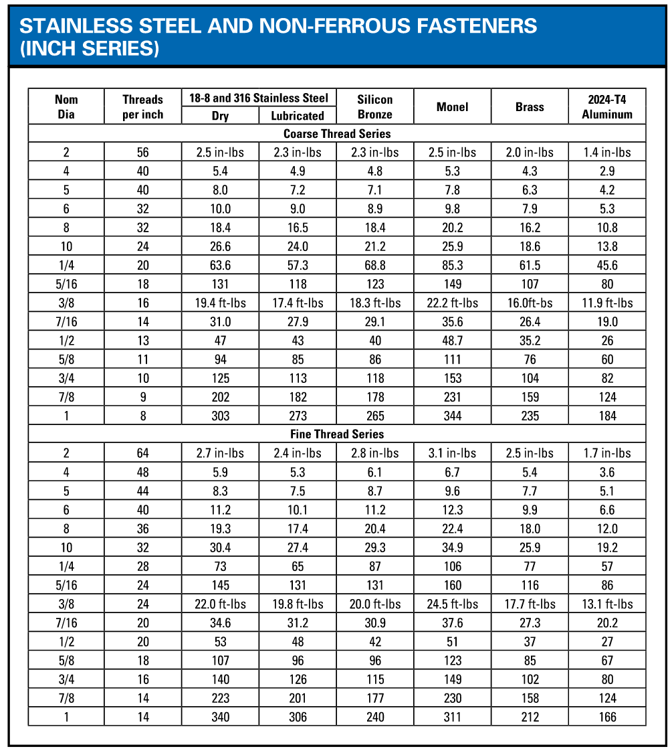
Please refer and adhere to any additional best practices for belt conveyors as detailed in all applicable CEMA standards, including the most recent edition of the ANSI/CEMA document titled “Belt Conveyors for Bulk Materials”.

Detailed Installation Instructions
- Prepare Components for Assembly
  - The Bio-BELT frame has been shipped [fully assembled. Remove the Bio-BELT frame from the shipping trailer using appropriate handling methods and move it to the approximate installation location.][in sections. Remove the Bio-BELT frame sections from the shipping trailer using appropriate handling methods and move them to the approximate installation location. Refer to the drawings for specific frame section placement and position the frame sections in the appropriate order.
    - Note that frame section order is often indicated by designated serial or assembly numbers associated with each of the Bio-BELT frame sections; Bio-BELT frame sections may also have the associated serial or assembly numbers physically printed on the frame sections.]
  - Remove any strapping, wire, or other tethering devices that may have been used during transit from the Bio-BELT components.

- Belt Frame and Support Installation
  - Inspect the proposed mounting surface(s) for the Bio-BELT support connections for levelness. The mounting surface must be level and true to avoid unnecessary bending or distortions in the Bio-BELT. If the mounting surface is not level, make necessary provisions (such as shims or grout) to ensure that the Bio-BELT will be installed level and straight. Periodically check for horizontal (and vertical if Bio-BELT is not inclined) levelness and straightness in the Bio-BELT throughout installation.
  - If precast anchors are used, ensure that the Bio-BELT supports are placed onto the existing anchors as detailed on the drawings and loosely install the Bio-BELT supports using the appropriate hardware. [For instances where Bio-BELT frame sections are already attached to the supports upon arrival at site, ensure that the Bio-BELT frame splice plates are seated correctly and aligned between adjacent frame sections. Do not yet install the hardware between frame sections.]
  - If non-precast floor-mounted anchors are used:
    - Install the anchors and associated hardware as shown on the drawings and as detailed in the anchor manufacturer’s installation instructions included in Appendix A: Catalog Cuts. Ensure that the appropriate cure time is observed.
    - After the cure time has been observed, carefully position the Bio-BELT supports onto the anchors and loosely fasten the Bio-BELT supports onto the anchors via the provided hardware. [For instances where Bio-BELT frame sections are already attached to the supports upon arrival at site, ensure that the Bio-BELT frame splice plates are seated correctly and aligned between adjacent frame sections. Do not yet install the hardware between frame sections.]
  - If non-precast overhead anchors are used:
    - Install the Bio-BELT supports to the overhead mounting surface as detailed on the drawings using the provided hardware. [For instances where Bio-BELT frame sections are already attached to the supports upon arrival at site, ensure that the Bio-BELT frame splice plates are seated correctly and aligned between adjacent frame sections. Do not yet install the hardware between frame sections.]
  - Install any additional support bracing using the provided hardware as detailed on the drawings.
  - [If supports have been provided separately from the Bio-BELT frame, install the completed Bio-BELT frame to the supports using the provided hardware.]
  - [If supports have been provided separately from the Bio-BELT frame, install the Bio-BELT frame to the supports using the provided hardware. Ensure that the Bio-BELT frame splice plates are seated correctly and aligned between adjacent frame sections.
  - Install the Bio-BELT frame sections to one another via the provided splice plate and hardware in the order previously confirmed with the drawings.
    - Note that the splice plate arrives to site pre-installed on one of the frame sections and only needs to be attached to the adjacent frame section via the provided hardware.
    - Utilize piano wire or equivalent to assist with alignment during installation. Follow all best practices for frame section assembly and alignment detailed in the ANSI/CEMA document titled “Belt Conveyors for Bulk Materials”.]
  - Adjust the leveling nuts associated with the anchors until the Bio-BELT is level.
  - Lock the Bio-BELT into place by tightening the top nut associated with each of the anchors.
  - Tighten all hardware according to the directions provided in Section 4.1 - Before Installation if not otherwise specified in the manufacturer’s recommendations included in Appendix A: Catalog Cuts (if any).

- [Gravity Take-Up Installation
  - Prior to beginning installation of the gravity take-up, ensure that a chain hoist or similar device capable of supporting the full weight of the gravity take-up assembly, weight box, AND all weights is available in the vicinity of the gravity take-up and can be utilized until the belt is fully installed in subsequent Step 4.
  - If not completed during previous Step 2, install the gravity take-up assembly support columns and any additional associated bracing as detailed on the drawings using the provided hardware.
    - If the gravity take-up supports are to be installed via anchors, adhere to the requirements included in the anchor manufacturer’s installation instructions within Appendix A: Catalog Cuts. Ensure that the appropriate cure time is observed prior to installing the supports onto the anchors via the associated hardware.
  - Verify that the support columns are plum and in line with one another.
  - Using a means of external support such as a chain hoist or similar device, carefully position the gravity take-up assembly with associated drum pulley on the support columns. Ensure that the rollers are appropriately positioned on the support columns on both sides of the gravity take-up assembly. Continue to support the gravity take-up assembly with the chain hoist or similar device until the belt is fully installed in subsequent Step 4.
  - Using the provided hardware, attach the weight box to the gravity take-up assembly as shown on the drawings. Do not yet install the weight plates.
  - Carefully raise and lower the gravity take-up to ensure that the unit travels smoothly up and down the entire length of travel with no binding.
  - Raise or lower the assembly to the vertical location detailed on the drawings in preparation for belt installation.]

- Belt Installation
  - Ensure that the ambient temperature is above 40ºF prior to removing the belt from its packaging. Temperatures below 40ºF may cause the belt to stiffen or crack during installation.
  - Unpack and install the belt to the Bio-BELT according to the following guidance:
    - [If the plow actuator is actuated, install the belt with the plow in the highest possible position (farthest away from the belt).]
    - [Position the screw take-up in the approximate middle of its adjustability range.]
    - If the belt is to be drawn directly from a roll onto the Bio-BELT, first support the roll squarely with a strong steel bar or similar component through the center core of the roll and place the steel bar or similar component on suitable supports.
    - If the belt is to be led onto the carrying idlers, lead the belt from the roll or crate such that the top cover (generally the thicker side, the side facing out on a roll, and the side of the belt that is branded) faces up and the bottom cover contacts the idlers. Generally, this translates to the belt being led off the top of the roll or crate.
    - If the belt is to be led onto the return idlers, lead the belt from the roll or crate such that the top cover (generally the thicker side, the side facing out on a roll, and the side of the belt that is branded) is in contact with the return idlers. Generally, this translates to the belt being led off the bottom of a roll.
    - Ensure that the belt is kept taut while installing.
    - Pull the belt onto the Bio-BELT frame by using a rope or cable attached to a clamp at the end of the belt. Do not cut a hole through the belt or “ears” into its corners to facilitate the rope or cable attachment. A clamp should be utilized that distributes the pull applied to the belt across its full width. The clamp should be secured with bolts approximately two (2) inches from the end of the belt at six-inch (6”) intervals. A rope or cable is then attached to the clamp with a shackle or by welding an eye to one side of the clamp. The rope or cable should be threaded over the conveyor and attached to a towing device to pull the belt onto the conveyor.
    - Once the belt is installed onto the idlers, pull the belt snugly against all idlers and drum pulleys.
  - [Vulcanize the belt ends to complete belt installation. It is strongly recommended that a trained and qualified professional vulcanizer is used to perform this work.]
  - [Field splice and lace the belt according to the procedures included in the manufacturer’s installation information (provided in Appendix A: Catalog Cuts). General practices for selecting and preparing a location for splicing are included below:
    - The belt should be spliced along the top run of the belt at or as close to possible to ground level. If there is a horizontal portion of Bio-BELT, the splice should be made along the horizontal portion.
    - Before splicing the belt, remove excess slack between return idlers along the length of the Bio-BELT. [Typically, the belt should sag between return idlers by approximately 2% of the center-to-center dimension of the return idlers.
      - To accomplish this, belt clamps may be utilized. The clamp on one end of the belt should be secured to the Bio-BELT frame. The clamp on the other end of the belt should be incrementally pulled with chain blocks or other similar tools attached to each side of the clamp and the Bio-BELT frame. Continue incrementally tensioning until the excess slack is removed and the screw take-up has moved to its recommended position.]]
  - [Refer to the estimated required counterweight on the drawings and install the provided weight plates one at a time into the weight box until the estimated weight is achieved. Ensure that the weight plates are secured as detailed on the drawings. Note that extra weight plates are generally provided, so not all weight plates may be used at this time.
  - Carefully and slowly lower the gravity take-up assembly until the assembly is fully supported by the belt. The chain hoist or similar support device can be removed at this time. Note that some adjustment in weight may be required at this time and as the belt stretches to achieve appropriate belt tensioning.]

- Ancillary Component Installation
- Install the emergency stop (E-Stop) switch and associated cabling.
    - Install the E-Stop switch at the mounting location shown on the drawings. A bracket has been mounted to the Bio-BELT for this purpose.
    - Route the E-Stop cabling through the pre-installed eye bolts on the Bio-BELT.
    - Refer to the manufacturer installation instructions for the E-Stop provided in Appendix A: Catalog Cuts for additional information, including wiring information.
- Install the zero-speed switch.
    - Install the zero-speed switch and pulser disc at the mounting location on the tail shaft shown on the drawings.
    - Refer to the manufacturer installation instructions for the zero-speed switch provided in Appendix A: Catalog Cuts for additional information, including wiring and calibration information.
- [Mount the Bio-BELT alignment switch(es) at the location(s) detailed on the drawings. Install and wire the alignment switch according to the manufacturer’s directions included in Appendix A: Catalog Cuts.]
- Complete all wiring and electrical connections.

- Final Inspection and Adjustment
  - Grout the area between the floor and Bio-BELT supports as detailed on the drawings. Note that grout is not provided by JMS.
  - The gear reducer has been shipped full of oil; however, it is important to verify that the oil is at an appropriate level before starting the gearmotor. Refer to Section 6.3 - Lubrication for details on checking the oil level.
  - [Remove the breather valve’s protective band on the gear reducer if present. Refer to Figure 2 for an example of a protective band on a breather valve (protective band in black). Note that the figure is representative only and may not directly reflect the orientation of the motor or breather valve provided for this project. If the protective band has already been removed, no action is needed.

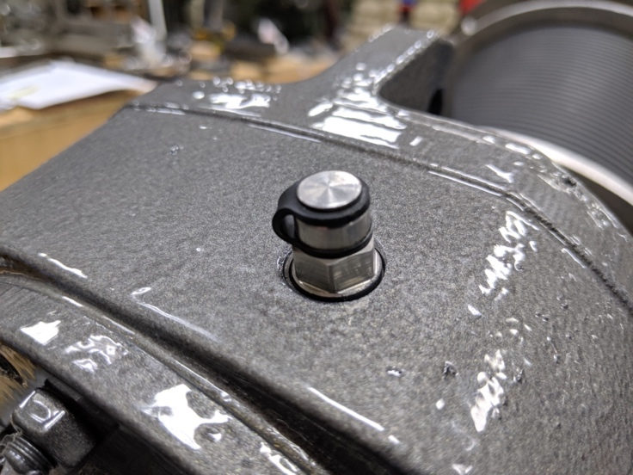
Figure 2. Breather Valve with Protective Band (in Black)]
  - [Set the limit switches on the plow actuators according to the manufacturer’s instructions included in Appendix A: Catalog Cuts.]
  - [Drive assembly v-belt tensioning
    - Remove the belt guard from the drive assembly.
    - Tension the v-belt according to the procedures detailed in the manufacturer’s installation and tensioning information (refer to Appendix A: Catalog Cuts).
    - Replace the belt guard on the drive assembly.]

Operating Procedures

General Equipment Operation
JMS belt conveyor assemblies, otherwise known as “Bio-BELTs”, are used widely in water and wastewater applications to efficiently transport bulk materials—such as dewatered biosolids, sludge, screenings, and grit—from one plant process to the next. JMS Bio-BELTs are specially designed for each application to handle the unique characteristics of the material being conveyed, which is critical for the effective transport of material through the process. JMS can design and manufacture custom Bio-BELT configurations or full systems to convey, store, load and unload material. A wide range of customizable components, including gearmotor configuration, belt style, conveyor inclination, and optional add-on components are available, ensuring that the Bio-BELT satisfies the requirements of each specific application.

Bio-BELTs are driven by electric gearmotors located at the head of the conveyor. [The gearmotor is coupled directly to the drive pulley of the Bio-BELT to facilitate belt rotation.][The gearmotor is connected to the drive pulley shaft via a V-belt to facilitate belt rotation.] The drive pulley features lagging to reduce belt slippage. Pulley shafts include one expansion bearing and one fixed bearing on each side of the shaft to prevent bearing side loading (which leads to reduced operational life). Stand clear of all belt idlers and drum pulleys during operation.

Skirting is utilized along the sides of the Bio-BELT frame to assist in the containment of material onto the Bio-BELT during conveyance. Deck plates are also supplied to prevent spillage onto the returning underside of the Bio-BELT.

[A wash box is supplied at the head of the Bio-BELT to remove any residual material that may adhere to the Bio-BELT.]

[Belt tensioning is maintained automatically using weights in the gravity take-up assembly. Over time, slight adjustments to the amount of weight may be required to achieve proper tensioning as the belt stretches. This is detailed in Section 6.1 - Preventative Maintenance.][Belt tension may be adjusted via the screw take-ups on the tail end of the Bio-BELT. Do not attempt to adjust belt tracking by skewing the screw take-ups or moving the drum pulleys. To adjust belt tracking, skew the idlers as prescribed in Section 6.2.2 - Belt Tracking.]

Please refer and adhere to any additional best practices for belt conveyors as detailed in all applicable CEMA standards, including the most recent edition of the ANSI/CEMA document titled “Belt Conveyors for Bulk Materials”.

Initial Startup
To start the equipment for the first time or after an extended shutdown, perform the following steps. Note that an operator must be standing by the Bio-BELT and associated control systems to stop the system in case of emergency.

To avoid placing excess stress on the belt and/or experiencing material spillage, the Bio-BELT must already be operating at the full intended speed prior to receiving product. Do not convey product onto the Bio-BELT before starting the Bio-BELT.

- Visually inspect the Bio-BELT and any associated equipment for damage. Notify JMS using the contact information provided herein if damage is observed.
- Verify that all preventative maintenance and lubrication procedures have been completed as directed in Section 6 - Maintenance, Lubrication, & Troubleshooting.
- Verify that there are no obstructions to the Bio-BELT (including any tools and/or debris) and that all personnel are clear of the machinery before starting the equipment. This includes visually confirming that there are no components contacting the belt that could rub, tear, or cut the belt upon startup.
- Verify that the E-Stop switch flag arm is in the non-tripped position (i.e. NOT upright).
- [Verify that the alignment switch is in the non-tripped position (i.e. upright).]
- Verify that the Bio-BELT discharge is clear.
- [Verify that the plow is in the desired position for startup.]
- [Adjust belt tensioning as needed according to the information provided in Section 6.2.1 - [Belt Tensioning.]
- Briefly energize the motor to check for proper direction of belt rotation. Correct motor connections if the belt is running in the opposite and incorrect direction.
- Start the Bio-BELT. Allow the Bio-BELT to run for approximately five minutes or at least three (3) full belt revolutions. During this time, inspect for the following:
  - Listen for any unusual noises.
  - Stop the Bio-BELT by pulling the emergency stop cable. This will verify that the E-Stop switch is wired correctly.
  - [Stop the Bio-BELT by pushing the alignment switch. This will verify that the alignment switch is wired correctly.]
  - Verify that the setpoints of the belt speed controller are +/- 10% of the target or design RPM of the Bio-BELT. The design RPM is provided for reference on the drawings and/or in the calculations within this O&M manual.
  - Observe the Bio-BELT at the head frame, take-up assembly, tail frame, and along the carrying and return idlers for proper and smooth operation.
  - Observe belt tracking. If belt tracking correction is required, adjust the idlers according to the guidelines provided in Section 6.2.2 - Belt Tracking.
- If a Bio-BELT with reversing capabilities is utilized, disengage the scraper on the non-discharge end of the belt and then run the Bio-BELT in reverse to check for proper operation.
- [Operate the plow and assess for proper function.]
- If the Bio-BELT will not be substantially operated for a month or longer after installation and initial startup, perform the following procedures during the interval of inactivity:
  - Adhere to all procedures outlined in Section 3.3 - Storage, including checking motors for resistance prior to applying power.
  - Inspect the Bio-BELT monthly, checking the components listed within Section 6.1 - Preventative Maintenance. This includes observing the lubricant levels and correcting as needed.
  - After ensuring that the startup requirements included in Section 5.3 - Startup are observed, operate the Bio-BELT for a minimum of fifteen (15) minutes each month. This ensures that lubrication is distributed properly to all components.

Startup
During startup, an operator must be standing by the Bio-BELT and associated control system to stop the Bio-BELT in case of an emergency. To start the Bio-BELT, perform the following procedures.

To avoid placing excess stress on the belt and/or experiencing material spillage, the Bio-BELT must already be operating at the full intended speed prior to receiving product. Do not convey product onto the Bio-BELT before starting the Bio-BELT.

- Visually inspect the Bio-BELT and any associated equipment for damage. Notify JMS using the contact information provided herein if damage is observed.
- [Visually inspect the belt tension and adjust if required according to Section 6.2.1 - [Belt Tensioning.]
- Verify that all preventative maintenance and lubrication procedures have been completed as directed in Section 6 - Maintenance, Lubrication, & Troubleshooting.
- Verify that there are no obstructions to the Bio-BELT (including any tools and/or debris) and that all personnel are clear of the machinery before starting the equipment.
- Verify that the E-Stop switch flag arm is in the non-tripped position (i.e. NOT upright).
- [Verify that the alignment switch is in the non-tripped position (i.e. upright).]
- Verify that the Bio-BELT discharge is clear.
- [Verify that the plow is in the desired position for startup.]
- If a Bio-BELT with reversing capabilities is utilized and the Bio-BELT is intended to be run in reverse, disengage the scraper on the non-discharge end of the belt.
- Prior to starting any upstream feed equipment, start the Bio-BELT slowly and gradually ramp up to the desired speed. Note that the Bio-BELT controls may be programmed to do this automatically; refer to Appendix E: Controls for more information if controls have been provided by JMS.
- Once the Bio-BELT has reached the intended operating speed, gradually begin to feed material onto the Bio-BELT by starting upstream feed equipment.
  - The feed should be started at a low rate and gradually increased until the specified design capacity is reached.
  - Do not overload the Bio-BELT or otherwise exceed the equipment speed, capacity, volume, material density, or rate of flow for which the Bio-BELT and gearmotor were designed.
- [Operate the plow as required to direct material to the appropriate discharge location.]

Shutdown
When it becomes necessary to shut down the equipment, perform the following procedures. Please note that the following procedures are intended to be for normal shutdown only.

During an emergency shutdown due to an alarm condition, proceed to the instructions included in Section 5.5 - Shutdown (Alarm Condition) .

- Shut down all upstream feed equipment according to the appropriate standard operating procedures.
- Continue to run the Bio-BELT until all material has been substantially discharged from the Bio-BELT.
  - In the event that system controls will not permit this operation with the control switch in the “AUTO” position, the control switch may be placed in the “MANUAL” position to allow for manual adjustment. Refer to Appendix E: Controls if controls have been provided by JMS.
- [Verify that the plow is in the desired position for shutdown.]
- Stop the gearmotor for the Bio-BELT.
  - On systems with interconnected equipment, note that the shutdown of the Bio-BELT may also require shutting down other equipment to prevent damage to the associated equipment or spillage of conveyed material.
- Remove any loose debris from the belt and clean the Bio-BELT to the extent possible as needed based on plant-specific layout and characteristics. Water, a broom or similar tool, and/or a high-pressure hose are all possible cleaning aids; use of all tools may not be practical at each installation location.
- Inspect the Bio-BELT idlers for instances of material or contaminant buildup. Clean contaminants from the idlers via hose and/or manual removal as required.
- In the event of an anticipated extended shutdown (longer than 30 days), LOTO all power to the Bio-BELT as a best practice.

Shutdown (Alarm Condition)
The Bio-BELT (and other equipment if interlocked via the control system; refer to Appendix E: Controls if controls have been provided by JMS) may be stopped at any time by activating the E-Stop safety device associated with the conveyor. If the E-Stop safety device was the source of the emergency shutdown, perform the following actions:
- Shut down all upstream feed equipment and any other interconnected equipment according to the appropriate standard operating procedures.
- Stop the motor for the Bio-BELT by turning the control switch to the “OFF” position.
- LOTO all power to the Bio-BELT.
- Identify and rectify the cause of the E-Stop alarm by visually checking the equipment. This may involve the removal of material on the conveyor.
- Visually inspect the Bio-BELT for damage and address as necessary according to the details provided in Section 6 - Maintenance, Lubrication, & Troubleshooting.
- Reset the E-Stop switch flag arm to the non-tripped position (i.e. NOT upright).
- At the control panel, select the “ALARM RESET” button.
- To restart the equipment, turn the control switch to the “ON” position (or “AUTO” position as appropriate). Return to the normal shutdown procedures included in Section 5.4 - Shutdown when appropriate.

The Bio-BELT has been supplied with a zero-speed switch that shuts down power to the associated motor if motion is lost (and other equipment if interlocked via the control system; refer to Appendix E: Controls if controls have been provided by JMS). If the zero-speed switch was the source of the emergency shutdown, perform the following actions:
- Shut down all upstream feed equipment and any other interconnected equipment according to the appropriate standard operating procedures.
- Stop the motor for the Bio-BELT by turning the control switch to the “OFF” position.
- LOTO all power to the Bio-BELT.
- Identify and rectify the cause of the zero-speed switch alarm by visually checking the equipment. This may involve the removal of material on the conveyor.
- Visually inspect the Bio-BELT for damage and address as necessary according to the details provided in Section 6 - Maintenance, Lubrication, & Troubleshooting.
- At the control panel, select the “ALARM RESET” button.
- To restart the equipment, turn the control switch to the “ON” position (or “AUTO” position as appropriate). Return to the normal shutdown procedures included in Section 5.4 - Shutdown when appropriate.

[The Bio-BELT has been supplied with an alignment switch that shuts down power to the associated motor (and other equipment if interlocked via the control system; refer to Appendix E: Controls if controls have been provided by JMS) if the belt begins to track improperly in the direction of the alignment switch. If the alignment switch was the source of the emergency shutdown, perform the following actions:
- Shut down all upstream feed equipment and any other interconnected equipment according to the appropriate standard operating procedures.
- Stop the motor for the Bio-BELT by turning the control switch to the “OFF” position.
- LOTO all power to the Bio-BELT.
- Realign the belt according to the belt tracking procedures provided in Section 6.2.2 - Belt Tracking. This requires removal of any material on the conveyor.
- Visually inspect the Bio-BELT for damage and address as necessary according to the details provided in Section 6 - Maintenance, Lubrication, & Troubleshooting.
- Reset the alignment switch to the non-tripped position (i.e. upright).
- At the control panel, select the “ALARM RESET” button.
- To restart the equipment, turn the control switch to the “ON” position (or “AUTO” position as appropriate). Return to the normal shutdown procedures included in Section 5.4 - Shutdown when appropriate.]

Maintenance, Lubrication, & Troubleshooting
[Note that a chain hoist or similar device capable of supporting the full weight of the gravity take-up assembly, weight box, AND all weights is required during installation or maintenance of the gravity take-up assembly.

Care should be taken to avoid cross-contamination between carbon steel and stainless-steel components when installing, maintaining, or otherwise working with the equipment or components. Please refer to the additional information about carbon steel contamination provided in Section 3.2.2 - Avoiding Cross-Contamination Between Materials.]

[While no special tools are required for working with the Bio-BELT, care should be taken to avoid cross-contamination between carbon steel and stainless-steel components when installing, maintaining, or otherwise working with the equipment or components. Please refer to the additional information about carbon steel contamination provided in Section 3.2.2 - Avoiding Cross-Contamination Between Materials.]

Please note that not all individual components comprising the Bio-BELT are crafted by JMS (as detailed on the Bill of Materials on the drawings). Although JMS has carefully developed this comprehensive O&M manual to summarize the recommended procedures for effectively maintaining the Bio-BELT and its components as a whole, any and all maintenance, lubrication, and/or troubleshooting procedures from individual component manufacturers for their specific component should supplement or take precedence over the requirements listed herein. Manufacturer reference information, including that which is supplied in Appendix A: Catalog Cuts, should always be referenced during maintenance, lubrication, and troubleshooting procedures where available. If questions arise over the proper maintenance, lubrication, and/or troubleshooting procedures, please contact JMS using the contact information provided in this O&M manual.

Please refer and adhere to any additional best practices for belt conveyors as detailed in all applicable CEMA standards, including the most recent edition of the ANSI/CEMA document titled “Belt Conveyors for Bulk Materials”.

Preventative Maintenance
Before any maintenance or inspection is performed, refer to ANSI/ASSP Z244.1-2016 for minimum safety requirements concerning energy sources.

Practice good housekeeping. Keep the area around the equipment clean and free of obstacles to provide easy access. Establish routine periodic inspections of the equipment to ensure continuous maximum operating performance.

[Note that a chain hoist or similar device capable of supporting the full weight of the gravity take-up assembly, weight box, AND all weights is required during installation or maintenance of the gravity take-up assembly. All other maintenance and troubleshooting can be performed with a basic maintenance tool kit.]

[A basic maintenance tool kit is all that is required to maintain this equipment. No special tools are necessary.]

While some component inspection requires observing the Bio-BELT during operation, do not attempt to service the Bio-BELT while in operation.

Table 2. Bio-BELT Preventative Maintenance
Component | Recommended Maintenance | Frequency
General | Inspect the entire Bio-BELT for any loose bolts or screws and tighten as required. Refer to the guidance provided in Section 4.1 - Before Installation. | Daily
Scraper(s) [and Plow(s) if applicable] | Inspect for material buildup or misalignment. Clean or adjust as required. | Daily
Scraper(s) [and Plow(s) if applicable] | Inspect for signs of wear. Replace wear components as needed. | Weekly
Belt | Inspect for proper tracking. Adjust as required using the procedures outlined in Section 6.2.2 - Belt Tracking. | Daily
Belt | Inspect for any spillage onto the return belt and clean as required. | Daily
Belt | Inspect for wear and damage. Replace as required. | Annually
Belt | [Inspect for proper belt tension (i.e. the belt should sag by approximately 2% between consecutive return idlers). Adjust as required according to the details provided in Section 6.2.1 - [Belt Tensioning. | Weekly]
Belt | Check splice for signs of wear. | Weekly
Belt | Refer to any additional preventative maintenance requirements included in the belt manufacturer’s information provided in Appendix A: Catalog Cuts. | Weekly
Belt | [Inspect for proper belt tensioning and increase or decrease the counterweight by adding or removing weight plates as required. | Weekly]
Drum Pulleys | Inspect the bearings on either side of all pulleys for operation and alignment. | Daily
Drum Pulleys | Lubricate the bearings on either side of all pulleys. Refer to Section 6.3 - Lubrication for additional details. | Refer to Section 6.3 - Lubrication.
Drum Pulleys | Inspect for material buildup and clean as required. | Daily
Drum Pulleys | Inspect for any signs of wear, damage, or misalignment. | Daily
Idlers | Inspect for material buildup and clean as required. Running the Bio-BELT while the idlers have excessive material buildup can cause significant belt tracking issues and/or damage to idlers. | Daily
Idlers | Verify that all idlers are rotating freely. | Daily
Idlers | Inspect idlers for any indications of wear. | Daily
Idlers | [Lubricate the idlers in accordance with the details provided in Section 6.3 - Lubrication. | Refer to the interval listed in Section 6.3 - Lubrication.]
[Motor | Relubricate the motor bearings according to the details provided in Section 6.3 - Lubrication. | Refer to the interval provided in Section 6.3 - Lubrication.]
[SEW Eurodrive Gear Reducer | Check the oil level. Refer to Section 6.3 - Lubrication for additional details. | Every 3,000 operating hours or every 6 months, whichever is sooner
[SEW Eurodrive Gear Reducer | Drain and refill oil according to the information provided in Section 6.3 - Lubrication. | Every 8,000 operating hours or every 3 years, whichever is sooner]
[Dodge Gear Reducer | Refer to the maintenance and lubrication requirements provided in the manufacturer’s literature included in Appendix A: Catalog Cuts. | Refer to the maintenance and lubrication requirements provided in the manufacturer’s literature included in Appendix A: Catalog Cuts.]
[Drive Assembly V-Belt | Refer to the maintenance and tensioning requirements provided in the manufacturer’s literature included in Appendix A: Catalog Cuts. | Refer to the maintenance and tensioning requirements provided in the manufacturer’s literature included in Appendix A: Catalog Cuts.]
Skirting | Inspect for wear or damage. Replace as required. | Weekly
[Plow Actuators | Test actuator limit switches according to the instructions provided in the manufacturer’s information included in Appendix A: Catalog Cuts. Adjust limit switches as needed, again referencing the actuator information included in Appendix A: Catalog Cuts. | Annually or as needed if plow is not functioning satisfactorily.
[Plow Actuators | Refer to the manufacturer’s maintenance information provided in Appendix A: Catalog Cuts for preventative maintenance procedures related to the actuator. | Refer to the maintenance intervals provided in the actuator manufacturer’s information included in Appendix A: Catalog Cuts.]
Drip Pan | Remove foreign material. If needed adjust scraper(s) [and plow(s) if provided] to facilitate removal of more material or prevent wear to the belt and scraper(s) [and plow(s) if provided]. | Monthly
[Gravity Take-Up Assembly  (Note that this is in addition to the preventative maintenance listed under “Drum Pulleys”) | Verify that the gravity take-up assembly is aligned and level and that the take-up is operating freely along the entire travel length. | Weekly]

Corrective Maintenance

[Belt Tensioning
If belt tensioning adjustments are warranted, correct the tensioning as needed via the screw take-up according to the following procedures.
- Typically, the belt should sag between return idlers by approximately 2% of the center-to-center dimension of the return idlers.
- Both sides of the screw take-up should be adjusted equally such that the screw take-up is uniform distance from the end of the conveyor frame (i.e. not skewed in one direction).
- In general, do not apply more tension than is necessary to drive the belt without slippage of the drum pulley.]

Belt Tracking
If belt tracking correction is required, adjust the idlers according to the guidelines provided below.
- Skew the idlers in the direction that the belt needs to move (similar to steering a bicycle). Do not attempt to move the drum pulleys.
- Adjust idler skewing slowly. Make incremental adjustments progressively to multiple idlers along the length of the Bio-BELT as opposed to large adjustments in one or two sets of idlers. No idler should be shifted more than ¼” in any direction from its squared position.
- To skew the idlers, loosen the mounting bolts and use a hammer to softly tap the idler frame ends until it is in the desired position. Retighten the idler mounting bolts.
- If overcorrecting occurs, reverse the process performed previously (remove some of the skew from idlers previously adjusted) instead of skewing additional idlers.

Lubrication
[Please refer to Figure 3 through Figure 5 for details about gear reducer mounting position and locations of components relating to its lubrication system. Please note that while the diagram shown in Figure 3 is sourced from the SEW Eurodrive O&M manual and is representative of the gear reducer provided for the project, the pictures provided in Figure 4 and Figure 5 are meant to serve as examples only and may not reflect the exact gear reducer or hardware orientation provided for this project.

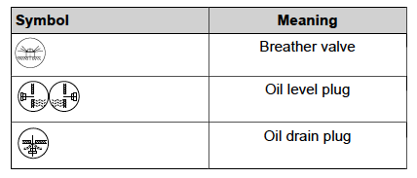
[INSERT PIC OF MOUNTING POSITION FROM SEW MANUAL]
Figure 3. SEW Eurodrive Gear Reducer Mounting Position “XX” and Location of Lubrication Components
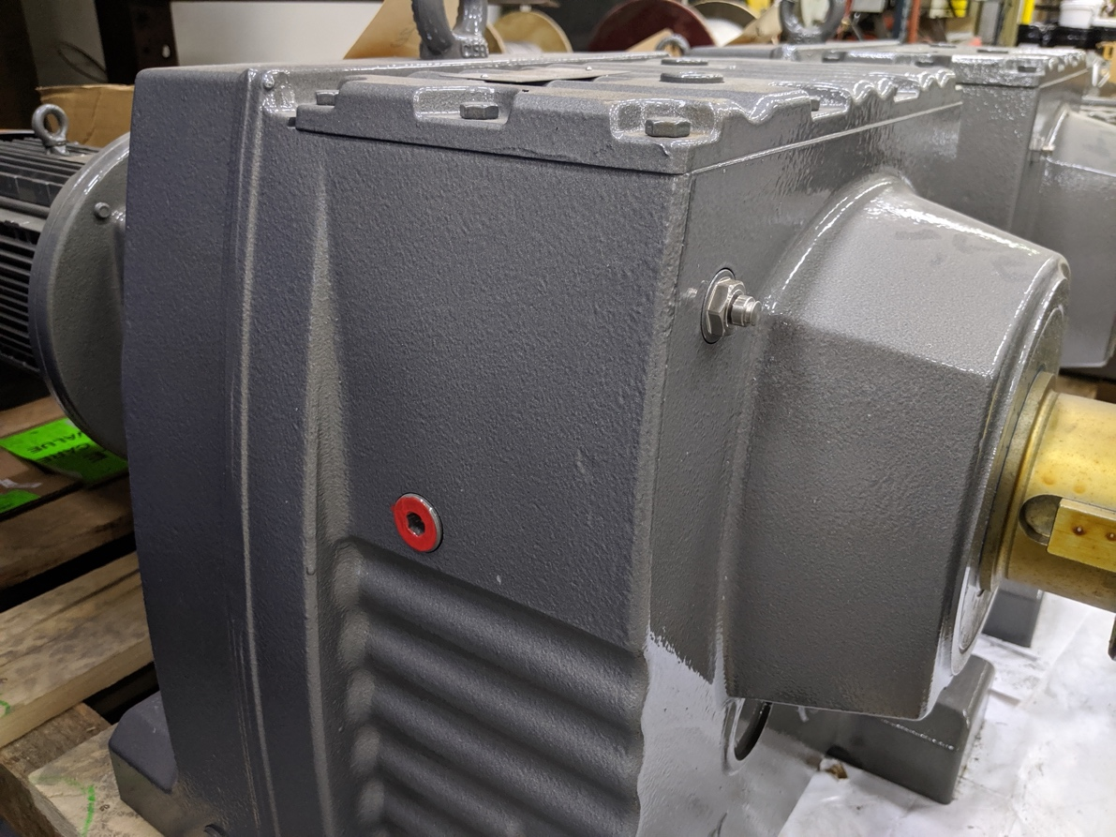
OIL LEVEL PLUG
BREATHER VALVE (PROTECTIVE BAND REMOVED)
Figure 4. Oil Level Plug (Painted Red) and Breather Valve (Protective Band Removed) (FOR REFERENCE ONLY)

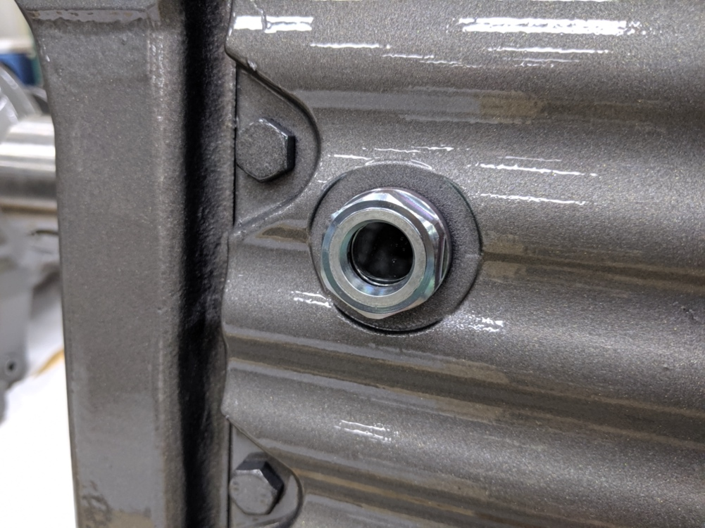
Figure 5. Example Sight Glass in Lieu of Oil Level Plug (If Applicable) (FOR REFERENCE ONLY)]

A lubrication schedule for various Bio-BELT components is included in Table 3. Unless otherwise noted, only check or change the oil when the gearmotor is not in operation and has had sufficient time to cool down to maintain safety and ensure proper measurement. While checking the oil, ensure that a container is placed beneath the oil level plug to capture small amounts of oil that may leak out. When changing the oil, ensure that oil is contained and disposed of in a proper manner.

Table 3. Bio-BELT Component Lubrication Requirements
Component | Activity | Interval | Quantity | Recommended Grease
[Motor | Drain oil and refill according to the manufacturer’s procedure included within Appendix A: Catalog Cuts. | Refer to the interval (if any) provided in the manufacturer’s information within Appendix A: Catalog Cuts | Refer to the quantity (if any) provided in the manufacturer’s information within Appendix A: Catalog Cuts. | Refer to the recommended grease type (if any) provided in the manufacturer’s information within Appendix A: Catalog Cuts.]
[SEW Eurodrive Gear Reducer | Check oil level | Every 3,000 operating hours or every 6 months, whichever is sooner | Refill to an acceptable level according to Figure 6. | See requirements for oil change below.
[SEW Eurodrive Gear Reducer | Drain oil and refill to oil level plug or sight glass. Refer to previous Figure 4 and Figure 5. | Every 8,000 operating hours or every 3 years, whichever is sooner | X | Recommended oil is listed on the SEW Eurodrive gear unit nameplate; if a specific brand is not listed, utilize the SEW Eurodrive brand oil for the listed oil type.]
[Dodge Gear Reducer | Change the oil. | Refer to the interval provided in the manufacturer’s information included in Appendix A: Catalog Cuts. | Refer to the quantity provided in the manufacturer’s information included in Appendix A: Catalog Cuts. | Refer to the recommended grease provided in the manufacturer’s information included in Appendix A: Catalog Cuts.]
Drum Pulley Bearings (both sides of all drum pulleys[, including gravity take-up pulleys]) | Lubricate the bearings. | Refer to the interval provided in the manufacturer’s information within Appendix A: Catalog Cuts | Refer to the quantity provided in the manufacturer’s information within Appendix A: Catalog Cuts. | Refer to the recommended grease type provided in the manufacturer’s information within Appendix A: Catalog Cuts.]
[Idlers | Clean the fitting and use a volume type grease gun (NOT high-pressure equipment) to relubricate all idlers. | Every 4,000-6,000 operating hours (depending on plant and operating conditions) | Pump grease as needed until a clean bead appears around the final opening of each seal. | Lithium EP grease with NLGI #2 consistency]
[Plow Actuator | Refer to the actuator manufacturer’s supplemental information provided in Appendix A: Catalog Cuts for necessary actuator lubrication requirements (if any).]

[When checking the oil at the SEW Eurodrive gear reducer, utilize Figure 6 to determine the proper oil level at the oil level plug. Figure 6 has been adapted from the SEW Eurodrive O&M manual. The oil level plug should be removed to properly check the oil.

If a sight glass has been provided in the place of an oil level plug on the gear reducer, the oil level can be checked visually through the sight glass without removing the sight glass. An example of a sight glass in lieu of an oil level plug is shown in previous Figure 5.

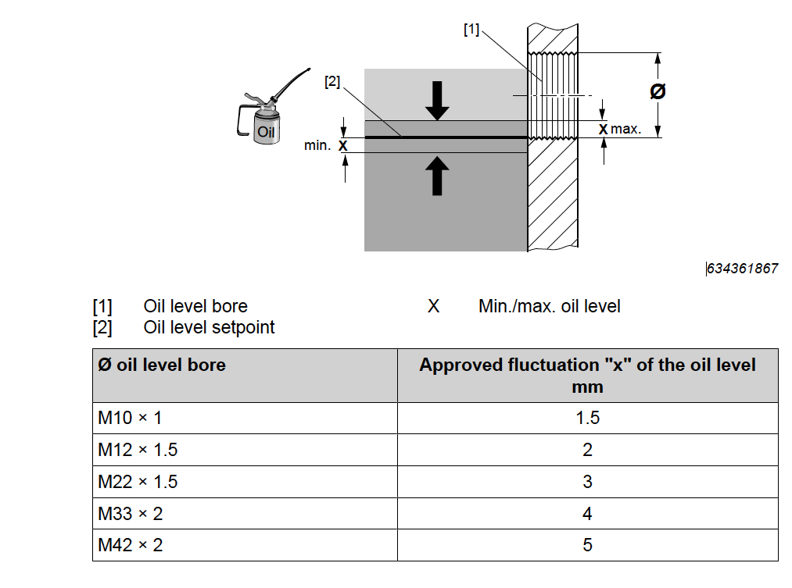
Figure 6. SEW Eurodrive Diagram for Checking Oil Level at the Gear Reducer

If the oil is too low in the SEW Eurodrive gear reducer during a routine oil level check, perform the following steps:
- Remove the breather valve from the breather bore. Refer to previous Figure 2.
- Remove the oil level plug. Refer to previous Figure 3. If a sight glass has been provided, the sight glass does not need to be removed. Refer to previous Figure 4.
- Add oil of the same type via the breather bore up to the lower edge of the oil level bore.
- Replace the breather valve and screw the valve tight to a torque of xxx lb-ft (XXX Nm).
- Replace the oil level plug and tighten to a torque of xxx lb-ft (XXX Nm).]

Troubleshooting
Table 4. Bio-BELT Troubleshooting
Problem | Probable Cause | Solution
The Bio-BELT will not run | Issue with circuit breaker or disconnect switch | Check the circuit breaker or disconnect switch and correct as required.
The Bio-BELT will not run | Motor starter needs to be reset | Check the motor starter reset and correct as required.
The Bio-BELT will not run | E-Stop switch is tripped | Check the E-Stop switch and correct as required. Refer to the instructions provided in Section 5.5 - Shutdown (Alarm Condition) .
The Bio-BELT will not run | Incorrect belt tensioning | Check belt tension and adjust as required. Refer to Section 6.2.1 - [Belt Tensioning for information regarding adjusting belt tensioning.]
The Bio-BELT will not run | Incorrect belt tensioning | [Check belt tension and increase or decrease the counterweight by adding or removing weight plates as required.]
The Bio-BELT will not run | Physical connection between drum pulley and motor has been interrupted | Check the direct drive coupling. Report any issues as necessary.
The belt does not track properly | Material buildup | Check for material buildup on the frame, belt, take-up, and/or drum pulleys and clean as required.
The belt does not track properly | Incorrect belt tensioning | [Check belt tension and adjust as required. Refer to Section 6.2.1 - [Belt Tensioning for information regarding adjusting belt tensioning.]
The belt does not track properly | Incorrect belt tensioning | [Check belt tension and increase or decrease the counterweight by adding or removing weight plates as required.]
The belt does not track properly | Drum pulleys are out of line | Check drum pulley alignment and levelness. The drum pulley should be perpendicular to the Bio-BELT frame; correct alignment as required by adjusting the location of one side of the drum pulley bearings. Correct drum pulley levelness as needed by adjusting the frame slightly or adding shims beneath the bearings.
The belt does not track properly | Idlers are improperly skewed or out of alignment | Check for over-skewed or misaligned idlers and adjust as required. Refer to Section 6.2.2 - Belt Tracking for belt tracking adjustment instructions.
The belt does not track properly | Material is fed onto the belt off-center | Make provisions in upstream feed equipment at the point of transfer such that material will be loaded onto the center of the belt.
The belt does not track properly | Too much material is being fed onto the belt at once | Reduce the material loading at the receiving end of the belt.
The belt does not track properly | Worn drum pulley lagging | Reface the drum pulley or replace the drum pulley in its entirety. Notify JMS using the contact information provided herein to determine the recommended solution and assist in remedying the issue.
The belt does not track properly | [Idlers are “stuck” | Ensure that the idlers have been lubricated as required by Section 6.3 - Lubrication.]
The belt does not track properly | [Issue with belt splicing | Check belt splicing for damage. Make corrections as needed by replacing the wire (if the belt was previously laced) or otherwise repairing the splice.]
The belt does not track properly | [Gravity take-up assembly is misaligned or unlevel | Align and/or level the gravity take-up assembly.]
Bio-BELT trips or overloads the breaker | Incorrect belt tensioning | [Check belt tension and adjust as required. Refer to Section 6.2.1 - [Belt Tensioning for information regarding adjusting belt tensioning.]
Bio-BELT trips or overloads the breaker | Incorrect belt tensioning | [Check belt tension and increase or decrease the counterweight by adding or removing weight plates as required.]
Bio-BELT trips or overloads the breaker | Blockage or obstruction | Inspect the equipment for any obstructions to the belt and clear them as necessary.
Excessive residual material is observed on the belt | Issue with scraper (or plow if applicable) | Inspect the scraper blade and mechanism (or plow if applicable). Replace wear parts or adjust the scraper (or plow) proximity to the belt as needed.
Belt rubs the frame | Idler is not square or level | Inspect all idlers and correct as necessary.
Belt rubs the frame | Drum pulley is not square or level | Inspect the drum pulleys and correct as necessary. The drum pulley should be perpendicular to the Bio-BELT frame; correct alignment as required by adjusting the location of one side of the drum pulley bearings. Correct drum pulley levelness as needed by adjusting the frame slightly or adding shims beneath the bearings.
Belt rubs the frame | [Gravity take-up assembly is misaligned or unlevel | Align and/or level the gravity take-up assembly.]
Other miscellaneous belt issue | Refer to troubleshooting information provided by the belt manufacturer (included in Appendix A: Catalog Cuts). | Refer to troubleshooting information provided by the belt manufacturer (included in Appendix A: Catalog Cuts).
[Wash box not draining | Drain is clogged or blocked with material. | Remove any material that has collected and blocked the drain.]
[Wash box not cleaning the belt/spraying water | Water pressure is insufficient. | Investigate water pressure in the wash box and adjust or mitigate as needed.]
[Wash box not cleaning the belt/spraying water | Wash box water ports are clogged with material | Remove any material that has collected and blocked the water ports.]
[Drive assembly v-belt issue or wear | Refer to the detailed troubleshooting procedures provided in the manufacturer’s information included in Appendix A: Catalog Cuts. | Refer to the detailed troubleshooting procedures provided in the manufacturer’s information included in Appendix A: Catalog Cuts.]

Policies

Warranty
All JMS equipment and/or materials are of high quality and are manufactured in conformity with the best commercial practices. JMS guarantees all equipment and materials manufactured or supplied by JMS to be free from defects in material and workmanship at the time of startup for a period of XXXXX. JMS will furnish without charge but will not install replacements for such parts and materials JMS finds to be defective.

This guarantee does not apply to any equipment which has been improperly handled or stored, improperly lubricated, subjected to misuse or neglect, misapplied with reference to the Engineer's Specifications, altered or tampered with, and/or damaged by corrective work performed without JMS’ specific written consent. No allowances will be made for such corrective work done without such consent.

Deterioration by chemical action, improper maintenance, or normal wear does not constitute defects and are therefore not covered by this warranty. Additionally, consumable items are not covered by this warranty. All warranty claims must be submitted within ten (10) calendar days of discovery of defects or they will be deemed waived. The foregoing is in lieu of all other warranties, whether expressed or implied.

Liability
It is expressly understood that JMS’ liability for JMS products is limited to the furnishing of such replacement parts, and that JMS will not be liable for any other expense, injury, loss, or damage, whether direct or consequential, including but not limited to loss of profits, production, or increased cost of operation arising in connection with the sale or use of, or inability to use, JMS equipment and/or materials for any purpose except as herein provided.

In the event a customer's order form states any liability terms which are additional to or different from these set forth herein, this form must be acknowledged in writing by JMS to accept any liability set forth in such form(s).

Returns
All returns must be authorized by JMS, and no credit will be allowed for returned items that are damaged in transit, incomplete, or received in an unsatisfactory condition. All items that are not eligible for credit will be returned to customer via freight collect or discarded upon customer's instructions.

Delivery
Delivery dates represent only JMS’ best estimate of the time required to complete the work and ship the material from JMS’ plant. All orders are accepted with the understanding that shipping dates are approximate and subject to change because of factory conditions, fires, strikes, material shortages, civil or military authority, acts of God, or other causes beyond JMS knowledge or control.

Back charges against JMS for alterations, shortages, damage repair, and/or discrepancies will be accepted only with written prior approval from a duly authorized representative of JMS.

Thread Lubricant Information
All JMS bolts and anchors are stainless steel material unless otherwise specified. Without an application of thread lubricant, bolting materials may become locked together. JMS strongly recommends the use of NSF-61 approved thread lubricant on all stainless-steel bolts and anchors.

Standard Erecting Practices
All fabricated equipment manufactured by JMS is shop checked for accuracy before shipment and should not present any erection problems. Due to specific field conditions, a reasonable amount of fit-up is considered standard erection practice. The use of tools such as “come-a-longs”, jacks, drift pins, and reamers is to be expected.

Standard erecting practice as defined by the AISC “Code of Standard Practice”, Section 7.14, states the following:

“The correction of minor misfits by moderate amounts of reaming, grinding, welding, or cutting, and the drawing of elements into line with drift pins shall be considered to be normal erection operations. Errors that cannot be corrected using the foregoing means, or that require major changes in member or connection configuration, shall be promptly reported to the ODRD, the ODRC, and the fabricator, by the erector, to enable the responsible entity to either correct the error or approve the most efficient and economical method of correction to be used by others.”

If a problem is traceable to JMS fabrication or engineering, JMS will work with you to resolve this problem. Back charges for replacing or correcting materials require prior written approval of an authorized JMS representative. The back charges will only be considered with prompt, complete cost documentation based on standard direct field labor hours and materials. Profit, overhead, and any other charges will not be allowed. Payment may be refused for corrective work without prior approval.

Problems other than minor misfits as defined by AISC 303 should be communicated in writing to JMS using the contact information provided in this O&M manual via the project’s non-conformance reporting procedure.

Appendix A: Catalog Cuts

Appendix B: Equipment Drawings

Appendix C: Calculations

Appendix D: Startup Reports

PLACEHOLDER

Startup reports will be completed and made available as appropriate.

Appendix E: Controls

Appendix F: O&M Revision History

Date | Rev. | Description of Change | Author
INSERT DATE MM/DD/YYYY | 0 | Initial release. | INSERT INITIALS

