JMS PROJECT NO LOCATION (CITY, STATE) Bio-DIVERTER O&M Manual Cover


Bio-DIVERTER
TAG NO

Operations and Maintenance Manual

PLANT NAME

LOCATION (CITY, STATE)

Specification Section SPEC NO.

Engineer of Record: ENGINEER OF RECORD
Customer: CUSTOMER

JMS Project No.: JMS PROJECT NO
Revision O&M REV NO
O&M RELEASE DATE

Table of Contents
Contact Information 5
1. Scope of Supply 7
1.1 Field Service 7
1.2 Scope Exclusions 7
1.3 Clarifications 7
1.4 Spare Parts 7
2. Safety Precautions 9
3. Delivery, Handling, and Storage 11
3.1 Upon Equipment Arrival 11
3.2 General Handling and Storage Information 11
3.2.1 Avoiding Cross-Contamination Between Materials 12
3.3 Storage 13
3.3.1 General Requirements for Indoor Storage 14
3.3.2 General Requirements for Outdoor Storage 15
3.3.3 Electric Motors and Actuators 15
4. Installation Instructions 19
4.1 Preparing for Installation 19
4.2 Component Naming Conventions 21
4.3 Detailed Installation Instructions 26
5. Operating Procedures 29
5.1 General Equipment Operation 29
5.2 Initial Startup 29
5.3 Startup 30
5.4 Shutdown 31
6. Maintenance, Lubrication, & Troubleshooting 32
6.1 Preventative Maintenance 32
6.2 Corrective Maintenance 33
6.3 Lubrication 33
6.4 Troubleshooting 35
7. Policies 37
7.1 Warranty 37
7.2 Liability 37
7.3 Returns 37
7.4 Delivery 37
7.5 Thread Lubricant Information 38
7.6 Standard Erecting Practices 38

Table of Figures
[Figure 1. Bio-DIVERTER (Dual Drop Points) 21
Figure 2. Bio-DIVERTER (Dual Drop Points) Reverse 22
Figure 3. Bio-DIVERTER (Dual Drop Points) Internal and Example Flow Path] 23
[Figure 4. Bio-DIVERTER (Multiple Drop Points) 24
Figure 5. Bio-DIVERTER (Multiple Drop Points) Reverse 25
Figure 6. Bio-DIVERTER (Multiple Drop Points) Internal and Example Flow Path] 26

List of Tables
Table 1. Typical Bolt Torque Chart 20
Table 2. Bio-DIVERTER Preventative Maintenance 32
Table 3. Bio-DIVERTER Comprehensive Lubrication Requirements 34
Table 4. Bio-DIVERTER Troubleshooting 35

List of Appendices
Appendix A: Supplemental Vendor Information 39
Appendix B: Equipment Drawings 41
Appendix C: Calculations 43
Appendix D: Startup Reports 45
Appendix E: Controls Information 49
Appendix F: O&M Manual Revision History 53
Appendix H: Comment & Response Log Template 57


Contact Information

Local JMS Representative:
JMS LOCAL REP NAME
JMS LOCAL REP COMPANY
JMS LOCAL REP ADDRESS
JMS LOCAL REP PHONE

JMS Project Manager:
JMS PROJECT MANAGER
Jim Myers & Sons, Inc.
PO Box 38778
Charlotte, NC 28278
Phone: (704) 554-8397
Fax: (704) 554-9113

For general inquiries regarding field services, contact custsvc@jmsequipment.com.
For general inquiries regarding aftermarket parts, contact AMP@jmsequipment.com.

Scope of Supply
The JMS scope of supply includes XXXXXXXXX (Bio-DIVERTER[s]). INSERT ANY OTHER INFORMATION FROM PROJECT SCOPE. Each Bio-DIVERTER is supplied with the following:
- INSERT ADDITIONAL DETAILS FROM SCOPE OF SUPPLY

Field Service
The JMS scope of supply XXXXX.

Additional service trips and service days are available at an additional cost. Compensation is required for any additional visits caused by site delays that result in the inability to complete field services during scheduled site visits.

Before beginning equipment installation, schedule JMS field service site visits in advance using the contact information provided in this O&M manual. Site visits should be scheduled at least four weeks in advance.

Scope Exclusions
The following items are excluded from the JMS scope of supply:
- XXXX INSERT EXCLUSIONS FROM SCOPE HERE XXXX

Clarifications
[INSERT ANY CLARFICIATIONS FROM SCOPE, OTHERWISE STATE:
There are no clarifications associated with the JMS scope of supply provided above.]

Spare Parts
The JMS scope of supply includes the following spare parts. Please note that a complete table of spare parts is also included on the GA drawings.
- Insert as necessary, otherwise can simply say “The JMS scope of supply does not include spare parts.” and remove all this text.

Safety Precautions
Safety must always be considered a basic factor in machinery operation. Most accidents are the result of carelessness or negligence. The following safety instructions are basic guidelines and should be considered as minimum provisions. Please note that not all precautions are applicable to all equipment components. Additional information should be obtained by the purchaser from other sources, including the latest editions of American Society of Mechanical Engineers Standards ANSI B20.1, ANSI B11.0, and ANSI A1264.1, as well as ANSI/ASSP Z244.1-2016.

It is the responsibility of the Contractor, installer, Owner, and user to install, maintain, and operate the equipment components and assemblies manufactured and supplied by JMS in such a manner as to comply with the Williams-Steiger Occupational Safety and Health Act. Furthermore, all parties should comply with all state and local laws and ordinances, as well as the American National Standards Institute Safety Code.

It is extremely important to follow the below precautions to prevent personal injury or property damage:
- Only persons properly trained and familiar with JMS equipment should be permitted to operate or maintain the unit.
- LOCK OUT/TAG OUT ALL POWER prior to any inspection or maintenance. Follow all plant and industry LOCK OUT/TAG OUT (LOTO) procedures and practices throughout the handling, installation, commissioning, startup, and maintenance of the equipment. This protects installation personnel from the unexpected release of all forms of potential energy. Equipment should be locked out in such a manner that the equipment cannot be restarted by anyone, including employees that are remote from the area. Other secondary devices should not be used as a substitute for locking out equipment power.
- Follow all plant and industry confined space procedures and practices throughout the handling, installation, commissioning, and startup of the equipment.
- Observe all posted safety labels while working on or around the equipment.
- Periodically run the equipment for a few minutes to check for excessive vibration, loose fasteners, security of covers and guards, noise, and bearing and gearmotor temperature.
- ALWAYS operate the equipment with covers, guards, and safety labels in place.
- NEVER walk on or across the equipment or its covers, guards, or grating.
- DO NOT place hands, feet, or clothing in equipment openings.
- DO NOT poke or prod the equipment or material in the equipment.
- ALWAYS practice good housekeeping to maintain a clear view of the equipment and all safety devices.
- ALWAYS wear suitable personal protective equipment (PPE), including safety harnesses, hard hats, steel toe shoes, gloves, etc.
- ALWAYS use proper tools and methods of handling to avoid injury.
- Do not modify the controls unless explicitly directed.
- Verify that all controls are visible and accessible at all times.
- Report any unsafe conditions.
- Do not use the equipment or any of its components for a purpose other than that for which it was intended. Do not attempt field modification of the equipment or any of its components.
- Do not overload the equipment or otherwise exceed the equipment speed, capacity, volume, material density, or rate of flow for which the equipment was designed.
- Do not utilize the equipment for any application other than that for which it was designed.

Delivery, Handling, and Storage

Upon Equipment Arrival
Although all possible precautions are taken to protect equipment against damage or losses during shipment, before accepting the shipment, check all items against the packing list for shortages and inspect for evidence of physical damage. In either case, immediately notify JMS using the contact information included herein. Keep a record of all claims and correspondence. Photographs are recommended.

As detailed and agreed upon in the original contract and purchase order, all equipment and components delivered to the receiving location should be inspected immediately. A full and complete inspection report noting any visible damage must be transmitted to JMS within ten (10) days of the delivery date. If a written report is not received by JMS within this period, it will be conclusively assumed that the equipment was received in good condition and meets the requirements of the purchase order and/or equipment specification. Failure to submit a full and complete inspection report in the time constraints dictated herein constitutes unqualified acceptance by the buyer or customer, and the buyer or customer waives any rights to rejection or remediation of the delivered equipment.

Do not remove protective covers, such as covers used for structural support, unless there are indications of damage. This does not include temporary shipping wrap, which can be removed. Boxes opened for inspection and inventory should be carefully repackaged to ensure protection of the contents, or the parts should be stored in a safe place. Refer to Section 3.3 - Storage within this O&M manual. Examine all packing boxes, wrappings, and covers for items that may be attached to them, especially if these items are to be discarded.

General Handling and Storage Information
Upon completion of the initial inspection, the equipment should be moved from the delivery truck to temporary storage (see Section 3.3 -Storage within this O&M manual) or immediately installed (see Section 4 - Installation Instructions within this O&M manual). When maneuvering the equipment, go slowly and use extreme caution. Watch for accidental damage caused during handling and document any issues. It is the responsibility of the handler and installer to ensure that appropriate measures are taken to prevent damage to the equipment during handling and installation.

Provided in the following sections are instructions for handling and storing the equipment. These instructions are intended to cover the basics but will not cover every conceivable situation. Use good judgment when handling and working with the equipment.

When handling or transporting the equipment, avoid supporting or lifting in a manner that places excessive stress on parts that are not designed to support the unit weight. In addition, never drag a unit. This will damage or distort the unit.

Unless otherwise noted, lifting lugs or spreader bars with slings are the recommended support method for lifting all equipment in instances where equipment components cannot be moved manually due to weight or other constraints. When utilized, the unsupported span of spreader bars should be no longer than 12 feet. Do not attempt to lift any equipment from only one support point. When support locations or lifting lugs are not specified on the drawings, support locations must be carefully selected with consideration to the overall equipment weight distribution (i.e. consider the positioning of unusually heavy items such as gearmotors or gates). Support points should be selected such that optimal load balance is achieved to avoid bending or other damage to the equipment.

Avoiding Cross-Contamination Between Materials
This equipment is partially or wholly constructed from corrosion-resistant stainless steel. The Owner and/or installer must protect the equipment against damage to and/or contamination of its protective oxide layer by taking all necessary precautions to prevent the equipment from coming in contact with any carbon steel or carbon-steel dust originating from sources outside the immediate system throughout the handling, installation, commissioning, and startup of the system. Failure to protect the equipment from damage to and/or contamination of its protective oxide layer will void the manufacturer’s material warranty.

As a general practice, keep carbon-steel components separate from stainless-steel components unless explicitly directed. Avoid stacking components in a manner such that carbon steel and stainless steel will be in unwarranted contact. While not an exhaustive list, protect the equipment from the following forms of carbon steel originating from sources outside the immediate system:
- Truck beds
- Forklifts
- Cables
- Chains
- Tools
- Wire brushes
- Grinding wheels
- Grinding dust
- Nylon lifting straps

If work on any carbon-steel components is being performed on site near the storage area for this project, cover stainless-steel components with tarps or paper to protect them from coming in contact with carbon dust particles. If work is being performed indoors, fans should be used to keep carbon-steel dust from falling onto stainless-steel components. If work is being performed outdoors, position the work involving carbon steel such that it is located downwind of the stainless-steel component storage area.

Select tools for installation and maintenance of the stainless-steel equipment that are made of stainless or non-magnetic material. Tools made of aluminum bronze, chrome alloys, or stainless alloys are examples of acceptable tool materials. Ensure the tools selected meet the torque requirements for the equipment as detailed in Table 1 in Section 4.1 - Preparing for Installation and the drawings.

Lifting straps previously used for handling carbon steel should not be used to handle stainless-steel equipment components. If there is no method for tracking which material the lifting straps may have handled previously, new lifting straps should be used.

Because a thin layer of chrome oxide naturally forms on the surface of stainless steel, stainless steel resists corrosion. During welding and machining operations, the chrome oxide layer can be damaged. To rebuild this corrosion-resistant layer, pickling and passivation in accordance with ASTM A380 and A967 are conducted on necessary parts of the equipment before it leaves JMS. However, if the corrosion-resistant layer is further breached by installation and/or handling practices, iron particles may be introduced. The introduction of these particles may lead to the appearance of surface corrosion on the stainless-steel component. In the majority of JMS equipment, the surface corrosion is merely aesthetic in nature and does not have any impact on equipment performance. However, these issues can be mitigated or prevented entirely during installation by following the guidance included in this O&M manual.

Some surface corrosion is practically unavoidable over time for most plants due to the environment in which the equipment will be used. Chemicals such as chlorine can introduce corrosion to stainless-steel components without the presence of iron particles, and a damp environment can propagate surface corrosion over time. Most corrosion does not have a performance impact on the equipment over its operational life assuming suitable performance characteristics have been specified. Contact JMS using the contact information provided in this O&M manual if concerns arise about the presence of surface corrosion on JMS equipment.

If surface corrosion is noted on stainless steel and needs to be removed, perform the following steps:
- Clean the affected area thoroughly with a clean rag to remove any moisture on the surface.
- Remove the corrosion from the contaminated area with an abrasive pad that is appropriate for working with stainless steel.
- Treat the abraded area with a local passivation chemical. JMS recommends the use of CitriSurf 2310.

Storage
Please note that the equipment storage instructions provided herein are the JMS standard requirements for all equipment and cover a variety of components comprehensively. Some instructions may not apply to the equipment covered in this O&M manual. Please disregard any instructions that clearly do not apply. In the case where a vendor O&M manual has been attached to this O&M manual and includes more stringent and/or differing equipment storage requirements, please adhere to the vendor O&M manual instructions. Failure to comply with these equipment storage instructions may void any and all warranties for the equipment.

After the equipment has been checked for any transit damage, JMS recommends the following procedures for equipment storage. Storage refers to the period of time following shipment but prior to installation in which the equipment or component must be protected from damage. For the purposes of this O&M manual, the following requirements are intended to apply when equipment is stored for 30 days or longer on site prior to installation. Requirements may vary based on the duration of the equipment storage.

It is preferred that all equipment be warehoused to protect against inclement weather, dust, and/or damage by vehicles. Similarly, all spare parts should be warehoused until ready for use. Storage inside a building is preferred but covering the equipment or component with a canvas tarp is acceptable unless otherwise indicated. Do not cover the equipment or component with a polyethylene sheet, as this will cause and trap condensation. Additional recommendations for indoor and outdoor storage of various components are highlighted below.

General Requirements for Indoor Storage
The following general requirements are applicable to all equipment or components stored indoors.
- Store the components in a cool, dry area that is not subject to extreme temperature fluctuations. Protect components from heat and flame, as well as from dirt, mud, and flying debris.
- Ensure the area for storage has adequate ventilation.
- Ensure the storage area ground surface is level.
- Provide space heaters for heating and drying.
- Provide adequate support under all equipment to prevent distortion and to raise equipment above any undesirable ground or floor conditions. All supports should be placed directly below the equipment’s vertical upright supports (where applicable) to prevent damage to the equipment. Ensure heavy objects are not stacked on top of the component.
- Ensure tenting and/or tarpaulins (if any) are well supported to provide sufficient ventilation.
- Re-coat parts which may have been scratched or wiped clean of their protective coating in shipment with paint, primer, or grease.
- Shield painted surfaces, including bitumastic coatings, from direct sunlight, which can lead to warping, damage, or chipping.
- Check the equipment periodically for accumulations of moisture and/or surface corrosion and remove. If surface corrosion is present, prepare the surface and re-coat with the proper material. Increase ventilation and reduce humidity.

General Requirements for Outdoor Storage
The following general requirements are applicable to all equipment or components stored outdoors. It is the responsibility of the Contractor to protect JMS equipment from damage due to outside storage.
- If warehousing is not possible, choose a site that has adequate drainage, ventilation, and size to maintain space for air circulation and access by inspecting personnel.
- Shield the materials from direct sunlight, rain, snow, dust, etc. with tenting if possible or well-supported tarpaulins at a minimum. Ensure good cover is provided at all times. Ensure that the equipment is protected from contact with other machinery, equipment, etc.
- Provide space heaters for heating and drying in cold or wet weather.
- Use blocks to raise all material off the ground a minimum of 6” higher than any expected level of rain, snow, etc (minimum of 6” off the ground). No portion of the component should contact the ground while stored. Always support the components directly below their vertical upright supports (where applicable) to prevent damage to the component.
- Provide adequate support of all fabricated steelwork to prevent warping.
- Perform frequent checks to locate surfaces affected by corrosion and accumulation of condensation. It is the responsibility of the Contractor to protect JMS equipment from surface corrosion due to outside storage, including corrosion occurring after the equipment is delivered to the job site but before final approval of equipment installation. If surface corrosion is found on painted surfaces, remove the corrosion, re-prime, and re-paint the surface. If the surface was originally grease-coated, remove the surface corrosion and re-coat the surface with waterproof grease.

Electric Motors and Actuators
In addition to the general requirements, adhere to the following additional requirements for storage of electric motors and actuators.
- Do not remove electrical compartment covers unless specifically instructed in the vendor O&M manual.
- Remove equipment from its original packaging unless the packaging specifically states otherwise (including removing from crates and removing plastic shrink wrap, if applicable). Remove any plastic shock-absorbing particles surrounding the cartons and/or films.
- Store small apparatuses in the original containers (if received dry).
- If not mounted, store motors in the original containers in a clean, dry, and protected warehouse.
- Ensure the storage area is free from vibration and extreme fluctuations in temperature.
- Ensure motors/gearmotors are properly lubricated.
- All breather drains are to be fully operable while in storage (drain plugs removed). The motors must be stored so that the drain is at the lowest point. All breathers and automatic “T” drains must be operable to allow breathing and draining at points other than through the bearings around the shaft (i.e. don’t open drains that are in line with the bearings). Motors should be stored in their proper mounting position. Vertical motors should be stored in a safe stable vertical position.
- Where motors are not in the original containers but are instead mounted on other pieces of machinery, the mounting must be such that the drains and breathers are fully operable. The drains must be kept at the lowest point on the motor and/or the drain plugs removed so that all condensation can drain freely.
- Apply corrosion resistant coating to external motor parts when the motor is stored in a corrosive environment.
- Coat all machined parts with Cosmoline (or similar preservative material) if not already coated.
- Connect all units equipped with heaters (if storage conditions in any way simulate or approach operational conditions).
- Keep the motors warm. If the motors are equipped with space heaters, energize them at all times. If space heaters were not supplied, auxiliary heat must be used to keep the motor windings warm and free of condensation.
- If the motor or actuator is installed but not cabled, it is recommended that any plastic transit cable entry plugs are replaced with metal plugs (which are sealed with PTFE tape).
- Check windings for resistance with a megohm meter at the time equipment is put in storage. At termination of storage, repeat this resistance check prior to applying power. The minimum reading should be 1 megohm for motors rated 600 volts or less. Any drop below this point indicates the need for electrical or mechanical drying. When storing a large quantity of motors, perform an inspection of a sample size of the motors by removing the end brackets and visually inspecting for the presence of water in the grease or surface corrosion on the bearing. If water or surface corrosion is present, replace the bearings and re-lubricate.
- Purge grease in the motors at the time of removal from storage, ensuring that an ample supply of fresh grease is in each grease cavity.
- If control panels are provided, adhere to the following additional storage recommendations:
  - If the control panel does not arrive to site wrapped in plastic, wrap the control panel in a covering of heavy-duty plastic or similar material to help prevent the entry of dirt and dust.
  - For control panels not installed and energized immediately, store in a clean, dry place. Maintain a storage temperature between -30 and 65 °C (-22 and 149 °F). If the storage temperature fluctuates or humidity exceeds 60%, use a space heater to help prevent condensation. If possible, store the control panels in a heated building that offers adequate air circulation and protection from dirt and water.
  - Control panels that are designed for indoor applications do not have sufficient packaging for outdoor storage. If these control panels are to be stored outdoors, install temporary electrical heating to help prevent condensation. Add packaging for protection from the outside elements. A space heater that is rated at 200 watts per section is adequate for the average control panel. Remove all loose packaging and flammable materials before you energize space heaters.
  - Keep dry internally all unenergized control panels for outdoor use by installing temporary heating or energizing optional self-contained space heaters.

Installation Instructions

Preparing for Installation
Read the entirety of the provided installation instructions before proceeding with installation. Examine field conditions as early as possible and take field dimensions to confirm that equipment as designed can be installed according to these instructions. Notify JMS immediately if there are undocumented field conditions which are adverse to successful equipment installation. The Contractor must also inspect the latest “APPROVED” or “RELEASED TO FAB” plan and elevation drawings prior to and throughout the installation process.

The following erection and installation procedures are meant to serve as guidelines for installing the JMS equipment and may not address site- or project-specific issues.

If any fit-up problems with equipment are noted during installation, alert JMS immediately using the contact information provided herein. Do not rework any equipment without contacting JMS. Any unauthorized rework will void the warranty on the equipment. JMS reserves the right to have its own personnel or contracted vendors correct field problems.
Problems other than minor misfits as defined by AISC 303 should be communicated in writing to JMS using the contact information provided in this O&M manual via the project’s non-conformance reporting procedure.

Throughout the installation procedures described herein, proper industry and plant LOCK OUT/TAG OUT procedures (and confined space entry procedures as necessary) must be followed. These actions protect personnel against electrical and/or mechanical hazards and environments, including asphyxiants.

Please note that all figures depicting the equipment included throughout this O&M manual are for illustrative purposes only and may not reflect the exact conditions or equipment provided for this project. Refer to the drawings for detailed and specific equipment information.

Ensuring all hardware and fasteners are secure at the points indicated throughout the O&M manual is an important aspect of successful equipment installation. If a loose fastener is observed during or after installation, inspect the gasket (if applicable) between the connected components for a bulge. If the gasket has a bulge, check and adjust equipment alignment. If there is no gasket or no bulge, torque the fasteners to the specified torque as required. Do not overtighten.

Care should be taken to avoid cross-contamination between carbon steel originating from sources outside the immediate system and stainless-steel components when installing, maintaining, or otherwise working with the equipment or components. Please refer to the additional information about carbon-steel contamination provided in Section 3.2.1 - Avoiding Cross-Contamination Between Materials.

Before beginning the equipment installation, schedule JMS field service site visits in advance using the contact information provided in this O&M manual. Refer to Section 1.1 - Field Service for detailed information about what field services are included. Site visits should be scheduled at least four weeks in advance.

Utilize the bolt torque chart provided in Table 1 throughout installation as necessary for general bolt torque values. Do not use impact tools to torque the bolts. Refer to the drawings for unique torque values that may differ from what is provided in Table 1. For 304 stainless-steel hardware, refer to the column labeled “18-8 and 316 Stainless Steel”. Refer to Section 7.5 - Thread Lubricant Information regarding the use of thread lubricant on stainless-steel hardware.

Table 1. Typical Bolt Torque Chart
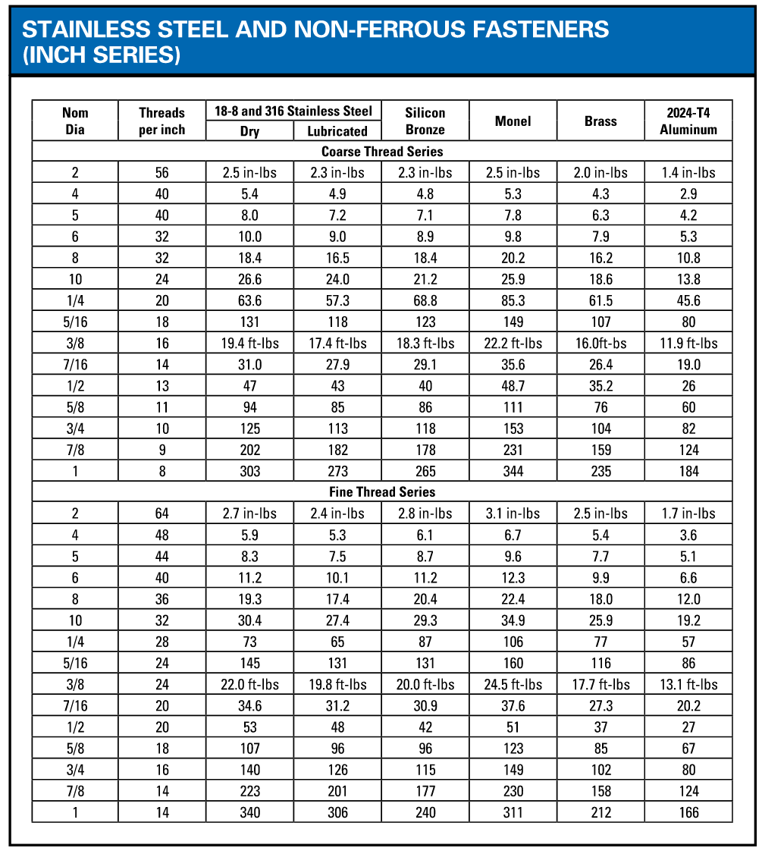

Component Naming Conventions
The following figures identify various Bio-DIVERTER components using the terminology found throughout the O&M manual and drawings. The figures are intended to be instructive examples only. The figures are representative in nature, meaning that the Bio-DIVERTER shown in the figure may not exactly match the Bio-DIVERTER provided as part of this project.

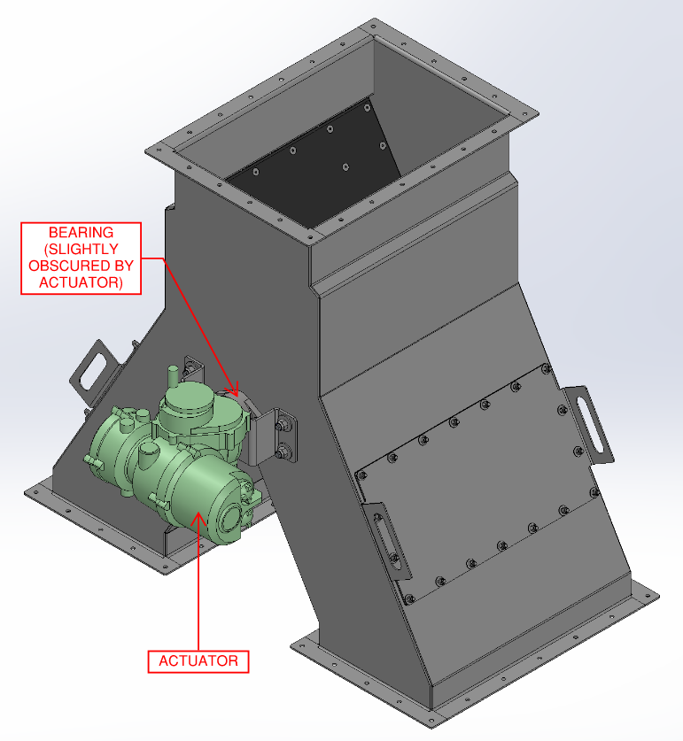
[Figure 1. Bio-DIVERTER (Dual Drop Points)

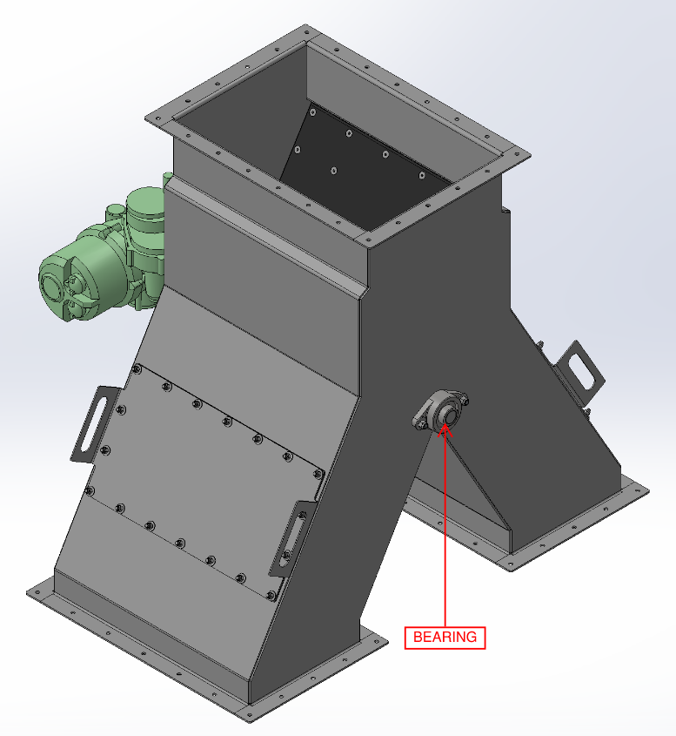
Figure 2. Bio-DIVERTER (Dual Drop Points) Reverse

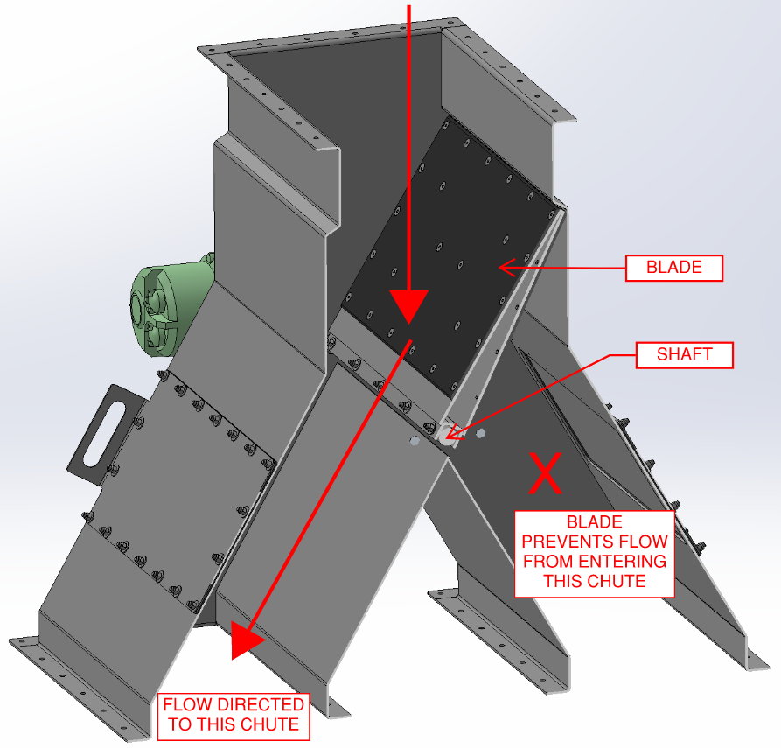
Figure 3. Bio-DIVERTER (Dual Drop Points) Internal and Example Flow Path]

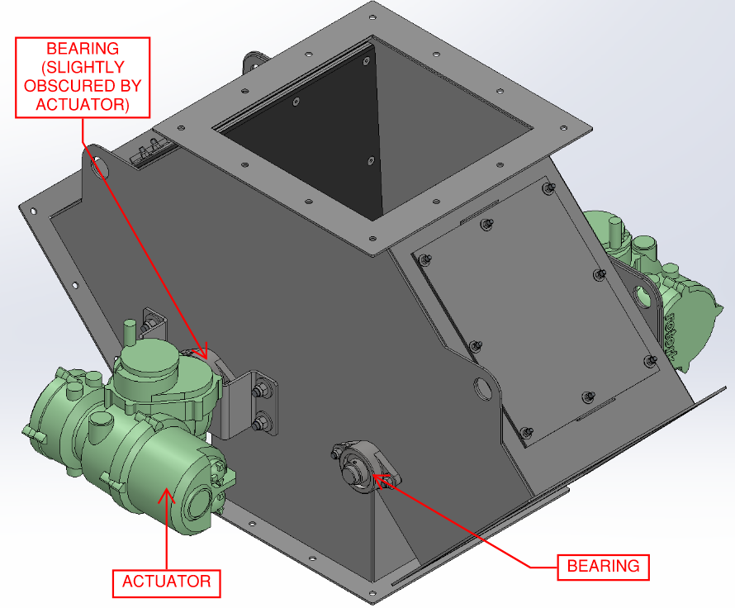
[Figure 4. Bio-DIVERTER (Multiple Drop Points)

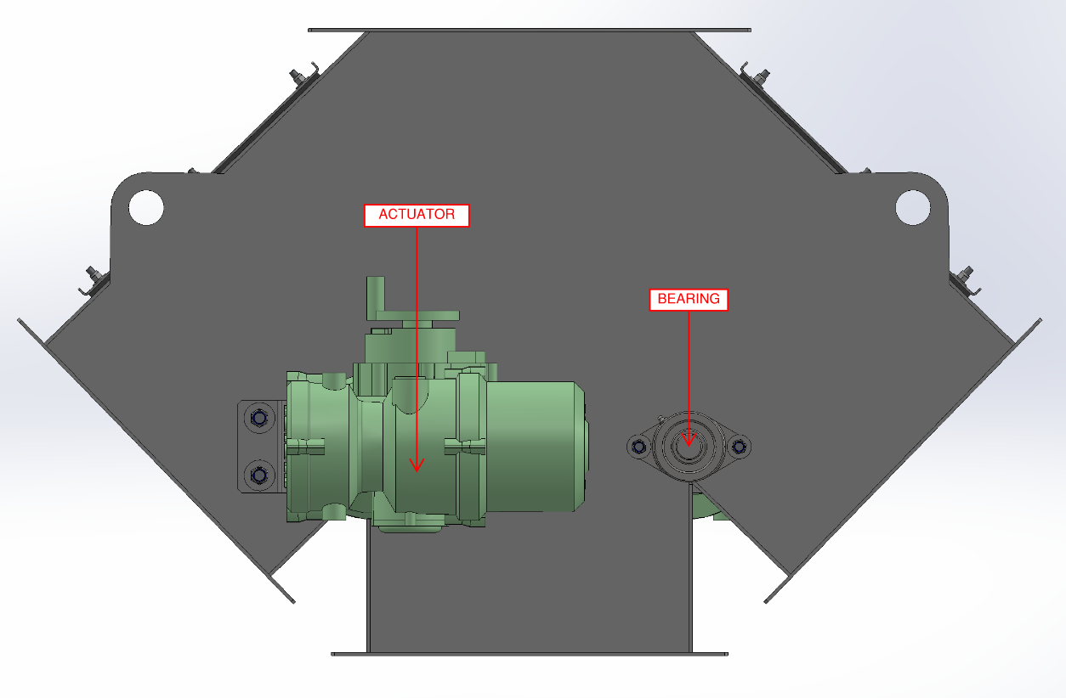
Figure 5. Bio-DIVERTER (Multiple Drop Points) Reverse

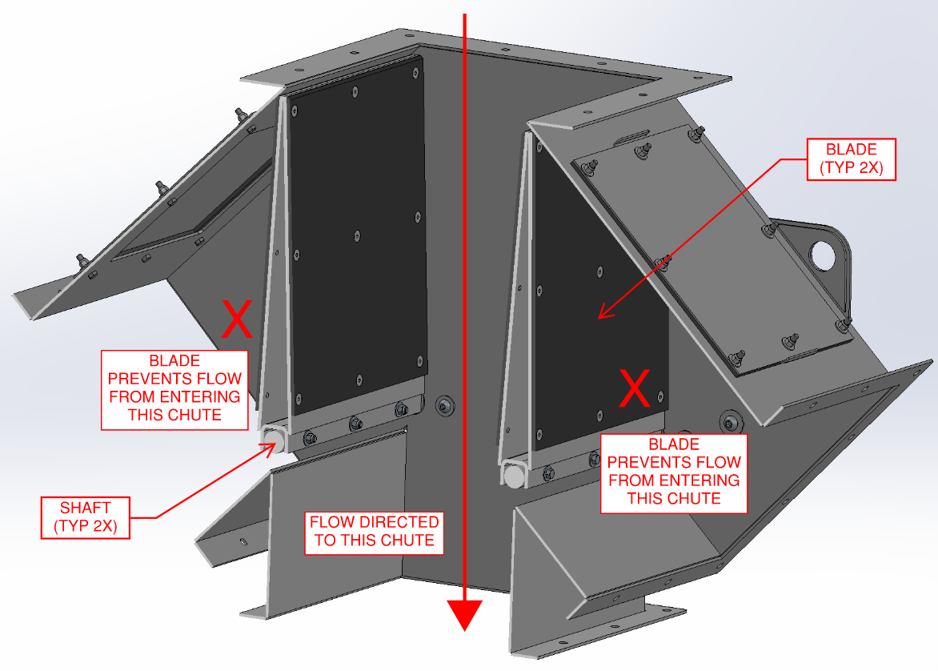
Figure 6. Bio-DIVERTER (Multiple Drop Points) Internal and Example Flow Path]

Detailed Installation Instructions
- Preparation
  - Remove any strapping, wire, or other tethering devices that may have been used during transit from the Bio-DIVERTER.
  - Ensure that the immediate upstream equipment, including the mating flange(s) to which the Bio-DIVERTER is to be attached, has been satisfactorily installed according to the separate manufacturer’s instructions.
  - Note that the Bio-DIVERTER should be lifted from the lifting lugs (if provided) or the Bio-DIVERTER flanges (if no lifting lugs have been provided). Refer to additional guidelines provided in Section 3 - Delivery, Handling, and Storage when lifting or moving the Bio-DIVERTER.

- Bio-DIVERTER Installation
  - [The Bio-DIVERTER arrives to site in sections. Install the Bio-DIVERTER sections to one another, ensuring that the provided gaskets are used between the sections, using the provided hardware as detailed on the drawings.
    - Note that consideration should be given to site-specific space constraints in which the entire Bio-DIVERTER assembly cannot be installed to the upstream and/or downstream components. In this instance, the Bio-DIVERTER sections should be attached sequentially starting at the upstream or downstream equipment flanges and working progressively (rather than assembling the entire Bio-DIVERTER and then connecting it in the process). Order of installation should be assessed and completed on a site-specific basis.]
  - Position the Bio-DIVERTER inlet flange and gasket against the upstream equipment discharge flange such that the flanges, gasket, and bolt holes are in alignment. Ensure the Bio-DIVERTER is oriented properly as detailed on the drawings.
  - Install the Bio-DIVERTER inlet flange to the upstream equipment discharge flange using the provided hardware.
  - Tighten the hardware according to the bolt torque chart included in Section 4.1 - Preparing for Installation. Verify that the gasket is uniformly compressed between the flanges.
  - [Repeat previous installation Step 2.a. through Step 2.d. for the connection on the opposite or downstream side of the Bio-DIVERTER.][Refer to the separate JMS xxxxx O&M manual for details regarding attachment of the Bio-DIVERTER outlets to the downstream equipment.]

- Actuator Wiring
  - Wire the actuator according to the actuator manufacturer’s installation instructions included in Appendix A: Supplemental Vendor Information.

Operating Procedures

General Equipment Operation
The JMS Bio-DIVERTER is a type of chute designed to aid in maintaining appropriate process flow for wastewater treatment material applications by directing the release of material to designated downstream processes. The Bio-DIVERTER can feature dual or multiple drop point designs and can be used either upstream to feed conveyors or downstream for product transfer or distribution to storage yards, vessels, or truck trailers. Intentionally designed with minimal moving parts and automated operation to reduce labor, the Bio-DIVERTER chute features an internal shaft and blade or flap valve (or multiple, if required) that can be rotated via an electric (or manual in unique cases) actuator such that the configuration of the blade(s) distribute material into a predetermined chute. This ensures that material is directed to the appropriate downstream process with consideration to equipment capacity, downtime, optimization, and/or operator preference and supports system redundancy and uniform distribution of material. The Bio-DIVERTER does not take the place of a gate and cannot be operated such that material is completely prevented or blocked from entering downstream processes.

Crafted of stainless steel with optional high-quality coatings for maximum longevity, the Bio-DIVERTER is carefully and specifically sized and designed for its intended application. Offering high-quality shop-welded and site-bolted construction, the Bio-DIVERTER ensures uniform product distribution and transfer to optimize downstream processes and increase efficiency. The Bio-DIVERTER is capable of directing a variety of materials, including sludge, grit, and screenings, and meets stringent blade deflection limits.

The Bio-DIVERTER is operated primarily through the use of an electric actuator, but a handwheel is provided on the actuator for manual operation when necessary. Manual actuation may be used as the sole actuation method in certain situations. Each Bio-DIVERTER is controlled by its own unique actuator.

Initial Startup
To start the equipment for the first time or after an extended shutdown, perform the following
Steps. Throughout the initial startup, document any issues, including photographs or videos if possible. Report any issues to JMS using the contact information provided in this O&M manual. Note that JMS field service representatives will likely be on site to witness initial startup after installation; refer to Section 1.1 - Field Service for details on the field services are provided by JMS. Note that an operator must be standing by the Bio-DIVERTER and associated control systems to stop the system in case of emergency.

- Visually inspect the Bio-DIVERTER and any associated equipment for damage. Notify JMS using the contact information provided herein if damage is observed.
- Verify proper installation of the Bio-DIVERTER per the procedures included in Section 4 - Installation Instructions.
- Verify that all bolts and hardware are properly tightened to the extent possible.
- Confirm electrical connections are made and with proper voltage.
- Verify that all preventative maintenance procedures have been completed as directed in Section 6 - Maintenance, Lubrication, & Troubleshooting. This includes lubrication of the bearings.
- Operate the Bio-DIVERTER according to any associated controls programming (not provided by JMS) and the actuator manufacturer’s instructions included in Appendix A: Supplemental Vendor Information. Ensure that the blade(s) move(s) appropriately in the proper directions to accommodate every possible outlet configuration. If multiple blades are used, verify that the Bio-DIVERTER control logic prevents the Bio-DIVERTER blades from operating simultaneously or in a way that causes the blades to collide.
  - Perform an “open limit” check to ensure that the blade(s) open(s) fully in each configuration.
  - Perform a “closed limit” check to ensure that the blade(s) close(s) fully in each configuration.
  - Verify Bio-DIVERTER operation in manual mode as well as auto/operation mode.
- Verify that the downstream processes are ready to receive material from the Bio-DIVERTER. Do not send material through the Bio-DIVERTER unless the downstream processes can receive material.
- With material passing through the Bio-DIVERTER in different configurations, verify the smooth transfer of material through the Bio-DIVERTER.
  - Verify Bio-DIVERTER operation in manual mode as well as auto/operation mode.

Startup
During startup, an operator must be standing by the Bio-DIVERTER and associated component control systems to stop the system in case of emergency. Perform the following procedures:

- Visually inspect the Bio-DIVERTER and any associated equipment for damage. Notify JMS using the contact information provided herein if damage is observed.
- Verify that all preventative maintenance procedures have been completed as directed in Section 6 - Maintenance, Lubrication, & Troubleshooting.
- If material will be directed through the Bio-DIVERTER, verify that the downstream processes are ready to receive material from the Bio-DIVERTER. Do not send material through the Bio-DIVERTER unless the downstream processes can receive material.
- The Bio-DIVERTER may be operated as required via the associated actuator and respective controls. Refer to the actuator manufacturer’s control information provided in Appendix A: Supplemental Vendor Information (as applicable) and/or the associated interlocked equipment controls (not provided herein).
  - Do not overload or otherwise exceed the design parameters and capacities of the equipment outlined in Appendix C: Calculations.

Shutdown
When it becomes necessary to shut down the equipment, perform the following procedures.
- If possible, allow upstream feed equipment (and downstream receiving equipment, as applicable) to continue running until all material has been discharged through the Bio-DIVERTER.
- Shut down all upstream feed equipment according to the appropriate standard operating procedures.
- Move the Bio-DIVERTER blade(s) to the desired shutdown position according to any associated controls programming (not provided by JMS) and the actuator manufacturer’s instructions included in Appendix A: Supplemental Vendor Information.
- Shut down all power to the Bio-DIVERTER. LOTO the Bio-DIVERTER when inspection and/or maintenance activities are to be performed.
- In the event of an emergency, adhere to the LOTO procedures until the source of the emergency condition is properly identified, addressed, and corrected. Do not attempt to turn on the actuators until normal operating conditions are restored.

Maintenance, Lubrication, & Troubleshooting
Care should be taken to avoid cross-contamination between carbon steel originating from sources outside the immediate system and stainless-steel components when installing, maintaining, or otherwise working with the equipment or components. Please refer to the additional information about carbon-steel contamination provided in Section 3.2.1 - Avoiding Cross-Contamination Between Materials.

Please note that not all individual components comprising the Bio-DIVERTER system are crafted by JMS (as detailed on the Bill of Materials on the drawings). Although JMS has carefully developed this comprehensive O&M manual to summarize the recommended procedures for effectively maintaining the Bio-DIVERTER system and its components as a whole, any and all maintenance, lubrication, and/or troubleshooting procedures from individual component manufacturers for their specific component should supplement or take precedence over the requirements listed herein. Manufacturer reference information, including that which is supplied in Appendix A: Supplemental Vendor Information, should always be referenced during maintenance, lubrication, and troubleshooting procedures where available. If questions arise over the proper maintenance, lubrication, and/or troubleshooting procedures, please contact JMS using the contact information provided in this O&M manual.

Before any maintenance or inspection is performed, refer to ANSI/ASSP Z244.1-2016 for minimum safety requirements concerning energy sources. Adhere to all requirements detailed in Section 2 - Safety Precautions when maintaining the equipment.

Practice good housekeeping. Keep the area around the equipment clean and free of obstacles to provide easy access. Establish routine periodic inspections of the equipment to ensure continuous maximum operating performance.

A basic maintenance tool kit is all that is required to maintain this equipment. No special tools are necessary.

Do not attempt to service the Bio-DIVERTER while in operation.

Preventative Maintenance
Table 2. Bio-DIVERTER Preventative Maintenance
Component | Recommended Maintenance | Frequency
General | Inspect Bio-DIVERTER for any material buildup to the extent possible. Clean as necessary. | Daily
Bearings | Lubricate the bearings. Refer to Section 6.3 - Lubrication for additional details. | Refer to Section 6.3 - Lubrication.
Gasket | Inspect Bio-DIVERTER gaskets for wear. This is often evidenced by leakage of water and/or material. Replace as necessary. | Quarterly
Hardware | Inspect Bio-DIVERTER hardware and secure any that are loose. Refer to the guidance provided in Section 4 - Installation Instructions. | Quarterly
Actuator  Note: This preventative maintenance activity only applies if limit switches have been included. | Test actuator limit switches according to the instructions provided in the manufacturer’s information included in Appendix A: Supplemental Vendor Information. Adjust limit switches as needed, again referencing the actuator information included in Appendix A: Supplemental Vendor Information. | Annually or as needed if Bio-DIVERTER blades are not fully rotating.

Corrective Maintenance
There is no corrective maintenance associated with the Bio-DIVERTERs.

Lubrication
A comprehensive lubrication schedule for the Bio-DIVERTER is provided in Table 3 on the next page.

Note that the actuator is sealed for life and does not have any lubrication requirements.

Table 3. Bio-DIVERTER Comprehensive Lubrication Requirements
Component | Activity | Interval | Quantity | Recommended Grease
Bearings | Grease the bearings. | Refer to the interval provided in the manufacturer’s information within Appendix A: Supplemental Vendor Information; if no interval provided, every 3 months. | Until grease just purges from the seals; refer to any additional details provided in the manufacturer’s information within Appendix A: Supplemental Vendor Information. | Refer to the recommended grease type provided in the manufacturer’s information within Appendix A: Supplemental Vendor Information.

Troubleshooting
Table 4. Bio-DIVERTER Troubleshooting
Problem | Probable Cause | Solution
Bio-DIVERTER is not operating when desired or as intended | Bio-DIVERTER is not receiving signal from controls | Verify that a signal is being sent from the control panel. Refer to the actuator manufacturer’s control information included in Appendix A: Supplemental Vendor Information (as applicable) and/or the associated interlocked equipment controls (not included herein).
Bio-DIVERTER is not operating when desired or as intended | Bio-DIVERTER is not receiving signal from controls | Verify that the signal is being received by the Bio-DIVERTER actuator.
Bio-DIVERTER is not operating when desired or as intended | Limit switches are not properly set | Refer to the actuator manufacturer’s instructions included in Appendix A: Supplemental Vendor Information for information on how to properly reset the limit switches.
Bio-DIVERTER is not operating when desired or as intended | Bio-DIVERTER actuator is tripping out on over torque | Inspect for blockages in the Bio-DIVERTER to the extent practical. If no blockages are observed, incrementally increase the actuator torque output (up to a maximum of 60% of the actuator’s total torque output value). Refer to the actuator manufacturer’s instructions included in Appendix A: Supplemental Vendor Information for detail.
Bio-DIVERTER is not operating when desired or as intended | No power at the actuator | Utilize a certified electrician to verify that power is being conveyed to the motor and back to the source.
Bio-DIVERTER is not operating when desired or as intended | Actuator failure | Notify JMS using the contact information provided in this O&M manual for recommended procedures.
Bio-DIVERTER is not operating when desired or as intended | Refer to any additional actuator troubleshooting included in Appendix A: Supplemental Vendor Information. | Refer to any additional actuator troubleshooting included in Appendix A: Supplemental Vendor Information.

Policies

Warranty
All JMS equipment and/or materials are of high quality and are manufactured in conformity with the best commercial practices. JMS guarantees all equipment and materials manufactured or supplied by JMS to be free from defects in material and workmanship at the time of startup for a period of XXXXX. JMS will furnish without charge but will not install replacements for such parts and materials JMS finds to be defective.

This guarantee does not apply to any equipment which has been improperly handled or stored, improperly lubricated, subjected to misuse or neglect, misapplied with reference to the Engineer's Specifications, altered or tampered with, and/or damaged by corrective work performed without JMS’ specific written consent. No allowances will be made for such corrective work done without such consent.

Deterioration by chemical action, improper maintenance, or normal wear does not constitute defects and are therefore not covered by this warranty. Additionally, consumable items are not covered by this warranty. All warranty claims must be submitted within ten (10) calendar days of discovery of defects or they will be deemed waived. The foregoing is in lieu of all other warranties, whether expressed or implied.

Liability
It is expressly understood that JMS’ liability for JMS products is limited to the furnishing of such replacement parts, and that JMS will not be liable for any other expense, injury, loss, or damage, whether direct or consequential, including but not limited to loss of profits, production, or increased cost of operation arising in connection with the sale or use of, or inability to use, JMS equipment and/or materials for any purpose except as herein provided.

In the event a customer's order form states any liability terms which are additional to or different from these set forth herein, this form must be acknowledged in writing by JMS to accept any liability set forth in such form(s).

Returns
All returns must be authorized by JMS, and no credit will be allowed for returned items that are damaged in transit, incomplete, or received in an unsatisfactory condition. All items that are not eligible for credit will be returned to customer via freight collect or discarded upon customer's instructions.

Delivery
Delivery dates represent only JMS’ best estimate of the time required to complete the work and ship the material from JMS’ plant. All orders are accepted with the understanding that shipping dates are approximate and subject to change because of factory conditions, fires, strikes, material shortages, civil or military authority, acts of God, or other causes beyond JMS knowledge or control.

Back charges against JMS for alterations, shortages, damage repair, and/or discrepancies will be accepted only with written prior approval from a duly authorized representative of JMS.

Thread Lubricant Information
All JMS bolts and anchors are stainless-steel material unless otherwise specified. Without an application of thread lubricant, bolting materials may become locked together. JMS strongly recommends the use of NSF-61 approved thread lubricant on all stainless-steel bolts and anchors.

Standard Erecting Practices
All fabricated equipment manufactured by JMS is shop checked for accuracy before shipment and should not present any erection problems. Due to specific field conditions, a reasonable amount of fit-up is considered standard erection practice. The use of tools such as “come-a-longs”, jacks, drift pins, and reamers is to be expected.

Standard erecting practice as defined by the AISC “Code of Standard Practice”, Section 7.14, states the following:

“The correction of minor misfits by moderate amounts of reaming, grinding, welding, or cutting, and the drawing of elements into line with drift pins shall be considered to be normal erection operations. Errors that cannot be corrected using the foregoing means, or that require major changes in member or connection configuration, shall be promptly reported to the ODRD, the ODRC, and the fabricator, by the erector, to enable the responsible entity to either correct the error or approve the most efficient and economical method of correction to be used by others.”

If a problem is traceable to JMS fabrication or engineering, JMS will work with the customer to resolve this problem. Back charges for replacing or correcting materials require prior written approval of an authorized JMS representative. The back charges will only be considered with prompt, complete cost documentation based on standard direct field labor hours and materials. Profit, overhead, and any other charges will not be allowed. Payment may be refused for corrective work without prior approval.

Problems other than minor misfits as defined by AISC 303 should be communicated in writing to JMS using the contact information provided in this O&M manual via the project’s non-conformance reporting procedure.

Appendix A: Supplemental Vendor Information

Appendix B: Equipment Drawings

Appendix C: Calculations

Appendix D: Startup Reports
PLACEHOLDER

Startup reports will be completed and made available as appropriate.

Appendix E: Controls Information
Refer to the actuator manufacturer’s control information included in Appendix A: Supplemental Vendor Information (as applicable) and/or the associated interlocked equipment controls (not included herein).

Appendix F: O&M Manual Revision History
Date | Rev. | Description of Change | Author
INSERT DATE | 0 | Initial release. | INSERT INITIALS

Appendix H: Comment & Response Log Template
BIO-DIVERTER O&M CREATION INPUTS PAGE

RULES FOR USING THIS PAGE
- THIS PAGE IS USED TO SIMPLIFY CREATION OF THE BIO-DIVERTER O&M WORD DOCUMENT ONLY.
- THIS IS NOT INTENDED TO TAKE THE PLACE OF MANUALLY REVIEWING THE DOCUMENT AND EDITING CONTENT/FORMATTING AS NECESSARY.
- WHEN EDITING THIS PAGE, BE CAREFUL NOT TO ACCIDENTALLY DELETE THE BOOKMARKS OR CONTENT CONTROLS. IT IS RECOMMENDED YOU NAVIGATE TO FILE->OPTIONS->ADVANCED->CHECK “SHOW BOOKMARKS” UNDER “SHOW DOCUMENT CONTENT” TO SEE BOOKMARKS.
- DELETE THIS PAGE IN O&M PDF VERSION

- O&M PREPARED BY (INITIALS): O&M PREPARED BY
- JMS PROJECT NO: JMS PROJECT NO
- LOCATION (CITY, STATE): LOCATION (CITY, STATE)
- DATE O&M IS BEING RELEASED (OR ANTICIPATED BEING RELEASED) (MONTH YEAR): O&M RELEASE DATE
- CUSTOMER PROVIDED TAG NO (TYPE A “SPACE” IF NONE): TAG NO
- PLANT NAME: PLANT NAME
- ENGINEER OF RECORD: ENGINEER OF RECORD
- CUSTOMER: CUSTOMER
- O&M REVISION NO.: O&M REV NO
- SPECIFICATION NUMBER: SPEC NO.
- JMS PROJECT MANAGER: JMS PROJECT MANAGER
- JMS LOCAL REP NAME: JMS LOCAL REP NAME
- JMS LOCAL REP COMPANY: JMS LOCAL REP COMPANY
- JMS LOCAL REP ADDRESS (USE “SHIFT+ENTER” TO CREATE MULTIPLE LINES):
JMS LOCAL REP ADDRESS
- JMS LOCAL REP PHONE: JMS LOCAL REP PHONE

