

Bio-HOPPER
Tag Number/Serial Number/Customer Provided #

Operations and Maintenance Manual

PLANT NAME

LOCATION

Specification Section XX XX XX

Engineer of Record: XXXX

Revision X
MONTH YEAR
Table of Contents
Contact Information 4
1. Scope of Supply 5
1.1 Equipment Data 5
1.2 Special Tools 5
1.3 Field Service 5
1.4 Scope Exclusions 5
1.5 Spare Parts 5
2. Safety Precautions 6
2.1 Equipment-Specific Safety 6
3. Delivery, Handling, and Storage 8
3.1 Upon Equipment Arrival 8
3.2 General Handling and Storage Information 8
3.2.1 Avoiding Cross-Contamination Between Materials 8
3.3 Storage 10
3.3.1 General Requirements for Indoor Storage 11
3.3.2 General Requirements for Outdoor Storage 11
3.3.3 Gear Units 12
3.3.4 Electric Motors and Actuators 12
4. Installation Instructions 15
4.1 Before Installation 15
4.2 Detailed Installation Instructions 17
5. Operating Procedures 25
5.1 General Equipment Operation 25
5.2 Initial Startup 25
5.3 Startup 26
5.4 Shutdown (Empty Hopper) 27
5.5 Shutdown (Material in Hopper) 28
5.6 Shutdown (Alarm Condition) 29
6. Maintenance, Lubrication, & Troubleshooting 31
6.1 Preventative Maintenance 31
6.2 Corrective Maintenance 33
6.3 Lubrication 33
6.4 Troubleshooting 38
7. Policies 41
7.1 Warranty 41
7.2 Liability 41
7.3 Returns 41
7.4 Delivery 41
7.5 Thread Lubricant Information 42
7.6 Standard Erecting Practices 42

Table of Figures
Figure 1. Breather Valve with Protective Band (in Black) 24
Figure 2. SEW Eurodrive Mounting Position "XXX" and Location of Lubrication Components 33
Figure 3. Oil Level Plug (Painted Red) and Breather Valve (Protective Band Removed) (FOR REFERENCE ONLY) 34
Figure 4. Example Sight Glass in Lieu of Oil Level Plug (If Applicable) (FOR REFERENCE ONLY) 34
Figure 5. SEW Eurodrive Diagram for Checking Oil Level 37

List of Tables
Table 1. Typical Bolt Torque Chart for Stainless Steel and Non-Ferrous Fasteners 16
Table 2. Bio-HOPPER Preventative Maintenance 31
Table 3. Bio-HOPPER Component Lubrication Requirements 35
Table 4. Bio-HOPPER Troubleshooting 38

List of Appendices
Appendix A: Catalog Cuts
Appendix B: Equipment Drawings
Appendix C: Calculations
Appendix D: Startup Reports
Appendix E: Controls
Appendix F: O&M Revision History

Contact Information
Local JMS Representative: | 
Rep Name
Company Name
Company Address
City, State Zip
(XXX)XXX-XXXX

JMS Project Manager:
PM Name Here
Jim Myers & Sons, Inc.
PO Box 38778
Charlotte, NC 28278
Phone: (704)554-8397
Fax: (704)554-9113

For general inquiries regarding field services, contact custsvc@jmsequipment.com.
For general inquiries regarding aftermarket parts, contact AMP@jmsequipment.com.

Scope of Supply
JMS is supplying X (Number) X (description from scope), also referred to herein as (a) “Bio-HOPPER”(s). The Bio-HOPPER(s) is/are supplied with the following features:
- INSERT SCOPE OF SUPPLY FROM APPROVED SUBMITTAL, including everything not already mentioned in sentence above

Equipment Data
Please refer to the above Scope of Supply and the drawing notes for Bio-HOPPER equipment parameters.

Special Tools
While no special tools are required working with the Bio-HOPPER system, care should be taken to avoid cross-contamination between carbon steel and stainless steel components when installing, maintaining, or otherwise working with the equipment or components. Please refer to the additional information about carbon steel contamination provided in Section 3.2.1 - Avoiding Cross-Contamination Between Materials.

Field Service
The JMS scope of supply xxxxx

Additional service trips and service days are available at an additional cost. Compensation is required for any additional visits caused by site delays that result in the inability to complete field services during scheduled site visits.

Before beginning equipment installation, schedule JMS field service site visits in advance using the contact information provided in this O&M manual. Site visits should be scheduled at least four weeks in advance.

Scope Exclusions
The following items are excluded from the JMS scope of supply:
- Any and all taxes including sales, use, gross receipts, or similar taxes imposed by federal, state, or local authorities
- … any electrical devices not specifically detailed in the Scope of Supply
- Site offloading, installation, measurements, and/or field assembly
- Any items required for system completion not listed in the Scope of Supply
- Calculations relating to anything outside of the Scope of Supply

Spare Parts
Please note that a complete table of spare parts is also included on the GA drawings.
- Insert as necessary, otherwise can simply say spare parts aren’t included for this project and remove all this text

Safety Precautions
Safety must always be considered a basic factor in machinery operation. Most accidents are the result of carelessness or negligence. The following safety instructions are basic guidelines and should be considered as minimum provisions. Please note that not all precautions are applicable to all equipment components. Additional information should be obtained by the purchaser from other sources, including the latest editions of American Society of Mechanical Engineers Standards ANSI B20.1, ANSI B11.0, and ANSI A1264.1, as well as ANSI/ASSP Z244.1-2016.

It is the responsibility of the Contractor, installer, Owner, and user to install, maintain, and operate the equipment components and assemblies manufactured and supplied by JMS in such a manner as to comply with the Williams-Steiger Occupational Safety and Health Act. Furthermore, all parties should comply with all state and local laws and ordinances, as well as the American National Standards Institute Safety Code.

It is extremely important to follow the below precautions to prevent personal injury or property damage:

- Only persons properly trained and familiar with JMS equipment should be permitted to operate or maintain the unit.
- LOCK OUT/TAG OUT ALL POWER prior to any inspection or maintenance.
- Periodically run the equipment for a few minutes to check for excessive vibration, loose fasteners, security of covers and guards, noise, and bearing and gearmotor temperature.
- ALWAYS operate the equipment with covers, guards, and safety labels in place.
- NEVER walk on or across the equipment or its covers, guards, or grating.
- DO NOT place hands, feet, or clothing in equipment openings.
- DO NOT poke or prod the equipment or material in the equipment.
- ALWAYS practice good housekeeping to maintain a clear view of the equipment and all safety devices.

Equipment-Specific Safety
Please follow all local safety regulations when working around the Bio-HOPPER system. Additional safety requirements are outlined below.

- Follow all plant and industry LOCK OUT/TAG OUT (LOTO) procedures and practices throughout the handling, installation, commissioning, startup, and maintenance of the Bio-HOPPER equipment. This protects installation personnel from the unexpected release of all forms of potential energy. Equipment should be locked out in such a manner that the equipment cannot be restarted by anyone, including employees that are remote from the area. Other secondary devices should not be used as a substitute for locking out equipment power.
- Follow all plant and industry confined space procedures and practices throughout the handling, installation, commissioning, and startup of the Bio-HOPPER equipment.
- Observe all posted safety labels while working on or around the Bio-HOPPER.
- The exposed screw and moving parts can cause severe injury; follow all plant and industry LOTO procedures and practices while working on or around the Bio-HOPPER and its components, including prior to the removal of any guards, railings, or covers for inspection or service.
- Operate the Bio-HOPPER only when all approved covers, railings, and guards are in place.
- Keep clothing, body parts, and hair away from the screws.
- Block any gravity loads prior to performing inspections or maintenance procedures.
- Clean up spillage or adhered solids near or on moving parts only when the equipment is locked out and all necessary covers, railings, and guards are in place.
- Do not modify the controls unless explicitly directed.
- Verify that all controls are visible and accessible at all times.
- Report any unsafe conditions.
- Do not use the Bio-HOPPER or any of its components for a purpose other than that for which it was intended. Do not attempt field modification of the Bio-HOPPER or any of its components.
- Do not poke or prod material into the Bio-HOPPER or any of its components via a bar or stick inserted into its openings during normal operation. Do not attempt to clear a jammed conveyor until the equipment has undergone appropriate LOTO procedures.
- Do not overload the Bio-HOPPER or otherwise exceed the equipment speed, capacity, volume, material density, or rate of flow for which the Bio-HOPPER and associated equipment were designed.
- Do not utilize the Bio-HOPPER for any application other than that for which it was designed.

Delivery, Handling, and Storage

Upon Equipment Arrival
Although all possible precautions are taken to protect equipment against damage or losses during shipment, before accepting the shipment, check all items against the packing list for shortages and inspect for evidence of physical damage. In either case, immediately notify JMS using the contact information included herein. Keep a record of all claims and correspondence. Photographs are recommended.

Do not remove protective covers unless there are indications of damage. Boxes opened for inspection and inventory should be carefully repackaged to ensure protection of the contents, or the parts should be stored in a safe place. Refer to Section 3.3 - Storage. Examine all packing boxes, wrappings, and covers for items that may be attached to them, especially if these items are to be discarded.

General Handling and Storage Information
Upon completion of the initial inspection, the equipment should be moved from the delivery truck to temporary storage (refer to Section 3.3 - Storage) or immediately installed (refer to Section 4 - Installation Instructions). When maneuvering the equipment, go slowly and use extreme caution. Watch for accidental damage caused during handling and document any issues. It is the responsibility of the handler and installer to ensure that appropriate measures are taken to prevent damage to the equipment during handling and installation.

Provided in the following sections are instructions for handling and storing the equipment. These instructions are intended to cover the basics but will not cover every conceivable situation. Use good judgment when handling and working with the equipment.

Unless otherwise noted, lifting lugs or spreader bars with slings are the recommended support method for lifting all equipment in instances where equipment components cannot be moved manually due to weight or other constraints. When utilized, the unsupported span of spreader bars should be no longer than 12 feet. Do not attempt to lift any equipment from only one support point. When support locations or lifting lugs are not specified on the drawings, support locations must be carefully selected with consideration to the overall equipment weight distribution (i.e. consider the positioning of unusually heavy items such as gearmotors or gates). Support points should be selected such that optimal load balance is achieved to avoid bending or other damage to the equipment.

Avoiding Cross-Contamination Between Materials
This equipment is partially or wholly constructed from corrosion-resistant stainless steel. The Owner and/or installer must protect the equipment against damage to and/or contamination of the stainless steel’s protective oxide layer by taking all necessary precautions to prevent stainless steel equipment from coming in contact with any carbon steel or carbon steel dust throughout the handling, installation, commissioning, and startup of the system. Failure to protect stainless steel equipment from damage to and/or contamination of its protective oxide layer will void the manufacturer’s material warranty.

As a general practice, keep carbon steel components separate from stainless steel components. Avoid stacking components in a manner such that carbon steel and stainless steel will be in contact. While not an exhaustive list, protect stainless steel equipment from the following forms of carbon steel:

- Truck beds
- Forklifts
- Cables
- Chains
- Tools
- Wire brushes
- Grinding wheels
- Grinding dust
- Nylon lifting straps

If work on any carbon steel components is being performed on site near the storage area for this project, cover stainless steel components with tarps or paper to protect them from coming in contact with carbon dust particles. If work is being performed indoors, fans should be used to keep carbon steel dust from falling onto stainless steel components. If work is being performed outdoors, position the work involving carbon steel such that it is located downwind of the stainless steel component storage area.

Select tools for installation and maintenance of the stainless steel equipment that are stainless or non-magnetic. Tools made of aluminum bronze, chrome alloys, or stainless alloys are examples of acceptable tool materials. Ensure the tools selected meet the torque requirements for the equipment as detailed on Table 1 in Section 4.1 - Before Installation and the drawings.

Lifting straps previously used for handling carbon steel should not be used to handle stainless steel equipment components. If there is no method for tracking which material the lifting straps may have handled previously, new lifting straps should be used.

Because a thin layer of chrome oxide naturally forms on the surface of stainless steel, stainless steel resists corrosion. During welding and machining operations, the chrome oxide layer can be damaged. To rebuild this corrosion-resistant layer, pickling and passivation in accordance with ASTM A380 and A967 are conducted on necessary parts of the equipment before it leaves JMS. However, if the corrosion-resistant layer is further breached by installation and/or handling practices, iron particles may be introduced. The introduction of these particles may lead to the appearance of surface corrosion on the stainless steel component. In the majority of JMS equipment, the surface corrosion is merely aesthetic in nature and does not have any impact on equipment performance. However, these issues can be mitigated or prevented entirely during installation by following the guidance included in this O&M manual.

Some surface corrosion is practically unavoidable over time for most plants due to the environment in which the equipment will be used. Chemicals such as chlorine can introduce corrosion to stainless steel components without the presence of iron particles, and a damp environment can propagate surface corrosion over time. Most corrosion does not have a performance impact on the equipment over its operational life assuming suitable performance characteristics have been specified. Contact JMS using the contact information provided in this O&M manual if concerns arise about the presence of surface corrosion on JMS equipment.

If surface corrosion is noted on stainless steel and needs to be removed, perform the following steps:
- Clean the affected area thoroughly with a clean rag to remove any moisture on the surface.
- Remove the corrosion from the contaminated area with an abrasive pad that is appropriate for working with stainless steel.
- Treat the abraded area with a local passivation chemical. JMS recommends the use of CitriSurf 2310.

Storage
Please note that the equipment storage instructions provided herein are the JMS standard requirements for all equipment and cover a variety of components comprehensively. Some instructions may not apply to the equipment covered in this O&M manual. Please disregard any instructions that clearly do not apply. In the case where a vendor O&M manual has been attached to this O&M manual and includes more stringent and/or differing equipment storage requirements, please adhere to the vendor O&M manual instructions. Failure to comply with these equipment storage instructions may void any and all warranties for the equipment.

After the equipment has been checked for any transit damage, JMS recommends the following procedures for equipment storage. Storage refers to the period of time following shipment but prior to installation in which the equipment or component must be protected from damage. For the purposes of this O&M manual, the following requirements are intended to apply when equipment is stored for 30 days or longer on site prior to installation. Requirements may vary based on the duration of the equipment storage.

It is preferred that all equipment be warehoused to protect against inclement weather, dust, and/or damage by vehicles. Similarly, all spare parts should be warehoused until ready for use. Storage inside a building is preferred but covering the equipment or component with a canvas tarp is acceptable unless otherwise indicated. Do not cover the equipment or component with a polyethylene sheet, as this will cause and trap condensation. Additional recommendations for indoor and outdoor storage of various components are highlighted below.

General Requirements for Indoor Storage
The following general requirements are applicable to all equipment or components stored indoors.
- Store the components in a cool, dry area that is not subject to extreme temperature fluctuations. Protect components from heat and flame, as well as from dirt, mud, and flying debris.
- Ensure the area for storage has adequate ventilation.
- Ensure the storage area ground surface is level.
- If the system includes a Mega-SETTLER, support the plate packs with dunnage in the form of 6” x 6” wood beams to raise them off of the ground and prevent distortion. Always support the plate packs under the vertical uprights in the plate settler truss frame. The individual plates inside the plate pack frame should not under any circumstance contact any part of the dunnage or ground.
- Provide space heaters for heating and drying.
- Provide adequate support under all equipment to prevent distortion and to raise equipment above any undesirable ground or floor conditions. Ensure heavy objects are not stacked on top of the component.
- Ensure tenting and/or tarpaulins (if any) are well supported to provide sufficient ventilation.
- Re-coat parts which may have been scratched or wiped clean of their protective coating in shipment with paint, primer, or grease.
- Shield painted surfaces, including bitumastic coatings, from direct sunlight, which can lead to warping, damage, or chipping.
- Check the equipment periodically for accumulations of moisture and/or surface corrosion and remove. If surface corrosion is present, prepare the surface and re-coat with the proper material. Increase ventilation and reduce humidity.
- In equipment containing rotating parts, rotate the equipment one and a half (1.5) rotations every two weeks. Rotation can be performed by bumping the motor (if applicable) or disengaging the motor (if applicable) and rotating by hand.

General Requirements for Outdoor Storage
The following general requirements are applicable to all equipment or components stored outdoors. It is the responsibility of the Contractor to protect JMS equipment from damage to equipment due to outside storage.
- If warehousing is not possible, choose a site that has adequate drainage, ventilation, and size to maintain space for air circulation and access by inspecting personnel.
- Shield the materials from direct sunlight, rain, snow, dust, etc. with tenting if possible or well-supported tarpaulins at a minimum. Ensure good cover is provided at all times. Ensure that the equipment is protected from contact with other machinery, equipment, etc.
- Provide space heaters for heating and drying in cold or wet weather.
- Use blocks to raise all material off the ground a minimum of 6” higher than any expected level of rain, snow, etc. Components should be stored a minimum of 6” off the ground. If the system includes a Mega-SETTLER, the use of 6” x 6” wood beams is recommended to support and raise the plate packs a minimum of 6” higher than any expected level of rain, snow, etc. Always support the plate packs under the vertical uprights in the plate settler truss frame. The individual plates inside the plate pack frame should not under any circumstance contact any part of the dunnage or ground.
- Provide adequate support of all fabricated steelwork to prevent warping.
- Perform frequent checks to locate surfaces affected by corrosion and accumulations of condensation. It is the responsibility of the Contractor to protect JMS equipment from surface corrosion due to outside storage, including corrosion occurring after the equipment is delivered to the job site but before final finish painting. If surface corrosion is found on painted surfaces, remove the surface corrosion, re-prime, and re-paint the surface. If the surface was originally grease-coated, remove the surface corrosion and re-coat the surface with waterproof grease.
- Block or prop open any inspection doors, etc. slightly to increase ventilation in housings.
- In equipment containing rotating parts, rotate the equipment one and a half (1.5) rotations every two weeks. Rotation can be performed by bumping the motor (if applicable) or disengaging the motor (if applicable) and rotating by hand.

Gear Units
In addition to the general requirements, adhere to the following additional requirements for storage of gear units.
- Although some components are shipped dry, units generally include run-in oils containing surface corrosion-proofing additives. The additives will protect internal gearing for an extended period (see subsequent bullets) under good storage conditions. Verify that the unit is prepared for extended storage with the equipment manufacturer.
- The gear units should remain tightly sealed until startup.
- Store gear units according to the mounting position.
- If the gear unit is packed in containers and shipped with desiccant and a moisture indicator sealed in the plastic wrap, regularly inspect the packaging and humidity indicator. Relative humidity should be less than 50% at all times. The gear unit should be stored under a roof and protected against rain and snow. The unit can be stored for up to 3 years if all conditions described herein are maintained.
- If the gear unit is received open (no packaging), perform regular inspections. Check for cleanness and mechanical damage and inspect the corrosion protection. The gear unit should be stored under a roof and enclosed at a constant temperature and atmospheric humidity (between 41 and 122 degrees F; less than 50% relative humidity). Ensure there are no sudden temperature variations, aggressive vapors, or shocks, and control ventilation with a filter free from dust and dirt. The unit can be stored for 2 years or more if all conditions described herein are maintained.

Electric Motors and Actuators
In addition to the general requirements, adhere to the following additional requirements for storage of electric motors and actuators.
- Do not remove electrical compartment covers unless specifically instructed in the vendor O&M manual.
- Block open control panel covers or doors so air can circulate.
- Open all cartons and remove all sealing films unless the carton specifically states otherwise. Remove moisture-absorbing materials if found in the cartons. Remove any plastic shock-absorbing particles surrounding the cartons and/or films.
- Store small apparatuses in the original containers (if received dry).
- If not mounted, store motors in the original containers in a clean, dry, and protected warehouse.
- Ensure the storage area is free from vibration and extreme fluctuations in temperature.
- Ensure motors are fully greased.
- Ensure all drains remain fully operable while in storage, and/or remove the drain plugs. The motors must be stored so that the drain is at the lowest point. All breathers and automatic “T” drains must be operable to allow breathing at locations other than through the bearing fits. Motors should be stored in their proper mounting position.
- Where motors are not in the original containers but are instead mounted on other pieces of machinery, the mounting must be such that the drains and breathers are fully operable. The drains must be kept at the lowest point on the motor and/or the drain plugs removed so that all condensation can drain freely.
- Apply corrosion resistant coating to external motor parts when the motor is stored in a corrosive environment.
- Coat all machined parts with Cosmoline (or similar preservative material) if not already coated.
- Connect all units equipped with heaters (if storage conditions in any way simulate or approach operational conditions).
- Keep the motors warm. If the motors are equipped with space heaters, energize them at all times. If space heaters were not supplied, auxiliary heat must be used to keep the motor windings warm and free of condensation.
- If the motor or actuator is installed but not cabled, it is recommended that any plastic transit cable entry plugs are replaced with metal plugs (which are sealed with PTFE tape).
- Check windings for resistance with a megohm meter at the time equipment is put in storage. At termination of storage, repeat this resistance check prior to applying power. The minimum reading should be 1 megohm for motors rated 600 volts or less. Any drop below this point indicates the need for electrical or mechanical drying. When storing a large quantity of motors, perform an inspection of a sample size of the motors by removing the end brackets and visually inspecting for the presence of water in the grease or surface corrosion on the bearing. If water or surface corrosion is present, replace the bearings and re-lubricate.
- Purge grease in the motors at the time of removal from storage, ensuring that an ample supply of fresh grease is in each grease cavity.
- If control panels are provided, adhere to the following additional storage recommendations:
  - If the control panel does not arrive to site wrapped in plastic, wrap the control panel in a covering of heavy-duty plastic or similar material to help prevent the entry of dirt and dust.
  - For control panels not installed and energized immediately, store in a clean, dry place. Maintain a storage temperature between -30 and 65 °C (-22 and 149 °F). If the storage temperature fluctuates or humidity exceeds 60%, use a space heater to help prevent condensation. If possible, store the control panels in a heated building that offers adequate air circulation and protection from dirt and water.
  - Control panels that are designed for indoor applications do not have sufficient packaging for outdoor storage. If these control panels are to be stored outdoors, install temporary electrical heating to help prevent condensation. Add packaging for protection from the outside elements. A space heater that is rated at 200 watts per section is adequate for the average control panel. Remove all loose packaging and flammable materials before you energize space heaters.
  - Keep dry internally all unenergized control panels for outdoor use by installing temporary heating or energizing optional self-contained space heaters.

Installation Instructions

Before Installation
Read the entirety of the provided installation instructions, including information on stainless steel hardware and the anchor manufacturer’s installation instructions provided in Appendix A: Catalog Cuts, before proceeding with installation. Examine field conditions as early as possible and take field dimensions to confirm that equipment as designed can be installed according to these instructions. Notify JMS immediately if there are undocumented field conditions which are adverse to successful equipment installation. The Contractor must also inspect the latest “APPROVED” or “RELEASED TO FAB” plan and elevation drawings prior to and throughout the installation process.

The following erection and installation procedures are meant to serve as guidelines for installing the JMS equipment and may not address site- or project-specific issues.

If any fit-up problems with equipment are noted during installation, alert JMS immediately using the contact information provided herein. Do not rework any equipment without contacting JMS. Any unauthorized rework will void the warranty on the equipment. JMS reserves the right to have its own personnel or contracted vendors correct field problems. Problems other than minor misfits as defined by AISC 303 should be communicated in writing to JMS using the contact information provided in this O&M manual via the project’s non-conformance reporting procedure.

Throughout the installation procedures described herein, proper industry and plant LOCK OUT/TAG OUT procedures (and confined space entry procedures as necessary) must be followed. These actions protect personnel against electrical and/or mechanical hazards and environments, including asphyxiants.

Please note that all figures depicting the equipment included throughout this O&M manual are for illustrative purposes only and may not reflect the exact conditions or equipment provided for this project. Refer to the drawings for detailed and specific equipment information.

While no special tools are required for working with the Bio-HOPPER system, care should be taken to avoid cross-contamination between carbon steel and stainless steel components when installing, maintaining, or otherwise working with the equipment or components. Please refer to the additional information about carbon steel contamination provided in Section 3.2.1 - Avoiding Cross-Contamination Between Materials.

Before beginning equipment installation, schedule JMS field service site visits in advance using the contact information provided in this O&M manual. Refer to Section 1 - Scope of Supply for detailed information about what field services are included. Site visits should be scheduled at least four weeks in advance.

Utilize the bolt torque chart provided in Table 1 throughout installation as necessary for general bolt torque values for stainless steel and non-ferrous fasteners only. Do not use impact tools to torque the bolts. Refer to the drawings for unique torque values that may differ from what is provided in Table 1. Please also note that Table 1 does not apply to anchors; refer to the anchor manufacturer’s installation instructions provided in Appendix A: Catalog Cuts for details on anchorage installation requirements. For 304 stainless steel hardware, refer to the column labeled “18-8 and 316 Stainless Steel”.

Table 1. Typical Bolt Torque Chart for Stainless Steel and Non-Ferrous Fasteners
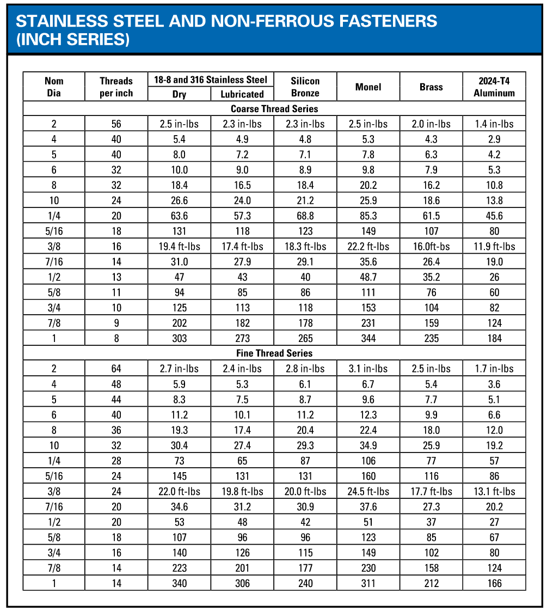

Detailed Installation Instructions
- Prepare Components for Assembly
  - Refer to the drawings for the locations of lifting lugs (if applicable) on the various Bio-HOPPER components. Where provided, move components using the lifting lugs only to prevent damage to the equipment.
  - Remove any strapping, wire, or other tethering devices that may have been used during transit from each of the Bio-HOPPER components.
  - [The Bio-HOPPER consists of two main parts, an upper assembly and a lower assembly (also called a “live bottom”), along with loose components as detailed on the drawings. The upper assembly of the Bio-HOPPER consists of multiple panels and requires onsite assembly, while the lower assembly of the Bio-HOPPER, consisting of live bottom screws, arrives to site completely assembled (with the exception of discharge components) and simply attaches to the upper assembly of the Bio-HOPPER.]
  - In any instances where carbon steel is installed adjacent to stainless-steel, ensure all provided gaskets, epoxies, and/or sealants are used between the dissimilar metals as detailed on the drawings.

- Installation of Bio-HOPPER Supports [and Load Discs or Stands]
  - [Verify that anchors for the Bio-HOPPER support columns have been precast in the concrete floor in the appropriate locations.]
  - [Drill or core and install anchors for the Bio-HOPPER support columns in the concrete floor at the locations detailed on the drawings. Refer to the anchor manufacturer’s installation instructions provided in Appendix A: Catalog Cuts.
  - Once the epoxy has completely cured as detailed in the anchor manufacturer’s installation instructions provided in Appendix A: Catalog Cuts, add the anchor plates to each of the sets of anchors.]
  - [Utilize the drawings to verify the proper orientation of load disc or stand plates and the load discs or stands prior to installing.
  - Once orientation has been verified, use the provided hardware to install the load disc or stand leveling plates (if provided separately) on the anchors at the location detailed on the drawings. Refer to the load disc or stand connection detail on the drawings.
  - Install the load discs or stands using the detailed instructions provided in Appendix A: Catalog Cuts.
  - Attach the load disc or stand adapter plates (if provided separately) to the top of the load discs or stands using the provided hardware. Refer to the load disc or stand connection detail on the drawings.
  - Use the load disc or stand leveling plate nuts to level each load disc or stand to the elevation listed on the drawings.
    - Periodically verify that the load discs or stands have remained level and at the correct elevation throughout the entire installation process.]
  - Using the provided hardware and details on the drawings, install the Bio-HOPPER support columns to the previously-installed anchors [or load disc or stand adapter plates].
  - Using the provided hardware and details on the drawings, install any additional support components (if applicable) including but not limited to cross bracing between support columns. Note that temporary supports may be required for successful Bio-HOPPER installation (regardless of whether or not additional support components have been provided). Care must be taken throughout installation to ensure that the full weight of the Bio-HOPPER can be supported at all times.
  - Measure and confirm that the center-to-center distances between Bio-HOPPER support columns match those which are shown on the drawings. Additionally, check the support columns for plumbness.
  - [Utilize the drawings to verify the proper orientation of load disc or stand plates and the load discs or stands prior to installing.
  - Once orientation has been verified, use the provided hardware to install the load disc or stand leveling plates on the support columns at the locations detailed on the drawings.
  - Install the load discs or stands using the detailed instructions provided in Appendix A: Catalog Cuts.
  - Attach the load disc or stand adapter plates (if provided separately) to the top of the load discs or stands using the provided hardware.
  - Use the load disc or stand leveling plate nuts to level each load disc or stand to the elevation listed on the drawings.
  - Periodically verify that the load discs or stands have remained level and at the correct elevation throughout the entire installation process.]

- [Bio-HOPPER Assembly and Installation
  - Throughout erection and installation of the upper assembly, note that installation should be performed using any available lifting lugs with consideration to the largest available lifting and rigging equipment at the site. Lifting and rigging should adhere to the requirements detailed in Section 3.2 - General Handling and Storage Information.
  - The guidance within this Step 3 generally describes upper assembly erection and installation assuming the entire upper assembly will be erected prior to placing the upper assembly onto the live bottom; however, site and rigging equipment constraints may necessitate that the upper assembly is placed onto the live bottom in smaller pieces (i.e. not completely assembled). Slight modifications may be made to the order of operations described herein if warranted by site or equipment constraints; however, all steps described herein must be accomplished in some order by the end of Step 3.
  - [Refer to the field assembly (FA) drawings. Field weld the first section of upper assembly panels together as detailed therein. Adhere to the details and welding notes provided on the FA drawings.]
  - [Refer to the field assembly (FA) drawings. Bolt the first section of upper assembly panels together as detailed therein. Adhere to the details provided on the FA drawings.
    - For stainless steel hardware, refer to previous Table 1 for torque information.
    - Refer to any additional applicable standards from AISC 303 prior to and during the bolting process (AISC 303 standards not provided herein).]
  - Check the first section of panels for squareness using the corner-to-corner dimensions provided on the FA drawings. Adjust the panel connections until squareness is achieved.
  - Erect any subsequent upper assembly sections (if applicable) in the manner detailed in previous Steps 3.c. and 3.e. according to the FA sheets.
  - [Fit and weld the roof panels onto the top of the upper assembly using the details and welding notes provided on the FA drawings.]
  - [Fit and bolt the roof panels onto the top of the upper assembly using the details provided on the FA drawings.
    - For stainless steel hardware, refer to previous Table 1 for torque information.
    - Refer to any additional applicable standards from AISC 303 prior to and during the bolting process (AISC 303 standards not provided herein).]
  - Prepare to move the upper assembly onto the supports by verifying the proper orientation of the upper assembly.
  - [Refer to the drawing detail concerning the connection between the Bio-HOPPER and support columns. If applicable, place the provided gasket, epoxy, or sealant on the support columns as detailed on the drawings.]
  - Carefully lift the upper assembly via lifting lugs or locations detailed on the drawings. Adhere to the general handling requirements detailed in previous Section 3.2 - General Handling and Storage Information while moving the upper assembly.
  - Slowly move the upper assembly into position above the supports, ensuring that the upper assembly does not contact the supports or any other equipment while in motion.
  - Gently lower the upper assembly onto the supports.
  - Use the provided hardware to secure the upper assembly to the support columns (ensuring that the gasket, epoxy, or sealant is firmly compressed if applicable).
    - For stainless steel hardware, refer to previous Table 1 for torque information.
    - For carbon steel hardware, refer to applicable RCSC standards regarding the connection of components using carbon steel hardware (RCSC standards not provided herein).
  - Prepare to attach the live bottom to the upper assembly by carefully applying RTV to the flange face of the live bottom as directed on the drawings. The RTV should not cover or cross the bolt holes at any location but should instead be applied around the bolt holes. Note that RTV is not supplied by JMS.
  - Immediately after applying RTV, place the provided gaskets on the flange face of the live bottom, ensuring that the gaskets are fully and firmly pressed into the RTV. Verify that the bolt holes align properly between the flange face and the gasket.
    - Verify that the gasket is flat and smooth along the length of the flange face.
  - Position the live bottom below the upper assembly. Refer to the drawings to ensure that the live bottom is oriented properly before attempting to raise and attach the live bottom to the upper assembly.
  - Carefully raise the live bottom flange face to meet the upper assembly flange face. Adhere to the general handling requirements detailed in previous Section 3.2 - General Handling and Storage Information while moving the live bottom.
  - Verify that the gaskets on the live bottom flange face are flush to the upper assembly flange. Adjust as required to ensure that the bolt holes on both flange faces and the gasket are aligned.
  - Use the provided hardware to secure the live bottom to the upper assembly.
    - For stainless steel hardware, refer to previous Table 1 for torque information.
    - For carbon steel hardware, refer to applicable RCSC standards regarding the connection of components using carbon steel hardware (RCSC standards not provided herein).
  - Ensure that the gasket between the Bio-HOPPER flange faces is firmly compressed.
  - The Bio-HOPPER should now be fully assembled and completely supported by the support columns.]

- [Bio-HOPPER Installation
  - [Refer to the drawing detail concerning the connection between the Bio-HOPPER and support columns. If applicable, place the provided gasket, epoxy, or sealant on the support columns as detailed on the drawings.]
  - Carefully lift the Bio-HOPPER using the lifting lugs or locations detailed on the drawings (if provided). Adhere to the general handling requirements detailed in previous Section 3.2 - General Handling and Storage Information while moving the Bio-HOPPER.
  - Use the drawings to verify that the Bio-HOPPER is oriented correctly prior to lowering the assembly.
  - Lower the Bio-HOPPER and install it to the support columns [and load discs or stands] using the provided hardware (ensuring that the gasket, epoxy, or sealant is firmly compressed if applicable).
    - For stainless steel hardware, refer to previous Table 1 for torque information.
    - For carbon steel hardware, refer to applicable RCSC standards regarding the connection of components using carbon steel hardware (RCSC standards not provided herein).]

- [Leveling Screw Installation
  - Note that the order of installation operations and installation methods proposed herein describes a specific stepwise procedure and may be modified as needed to accommodate unique site constraints, conditions, and/or requirements; however, the leveling screw must be installed as detailed on the drawings and in a manner that agrees with the procedures for successful installation included herein.
  - Tail Bearing Plate Installation
    - Install the bearing onto the tail bearing plate using the provided hardware.
    - Install the tail shaft onto the tail bearing plate by positioning it in the bearing.
    - Install the clipper seal onto the tail shaft. The clipper seal should be located on the opposite side of the tail bearing plate from the bearing. Refer to the drawings for additional detail.
    - Verify the location and orientation of the tail bearing plate on the Bio-HOPPER with the drawings.
    - Position the tail bearing plate and provided gasket onto the pre-installed bolts at the designated penetration location on the Bio-HOPPER wall.
    - Install the tail bearing plate by threading the provided nuts onto the bolts. Torque the nuts according to the information provided in Section 4.1 - Before Installation and ensure that the gasket is firmly seated between the mating faces.
  - Screw Installation
    - Carefully lift the leveling screw and maneuver the screw through the Bio-HOPPER wall penetration for the drive plate. Ensure that the screw does not contact the Bio-HOPPER at any time during this process.
    - Once the screw is completely inside the Bio-HOPPER and approximately in position, fit the screw over the shaft and align the bolt holes.
    - Install the screw onto the tail shaft at the tail bearing plate using the provided bolts. Continue to support the screw using external lifting equipment until the screw is fully installed onto the drive plate in subsequent Step 5.d.
    - [An alternative method for screw installation is to lower the screw into the Bio-HOPPER from the top and install the screw to the bearing plates as outlined previously in this step. Continue to support the screw using external lifting equipment until the screw is fully installed onto the drive plate in subsequent Step 5.d.]
  - Drive Plate Installation
    - Install the motor onto the drive plate using the provided hardware.
    - If the drive shaft is not already installed, insert and install the drive shaft into the motor.
    - Verify the location and orientation of the drive plate on the Bio-HOPPER with the drawings.
    - Position the drive plate and provided gasket onto the pre-installed bolts at the designated penetration location on the Bio-HOPPER wall. Ensure that the drive shaft is inserted into the leveling screw and that the bolt holes are aligned.
    - Install the drive plate by threading the provided nuts onto the bolts. Torque the nuts according to the information provided in Section 4.1 - Before Installation and ensure that the gasket is firmly seated between the mating faces.
    - Attach the drive shaft to the screw using the provided hardware].

- Ancillary Component Installation
  - [Attach grizzly bar weldment pieces to each other (as required) using the provided hardware.
  - Position grizzly bar assembly onto the weldments on the Bio-HOPPER as shown on the drawings.]
  - [Install the transition chutes to the Bio-HOPPER live bottom discharge flanges using the provided hardware.]
  - [Install [slide][knife] gates to the [Bio-HOPPER live bottom discharge][transition chute] flanges using the provided hardware.]
    - [Refer to the information included in the separate JMS Bio-GATE O&M manual for proper Bio-GATE installation procedures.]
  - [Install flexible discharge chutes to the Bio-HOPPER discharge flanges using the provided hardware and backer plates.]
  - [Install the ladder to the Bio-HOPPER at the location detailed on the drawings using the provided hardware.]
  - [Install the stairs on the Bio-HOPPER at the location detailed on the drawings using the provided hardware.]
  - [Install all supplied handrails to the Bio-HOPPER using the provided hardware.]
  - [Assemble the maintenance platform to the Bio-HOPPER at the location detailed on the drawings, including attaching any supports via the provided hardware if necessary. Complete assembly of the maintenance platform may involve the installation of individual components such as a toe plate, handrail, etc. according to the drawings.]
  - [Install the pump loadout connection by performing the following steps. Refer to the drawings throughout the installation process. Note that the following steps are comprehensive, and not all components may be provided for this project. Refer to the drawings for the appropriate component layout and configuration.
    - Position the provided gasket on the discharge weldment that will connect to the Bio-HOPPER discharge flange. Ensure that the bolt holes are aligned appropriately.
    - Attach the discharge weldment to the Bio-HOPPER discharge flange using the provided hardware. Verify that the gasket is secured between the two components.
    - Position the provided gasket on the knife gate flange. Ensure that the bolt holes are aligned appropriately.
    - Attach the knife gate to the discharge weldment using the provided hardware. Verify that the gasket is secured between the two components.
    - Attach the expansion joint to the knife gate using the provided hardware.
    - Attach the pump plate or pump transition weldment to the expansion joint using the provided hardware.
    - Position the pump gasket on the pump flange. Ensure that the bolt holes are aligned appropriately.
    - Attach the pump plate or pump transition weldment to the pump using the provided hardware. Verify that the gasket is secured between the two components.]
  - [Install the bypass discharge chute using the provided hardware according to the details included on the drawings.]
  - Make any necessary physical connections to upstream processes and equipment using the provided hardware, details included on the drawings, and associated upstream equipment O&Ms (if applicable).
  - Install the E-Stop switch and cabling onto the live bottom screws using the following procedures:
    - If the E-Stop switch was provided separately, install the E-Stop switch at the mounting location shown on the drawings. A bracket has been mounted to the screw for this purpose.
    - Route the E-Stop cabling through the pre-installed brackets along the length of the screw.
  - Install the zero-speed switch(es) onto the live bottom [and leveling] screws at the mounting location shown on the drawings.
  - [Install the level sensor(s) using the provided hardware and installation details provided in Appendix A: Catalog Cuts.]

- Electrical Component Inspection and Wiring
  - Gear reducers are supplied with the correct grade of lubricant for the specified mounting position prior to arriving at site; however, it is important to verify that the lubrication is at the appropriate level prior to operating the gear reducer. Refer to Section 6.3 - Lubrication for additional information. Consult with JMS using the contact information provided in this O&M manual prior to operating the gear reducer if there is concern regarding the lubricant level.
  - Remove the breather valve’s protective band on the gear reducer if present. Refer to Figure 1 for an example of a protective band on a breather valve (protective band in black). Note that the figure is representative only and may not directly reflect the orientation of the motor or breather valve provided for this project. If the protective band has already been removed, no action is needed.

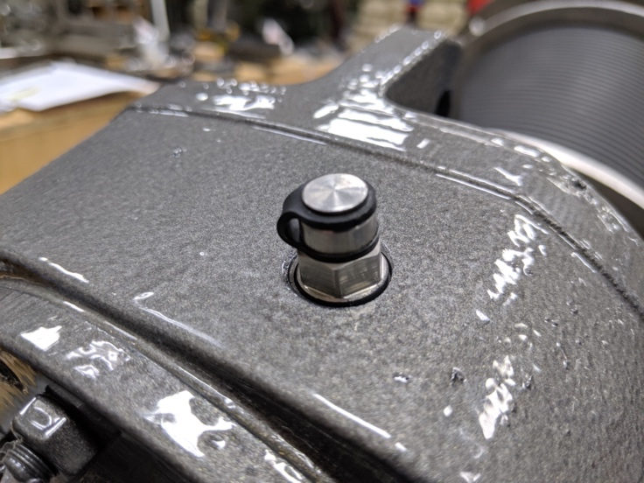
Figure 1. Breather Valve with Protective Band (in Black)
  - Wire the load discs or stands, control system, motors, E-Stop switch, and zero-speed switch(es) per the details provided in Appendix A: Catalog Cuts and Appendix E: Controls (if controls have been provided by JMS).
  - [Wire all Bio-GATE actuators according to the details provided in the separate JMS Bio-GATE O&M manual.]
  - [Wire the level sensors according to the detailed provided in Appendix A: Catalog Cuts.]

- Final Installation Inspection
  - Verify that the Bio-HOPPER and load discs or stands have remained level throughout the installation process via a machinist level or similar device. Re-level the Bio-HOPPER at the load discs or stands if necessary using the manufacturer’s instructions provided in Appendix A: Catalog Cuts.
  - Verify that the equipment has been installed as detailed on the drawings.
  - Verify that all tools and any foreign materials have been removed from the Bio-HOPPER.
  - Lubricate the bearings and seals according to the information provided in Section 6.3 - Lubrication.
  - Verify that all safety labels are firmly affixed to the Bio-HOPPER components and visible.
  - Before processing any material, turn on the Bio-HOPPER screws and inspect the freedom of rotation of the entire screws using a dial indicator or similar tool. Total shaft indicator runout at the bearing should not be greater than 0.030 inches. If runout is greater than 0.030 inches, straighten the bent screw assembly. Consult JMS personnel using the contact information provided in this O&M manual if straightening the screw assembly does not correct the problem.
  - Grout beneath the Bio-HOPPER support columns using non-shrink grout as detailed on the drawings. Grout is not provided by JMS.

Operating Procedures

General Equipment Operation
The JMS Bio-HOPPER is a material storage solution in which material is temporarily contained before being discharged to a downstream process by plant operators at an appropriate time and rate. Bio-HOPPERs are generally rectangular or square storage vessels tailored to specific plant needs. Material is loaded into the Bio-HOPPERs by upstream processes from above, contained in the Bio-HOPPER for the desired duration (such as until the Bio-HOPPER is full or all material has been fed from upstream processes), and finally discharged through the bottom of the Bio-HOPPER through activation of Bio-HOPPER discharge mechanisms, including gates or valves. When the Bio-HOPPER discharge mechanisms are off or closed and upstream processes are running, material will collect in the Bio-HOPPER. When the Bio-HOPPER discharge mechanisms are on or open, material will be directed to the downstream processes.

The lower assembly of the Bio-HOPPER consists of a live bottom, which includes electrically-operated horizontal screws. The live bottom is utilized to intentionally and equally distribute material to the specified discharge location(s).

[The upper assembly of the Bio-HOPPER features an electrically-operated horizontal leveling screw (or multiple screws as applicable). A leveling screw is utilized as material enters the Bio-HOPPER from upstream feed equipment to equally distribute material throughout the vessel.]

Bio-HOPPERs are designed with many configurations, capacities, discharge mechanisms, construction methods, and ancillary components to provide a wide range of effective material storage solutions.

Because Bio-HOPPERs are often interconnected to other upstream and downstream equipment, proper operation of the Bio-HOPPER—particularly shutdown—may require similar actions to other equipment in the system to prevent damage to equipment or spillage of material.

Generally external devices such as load discs or stands or level sensors are provided to notify operators when the Bio-HOPPER is full. Bio-HOPPER level can also be visually observed at available access points assuming appropriate safety procedures are observed.

Initial Startup
When starting the equipment for the first time or after an extended shutdown, perform the following procedures. Note that an operator must be standing by the Bio-HOPPER and associated component control systems to stop the system in case of emergency.

- Visually inspect the Bio-HOPPER and any associated equipment for damage. Notify JMS using the contact information provided herein if damage is observed.
- Verify that all preventative maintenance and lubrication procedures have been completed as directed in Section 6 - Maintenance, Lubrication, & Troubleshooting.
- Verify that the E-Stop switch flag arm is in the non-tripped position (i.e. NOT upright).
- Verify that all personnel are clear of the equipment and that all obstructions have been removed from the Bio-HOPPER system, especially feed and discharge locations. Do not operate the Bio-HOPPER until all obstructions have been safely cleared.
- Verify that all covers, guards, safety devices, and controls are installed and operating correctly.
- Verify that the Bio-HOPPER discharge is clear.
- Start all electrically-actuated Bio-HOPPER components by placing the control switches in the “ON” or “AUTO” position and operating the equipment according to the procedures detailed in Appendix E: Controls (if controls have been provided by JMS).
- Allow the Bio-HOPPER components to operate empty for a maximum of five minutes. Operating the Bio-HOPPER empty longer than five minutes may cause equipment damage.
- Observe all Bio-HOPPER equipment components for the following:
  - Overheating of the bearings
  - Unusual noises
  - Gear reducer/motor oil leakage and/or overheating (surface temperature of the gear reducer/motor should be less than 104º F).
  - Rough operation
- Operate the Bio-HOPPER discharge gates according to the information provided in [Appendix A: Catalog Cuts][the separate JMS Bio-GATE O&M manual] and inspect for proper operation.
- If any of the abnormalities from previous Step 9 are noted, refer to the appropriate maintenance actions and/or troubleshooting procedures provided in Section 6 - Maintenance, Lubrication, & Troubleshooting.

Startup
During startup, an operator must be standing by the Bio-HOPPER and associated component control systems to stop the system in case of emergency. Perform the following procedures:

- Visually inspect the Bio-HOPPER and any associated equipment for damage. Notify JMS using the contact information provided herein if damage is observed.
- Verify that all preventative maintenance and lubrication procedures have been completed as directed in Section 6 - Maintenance, Lubrication, & Troubleshooting.
- Verify that the E-Stop switch flag arm is in the non-tripped position (i.e. NOT upright).
- Verify that all personnel are clear of the equipment and that all obstructions have been removed from the Bio-HOPPER system, especially feed and discharge locations. Do not operate the Bio-HOPPER until all obstructions have been safely cleared.
- Verify that all covers, guards, safety devices, and controls are installed and operating correctly.
- Verify that the Bio-HOPPER discharge is clear.
- Verify that all discharge gates are in the desired position for the intended operation. Refer to [Appendix A: Catalog Cuts][the separate O&M manual for JMS Bio-GATEs] for detailed information.
  - It is recommended that all discharge gates are closed while the live bottom is off and the Bio-HOPPER is being filled.
  - It is recommended that at least one discharge gate is open when the live bottom screws are in operation.
- [Verify that the pumps associated with the Bio-HOPPER loadout connection are prepared to process material. Note that it is not recommended that the Bio-HOPPER live bottom screws be in operation without simultaneously operating the discharge pumps.]
- If there is no material in the Bio-HOPPER, start upstream feed equipment to allow material to gather in the Bio-HOPPER for several minutes if possible. If it is not possible to feed material prior to starting the Bio-HOPPER screws, do not operate the screws while the Bio-HOPPER is empty for longer than five minutes. Operating the Bio-HOPPER empty longer than five minutes may cause equipment damage.
- Start the Bio-HOPPER live bottom screws by placing the associated control switches in the “ON” or “AUTO” position and operating the screws according to the procedures detailed in Appendix: E - Controls (if controls have been provided by JMS).
- Gradually continue to feed material into the Bio-HOPPER via upstream feed equipment.
  - The feed rate should start low and be gradually increased until the specified design capacity is reached. The intended Bio-HOPPER feed rate is detailed on the drawings.
  - Do not overload the Bio-HOPPER or otherwise exceed the equipment speed, capacity, volume, material density, or rate of flow for which the Bio-HOPPER and associated equipment were designed.
- [Note that the leveling screw should not be started until material has built up in the Bio-HOPPER to the height of the leveling screw.
  - If controls have been provided by JMS, refer to Appendix E: Controls for any relevant information regarding automatic leveling screw controls.
  - The leveling screw can also be started manually.]

Shutdown (Empty Hopper)
When it becomes necessary to shut down the equipment, perform the following procedures. Please note that the following procedures are intended to be for normal shutdown only and assume that all material can be discharged from the Bio-HOPPER. During a situation in which all material may not be discharged from the Bio-HOPPER or an emergency shutdown, proceed to the instructions included in Section 5.5 - Shutdown (Material in Hopper) and Section 5.6 - Shutdown (Alarm Condition) respectively.

- Shut down all upstream feed equipment according to the appropriate standard operating procedures.
- Allow the Bio-HOPPER to continue running until all material has been discharged from the equipment.
  - In the event that system controls will not permit this operation with the control switches in the “AUTO” position, the control switches may be placed in the “MANUAL” position to allow for manual adjustment. Refer to Appendix E: Controls if controls have been provided by JMS.
  - [Verify that the pumps associated with the Bio-HOPPER loadout connection are stopped according to plant standard operating procedures after all material has been processed.]
  - [Note that the leveling screw motor should be stopped after material no longer reaches the height of the leveling screw inside the Bio-HOPPER. The leveling screw may be programmed to stop automatically; otherwise, the leveling screw can be stopped manually. Refer to any relevant information in Appendix E: Controls if controls have been provided by JMS).]
- Stop the motor for all Bio-HOPPER equipment.
- Verify that the [slide][knife] gates are in the desired position for shutdown. Manipulate the gate position via the associated actuator if needed. [Refer to the separate O&M manual for JMS Bio-GATEs for detailed information.]
- LOTO all power to the Bio-HOPPER system.
- Inspect the Bio-HOPPER bolts and alignments, realigning and tightening as necessary.
- In the event of an expected extended shutdown (longer than 30 days), the following additional procedures should be performed:
  - Rotate all Bio-HOPPER screws one and a half (1.5) rotations every two weeks. Screw rotation can be performed by bumping the motor or disengaging the motor and rotating the screw by hand.
  - Adhere to all procedures for equipment storage included in Section 3.3 - Storage and any additional component manufacturer recommendations detailed in Appendix A: Catalog Cuts. This includes but is not limited to proper lubrication and protection of the motor.

Shutdown (Material in Hopper)
If the Bio-HOPPER requires shutdown while material is still contained in the Bio-HOPPER, perform the following procedures. Please note that the following procedures are intended to be for shutdown in which material will remain in the Bio-HOPPER. During a normal shutdown in which all material can empty from the Bio-HOPPER or an emergency shutdown, proceed to the instructions included in Section 5.4 - Shutdown (Empty Hopper) and Section 5.5 - Shutdown (Alarm Condition) respectively.

      - Stop the motor for all Bio-HOPPER equipment.
- [Note the following exception: the leveling screw may be allowed to run while the Bio-HOPPER is filling once material reaches the height of the leveling screw inside the Bio-HOPPER.]
      - [Verify that the pumps associated with the Bio-HOPPER loadout connection are stopped according to plant standard operating procedures.]
      - Close the [slide][knife] gates via the associated actuation device. [Refer to the detailed instruction provided in the separate JMS Bio-GATE O&M manual.]
      - [Turn off the power to the gate actuators. Refer to the detailed instruction provided in the separate JMS Bio-GATE O&M manual.]
      - Upstream feed equipment may continue to run and fill the Bio-HOPPER with material until the Bio-HOPPER is full. Visually observe the filling process so the Bio-HOPPER does not overflow.
- [Note that the leveling screw may be allowed to run while the Bio-HOPPER is filling once material reaches the height of the leveling screw inside the Bio-HOPPER.]
      - If upstream feed equipment is still running, shut down the equipment according to the appropriate standard operating procedures when the Bio-HOPPER is full or at the desired level.

Shutdown (Alarm Condition)
The Bio-HOPPER live bottom screws (and other equipment if interlocked via the control system; refer to Appendix E: Controls if controls have been provided by JMS) may be stopped at any time by activating the E-Stop safety device associated with the screws. If the E-Stop safety device was the source of the emergency shutdown, perform the following actions:
- Shut down all upstream feed equipment and any other interconnected equipment according to the appropriate standard operating procedures.
- Stop the motor for all Bio-HOPPER equipment by turning the appropriate control switches to the “OFF” position.
- [Verify that the pumps associated with the Bio-HOPPER loadout connection are stopped according to plant standard operating procedures.]
- Close the [slide][knife] gates via the associated actuation device or, if not possible for electrically actuated equipment, the actuator’s manual handwheel. [Refer to the detailed instructions provided in the separate JMS Bio-GATE O&M manual.]]
- LOTO all power to the Bio-HOPPER system.
- Identify and rectify the cause of the E-Stop alarm by visually checking the equipment.
- Visually inspect the equipment for damage and address as necessary according to the details provided in Section 6 - Maintenance, Lubrication, & Troubleshooting.
- Reset the switch flag arm to the non-tripped position (i.e. NOT upright).
- At the control panel, select the “ALARM RESET” button.
- To restart the equipment, turn the control switches to the “ON” position (or “AUTO” position as appropriate). Return to the normal shutdown procedures included in Section 5.4 - Shutdown (Empty Hopper) when appropriate.

The Bio-HOPPER live bottom screws [and leveling screw(s)] have been supplied with a zero-speed switch that shuts down power to the associated motor(s) if motion is lost (and other equipment if interlocked via the control system; refer to Appendix E: Controls if controls have been provided by JMS). If the zero-speed switch was the source of the emergency shutdown, perform the following actions:
- Shut down all upstream feed equipment and any other interconnected equipment according to the appropriate standard operating procedures.
- Stop the motor for all Bio-HOPPER equipment by turning the control switches to the “OFF” position.
- [Verify that the pumps associated with the Bio-HOPPER loadout connection are stopped according to plant standard operating procedures.]
- Close the [slide][knife] gates via the associated actuation device or, if not possible for electrically actuated equipment, the actuator’s manual handwheel. [Refer to the detailed instructions provided in the separate JMS Bio-GATE O&M manual.]
- LOTO all power to the Bio-HOPPER system.
- Identify and rectify the cause of the zero-speed switch alarm by visually checking the equipment.
- Visually inspect the equipment for damage and address as necessary according to the details provided in Section 6 - Maintenance, Lubrication, & Troubleshooting.
- At the control panel, select the “ALARM RESET” button.
- To restart the equipment, turn the control switches to the “ON” position (or “AUTO” position as appropriate). Return to the normal shutdown procedures included in Section 5.4 - Shutdown (Empty Hopper) when appropriate.

Maintenance, Lubrication, & Troubleshooting
While no special tools are required for working with the Bio-HOPPER system, care should be taken to avoid cross-contamination between carbon steel and stainless steel components when installing, maintaining, or otherwise working with the equipment or components. Please refer to the additional information about carbon steel contamination provided in Section 3.2.1 - Avoiding Cross-Contamination Between Materials.

Please note that not all individual components comprising the Bio-HOPPER system are crafted by JMS (as detailed on the Bill of Materials on the drawings). Although JMS has carefully developed this comprehensive O&M manual to summarize the recommended procedures for effectively maintaining the Bio-HOPPER system and its components as a whole, any and all maintenance, lubrication, and/or troubleshooting procedures from individual component manufacturers for their specific component should supplement or take precedence over the requirements listed herein. Manufacturer reference information, including that which is supplied in Appendix A: Catalog Cuts, should always be referenced during maintenance, lubrication, and troubleshooting procedures where available. If questions arise over the proper maintenance, lubrication, and/or troubleshooting procedures, please contact JMS using the contact information provided in this O&M manual.

Preventative Maintenance
Before any maintenance or inspection is performed, refer to ANSI/ASSP Z244.1-2016 for minimum safety requirements concerning energy sources.

Practice good housekeeping. Keep the area around the equipment clean and free of obstacles to provide easy access. Establish routine periodic inspections of the equipment to ensure continuous maximum operating performance.

A basic maintenance tool kit is all that is required to maintain this equipment. No special tools are necessary.

Table 2. Bio-HOPPER Preventative Maintenance
Component | Recommended Maintenance | Frequency
Screws | Check the screw and associated motor for any unusual noises or vibrations. | Daily
Screws | Inspect for material spillage at inlet(s) and outlet(s). Clean any spills as required. Find cause of spillage and correct. | Daily
Screws | Visually inspect the shaft seals on either end of the screw shaft for any leakage. Refer to Section 6.4 - Troubleshooting if leaks are observed. | Daily
Screws | Visually inspect the couplings at both ends of the screw shaft for evidence of excessive movement. | Quarterly
Screws | Visually inspect the cross holes at both ends of the screw shaft for evidence of elongation. | Quarterly
Screws | Inspect the coupling bolts and other associated hardware at both ends of the screw for evidence of damage or looseness. | Quarterly
Screws | Visually inspect the screw shaft and trough along its entire length for evidence of damage. This may require opening associated protective covers. | Quarterly
Screws | Visually inspect the screw flights for evidence of wear and/or an inappropriate wear pattern. This may require opening associated protective covers. | Quarterly
Screws | [Inspect trough liner for wear. Replace the liner if wear exceeds ¼”. | As able when other equipment maintenance is performed on the live bottom screws such that the liner is visible]
External Hardware | Inspect all bolts and anchors associated with the Bio-HOPPER and secure any that are loose. Refer to the guidance provided in Section 4 - Installation Instructions regarding proper hardware tightening. | Quarterly
SEW Eurodrive Gear Reducer | Check oil level. Refer to Section 6.3 - Lubrication. | Every 3,000 operating hours or every 6 months, whichever is sooner
SEW Eurodrive Gear Reducer | Drain and refill the oil according to the information and schedule provided in Section 6.3 - Lubrication. | Every 8,000 operating hours or every 3 years, whichever is sooner
[Motor | Relubricate the motor bearings according to the details provided in Section 6.3 - Lubrication. | Refer to the interval provided in Section 6.3 - Lubrication.]
Screw Roller Bearing | Lubricate the bearing according to the details provided in Section 6.3 - Lubrication. | Refer to the interval provided in Section 6.3 - Lubrication.
[Screw Hanger Bearing | Lubricate the bearing according to the details provided in Section 6.3 - Lubrication. | Refer to the interval provided in Section 6.3 - Lubrication.]
[Screw Hanger Bearing | Inspect bearings for wear. If wear exceeds 1/8”, replace the bearing. | Quarterly]
Packing Gland Seal | Relubricate the seal according to the details provided in Section 6.3 - Lubrication. | Refer to the interval provided in Section 6.3 - Lubrication.

Corrective Maintenance
There are no recommended corrective maintenance procedures for the Bio-HOPPER.

Lubrication
Please refer to Figure 2 through Figure 4 for details about gear reducer mounting position and locations of components relating to the lubrication system. Please note that while the diagram shown in Figure 2 is sourced from the SEW Eurodrive O&M manual and is representative of the gear reducer provided for the project, the pictures provided in Figure 3 and Figure 4 are meant to serve as examples only and may not reflect the exact gear reducer or hardware orientation provided for this project.

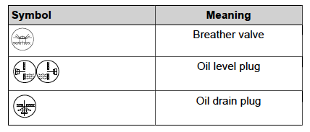
[INSERT PIC OF MOUNTING POSITION FROM SEW MANUAL]
Figure 2. SEW Eurodrive Mounting Position "XXX" and Location of Lubrication Components
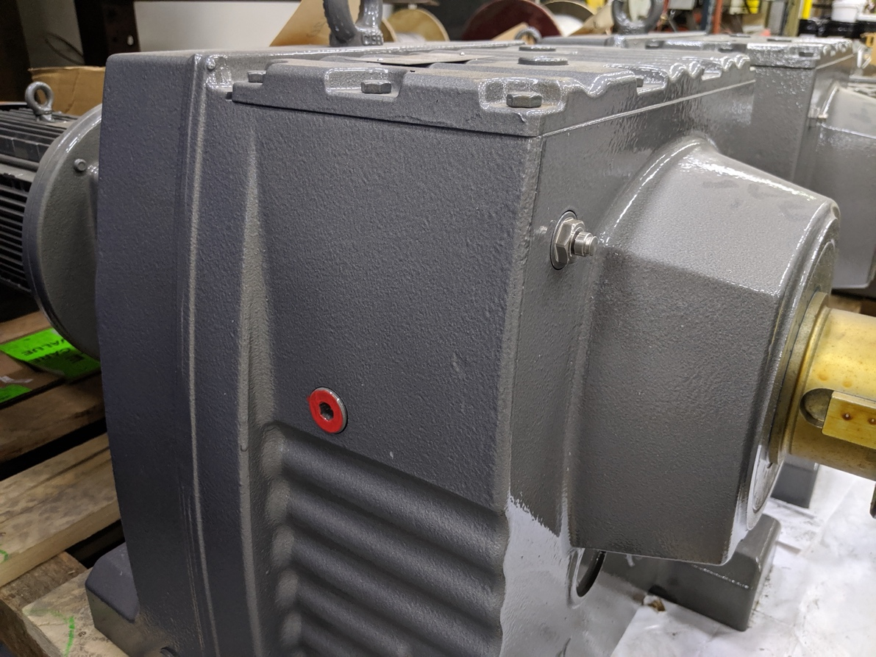
OIL LEVEL PLUG
BREATHER VALVE (PROTECTIVE BAND REMOVED)
Figure 3. Oil Level Plug (Painted Red) and Breather Valve (Protective Band Removed) (FOR REFERENCE ONLY)
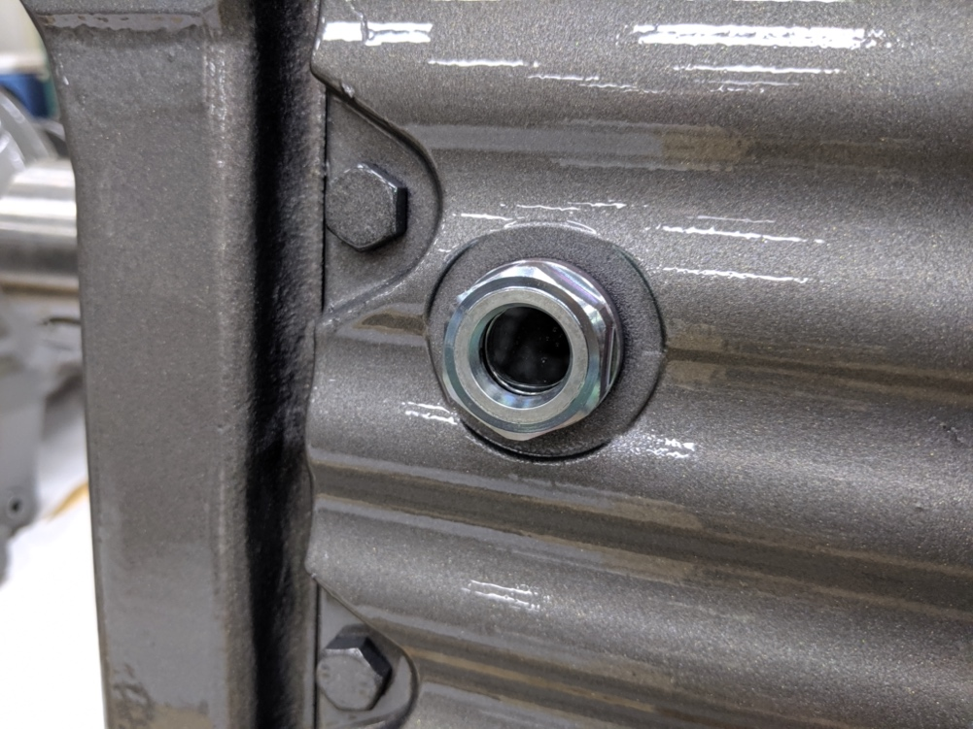
Figure 4. Example Sight Glass in Lieu of Oil Level Plug (If Applicable) (FOR REFERENCE ONLY)
A lubrication schedule for all Bio-HOPPER components is included in Table 3. Only check or change the oil when the gear reducer is not in operation and has had sufficient time to cool down to maintain safety and ensure proper measurement. While checking the oil, ensure that a container is placed beneath the oil level plug to capture small amounts of oil that may leak out. When changing the oil, ensure that oil is contained and disposed of in a proper manner.

Table 3. Bio-HOPPER Component Lubrication Requirements
Component | Activity | Interval | Quantity | Recommended Grease
SEW Eurodrive Gear Reducer (Live Bottom) | Check oil level. | Every 3,000 operating hours or every 6 months, whichever is sooner | Refill to an acceptable level according to Figure 5. | See requirements for oil change below
SEW Eurodrive Gear Reducer (Live Bottom) | Drain oil and refill to oil level plug or sight glass. Refer to previous Figure 3 and Figure 4. | Every 8,000 operating hours or every 3 years, whichever is sooner | X | Recommended oil is listed on the SEW Eurodrive gear unit nameplate; if a specific brand is not listed, utilize the SEW Eurodrive brand oil for the listed oil type.
[Motor (Live Bottom) | Drain oil and refill according to the manufacturer’s procedure included within Appendix A: Catalog Cuts. | Refer to the interval (if any) provided in the manufacturer’s information within Appendix A: Catalog Cuts | Refer to the quantity (if any) provided in the manufacturer’s information within Appendix A: Catalog Cuts. | Refer to the recommended grease type (if any) provided in the manufacturer’s information within Appendix A: Catalog Cuts.]
[SEW Eurodrive Gear Reducer (Leveling Screw) | Check oil level. | Every 3,000 operating hours or every 6 months, whichever is sooner | Refill to an acceptable level according to Figure 5. | See requirements for oil change below
[SEW Eurodrive Gear Reducer (Leveling Screw) | Drain oil and refill to oil level plug or sight glass. Refer to previous Figure 3 and Figure 4. | Every 8,000 operating hours or every 3 years, whichever is sooner | X | X]
[Motor (Leveling Screw) | Drain oil and refill according to the manufacturer’s procedure included within Appendix A: Catalog Cuts. | Refer to the interval (if any) provided in the manufacturer’s information within Appendix A: Catalog Cuts | Refer to the quantity (if any) provided in the manufacturer’s information within Appendix A: Catalog Cuts. | Refer to the recommended grease type (if any) provided in the manufacturer’s information within Appendix A: Catalog Cuts.]
Screw Roller Bearing | Refill the automatic lubrication system (if provided) according to the information provided within Appendix A: Catalog Cuts or otherwise relubricate the roller bearing. | Every 3 months | Until grease just purges from the bearing | Lithium complex-base grease (or a grease which is compatible with NLGI #2 lithium complex base grease)
[Screw Hanger Bearing | Refill the automatic lubrication system (if provided) or otherwise refer the information provided within Appendix A: Catalog Cuts regarding any applicable lubrication requirements. | Refer to the interval (if regreasing is required) provided in the manufacturer’s information within Appendix A: Catalog Cuts. | Refer to the quantity (if regreasing is required) provided in the manufacturer’s information within Appendix A: Catalog Cuts. | Refer to the recommended grease type (if regreasing is required) provided in the manufacturer’s information within Appendix A: Catalog Cuts.]
Packing Gland Seal | If the seal has a grease fitting, replenish grease. Otherwise, no action needed. | As required based on operation, at least quarterly. | Until grease just purges from the fitting. | Grease compatible with plant processing requirements.

When checking the oil at the SEW Eurodrive gear reducer, utilize Figure 5 to determine the proper oil level at the oil level plug. Figure 5 has been adapted from the SEW Eurodrive O&M manual. The oil level plug should be removed to properly check the oil.

If a sight glass has been provided in the place of an oil level plug, the oil level can be checked visually through the sight glass without removing the sight glass. An example of a sight glass in lieu of an oil level plug is shown in previous Figure 4.

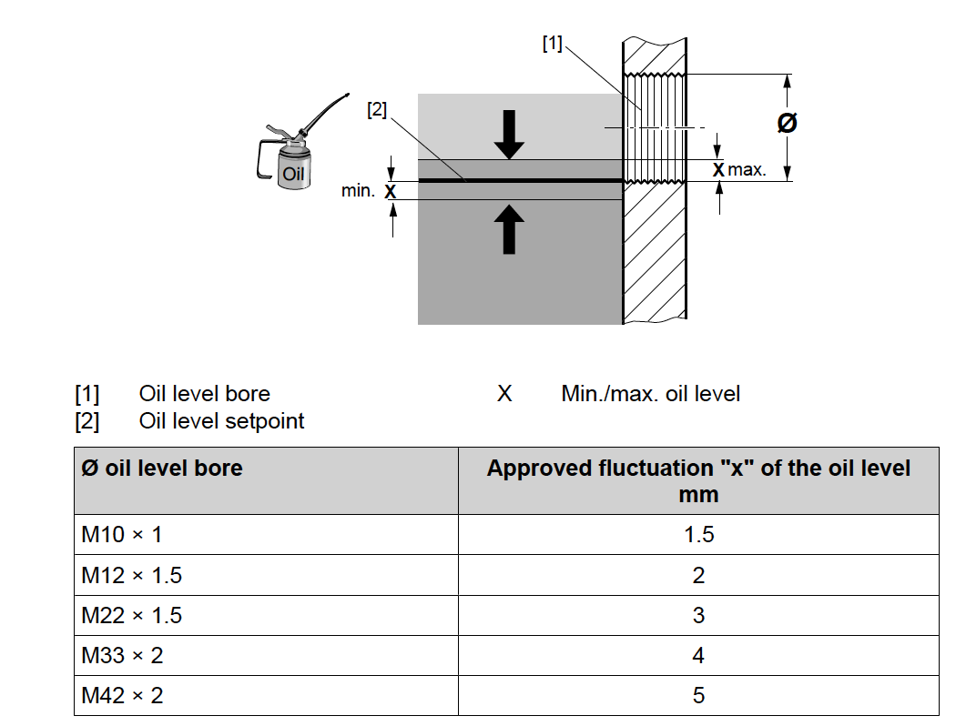
Figure 5. SEW Eurodrive Diagram for Checking Oil Level

If the oil is too low at the SEW Eurodrive gear reducer during a routine oil level check, perform the following steps:
- Remove the breather valve from the breather bore. Refer to previous Figure 2.
- Remove the oil level plug. Refer to previous Figure 3. If a sight glass has been provided, the sight glass does not need to be removed. Refer to previous Figure 4.
- Add oil of the same type via the breather bore up to the lower edge of the oil level bore.
- Replace the breather valve and screw the valve tight to a torque of xxx lb-ft (xxx Nm).
- Replace the oil level plug and tighten to a torque of xxx lb-ft (xxx Nm).

[The motor bearings are sealed for life and therefore do not have any lubrication requirements.]

Troubleshooting
Table 4. Bio-HOPPER Troubleshooting
Problem | Probable Cause | Solution
Screws are not operating | Screws are not receiving a run signal | Check controls (refer to Appendix E: Controls if controls have been provided by JMS) and verify that a run signal is being transmitted to the screws.
Screws are not operating | The E-Stop switch flag arm is in the tripped (i.e. upright) position | Reset the E-Stop switch flag arm to the non-tripped position (i.e. NOT upright).
Screws are not operating | Issue with other permissive control | Check other permissive controls such as zero-speed switches for proper operation and positioning.
Screws are not operating | Screws are not receiving power | Following all proper plant SOPs and LOTO procedures, verify that there is power at the motor.
Screws are not operating | Screws are jammed | LOTO power to the screws and manually clear material jams from the screws.
Screws are not operating | Motor failure | Notify JMS using the contact information provided in this O&M for recommended procedures.
Screw motor trips out on overload | Too much material in the Bio-HOPPER | Inspect the Bio-HOPPER for proper loading. Verify that the Bio-HOPPER design capacities (including speed, capacity, volume, material density, and/or rate of flow) are not exceeded. Reduce loading as required upon next startup. The feed rate should start low and gradually increase.
Screw motor trips out on overload | Worn or failed bearing causing screw misalignment or allowing screw to contact the trough | Inspect bearings and screw alignment. Replace failed bearings as necessary.
Material leaks through the seal on the end of the screw | Seal is worn | Add two pumps of grease to the seal. Tighten the nuts on the follower one turn at a time in a cross-tightening sequence, wait one hour, and repeat the tightening procedure again if leakage is still observed. If leakage increases instead of decreases, the seal requires replacement.
Material is leaking through the bearing | End bearing failure | Replace the bearing.
Material is leaking through the bearing | Lack of lubrication at live bottom screw shaft end bearing | Ensure that all bearings are regularly lubricated according to the details provided in Section 6.3 - Lubrication.
Premature trough wear | High spot on trough as installed | Eliminate high spot by carefully manipulating the affected area of the trough until the dent has been removed and the screw no longer contacts the trough when rotated.
Premature trough wear | High spot on screw as installed | Eliminate high spot by grinding the screw flighting until the screw no longer contacts the trough when rotated.
Premature trough wear | Screw is bent | Replace or repair screw as needed. Notify JMS using the contact information provided herein if a replacement screw is needed. Repair may be performed by carefully removing the affected screw in its entirety, cutting out the bent portion of the screw, bracing the bent portion of the screw, realigning the bent portion of the screw, welding the entire screw back together, and replacing the corrected screw.
Holes at screw and shaft connection are elongated | Bio-HOPPER screws have been subjected to frequent jogging or start/stop overload shock | Avoid frequently starting and stopping the screws. Eliminate overload shock by not starting or initially feeding the Bio-HOPPER at full speed or design capacity. In the event of excessive elongation that causes the bolts to be extremely loose, contact JMS for guidance on whether full screw replacement is needed.
Unusual noises are observed from the screws | Worn or failed bearing causing screw misalignment or allowing screw to contact the trough | Inspect bearings and screw alignment. Replace failed bearings as necessary.
Screw “jumps” in the trough | [Screw hold downs are misadjusted | Adjust the screw hold downs such that there is only a small amount of clearance above the screws. Refer to the SA drawings for a visual of the proximity between the screws and screw hold downs.]
Screw “jumps” in the trough | Screw is bent | Notify JMS using the contact information provided in this O&M manual to determine the appropriate course of action. The screw may need to be straightened (to be performed by the manufacturer only) or totally replaced.

Policies

Warranty
All JMS equipment and/or materials are of high quality and are manufactured in conformity with the best commercial practices. JMS guarantees all equipment and materials manufactured or supplied by JMS to be free from defects in material and workmanship at the time of startup for a period of XXXXX. JMS will furnish without charge but will not install replacements for such parts and materials JMS finds to be defective.

This guarantee does not apply to any equipment which has been improperly handled or stored, improperly lubricated, subjected to misuse or neglect, misapplied with reference to the Engineer's Specifications, altered or tampered with, and/or damaged by corrective work performed without JMS’ specific written consent. No allowances will be made for such corrective work done without such consent.

Deterioration by chemical action, improper maintenance, or normal wear does not constitute defects and are therefore not covered by this warranty. Additionally, consumable items are not covered by this warranty. All warranty claims must be submitted within ten (10) calendar days of discovery of defects or they will be deemed waived. The foregoing is in lieu of all other warranties, whether expressed or implied.

Liability
It is expressly understood that JMS’ liability for JMS products is limited to the furnishing of such replacement parts, and that JMS will not be liable for any other expense, injury, loss, or damage, whether direct or consequential, including but not limited to loss of profits, production, or increased cost of operation arising in connection with the sale or use of, or inability to use, JMS equipment and/or materials for any purpose except as herein provided.

In the event a customer's order form states any liability terms which are additional to or different from these set forth herein, this form must be acknowledged in writing by JMS to accept any liability set forth in such form(s).

Returns
All returns must be authorized by JMS, and no credit will be allowed for returned items that are damaged in transit, incomplete, or received in an unsatisfactory condition. All items that are not eligible for credit will be returned to customer via freight collect or discarded upon customer's instructions.

Delivery
Delivery dates represent only JMS’ best estimate of the time required to complete the work and ship the material from JMS’ plant. All orders are accepted with the understanding that shipping dates are approximate and subject to change because of factory conditions, fires, strikes, material shortages, civil or military authority, acts of God, or other causes beyond JMS knowledge or control.

Back charges against JMS for alterations, shortages, damage repair, and/or discrepancies will be accepted only with written prior approval from a duly authorized representative of JMS.

Thread Lubricant Information
All JMS bolts and anchors are stainless steel material unless otherwise specified. Without an application of thread lubricant, bolting materials may become locked together. JMS strongly recommends the use of NSF-61 approved thread lubricant on all stainless steel bolts and anchors.

Standard Erecting Practices
All fabricated equipment manufactured by JMS is shop checked for accuracy before shipment and should not present any erection problems. Due to specific field conditions, a reasonable amount of fit-up is considered standard erection practice. The use of tools such as “come-a-longs”, jacks, drift pins, and reamers is to be expected.

Standard erecting practice as defined by the AISC “Code of Standard Practice”, Section 7.14, states the following:

“The correction of minor misfits by moderate amounts of reaming, grinding, welding, or cutting, and the drawing of elements into line with drift pins shall be considered to be normal erection operations. Errors that cannot be corrected using the foregoing means, or that require major changes in member or connection configuration, shall be promptly reported to the ODRD, the ODRC, and the fabricator, by the erector, to enable the responsible entity to either correct the error or approve the most efficient and economical method of correction to be used by others.”

If a problem is traceable to JMS fabrication or engineering, JMS will work with you to resolve this problem. Back charges for replacing or correcting materials require prior written approval of an authorized JMS representative. The back charges will only be considered with prompt, complete cost documentation based on standard direct field labor hours and materials. Profit, overhead, and any other charges will not be allowed. Payment may be refused for corrective work without prior approval.

Problems other than minor misfits as defined by AISC 303 should be communicated in writing to JMS using the contact information provided in this O&M manual via the project’s non-conformance reporting procedure.

Appendix A: Catalog Cuts

Appendix B: Equipment Drawings

Appendix C: Calculations

Appendix D: Startup Reports

PLACEHOLDER

Startup reports will be completed and made available as appropriate.

Appendix E: Controls

Appendix F: O&M Revision History

Date | Rev. | Description of Change | Author
INSERT DATE (ONE LINE) MM/DD/YYYY | 0 | Initial release. | INSERT INITIALS

