

Bio-SCREW (Shaftless)
Tag Number/Serial Number/Customer Provided #

Operations and Maintenance Manual

PLANT NAME

LOCATION

Specification Section XX XX XX

Engineer of Record: XXXX

Revision X
MONTH YEAR
Table of Contents
Contact Information 5
1. Scope of Supply 6
1.1 Equipment Data 6
1.2 Special Tools 6
1.3 Field Service 6
1.4 Scope Exclusions 6
1.5 Spare Parts 6
2. Safety Precautions 7
2.1 Equipment-Specific Safety 7
3. Delivery, Handling, and Storage 9
3.1 Upon Equipment Arrival 9
3.2 General Handling and Storage Information 9
3.2.1 Avoiding Cross-Contamination Between Materials 10
3.3 Storage 11
3.3.1 General Requirements for Indoor Storage 12
3.3.2 General Requirements for Outdoor Storage 13
3.3.3 Gear Units 13
3.3.4 Electric Motors and Actuators 14
4. Installation Instructions 16
4.1 Before Installation 16
4.2 Detailed Installation Instructions 18
5. Operating Procedures 29
5.1 General Equipment Operation 29
5.2 Initial Startup 29
5.3 Startup 30
5.4 Shutdown 31
5.5 Shutdown (Alarm Condition) 31
6. Maintenance, Lubrication, & Troubleshooting 33
6.1 Preventative Maintenance 33
6.2 Corrective Maintenance 35
6.2.1 Liner Replacement Procedures 35
6.3 Lubrication 44
6.4 Troubleshooting 48
7. Policies 51
7.1 Warranty 51
7.2 Liability 51
7.3 Returns 51
7.4 Delivery 51
7.5 Thread Lubricant Information 52
7.6 Standard Erecting Practices 52

Table of Figures
Figure 1. Field Weld Detail for Shaftless Screw Flight 19
Figure 2. Verifying Screw Flight Alignment Using the Alignment Plate 20
Figure 3. Clamping and Preheating the Spiral Flight Joints 21
Figure 4. Example of a Proper Fit-Up/Open Root Gap Weld with Alignment Plate and Clamps Removed 22
Figure 5. Back Gouging 23
Figure 6. Welding on Alternating Sides 24
Figure 7. Proper Welding Practice (Stringer Passes and Underfill on Outside) 25
Figure 8. Improper Welding Practices (Underfill, Weave, Surface Profile) 26
Figure 9. Breather Valve with Protective Band (in Black) 27
Figure 10. Shaftless Bio-SCREW Covers - Removal 35
Figure 11. Shaftless Bio-SCREW Hold Downs - Removal 36
Figure 12. Shaftless Bio-SCREW Drive Shaft & Shaftless Spiral Flanged Connection - Disconnect 37
Figure 13. Shaftless Bio-SCREW Retainer Clips – Removal of Liner 39
Figure 14. Liner Removal Technique (Shaftless Spiral in Trough) 40
Figure 15. Liner Installation Technique (Shaftless Spiral in Place) 41
Figure 16. Shaftless Bio-SCREW Retainer Clips – Replacement of Liner 42
Figure 17. Shaftless Bio-SCREW Drive Shaft & Shaftless Spiral Flanged Connection - Reconnect 43
Figure 18. Shaftless Bio-SCREW Hold Downs - Replacement 44
Figure 19. Shaftless Bio-SCREW Covers - Replacement 44
Figure 10. SEW Eurodrive Mounting Position "XXX" and Location of Lubrication Components 45
Figure 11. Oil Level Plug (Painted Red) and Breather Valve (Protective Band Removed) (FOR REFERENCE ONLY) 45
Figure 12. Example Sight Glass in Lieu of Oil Level Plug (If Applicable) (FOR REFERENCE ONLY) 46
Figure 13. SEW Eurodrive Diagram for Checking Oil Level 47

List of Tables
Table 1. Typical Bolt Torque Chart 17
Table 2. Bio-SCREW Preventative Maintenance 33
Table 3. Bio-SCREW Component Lubrication Requirements 46
Table 4. Bio-SCREW Troubleshooting 48

List of Appendices
Appendix A: Catalog Cuts
Appendix B: Equipment Drawings
Appendix C: Calculations
Appendix D: Startup Reports
Appendix E: Controls
Appendix F: O&M Revision History


Contact Information
Local JMS Representative:
Rep Name
Company Name
Company Address
City, State Zip
(XXX)XXX-XXXX
JMS Project Manager:
PM Name Here
Jim Myers & Sons, Inc.
PO Box 38778
Charlotte, NC 28278
Phone: (704)554-8397
Fax: (704)554-9113

For general inquiries regarding field services, contact custsvc@jmsequipment.com.
For general inquiries regarding aftermarket parts, contact AMP@jmsequipment.com.

Scope of Supply
The JMS scope of supply includes X (Number) X (description from scope), also referred to herein as (a) “Bio-SCREW”(s). INSERT OTHER DETAILS ABOUT THE BIO-SCREWS FROM SCOPE HERE

The Bio-SCREW(s) is/are supplied with the following features:
- INSERT SCOPE OF SUPPLY FROM APPROVED SUBMITTAL, including everything not already mentioned in sentence above

Equipment Data
Please refer to the above Scope of Supply, the notes on the drawings included in Appendix B: Equipment Drawings, and the calculations included in Appendix C: Calculations for detailed Bio-SCREW equipment parameters.

Special Tools
While no special tools are required for working with the Bio-SCREW, care should be taken to avoid cross-contamination between carbon steel and stainless-steel components when installing, maintaining, or otherwise working with the equipment or components. Please refer to the additional information about carbon steel contamination provided in Section 3.2.1 - Avoiding Cross-Contamination Between Materials.

Field Service
The JMS scope of supply xxxxx INCLUDE FROM SCOPE XXX

Additional service trips and service days are available at an additional cost. Compensation is required for any additional visits caused by site delays that result in the inability to complete field services during scheduled site visits.

Before beginning equipment installation, schedule JMS field service site visits in advance using the contact information provided in this O&M manual. Site visits should be scheduled at least four weeks in advance.

Scope Exclusions
The following items are excluded from the JMS scope of supply:
- XXXXX INCLUDE FROM SCOPE XXX

Spare Parts
The JMS scope of supply includes the following spare parts. Please note that a complete table of spare parts is also included on the GA drawings.
- Insert as necessary, otherwise can simply say spare parts aren’t included for this project and remove all this text

Safety Precautions
Safety must always be considered a basic factor in machinery operation. Most accidents are the result of carelessness or negligence. The following safety instructions are basic guidelines and should be considered as minimum provisions. Please note that not all precautions are applicable to all equipment components. Additional information should be obtained by the purchaser from other sources, including the latest editions of American Society of Mechanical Engineers Standards ANSI B20.1, ANSI B11.0, and ANSI A1264.1, as well as ANSI/ASSP Z244.1-2016.

It is the responsibility of the Contractor, installer, Owner, and user to install, maintain, and operate the equipment components and assemblies manufactured and supplied by JMS in such a manner as to comply with the Williams-Steiger Occupational Safety and Health Act. Furthermore, all parties should comply with all state and local laws and ordinances, as well as the American National Standards Institute Safety Code.

It is extremely important to follow the below precautions to prevent personal injury or property damage:

- Only persons properly trained and familiar with JMS equipment should be permitted to operate or maintain the unit.
- LOCK OUT/TAG OUT ALL POWER prior to any inspection or maintenance.
- Periodically run the equipment for a few minutes to check for excessive vibration, loose fasteners, security of covers and guards, noise, and bearing and gearmotor temperature.
- ALWAYS operate the equipment with covers, guards, and safety labels in place.
- NEVER walk on or across equipment covers, guards, or grating.
- DO NOT place hands, feet, or clothing in equipment openings.
- DO NOT poke or prod the equipment or material in the equipment.
- ALWAYS practice good housekeeping to maintain a clear view of the equipment and all safety devices.

Equipment-Specific Safety
Please follow all local safety regulations when working around the Bio-SCREW. Additional safety requirements are outlined below.

- Follow all plant and industry LOCK OUT/TAG OUT (LOTO) procedures and practices throughout the handling, installation, commissioning, startup, and maintenance of the Bio-SCREW. This protects installation personnel from the unexpected release of all forms of potential energy. Equipment should be locked out in such a manner that the equipment cannot be restarted by anyone, including employees that are remote from the area. Other secondary devices should not be used as a substitute for locking out equipment power.
- Follow all plant and industry confined space procedures and practices throughout the handling, installation, commissioning, and startup of the Bio-SCREW.
- Observe all posted safety labels while working on or around the Bio-SCREW.
- The exposed screw and moving parts can cause severe injury; follow all plant and industry LOTO procedures and practices while working on or around the Bio-SCREW and its components, including prior to the removal of any guards, railings, or covers for inspection or service.
- Operate the Bio-SCREW only when all approved covers, railings, and guards are in place.
- Keep clothing, body parts, and hair away from the screws.
- Block any gravity loads prior to performing inspections or maintenance procedures.
- Clean up spillage or adhered solids near or on moving parts only when the equipment is locked out and all necessary covers, railings, and guards are in place.
- Do not modify the controls unless explicitly directed.
- Verify that all controls are visible and accessible at all times.
- Report any unsafe conditions.
- Do not use the Bio-SCREW or any of its components for a purpose other than that for which it was intended. Do not attempt field modification of the Bio-SCREW or any of its components.
- Do not poke or prod material into the Bio-SCREW or any of its components via a bar or stick inserted into its openings during normal operation. Do not attempt to clear a jammed conveyor until the equipment has undergone appropriate LOTO procedures.
- Do not overload the Bio-SCREW or otherwise exceed the equipment speed, capacity, volume, material density, or rate of flow for which the Bio-SCREW and gearmotor were designed.
- Do not utilize the Bio-SCREW for any application other than that for which it was designed.

Delivery, Handling, and Storage

Upon Equipment Arrival
Although all possible precautions are taken to protect equipment against damage or losses during shipment, before accepting the shipment, check all items against the packing list for shortages and inspect for evidence of physical damage. In either case, immediately notify JMS using the contact information included herein. Keep a record of all claims and correspondence. Photographs are recommended.

As detailed and agreed upon in the original contract and purchase order, all equipment and components delivered to the receiving location should be inspected immediately. A full and complete inspection report noting any visible damage must be transmitted to JMS within ten (10) days of the delivery date. If a written report is not received by JMS within this period, it will be conclusively assumed that the equipment was received in good condition and meets the requirements of the purchase order and/or equipment specification. Failure to submit a full and complete inspection report in the time constraints dictated herein constitutes unqualified acceptance by the buyer or customer, and the buyer or customer waives any rights to rejection or remediation of the delivered equipment.

Do not remove protective covers unless there are indications of damage. Boxes opened for inspection and inventory should be carefully repackaged to ensure protection of the contents, or the parts should be stored in a safe place. Refer to Section 3.3 - Storage. Examine all packing boxes, wrappings, and covers for items that may be attached to them, especially if these items are to be discarded.

General Handling and Storage Information
Upon completion of the initial inspection, the equipment should be moved from the delivery truck to temporary storage (refer to Section 3.3 - Storage) or immediately installed (refer to Section 4 - Installation Instructions). When maneuvering the equipment, go slowly and use extreme caution. Watch for accidental damage caused during handling and document any issues. It is the responsibility of the handler and installer to ensure that appropriate measures are taken to prevent damage to the equipment during handling and installation.

Provided in the following sections are instructions for handling and storing the equipment. These instructions are intended to cover the basics but will not cover every conceivable situation. Use good judgment when handling and working with the equipment.

Unless otherwise noted, lifting lugs or spreader bars with slings are the recommended support method for lifting all equipment in instances where equipment components cannot be moved manually due to weight or other constraints. When utilized, the unsupported span of spreader bars should be no longer than 12 feet. Do not attempt to lift any equipment from only one support point. When support locations or lifting lugs are not specified on the drawings, support locations must be carefully selected with consideration to the overall equipment weight distribution (i.e. consider the positioning of unusually heavy items such as gearmotors or gates). Support points should be selected such that optimal load balance is achieved to avoid bending or other damage to the equipment.

Please refer and adhere to any additional best practices for screw conveyors as detailed in all applicable CEMA standards, including ANSI/CEMA Standard No. 350 “Screw Conveyor for Bulk Materials” and ANSI/CEMA Standard 353 “Shaftless Screw Conveyor Safety Operation and Maintenance Manual”.

    - Avoiding Cross-Contamination Between Materials
This equipment is partially or wholly constructed from corrosion-resistant stainless steel. The Owner and/or installer must protect the equipment against damage to and/or contamination of the stainless steel’s protective oxide layer by taking all necessary precautions to prevent stainless steel equipment from coming in contact with any carbon steel or carbon steel dust throughout the handling, installation, commissioning, and startup of the system. Failure to protect stainless steel equipment from damage to and/or contamination of its protective oxide layer will void the manufacturer’s material warranty.

As a general practice, keep carbon steel components separate from stainless steel components. Avoid stacking components in a manner such that carbon steel and stainless steel will be in contact. While not an exhaustive list, protect stainless steel equipment from the following forms of carbon steel:

- Truck beds
- Forklifts
- Cables
- Chains
- Tools
- Wire brushes
- Grinding wheels
- Grinding dust
- Nylon lifting straps

If work on any carbon steel components is being performed on site near the storage area for this project, cover stainless steel components with tarps or paper to protect them from coming in contact with carbon dust particles. If work is being performed indoors, fans should be used to keep carbon steel dust from falling onto stainless steel components. If work is being performed outdoors, position the work involving carbon steel such that it is located downwind of the stainless steel component storage area.

Select tools for installation and maintenance of the stainless steel equipment that are stainless or non-magnetic. Tools made of aluminum bronze, chrome alloys, or stainless alloys are examples of acceptable tool materials. Ensure the tools selected meet the torque requirements for the equipment as detailed on Table 1 in Section 4.1 - Before Installation and the drawings.

Lifting straps previously used for handling carbon steel should not be used to handle stainless steel equipment components. If there is no method for tracking which material the lifting straps may have handled previously, new lifting straps should be used.

Because a thin layer of chrome oxide naturally forms on the surface of stainless steel, stainless steel resists corrosion. During welding and machining operations, the chrome oxide layer can be damaged. To rebuild this corrosion-resistant layer, pickling and passivation in accordance with ASTM A380 and A967 are conducted on necessary parts of the equipment before it leaves JMS. However, if the corrosion-resistant layer is further breached by installation and/or handling practices, iron particles may be introduced. The introduction of these particles may lead to the appearance of surface corrosion on the stainless steel component. In the majority of JMS equipment, the surface corrosion is merely aesthetic in nature and does not have any impact on equipment performance. However, these issues can be mitigated or prevented entirely during installation by following the guidance included in this O&M manual.

Some surface corrosion is practically unavoidable over time for most plants due to the environment in which the equipment will be used. Chemicals such as chlorine can introduce corrosion to stainless steel components without the presence of iron particles, and a damp environment can propagate surface corrosion over time. Most corrosion does not have a performance impact on the equipment over its operational life assuming suitable performance characteristics have been specified. Contact JMS using the contact information provided in this O&M manual if concerns arise about the presence of surface corrosion on JMS equipment.

If surface corrosion is noted on stainless steel and needs to be removed, perform the following steps:
- Clean the affected area thoroughly with a clean rag to remove any moisture on the surface.
- Remove the corrosion from the contaminated area with an abrasive pad that is appropriate for working with stainless steel.
- Treat the abraded area with a local passivation chemical. JMS recommends the use of CitriSurf 2310.

Storage
Please note that the equipment storage instructions provided herein are the JMS standard requirements for all equipment and cover a variety of components comprehensively. Some instructions may not apply to the equipment covered in this O&M manual. Please disregard any instructions that clearly do not apply. In the case where a vendor O&M manual has been attached to this O&M manual and includes more stringent and/or differing equipment storage requirements, please adhere to the vendor O&M manual instructions. Failure to comply with these equipment storage instructions may void any and all warranties for the equipment.

After the equipment has been checked for any transit damage, JMS recommends the following procedures for equipment storage. Storage refers to the period of time following shipment but prior to installation in which the equipment or component must be protected from damage. For the purposes of this O&M manual, the following requirements are intended to apply when equipment is stored for 30 days or longer on site prior to installation. Requirements may vary based on the duration of the equipment storage.

It is preferred that all equipment be warehoused to protect against inclement weather, dust, and/or damage by vehicles. Similarly, all spare parts should be warehoused until ready for use. Storage inside a building is preferred but covering the equipment or component with a canvas tarp is acceptable unless otherwise indicated. Do not cover the equipment or component with a polyethylene sheet, as this will cause and trap condensation. Additional recommendations for indoor and outdoor storage of various components are highlighted below.

Please refer and adhere to any additional best practices for screw conveyors as detailed in all applicable CEMA standards, including ANSI/CEMA Standard No. 350 “Screw Conveyor for Bulk Materials” and ANSI/CEMA Standard 353 “Shaftless Screw Conveyor Safety Operation and Maintenance Manual”.

General Requirements for Indoor Storage
The following general requirements are applicable to all equipment or components stored indoors.
- Store the components in a cool, dry area that is not subject to extreme temperature fluctuations. Protect components from heat and flame, as well as from dirt, mud, and flying debris.
- Ensure the area for storage has adequate ventilation.
- Ensure the storage area ground surface is level.
- If the system includes a Mega-SETTLER, support the plate packs with dunnage in the form of 6” x 6” wood beams to raise them off of the ground and prevent distortion. Always support the plate packs under the vertical uprights in the plate settler truss frame. The individual plates inside the plate pack frame should not under any circumstance contact any part of the dunnage or ground.
- Provide space heaters for heating and drying.
- Provide adequate support under all equipment to prevent distortion and to raise equipment above any undesirable ground or floor conditions. Ensure heavy objects are not stacked on top of the component.
- Ensure tenting and/or tarpaulins (if any) are well supported to provide sufficient ventilation.
- Re-coat parts which may have been scratched or wiped clean of their protective coating in shipment with paint, primer, or grease.
- Shield painted surfaces, including bitumastic coatings, from direct sunlight, which can lead to warping, damage, or chipping.
- Check the equipment periodically for accumulations of moisture and/or surface corrosion and remove. If surface corrosion is present, prepare the surface and re-coat with the proper material. Increase ventilation and reduce humidity.
- In equipment containing rotating parts, rotate the equipment one and a half (1.5) rotations every two weeks. Rotation can be performed by bumping the motor (if applicable) or disengaging the motor (if applicable) and rotating by hand.

General Requirements for Outdoor Storage
The following general requirements are applicable to all equipment or components stored outdoors. It is the responsibility of the Contractor to protect JMS equipment from damage to equipment due to outside storage.
- If warehousing is not possible, choose a site that has adequate drainage, ventilation, and size to maintain space for air circulation and access by inspecting personnel.
- Shield the materials from direct sunlight, rain, snow, dust, etc. with tenting if possible or well-supported tarpaulins at a minimum. Ensure good cover is provided at all times. Ensure that the equipment is protected from contact with other machinery, equipment, etc.
- Provide space heaters for heating and drying in cold or wet weather.
- Use blocks to raise all material off the ground a minimum of 6” higher than any expected level of rain, snow, etc. Components should be stored a minimum of 6” off the ground. If the system includes a Mega-SETTLER, the use of 6” x 6” wood beams is recommended to support and raise the plate packs a minimum of 6” higher than any expected level of rain, snow, etc. Always support the plate packs under the vertical uprights in the plate settler truss frame. The individual plates inside the plate pack frame should not under any circumstance contact any part of the dunnage or ground.
- Provide adequate support of all fabricated steelwork to prevent warping.
- Perform frequent checks to locate surfaces affected by corrosion and accumulations of condensation. It is the responsibility of the Contractor to protect JMS equipment from surface corrosion due to outside storage, including corrosion occurring after the equipment is delivered to the job site but before final finish painting. If surface corrosion is found on painted surfaces, remove the surface corrosion, re-prime, and re-paint the surface. If the surface was originally grease-coated, remove the surface corrosion and re-coat the surface with waterproof grease.
- Block or prop open any inspection doors, etc. slightly to increase ventilation in housings.
- In equipment containing rotating parts, rotate the equipment one and a half (1.5) rotations every two weeks. Rotation can be performed by bumping the motor (if applicable) or disengaging the motor (if applicable) and rotating by hand.

Gear Units
In addition to the general requirements, adhere to the following additional requirements for storage of gear units.
- Although some components are shipped dry, units generally include run-in oils containing surface corrosion-proofing additives. The additives will protect internal gearing for an extended period (see subsequent bullets) under good storage conditions. Verify that the unit is prepared for extended storage with the equipment manufacturer.
- The gear units should remain tightly sealed until startup.
- Store gear units according to the mounting position.
- If the gear unit is packed in containers and shipped with desiccant and a moisture indicator sealed in the plastic wrap, regularly inspect the packaging and humidity indicator. Relative humidity should be less than 50% at all times. The gear unit should be stored under a roof and protected against rain and snow. The unit can be stored for up to 3 years.
- If the gear unit is received open (no packaging), perform regular inspections. Check for cleanness and mechanical damage and inspect the corrosion protection. The gear unit should be stored under a roof and enclosed at a constant temperature and atmospheric humidity (between 41 and 122 degrees F; less than 50% relative humidity). Ensure there are no sudden temperature variations, aggressive vapors, or shocks, and control ventilation with a filter free from dust and dirt. The unit can be stored for 2 years or more.

Electric Motors and Actuators
In addition to the general requirements, adhere to the following additional requirements for storage of electric motors and actuators.
- Do not remove electrical compartment covers unless specifically instructed in the vendor O&M manual.
- Block open control panel covers or doors so air can circulate.
- Open all cartons and remove all sealing films unless the carton specifically states otherwise. Remove moisture-absorbing materials if found in the cartons. Remove any plastic shock-absorbing particles surrounding the cartons and/or films.
- Store small apparatuses in the original containers (if received dry).
- If not mounted, store motors in the original containers in a clean, dry, and protected warehouse.
- Ensure the storage area is free from vibration and extreme fluctuations in temperature.
- Ensure motors are fully greased.
- Ensure all drains remain fully operable while in storage, and/or remove the drain plugs. The motors must be stored so that the drain is at the lowest point. All breathers and automatic “T” drains must be operable to allow breathing at locations other than through the bearing fits. Motors should be stored in their proper mounting position.
- Where motors are not in the original containers but are instead mounted on other pieces of machinery, the mounting must be such that the drains and breathers are fully operable. The drains must be kept at the lowest point on the motor and/or the drain plugs removed so that all condensation can drain freely.
- Apply corrosion resistant coating to external motor parts when the motor is stored in a corrosive environment.
- Coat all machined parts with Cosmoline (or similar material) if not already coated.
- Connect all units equipped with heaters (if storage conditions in any way simulate or approach operational conditions).
- Keep the motors warm. If the motors are equipped with space heaters, energize them at all times. If space heaters were not supplied, auxiliary heat must be used to keep the motor windings warm and free of condensation.
- If the motor or actuator is installed but not cabled, it is recommended that any plastic transit cable entry plugs are replaced with metal plugs (which are sealed with PTFE tape).
- Check windings for resistance with a megohm meter at the time equipment is put in storage. At termination of storage, repeat this resistance check prior to applying power. The minimum reading should be 1 megohm for motors rated 600 volts or less. Any drop below this point indicates the need for electrical or mechanical drying. When storing a large quantity of motors, perform an inspection of a sample size of the motors by removing the end brackets and visually inspecting for the presence of water in the grease or surface corrosion on the bearing. If water or surface corrosion is present, replace the bearings and re-lubricate.
- Purge grease in the motors at the time of removal from storage, ensuring that an ample supply of fresh grease is in each grease cavity.
- If control panels are provided, adhere to the following additional storage recommendations:
  - If the control panel does not arrive to site wrapped in plastic, wrap the control panel in a covering of heavy-duty plastic or similar material to help prevent the entry of dirt and dust.
  - For control panels not installed and energized immediately, store in a clean, dry place. Maintain a storage temperature between -30 and 65 °C (-22 and 149 °F). If the storage temperature fluctuates or humidity exceeds 60%, use a space heater to help prevent condensation. If possible, store the control panels in a heated building that offers adequate air circulation and protection from dirt and water.
  - Control panels that are designed for indoor applications do not have sufficient packaging for outdoor storage. If these control panels are to be stored outdoors, install temporary electrical heating to help prevent condensation. Add packaging for protection from the outside elements. A space heater that is rated at 200 watts per section is adequate for the average control panel. Remove all loose packaging and flammable materials before you energize space heaters.
  - Keep dry internally all unenergized control panels for outdoor use by installing temporary heating or energizing optional self-contained space heaters.

Installation Instructions

Before Installation
Read the entirety of the provided installation instructions[, including information on stainless steel hardware and the anchor manufacturer’s installation instructions provided in Appendix A: Catalog Cuts,] before proceeding with installation. Examine field conditions as early as possible and take field dimensions to confirm that equipment as designed can be installed according to these instructions. Notify JMS immediately if there are undocumented field conditions which are adverse to successful equipment installation. The Contractor must also inspect the latest “APPROVED” or “RELEASED TO FAB” plan and elevation drawings prior to and throughout the installation process.

The following erection and installation procedures are meant to serve as guidelines for installing the JMS equipment and may not address site- or project-specific issues.

If any fit-up problems with equipment are noted during installation, alert JMS immediately using the contact information provided herein. Do not rework any equipment without contacting JMS. Any unauthorized rework will void the warranty on the equipment. JMS reserves the right to have its own personnel or contracted vendors correct field problems. Problems other than minor misfits as defined by AISC 303 should be communicated in writing to JMS using the contact information provided in this O&M manual via the project’s non-conformance reporting procedure.

Throughout the installation procedures described herein, proper industry and plant LOCK OUT/TAG OUT procedures (and confined space entry procedures as necessary) must be followed. These actions protect personnel against electrical and/or mechanical hazards and environments, including asphyxiants.

Please note that all figures depicting the equipment included throughout this O&M manual are for illustrative purposes only and may not reflect the exact conditions or equipment provided for this project. Refer to the drawings for detailed and specific equipment information.

While no special tools are required for working with the Bio-SCREW, care should be taken to avoid cross-contamination between carbon steel and stainless-steel components when installing, maintaining, or otherwise working with the equipment or components. Please refer to the additional information about carbon steel contamination provided in Section 3.2.1 - Avoiding Cross-Contamination Between Materials.

Before beginning equipment installation, schedule JMS field service site visits in advance using the contact information provided in this O&M manual. Refer to Section 1 - Scope of Supply for detailed information about what field services are included. Site visits should be scheduled at least four weeks in advance.

Utilize the bolt torque chart provided in Table 1 throughout installation as necessary for general bolt torque values. Do not use impact tools to torque the bolts. Refer to the drawings for unique torque values that may differ from what is provided in Table 1. Please also note that Table 1 does not apply to anchors[; refer to the anchor manufacturer’s installation instructions provided in Appendix A: Catalog Cuts for details on anchorage installation requirements.] For 304 stainless steel hardware, refer to the column labeled “18-8 and 316 Stainless Steel”.

Additionally, refer to the Bolt Torque Chart provided in ANSI/CEMA Standard 353 “Shaftless Screw Conveyor Safety Operation and Maintenance Manual” for information not provided in this Table 1 as needed.

Table 1. Typical Bolt Torque Chart
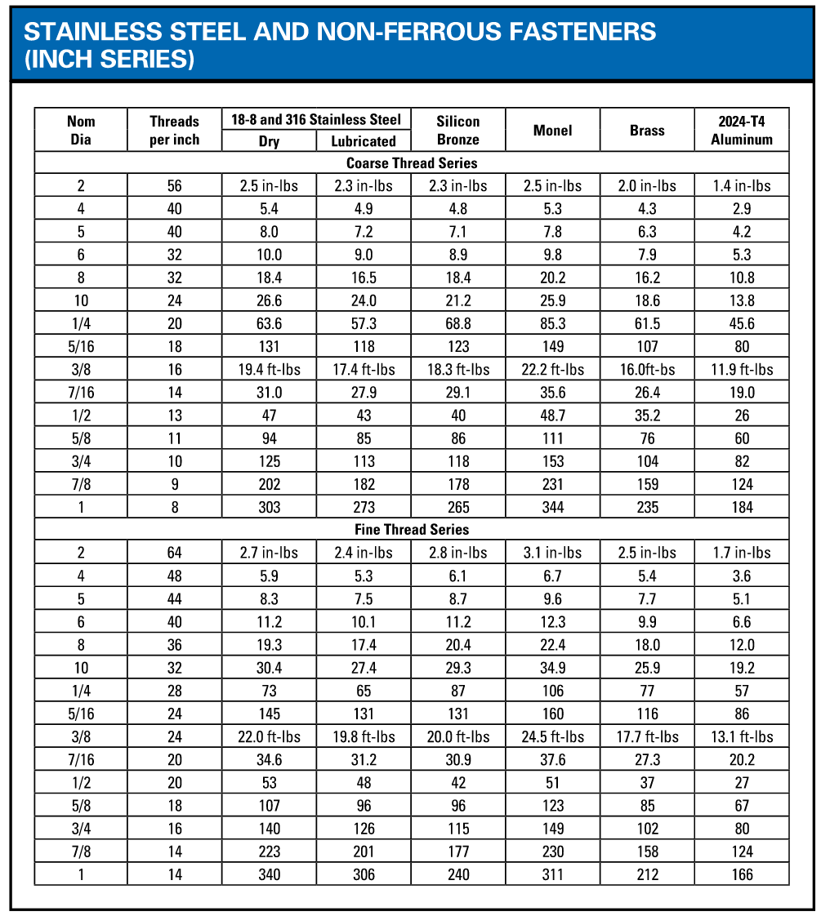

Please refer and adhere to any additional best practices for screw conveyors as detailed in all applicable CEMA standards, including ANSI/CEMA Standard No. 350 “Screw Conveyor for Bulk Materials” and ANSI/CEMA Standard 353 “Shaftless Screw Conveyor Safety Operation and Maintenance Manual”.

Detailed Installation Instructions
- Prepare Components for Assembly
  - Remove any strapping, wire, or other tethering devices that may have been used during transit from the Bio-SCREW.
  - Gather all loose components and hardware.

- Support Installation
  - Inspect the proposed mounting surface(s) for the Bio-SCREW support legs for levelness. The mounting surface must be level and true to avoid unnecessary bending or distortions in the Bio-SCREW. If the mounting surface is not level, make necessary provisions (such as shims or grout) to ensure that the Bio-SCREW will be installed level and straight. Periodically check for horizontal (and vertical if Bio-SCREW is not inclined) levelness and straightness in the Bio-SCREW throughout installation.
  - If precast anchors are used, ensure that the Bio-SCREW supports are placed onto the existing anchors as detailed on the drawings and loosely install the Bio-SCREW supports using the provided hardware.
  - If non-precast floor-mounted anchors are used:
    - Install the anchors and associated hardware as shown on the drawings and as detailed in the anchor manufacturer’s installation instructions included in Appendix A: Catalog Cuts. Ensure that the appropriate cure time is observed.
    - After the cure time has been observed, carefully position the Bio-SCREW supports onto the anchors and loosely fasten the Bio-SCREW supports onto the anchors via the provided hardware.
  - If non-precast overhead anchors are used:
    - Install the Bio-SCREW supports to the overhead mounting surface as detailed on the drawings using the provided hardware.
  - Install any additional support bracing using the provided hardware as detailed on the drawings.
  - Tighten all hardware according to the directions provided in Section 4.1 - Before Installation if not otherwise specified in the manufacturer’s recommendations included in Appendix A: Catalog Cuts (if any).

- Bio-SCREW Installation
  - [Utilize the drawings to position the trough segments in the appropriate order and direction, loosely installing them onto the supports and to each other using the provided hardware. Matchmarks have been provided on the trough segments as appropriate for ease of assembly.
  - Utilize piano wire or equivalent to align the trough bottom centerlines carefully and precisely. Verify that the trough centerline and piano wire are a consistent distance apart (within +/-1/8”) across the length of the trough. If needed, refer to ANSI/CEMA Standard 353 “Shaftless Screw Conveyor Safety Operation and Maintenance Manual” for detailed information about trough alignment.
  - Fully tighten the trough segments to one another. Refer to Section 4.1 - Before Installation for details regarding hardware tightening. Verify that the gasket is securely fastened between the trough segment mating surfaces.
  - Fully tighten the trough segments onto the supports. Refer to Section 4.1 - Before Installation for details regarding hardware tightening.
  - Confirm trough alignment once more using piano wire or equivalent.
  - Position the trough liner segments in the trough as detailed on the drawings.
  - Refer to the drawings (included in Appendix B: Equipment Drawings) to determine the correct screw flight orientation and position the screw segments inside the trough appropriately. Matchmarks have been provided on the screw segments as appropriate for ease of assembly.
  - Starting at the screw segment nearest the drive end of the Bio-SCREW, field weld the remaining screw segments using the following shaftless spiral splice weld instructions. If the screw segments are constructed of stainless steel, contact JMS regarding any special procedures that may deviate from the instructions included herein. Refer to the double V-groove butt splice multi-pass weld depicted in Figure 1 throughout the field welding procedure.

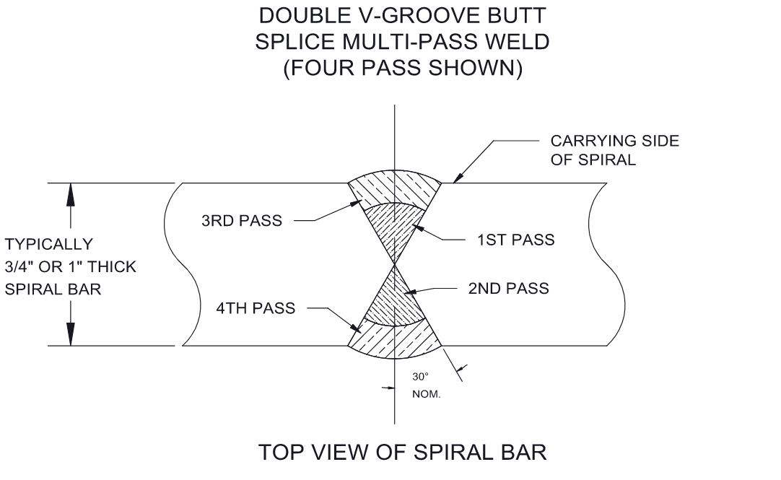
Figure 1. Field Weld Detail for Shaftless Screw Flight

    - Because the screw will be welded directly in the trough, insert a thin gauge (approximately 20 gauge) steel sheet under the screw and over the trough liner and any nearby equipment to protect the components from hot weld splatter. In the absence of sheet metal, a carefully positioned heat resistant blanket may be utilized. Ensure that the protective sheet or blanket is in place throughout the welding procedure.
    - Secure the flight joint in the center of the trough. Utilize the provided match marks to verify that the sections are located appropriately.
    - Secure the flights on each side of the joint to be welded by placing spacers on both sides of the flight’s pitches on each side of the trough.
    - Use the provided spiral flight alignment plate to verify the flight alignment at the joint. Refer to Figure 2.

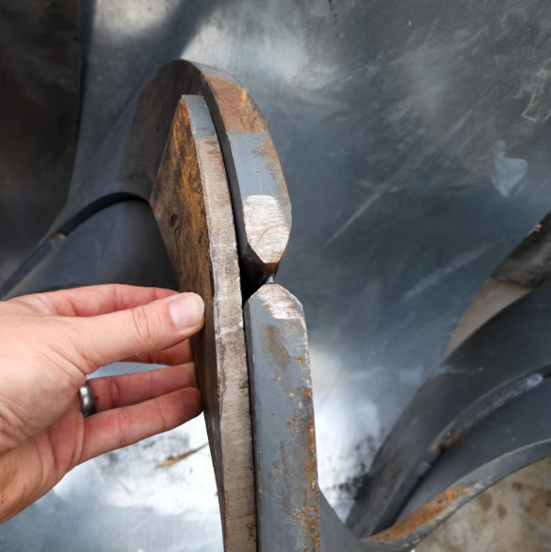
Figure 2. Verifying Screw Flight Alignment Using the Alignment Plate
    - Secure the joint to be welded by clamping the flights on both sides of the joint to the provided flight alignment plate. Refer to Figure 3.

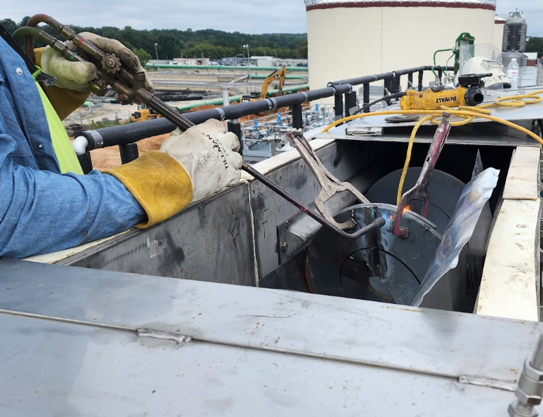
Figure 3. Clamping and Preheating the Spiral Flight Joints
    - Preheat the joint to be welded and surrounding area to approximately 200°F to 300°F (90°C to 150°C). Refer to previous Figure 3.
    - Fit (tack) the two sides of the joint together using a uniform open root gap weld on the first side of the joint. Utilize 9018 weld rod on the exposed side (side one). Similar high-strength, low-hydrogen type rods may be used so long as the rods have a minimum PSI rating of 70,000.
    - Remove the clamps and flight alignment plate. Refer to Figure 4 for an example of a proper fit-up/open root gap weld with clamps and alignment plate removed.
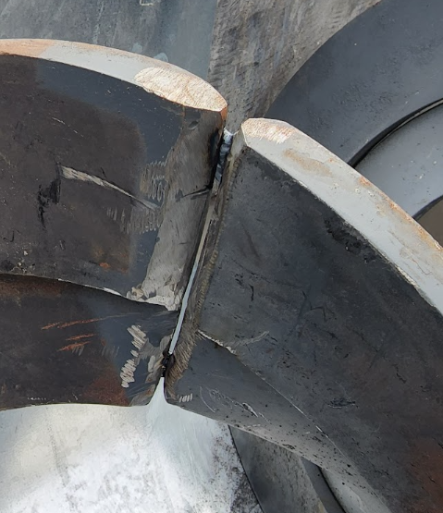
Figure 4. Example of a Proper Fit-Up/Open Root Gap Weld with Alignment Plate and Clamps Removed
    - Remove all slag and bevel grind the opposite side of the joint (side two). Note that the ends of the screw may be bevel ground in the shop prior to arrival at site and field grinding may not be required. Refer to Figure 5.
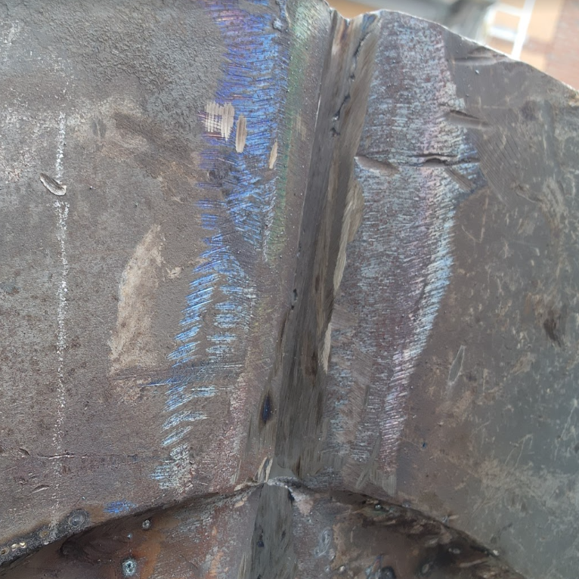
Figure 5. Back Gouging
    - Root weld the second side of the joint (side 2).
    - Repeat the weld procedure on alternating sides until complete. Refer to Figure 6 for an example of welding on alternating sides of the joint, as well as Figure 7 and Figure 8 for examples of proper and improper welding practices respectively.

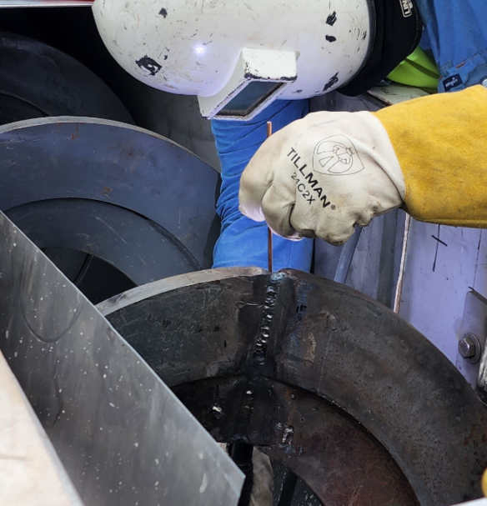
Figure 6. Welding on Alternating Sides
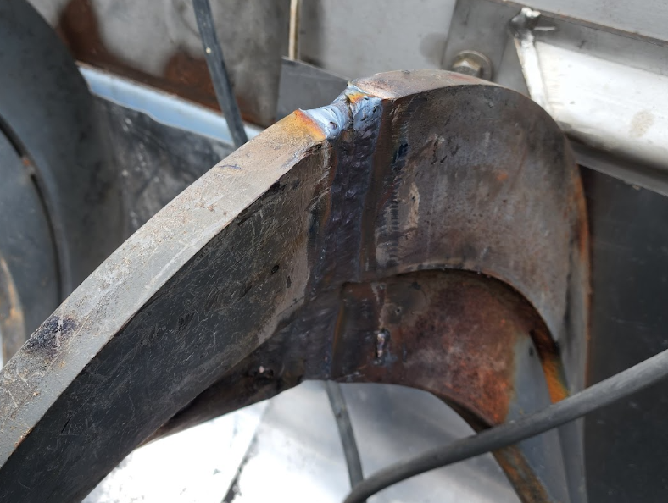
Figure 7. Proper Welding Practice (Stringer Passes and Underfill on Outside)
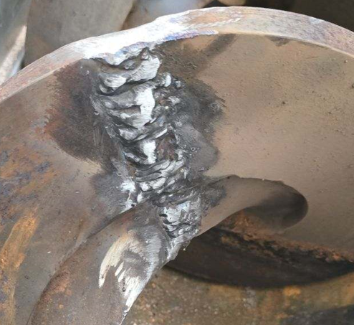
Figure 8. Improper Welding Practices (Underfill, Weave, Surface Profile)
    - After all welding is complete, remove any slag that may be left. Smooth the outside diameter of the screw flighting with a grinder if necessary to remove any high spots.
    - Allow the welded joints to cool down naturally to an ambient temperature. Do not operate the Bio-SCREW for a minimum of 8 hours.]
  - [Position the Bio-SCREW on the supports in the orientation detailed on the drawings. Verify that the Bio-SCREW is only contacting the supports at the designated support connection locations as detailed on the drawings.
  - Attach the Bio-SCREW to the supports using the provided hardware. Tighten the hardware according to the directions provided in Section 4.1 - Before Installation, verifying that the Bio-SCREW is secure and level upon completion.]

- Gearmotor Installation
  - Wire the gearmotor in accordance with the manufacturer’s installation instructions provided in Appendix A: Catalog Cuts.
  - After electrical connections have been made and before processing any material, turn the Bio-SCREW on and inspect the screw for proper direction of travel as detailed on the drawings. Incorrect screw rotation can result in serious damage to the Bio-SCREW, gearmotor, and associated upstream and downstream equipment. If screw rotation is incorrect, utilize a certified electrician to reconnect electrical leads and reverse gearmotor rotation.
  - Gearmotors are supplied with the correct grade of lubricant for the specified mounting position prior to arriving at site; however, it is important to verify that the lubrication is at the appropriate level prior to operating the gearmotor. Refer to Section 6.3 - Lubrication for additional information. Consult with JMS using the contact information provided in this O&M manual prior to operating the gearmotor if there is concern regarding the lubricant level.
  - Remove the breather valve’s protective band on the gearmotor if present. Refer to Figure 9 for an example of a protective band on a breather valve (protective band in black). Note that the figure is representative only and may not directly reflect the orientation of the motor or breather valve provided for this project. If the protective band has already been removed, no action is needed.

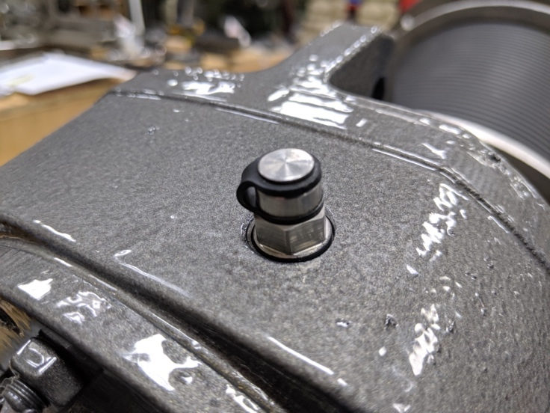
Figure 9. Breather Valve with Protective Band (in Black)
- Ancillary Component Installation and Adjustment
  - E-Stop Switch and Cabling Installation
    - If the E-Stop switch was provided separately, install the E-Stop switch at the mounting location shown on the drawings. A bracket has been mounted to the Bio-SCREW for this purpose.
    - Route the E-Stop cabling through the pre-installed brackets along the length of the Bio-SCREW.
    - Refer to the manufacturer’s installation instructions for the E-Stop provided in Appendix A: Catalog Cuts for additional information, including wiring information.
  - Zero-Speed Switch Installation
    - Install the zero-speed switch at the mounting location shown on the drawings.
    - Refer to the manufacturer’s installation instructions for the zero-speed switch provided in Appendix A: Catalog Cuts for additional information, including wiring information.

- Final Inspection
  - Verify that the drive shaft is centered in the end seal (if not integral to the gearmotor). Realign if necessary.
  - Verify that all safety labels are firmly affixed to the Bio-SCREW and visible.
  - Before processing any material, turn on the Bio-SCREW gearmotor and inspect the freedom of rotation of the entire screw using a dial indicator or similar tool. Total screw indicator runout should not be greater than 0.030 inches. If runout is greater than 0.030 inches, straighten the bent screw assembly. Consult JMS personnel using the contact information provided in this O&M manual if straightening the screw assembly does not correct the problem.
  - Verify that the entire Bio-SCREW assembly is horizontally (and vertically unless the Bio-SCREW is inclined) level and straight. Adjust the anchorage bolts or connecting hardware as required to achieve this.
  - [Grout beneath the supports using non-shrink grout as detailed on the drawings.]
  - Rotate the Bio-SCREW by hand to ensure that no binding occurs before proceeding with initial startup (detailed in Section 5.2 - Initial Startup). If binding occurs, find and report the source of the binding to determine appropriate mitigative measures.
  - Install the Bio-SCREW cover (if not already installed) by performing the following steps:
    - Position the provided gasket on the trough flange where it will mate with the cover.
    - Position the Bio-SCREW covers on the trough, referring to the drawings to determine proper cover sequence and positioning of inlet openings. Handle the covers carefully to avoid warping and bending.
    - Install the Bio-SCREW covers using the provided fasteners. Refer to Section 4.1 - Before Installation for details on fastener tightening. Do not tighten the covers excessively as doing so may warp the cover and result in leakage.

Operating Procedures

General Equipment Operation
The JMS shaftless Bio-SCREW is used to smoothly and continuously transfer or convey bulk material from one step in the plant process to the next. With a wide variety of uses in water and wastewater industries, the Bio-SCREW consists of one or more inlet locations to receive material from upstream feed equipment and one or more discharge locations to deliver material to the downstream equipment or receiving vessel. The Bio-SCREW is easily adapted to congested locations for horizontal, inclined, or vertical conveyance and is designed to meet unique and specific plant needs. The Bio-SCREW is also resistant to high temperature, abrasives, and sticky materials and is completely enclosed to prevent odors or spillage.

The Bio-SCREW features an emergency stop (E-Stop) switch with a pull cord that runs along the length of the Bio-SCREW. The pull cord may be manually activated to stop the Bio-SCREW in the event of an emergency.]

[The Bio-SCREW also features a zero-speed switch that is used to detect stoppage of the Bio-SCREW, notify the control system, and stop any interlocked pieces of equipment.

During startup, the Bio-SCREW should run empty for a period of time as detailed herein prior to receiving material for processing and handling to avoid overloading or damaging the Bio-SCREW. During shutdown, the Bio-SCREW should continue to run long enough after all upstream feed equipment has been stopped such that all material is cleared from the Bio-SCREW. When all material is cleared, the Bio-SCREW can be shut down.

Please refer and adhere to any additional best practices for screw conveyors as detailed in all applicable CEMA standards, including ANSI/CEMA Standard No. 350 “Screw Conveyor for Bulk Materials” and ANSI/CEMA Standard 353 “Shaftless Screw Conveyor Safety Operation and Maintenance Manual”.

Initial Startup
When starting the equipment for the first time or after an extended shutdown, perform the following procedures. Note that an operator must be standing by the Bio-SCREW and associated control systems to stop the system in case of emergency.
- Visually inspect the Bio-SCREW and any associated equipment for damage. Notify JMS using the contact information provided herein if damage is observed.
- Verify that all preventative maintenance and lubrication procedures have been completed as directed in Section 6 - Maintenance, Lubrication, & Troubleshooting.
- Verify that the E-Stop switch flag arm is in the non-tripped position (i.e. NOT upright).
- Verify that all personnel are clear of the equipment and that all obstructions (including any tools and/or debris) have been removed from the Bio-SCREW. Do not operate the Bio-SCREW until all obstructions have been safely cleared.
- Verify that all covers, safety devices, and controls are installed and operating correctly.
- Verify that the Bio-SCREW discharge is clear.
- Prior to starting any upstream feed equipment, start the Bio-SCREW.
- Allow the Bio-SCREW to operate empty for a maximum of five minutes (or as otherwise directed by JMS during dry startup procedures). Operating the Bio-SCREW empty longer than five minutes may cause damage to the trough liners.
- Calibrate the zero-speed switch during the Bio-SCREW’s initial startup period by performing the following procedures:
  - Run the Bio-SCREW at the desired operational speed to establish the baseline speed for which zero-speed detection needs to be calibrated.
  - Obtain and prepare a stopwatch to ensure precise timing for counting pulses.
  - Count the pulses, or the number of blinks from the LED indicator, within one minute using the stopwatch for accurate timing. Blinking of the LED indicator signifies detection of the screw flighting by the probe during each rotation of the screw. The total pulse count represents the actual pulses per minute at the set speed.
  - Adjust the zero-speed dial using the P1 knob to set the threshold to the counted pulse value. This ensures that the system recognizes anything below the set pulse count as “zero speed”.
- Observe the Bio-SCREW for the following during the initial startup period:
  - Unusual noises
  - Gear reducer/motor oil leakage and/or overheating (surface temperature of the gear reducer/motor should be less than 104º F).
  - Rough operation
- If any of the abnormalities from previous Step 10 are noted, refer to the appropriate maintenance actions and/or troubleshooting procedures provided in Section 6 - Maintenance, Lubrication, & Troubleshooting.

Startup
During startup, an operator must be standing by the Bio-SCREW and associated control system to stop the Bio-SCREW in case of emergency. Perform the following procedures:

- Visually inspect the Bio-SCREW and any associated equipment for damage. Notify JMS using the contact information provided herein if damage is observed.
- Verify that all preventative maintenance and lubrication procedures have been completed as directed in Section 6 - Maintenance, Lubrication, & Troubleshooting.
- Verify that the E-Stop switch flag arm is in the non-tripped position (i.e. NOT upright).
- Verify that all personnel are clear of the equipment and that all obstructions (including any tools and/or debris) have been removed from the Bio-SCREW. Do not operate the Bio-SCREW until all obstructions have been safely cleared.
- Verify that all covers, safety devices, and controls are installed and operating correctly.
- Verify that the Bio-SCREW discharge is clear.
- Prior to starting any upstream feed equipment, start the Bio-SCREW.
- Gradually begin to feed material into the Bio-SCREW by starting upstream feed equipment.
  - The feed rate should start low and be gradually increased until the specified design capacity is reached.
  - Do not overload the Bio-SCREW or otherwise exceed the equipment speed, capacity, volume, material density, or rate of flow for which the Bio-SCREW and gearmotor were designed.

Shutdown
When it becomes necessary to shut down the equipment, perform the following procedures. Please note that the following procedures are intended to be for normal shutdown only. During an emergency shutdown due to an alarm condition, proceed to the instructions included in Section 5.5 - Shutdown (Alarm Condition).

- Shut down all upstream feed equipment according to the appropriate standard operating procedures.
- Allow the Bio-SCREW to continue running until all material has been discharged from the equipment.
  - In the event that system controls will not permit this operation with the control switch in the “AUTO” position, the control switch may be placed in the “MANUAL” position to allow for manual adjustment. Refer to Appendix E: Controls if controls have been provided by JMS.
- Stop the gearmotor for the Bio-SCREW.
- LOTO all power to the Bio-SCREW.
- Inspect the Bio-SCREW bolts and alignments, realigning and tightening as necessary.
- In the event of an expected extended shutdown (longer than 30 days), the following additional procedures should be performed:
  - Ensure all foreign material is removed from the Bio-SCREW or manually remove as necessary. If the material is corrosive, hygroscopic, or tends to harden (or “set up)”, the Bio-SCREW trough should be thoroughly and completely cleaned to remove any material that may remain in the bottom of the trough upon shutdown even when the majority of material has been discharged.
  - Rotate the Bio-SCREW one and a half (1.5) rotations every two weeks. Screw rotation can be performed by bumping the motor or disengaging the motor and rotating the screw by hand.
  - Adhere to all procedures for equipment storage included in Section 3.3 - Storage and any additional component manufacturer recommendations detailed in Appendix A: Catalog Cuts. This includes but is not limited to proper lubrication and protection of the gearmotor.

Shutdown (Alarm Condition)
The Bio-SCREW (and other equipment if interlocked via the control system; refer to Appendix E: Controls if controls have been provided by JMS) may be stopped at any time by activating the E-Stop safety device associated with the screw. If the E-Stop safety device was the source of the shutdown, perform the following actions:
- Shut down all upstream feed equipment and any other interconnected equipment according to the appropriate standard operating procedures.
- Stop the motor for the Bio-SCREW by turning the control switch to the “OFF” position.
- LOTO all power to the Bio-SCREW.
- Identify and rectify the cause of the E-Stop alarm by visually checking the equipment. This may involve the removal of screw covers and/or material in the screw.
- Visually inspect the screws for damage and address as necessary according to the details provided in Section 6 - Maintenance, Lubrication, & Troubleshooting.
- Reset the switch flag arm to the non-tripped position (i.e. NOT upright) and replace any covers (if removed).
- At the control panel, select the “ALARM RESET” button.
- To restart the equipment, turn the Bio-SCREW control switch to the “ON” position (or “AUTO” position as appropriate). Return to the normal shutdown procedures included in Section 5.4 - Shutdown when appropriate.

The Bio-SCREW has been supplied with a zero-speed switch that shuts down power to the associated motor if motion is lost (and other equipment if interlocked via the control system; refer to Appendix E: Controls if controls have been provided by JMS). If the zero-speed switch was the source of the emergency shutdown, perform the following actions:
- Shut down all upstream feed equipment and any other interconnected equipment according to the appropriate standard operating procedures.
- Stop the motor for the Bio-SCREW by turning the control switch to the “OFF” position.
- LOTO all power to the Bio-SCREW.
- Identify and rectify the cause of the zero-speed switch alarm by visually checking the equipment. This may involve the removal of screw covers and/or material in the screw.
- Visually inspect the screws for damage and address as necessary according to the details provided in Section 6 - Maintenance, Lubrication, & Troubleshooting. Replace any covers removed previously.
- At the control panel, select the “ALARM RESET” button.
- To restart the equipment, turn the Bio-SCREW control switch to the “ON” position (or “AUTO” position as appropriate). Return to the normal shutdown procedures included in Section 5.4 - Shutdown when appropriate.

Maintenance, Lubrication, & Troubleshooting
While no special tools are required for working with the Bio-SCREW, care should be taken to avoid cross-contamination between carbon steel and stainless-steel components when installing, maintaining, or otherwise working with the equipment or components. Please refer to the additional information about carbon steel contamination provided in Section 3.2.1 - Avoiding Cross-Contamination Between Materials.

Please note that not all individual components comprising the Bio-SCREW are crafted by JMS (as detailed on the Bill of Materials on the drawings). Although JMS has carefully developed this comprehensive O&M manual to summarize the recommended procedures for effectively maintaining the Bio-SCREW and its components as a whole, any and all maintenance, lubrication, and/or troubleshooting procedures from individual component manufacturers for their specific component should supplement or take precedence over the requirements listed herein. Manufacturer reference information, including that which is supplied in Appendix A: Catalog Cuts, should always be referenced during maintenance, lubrication, and troubleshooting procedures where available. If questions arise over the proper maintenance, lubrication, and/or troubleshooting procedures, please contact JMS using the contact information provided in this O&M manual.

Please refer and adhere to any additional best practices for screw conveyors as detailed in all applicable CEMA standards, including ANSI/CEMA Standard No. 350 “Screw Conveyor for Bulk Materials” and ANSI/CEMA Standard 353 “Shaftless Screw Conveyor Safety Operation and Maintenance Manual”.

Preventative Maintenance
Before any maintenance or inspection is performed, refer to ANSI/ASSP Z244.1-2016 for minimum safety requirements concerning energy sources.

Practice good housekeeping. Keep the area around the equipment clean and free of obstacles to provide easy access. Establish routine periodic inspections of the equipment to ensure continuous maximum operating performance.

A basic maintenance tool kit is all that is required to maintain this equipment. No special tools are necessary.

Table 2. Bio-SCREW Preventative Maintenance
Component | Recommended Maintenance | Frequency
General | Ensure no debris or material is collecting on the face of sealing surfaces or otherwise between the drive shaft and gearmotor. Remove material as required. | Daily
General | Inspect the Bio-SCREW (especially discharge and inlet locations) for material buildup. Remove as required. | Daily
General | Ensure all trough covers and guards (if any) are installed and functioning properly. | Daily (or as often as equipment is in operation)
General | Inspect Bio-SCREW and gearmotor for unusual noises or vibrations. | Daily
General | Inspect for material spillage at inlet(s) and outlet(s). Clean any spills as required. Find cause of spillage and correct. | Daily
General | Visually inspect seal on the drive end of the screw for any leakage. Refer to Section 6.4 - Troubleshooting if leaks are observed. | Daily
General | Visually inspect the screw and trough along its entire length for evidence of damage. This may require opening protective covers. | Quarterly
General | Visually inspect screw flights for evidence of wear and/or an inappropriate wear and wear pattern. This may require opening associated protective covers. | Quarterly
General | Open trough covers and inspect trough liner for wear. Replace the liner if wear exceeds ¼”. | Quarterly
External Hardware | Inspect all bolts and anchors and secure any that are loose. Refer to the guidance provided in Section 4.1 - Before Installation regarding proper hardware tightening. | Quarterly
SEW Eurodrive Gear Reducer | Check oil level. Refer to Section 6.3 - Lubrication. | Every 3,000 operating hours or every 6 months, whichever is sooner
SEW Eurodrive Gear Reducer | Drain and refill the oil according to the information and schedule provided in Section 6.3 - Lubrication. | Every 8,000 operating hours or every 3 years, whichever is sooner
[Motor | Relubricate the motor bearings according to the details provided in Section 6.3 - Lubrication. | Refer to the interval provided in Section 6.3 - Lubrication.]
Packing Gland Seal | Relubricate the seal according to the details provided in Section 6.3 - Lubrication. | Refer to the interval provided in Section 6.3 - Lubrication.

Corrective Maintenance

Liner Replacement Procedures
Trough liners serve as the main wear component of shaftless screw conveyors by absorbing the rotational forces produced during normal operation of the screw flighting. Regular liner inspection and replacement as warranted are routine maintenance tasks that should be completed to ensure optimal conveyor operation and longevity. Liner replacement is required if liner wear exceeds ¼” in any area or in other unique circumstances as dictated by plant conditions or preferences.

Liners are made of UHMW PE material. New UHMW PE liners arrive to site in a preformed “U” shape for installation into the trough. The liners will not retain their shape if removed from packaging too early; therefore, the preformed liners should not be removed from packaging until immediately before installation.

To replace the liner in a shaftless Bio-SCREW:
- Ensure that new replacement liner is available but do not remove the liner from its packaging.
- Ensure that the Bio-SCREW is empty.
- LOTO all power to the Bio-SCREW.
- If the Bio-SCREW covers are bolted or clamped, remove the Bio-SCREW covers by removing the bolts or clamps. Refer to Figure 10.

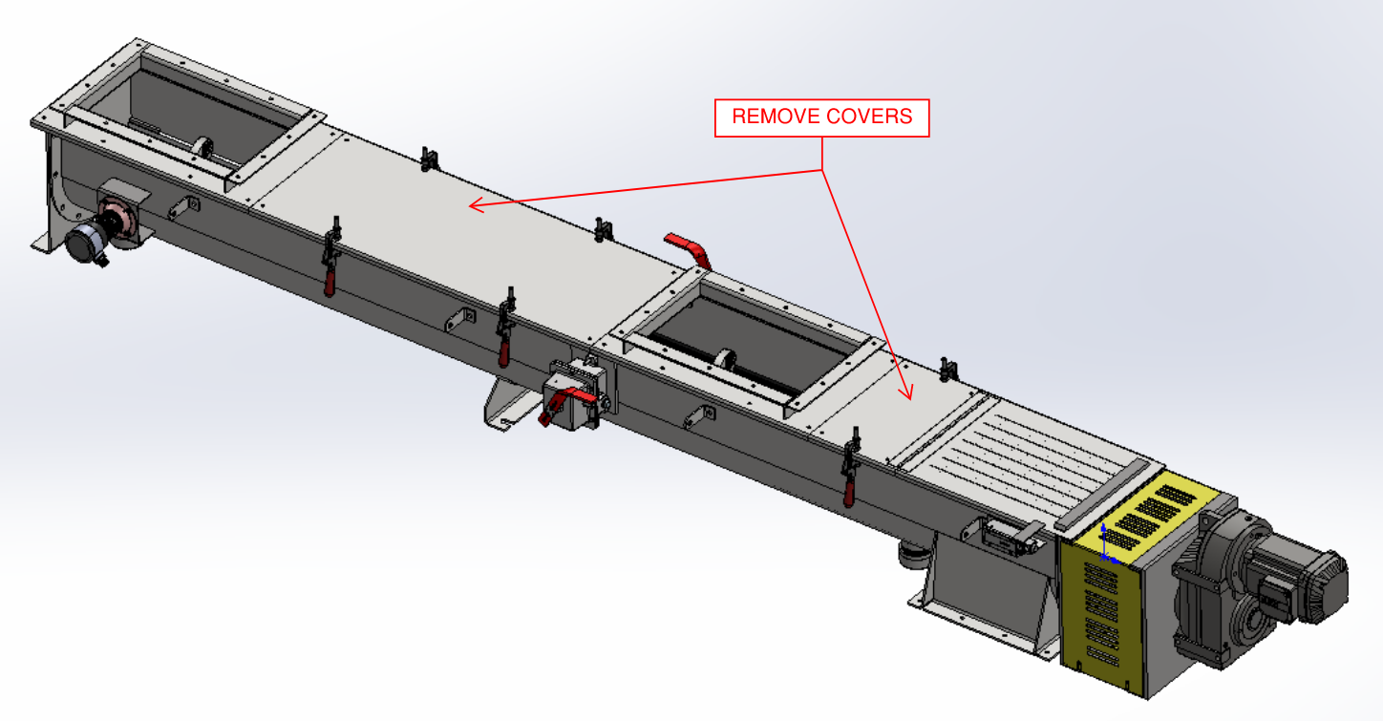
Figure 10. Shaftless Bio-SCREW Covers - Removal

- Clean the Bio-SCREW, including the shaftless spiral.

- Remove the Bio-SCREW hold downs from the conveyor trough by removing the bolts attaching the hold downs to the trough. Refer to Figure 11.

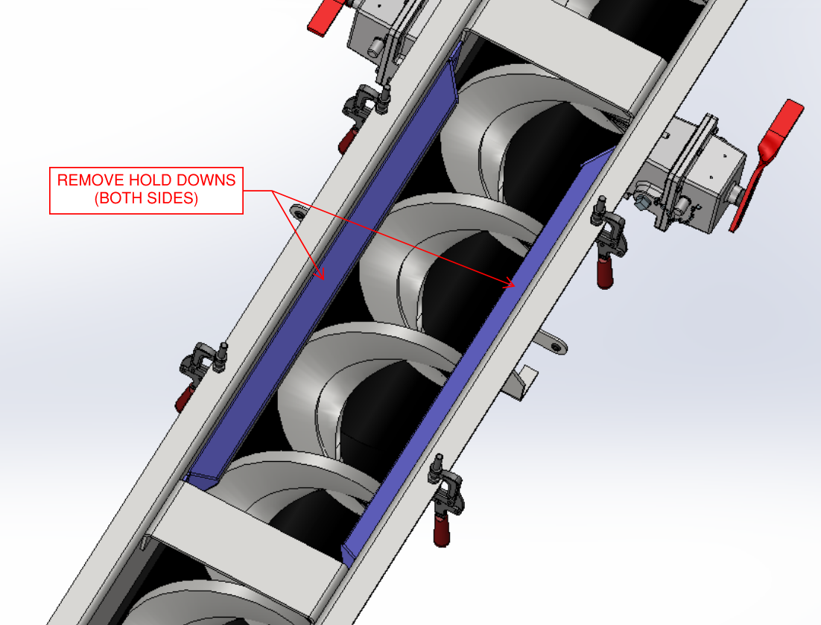
Figure 11. Shaftless Bio-SCREW Hold Downs - Removal
- Disconnect the shaftless spiral from the drive shaft by loosening the bolts at the flanged connection and separating the spiral from the flange. Refer to Figure 12.

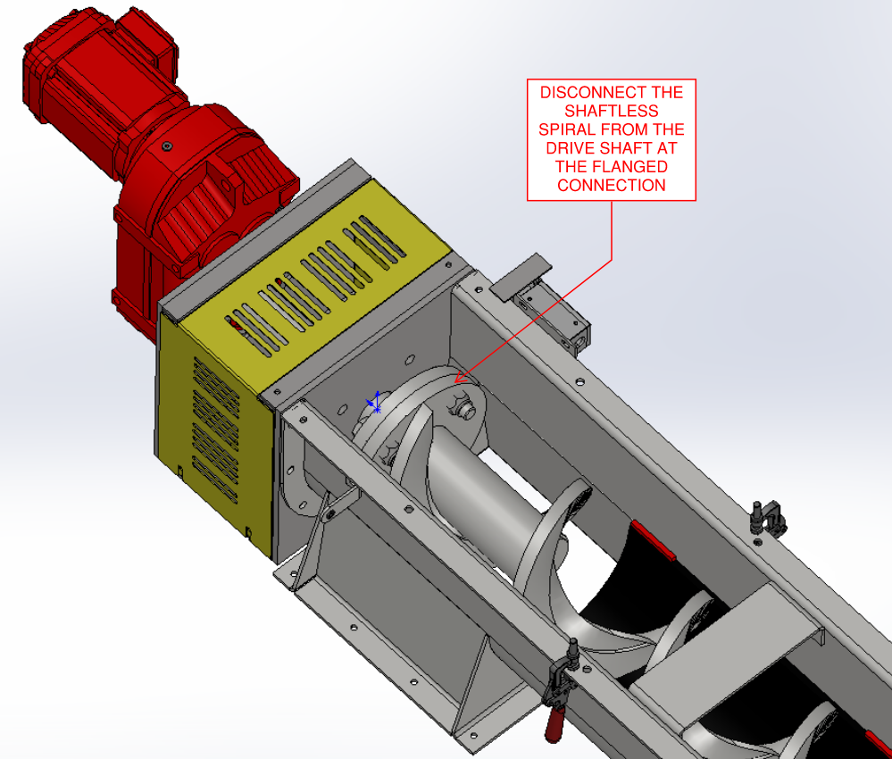
Figure 12. Shaftless Bio-SCREW Drive Shaft & Shaftless Spiral Flanged Connection - Disconnect
- Lift the shaftless spiral from off of the liner using one of the methods provided below as appropriate:
  - If the shaftless spiral is accessible from the top/overhead:
    - Evenly support the full weight of the shaftless spiral and lift the shaftless spiral off of the liner. The shaftless spiral only needs to be lifted a few inches to facilitate liner replacement, but it can be lifted completely out of the trough as desired. Note that if the shaftless spiral is being lifted in its entirety, the spiral is considerably “flexible” and will bend at the lifting point. To make the shaftless spiral easier to lift in its entirety, a piece of pipe or similar material may be inserted from the tail/non-drive end of the spiral and utilized as the lifting mechanism. The inserted pipe will evenly distribute the weight of the shaftless spiral.
    - Lift only the portion of shaftless spiral above the liner being replaced. The shaftless spiral only needs to be lifted a few inches to facilitate liner replacement. Support the shaftless spiral such that distortion of or damage to the spiral is prevented. This includes the use of clamps to hold the shaftless spiral in place and/or wedge blocks beneath the spiral on each side of the liner being replaced.
  - If the shaftless spiral is only accessible from the drive or tail end of the Bio-SCREW:
    - Removal of the tail plate is preferred if possible. Carefully remove the drive or tail plate from the Bio-SCREW by removing the associated bolts. Carefully maneuver the shaftless spiral out of the drive or tail end of the Bio-SCREW.

- Insert a heavy-duty screwdriver, lever, or similar tool between the trough and the liner so the liner being replaced releases from the retainers. Similarly, a pry tool may be utilized to pry the liner from the retainers as needed. Ensure that the liner being replaced has been released from the retainers in all locations. Refer to Figure 13.

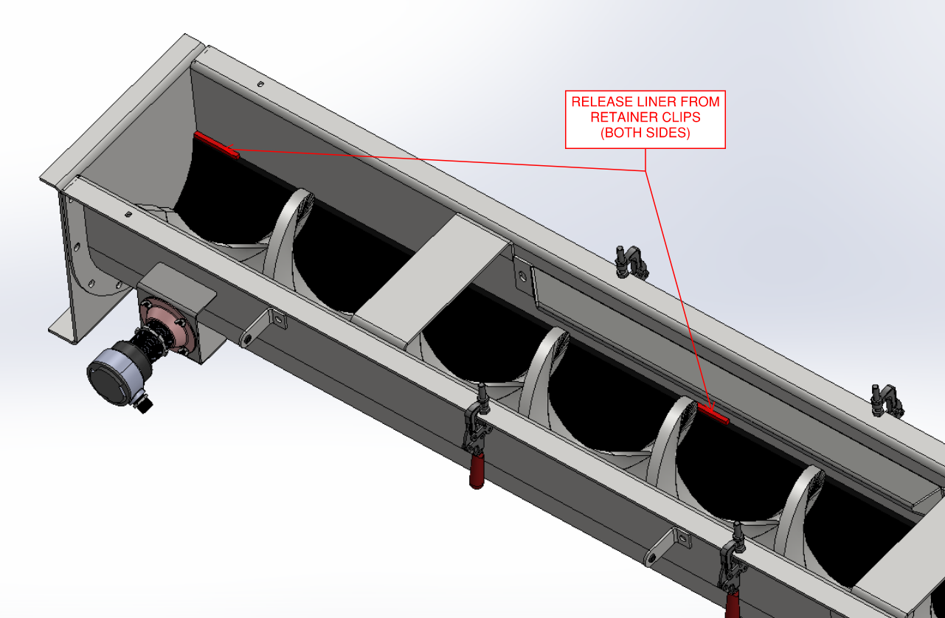
Figure 13. Shaftless Bio-SCREW Retainer Clips – Removal of Liner
- Remove the worn liner.
  - If the shaftless spiral is not completely removed from the trough, removal of the liner can be done by rotating the liner around the shaftless spiral instead of raising the liner directly out of the trough. Refer to Figure 14.

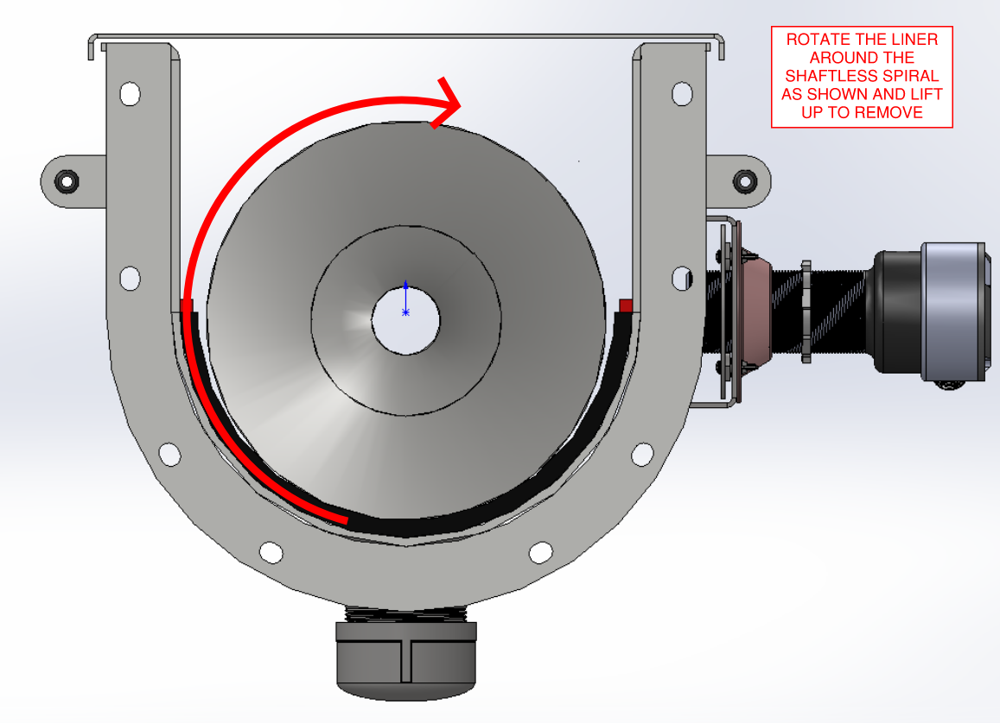
Figure 14. Liner Removal Technique (Shaftless Spiral in Trough)
- Remove the new liner from its shipment packaging.

- Insert the new liner.
  - If the shaftless spiral is not completely removed from the trough, installation of the liner can be done by rotating the liner around the shaftless spiral instead of lowering the liner directly into the trough. Refer to Figure 15.

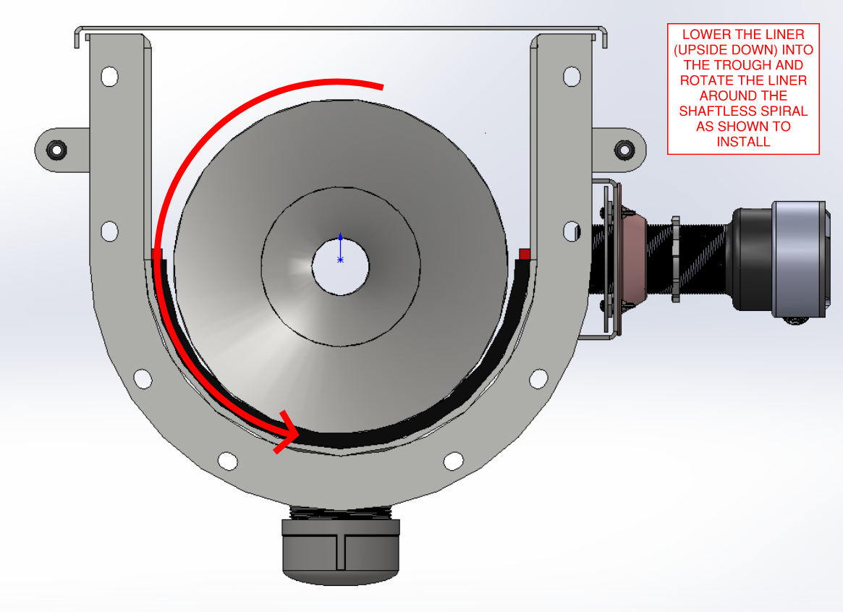
Figure 15. Liner Installation Technique (Shaftless Spiral in Place)
- Snap or otherwise secure the new liner under the retainers on both sides of the trough. This may involve use of a pry tool as needed. Ensure the liner is secured beneath the retainers in all locations. Refer to Figure 16.

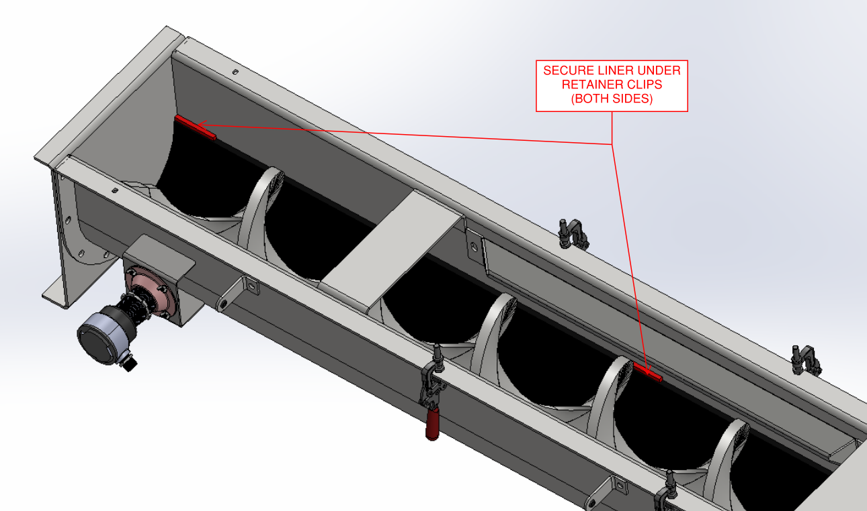
Figure 16. Shaftless Bio-SCREW Retainer Clips – Replacement of Liner
- Replace the shaftless spiral into the trough and onto the liner.
  - If the drive or tail plates were removed to facilitate shaftless spiral removal, replace the drive or tail plate by installing the associated bolts. Refer to the project operation and maintenance (O&M) manual for a typical bolt torque chart and/or unique torque values where indicated.

- Reconnect the shaftless spiral to the drive shaft by aligning the bolt holes on the flanged connection and installing the bolts. Refer to Figure 17. Additionally, refer to the project operation and maintenance (O&M) manual for a typical bolt torque chart and/or unique torque values where indicated.

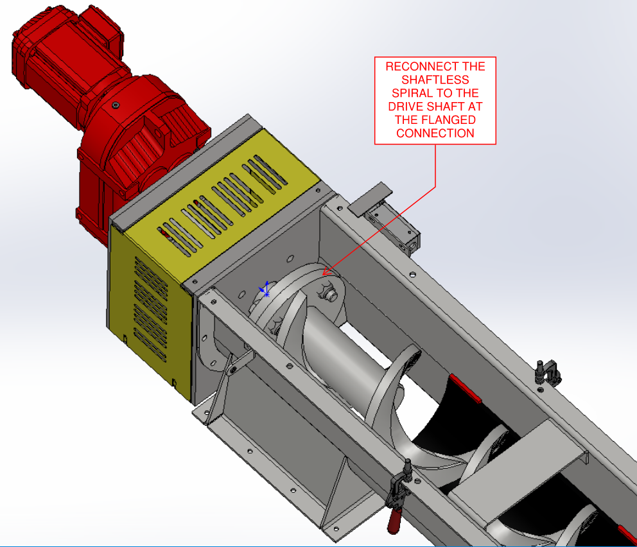
Figure 17. Shaftless Bio-SCREW Drive Shaft & Shaftless Spiral Flanged Connection - Reconnect
- Replace the Bio-SCREW hold downs in the conveyor trough by replacing the bolts connecting the hold downs to the trough. Refer to Figure 18.

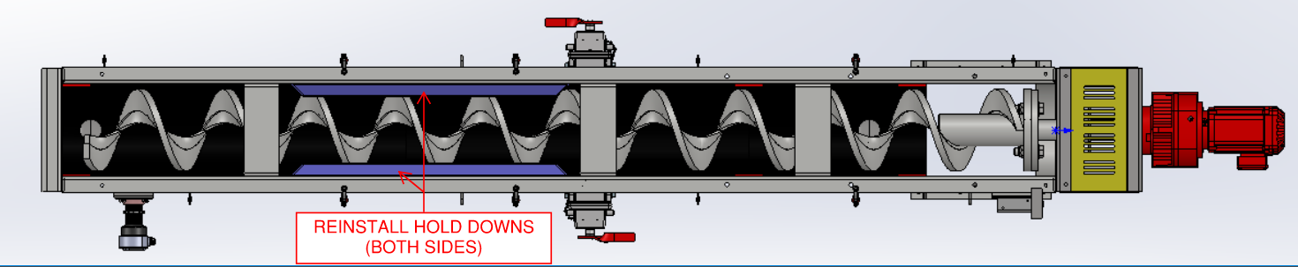
Figure 18. Shaftless Bio-SCREW Hold Downs - Replacement

- Replace the Bio-SCREW covers. Refer to Figure 19.

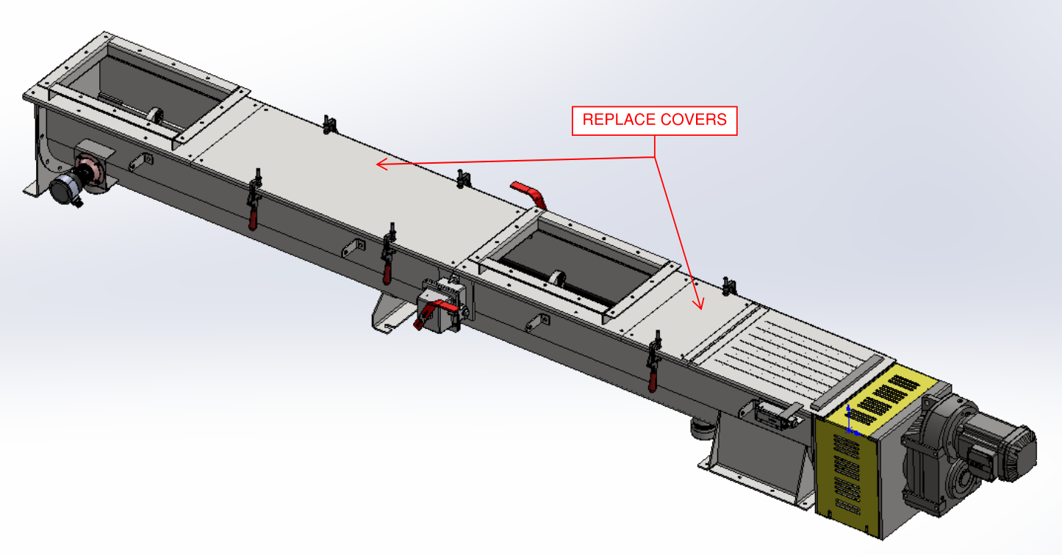
Figure 19. Shaftless Bio-SCREW Covers - Replacement

Lubrication
Please refer to Figure 20 through Figure 22 for details about gear reducer mounting position and locations of components relating to the lubrication system. Please note that while the diagram shown in Figure 20 is sourced from the SEW Eurodrive O&M manual and is representative of the gear reducer provided for the project, the pictures provided in Figure 21 and Figure 22 are meant to serve as examples only and may not reflect the exact gear reducer or hardware orientation provided for this project.

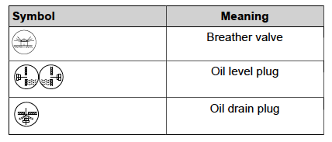
[INSERT PIC OF MOUNTING POSITION FROM SEW MANUAL]
Figure 20. SEW Eurodrive Mounting Position "XXX" and Location of Lubrication Components
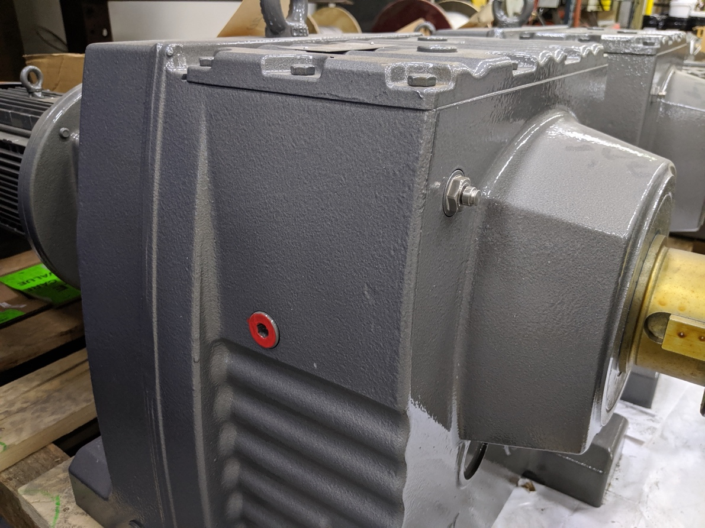
OIL LEVEL PLUG
BREATHER VALVE (PROTECTIVE BAND REMOVED)
Figure 21. Oil Level Plug (Painted Red) and Breather Valve (Protective Band Removed) (FOR REFERENCE ONLY)
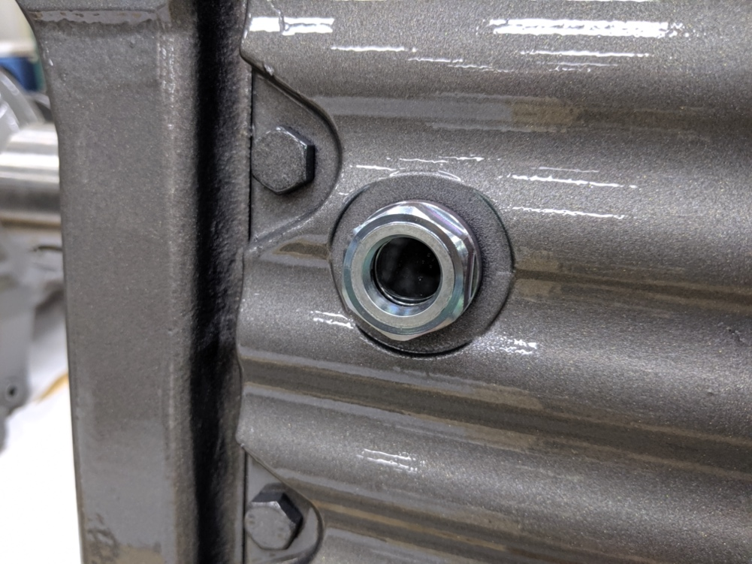
Figure 22. Example Sight Glass in Lieu of Oil Level Plug (If Applicable) (FOR REFERENCE ONLY)
A lubrication schedule for all Bio-SCREW components is included in Table 3. Only check or change the oil when the gear reducer is not in operation and has had sufficient time to cool down to maintain safety and ensure proper measurement. While checking the oil, ensure that a container is placed beneath the oil level plug to capture small amounts of oil that may leak out. When changing the oil, ensure that oil is contained and disposed of in a proper manner.

Table 3. Bio-SCREW Component Lubrication Requirements
Component | Activity | Interval | Quantity | Recommended Grease
SEW Eurodrive Gear Reducer | Check oil level. | Every 3,000 operating hours or every 6 months, whichever is sooner | Refill to an acceptable level according to Figure 23. | See requirements for oil change below.
SEW Eurodrive Gear Reducer | Drain oil and refill to oil level plug or sight glass. Refer to previous Figure 21 and Figure 22. | Every 8,000 operating hours or every 3 years, whichever is sooner | X | Recommended oil is listed on the SEW Eurodrive gear unit nameplate; if a specific brand is not listed, utilize the SEW Eurodrive brand oil for the listed oil type.
[Motor | Drain oil and refill according to the manufacturer’s procedure included within Appendix A: Catalog Cuts. | Refer to the interval (if any) provided in the manufacturer’s information within Appendix A: Catalog Cuts | Refer to the quantity (if any) provided in the manufacturer’s information within Appendix A: Catalog Cuts. | Refer to the recommended grease type (if any) provided in the manufacturer’s information within Appendix A: Catalog Cuts.]
Packing Gland Seal | If the seal has a grease fitting, replenish grease. Otherwise, no action needed. | As required based on operation, at least quarterly. | Until grease just purges from the fitting. | Grease compatible with plant processing requirements.

When checking the oil at the SEW Eurodrive gear reducer, utilize Figure 23 to determine the proper oil level at the oil level plug. Figure 23 has been adapted from the SEW Eurodrive O&M manual. The oil level plug should be removed to properly check the oil.

If a sight glass has been provided in the place of an oil level plug, the oil level can be checked visually through the sight glass without removing the sight glass. An example of a sight glass in lieu of an oil level plug is shown in previous Figure 22.

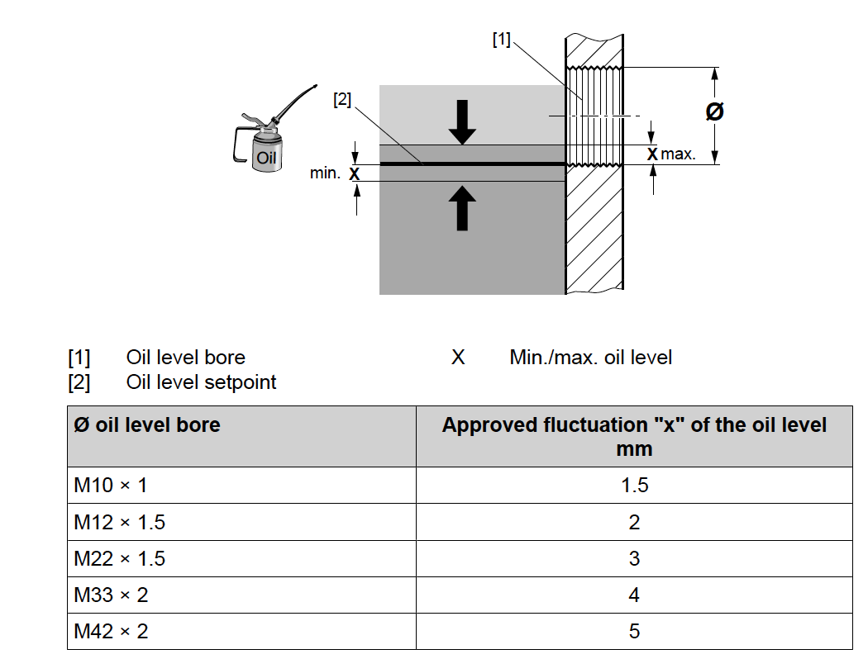
Figure 23. SEW Eurodrive Diagram for Checking Oil Level

If the oil is too low at the SEW Eurodrive gear reducer during a routine oil level check, perform the following steps:
- Remove the breather valve from the breather bore. Refer to previous Figure 20.
- Remove the oil level plug. Refer to previous Figure 21. If a sight glass has been provided, the sight glass does not need to be removed. Refer to previous Figure 22.
- Add oil of the same type via the breather bore up to the lower edge of the oil level bore.
- Replace the breather valve and screw the valve tight to a torque of xxx lb-ft (xxx Nm).
- Replace the oil level plug and tighten to a torque of xxx lb-ft (xxx Nm).

[The motor bearings are sealed for life and therefore do not have any lubrication requirements.]

Troubleshooting
Table 4. Bio-SCREW Troubleshooting
Problem | Probable Cause | Solution
Bio-SCREW is not operating | Bio-SCREW is not receiving a run signal | Check controls (refer to Appendix E: Controls if controls have been provided by JMS) and verify that a run signal is being transmitted to the Bio-SCREW.
Bio-SCREW is not operating | The E-Stop switch flag arm is in the tripped position (i.e. upright) | Reset the E-Stop switch flag arm to the non-tripped position (i.e. NOT upright).
Bio-SCREW is not operating | Issue with other permissive control | Check other permissive controls such as zero-speed switches for proper operation and positioning.
Bio-SCREW is not operating | Bio-SCREW is not receiving power | Following all proper plant SOPs and LOTO procedures, verify that there is power at the motor.
Bio-SCREW is not operating | Bio-SCREW is jammed | LOTO power to the Bio-SCREW and manually clear material jams from the screw.
Bio-SCREW is not operating | Motor failure | Notify JMS using the contact information provided in this O&M for recommended procedures.
Bio-SCREW motor trips out on overload | Too much material in the Bio-SCREW | Inspect the Bio-SCREW for proper loading. Verify that the Bio-SCREW design capacities (including speed, capacity, volume, material density, and/or rate of flow) are not exceeded. Reduce loading as required upon next startup. The feed rate should start low and gradually increase.
Material leaks through the seal on the drive end of the screw | [Drainpipe is blocked | Investigate and clear drainpipe blockage.]
 | Seal is worn | Add two pumps or grease to the seal. Tighten the nuts on the follower one turn at a time in a cross-tightening sequence, wait one hour, and repeat the tightening procedure again if leakage is still observed. If leakage increases instead of decreases, the seal requires replacement.
Premature wear to the trough liner | High spot on trough as installed | Eliminate high spot by carefully manipulating the affected area of the trough until the dent has been removed and the screw no longer contacts the trough when rotated.
Premature wear to the trough liner | High spot on screw as installed | Eliminate high spot by grinding the screw flighting until the high spot is removed and the screw flighting is smooth and consistent.
Premature wear to the trough liner | Screw is bent | Replace or repair screw as needed. Notify JMS using the contact information provided herein if a replacement screw is needed. Repair may be performed by carefully removing the affected screw in its entirety, cutting out the bent portion of the screw, bracing the bent portion of the screw, realigning the bent portion of the screw, welding the entire screw back together, and replacing the corrected screw.
Screw “jumps” in the trough | [Screw hold downs are misadjusted | Adjust the screw hold downs such that there is only a small amount of clearance above the screws. Refer to the SA drawings for a visual of the proximity between the screws and screw hold downs.]
Screw “jumps” in the trough | Screw is bent | Notify JMS using the contact information provided in this O&M manual to determine the appropriate course of action. The screw may need to be straightened (to be performed by the manufacturer only) or totally replaced.
Screw becomes misaligned or bent or otherwise binds | Trough liner is worn | Replace the entire trough liner.

Policies

Warranty
All JMS equipment and/or materials are of high quality and are manufactured in conformity with the best commercial practices. JMS guarantees all equipment and materials manufactured or supplied by JMS to be free from defects in material and workmanship at the time of startup for a period of XXXXX. JMS will furnish without charge but will not install replacements for such parts and materials JMS finds to be defective.

This guarantee does not apply to any equipment which has been improperly handled or stored, improperly lubricated, subjected to misuse or neglect, misapplied with reference to the Engineer's Specifications, altered or tampered with, and/or damaged by corrective work performed without JMS’ specific written consent. No allowances will be made for such corrective work done without such consent.

Deterioration by chemical action, improper maintenance, or normal wear does not constitute defects and are therefore not covered by this warranty. Additionally, consumable items are not covered by this warranty. All warranty claims must be submitted within ten (10) calendar days of discovery of defects or they will be deemed waived. The foregoing is in lieu of all other warranties, whether expressed or implied.

Liability
It is expressly understood that JMS’ liability for JMS products is limited to the furnishing of such replacement parts, and that JMS will not be liable for any other expense, injury, loss, or damage, whether direct or consequential, including but not limited to loss of profits, production, or increased cost of operation arising in connection with the sale or use of, or inability to use, JMS equipment and/or materials for any purpose except as herein provided.

In the event a customer's order form states any liability terms which are additional to or different from these set forth herein, this form must be acknowledged in writing by JMS to accept any liability set forth in such form(s).

Returns
All returns must be authorized by JMS, and no credit will be allowed for returned items that are damaged in transit, incomplete, or received in an unsatisfactory condition. All items that are not eligible for credit will be returned to customer via freight collect or discarded upon customer's instructions.

Delivery
Delivery dates represent only JMS’ best estimate of the time required to complete the work and ship the material from JMS’ plant. All orders are accepted with the understanding that shipping dates are approximate and subject to change because of factory conditions, fires, strikes, material shortages, civil or military authority, acts of God, or other causes beyond JMS knowledge or control.

Back charges against JMS for alterations, shortages, damage repair, and/or discrepancies will be accepted only with written prior approval from a duly authorized representative of JMS.

Thread Lubricant Information
All JMS bolts and anchors are stainless steel material unless otherwise specified. Without an application of thread lubricant, bolting materials may become locked together. JMS strongly recommends the use of NSF-61 approved thread lubricant on all stainless steel bolts and anchors.

Standard Erecting Practices
All fabricated equipment manufactured by JMS is shop checked for accuracy before shipment and should not present any erection problems. Due to specific field conditions, a reasonable amount of fit-up is considered standard erection practice. The use of tools such as “come-a-longs”, jacks, drift pins, and reamers is to be expected.

Standard erecting practice as defined by the AISC “Code of Standard Practice”, Section 7.14, states the following:

“The correction of minor misfits by moderate amounts of reaming, grinding, welding, or cutting, and the drawing of elements into line with drift pins shall be considered to be normal erection operations. Errors that cannot be corrected using the foregoing means, or that require major changes in member or connection configuration, shall be promptly reported to the ODRD, the ODRC, and the fabricator, by the erector, to enable the responsible entity to either correct the error or approve the most efficient and economical method of correction to be used by others.”

If a problem is traceable to JMS fabrication or engineering, JMS will work with you to resolve this problem. Back charges for replacing or correcting materials require prior written approval of an authorized JMS representative. The back charges will only be considered with prompt, complete cost documentation based on standard direct field labor hours and materials. Profit, overhead, and any other charges will not be allowed. Payment may be refused for corrective work without prior approval.

Problems other than minor misfits as defined by AISC 303 should be communicated in writing to JMS using the contact information provided in this O&M manual via the project’s non-conformance reporting procedure.

Appendix A: Catalog Cuts

Appendix B: Equipment Drawings

Appendix C: Calculations

Appendix D: Startup Reports

PLACEHOLDER

Startup reports will be completed and made available as appropriate.

Appendix E: Controls

Appendix F: O&M Revision History

Date | Rev. | Description of Change | Author
INSERT DATE MM/DD/YYYY | 0 | Initial release. | INSERT INITIALS

