Deliverable

Node architecture and memory

1. Complete the following table with the relevant architectural characteristics of the di erent node types available in boada:

boada-1 to boada-4 boada-5 boada-6 to boada-8

Number of sockets per node 2 2 2

Number of cores per socket 6 6 8

Number of threads per core 2 2 1

Maximum core frequency 2395 MHz 2600MHz 1700MHz

L1-I cache size (per-core) 32K 32K 32K

L1-D cache size (per-core) 32K 32K 32K

L2 cache size (per-core) 256K 256K 256K

Last-level cache size (per-socket) 12288K 15360K 20480K

Main memory size (per socket) 12GB 31GB 16GB

Main memory size (per node) 23GB 63GB 31GB

1. Include in the document the architectural diagram for one of the nodes boada-1 to boada-4 as obtained when using the lstopo command.

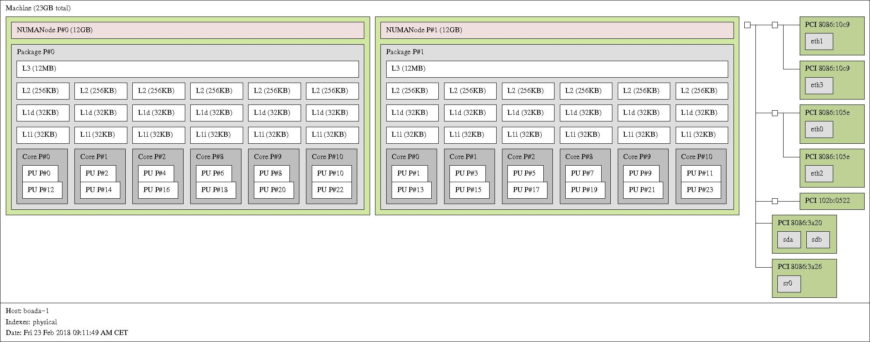

Timing sequential and parallel executions

1. Plot the execution time and speed-up that is obtained when varying the number of threads (strong scalability) and problem size (weak scalability) for pi omp.c on the di erent node types available in boada. Reason about the results that are obtained.

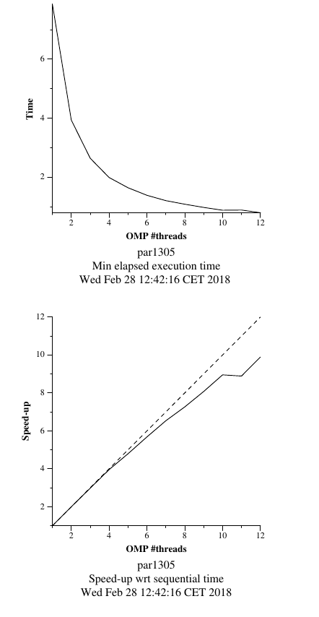

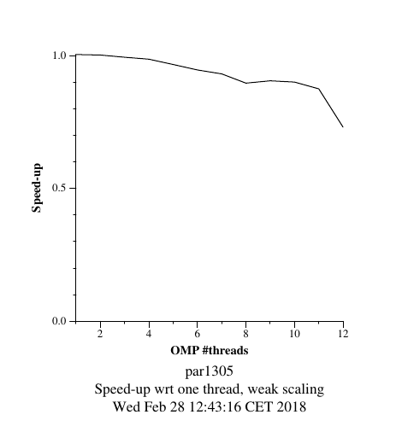

Analysis of task decompositions with Tareador

1. Include the relevant(s) part(s) of the code to show the new task definition(s) in v4 of 3dfft seq.c. Capture the final task dependence graph that has been obtained after version v4.

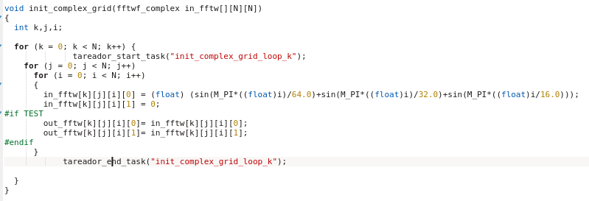

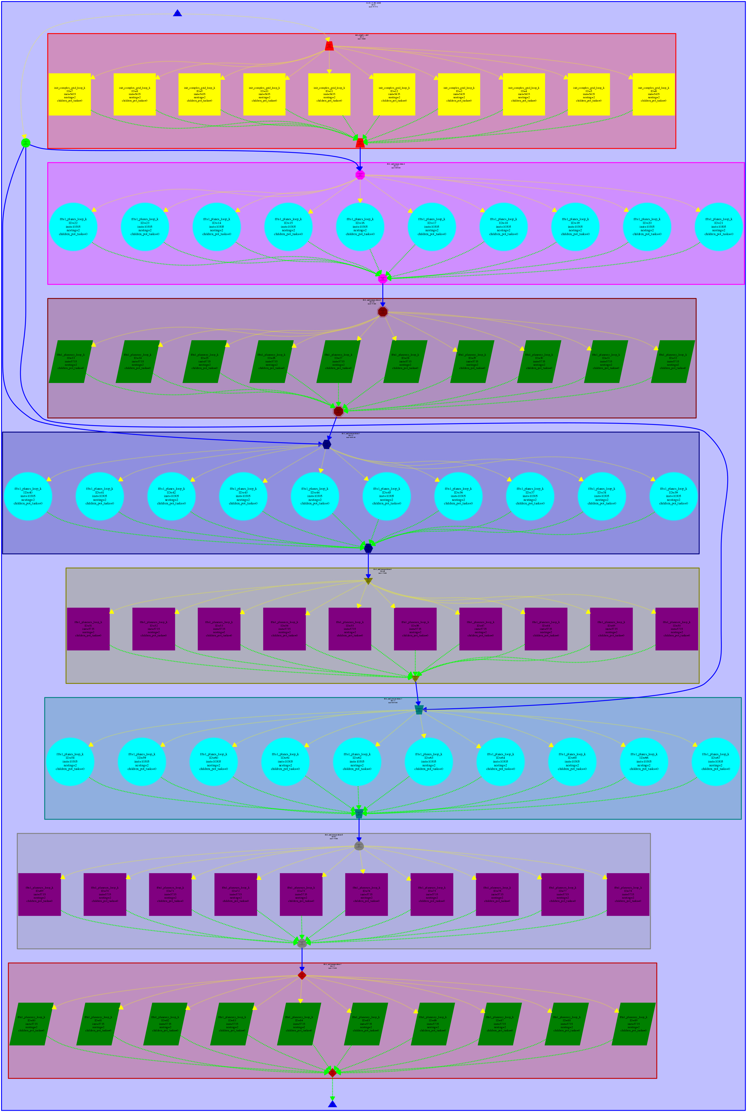

1. Complete the following table for the initial and di erent versions generated for 3dfft seq.c, brie y commenting the evolution of the metrics with the diferent versions.

|  |  |  |  |
| --- | --- | --- | --- |
| Version | T1 | T∞ | Parallelism |
| Seq | 593772 | 593758 | 1.000024 |
| v1 | 593772 | 593758 | 1.000024 |
| v2 | 593772 | 315429 | 1.882427 |
| v3 | 593772 | 107063 | 5.546006 |
| v4 | 593772 | 60148 | 9.871849 |

1. With the results from the parallel simulation with 2, 4, 8, 16 and 32 processors, draw the execution time and speedup plots for version v4 with respect to the sequential execution (that you can estimate from the simulation of the initial task decomposition that we provided in 3dfft seq.c, using just 1 processor). Briefly comment the scalability behaviour shown on these two plots.

Tracing the execution of parallel programs

1. From the analysis with Paraver that you have done for the complete parallelization of

3dfft-omp.c, explain how have you computed the value for Φ, the parallel fraction of the application. Please, in-clude any Paraver timeline that may help to understand how you have performed the computation of Φ.

1. Show and comment the profile of the % of time spent in the diferent OpenMP states for the complete parallelization of 3dfft_omp.c on 4 threads.