Can Engineers Write?
JOAN KNAP

CONGRATULAT1ONS, graduates! Engineering school has taught you all you need to know to guarantee a successful career, right? Maybe not. You haven’t learned how to write a report. However, the fact that you got through engineering school means that you can surely handle such trivialities as writing assignments, doesn't it? Perhaps. But recent studies such as the major study of graduate adequacy conducted by Colorado School of Mines in 1978, suggest that many graduating engineers are deficient in communication skills, particularly writing. The studies also conclude that those skills are necessary for a successful career.
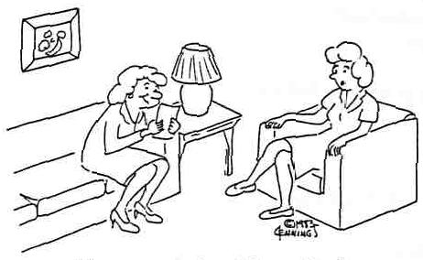
"My son never writes home—he’s an engineer."
The experience of practicing engineers bears out the correlation between writing skills and successful careers. Engineers who write well advance in rank, eventually reaching management levels. Those who cannot write tend to be passed over for promotions and remain in routine jobs. Junior engineers may find writing requirements minimal during the first year or two of practice, but as they gain expertise, they are increasingly required to communicate that expertise. Those who can do so are promoted to more challenging, better paying positions.
Unfortunately, the usual engineering curriculum offers little or no help in developing students' writing abilities. Since grades depend on tests involving calculations only, students have no incentive lo improve their writing. Further, constant emphasis on mathematical rather than verbal material may actually decrease ability to communicate verbally over a four- or five-year period. And, finally, many students adopt a defeatist attitude toward writing; because they don't write, they assume they can't.
Yet most engineers have the potential to write well. Indeed, because they have been trained to think logically, engineering students often have the capability of becoming better writers than humanities students. What they need is instruction and practice.

[From: BEER. D.F. (1992). Writing and Speaking in the Technology Professions. New York: IEEE Press]

Why Study Technical and Professional Communication?
THOMAS N. HUCKIN & LESLIE OLSEN
Why should engineers, scientists, and other technical professionals study technical writing or speaking? Their primary training and interests lie in technical areas; most science and engineering students successfully pursue their technical subjects without extra writing courses, and practicing engineers and scientists in government and industry work on technical projects. It might seem, then, that writing and communication are superfluous to a technical education.

In fact, this is not the case. Scientists and engineers may be technically brilliant and creative, but unless they can convince coworkers. clients, and supervisors of their worth, their technical skills will be unnoticed, unappreciated, and unused. In a word, if technical people cannot communicate to others what they are doing and why it is important, it is they and their excellent technical skills that will be superfluous. From this perspective, communication skills are not just handy; they are critical tools for success, even survival, in "real world" environments.

Every technical person stands to gain from improving his or her communication skills. Most scientists and engineers work in organizational settings where teamwork is essential. Good teamwork is impossible without good communication. And those scientists and engineers who work independently have to communicate with clients, sponsors, or other interested parties. For many technical professionals, the ultimate product of their work is a written document. If that document is badly written, it reflects badly not only on the individual involved but on the entire organization. Organizations know this, of course, and sometimes base hiring and promotion decisions on writing ability. To maximize your chances for landing a good job and doing well at it, you should work on your communication skills — even if you think they're already pretty good. Communication will become even more important as you progress through your career; the better you are at it, the more likely you are to be promoted.

[From; HUCKIN, N.; OLSEN L. (1991). Technical Writing and Professional Communication for Nonnative Speakers of English. New York: McGraw-Hill.]

TASK 1

Read the two extracts “Can Engineers Write?” and “Why Study Technical and Professional Communication?” Then, discuss in pairs and answer the following questions.

- According to the texts, is writing assignments a triviality? Why? / Why not?

- Do you think that FIB’s engineering curriculum offers enough help to develop students’ writing abilities?

- Do you think an engineer can write as well as humanities students? Why? / Why not?

TASK 2

Now try to answer the following questions about technical communication.

- Why do engineers and scientists write?

- What do engineers and scientists write?

- Who do engineers and scientists write to?

- In your opinion, what characteristics should good technical writing display?

