**ArcGIS Pro Shoreline Digitization Tool**

**Robert Elliott**

**M.S. GIS (Eastern Michigan University)**

**Advisor: Dr. Yichun Xie**

**Table of Contents**

I. Introduction

II. Methodology  
 III. Data Sources

IV. Tool Usage Instructions

i. Creating the Tool in ArcGIS Pro

ii. Running the Tool

V. Tool Parameter Descriptions

VI. Interpreting Tool Output

VII. Tool Usage Considerations, Limitations, and Troubleshooting

VIII. Adjusting for Tide and Beach Slope

IX. References

X. Appendix: Using the Shoreline Digitization Tool with Single-Band Imagery

**I. Introduction:**

Rapid and accurate shoreline change detection has many important implications to human society and to the natural world. From sea level rise exposure risk assessment to rapid disease vector risk (e.g. from water pooling) to natural habitat conservation, it is important to be able to observe and quantify how shorelines are changing over time. Automating shoreline digitization allows large areas of shoreline to be identified with significantly less time and expense than digitizing shoreline manually. We chose to use an ArcGIS Pro "script tool" because script tools are relatively simple to share and use by people and organizations that may not have coding experience. The script tool is based on the python language but does not require the end user to know any python or other coding language. Rather, the end user will only have to specify a handful of parameters, one of them being the file location of a pre-written python file (.py). For those with python experience, the code is thoroughly commented to explain the underlying logic and allow for customization by the end user. The script tool was created using ArcPro version 2.5. It should be compatible with all later versions but may not be compatible with earlier versions. Though powerful, the tool is ever-evolving and may not be able to automate shoreline digitization 100% of the time. Visual interpretation by an analyst is required to confirm the tool's accuracy, and in some cases manual shoreline delineation may still be necessary for at least part of an image. This script tool has learned from existing shoreline tools (e.g. CoastSat) but has also improved upon adaptability and user-friendliness.

**II. Shoreline Script Tool Methodology:**

The shoreline digitization script tool is optimized to analyze high resolution multi-band aerial imagery, such as that collected from UAVs. The tool's shoreline detection algorithms use bands that are common and inexpensive to collect (R, G, B, NIR) and also allows for the more expensive but useful shortwave infrared (SWIR) band. Using the shoreline digitization tool does not require any specific knowledge of the algorithms used. Suffice to say, if the imagery bands required for a given algorithm are provided by the user, then the algorithm will be used to create output. The tool user's task will simply be to select the shoreline from the algorithm that most accurately delineated the shoreline. The five shoreline detection algorithms used are as follows: Binary (Otsu) thresholded (M)NDWI, Unsupervised classification using ISO clusters (machine learning), Binary thresholded NDWI plus Band Ratio (("Blue" > "NIR") & ("Blue" > "Red")), Binary thresholded MNDWI plus Band Ratio, and User-input binary threshold values. Combining NDWI with a band ratio approach yields an output that may increase RGBNIR shoreline detection in areas with shoreline impervious surfaces (e.g. houses, concrete). The simplicity of the tool's algorithm removes a lot of the labor and subjectivity that are often inherent to more complex machine learning and image classification, contrast enhancement, and/or spatial filtering workflows. In general, NDWI identifies pixels with a value greater than zero as water (McFeeters, 1996). However, the classification sometimes works better if the cut-off is set to a value other than 0 (say, 0.3). The shoreline script tool's default approach is to identify the largest (surface area) water body in an image and delineate its shoreline. In other words, the current version of the tool only delineates the shoreline of one water body per aerial image. Though simple in design, the shoreline script tool is customizable to allow the user to manually input NDWI threshold levels that can improve shoreline detection. The ArcGIS Pro script tool (custom toolbox) format allows the end user to efficiently automate shoreline digitization without any coding.

**III. Shoreline Script Tool Data Sources:**

The script tool is designed to work with rasters saved to a folder on a hard drive. These rasters can be downloaded manually or through using an API (e.g. Google Earth Engine), but the tool is not currently designed for cloud-based analysis. The Shoreline digitization script tool is designed to accept multi-band rasters/images as input. Some imagery may only be available as single-band (e.g. Landsat from Earth Explorer). In such a case, the individual bands must first be "composited" prior to input into the shoreline tool. See "Appendix" for band compositing instructions. Images with high spatial resolution (e.g. 1 meter) will increase the accuracy of shoreline detection. One caution, though, is that images of a very large file size may cause the tool to run very slowly or perhaps cause it to fail completely. Organizations may have their own sources for high-resolution aerial imagery. If not, aerial imagery is available for public download through the USGS Earth Explorer website (https://earthexplorer.usgs.gov/), the National Map Viewer, and other sources. It is necessary to create an Earth Explorer account and be logged in before downloading data. There are many ways to search for data using Earth Explorer. One relatively simple way is to zoom into the area of interest on the Earth Explorer home page and then under "Polygon" select "Use Map." The area in the map's view will be selected. Next set your "Data Range" for desired imagery dates and select the "Data Sets" button. On the next screen under "Select Your Data Set(s)", expand "Aerial Imagery" and check the box next to NAIP. Then select the "Results" button (you might have to scroll down to see it). Assuming you have logged in, you will now be able to download the data of interest.

**IV. Shoreline Script Tool Usage Instructions:**

The hope was to create an ArcPro Python Toolbox to allow for easy sharing of the tool. Unfortunately, the Python Toolbox code behaved unpredictably, so the script tool (custom toolbox) format was chosen. Attempts at sharing the script tool through a "geopackage" (.gpkx file) were also unsuccessful. This being said, the end user will have to create their own script tool and associate it with the provided code. This document describes the script tool creation process, which is really quite straightforward.

*i. Creating the Script Tool*

Step #1: Open the ArcPro "Catalog Pane"

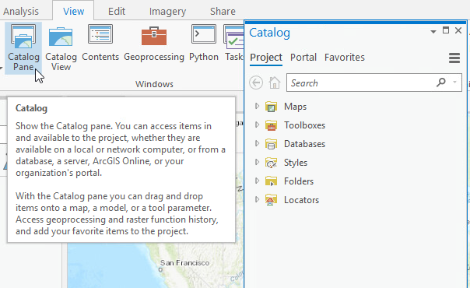

Figure #1

Step #2: Expand the "Toolboxes" menu and right click on the project's default toolbox then select "New" > "Script"

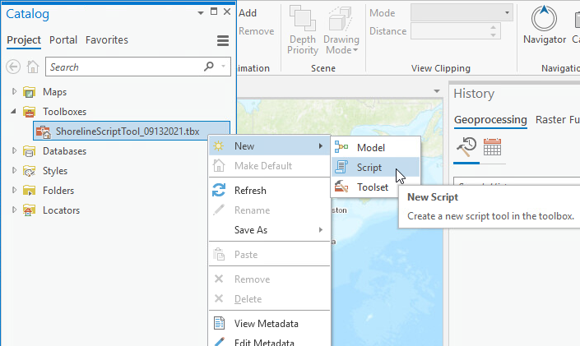

Figure #2

Step #3: In the "New Script" dialog box that opens, enter information in the "General" and "Parameters" tabs. If the "New Script" dialog box does not open automatically, right click on the script tool and select "Properties." In the "General" tab, give your script tool a descriptive name and label. Under "Script File", specify the location of the Python (.py) file that contains the code for the script tool. If you have coding experience, you can read the code in a text editor and even alter the code, but successfully running the script tool does not require any knowledge of coding.

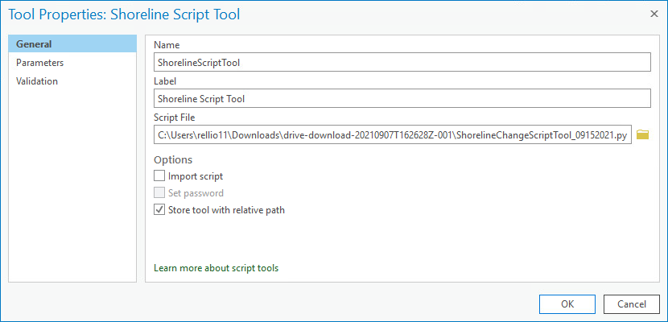

Figure #3

Step #4: Enter the Script Tool Parameters in the "Parameters" tab. Figure #4 (below) shows the tool's parameters with descriptive names. You can change values in the "Label" and "Name" columns, but the values for "Data Type", "Type" and "Direction" should be entered exactly as shown in the screenshot below. Select "OK" after all the values are filled for the tool parameters. More detailed information on the parameters is available in the "Parameter Descriptions" section.

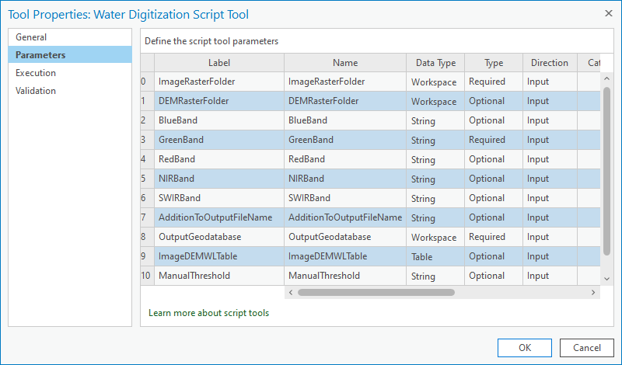

Figure #4

Note: It may seem that the OutputGeodatabase parameter should have its direction as "Output", but for some reason the tool works best with the direction set to "Input."

Step #5: In order to run the script tool, it needs to be linked to the corresponding python code (.py file). This step is accomplished under the Tool Properties "Execution" tab. The only action required in this tab is to enter the .py file path in the space provided (see below). After doing so, click "OK" on the Tool Properties dialog box, and the tool is created.

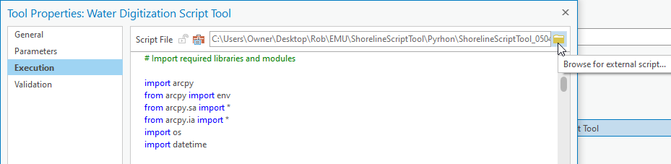

Figure #5

The script tool will be created underneath the project's default toolbox in the Catalog. The tool can be accessed from the Catalog Pane at any time.

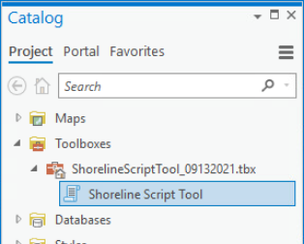

Figure #6

The tool will initially only exist in the Catalog Pane of the project for which it was created, but it can be imported to a new project by selecting Insert > Toolbox > Add Toolbox

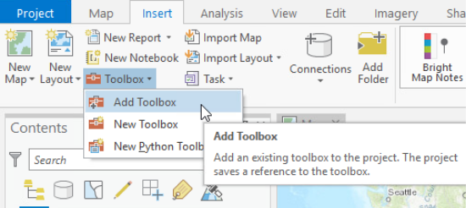

Figure #7

*ii. Running the Script Tool*

To run the script tool, simply open the Catalog Pane and double click the tool. Next, enter the appropriate parameter values, which are explained in detail in the "Parameter Descriptions" section. Figure #8 shows an example of Shoreline Script Tool Parameter Inputs:

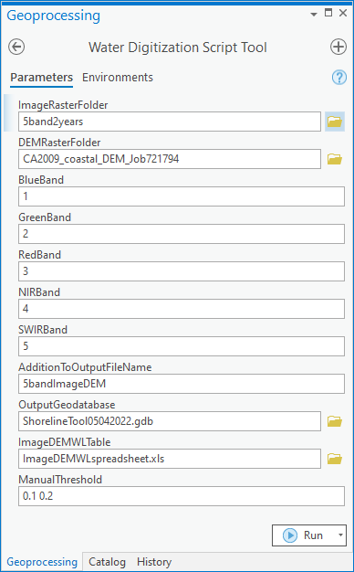

Figure #8

After entering the parameters, select "Run." The time it takes for the tool to complete will depend on the size and number or input rasters. Upon running the script tool, the outputs for the first ten input rasters are added to the table of contents, and any remaining outputs will be saved to the output geodatabase but not automatically added to the table of contents. It may be necessary to "refresh" the output geodatabase before the output data appears.

**V. Parameter Descriptions:**

True to coding convention, ArcPro begins its parameter count at zero. This discussion likewise begins with Parameter0. For easy reference, you can refer to the screenshot of the parameters in Figure #4 (above).

*Parameter0 (Required): Image Raster Folder*

This parameter is the folder path where the input aerial images are stored. Though the script tool has not been tested with all raster types, any multi-band raster format recognized by ArcPro should be acceptable. Aerial image inputs must be multi-band. Some image types (e.g. Landsat) may require compositing (e.g. with the ArcPro "Composite Bands" tool) prior to usage in the script tool. The script tool should be capable of distinguishing the rasters from other data types in the folder, but the tool will not be able to access rasters that are within additional folders inside the Image Raster Folder path provided. To accurately detect shoreline change, it is important that all the rasters be in the same geographic coordinate system. It is also important to be aware that the tool may not work for rasters of particularly large file size, which would likely be determined by ArcGIS limitations rather than limitations specific to the shoreline script tool.

*Parameter1 (Optional): DEM Raster Folder*

This parameter can be added if the user wants to establish a contour on a DEM at a given water level. For example, the user may find data (e.g. NOAA) for the water level at the time that the aerial image was taken. That water level data can then be used to create a contour on the DEM, and that contour can then be compared to the shoreline delineated from the aerial image. In this way, differences between the DEM contour and the aerial image shoreline become tide-adjusted and can be compared to one another to identify possible shoreline change. DEMs are single-band rasters that include a z-value (elevation). It is important to note that non-shoreline contours may also be created. In DEMs covering large areas and/or hilly terrain, many such additional contours may be created. Assuming the water level input is higher than the water level in the DEM, the contour representing the shoreline should be quite apparent. This shoreline contour can then be compared to the shoreline delineated from the aerial image in order to identify potential areas of shoreline change. The script tool only analyzes the intersection of the aerial image and DEM extent. If a DEM is not available for an area, isolated coastal elevation points and/or contour lines (based on beach slope data) can be interpolated to create a basic DEM surface for input into the shoreline script tool. More information on this interpolation approach is included below.

*Parameters 2-6 (Optional): Blue, Green, Red, NIR, and SWIR Bands*

The basis for automated shoreline delineation lies in research-based band indexes and ratios. The normalized difference water index (NDWI) has been shown (McFeeters, 1996) to differentiate water from land with a relatively high degree of accuracy. The modified NDWI (MNDWI) has been shown to often improve upon the accuracy of the NDWI (Xu, 2006). When combined with the (M)NDWI technique, the "band ratio" technique (Niya, 2013) can in some cases assist in distinguishing water from impervious surfaces at the shoreline. If the script tool is run with (M)NDWI bands and there is a lot of interference from shoreline impervious surfaces, it may be worth adding the blue and red bands to the analysis. Adding the band ratio method allows all four bands to aid in shoreline delineation for common high resolution imagery sources (e.g. NAIP, UAV). There is no harm in inputting values for all five bands. The script tool input band number corresponds to the order of the band within the multi-band image. For example, in NAIP multi-band imagery, the 2nd band (green) should be input as 2 and the 4th band (NIR) should be input as 4. When inputting the band number, do not add any characters or punctuation aside from the single digit. If a SWIR band is input, then MNDWI (rather than NDWI) will be computed.

*Parameter7 (Optional): User Addition to Output Filename*

The script tool user may want to include their own addition to the output file names. Doing so may help the user to keep track of various runs of the tool. It is important that this filename addition not include invalid characters (e.g. spaces). The name asked for in this parameter is simply a text string, not a file path. The output will automatically be saved to the Output Geodatabase that is later defined in Parameter8.

*Parameter8 (Required): Output Geodatabase*

This parameter specifies the location to which the output files will be saved. To avoid potential tool confusion, the output should not be saved to the same folders that contain the aerial images or DEMs. Saving the output to a file geodatabase (versus to a folder) avoids tool errors and allows for easy water area measurement through the "shape_area" field.

*Parameter9 (Optional): ImageDEMWLTable*

Various aerial images may be associated with various DEMs. If users include a DEM input, they must also include an Excel file (.xls or .xlsx) that contains the relation between aerial images and DEMs. The script tool code will convert the Excel file to a File Geodatabase table then loop through each row and access the aerial image and its matching DEM from their respective folder locations. The Excel file should also include water level data to provide the basis for the contour to be drawn on the DEM. The script tool relies upon exact (case sensitive) of Excel file field/column titles to access the proper aerial image and DEM files from their folder locations. These field/column titles are: ImageBaseName DEMBaseName WaterLevel

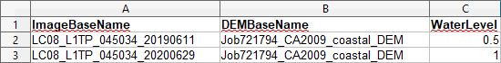

A quirk of Parameter9 is that the Excel file path will sometimes include the sheet title (see below).

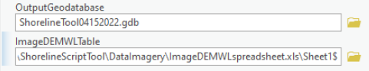

In order to run the tool, the sheet title must be manually deleted from the file path such that the path ends with either .xls or .xlsx.

*Parameter10 (Optional): UserThreshold*

The shoreline digitization script tool's power to accurately identify shoreline comes from its ability to use various (M)NDWI threshold values for the land/water interface. By default the script tool outputs a shoreline and water body polygon based on a) Otsu binary thresholding on the (M)NDWI raster and b) Otsu (M)NDWI + Band Ratio (if red and blue bands are input). Often these outputs will satisfactorily delineate the shoreline. Again, visual confirmation is required by the user to assess tool accuracy. Sometimes the default outputs do not accurately delineate the shoreline. In such cases, the user may choose to re-run the tool on inadequately delineated images and use custom threshold values. Threshold values can vary substantially from one image to another. It may be possible to improve shoreline detection accuracy by narrowing down the proper threshold values over the course of several tool runs. It is not necessary for the user to understand why a given threshold may be appropriate, but from experience, realistic threshold inputs for Parameter11 are often between 0 and 0.4. They should be input in the precise format:

0.1 0.2 0.3

The tool outputs a shoreline feature and a water polygon feature for each threshold input value. The output name for the first input value is "NDWIThreshold_1", the second input value is "NDWIThreshold_2", etc. If it were to become apparent upon running the tool that the best threshold value lies between, say 0.1 and 0.2, then the user could re-run the tool with a 0.15 (or similar) value.

**VI. Interpreting Shoreline Tool Output:**

The shoreline digitization script tool attempts to simplify its output for straightforward analysis. Depending on the image bands used, different final products will be output. The simplest workflow entails using only the green and infrared bands and leads to a binary (Otsu) thresholding product of the (M)NDWI raster. If no SWIR band is provided, the NIR band is used, and the output is named 'OtsuNDWI.' If a SWIR band is provided, the output is named 'OtsuMNDWI.' If the user provides red and blue bands, an additional output is the sum of the Otsu(M)NDWI raster and the Band Ratio raster. This sum does not appear to exist in the remote sensing literature, but it seems promising for helping to remove impervious surfaces from the shoreline. More study is needed to assess its utility, but in the meantime, the user may find it useful. The output name of this sum is "BRNIROtsuNDWI" when used with NIR and "BRSWIROtsuNDWI" when used with SWIR. If the user manually enters (M)NDWI threshold levels, those outputs will be named "NDWIThreshold_#." If the user inputs a table with DEM rasters and water level data, then the script tool will also create DEM contour lines. These contours will be named "GroundReferenceWaterLevel."

The full file names also include the image raster name, the user's name addition, and a timestamp in the format MonthDayHourMinute. The full output name will be available in the MERGE_SRC field in the output attribute table. See example below:

LC08_L1TP_045034_20200629_GroundReferenceWaterLevel_UserNameAddition_04291206

In order to facilitate output file management, all of the output features for a given input aerial image are merged into a single feature class. Output can be matched with input based on the output name. A single shoreline output can be analyzed simply by selecting the row of interest, and the feature will be highlighted in blue. To create a layer from a single feature alone, simply right click on the feature class in the table of contents, then choose Selection > Make Layer From Selected Features.

In many cases, the shoreline detection will be very accurate for at least one of the default threshold values (i.e. Otsu, BandRatio). In other cases, different threshold values may need to be entered and the tool re-run. In still other cases, the output polygon will be mostly accurate but may require some manual trimming to improve accuracy. The degree of accuracy required will depend on the objectives of the end user. Again, there may be some cases in which shoreline detection automation will not be possible, but the tool will generally save the end user substantial effort by at least partially automating shoreline detection.

After selecting a shoreline feature that closely matches the aerial image on which it was based, the tool user/analyst should be able to interpret useful shoreline change information from visual assessment. Comparing the shoreline feature delineated from the aerial images to the DEM-based contours should be particularly useful. That said, a somewhat more rigorous shoreline change assessment can be conducted with a few additional steps (described in the following paragraph). For a very detailed shoreline change analysis, the shoreline script tool's output can be used as input for the Digital Shoreline Analysis System (DSAS).

Once users select the image-based shoreline feature that best matches their shore section of interest, they can go further by using the feature as a mask in the ArcPro's Extract by Mask tool (again, no user coding required). With the shoreline feature as a mask, the DEM pixels along the shoreline feature can be extracted. There will then be pixels with elevation data in the same horizontal location as the water in the aerial image. This elevation data should be taken with a grain of salt, but it can still be very useful in helping the analyst to identify areas of shoreline change. Adjusting the symbology of the shoreline extracted DEM can help to highlight areas of change. The "Temperature" color scheme is a good choice for highlighting differences in pixel values.

**VII. Tool Usage Considerations, Limitations, and Troubleshooting:**

The shoreline digitization tool is best thought of as an *attempt* to fully automate shoreline detection and digitization. While the tool will accurately detect at least part of an image's shoreline in most cases, sometimes the inherent uncertainties of remote sensing will lead to inadequate detection. That notwithstanding, given the time and labor involved in manual shoreline digitization, the script tool has great potential to facilitate and automate shoreline monitoring (especially in applications with large datasets).

*General Usage Tips:*

-Full functionality of the shoreline digitization script tool requires an *Advanced* ArcPro license.

-If no DEM is provided, the tool will delineate the entire shoreline for the input aerial images. If a DEM and relational Excel file are provided, the tool will only add a DEM-based contour to the intersection of the aerial image extent with the DEM extent.

-Make sure that all parameters are entered correctly and are of the format required by the tool. For example, entering a file path for a folder containing a folder containing the input rasters will result in tool failure. The file path entered must contain the rasters themselves, and the rasters must not be within an additional folder.

-Aerial images and DEMs must be in the same coordinate systems. It may be necessary to reproject image/DEM pairs into matching coordinate systems prior to running the script tool.

-Make sure that the horizontal units (e.g. feet, meters) are the same for both the input aerial images and DEM.

-Sometimes ArcGIS (and the Shoreline Script tool by extension) will behave very strangely (e.g. failing when it previously succeeded with the exact same parameters). It may help to reboot ArcGIS and/or your computer or possibly start a new ArcGIS project.

-Using Jupyter Notebook while ArcPro is also running can sometimes cause issues. Rebooting the program(s) will sometimes fix the issue.

-It is possible for geodatabases to become corrupt, and it may sometimes be necessary to repair a geodatabase or create a new one.

-Due to time constraints, in its current form the tool lacks validation and error-checking measures. Common sources of error that could cause tool failure include:

Issue: Input files with invalid characters (e.g. spaces)

Solution: Make sure all file names contain only valid characters

Issue: Tool fails and returns an error: 999999

Potential Solution:

-"999999" is a generic ArcGIS error code that may have many causes. One possibility is that the input raster(s) may be too large.

Issue: Shoreline not delineated accurately

Potential Solution:

-Double-check that the band numbers input in the script tool parameters match the order of bands in the input rasters. It's important to note that different imagery types (e.g. NAIP vs. Landsat) may have different band orders

-If imagery contains a SWIR band but was not used in the tool's run, try inputting the SWIR band number.

-Inputting the red and blue bands may improve shoreline detection accuracy (esp. if there are many impervious surfaces along the shore).

Issue: Failure to acquire a "schema lock" on a table. This error may manifest itself as other (non schema lock) error codes as well

Potential Solution: Make sure that the tool is not being accessed from multiple applications (e.g. ArcPro script tool, Jupyter Notebook) simultaneously

Issue: "ArcGIS.Desktop.Core.Geoprocessing.GPItemException" error is thrown.

Solution: One step in the script tool involves the conversion of an excel file to a file geodatabase table. This action requires the installation of a driver, discussed here:

<https://community.esri.com/t5/arcgis-pro-questions/arcgis-desktop-core-geoprocessing-gpitem/td-p/1130590>

and here:

<https://pro.arcgis.com/en/pro-app/latest/help/data/excel/work-with-excel-in-arcgis-pro.htm>

Issue: Tool completed successfully but data does not appear in "Add Data" pane

Potential Solution: Refresh 'Add Data' pane

Issue: Shoreline is not accurately delineated.

Potential Solution: Clouds will interfere with analysis. Find images without clouds or remove clouds from the images prior to analysis by the script tool. Also, images of smaller areas will likely yield more accurate shoreline delineation.

**VIII. Adjusting for Tide and Beach Slope:**

When analyzing aerial images of large bodies of water (e.g. oceans), the tide (water level) at the time/day of imagery capture is very significant. For example, an image taken at low tide could lead an analyst to conclude that the shore had expanded seaward if compared to an image taken at high tide. The sole purpose of the DEM input into the shoreline digitization script tool is for tide and beach slope analysis. If only aerial images and no DEM are input, then the tool can still be useful to delineate the shoreline and estimate water surface area of minimally tide-affected water bodies such as small inland lakes and rivers. In tide-affected water bodies, the script tool does not attempt to adjust aerial image-derived shoreline features for tide, per se. For one, simply adjusting the shoreline features horizontally is not likely to accurately represent variations in beach slope. Alternatively, simply drawing a contour on a DEM at the water level at time of aerial image capture does not utilize any shoreline information that the aerial image can offer. The script tool is designed to allow an analyst to compare multi-band aerial imagery to a baseline DEM in order to identify areas of potential shoreline change. This technique offers a higher temporal resolution, less costly and less labor-intensive approach for monitoring shoreline change as compared to field measurement or shoreline assessment based on a DEM alone.

If the day/time of the aerial image capture is known, then it may be possible to access the field-measured tide data for the time of image capture. Unfortunately, NAIP data does not include time of capture (<https://www.fsa.usda.gov/Internet/FSA_File/am_imagedates.pdf>), though UAV and high resolution satellite data generally does. In the United States, frequent and accurate field-measured water level data can be found through NOAA (<https://tidesandcurrents.noaa.gov/>). Be sure to match the vertical datum (e.g. NAVD88) of the water level data to the vertical datum used for the DEM. NOAA even offers an API for automated tide data access, though manually accessing the data is quick and simple. The field-measured water level value can then be input into the user's Excel file in the "WaterLevel" field. A contour line will be drawn on the DEM at the input water level when the Excel file is used as input in the ImageDEMWLTable parameter.

While the shoreline digitization script tool parameter only accepts a DEM, if one is not available, a user may be able to create a simple DEM from multiple elevation data points and/or a slope raster through interpolation. ArcGIS has various tools for interpolation, such as "Spline" (for points) and "Topo to Raster" (for contour lines). The literature suggests that spline is a common approach for interpolating coastal surfaces, though the script tool user should conduct their own research if using an interpolation approach.

**IX. References:**

McFeeters, Stuart K. "The use of the Normalized Difference Water Index (NDWI) in the delineation of open water features." International journal of remote sensing 17, no. 7 (1996): 1425-1432.

Niya, Ali Kourosh, Ali Asghar Alesheikh, Mohsen Soltanpor, and Mir Masoud Kheirkhahzarkesh. "Shoreline change mapping using remote sensing and GIS." International Journal of Remote Sensing Applications 3, no. 3 (2013): 102-107.

Xu, Hanqiu. "Modification of normalised difference water index (NDWI) to enhance open water features in remotely sensed imagery." International journal of remote sensing 27, no. 14 (2006): 3025-3033.

**X. Appendix**

*Using the Shoreline Digitization Tool with Single-Band Imagery*

1) Use ArcGIS "Composite Bands" tool

It is only necessary to composite the bands that will be used in the script tool. For example, if you are only conducting an NDWI analysis, you will only use the green and NIR bands, and the composite raster will only have two bands.

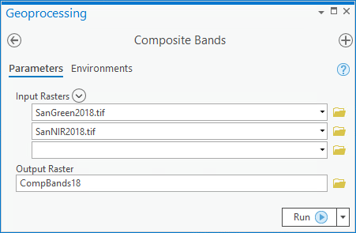

2) Export Composite Raster (ideally directly into folder that will be used as script tool input)

i)

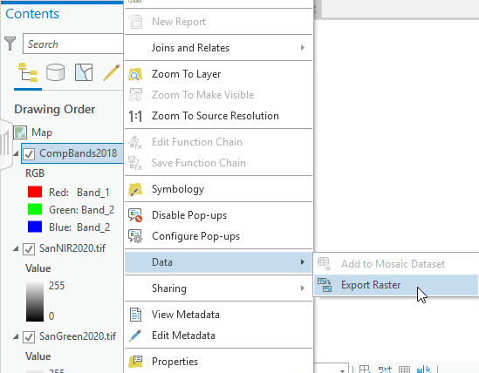

ii)

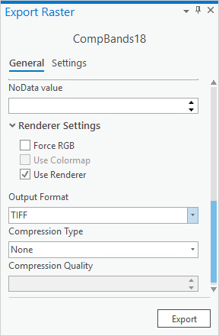

3) Input Composite Band Raster as Script Tool Parameter

Generally the first band added to the ArcGIS "Composite Bands" tool will be band #1, the second band added will be band #2, and so forth.