TwoRavens Local Installation

In the terminal:

git clone https://github.com/IQSS/TwoRavens.git

Then, download and install R at https://www.r-project.org. Execute the following with R to install R packages:

install.packages(c("VGAM", "AER", "dplyr", "quantreg", "geepack", "maxLik", "Amelia", "Rook","jsonlite","rjson", "devtools", "DescTools", "Zelig"))

Then set your working directory to ~TwoRavens/rook via, for example:

setwd("/Users/vjdorazio/Desktop/github/TwoRavens/rook")

Then source rooksource.R to get the app up:

source("rooksource.R")

Note that this may install many packages, depending on what already exists. If it asks, just say that you want to install things from the source. The local server with the apps should be up and R should say something like:

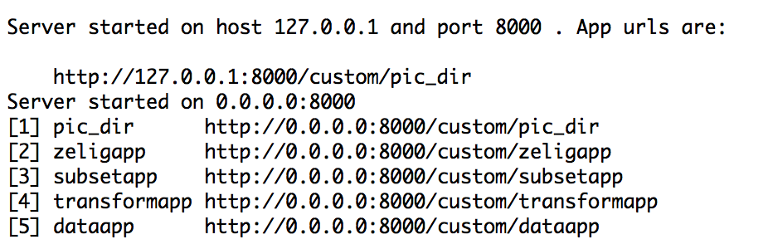

Now, in the terminal, cd to ~TwoRavens and spin up a server with Python. For example:

cd Desktop/github/TwoRavens

python -m SimpleHTTPServer 8888 &

Now, in your browser (e.g., Safari, Chrome), go to that URL:

http://localhost:8888

Click on "gui.html". You should be up and running. Play around with TwoRavens and make sure that you can do things like estimate a model, subset the data, create transformations, etc.