

8

30

You win the game!

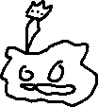

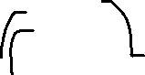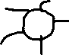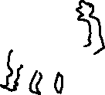

Power Plant

Pump-King

**Harvest**

You may play a Harvest Card from The Compost without paying its cost

copy paste works!

Few notes:

Placing it in word doc makes it easy to print sheets

Make this as SIMPLE AS POSSIBLE

Image is going to be stick figures, low quality, not the mona lisa.

Blue color = change as per the icon color

Circle mid right is the icon place

Seeds are displayed in the sidebar, copy paste the icon into the lower part, actual # is placed in top left corner - overlap is OK, different sizes of seeds are OK, but doubtful we would need it

delete these and ctrl cv these onto the herbicide manual



6

3

Reap

Gain 1 seed

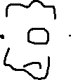

Willowed Wallflower

Moonglow-shine

**End of Turn**

If you had at least 2 plants move into your garden this turn, draw 2 cards



12

5

Harvest

You may move this plant and up to one adjacent plant to another position

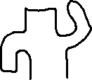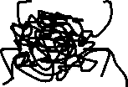

Tumble-Bundle

Sheriff Cact-US

**Sow**

If any of the plants you’ve played are in another player’s garden, return it



8

5

Sow

Swap any number of cards from your hand with cards in the Compost Pile

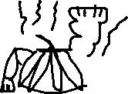

GIGA Garlic

Tax Tomatillo

**End of Turn**

If you haven’t played a plant this turn, gain 5 seeds



4

5

Harvest

You may swap this plant and one other plant from another player’s garden

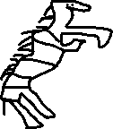



Swapping Scallion

Zebra Grass

**Reap**

Gain 2 seeds



8

5

Sow

Swap any number of cards from your hand with cards in the Compost Pile

GIGA Garlic

Moonglow-shine

**End of Turn**

If you had at least 2 plants move into your garden this turn, draw 2 cards



8

5

Harvest

You may move this plant and up to one adjacent plant to another position

Tumble-Bundle

Sheriff Cact-Us

**Sow**

If one of the plants you’ve played is in another player’s garden, return it