**Goals and Objectives**

We engage in engineering, consulting, and management work that supports multifaceted development. Our focus areas include Education, Health, Disaster Management, Life Skills Development, Gender Equality and Social Inclusion, Livelihood Improvement, Good Governance, Climate Change and Environmental Protection, Youth Empowerment, Children's and Women's Rights and Security, Initial Environmental Examination (IEE), Environmental Impact Assessment (EIA), Local Adaptation Plan of Action (LAPA) preparation, Detail Project Report (DPR) preparation, Cash and Voucher Assistance to create a positive impact and contribute to sustainable development in various communities.

We collaborate with a wide range of stakeholders, including various government agencies, ministries, institutions, business establishments, and financial organizations, as well as national and international non-profit organizations. Our work involves conducting research and surveys, monitoring and evaluation, and implementing activities focused on accountability and learning. We also engage in social service initiatives and offer training and capacity-building programs. Also, we develop operational manuals, design projects, prepare proposals, and conduct fundraising activities. Our efforts are complemented by the creation of audio and visual materials to effectively communicate and awareness raising.

We offer expert services to a wide range of clients, including government agencies, ministries, and institutions, as well as business establishments and industry stakeholders. Our support extends to financial organizations and non-profit entities, both national and international. By tailoring our services to meet the specific needs of each organization, we ensure effective guidance and assistance across various sectors.

We specialize in the production of video films, motion pictures, documentaries, and advertisements, as well as the publishing and distribution of films. Our services also encompass audio production and publishing, along with television broadcasting. We engage in various photography activities and offer 2D and 3D animation production and distribution, delivering creative content across multiple platforms.

**Team Bio and Qualifications**

**Ms. Sanju Bagale: Chairman**

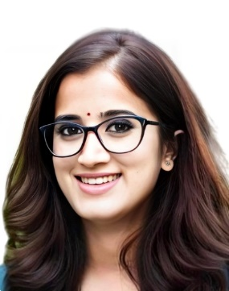

**Ms. Sanju Bagale** holds MSc in Environment Management and Master in Rural Development. Ms. Bagale is humanitarian and development professional with over 13 + years of experience, specializing in people management and project leadership across diverse, cross-cultural teams. Skilled in strategic decision-making, capacity building, and adhering to global humanitarian standards, with expertise in designing and implementing projects in areas such as food security and livelihood, cash and voucher assistance, disaster risk reduction, climate change adaptation, and environmental safeguarding. Experienced in managing projects funded by major donors including DFID, DEC, OCHA, Swiss Solidarity, USAID, and MCC.

**Mr. Praveen Kumar Regmi: Executive Director**

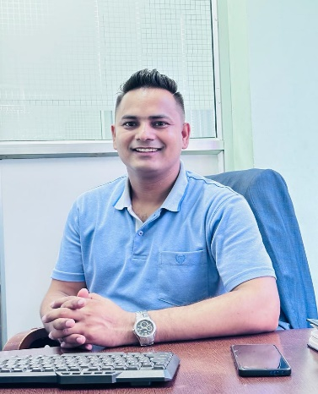

**Mr. Praveen Kumar Regmi** is the Academic Coordinator and Associate Professor at School of Environmental Science and Management and has completed his master’s in environmental management. Mr. Regmi holds experience in Climate Change issues, policy and climate finance sectors. Working, managing and leading Environmental Assessment work of multiple infrastructure development projects including roads, highways, transmission lines, river management and other major infrastructure projects, Mr. Regmi is associated as Physical Science expert with Ministry of Forest and Environment. Mr. Regmi is an Environmental Management professional with his expertise in the field green resilient infrastructure development, Environmental Assessment, Natural Resource Safeguards and Sustainable development.

**Ms. Benju Bagale: Program Coordinator**

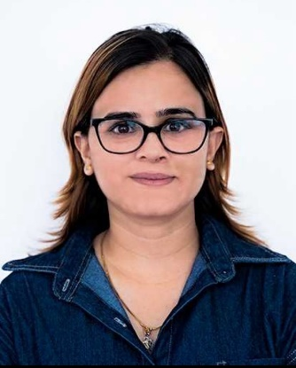

**Ms. Benju** **Bagale** holds master’s in environmental management and Bachelor of Science in Geology. Ms. Benju is the Environmental and CVA professional with her experience in the sectors of Emergency preparedness and response, Cash and Voucher Assistance (Value Voucher, Cash for Work, Multipurpose Grant), Initial Environmental Examination, Environmental Impact Assessment. She is involved with different capacity building training related to Cash and Voucher Assistance.

**Ms. Arju Bagale: Board of Director**

**Ms. Arju Bagale** is an Academic Director at Shikshya Academy. Ms. Arju is the ACCA member and ACCA tutor with years of audit experience. She has gained her experience in the sector of financial literacy as well. She had functioned as Article Trainee, Internal Control Consultant, Loan Profiling Consultant, ACCA Tutor.

**Mr. Sahash Lamichhane: Board of Director**

**Mr. Sahash Lamichhane** holds Master in Rural Development and MSc. Environmental Management with bachelor’s in forestry. Mr. Lamichhane has his experience with different organization and donor agencies in the sector of Climate Change, Early Warning System, Disaster Risk Reduction, GIS, Nature Based Solution, IEE assessment, EIA assessment, Local Adaptation Plan of Action (LAPA) preparation, Bio-Engineering, Social Protection and Environmental Compliance, GEDSI, Health Safety, First Aid.

**Programs and Projects**

* Developing Training Packages on Natural Resource Safeguard in Linear Infrastructure Development
* Capacity Building of the local government engineer technicals on green road engineering
* Capacity building of Foresters, Wardens and Rangers on investigating and prosecuting flora and fauna crimes
* Capacity building of transportation workers on controlling illegal wildlife crimes.
* Urban Air Profile and health impacts in Kathmandu
* Community and ecosystem based non-timber forest products production, processing and marketing initiative
* Brief Environmental Study (BES) of Joint Transmission Line of Doodhpokhari Chepe Hydropower Project and Super Chepe Hydropower project (33 KV double circuit)
* Generating field evidence and formulating the operational plan to make Karnali a water safe province.
* IEE study of for sustainable extraction of sand, stone and gravel of Babai and Phedi khola river, Shantinagar Rural Municipality, Dang
* IEE study of for sustainable extraction of sand, stone and gravel of Hima river, Sinja Rural Municipality, Jumla
* Cooperative Management and Leadership training in Nuwakot

**Ongoing projects**

1. Assessing the effectiveness of wildlife friendly linear infrastructure mitigation measures:

**Funding:** Zoological Society of London (ZSL)

**Duration:** August 2024 to January 2025.

**Publications and Reports**

* Urban agricultural practices and solid waste management in Lalitpur Municipality.
* Study of Chepang-Nature Relationship in Chitwan.
* Ecological, Geological, Limnological and Socioeconomic study of Fewa Watershed Area, Kaski
* Faunal Diversity of the Central Zoo, Lalitpur

**Contact Information: Email, Phone, Address**

Email: [rasitaconsult@gmail.com](mailto:rasitaconsult@gmail.com)

Phone: +9779802822893, +9779849296810

Address: Chandragiri 06, Radhakrishna Kathmandu