**Software Requirements Specification**

**for**

**Pharmacy Store Management System**

Version 1.0 Approved

Prepared by

Thomas Woods (TL)

Mustafa Nafia

Huda Ali

Computer Science and Engineering Department

Indiana University Southeast

Date: October17th, 2020

**Table of contents**

**Table of contents**………………………………………………………………………….i

1. **Proposed software architecture**.........................................2

* Overview…………………………………………….…….2
* Subsystem decomposition……………………........………3
* Hardware/software mapping……………………..……......4
* Persistent data management.................................................5
* Access control and security.................................................5
* Global software control.......................................................6
* Boundary conditions............................................................6

1. **System data components**..................................................7

* Data stores..........................................................................7
* Data flows..........................................................................7
* Data elements.....................................................................7
* Data storage.......................................................................7
* Data connections...............................................................7

1. **System processes components**........................................7

* Use cases...........................................................................7
* Functions...........................................................................7
* Triggers.............................................................................7
* Processors..........................................................................8
* Actors/External Entities.....................................................8

1. **Proposed software architecture**

**1.1 Overview**

In this document, we will describe the architecture of the software for Pharmacy Store Management System (PSMS). The software developed by Indiana University Southeast Computer Science department student group. The main purpose of this document is to describe, in sufficient detail, the components of the software. It will analyze the behavior and responsibility of the attributes. As well as a description to the interface to allow more design characteristics and planning.

**1.2** **Subsystem decomposition**

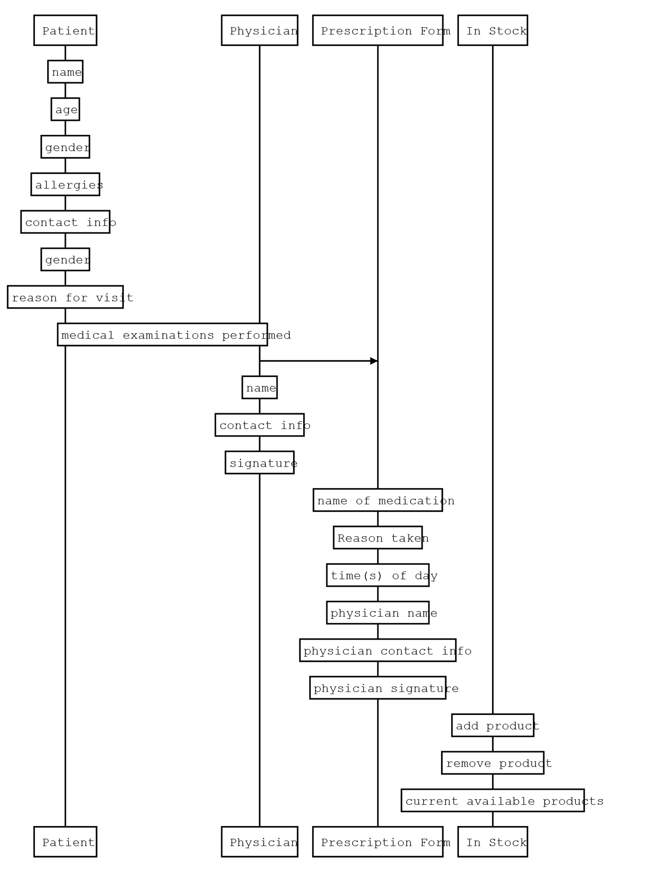

**1.3Hardware/software mapping**

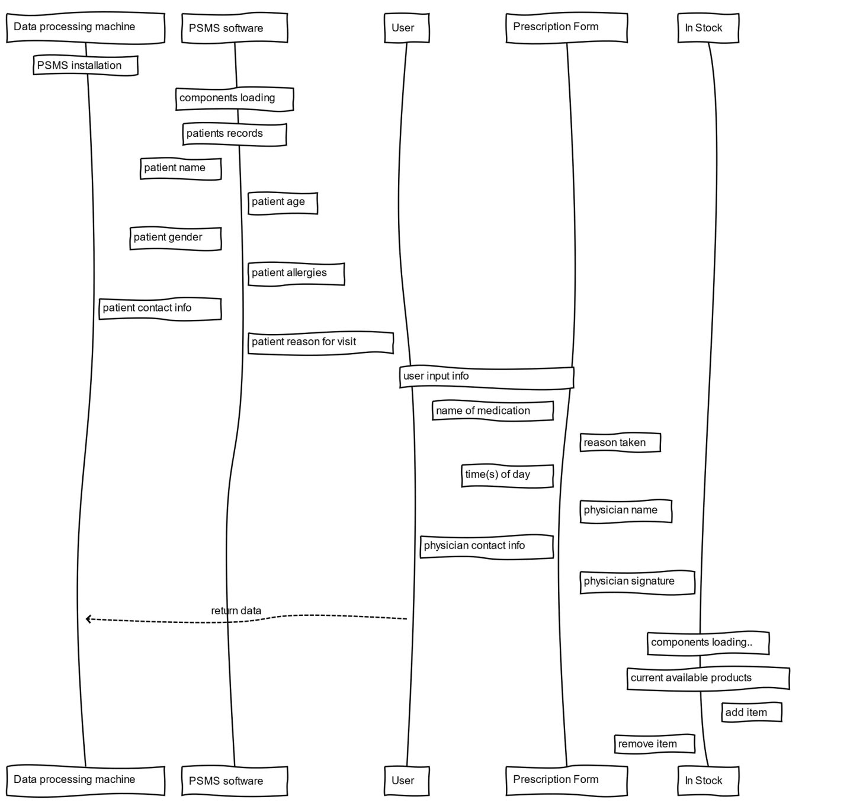

**1.4Persistent data management**

The data related to patient in which the user input the name, age, gender, etc. Such data will be stored to be accessed for records purposes. As well as the current products in stock that will help see which items are available and which are out of stock.

**1.5Access control and security**

|  |  |
| --- | --- |
| ***Attribute*** | ***Authorized user*** |
| **Installation / Maintenance** | **Software Development Group** |
| **PSMS main control** | **Authorized User** |
| **Access patient records** | **Physician Permission required** |
| **Prescription form** | **Physician permission required** |
| **In stock** | **Authorized user** |

* 1. **Global software control**

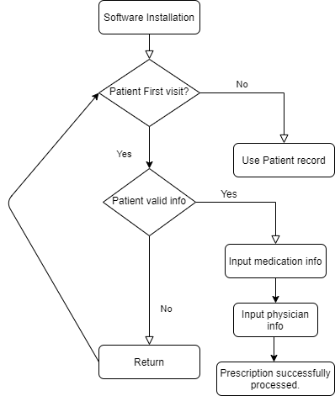

**1.7 Boundary conditions**

The system will be used daily to serve its purpose. As developers we will focus on error handling before, during, and after the release of the product. Our plan during development is to discuss possible runtime errors that may occur. Our long-term goal is to continuously preserve meetings to test and debug our software andbe available to provideimmediate tech support to our customers.

1. **System data components**

**2.1 Data stores**

**Doctor name, Doctor Phone#, Doctor email, Patient name, Patient phone#, patient email, Pharmacist name, Pharmacist phone#, pharmacist email, Patient prescription, patient known conditions, unclaimed prescription, pharmacist inventory, known side effects, known bad combinations.**

**2.2Data flows**

**Data flows will consist of strings that will be added to the different types of data stores when performing an add function for the given data set.**

**There will also be data flow for finding conflicts with a patient’s current prescriptions, and known bad combinations, as well as side effects.**

**2.3 Data elements**

**Data will consist of string, and string list types.**

* 1. **Data storage**

**Data will be stored on the disk space of the computer itself.**

**An online server could be used in place, but a solution that would be feasible for us to have full access to would have to be worked on.**

**2.5 Data connections**

Phone and email between the doctor and pharmacist will be the main way of sending certain types of information, those being conflicts with added prescriptions, or known bad combinations of medications. A network connection is being considered for this application as a faster means of a data connection.

1. **System processes components**

**3.1 Use Cases**

**One use case will be an either end/start of day process that checks to see if there are any patients that have not come in to receive their medication.**

**Another use case will be when after attempting to add a prescription to a patients list of medications that is already there. It will notify the pharmacist of the possible issue, and provide the doctor’s number and email to help figure out if the new prescription is necessary or not.**

**All other use cases are just modifying the application’s database and can be listed as simple functions.**

**3.2 Functions**

**Add to inventory – will add an item and properties to inventory database set**

**Remove from inventory – remove an item and properties from database set**

**Change property of inventory – change/add properties to items in inventory**

**Add user – add a new user to use the application**

**Remove user- remove user from accessing application.**

**Change user privileges – change user’s level of access and other properties**

**Add patient – add patient and properties**

**Remove patient – remove patient and properties**

**Change patient properties – change properties of user**

**Add patient prescription. – add prescription to list of patients medications**

**3.3 Triggers**

Most events will be transaction triggered with this application mostly functioning as a database, however there will be a couple of state triggers based on if there is an attempt to add an already existing prescription to a patient’s list. There will also be a time trigger for if a patient’s prescription has not been picked up after a certain time.

**3.4 Processors**

Pharmacists’ will be responsible for contacting doctors about conflicts with different medications if network is not available, or not implemented. This is expected to take place at the time that the conflict is found, but can be halted until later. The computer that the application is installed on will perform the storing, queries, and other database actions.

**3.5 Actors/External Entities**

This system must be able to allow technician maintenance to work on it. The FDA might also have to be able to interact with the application. Health insurance agencies might also need to interface with the application.