

AI-Assisted-BizFlow-Platform
Final Release Document

– DaNang, November 2026 –

RECORD OF CHANGES
Version | Date | A*, M, D | In charge | Change Description
V1.0 | 02/11/2026 | A | Tran Manh Tuong | Initial Final Release document: deliverable package inventory, installation instructions verified end to end on a development machine, and a user manual covering seven business workflows with 29 screenshots captured from the running application.
(*) A — Added, M — Modified, D — Deleted

TABLE OF CONTENTS
I. DELIVERABLE PACKAGE
1. Deliverable inventory
2. Source code and related resources
3. Release version metrics
II. INSTALLATION GUIDES
1. Environment prerequisites
2. Option A — Run with Docker Compose (packaged)
3. Option B — Run in development mode
4. Configuration parameters
5. Loading sample data and demo accounts
6. Post-installation verification
7. Troubleshooting
III. USER MANUAL
1. Overview
2. Workflow 1 — Authentication and Workspace Access
3. Workflow 2 — Task Management and Execution
4. Workflow 3 — Internal Service Requests
5. Workflow 4 — Approvals and SLA Monitoring
6. Workflow 5 — AI Assistant and Task Decomposition
7. Workflow 6 — Reporting, Notifications and Record Search
8. Workflow 7 — System Administration and Audit

I. Deliverable Package
This section lists every source program, database script and document, with its version, included in the final release of the AI-Assisted BizFlow Platform project.
1. Deliverable inventory
No. | File | Location | Notes
1 | BizFlow_DB_final.sql | docs/release/ | Full export of the release PostgreSQL 18 database: 40 business tables, 17 enum types, 54 permission codes and the complete simulated enterprise dataset (15 staff accounts, 7 departments, 4 services, 6 tasks, 3 service requests).
2 | BizFlow_RDS_Document.docx | docs/ | Requirement & Design Specification (Report 3), version V1.0: 5 actors, 7 per-subsystem use case diagrams, descriptions of 10 core use cases and the ERD.
3 | BizFlow_SDS_Document.docx | docs/ | Software Design Specification (Report 4), version V1.0: Modular Monolith Clean Architecture, front-end and back-end package diagrams, database design and 4 sequence diagrams for the core features.
4 | BizFlow_Final_Release_Document.docx | docs/ | This document — deliverable package, installation guide and final user manual. A Vietnamese edition is published under the same name without the _EN suffix.
5 | ISSUES_REPORT_CODE.xlsx | docs/project-audit/ | Issue and technical defect tracking list for the whole project.
6 | REQUIREMENT_TRACEABILITY_MATRIX.md | docs/project-audit/ | Requirement traceability matrix mapping each requirement ID to the RDS/SDS documents and the implementing source files.
7 | IMPLEMENTATION_GAP_ANALYSIS.md | docs/project-audit/ | Reconciliation of all 132 specification requirements against the codebase, classified as VERIFIED / PARTIALLY_IMPLEMENTED / NOT_IMPLEMENTED / OUT_OF_SCOPE.
8 | REMEDIATION_BACKLOG.md | docs/project-audit/ | Remaining product backlog: items, priority and final status of functions that were not completed.
9 | RDS_SDS_SCHEMA_CORRECTIONS.md | docs/project-audit/ | Corrections to the RDS/SDS against the actual source code (table counts, enums, states and permissions).
10 | diagrams/ and generated_images/ folders | docs/ | All source diagrams as PNG: 7 use case diagrams, the ERD, the architecture diagram, package diagrams and 4 sequence diagrams.
11 | Release screenshot set | Part III of this document | 29 screenshots captured directly from the running application on the simulated enterprise dataset, used throughout the user manual.
Note: Under the university naming convention, deliverable file names must be prefixed with the group code and project code (for example G1-BizFlow_DB_final.sql). This prefix has not been applied in the repository because the group code does not appear in any project document; the team must add it before submission.
2. Source code and related resources
Item | Content
Source repository | https://github.com/TxRyeSayNo/AI-Assisted-BizFlow-Platform
Tagged source code | The repository currently has no tags. The team must create a release tag before submission, for example: git tag -a v1.0 -m "Final Release" && git push origin v1.0, then record the tag link here.
Demonstration video | <<YouTube link — to be supplied>>
Source code layout | backend/BizFlow.Api — presentation layer, 26 REST controllers and the SignalR hub.  backend/BizFlow.Application — application services, authorization and auditing.  backend/BizFlow.Domain — entities, state machines and business rules.  backend/BizFlow.Infrastructure — EF Core, 36 migrations, Redis/S3/SMTP/OpenAI integrations.  frontend/ — Angular 22 standalone application, 34 routes.  tests/ — UnitTests, IntegrationTests, E2ETests (Playwright), BrowserHarness.
3. Release version metrics
The figures below were measured directly against the source code and the release database at the time this document was produced.
Component | Version / Count
Back-end platform | .NET 10 (SDK 10.0.401), ASP.NET Core
ORM & migrations | Entity Framework Core 10, 36 migrations
Database | PostgreSQL 18.3
Front-end platform | Angular 22.2.0, TypeScript 6.0.2
Node environment | Node 22.22.3, npm 11.6.2
Business tables | 40 (excluding __EFMigrationsHistory)
PostgreSQL enum types | 17
Permission codes | 54
REST controllers | 26
Front-end routes | 34
Realtime channel | SignalR — /api/v1/realtime/notifications
Background jobs | Hangfire (PostgreSQL storage) + MailKit

II. Installation Guides
The instructions below were carried out and verified end to end on Windows 11 with Docker Desktop (Linux containers) while this document was being produced: creating the database, applying migrations, loading sample data, running the API and the web client, signing in successfully and capturing every screenshot used in Part III.
1. Environment prerequisites
Component | Required version | Notes
.NET SDK | 10.0.401 | Pinned by global.json in the repository root.
Node.js | 22.22.3 or later | Required by the Angular CLI 22.2 engine constraint.
npm | 11.6.2 | Ships with Node 22.
Docker Desktop | Linux containers | Used for PostgreSQL, Redis, MinIO and integration tests.
PostgreSQL | 18.3 | Runs through Docker Compose; no local installation required.
2. Option A — Run with Docker Compose (packaged)
This option brings the whole system up as containers and is suited to a quick demonstration without installing the .NET SDK or Node locally.
Step 1. Prepare the environment file:
copy deploy\.env.example deploy\.env
Open deploy/.env and replace every placeholder with a real secret: POSTGRES_PASSWORD, BIZFLOW_DATABASE_CONNECTION and JWT_SIGNING_KEY_BASE64.
Step 2. Generate the JWT signing key (at least 32 random bytes, base64 encoded):
[Convert]::ToBase64String((1..48 | ForEach-Object { Get-Random -Max 256 }))
Step 3. Build and start:
$compose = @('compose','--env-file','deploy/.env','-f','deploy/docker-compose.yml','-f','deploy/docker-compose.app.yml')
docker @compose --profile tools build api web migrate
docker @compose up -d --wait postgres
docker @compose run --rm migrate
docker @compose up -d --wait api web
Open http://localhost:8080 (or the port set in WEB_PORT). Applying migrations is a deliberate, one-shot operator command rather than an API startup action; re-running it against an already current database is safe.
Note: The container images contain no demo account and no administrator password. A brand-new database has no login account at all. Complete Section 5 to load the sample dataset before demonstrating the system.
3. Option B — Run in development mode
This is the exact procedure used to produce every screenshot in Part III. Each step below has been executed successfully.
Step 1 — Start PostgreSQL
docker compose --env-file deploy/.env -f deploy/docker-compose.yml up -d postgres
The database listens on loopback only (127.0.0.1:5432) and persists in the bizflow-local_postgres-data volume.
Step 2 — Create the release database
docker exec bizflow-local-postgres-1 psql -U bizflow -d postgres -c "CREATE DATABASE bizflow_demo OWNER bizflow ENCODING 'UTF8';"
Step 3 — Set environment variables and apply migrations
$env:ConnectionStrings__BizFlow = "Host=localhost;Port=5432;Database=bizflow_demo;Username=bizflow;Password=<PASSWORD>"
$env:Jwt__Issuer = "BizFlow"
$env:Jwt__Audience = "BizFlow.Web"
$env:Jwt__SigningKeyBase64 = "<BASE64_KEY_OF_AT_LEAST_32_BYTES>"
dotnet tool restore
dotnet ef database update --project backend/BizFlow.Infrastructure --startup-project backend/BizFlow.Infrastructure
Expected result: 36 migrations applied, creating 40 business tables and 17 enum types.
Step 4 — Run the API
$env:ASPNETCORE_ENVIRONMENT = "Development"
$env:ASPNETCORE_URLS = "http://localhost:5154"
dotnet run --project backend/BizFlow.Api --no-launch-profile
The API listens on http://localhost:5154. In the Development environment the OpenAPI specification is served at /openapi/v1.json.
Step 5 — Run the Angular client
cd frontend
npm ci
npm start
The development server runs at http://localhost:4200 and automatically proxies /api and /health to port 5154 according to frontend/proxy.conf.json.
Note: Use npm ci, not npm install. During verification, a pre-existing node_modules folder was missing the firebase@11.4.0 package, which made the build fail with TS2307: Cannot find module 'firebase/app'. npm ci installs exactly what package-lock.json specifies and resolves this permanently.
4. Configuration parameters
Environment variable | Required | Description
ConnectionStrings__BizFlow | Yes | Npgsql connection string for PostgreSQL.
Jwt__Issuer | Yes | Token issuer, for example BizFlow.
Jwt__Audience | Yes | Token audience, for example BizFlow.Web.
Jwt__SigningKeyBase64 | Yes | Cryptographically random key of at least 32 bytes, base64 encoded. Startup is rejected if it is missing. Never commit this key.
Redis__ConnectionString | No | If omitted, the system falls back to an in-process cache.
Storage__* | No | MinIO/S3 settings for attachments. If omitted, the system uses local file storage.
OpenAI__ApiKey | No | OpenAI key for the AI features. If unconfigured, the system falls back to built-in heuristics — the AI features still work but return simpler results.
Smtp__* | No | TLS SMTP settings. Email-based password recovery is enabled only once these are configured.
5. Loading sample data and demo accounts
A new database has no accounts. The two SQL scripts below create the simulated enterprise dataset used for demonstrations and for every screenshot in Part III.
docker cp deploy/seed_sample_data.sql bizflow-local-postgres-1:/tmp/seed_sample.sql
docker cp deploy/seed_enterprise_simulation.sql bizflow-local-postgres-1:/tmp/seed_ent.sql
docker exec bizflow-local-postgres-1 psql -U bizflow -d bizflow_demo -v ON_ERROR_STOP=1 -f /tmp/seed_sample.sql
docker exec bizflow-local-postgres-1 psql -U bizflow -d bizflow_demo -v ON_ERROR_STOP=1 -f /tmp/seed_ent.sql
After loading, the system contains 1 company (BizFlow Corporation), 7 departments, 15 staff accounts, 4 internal services, 6 tasks and 3 service requests in various states.
The release database can also be restored directly from the bundled export:
docker exec -i bizflow-local-postgres-1 psql -U bizflow -d bizflow_demo < docs/release/BizFlow_DB_final.sql
Demo accounts
All sample accounts share the password Password123! and the workspace key bizflow-corp.
Employee code | Full name | Role in the system
ADMIN001 | Phạm Minh Đức (CEO) | Company Administrator — full authority within the company
MGR001 | Lê Hoàng Nam (CTO) | Manager — coordinates within their management scope
EMP001 | Nguyễn Văn Nhân Viên (Dev) | Employee — sees only work within their own permission scope
SALES_MGR | Nguyễn Tiến Đạt | Head of B2B Sales
MKT_MGR | Vũ Phương Thảo | Head of Marketing
FIN_MGR | Đặng Thu Hà | Chief Accountant
HR_MGR | Bùi Mai Lan | Head of Human Resources
CS_MGR | Trịnh Quốc Bảo | Head of Customer Success
Note: This is simulated data for demonstration environments only. Never load these scripts into a production environment.
6. Post-installation verification
Run the following checks in order to confirm the system is ready:
# | Check | Expected result
1 | GET http://localhost:5154/health/live | HTTP 200 — the API process is alive.
2 | GET http://localhost:5154/health/ready | {"status":"ready"} — the database is reachable and the migration history matches.
3 | POST /api/v1/auth/login with identifier ADMIN001, password Password123!, tenantKey bizflow-corp | HTTP 200 with an accessToken and a refreshToken.
4 | Open http://localhost:4200 and sign in | The workspace screen loads and shows the correct user name and role.
5 | dotnet test BizFlow.slnx | The test suite runs against a disposable PostgreSQL instance via Testcontainers; Docker must be running.
Note: /health/ready only checks database access and that the migration history matches exactly. It does not prove that every business feature is complete, nor does it detect manual schema drift.
7. Troubleshooting
Symptom | Cause and resolution
Angular build fails with TS2307: Cannot find module 'firebase/app' | The node_modules folder is incomplete or stale. Stop the development server and run npm ci inside the frontend folder.
npm ci fails with EBUSY: resource busy or locked | An ng serve process is holding files inside node_modules. Terminate the running Node process completely, then re-run npm ci.
The API starts and immediately exits because JWT configuration is missing | Set all three of Jwt__Issuer, Jwt__Audience and Jwt__SigningKeyBase64. The key must be the base64 encoding of at least 32 random bytes.
Login returns 401 AUTH.INVALID_CREDENTIALS although the password is correct | The Workspace Key is missing. The system validates the workspace key, the user identifier and the password together; with the sample dataset the workspace key is bizflow-corp.
Reloading the page (F5) signs the user out | This is intentional behaviour: tokens are held in application memory and never written to web storage, which reduces the risk of token theft. Navigate using the in-application menu rather than reloading the page.
Testcontainers cannot find Docker on Windows | Inspect docker context inspect and set $env:DOCKER_HOST='npipe://./pipe/dockerDesktopLinuxEngine' for that terminal.
AI features return simple results with few items | OpenAI__ApiKey is not configured, so the system is running on its built-in heuristic fallback. Configure an OpenAI key for richer decomposition results.
Password recovery does not send email | Email-based password recovery stays disabled until an operator configures TLS SMTP and the front-end origin.

III. User Manual
1. Overview
The AI-Assisted BizFlow Platform is a multi-tenant platform for orchestrating internal work and service requests across an enterprise. It digitises the full lifecycle: a request is raised, routed to the responsible department, turned into concrete tasks, executed against a checklist, submitted with evidence, accepted, and finally closed — all under service level agreement (SLA) commitments and with an immutable audit trail.
What distinguishes the platform is the artificial intelligence layer embedded throughout it: the AI Agent answers questions about work strictly within the asking user's permission scope, decomposes natural-language instructions into proposed task lists, assesses the risk of missing deadlines and summarises progress. The governing principle is human-in-the-loop: AI only proposes, and every change to the database must be explicitly confirmed by a person.
Note: The product interface is standardised in Vietnamese, so the screenshots throughout this manual show Vietnamese labels. In the instructions below, each on-screen control is named in bold exactly as it appears in the application, followed by its English meaning in parentheses.
1.1. System actors
# | Actor | Scope of use
1 | Guest / Public User | Unauthenticated public visitor: submits a new company registration, recovers a password.
2 | Staff / Employee | Internal staff member: raises service requests, accepts and executes tasks, ticks checklist items, submits results and converses with the AI Assistant.
3 | Manager / Supervisor | Department head: routes requests, assigns tasks, approves and accepts results within their management scope.
4 | Company Admin | Company administrator: manages users, departments, roles and permissions, the service catalogue, business workflows and SLA profiles.
5 | Platform Admin | SaaS platform administrator: reviews company registration dossiers, activates workspaces and audits the whole platform.
1.2. Map of business workflows
This manual is organised around seven workflows corresponding to the seven main function groups on the navigation bar:
Workflow | Name | Primary roles | Main screens
1 | Authentication & Workspace Access | All actors | /login, /register-company, /workspace
2 | Task Management & Execution | Employee, Manager | /tasks, /tasks/new, /tasks/:id
3 | Internal Service Requests | Employee, Manager | /requests, /requests/new, /requests/:id
4 | Approvals & SLA Monitoring | Manager, Admin | /approvals, /sla-monitor
5 | AI Assistant & Task Decomposition | All internal users | AI Agent widget, /tasks/ai-decomposition
6 | Reporting, Notifications & Search | Manager, Admin | /reports, /notifications, /records/search
7 | System Administration & Audit | Company Admin | /settings/**, /audit
1.3. Common screen layout
After signing in, every screen shares one layout: a vertical navigation bar on the left grouped by the seven workflows; a top bar showing the company being accessed, the button that opens the AI Agent, the notification bell, the signed-in identity with its role, and the sign-out button; and a content area that always opens with a breadcrumb so users know where they are.
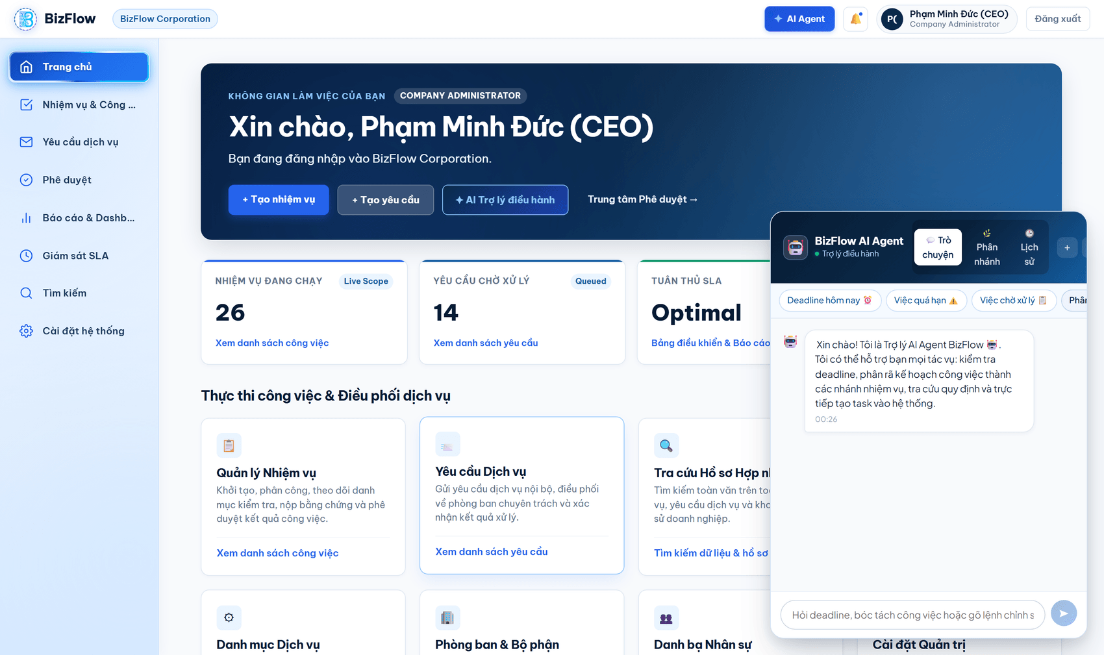
Figure 1. Company Admin workspace, with the AI Agent opening automatically at the start of a new session
The metric cards at the top of the page summarise the volume of work in progress, the number of requests awaiting handling and SLA compliance status. All of these figures are scoped to the permissions of the signed-in user.

2. Workflow 1 — Authentication and Workspace Access
Purpose: bring the user into the correct company workspace while guaranteeing absolute data isolation between companies. This workflow is mandatory before any other business operation.
2.1. Signing in with an employee code or company email
- Open a browser and go to the system address. The application redirects to the sign-in screen.
- Enter the workspace key issued by your company in Mã không gian làm việc (Workspace Key) — with the demo data this is bizflow-corp. This field is mandatory and identifies the company you belong to.
- Choose the identifier type: Mã nhân viên (employee code) or Email doanh nghiệp (company email).
- Enter the corresponding identifier and your password. Use Hiện (show) to check what you typed.
- The option Ghi nhớ đăng nhập trên thiết bị này (remember me on this device) should only be used on a personal machine.
- Click ĐĂNG NHẬP NGAY (sign in now).
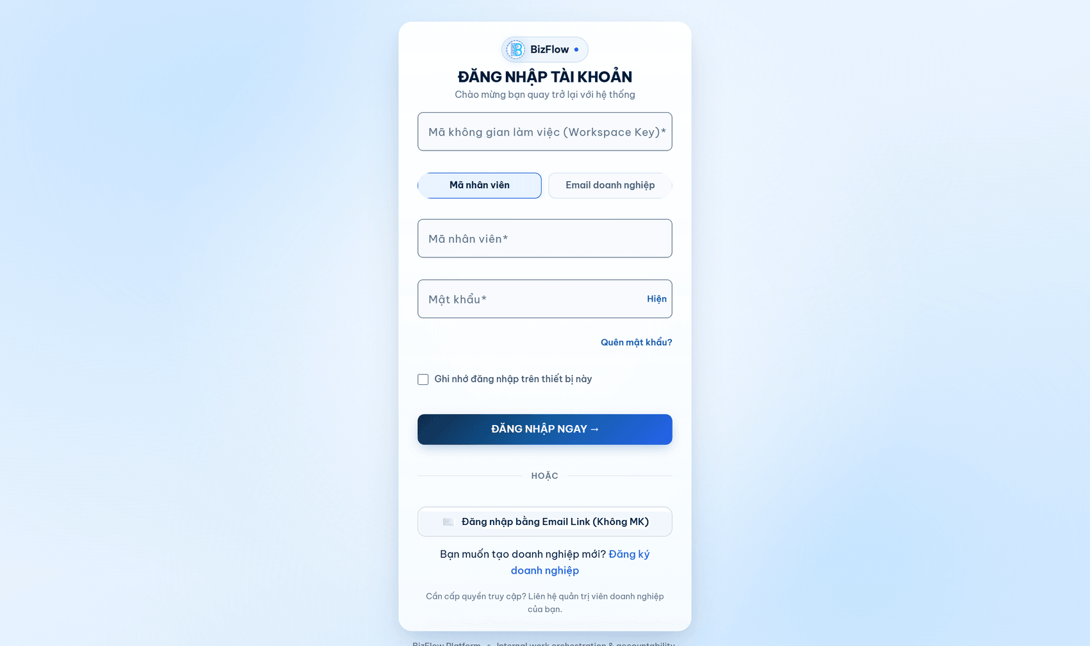
Figure 2. Sign-in screen with its three mandatory fields: workspace key, identifier and password
Note: If any one of those three fields is wrong, the system returns the same generic error, AUTH.INVALID_CREDENTIALS. This is a deliberate security design that avoids telling an attacker which component was incorrect.
2.2. Password recovery
- On the sign-in screen, click Quên mật khẩu? (forgot password).
- Enter the workspace key and the registered company email address.
- Submit the request. The system sends a time-limited reset link to your mailbox.
- Open the link from the email and set a new password.
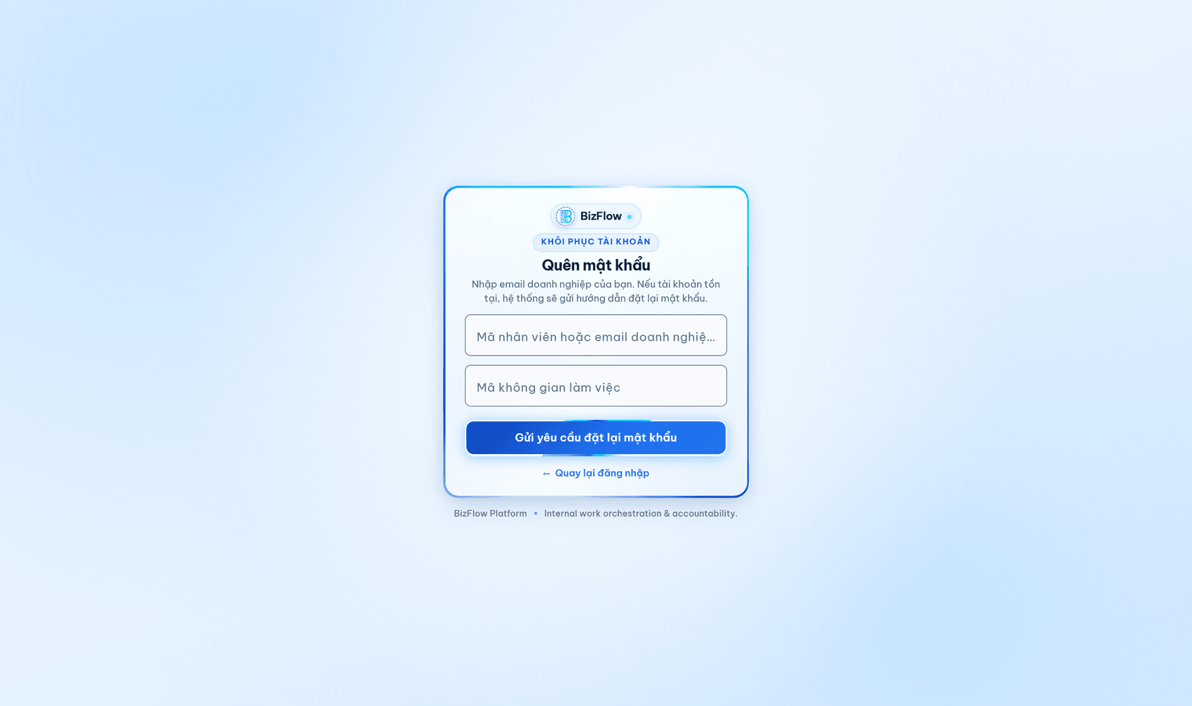
Figure 3. Password recovery request screen
Note: For security reasons the system always returns the same message whether or not the email exists, which prevents account enumeration. Email delivery works only after an administrator has configured TLS SMTP.
2.3. Registering a new company
This is for companies that do not yet have a workspace on the platform. A submitted dossier is reviewed by a Platform Admin before activation.
- On the sign-in screen, click Đăng ký doanh nghiệp (register a company).
- Fill in the company details: name, tax identification number, contact person, contact email and phone number.
- Enter the desired workspace key; the system checks availability in real time and suggests alternatives if it is already taken.
- Upload the legal dossier (business licence) in an accepted format and size.
- Submit the dossier and wait for the review outcome by email.
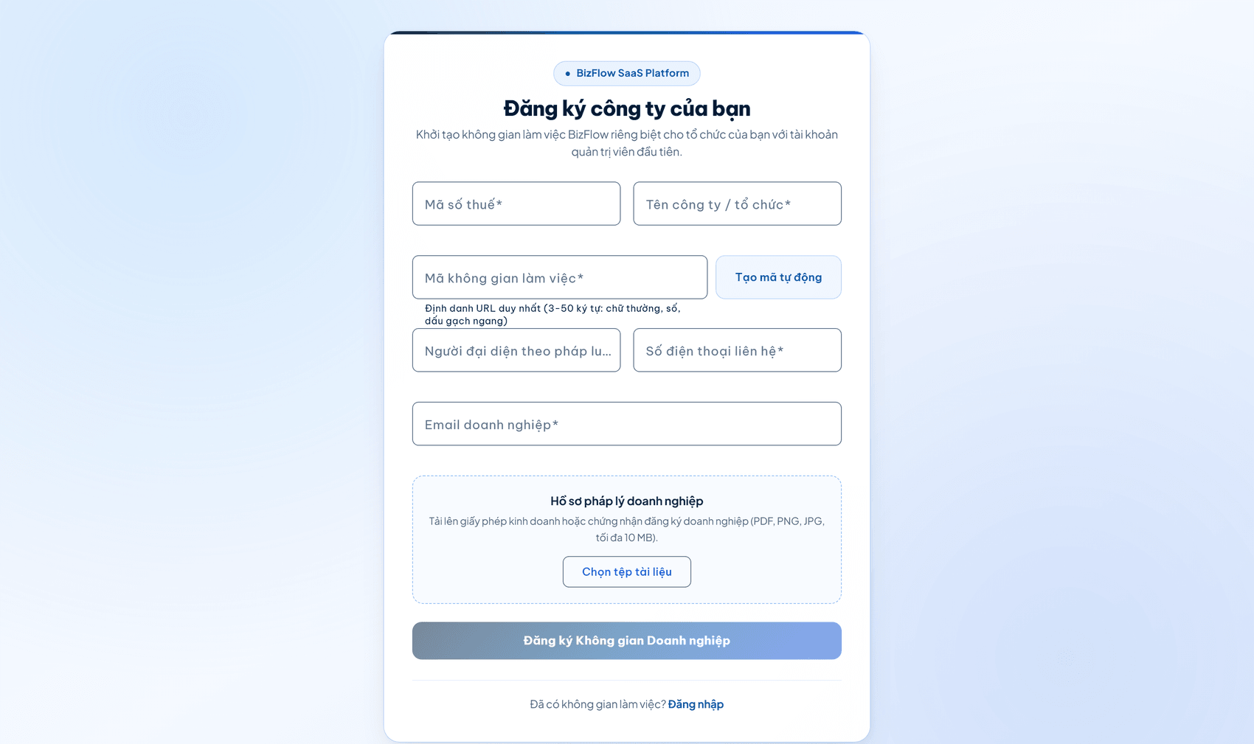
Figure 4. Public company registration form

3. Workflow 2 — Task Management and Execution
Purpose: create, assign, execute and accept work. This is the central workflow of the platform, where responsibility is unambiguous at every point in time and every state transition is recorded.
3.1. Viewing the task list
- Choose Nhiệm vụ & Công việc (Tasks & Work) on the left-hand navigation bar.
- Use the title search box together with the Trạng thái (status) and Độ ưu tiên (priority) filters, then click Áp dụng bộ lọc (apply filters).
- Each row shows the title, priority, the person currently responsible and the owning department. Click a title to open the detail view.
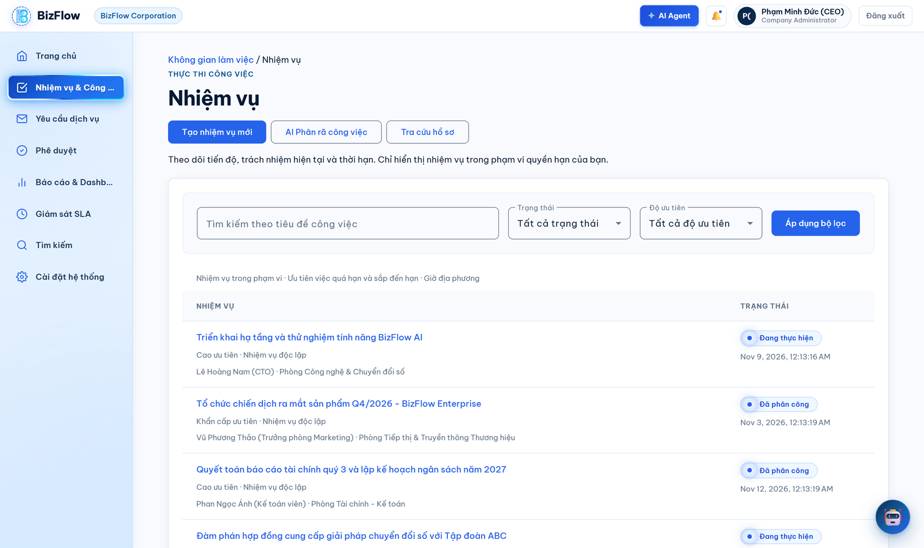
Figure 5. Task list within the Company Admin permission scope
This list is always constrained by the server according to the user's actual permissions, not filtered in the browser. The figure below shows the same screen for an employee account: only tasks within that person's scope are visible.
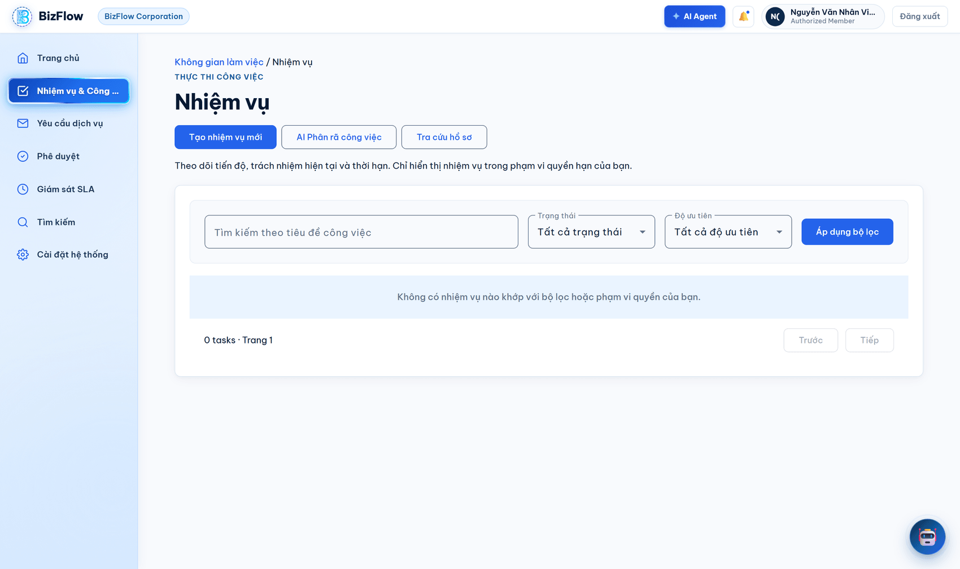
Figure 6. The same task screen seen by an Employee account — the data scope is narrowed by permissions
3.2. Creating a new task
- On the task screen, click Tạo nhiệm vụ mới (create new task).
- Enter the title and a detailed description of the work to be done.
- Select the priority: Low, Medium, High or Critical.
- Set the deadline. The system accepts future points in time only.
- Add checklist items in the order in which they should be performed.
- Save. The task is created in DRAFT state.
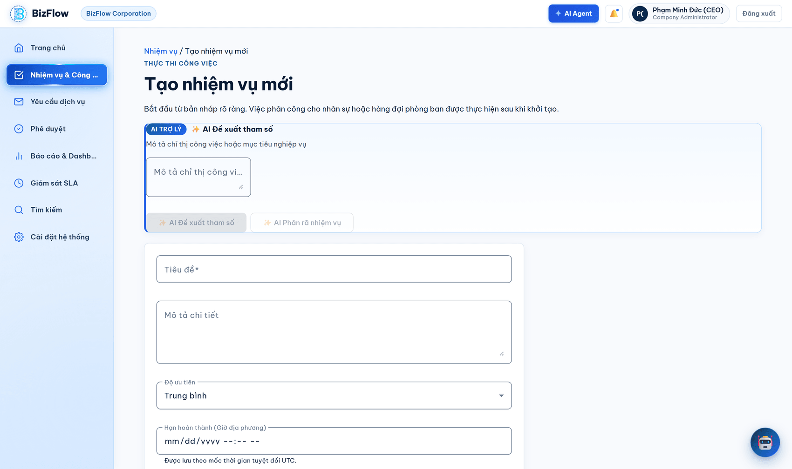
Figure 7. New task form
3.3. Tracking and executing a task
The task detail screen is where all information and actions for the whole lifecycle of a piece of work come together.
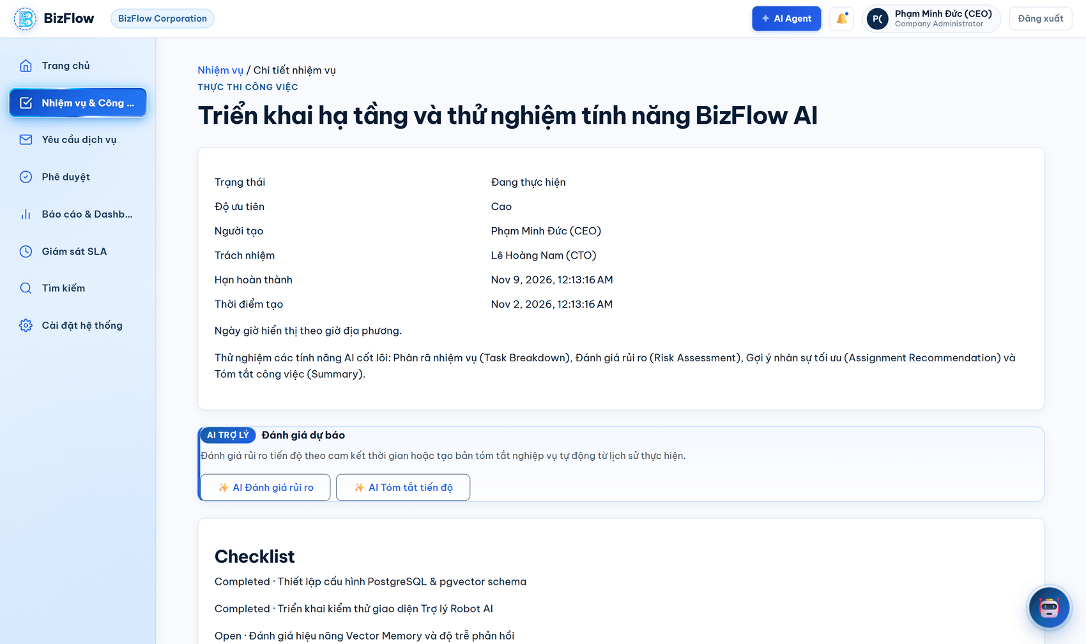
Figure 8. Task detail screen: core information, the AI forecasting panel and the checklist
- Header block: current state, priority, creator, the person currently responsible, the deadline and the creation time.
- AI assistant block: AI Đánh giá rủi ro (AI risk assessment) estimates the risk of missing the deadline based on progress against remaining time; AI Tóm tắt tiến độ (AI progress summary) generates a business summary from the execution history.
- Checklist block: tick each completed item; the system recalculates the progress percentage automatically.
- History block: every state transition, assignment, progress report and result evidence is stored append-only and cannot be edited or deleted.
3.4. Task state lifecycle
A task moves through ten states. The system permits only valid transitions and always checks permissions before performing one.
State | Meaning | Who acts next
DRAFT | Draft, not yet assigned to anyone. | Creator or manager
ASSIGNED | Assigned to an individual or a department. | The assignee or department
ACCEPTED | The performer has confirmed acceptance. | The performer
IN_PROGRESS | Work is under way. | The performer
SUBMITTED | Result submitted, awaiting acceptance. | The accepting manager
REJECTED | Assignment declined, or the result was returned for rework. | Manager or performer
OVERDUE | Past the committed deadline. | The performer (may continue)
COMPLETED | Execution finished. | Manager
CONFIRMED | Formally accepted. | —
CANCELLED | Cancelled before completion. | —
Note: When a task is overdue, the system requires the performer to resume the outstanding work before a result can be submitted. When a result is returned for rework, the task goes back to IN_PROGRESS rather than to draft.

4. Workflow 3 — Internal Service Requests
Purpose: let staff raise requests against the published service catalogue so that they are routed, received, handled and closed under SLA commitments.
4.1. Viewing service requests
- Choose Yêu cầu dịch vụ (Service requests) on the navigation bar.
- Filter by state or search by title to narrow the list.
- Click a request to view its details and processing history.
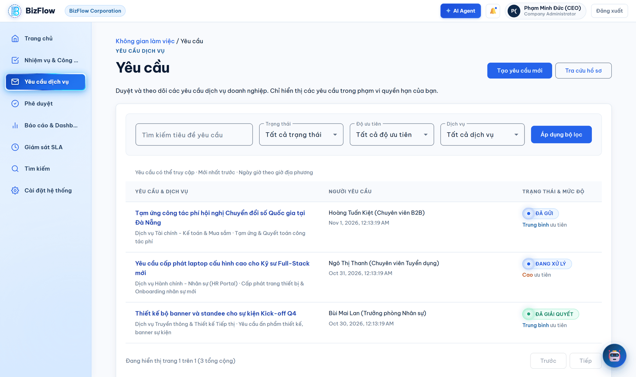
Figure 9. Internal service request list
4.2. Creating and submitting a service request
- Click Tạo yêu cầu mới (create new request).
- Select the service and the service category from the catalogue published by the company.
- Enter the title and a detailed description of what is needed.
- Choose a priority that reflects the real urgency.
- Attach supporting documents if required.
- Save as draft to continue later, or submit the request to start the handling process.
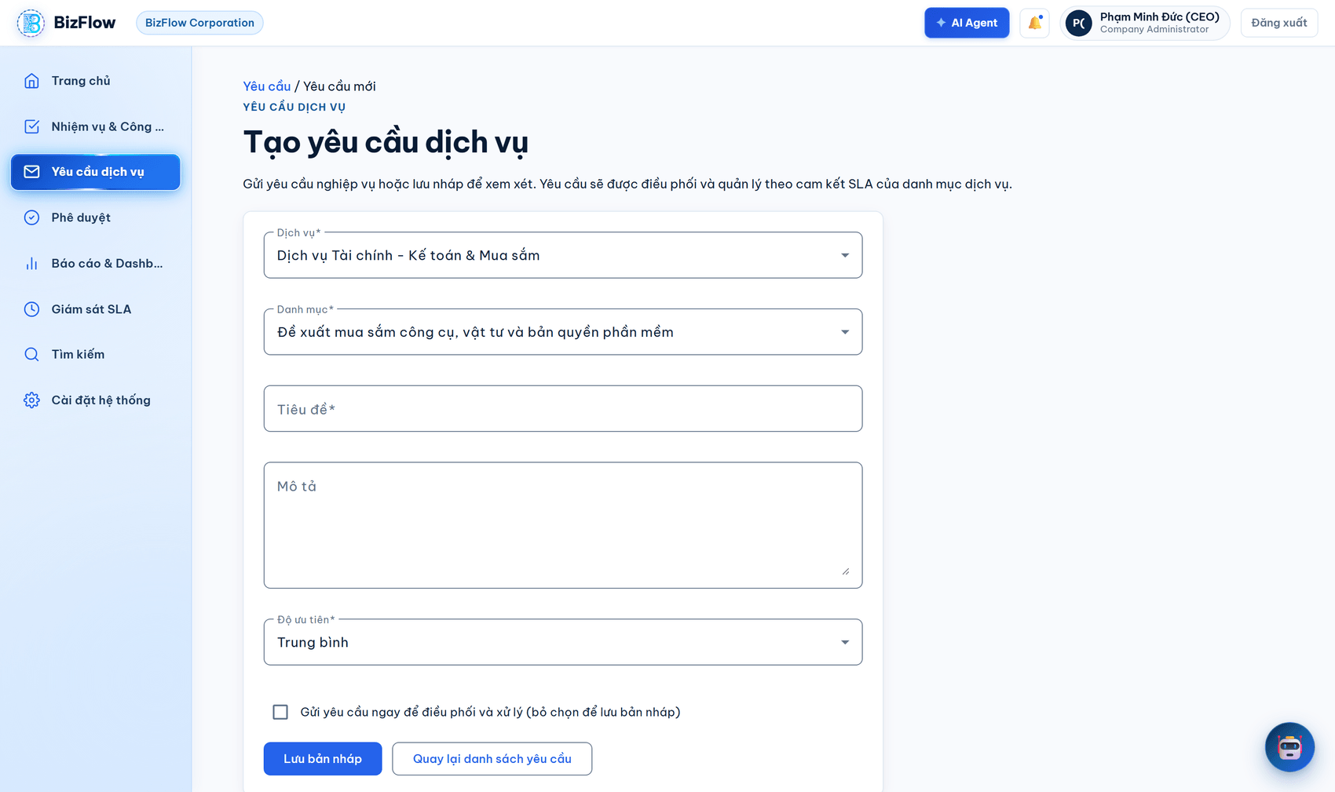
Figure 10. New service request form
Note: At the moment of submission the system takes a snapshot of the SLA version and the workflow version then in force and binds them permanently to the request. Editing the SLA configuration afterwards does not change the commitments of requests already submitted.
4.3. Tracking request progress
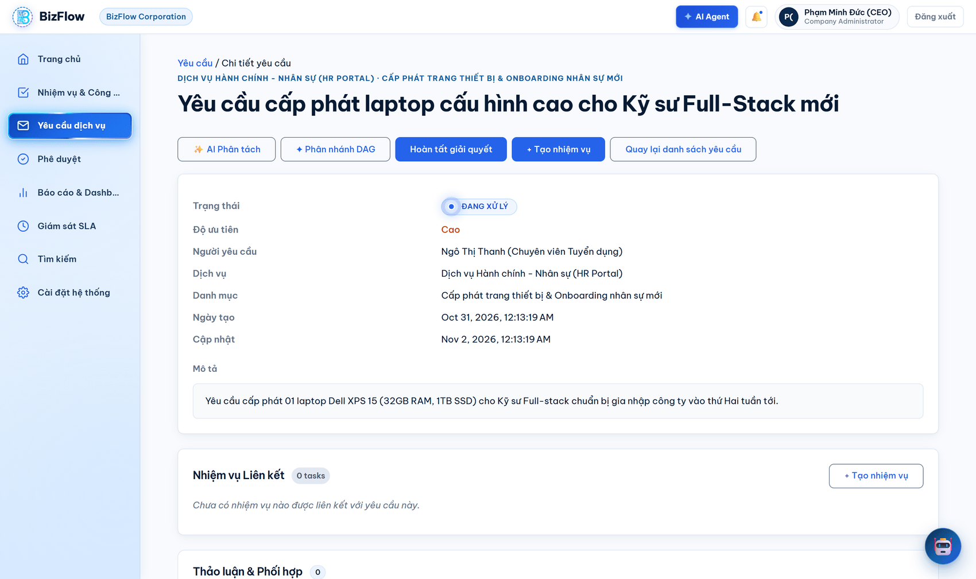
Figure 11. Service request detail screen and processing history
A service request has twelve states:
State | Meaning
DRAFT | Draft; the requester is still composing it.
SUBMITTED | Submitted, awaiting routing.
ROUTED | Routed to the responsible department.
RECEIVED | The receiving department has confirmed receipt.
IN_PROGRESS | Being handled.
WAITING_FOR_INFORMATION | Waiting for the requester to supply more information — the SLA clock is paused.
RESOLVED | Handled, awaiting requester confirmation.
CONFIRMED | The requester has confirmed the outcome.
CLOSED | The record is closed.
REJECTED | Rejected with a mandatory reason.
CANCELLED | Cancelled by the requester.
OVERDUE | Past the SLA commitment.
Note: A request can move to RESOLVED only when every linked child task has been completed. This business rule is enforced by the system and cannot be bypassed through the user interface.

5. Workflow 4 — Approvals and SLA Monitoring
Purpose: give managers a single place to handle items awaiting a decision and to detect the risk of breaching service level commitments early.
5.1. Approval centre
- Choose Phê duyệt (Approvals) on the navigation bar.
- The list gathers everything awaiting your decision: task results pending acceptance, service requests pending approval, and approval steps within business workflows.
- Open each item to review the attached evidence before deciding.
- Approve to accept, or reject with a mandatory reason to return the item for rework.
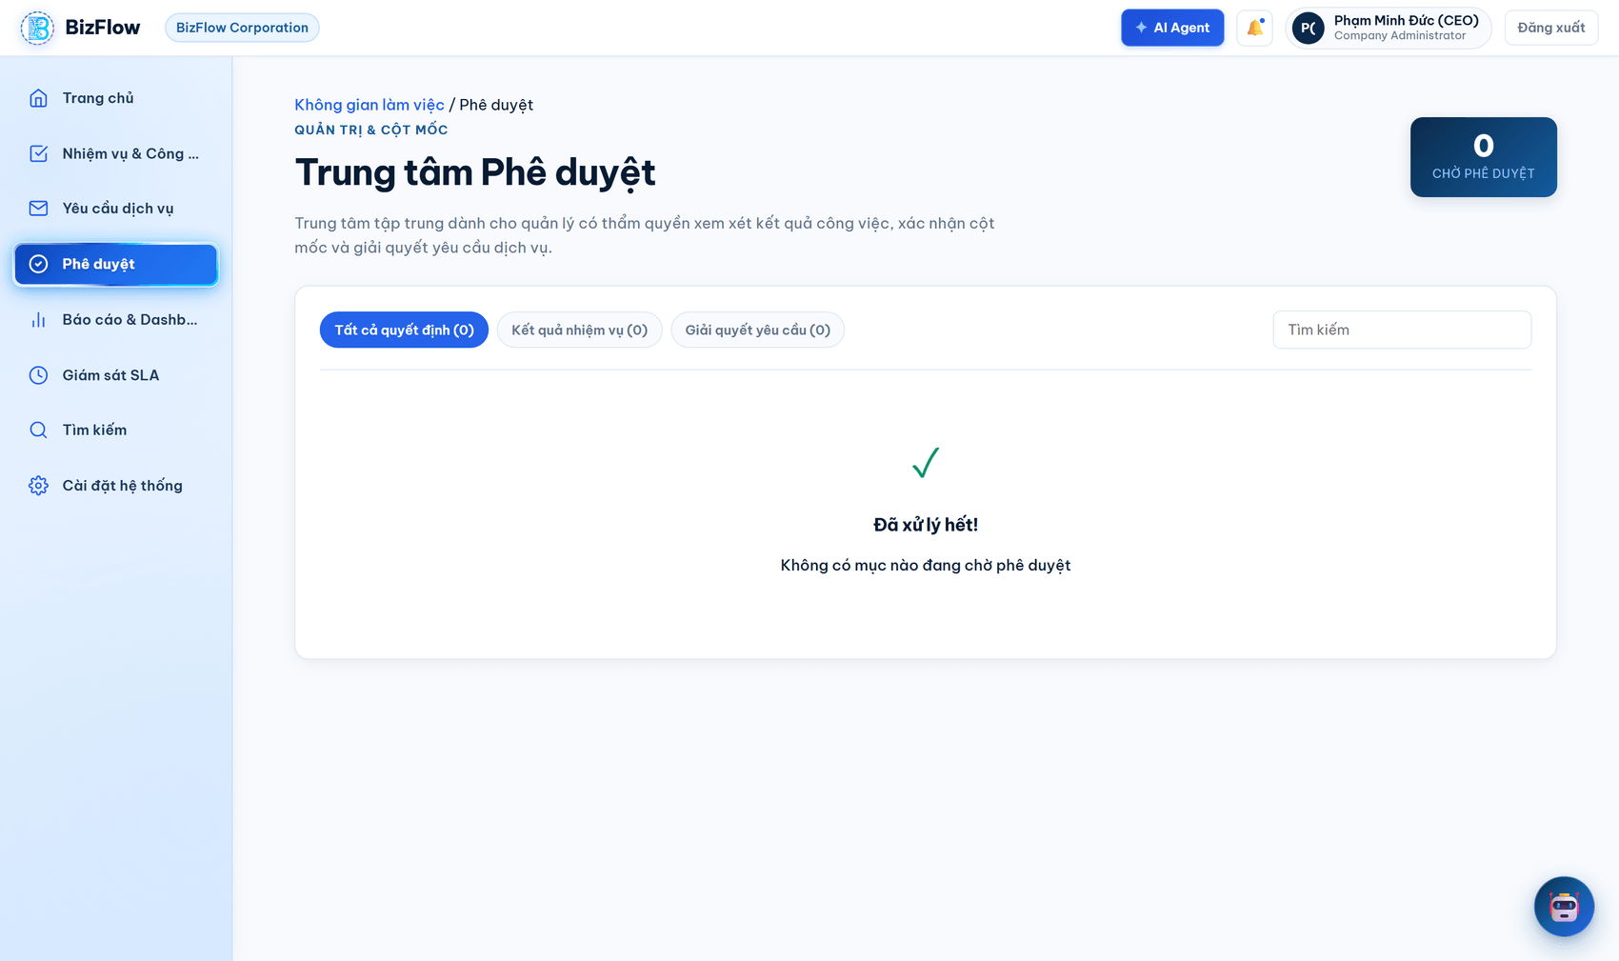
Figure 12. Centralised approval centre
Note: Every approval or rejection is written to the audit log together with the identity of the decision maker, the timestamp and the reason.
5.2. SLA monitoring
- Choose Giám sát SLA (SLA monitoring) on the navigation bar.
- Track items grouped by risk level: within commitment, approaching the deadline, and already overdue.
- Click an item to jump straight to the corresponding task or request and intervene in time.
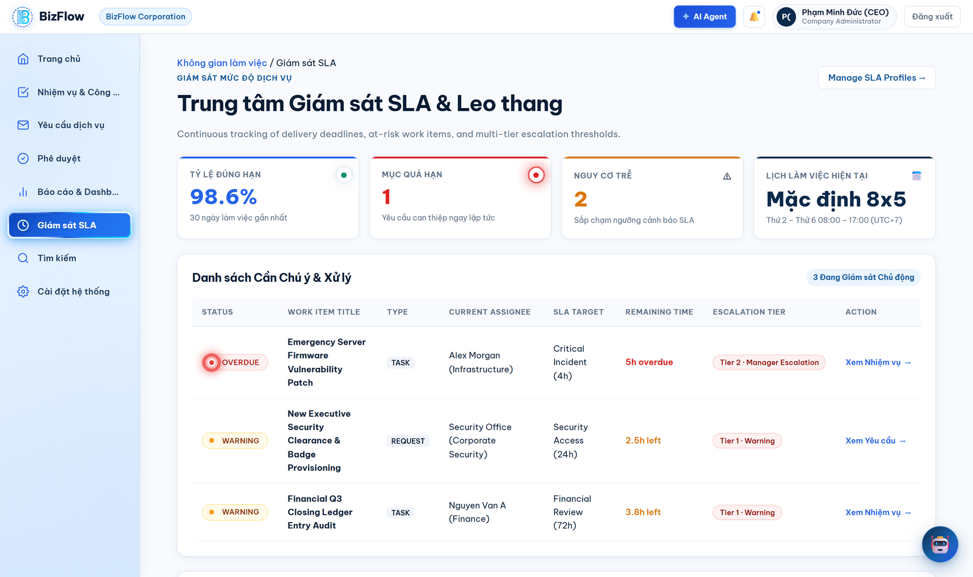
Figure 13. Service level agreement monitoring board
SLA deadlines are calculated against the working calendar and public holidays configured by each company, not against continuous wall-clock time. When a request moves to the waiting-for-information state, the SLA clock pauses automatically and resumes only when handling continues.

6. Workflow 5 — AI Assistant and Task Decomposition
Purpose: shorten the time spent looking things up and planning work using natural language, while leaving the human user in full control of every change to the data.
6.1. Conversing with the AI Agent
The AI Agent sits in the bottom-right corner of every screen. At the start of each new session the assistant window opens automatically. Clicking [X] collapses it to a round icon; that collapsed state applies only to the current session, and the assistant reopens at the next sign-in.
- Click the assistant icon or the AI Agent button in the top bar to open the chat window.
- Use the quick prompts: Deadline hôm nay (today's deadlines), Việc quá hạn (overdue work), Việc chờ xử lý (work awaiting handling).
- Or type a free-form question, for example "Which of my tasks are due soon today?".
- Send it and read the answer, which is assembled from your real work data.
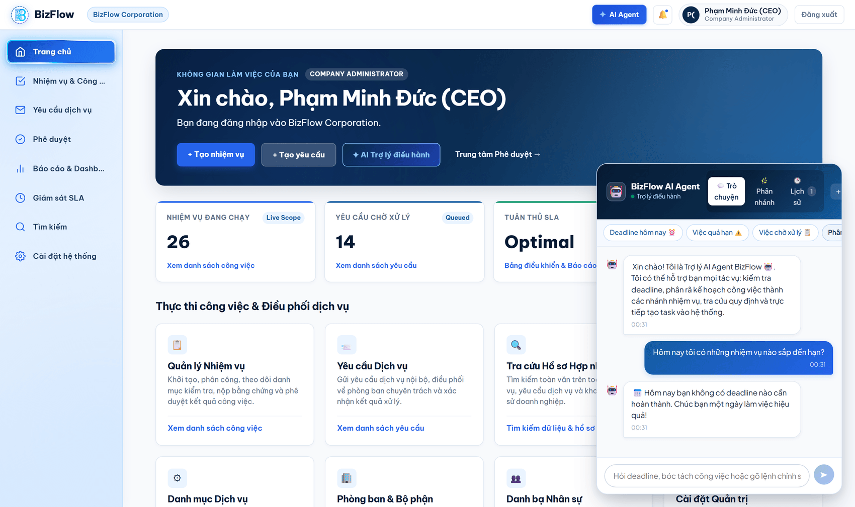
Figure 14. The AI Agent answering a question about deadlines from the user's real data
Note: The assistant retrieves only data inside the asking user's permission scope and management scope. It does not speculate beyond the context it is given; where there is no data it says so rather than inventing content.
Beyond answering questions, the assistant window supports quick commands: /task opens the task decomposition flow and /notifications opens personal deadline reminder settings.
6.2. Decomposing work from natural language
This feature takes a description or a complex instruction and proposes a list of sub-tasks. It is where the platform's human-in-the-loop principle is most visible.
- Go to the task screen and click AI Phân rã công việc (AI task decomposition), or type the /task command in the assistant window.
- Enter the original instruction or requirement in the description box. The quick templates Onboarding nhân viên mới (new employee onboarding) and Nâng cấp hệ thống định kỳ (scheduled system upgrade) pre-fill common cases.
- Click Phân tích & Xem trước đề xuất (analyse and preview proposals).
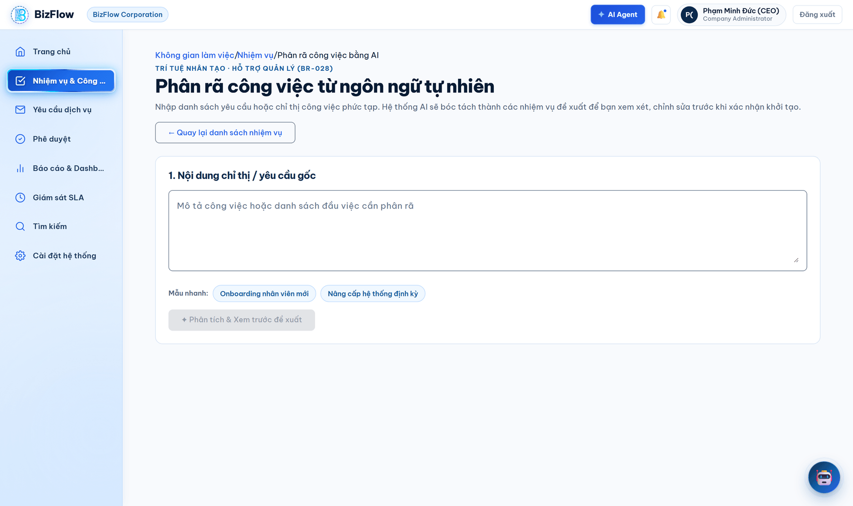
Figure 15. Entering the instruction to be decomposed
- The system shows a draft preview. At this point absolutely nothing has been written to the database.
- Review each proposal: untick items you do not need, and edit the title, work type, priority and owning department inline.
- Click + Thêm đầu việc tùy chỉnh (add a custom item) to add anything the AI did not propose.
- When satisfied, click Xác nhận tạo việc (confirm task creation). Only at this action does the system actually check permissions and write data.
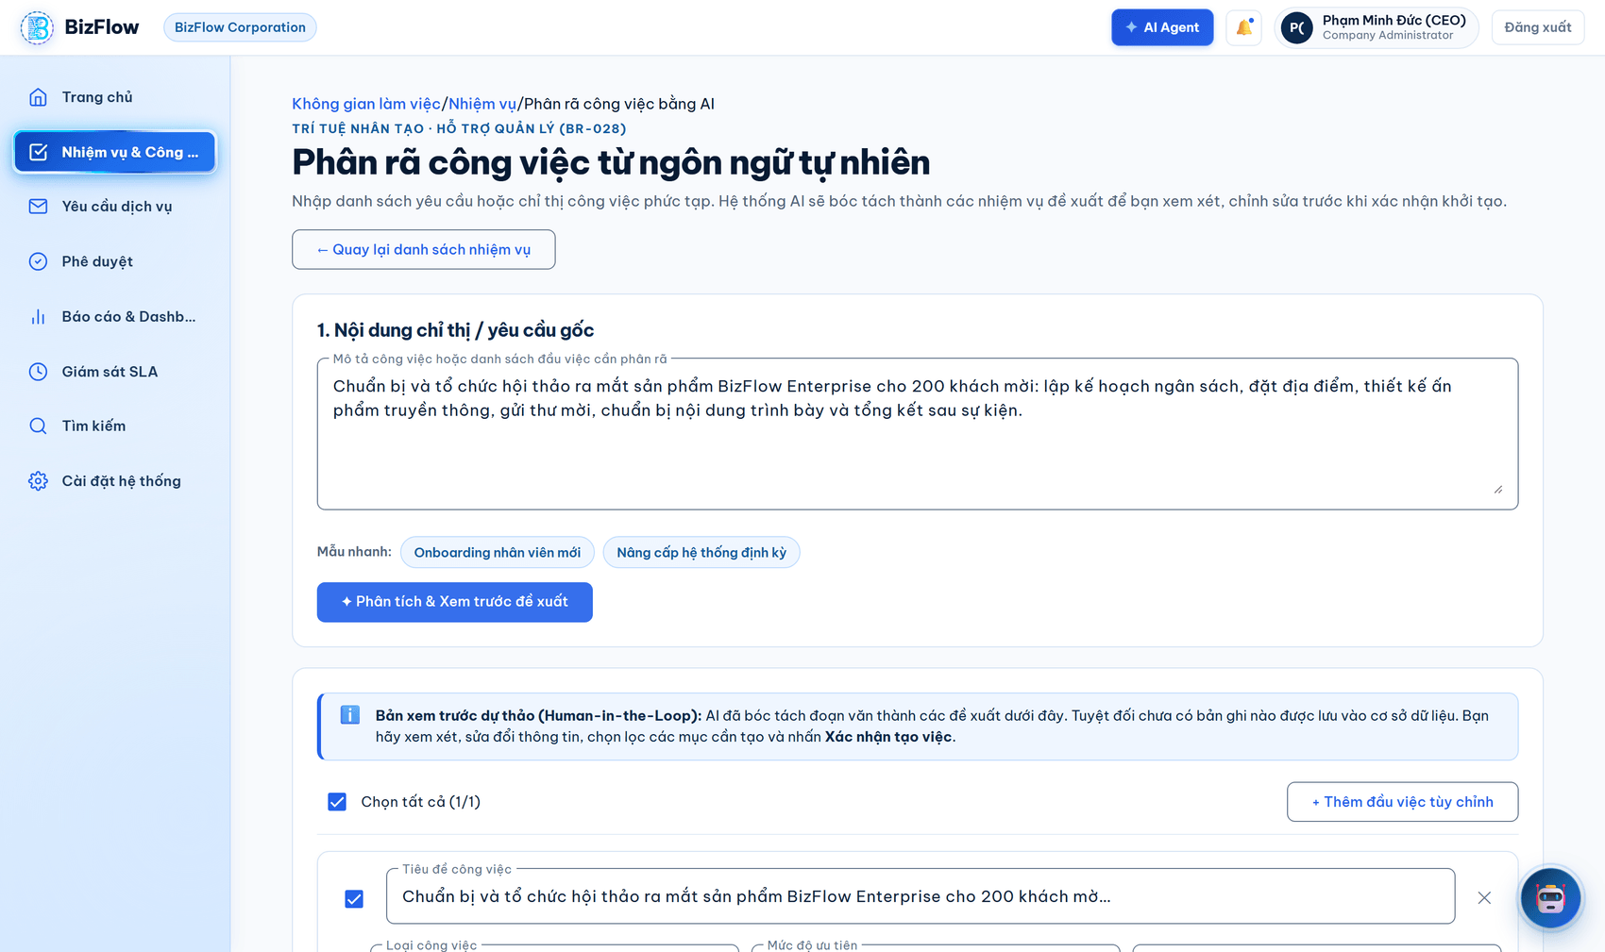
Figure 16. Human-in-the-loop preview: the AI only proposes; a person reviews and confirms before anything is written
Note: Business rule BR-028 forbids the AI from writing to the database on its own. The rule is enforced architecturally: the preview API is pure read and compute, and only the confirmation API, invoked deliberately by the user, has write authority.
Note: If no OpenAI key is configured, the AI features still work through built-in heuristics, but the decomposition returns fewer and simpler items than it would with a key.
6.3. Other AI features in the system
Feature | Where it is used | What it does
Deadline risk assessment | Task detail | Estimates the risk of missing the deadline from actual progress against remaining time.
Progress summary | Task detail | Generates a business summary from the execution history and progress reports.
Request narrative summary | Request detail | Summarises the entire conversation and handling history of a service request.
Classification and routing suggestion | Service request creation | Suggests a suitable category, priority and receiving department.
Document summarisation | Attachments | Summarises the content of an uploaded document.
Workflow branching | AI Assistant — branching tab | Proposes a work branch diagram for multi-step plans.

7. Workflow 6 — Reporting, Notifications and Record Search
Purpose: give management a complete operational picture and help every user avoid missing work that needs attention.
7.1. Dashboard and reports
- Choose Báo cáo & Dashboard (Reports & Dashboard) on the navigation bar.
- Select the relevant tab: Bảng Điều khiển Quản lý (management dashboard), Báo cáo Tổng hợp Doanh nghiệp (company summary report), Phân tích Tải Công việc (workload analysis) or Hiệu suất Cam kết SLA (SLA performance).
- Filter by department and date range, or use the 7 ngày qua / 30 ngày qua shortcuts, then click Áp dụng Bộ lọc (apply filters).
- Use the export function to download the report as Excel or CSV.
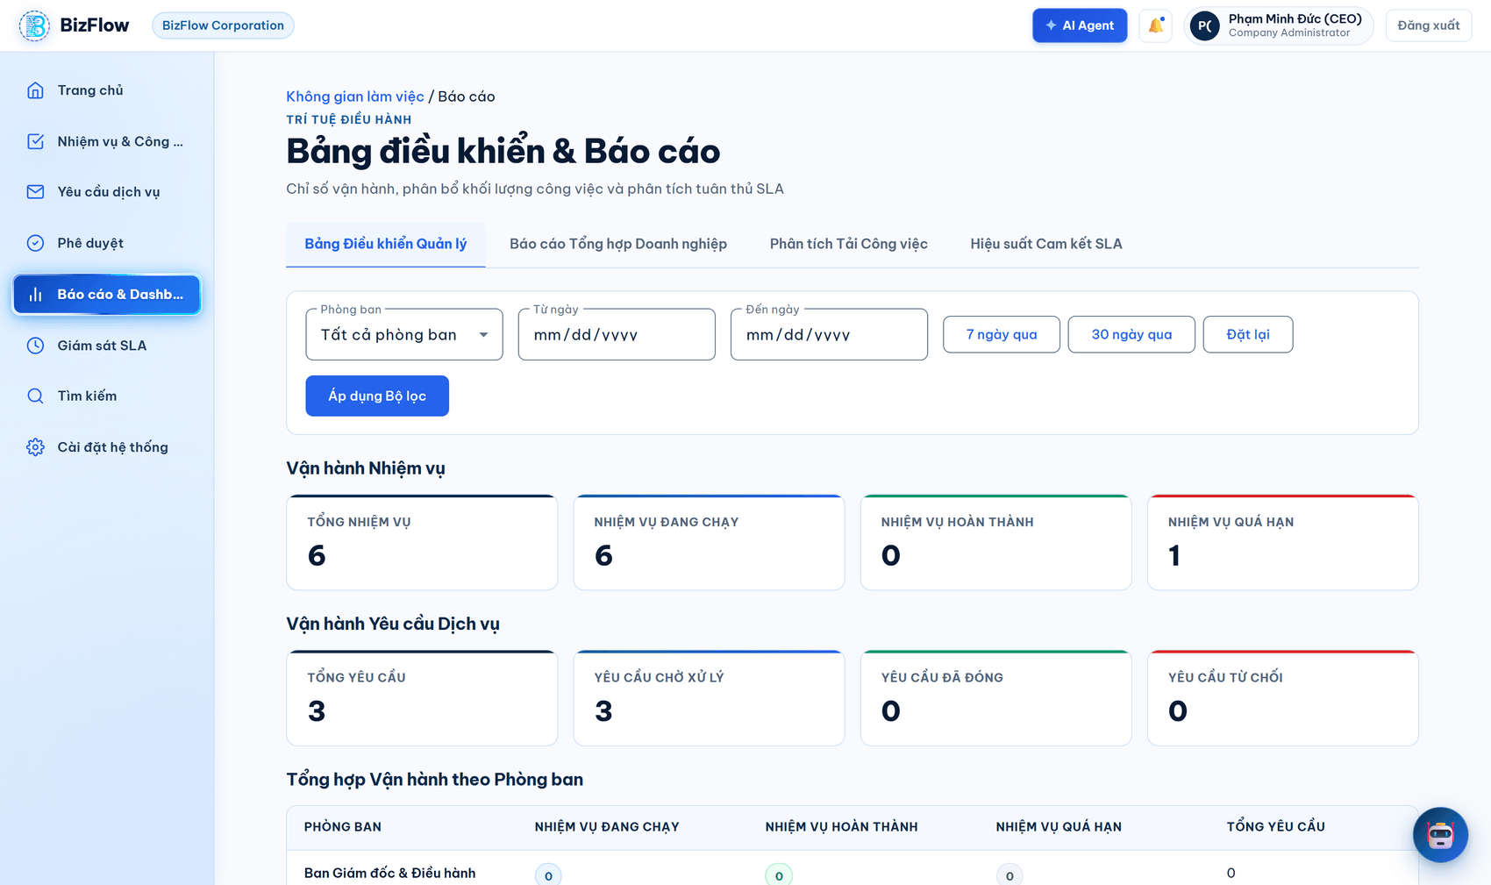
Figure 17. Operational dashboard with task metrics, request metrics and a per-department summary
Metrics are grouped into three layers: task operations (total, in progress, completed, overdue), service request operations (total, awaiting handling, closed, rejected) and a per-department summary table. The data scope is always limited by the reporting permissions granted to the user.
7.2. Notification centre
- Click the bell icon in the top bar, or go to Thông báo (Notifications).
- Filter by Chưa đọc (unread) to focus on items that need action.
- Click a notification to jump straight to the related task or request; the notification is marked as read automatically.
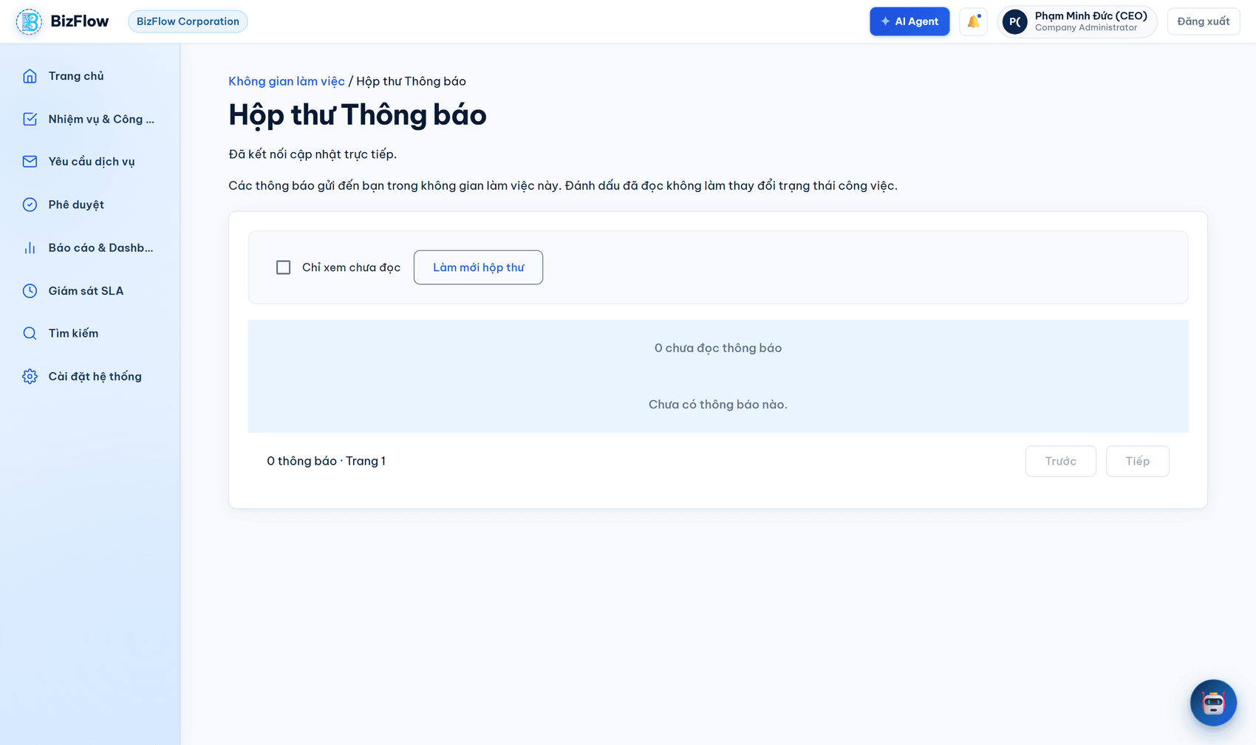
Figure 18. User notification centre
Notifications are pushed in real time over SignalR to open sessions. The database-backed inbox is always the source of truth: after a disconnection and reconnection the system synchronises so that no notification is missed. Each person receives only the notifications addressed to them.
7.3. Unified record search
- Choose Tìm kiếm (Search) on the navigation bar.
- Enter a keyword; the system searches tasks, service requests and archived records simultaneously.
- Narrow the results with the record type and date range filters.
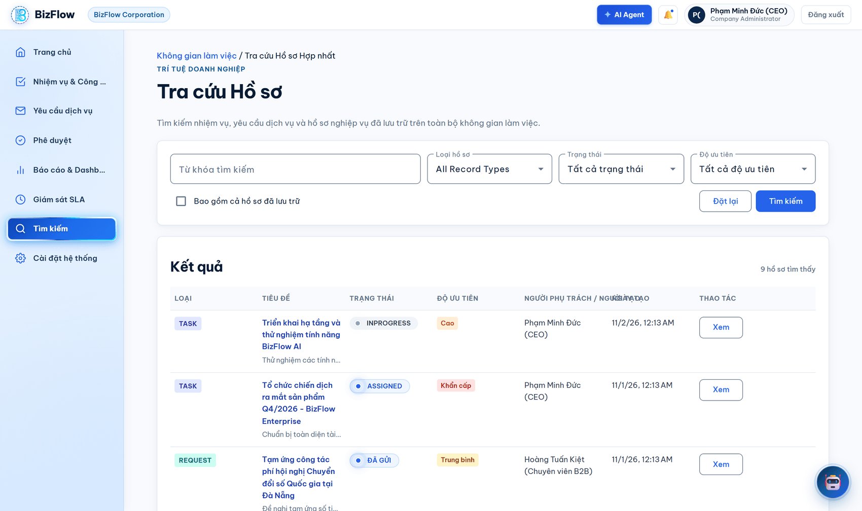
Figure 19. Unified record search screen

8. Workflow 7 — System Administration and Audit
Purpose: let the company administrator configure the platform to match their own organisational structure and policies, and supervise every change through the audit log.
8.1. System settings page
Choose Cài đặt hệ thống (System settings) on the navigation bar to reach the hub for every configuration group.
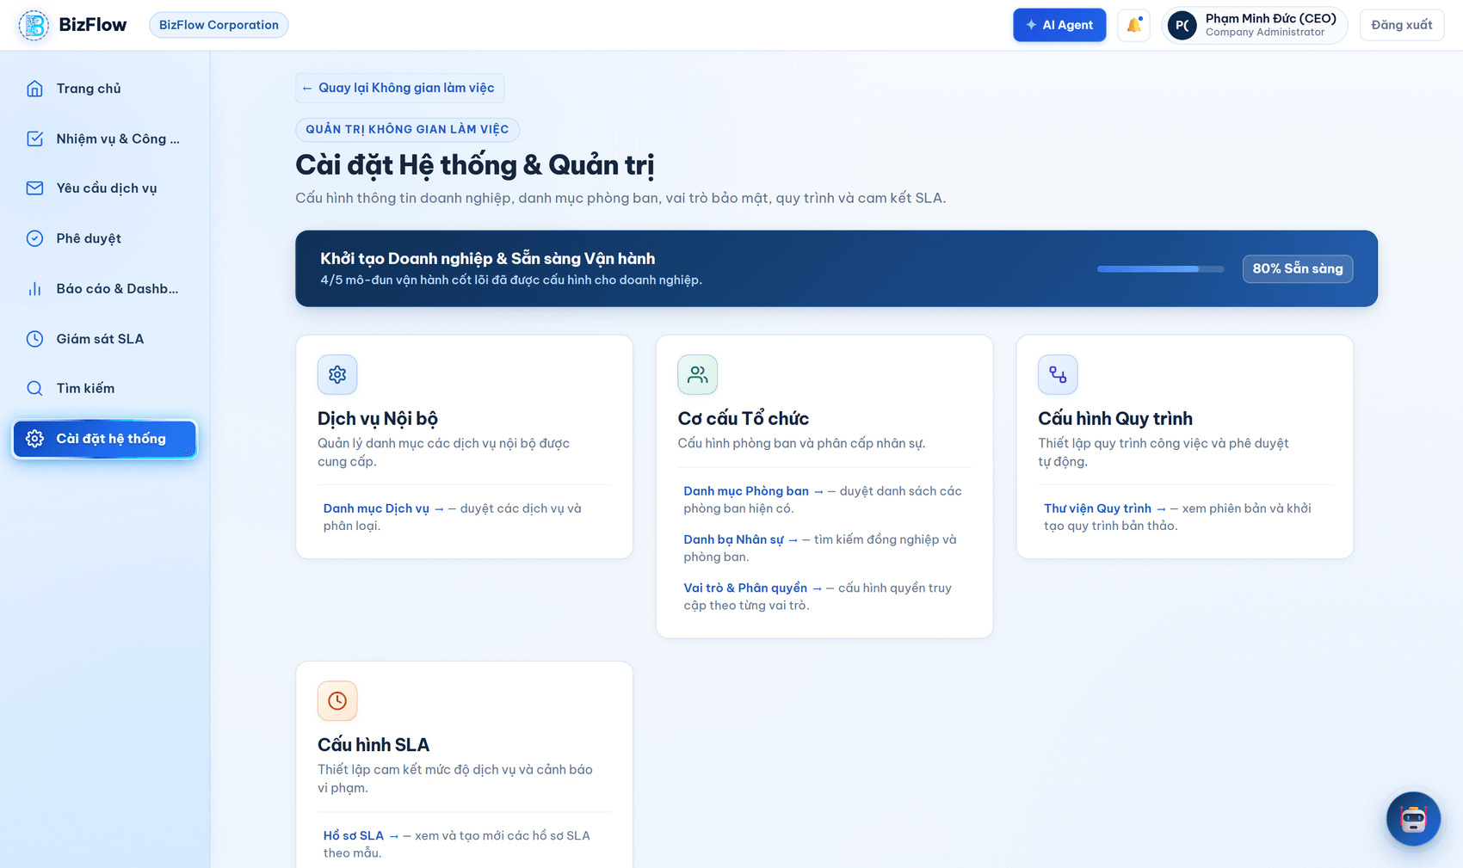
Figure 20. System settings page
8.2. Department management
- Go to Cài đặt hệ thống → Phòng ban & Bộ phận (Departments & Units).
- Search by name or code and filter by active status.
- Departments are organised hierarchically; this structure is the basis for determining each officer's management scope.
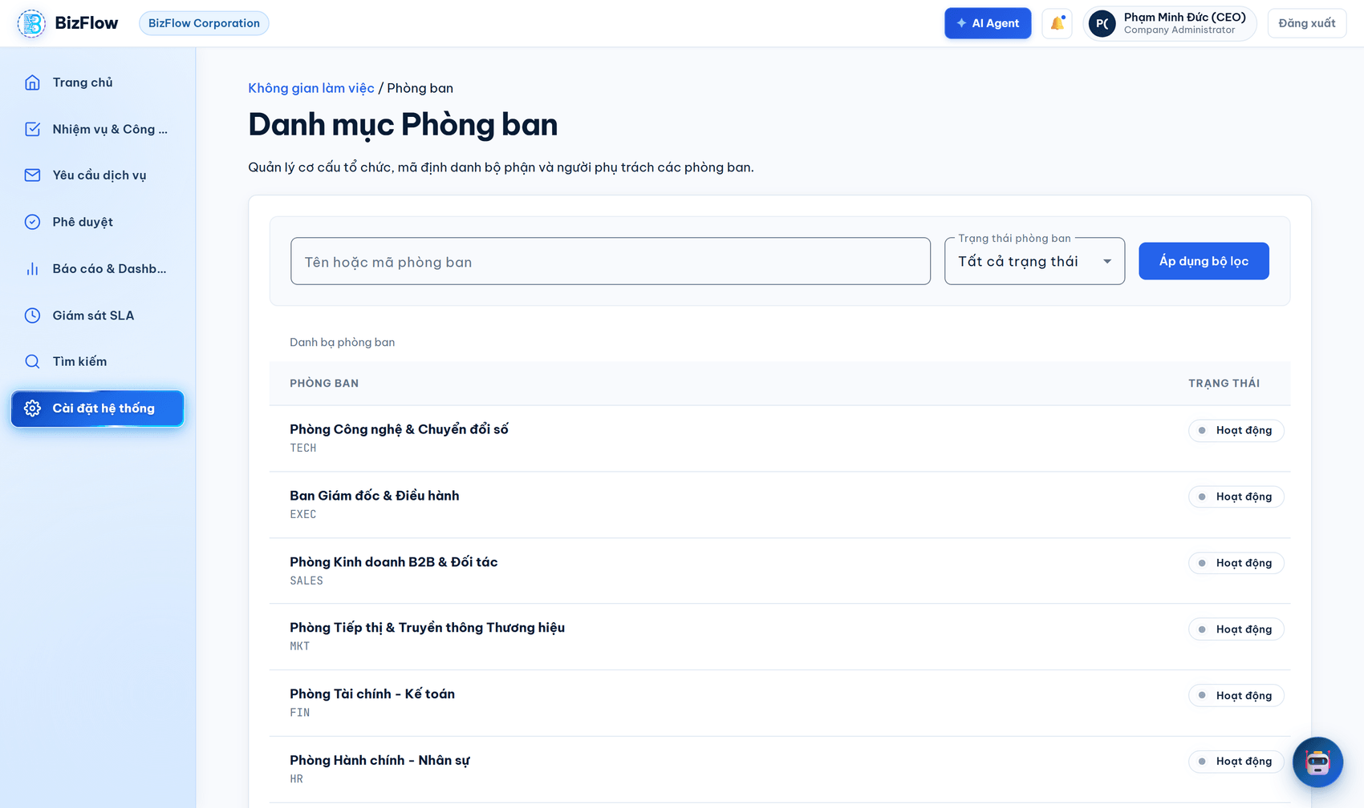
Figure 21. Department directory in its hierarchical structure
8.3. User management
- Go to Cài đặt hệ thống → Danh bạ Nhân sự (People directory).
- Search by full name, employee code or email; filter by account status.
- Open a user to view their profile, owning department and assigned roles.
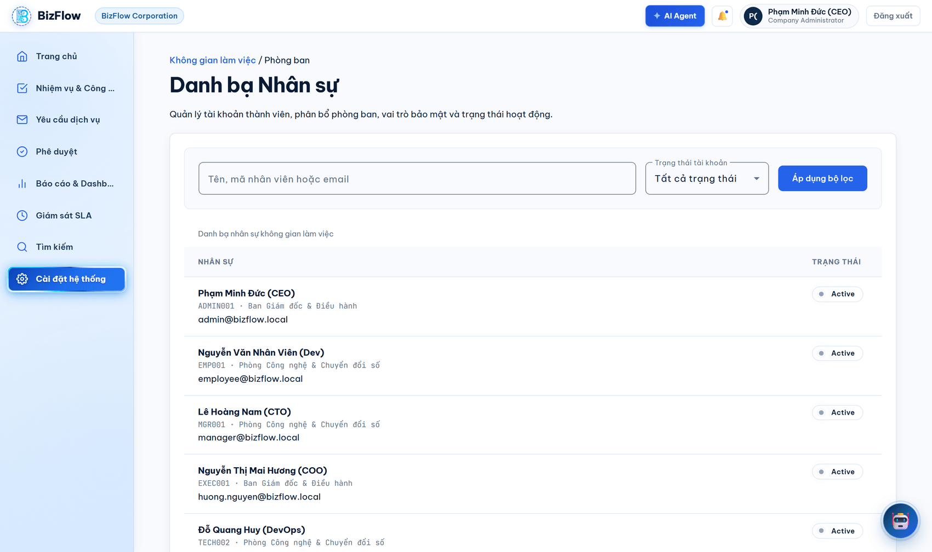
Figure 22. Company people directory
8.4. Roles and permissions
- Go to Cài đặt hệ thống → Vai trò và quyền hạn (Roles and permissions).
- Create custom roles that match the company's own structure.
- Tick the permission codes to grant to that role.
- Save. The change is written to the audit log.
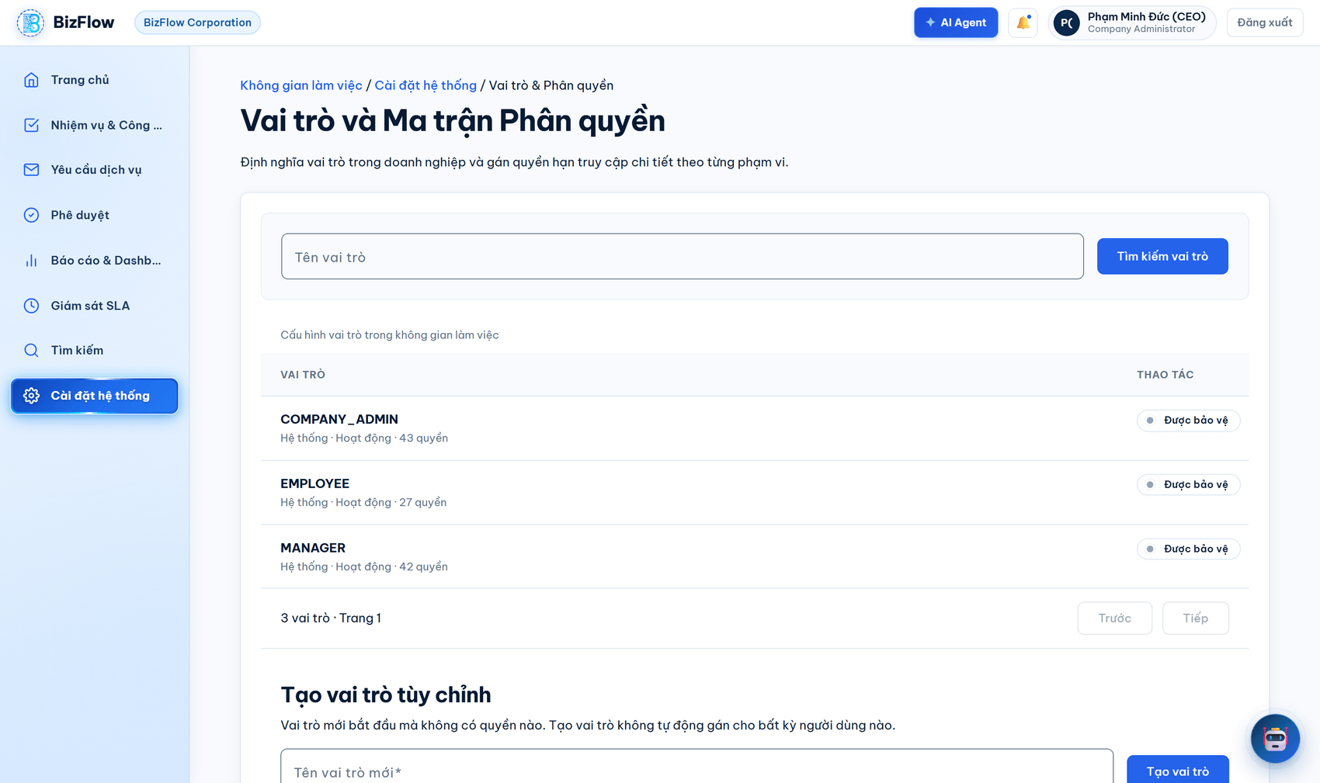
Figure 23. Role configuration and permission matrix screen
Note: A role name by itself grants no authority. The server always resolves permissions explicitly by permission code and resource scope. Client-side route guards are usability aids, not security controls. The system protects built-in system roles and rejects edits based on stale data.
8.5. Service catalogue
- Go to Cài đặt hệ thống → Danh mục Dịch vụ (Service catalogue).
- Create a new service with its initial categories, or add categories to an existing service.
- Bind a workflow version and a default SLA profile to each service.
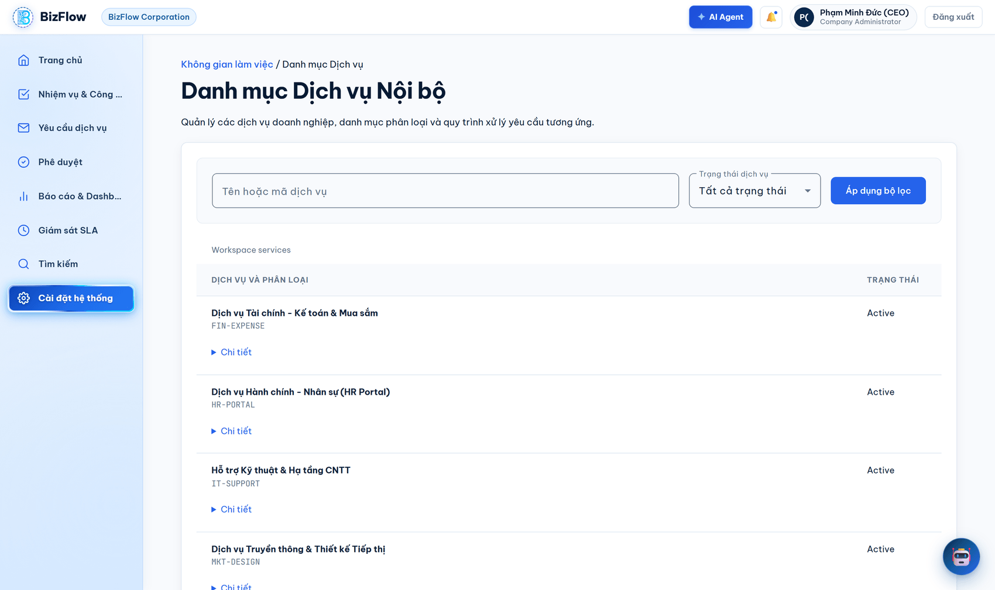
Figure 24. Internal service catalogue management
8.6. Business workflows
- Go to Cài đặt hệ thống → Quy trình nghiệp vụ (Business workflows).
- Create a new workflow by naming it and selecting the business type it applies to.
- Create the next version and edit its steps and transition conditions.
- Publish the version once it is complete.
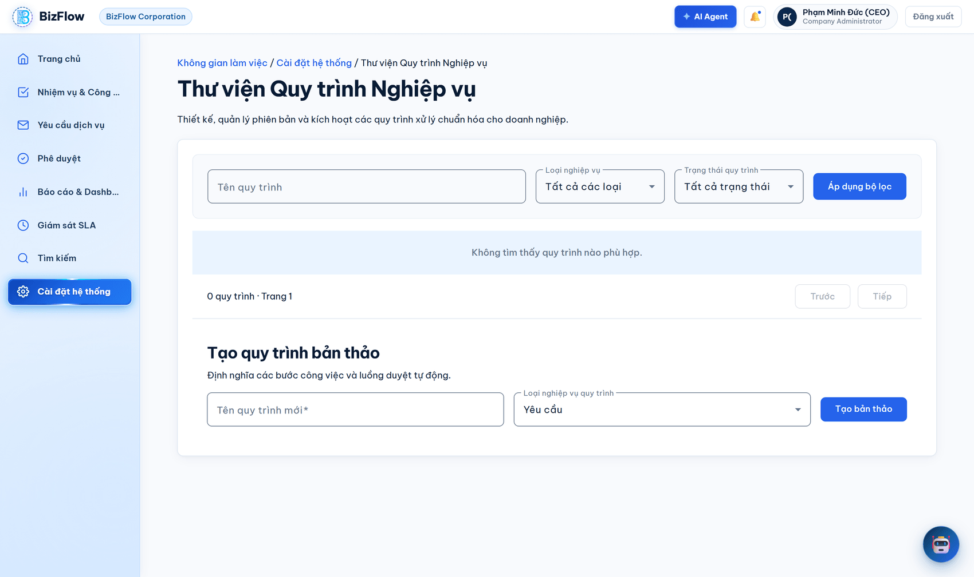
Figure 25. Business workflow library and version management
Note: A published version is immutable, and this is enforced at the database level. To change it you must create a new version. Records already running against an older version are therefore unaffected.
8.7. Service level agreement (SLA) profiles
- Go to Cài đặt hệ thống → Hồ sơ SLA (SLA profiles).
- Create a new SLA profile and name it after the group of services it applies to.
- Configure the response time and handling time targets.
- Set the company working calendar and the list of public holidays.
- Configure the escalation policy for when a commitment is at risk.
- Save to create a new version; use the version history to review each stored configuration snapshot.
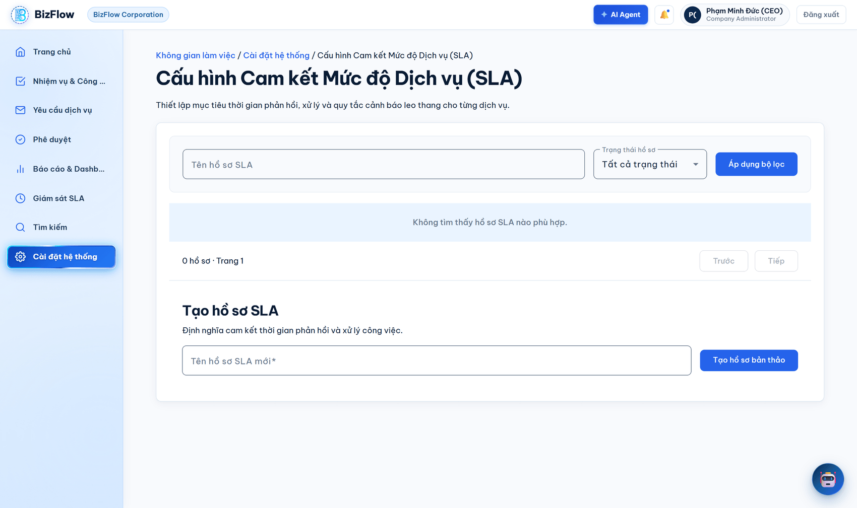
Figure 26. Service level agreement profile catalogue
8.8. Audit log
- Go to Kiểm toán (Audit).
- Filter by event type, actor or date range.
- Open an event to see the before and after values in detail.
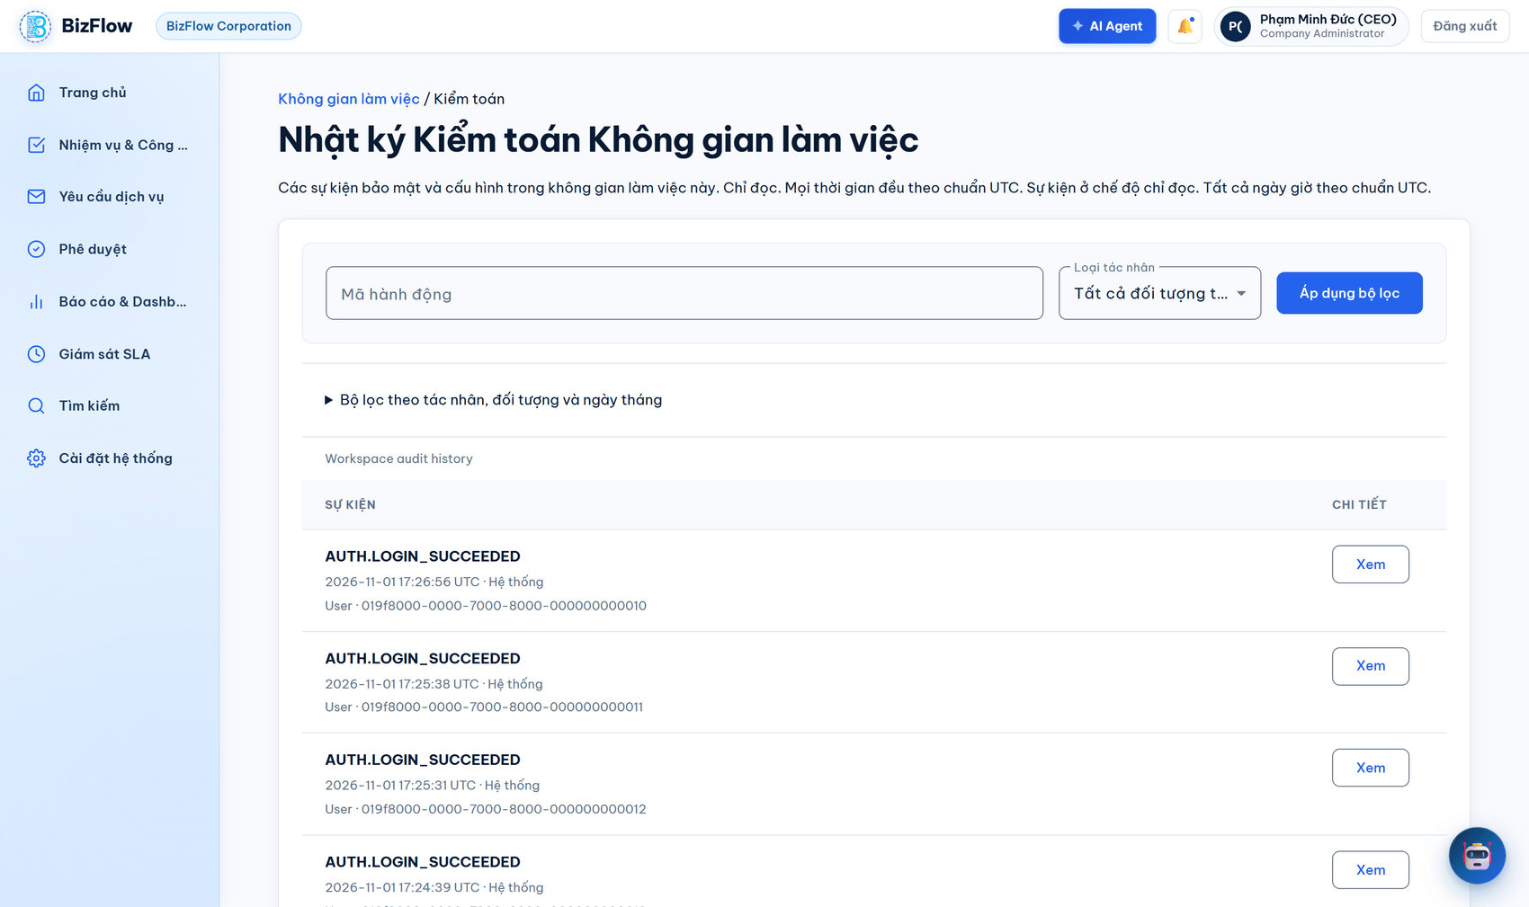
Figure 27. Audit log viewer
The audit log is append-only: existing entries cannot be edited or deleted. Each event records the actor identity, the actor type (user, system or AI), the timestamp and the before/after value pair. The company event stream and the platform event stream are kept entirely separate.
8.9. Role-specific perspectives
The same system presents a different workspace to each role. The two figures below show the main screen for the Manager role and the Employee role, for comparison with the Company Admin screen in Section 1.3.
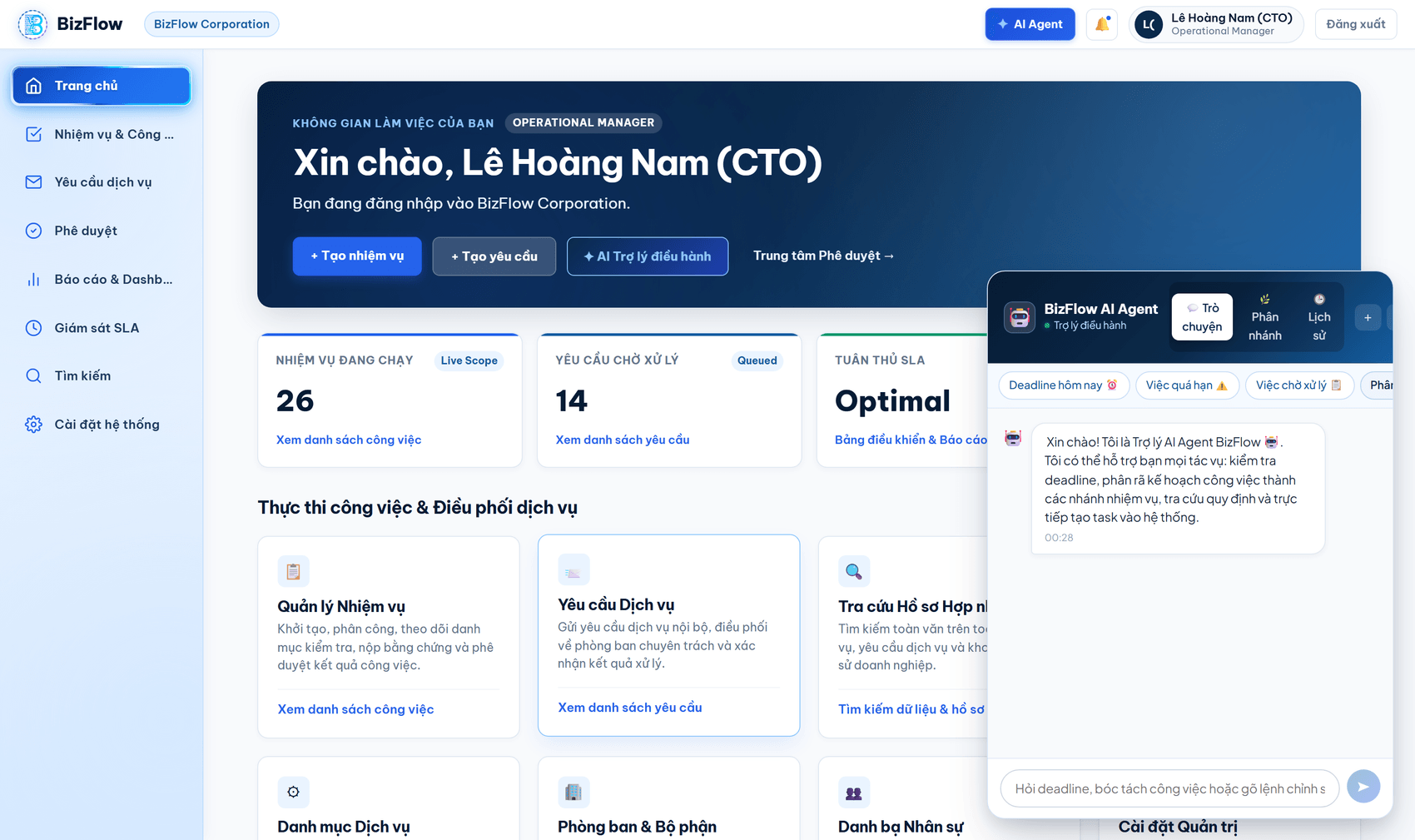
Figure 28. Workspace of the Manager role
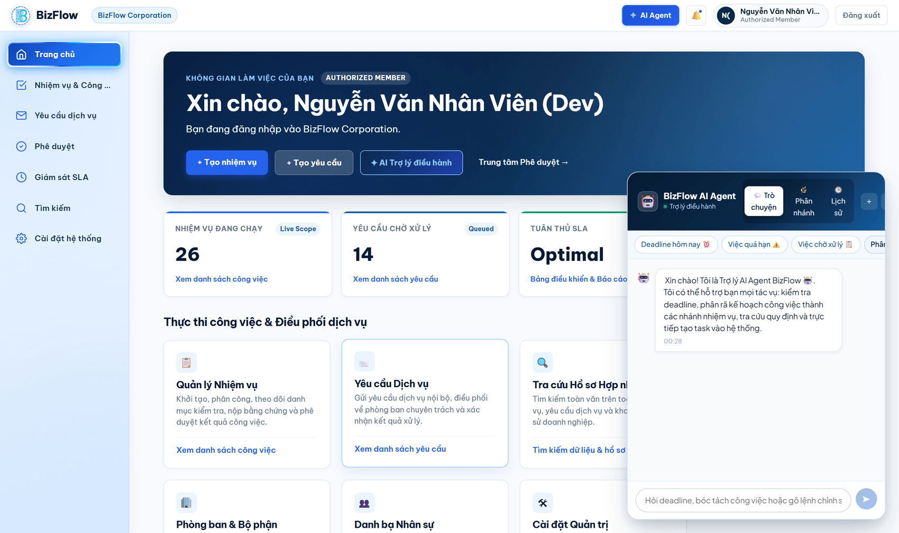
Figure 29. Workspace of the Employee role
The difference is not merely cosmetic. The server resolves permissions and resource scope on every request, so a user cannot reach data outside their scope even by typing a screen address directly into the browser.

