Perceptions of drinking water management and safety: A public survey of U.S. residents

T. Allen Berthold, Audrey McCrary, Stephanie deVilleneuve, and Michael Schramm

Texas Water Resources Institute, Texas A&M AgriLife, College Station Texas, USA (Berthold, McCrary, deVilleneuve, Schramm). Correspondence to Schramm: [michael.schramm@ag.tamu.edu](mailto:michael.schramm@ag.tamu.edu))

**Research Impact Statement:** TBD

**ABSTRACT:** TBD

(**Keywords:** drinking water; public perception; water quality; survey.)

# Introduction

# Methodology

## Survey Instrument

The online survey was administered and distributed through the Qualtrics online panel in April 2023. Panels were recruited using gender, age, and race/ethnicity quotas to obtain approximately representative samples of the U.S. population. Panels were continuously sampled until a representative sample was obtained, with a total sample size of 1,100 respondent and estimated ±3% margin of error at 95% confidence (Dillman 2011). Quality checks, performed by Qualtrics, excluded responses that failed attention or speed checks, IP address checks, or failed to meet representative demographic criteria. All participants were provided and agreed to a written informed consent agreement. The Texas A&M University Institutional Review Board reviewed the study protocol prior to distribution and deemed the study exempt from formal review.

We sought to characterize (1) choice in primary drinking water source; (2) problems experienced with drinking water; (3) concern about drinking water contamination; (4) perceptions of trust and safety in drinking water quality and associated management entities; and (5) how people receive information about drinking water quality. Participants were asked for their main source of household tap water (municipal public supply, public rural water district, private ground or surface water, private rainwater collection) and their main source of drinking water (unfiltered tap, filtered tap, bottled/prepackaged, or other). We also asked if they had experienced any of 12 different potential drinking water issues. To characterize concerns about contamination sources, we also asked how concerned they were about 10 different potential sources of contamination on a five-point scale from *“not at all concerned”* to *“extremely concerned.”*

Levels of responsibility and trust in different entities involved in drinking water management were assessed with 2 questions. First, participants were asked what level of responsibility (on a five-point scale from *“no responsibility”* to *“full responsibility”*) they believed each of six different entities had for ensuring drinking water is safe. We also asked what the participants level of trust was in each of those entities (on a five-point scale from *“do not trust at all”* to *“fully trust”*). To assess the public’s perceived safety of drinking water, we asked participants to rate their drinking water safety on an ordinal scale from 0 through 10. We assessed sources of drinking water quality information by asking how often (five-point scale from *“never”* to *“always”*) each of 11 different sources were used to get information about drinking water quality. Questions are documented in the supplementary information (Table S1).

## Analysis

Survey responses were weighted to match marginal sex/gender, age group, race/ethnicity, and education proportions to national level benchmarks from the 5-year 2021 American Community Survey (ACS; Table S2). We chose to weight gender using “male” and “non-male” binary responses because the ACS only provides binary responses for sex. This approach groups “female” and “other” respondents under the same marginal weight. Race and ethnicity were recoded at white or Caucasian and non-white categories due to small subpopulation sample sizes. Weights were developed by poststratification raking using the American National Election Study (ANES) weighting algorithm implemented in the *anesrake* R package (DeBell and Krosnick 2009; Pasek 2018). Weighted summary statistics were calculated using the *survey* R package (Lumley 2004). Confidence intervals for proportions were computed using the “logit” method with the “svyciprop” function.

## Models

We explored factors associated with changes in (1) primary drinking water source, (2) perceived safety of drinking water, and (3) perception of drinking water safety using regression-based approaches. Each of our models included demographic variables (Table S2), source of household tap water, and experience with any of (1) odd taste, (2) odd smell, (3) discolored water, or (4) cloudy water as explanatory variables. Primary drinking water source (unfiltered tap water, filtered tap water, or bottled water) was modeled using a multinomial logistic regression model (Agresti 2002). We used proportional odds models (McCullagh 1980; Agresti 2002) to explore factors associated (1) trust in entities responsible for drinking water safety (five-point scale), and (2) self-reported rating (on scale 1-10) of drinking water safety. Multinomial logistic regressions were fit using the *svyVGAM* R package (Lumley 2023) and proportional odds models were fit using the *survey* R package (Lumley 2004). We calculated the generalized variance inflation factor (GVIF) to evaluate potential impacts of multi-collinearity among model predictors on our interpretation of the models (Fox and Monette 1992). We report our model results as odds-ratios.

# Results

## Sources of drinking water and drinking water problems

The majority of respondents lived in homes with a municipal public water supply (56%, 1.6% SE) with 13.3% using some type of private water supply (Table 1). A relatively high percentage of respondents stats they did not know what the source of their tap water was (13.3%, 1.2% SE). The majority of respondents (65.5%) used unfiltered or filtered tap water as their main source of drinking water (Table 1). Bottled or pre-packaged water was the primary drinking water sources for 34.2% (1.6% SE) of respondents. Only 3.1% (0.6% SE) of respondents stated that they had not experienced any issues with their tap water (Table 2). Odd taste (27.5%, 1.4% SE), hardness or scale buildup (20.3%, 1.3% SE), and odd smell (18.8%, 1.3% SE) were the most common issues. Notably, 14.9% (1.1% SE) of respondents stated they have experienced a boil water notice.

**Table 1.** The proportion of respondents with the specified household water source and drinking water source.)

| **Response** | **Proportion** | **SE** |
| --- | --- | --- |
| **What is the source of your household tap water?** | | |
| Public supply - municipal | 0.561 | 0.016 |
| Public supply - rural water district | 0.163 | 0.012 |
| Private supply - well, river, pond | 0.114 | 0.01 |
| Private supply - rainwater harvest system | 0.019 | 0.004 |
| I don’t know | 0.139 | 0.012 |
| Other | 0.004 | 0.002 |
| **What is your main source of drinking water?** | | |
| Unfiltered tap water | 0.28 | 0.015 |
| Filtered tap water | 0.375 | 0.015 |
| Bottled/prepackaged water | 0.341 | 0.016 |
| Other | 0.003 | 0.001 |

**Table 2.** Proportion of respondents that have experienced specified issues with their drinking water.)

| **Issue** | **Proportion** | **SE** |
| --- | --- | --- |
| Odd taste | 0.274 | 0.014 |
| Odd smell | 0.187 | 0.013 |
| Discolored water | 0.117 | 0.01 |
| Cloudy water | 0.148 | 0.011 |
| Staining of clothes, teeth, or skin | 0.055 | 0.007 |
| High salt content | 0.031 | 0.005 |
| Hardness or scale buildup | 0.202 | 0.013 |
| Corrosion of pipes or water fixtures | 0.081 | 0.009 |
| Boil water notice | 0.149 | 0.011 |
| Water shortage | 0.094 | 0.009 |
| None of the above | 0.031 | 0.006 |
| Other | 0.031 | 0.006 |

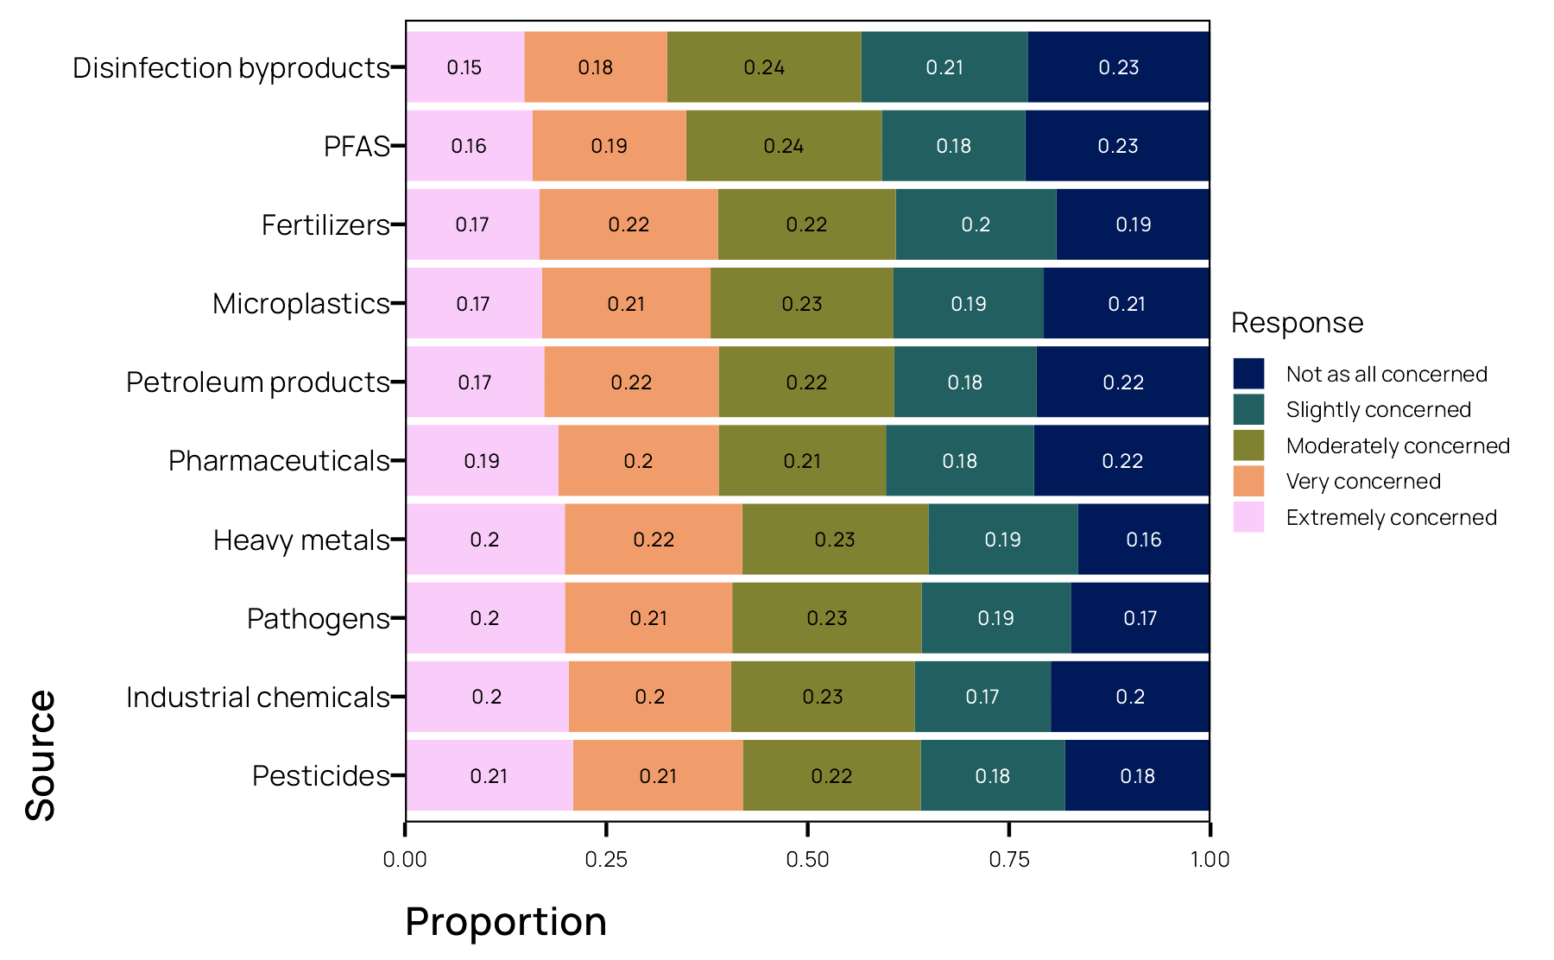

**Figure 1.** Contaminants of concern

We did not observe strong differences among response levels between different contaminants of potential concern (Figure 1). Pesticides (*extremely concerned* = 21%, 1.3% SE; *very concerned* = 21.1%, 1.3% SE), industrial chemicals (*extremely concerned* = 20.3%, 1.3% SE; *very concerned* = 20.1%, 1.3% SE), pathogens (*extremely concerned* = 19.9%, 1.3% SE; *very concerned* = 20.8%, 1.3% SE), and heavy metals (*extremely concerned* = 19.8%, 1.3% SE; *very concerned* = 22.0%, 1.3% SE) are sources that elicited the highest levels of concern across all respondents. Disinfection byproducts (*Not at all concerned* = 22.6%, 1.4% SE; *slightly concerned* = 20.7%, 1.3% SE) and PFAS (*not at all concerned* = 23.0%, 1.4% SE; *slightly concerned* = 17.8%, 1.2% SE) were sources of least concern.

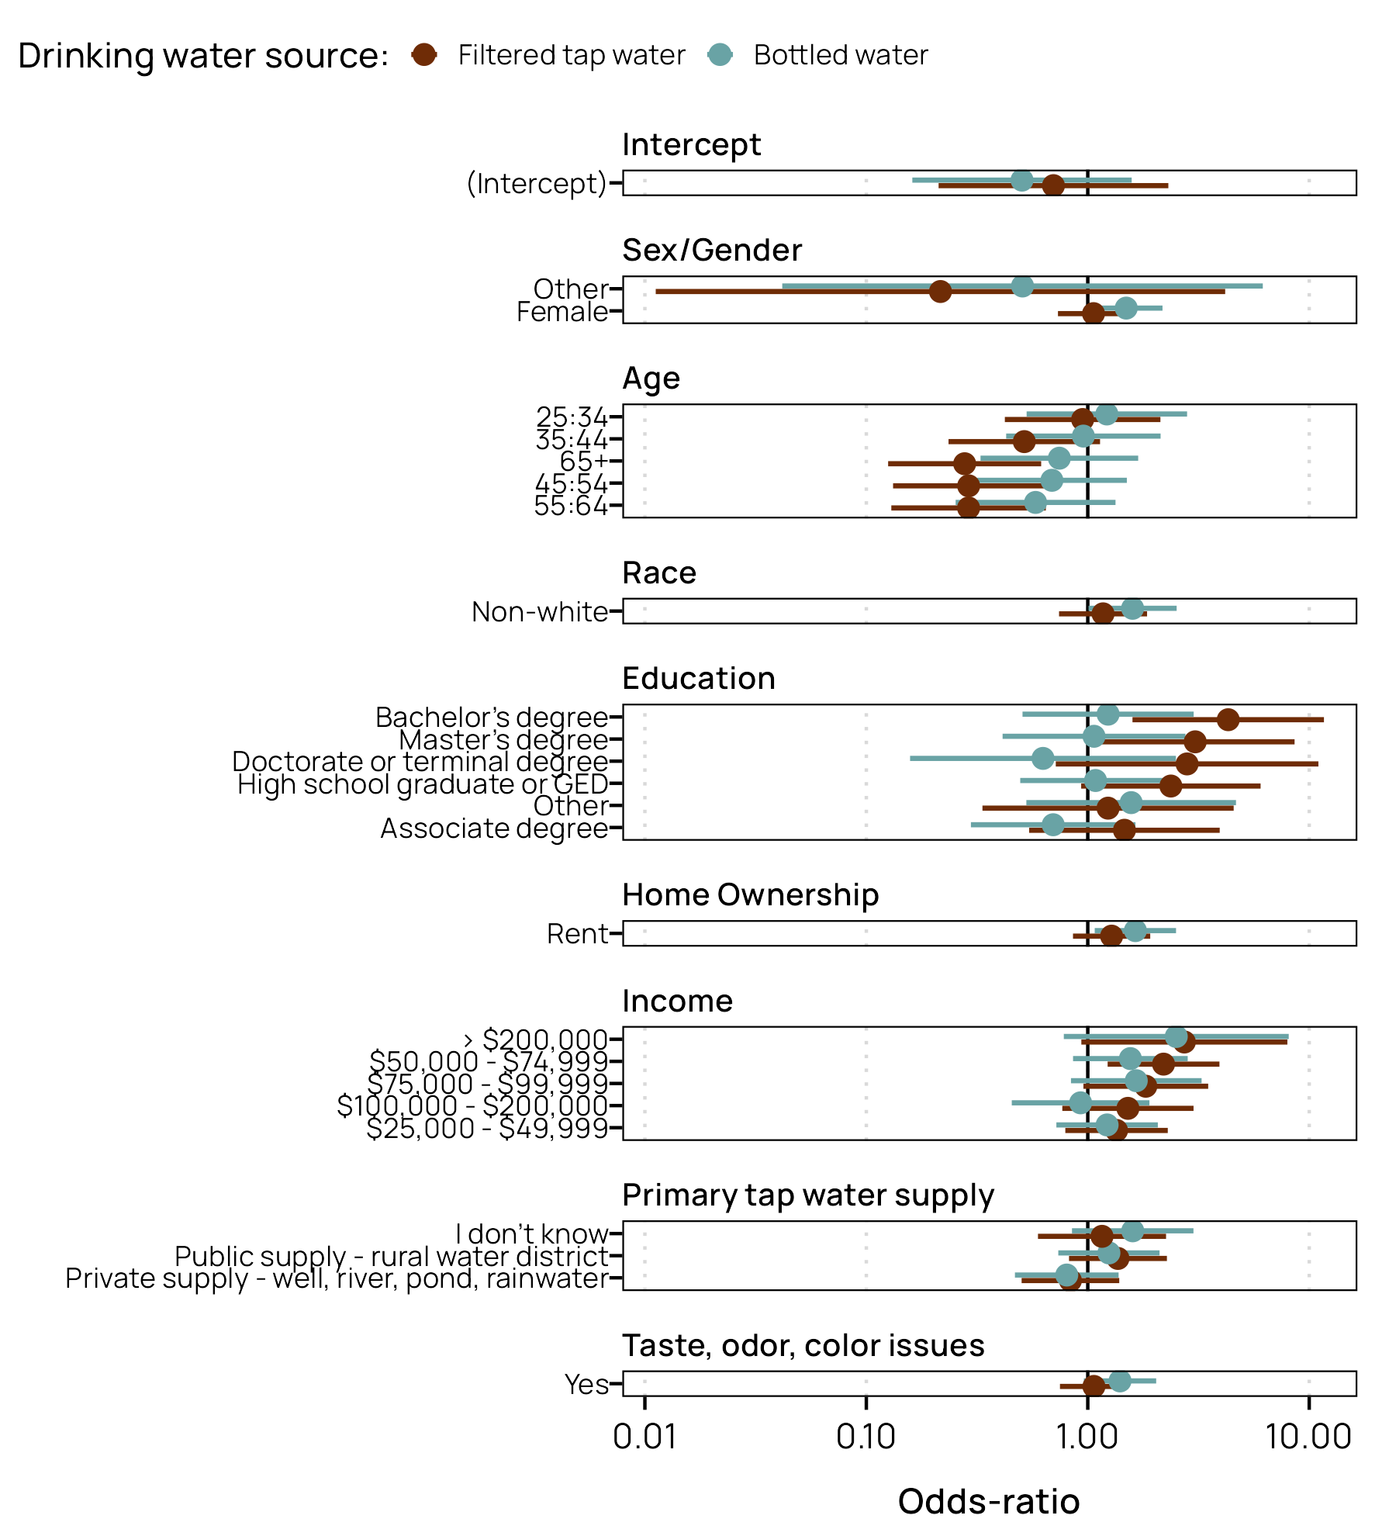

**Figure 2.** Primary drinking water model coefficients (odds-ratios) and 95% CIs. Odds-ratios are relative to unfiltered tap water.

Based on the multinomial regression model, we found limited effects of demographic variables, drinking water sources, and experience with odd taste, color, or smell on the odds of using bottled drinking water compared to unfiltered drinking water (Figure 2, Table S3). Notably, females had 1.49 times the odds (95% CI [1.02, 2.17]) of using bottled drinking water instead of unfiltered tap water compared to males. Non-whites had 1.59 times the odds (95% CI [1.01, 2.52]) of using bottled drinking water instead of unfiltered drinking water compared to white respondents. Renters had 1.64 times the odds (95% CI [1.07, 2.50]) compared to homeowners.

Conversely, older respondents were more likely to use unfiltered drinking water compared to filtered water (45:54 age group: OR = 0.29, 95% CI [0.132, 9.636]; 55:64 age group: OR = 0.29, 95% CI [0.130, 0.647]; 65+ age group: OR = 0.278, 95% CI [0.002, 1.25]) but there was not strong evidence for differences in odds between bottled water and unfiltered drinking water among any of the age groups. Education also showed strong effects on the use of filtered drinking water. Having a bachelor’s degree resulted in 4.31 times the odds of using filtered drinking water compared to those not graduating high school. A master’s degree had a similarly large effect (OR = 3.06, 95% CI [1.09, 8,59]).

## Sources of information

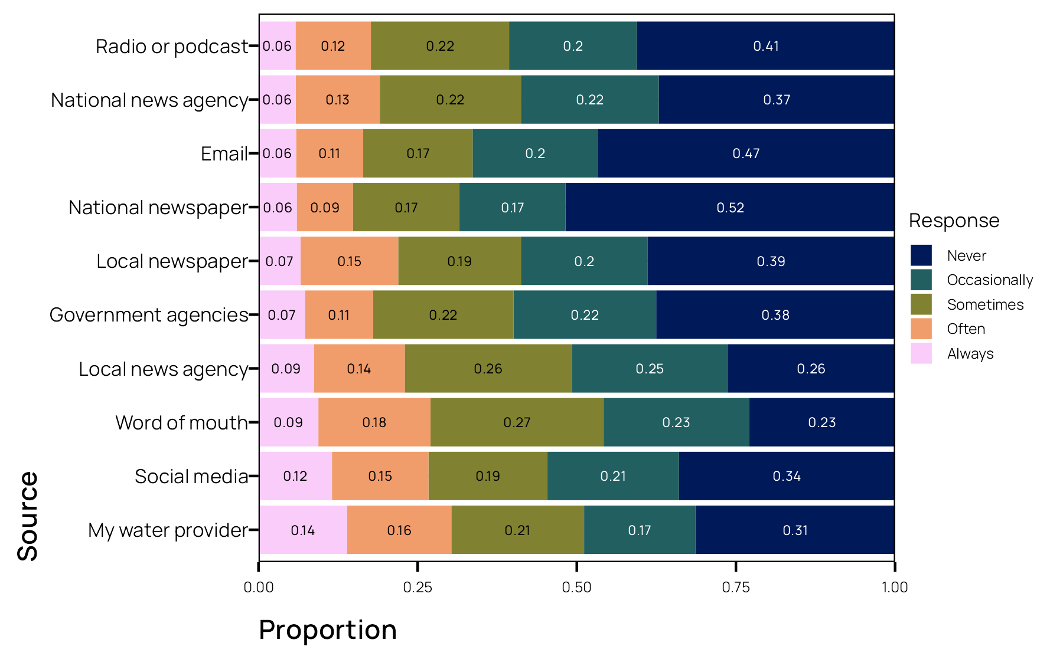

**Figure 3.** Sources of drinking water quality information.

Water providers appear to be the most relied upon source for information on drinking water with 13.9% (1.1% SE) and 16.4% (1.2% SE) of responses indicating water providers are *always* or *often* used as a source of information (Figure 3). Both social media (*always* = 11.5%, ±1% SE; *often* = 15.2%, ±1.1% SE) and word-of-mouth (*always* = 9.4%, ±1% SE; *often* = 17.6%, ±1.2% SE) are also frequent sources of information with similar or higher usage than local news agencies (*always* = 8.7%, ±0.9% SE; *often* = 14.3%, ±1.1% SE) or local newspapers (*always* = 6.6%, ±0.8% SE; *often* = 15.3%, ±1.1% SE). Some of the least utilized sources included radio or podcasts (*never* = 40.5%, ±1.6% SE; *occasionally* = 20.1%, ±1.3% SE), email (*never* = 46.7%, ±1.6% SE; *occasionally* = 19.6%, ±1.3% SE), national newspapers (*never* = 51.8%, ±1.6% SE; *occasionally* = 16.7%, ±1.2% SE), and government agencies (*never* = 37.5%, ±1.6% SE; *occasionally* = 22.4%, ±1.4% SE).

## Perceived responsibility, trust, and safety

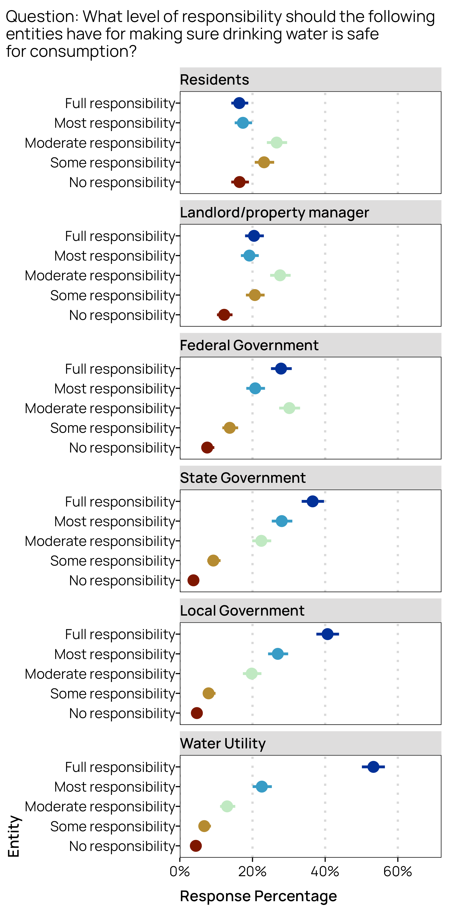

**Figure 4.** Weighted response percentages for the level of responsibility people believe different entities have for ensuring drinking water safety. Points represent the population-level estimated percent response, error bars are the 95% confidence intervals.

53.3% (95% CI [50.1%, 56.4%]) of people said that water utilities have *“full responsibility”* for ensuring drinking water safety (Figure 4). Local and state government also received high percentages of *“full responsibility”* by the public (local government = 40.7%, 95% CI [37.6%, 43.8%]; state government = 36.6%, 95% CI [33.5%, 39.7%]). Relative to other governmental institutions, fewer people felt the federal government had full responsibility (27.9%, 95% CI [25.1%, 30.8%]) for drinking water safety but a relatively higher percentage indicated the federal government has *“moderate responsibility”* (30.1%, 95% CI [27.3%, 33.1%]). Moderate responsibility was the most common response for the level of responsibility attributed to household residents (26.6%, 95% CI [24.0%, 29.5%]) and landlords/property managers (27.6%, 95% CI [24.9%, 30.5%]). A relatively high proportion of responses indicated residents have no responsibility for drinking water quality (16.4%, 95% CI [14.1%, 19.0%]).

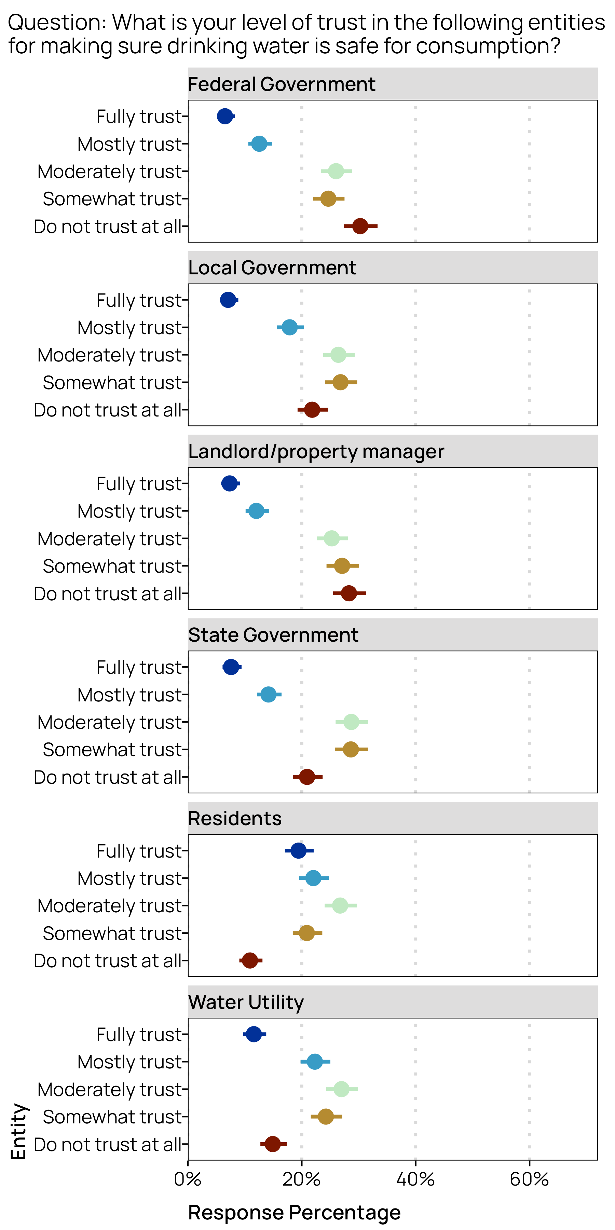

**Figure 5.** Weighted response percentages for the level of trust people have in the entities responsible for ensuring drinking water safety. Points represent the population-level estimated percent response, error bars are the 95% confidence intervals.

Water utilities were more trusted by the public than other governmental institutions (Figure 5). We found a higher percentage of respondents *“fully trust”* water utilities (11.6%, 95% CI [9.7%, 13.8%]) for making sure that drinking water is safe compared to state (7.6%, 95% CI [6.1%, 9.4%]), local (7.1%, 95% CI [5.6%, 8.9%]), and the federal government (6.5%, 95% CI [5.1%, 8.2%]). Water utilities and local government had higher rates of *“mostly trust”* responses (water utility = 22.3%, 95% CI [19.8%, 25.0%], local government = 17.9%, 95% CI [15.6%, 20.4%]) relative to state government (14.2%, 95% CI [12.1%, 16.4%]) and federal government (12.5%, 95% CI [10.6%, 14.7%]).

The federal government received the highest rates of distrust with 30.3% (95% CI [27.4%, 33.3%]) of responses indicating they *“do not trust at all”* the federal government for ensuring safety of their drinking water (Figure 5). State and local governments fared slightly better with distrust, with 20.9% (95% CI [18.4%, 23.7%]) and 21.8% (95% CI [19.3%, 24.6%]) of responses stating they *“do not trust at all”* state and local government respectively for ensuring safety of drinking water. Water utilities fared the best among governmental institutions for distrust with 14.9% (95% CI [12.7%, 17.4%]) indicating they *“do not trust at all”* water utilities for ensuring safety of drinking water.

Landlords/property managers received rates of trust and distrust that appear very similar to response rates for the federal government (*“fully trust”* = 7.3%, 95% CI [5.8%, 9.2%]; *“do not trust at all”* = 28.3%, 95% CI [25.5%, 31.3%]). Comparatively, household residents received the highest responses rates for *“fully trust”* (19.4%, 95% CI [17.0%, 22.1%]) and lowest responses rates for *“do not trust at all”* (10.9%, 95% CI [9.0%, 13.1%]) among all entities. The marginal response rates by primary tap water source (Figure S1) do not suggest that there are strong differences between those on private water sources or public water sources when it comes to trust in the ability of residents to ensure drinking water is safe.

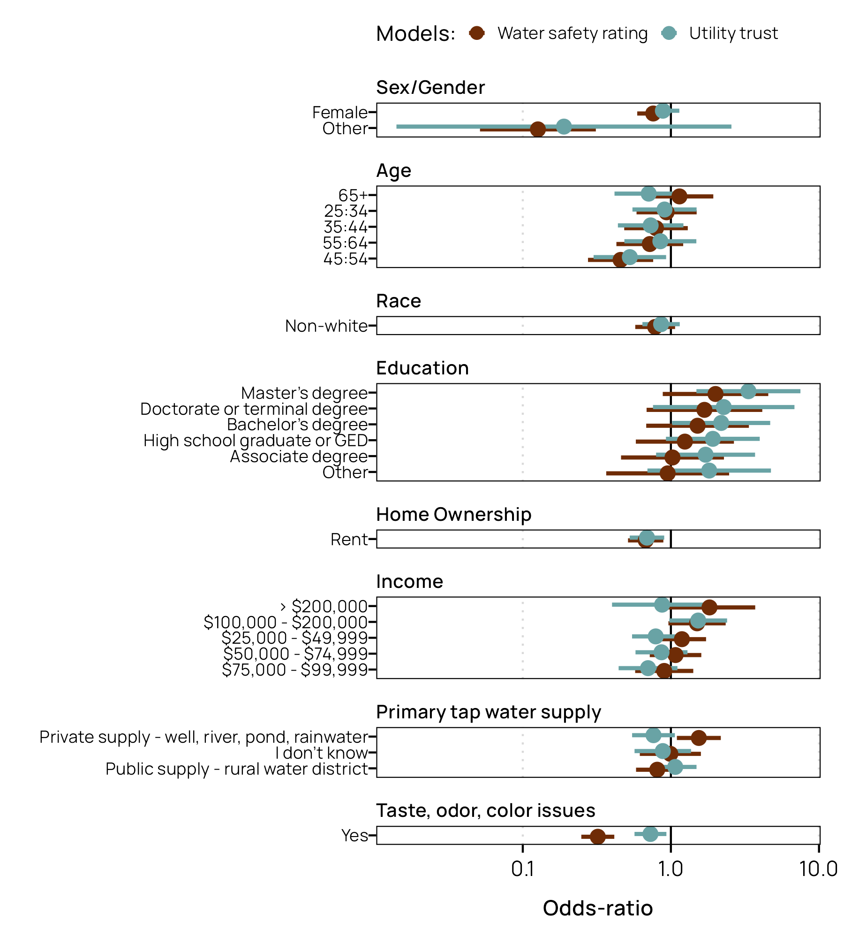

**Figure 6.** Estimated effect sizes (odds-ratios) and 95% confidence intervals of selected variables on (1) level of trust in drinking water utilities, and (2) perceived safety of drinking water.

The proportional odds model provides evidence that sex/gender, home ownership, household tap supply, and experience with taste/odor/color issues are associated with the perception of drinking water safety (Figure 6, Table S4). Females were 1.32 times more likely to rate their drinking water less safe than males (OR = 0.76, 95% CI [0.59, 0.97]). Respondents identifying their gender as other had 7.69 times the odds (OR = 0.13, 95% CI [0.05, 0.32]) of rating their drinking water less safe than male respondents. Home ownership provided a strong signal with renters 1.49 times more likely to provide a lower drinking water safety ranking than homeowners (OR = 0.67, 95% CI [0.51, 0.89]). Respondents on private water supplies had 1.54 times that odds of providing a higher drinking water safety rating than people on municipal supplies (OR = 1.54, 95% CI [1.10, 2.16]). People that experienced taste/odor/color issues with 3.12 times more likely to provide a lower safety rating than those that never experienced an issue (OR = 0.32, 95% CI [0.24, 0.41]).

We identified difference among some age groups, but a clear pattern was not evident. Respondents in the 45-54 age bracket were 2.22 times more likely to provide a lower drinking water safety rating than the 18-24 year old age group.

# Discussion

# Conclusion

# Supporting Information

Additional supporting information may be found online under the Supporting Information tab for this article: Tables with survey questions, unweighted and weighted survey demographics, summary tables for regression models and additional figures of marginal survey responses.

# Data Availability

Data and code used in analysis is publicly available in TBD.

# Acknowledgements

TBD

# Literature Cited

Agresti A. 2002. Categorical data analysis. 2nd ed. New York: Wiley-Interscience (Wiley series in probability and statistics).

DeBell M, Krosnick JA. 2009. Computing Weights for American National Election Study Survey Data. Ann Arbor, MI,; Palo Alto, CA: American National Election Studies Report No.: nes012427. <http://www.electionstudies.org/resources/papers/nes012427.pdf>.

Dillman DA. 2011. Mail and internet surveys: The tailored design method. Hoboken, N.J.: Wiley.

Fox J, Monette G. 1992. Generalized collinearity diagnostics. Journal of the American Statistical Association. 87(417):178–183. doi:[10.1080/01621459.1992.10475190](https://doi.org/10.1080/01621459.1992.10475190).

Lumley T. 2004. Analysis of complex survey samples. Journal of Statistical Software. 9(8). doi:[10.18637/jss.v009.i08](https://doi.org/10.18637/jss.v009.i08).

Lumley T. 2023. svyVGAM: Design-Based Inference in Vector Generalised Linear Models. <https://cran.r-project.org/package=svyVGAM>.

McCullagh P. 1980. Regression models for ordinal data. Journal of the Royal Statistical Society Series B (Methodological). 42(2):109–142. doi:[10.1111/j.2517-6161.1980.tb01109.x](https://doi.org/10.1111/j.2517-6161.1980.tb01109.x).

Pasek J. 2018. anesrake: ANES Raking Implementation. <https://CRAN.R-project.org/package=anesrake>.