Report Title

Your Name 1, Coauthor Name 2

1 Position, Texas Water Resources Institute, Texas A&M AgriLife Research

2 Position, Texas Water Resources Institute, Texas A&M AgriLife Extension Service

April 1, 2021

Texas Water Resources Institute

Texas A&M Agrilife

College Station, TX

TR-ABCD

This project was funded through a grant from a generous agency.

Insert other funding or partnership acknowledgments here.

Table of Contents

Table of Figures

Table of Tables

Abbreviations

# Headings

## Second Level Heading

### Third Level Heading

First, second, and third level headings are defined by #, ##, and ### respectively.

# Unumbered heading

Headings are automatically numbered. If you want a section heading to remain unnumbered use {-} after the heading. If you don’t want any heading numbers, edit the yaml code block at the top of the rmarkdwon document as follows:

output:   
 twriRmdTemplate::twri_rmd:  
 number_sections : false  
 plots:  
 style: Normal  
 align: center  
 caption:  
 style: Image Caption  
 pre: 'Figure '  
 sep: '. '

# Tables

This is an example of an unformatted table and how we cross-reference that table (Table ).

Table : this is the builtin mtcars data.

| mpg | cyl | disp | hp | drat | wt | qsec | vs | am | gear | carb |
| --- | --- | --- | --- | --- | --- | --- | --- | --- | --- | --- |
| 21.0 | 6 | 160.0 | 110 | 3.90 | 2.620 | 16.46 | 0 | 1 | 4 | 4 |
| 21.0 | 6 | 160.0 | 110 | 3.90 | 2.875 | 17.02 | 0 | 1 | 4 | 4 |
| 22.8 | 4 | 108.0 | 93 | 3.85 | 2.320 | 18.61 | 1 | 1 | 4 | 1 |
| 21.4 | 6 | 258.0 | 110 | 3.08 | 3.215 | 19.44 | 1 | 0 | 3 | 1 |
| 18.7 | 8 | 360.0 | 175 | 3.15 | 3.440 | 17.02 | 0 | 0 | 3 | 2 |
| 18.1 | 6 | 225.0 | 105 | 2.76 | 3.460 | 20.22 | 1 | 0 | 3 | 1 |
| 14.3 | 8 | 360.0 | 245 | 3.21 | 3.570 | 15.84 | 0 | 0 | 3 | 4 |
| 24.4 | 4 | 146.7 | 62 | 3.69 | 3.190 | 20.00 | 1 | 0 | 4 | 2 |
| 22.8 | 4 | 140.8 | 95 | 3.92 | 3.150 | 22.90 | 1 | 0 | 4 | 2 |
| 19.2 | 6 | 167.6 | 123 | 3.92 | 3.440 | 18.30 | 1 | 0 | 4 | 4 |

The [flextable](https://davidgohel.github.io/flextable/) package provides additional formatting flexibility when exporting to Word.

Table : Flextable formatted mtcars dataset.

| mpg | cyl | disp | hp | drat | wt | qsec | vs | am | gear | carb |
| --- | --- | --- | --- | --- | --- | --- | --- | --- | --- | --- |
| 21.0 | 6 | 160.0 | 110 | 3.90 | 2.620 | 16.46 | 0 | 1 | 4 | 4 |
| 21.0 | 6 | 160.0 | 110 | 3.90 | 2.875 | 17.02 | 0 | 1 | 4 | 4 |
| 22.8 | 4 | 108.0 | 93 | 3.85 | 2.320 | 18.61 | 1 | 1 | 4 | 1 |
| 21.4 | 6 | 258.0 | 110 | 3.08 | 3.215 | 19.44 | 1 | 0 | 3 | 1 |
| 18.7 | 8 | 360.0 | 175 | 3.15 | 3.440 | 17.02 | 0 | 0 | 3 | 2 |
| 18.1 | 6 | 225.0 | 105 | 2.76 | 3.460 | 20.22 | 1 | 0 | 3 | 1 |
| 14.3 | 8 | 360.0 | 245 | 3.21 | 3.570 | 15.84 | 0 | 0 | 3 | 4 |
| 24.4 | 4 | 146.7 | 62 | 3.69 | 3.190 | 20.00 | 1 | 0 | 4 | 2 |
| 22.8 | 4 | 140.8 | 95 | 3.92 | 3.150 | 22.90 | 1 | 0 | 4 | 2 |
| 19.2 | 6 | 167.6 | 123 | 3.92 | 3.440 | 18.30 | 1 | 0 | 4 | 4 |

# Figures

We can embed and cross-reference plots (Figure ).

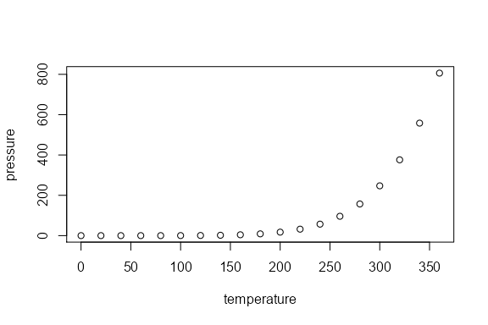

Figure . pressure dataset

# Landscape Section

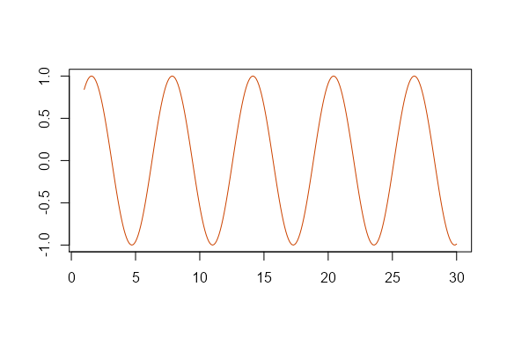

Figure . sin function

# Math

Wrap variables or math in a single $ to show math inline. For example, $ε∼N(0,1)$. Standalone equations are wrapped with $$.

$${\left(\prod_{i=1}^{n}{y_{i}}\right)}^{\frac{1}{n}}=\text{exp}\left[\frac{1}{n}\sum_{i=1}^{n}{\text{log}}y_{i}\right], \text{when} y_{1},y_{2},...,y_{n}>0$$

If the equations need to be numbered and cross-referenced the format as:

\begin{equation}  
\left(\prod_{i=1}^{n}y_i\right)^{\frac{1}{n}} = \exp\left[\frac{1}{n}\sum_{i=1}^n\log{y_i}\right], \quad \textrm{when} \quad y_1, y_2, ..., y_n > 0  
(\#eq:gmean)  
\end{equation}

Which renders as (Equation (1):

$${\left(\prod_{i=1}^{n}{y_{i}}\right)}^{\frac{1}{n}}=\text{exp}\left[\frac{1}{n}\sum_{i=1}^{n}{\text{log}}y_{i}\right], \text{when} y_{1},y_{2},...,y_{n}>0 (1)$$

# References

In-text references and bibliography generation are handled automatically. It relies on creating a bibtex .bib file with your references. Software such as Zotero, Mendely, and even Google Scholar can generate the bibtex entries for you. The entries are stored in the bibliography.bib file inside the same directory as this .Rmd file. To make a in text citation, use the following syntax, [@helsel_statistical_2002] to generate the reference at the end of this sentence (Helsel and Hirsch 2002). Use a semicolon to include multiple references [@helsel_statistical_2002; @hirsch2010weighted] (Helsel and Hirsch 2002; Hirsch et al. 2010). Or we might use @helsel_statistical_2002 without brackets to indicate Helsel and Hirsch (2002) provide a fundamental overview of water quality statistics. The bibliography will populate automatically.

# Styling and fonts

This template uses Minion Pro for body fonts and Open Sans for headings following TWRI brand guidance and AgriLife brand guidance. I can’t bundle Minion Pro in this package because of licensing, but you can download and install both fonts from AgriLife (<https://agrilife.tamu.edu/wp-content/uploads/2021/03/AgriFonts.zip>). I recommend downloading and installing the fonts before knitting your documents. Note that Minion Pro won’t “embed” in Word documents because it is an OTF style font and currently Word only embeds TTF fonts. That means collaborators without the font installed on their system will see a different serif font on their system in Word. Once exported to pdf, both OTF and TTF fonts should be embedded correctly.

# Bibliography

Helsel D, Hirsch R. 2002. Statistical methods in water resources. U.S. Geological Survey (Techniques of water-resources investigations of the United States Geologic Survey). <http://water.usgs.gov/pubs/twri/twri4a3/>.

Hirsch RM, Moyer DL, Archfield SA. 2010. Weighted regressions on time, discharge, and season (WRTDS), with an application to Chesapeake Bay river inputs. JAWRA Journal of the American Water Resources Association. 46(5):857–880. doi:[10.1111/j.1752-1688.2010.00482.x](https://doi.org/10.1111/j.1752-1688.2010.00482.x).

# Appendix A

You can add more info, tables, and figures here.