SecureChat System

Test Report - Assignment A02
Roll Number: i220831
Name: Tabish Noman Khan
Date: November 15, 2025
Repository: https://github.com/Txbish/securechat-skeleton

Testing & Evidence

Wireshark Capture
- Server Listening on Port 5555 and communicating with client
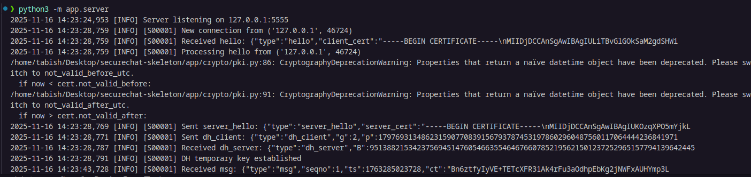
- Client Running and Logging in and sending messages according to desired format and payload is encrypted.
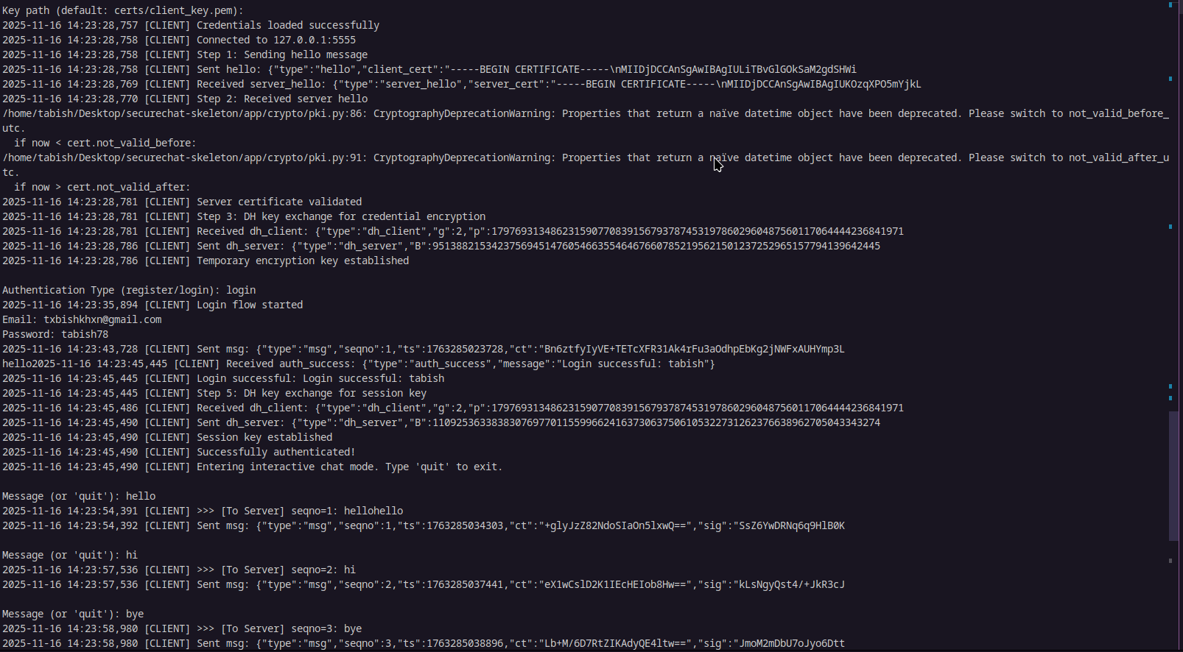

- The Wireshark capture on Port 5555 also generated a pcapng file, which is in the assignment submission.
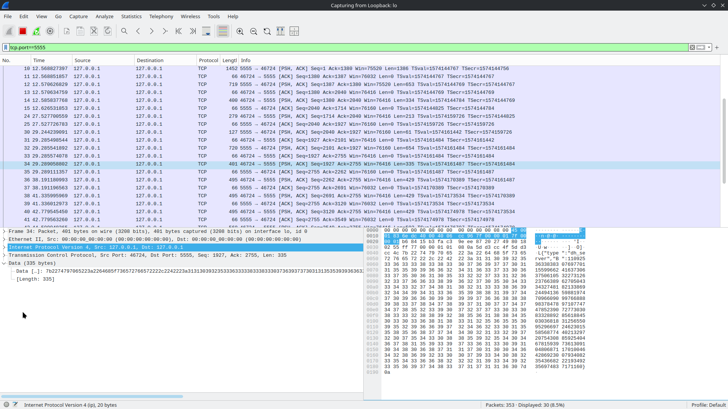

Invalid Certificate Test
- Forged Certificate and Key Test
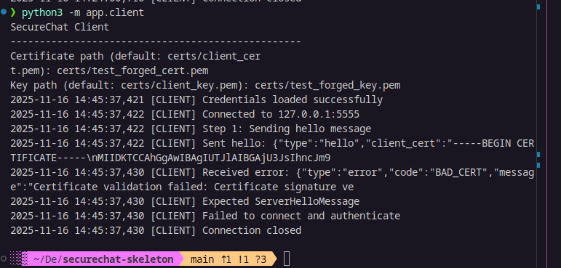
- Self-Signed Certificate and Key Test
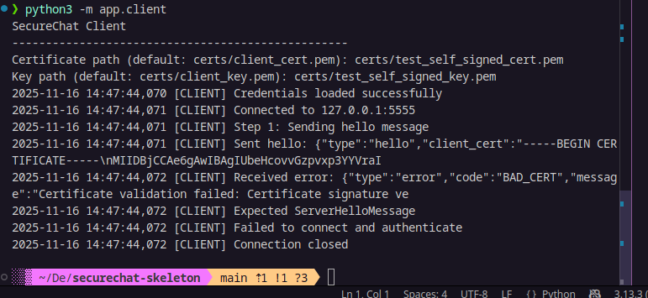
- Expired Certificate and Key Test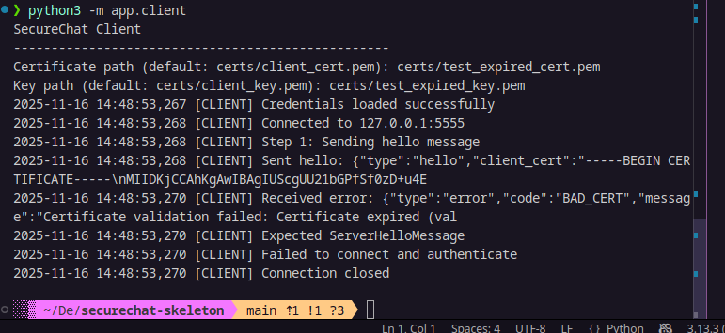

Tampering Test
- Tampered with Ciphertext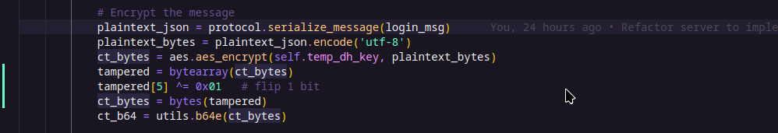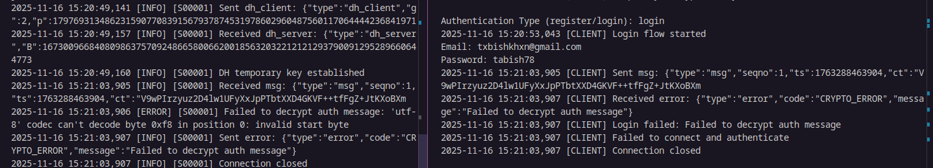

Replay Test
- Set Seq No after 3 to 1 to induce Replay Failure
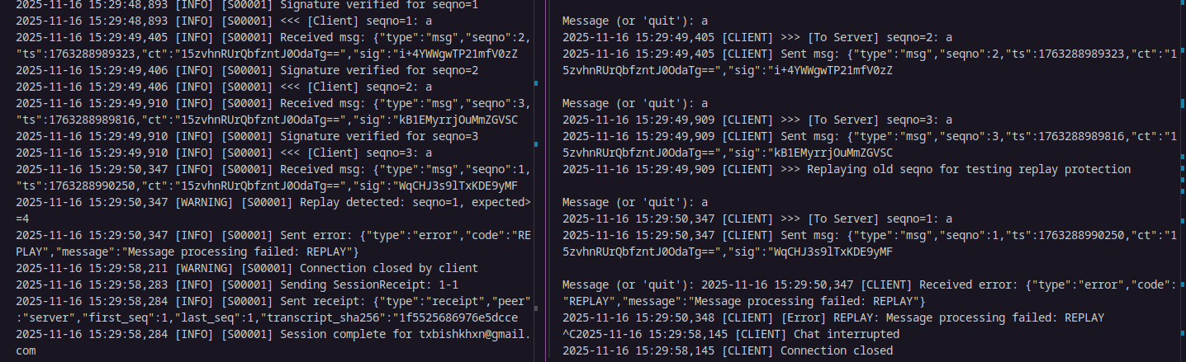

Non‑Repudiation Verification
