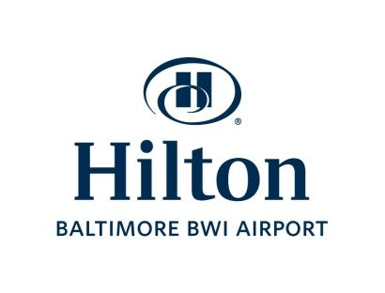**EMERGENCY INFORMATION**

Closest Hospital:

* Harbor Hospital– (410) 350.3200 (non-heart related)
  + Address: Harbor – 3001 S. Hanover St. Baltimore MD 21225
* [](http://www.honorflight.org/)Baltimore Washington Medical Center (heart related)
  + Phone: (410) 787-4000
  + Address: - 301 Hospital Dr. Glen Burnie MD 21061

2.      Closest pharmacy: Name: CVS

* 7095 Baltimore Annapolis Blvd, Glen Burnie MD, 21061 (4-5 Miles)
* Phone: (410) 859.3113
* Hours of operation: (Store) 8am – 10pm (Pharmacy) M-F 8am – 9pm S-Sn 9&10am – 6pm

3.      Local Fire Station: Name: BWI Fire and Rescue

* Address: Baltimore MD, 21240
* Phone: (800) 435.9294

4.      Local Police Station: Name: Anne Arundel Northern District Police

* Address: 939 Hammonds Ln, Brooklyn MD, 21225
* Non-Emergency Phone: (410) 222.6135

5.      Hotel Security Personnel/Director of Security: Michael Sewell

Number:  443.577.2471

6.      General Manager: Keith Moses Number:

Number: 410.694.0808 ext.5101

9.      Any additional internal emergency procedures: The hotel keeps an emergency preparedness binder for all situations in Security, Front Desk and Engineering. The hotel keeps a log of all chemicals used in the hotel and how to treat in case of accidental ingestion or skin absorption, kept in each department. In case of emergency, call 911 from guest room, hotel operator will be made aware as soon as a call is placed to 911 from an internal hotel phone. If calling from cell phone the address of the hotel is 1739 W. Nursery Road, please inform the hotel if you have called for assistance as soon as possible so we may help direct to location of incident. In case of cardiac arrest AED’s are located on 2nd floor across from the gym and additional one is located behind the front desk. Hotel staff is trained on AED and a list of certified CPR staff is kept at the front desk.