**Honor Flight Rochester Mission Facts** (updated 4-24-19)

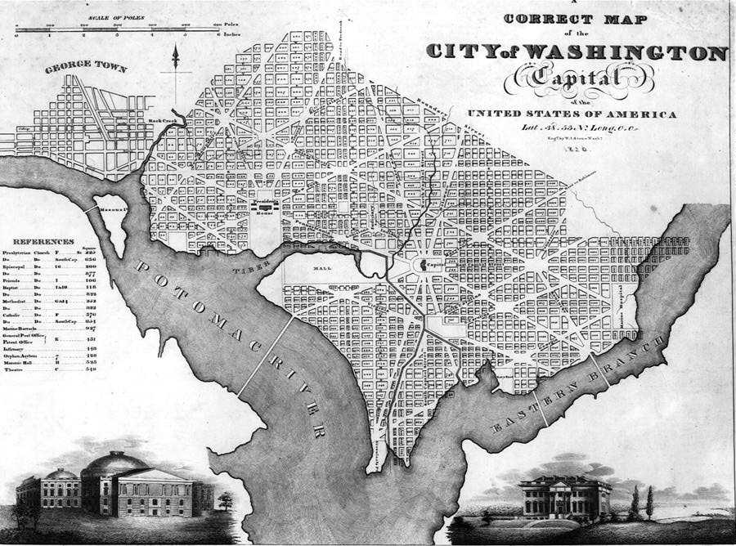 **DC**

1. Washington DC was the first designed American city, planned in 1791.
2. Both Virginia and Maryland donated some land to make Washington DC. Later, Virginia’s land was given back.
3. The city was named after George Washington, but the DC portion was named in memory of Christopher Columbus
4. DC streets are set up like a grid of letters and numbers. There is no “J’ street. Long ago, the letter J did not exist. Once it was added to the English alphabet, it closely resembled the letter I. Many believe that when the streets were laid out, the letter J was skipped to avoid confusion.
5. Washington DC was designed by Pierre L'Enfant and the original layout can be seen in the stone at Freedom Plaza on Pennsylvania Ave and 14th St.
6. There are more than 170 embassies in DC
7. All of DC has an area of only 68.25 square miles
8. Although DC residents pay taxes to the federal government, they do not have a representative in Congress. That is why you see “taxation without representation” on some DC license plates.

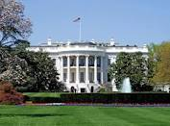 **The White House**

1. Built in 1792
2. George Washington never actually lived in the White House (it was still being built)
3. Was originally called the Presidents house. A Baltimore reporter once called it the White House and it stuck. Theodore Roosevelt made it the official name in 1901.
4. Thomas Jefferson had a pet mockingbird that flew freely around the White house (unless there were guests)
5. 132 rooms, 6 floors, 3 elevators, 412 doors, 147 windows, 28 fireplaces, 35 bathrooms
6. It is visited by 6,000 people every day
7. It employs 5 full time chefs.
8. It takes 570 gallons of paint to cover the outside of the White House
9. It costs about 25 thousand dollars a day to run the White House

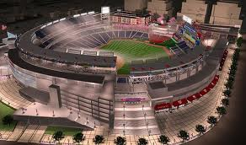 **Nationals Baseball Park:**

1. Opened march 30,2008 – cost over $611 Million – seats 41,546
2. For the first season, the official hot dog was Zweigle’s

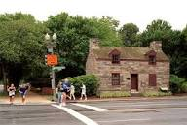 **Canal Lock Keeper’s House**

1. Corner of 17th and Constitution. Built in 1835 (corner where you turn to the WW2 Memorial)
2. Street used to be part of the canal.
3. The Canal was used until railroad built over it.
4. Housed the lock keeper and his family of 13 children from 1835 to 1855.
5. Was abandoned in 1855 and was used by squatters then by the Park Police as a jail.
6. In 2017 it was moved back 30 feet as part of the Constitution Gardens renovation.

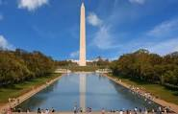 **Washington Monument**

1. The monument was originally designed to be surrounded by a circular wall.
2. Dedicated in 1885 and was opened to the public in 1888
3. It cost $1,187,000 to build
4. It is 555 feet, 51/2 inches tall and weighs 90,854 tons
5. It is made of 36,491 blocks
6. They began building the monument in 1848, stopped in 1854 when the Washington National Monument Society ran out of money. 25 years later the US government took over and completed the upper 2/3 in 1884 using marble from a different quarry.
7. The fastest known ascent up the stairs of the monument, to the top, is 6.7 minutes
8. In a 30MPH wind the monument will sway .125”
9. Was temporarily closed in August 23, 2011 due to the earthquake.

[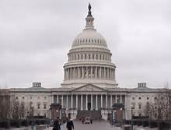](http://www.bing.com/images/search?q=interesting+facts+about+the+capitol+building&id=8B1E8DE1F7ABF33457597388A70A274750161AC8&FORM=IQFRBA#view=detail&id=807A535A1CD1725C772EAEA4C919A5F2752F027B&selectedIndex=2) **Capitol Building**

1. The Capitol Building is the most visited of the federal buildings
2. Construction began in 1793. Original building completed in 1826. Several additions have been made sense.
3. 751 feet wide X 350 feet deep X 288 feet to the top of the Statue of Freedom
   1. Statue of Freedom – artist Thomas Crawford 1863
4. A burial area was created for George Washington in the Capitol Building, but he was buried in Mt. Vernon
5. Flags are flown 24 hours a day over the east and west fronts of the building (this began during World War One)
6. The dome of the building is made of 8 million 9 hundred thousand pounds of cast iron
7. The top of the capitol building is 209 feet lower than the Washington monument

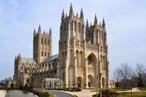 **Washington National Cathedral**

1. Officially the Cathedral Church of St. Peter and Saint Paul
2. Located at the corner of Massachusetts and Wisconsin Avenues
3. Completed in 1990 after 83 years of construction
4. Carillon and bell tower is the highest point in D.C.

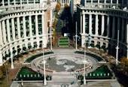 **Navy Plaza**

1. Every year, the waters of the fountains are replenished with water from the Seven Seas
2. Who can read the Semaphore flags?
   * When read as letters, spell out “U-S-N-A-V-Y-M-E-M-O-R-I-A-L.”

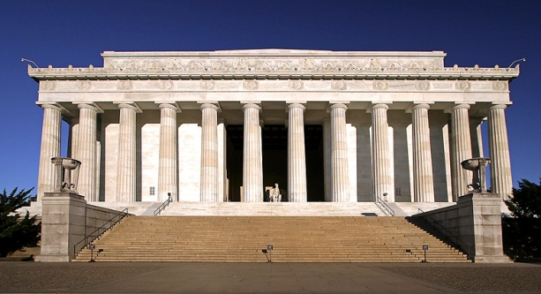 **Lincoln Memorial**

1. Martin Luther King gave his “I have a Dream” speech at the Lincoln Memorial
2. The seated statue of Abraham Lincoln is 19 feet high and 19 feet wide
3. Some say that Lincoln’s fingers are positioned to sign the letters “A” and “L”
4. There are 30 columns around the whole memorial
5. It cost 3 million dollars to build
6. It is made of marble and limestone
7. **Trip leader notes:**
   1. **Good restrooms are located at the left front of the Memorial. Signs indicate the way.**

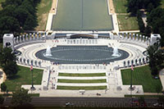 **World War II Memorial**

1. The site was FIRST dedicated by President Clinton on Veterans day 1995
2. Construction didn’t start until September 2001 and opened to the public on April 29, 2004 and dedicated on May 29, 2004.
3. 4.4 million people visit each year
4. The “Kilroy was here” doodle is found hidden in the memorial
5. It contains 56 granite columns, one for each state in 1945 plus Hawaii, Alaska, VI, PR, Guam, Samoa, Philippines
6. Senator and Mrs. Dole may or may not be here today to welcome us. CAUTION: please DO NOT touch or shake hands with Senator Dole as he is extremely frail.
7. **Trip leader notes:**
   1. **Restrooms are located near the bus drop off point**
   2. **WW2 Vets can register at the kiosks near the bus drop off point.**

**Detailed notes:** Operated by the National Park Service, it was designed to be "a memorial to the spirit, sacrifice, and commitment of the American people to the common defense of the nation and to the broader causes of peace and freedom from tyranny throughout the world".

Designing the Memorial

In 2001, a national competition was held to determine who would design the memorial. The winner was Friedrich St. Florian, an architect based in Providence, R.I. Florian was dubbed lead designer and was joined by a team of additional design professionals, including sculptor Ray Kaskey and stone carver/letterer Nick Benson.

Almost all the funds for the National World War II Memorial were raised from private donations. The memorial received more than $197 million in cash and pledges including $16 million from the federal government.

**The Memorial**

Compared to many of the other memorials located in the nation's capital, the World War II Memorial seems massive. It sits on a 7.4 acre (3 ha) site and measures approximately

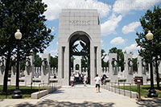

337 feet long by 240 feet wide (103 x 73 meter).

The memorial, which sits about 6 feet or approx 2 meter below grade, includes 56 identical white pillars arranged in 2 semi-circles surrounding a central plaza, each pillar bearing the name of the 48 states that were part of the U.S. during World War II. There's also one for the territories of Alaska and Hawaii as well as Puerto Rico, Guam, Philippines, American Samoa, and the U.S. Virgin Islands. The pillars feature bronze and granite wreaths designed by Kaskey.

On the northern side is an arch dedicated to the Atlantic theater and on the other side is an arch inscribed with the word "Pacific", paying tribute to the battles staged there. Kaskey also designed the wreaths and brass eagles under those arches. In addition, he created 24 bas-relief panels

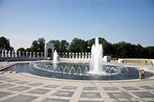*Rainbow Pool*

depicting not only specific battles but also the war effort at home, with titles such as "shipbuilding" and "women in military".

In the center of the plaza is the "Rainbow Pool" with its attractive circle of fountains. Flagpoles frame the entrance to the memorial and bases of granite and bronze are adorned with the military service seals of the Army, Navy, Marine Corps, Army Air Forces, Coast Guard and Merchant Marine. Ramps emerge from the entrance and lead around the plaza, accommodating handicapped visitors.

The 9-foot-high (3m) Freedom Wall, decorated with 4,043 gold stars, completes the picture and commemorates those who lost their lives in the war, with one star for each 100 soldiers who died.

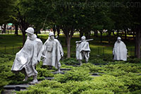 **Korean War Memorial**

1. The statues are 14 Army soldiers, 3 Marines, 1 Navy, and 1 Air Force
2. 3 of the statues are in the trees
3. The wall that runs along the memorial measures 164 feet long
4. There is a plaque in the memorial that reads ‘freedom is not free”
5. more than 54,000 died. It’s been called the “Forgotten War”;
6. In 1988, a 2-acre site on the Mall was claimed as a memorial to the Korean War.
7. Frank Gaylord, a sculptor (and World War Two veteran) from Clarksburg, West Virginia, created the 19 stainless steel statues (about 7ft tall each).
8. The granite mural was crafted by Louis Nelson, a New York City designer.
9. The $18 million memorial was funded by private contributions.
10. The groundbreaking ceremony was held in 1992, with President George Bush in attendance.
11. The memorial includes the words: “Freedom is not free.”

**Detailed notes:** A plaque in front of the Korean War Veterans Memorial reads “Our nation honors her sons and daughters who answered the call to defend a country they never knew and a people they never met.” Dedicated on July 27, 1995 by President Bill Clinton and South Korean President Kim Young Sam, the memorial honors the 1.5 million Americans who served in the Korean War.

The structure consists of a circle intersected by a triangular wall. The wall is sandblasted with 2,500 photographic images of troops from the land, sea, and air, who fought in the Korean War. Nineteen stainless steel soldiers adorn the triangle, each one over seven feet tall. At night, lights shine on the statues casting shadows on the wall for a total 38…representing the 38th parallel.

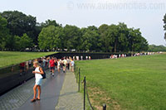 **Vietnam Wall**

**The Vietnam Veterans Memorial honors the men and women who served in the Vietnam War.**

1. There are 58,320 names on the wall as of May 2018.
2. Names are arranged by date of death or when they were declared MIA
3. First casualty was Richard Fitzgibbon June 8, 1956. His son is also on the wall.
4. There are three sets of fathers and sons on the wall.
5. There are 31 sets of brothers on the wall
6. 8 thousand 283 of the soldiers on the wall were just 19 years old
7. 33 thousand 103 were 18 years old
8. 12 soldiers were 17 years old
9. 5 soldiers on the wall were 16 years old
10. Youngest name on the wall is PFC Dan Bullock, he was 15 years old.
11. Eight women are on the wall (nurses)
12. 997 were killed on their first day in Viet Nam
13. 1448 were killed on what was to be their last day in Viet Nam
14. 244 soldiers were awarded the Medal of Honor, 153 are on the wall.
15. Most deaths on one day was 245 (Tet Offensive) Jan 31, 1968
16. Most deaths in one month was 2415, May 1968

**Detailed notes:** The V-shaped wall is located in the Constitution Gardens. One end of the wall points to the Washington Monument while the other points to the nearby Lincoln Memorial.

Design Competition

The construction of a memorial was approved by Congress in 1980 as a result of campaigns by Vietnam Veterans. The project was financed privately; the necessary funds were collected by the Vietnam Veterans Memorial Fund. They announced a national competition for the design of the memorial.  
One of the 1421 entries in the competition was submitted by Maya Ying Lin, a 20 year old student at Yale University. Her design was the result of an earlier class assignment. She only received a B grade on the assignment, but a jury of architects and sculptors unanimously selected her design.

**The Wall**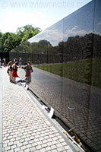

Lin's design was very simple: two black triangular granite walls are sunk into the ground at an angle of 125 degrees. Each wall is 250ft or 76m long. Both walls start at a height of 8 inches (20cm) and meet at their highest point where the walls are 10ft (3m) high. Inscribed in the wall are the names of more than 58,000 men and women who were killed in the Vietnam War or who are still missing in action. A diamond next to the name indicates the person was killed, a cross indicates the person is missing. If a body is identified, the cross is circled.

Controversy

The austere design of the memorial, a scar in the earth, was controversial. Some Vietnam Veterans opposed the design which lacked

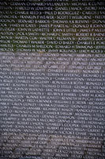

statues or an American flag. To silence the critics, a group of statues was erected near the Vietnam memorial in 1984, two years after the wall was dedicated. Over time, people started to better understand the powerful image of the wall. The cleavage in the earth symbolizes the country divided over the Vietnam War, while the seemingly endless list of names visualizes the many sacrifices that were made better than any traditional monument could have done.

In 1993 another sculpture, depicting three women and a wounded soldier, was added to the Vietnam Memorial. It honors the women who served in the Vietnam War.

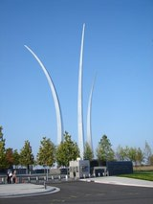 **Air Force Memorial**

1. The design of the memorial symbolizes flight, the spires are 270 feet high made of ¾ inch stainless steel plate with a core of reinforced concrete.
   1. The three spires, dispersing in a “bomb burst” maneuver, represent the contrails of the Air Force Thunderbirds.
   2. The three spires that constitute the memorial signify the three core values of the Air Force: integrity first, service before self, and excellence in all that is done.
2. Dedicated: 14 October 2006 President George W. Bush delivered the keynote speech
3. Path of 9-11 plane that hit the Pentagon went right over the memorial. It was under construction and if it had been finished, the plane probably could not have hit the Pentagon.
   1. Took out the radio tower on the hotel roof behind the memorial
4. It cost $30 million to construct the Air Force Memorial mainly through private funds
5. It overlooks the Pentagon and Washington DC
6. Designed by: James Ingo Freed (Pei Cobb Freed & Partners)
7. The Air Force “star”, embedded in granite, lies beneath the three spires as the rank insignia of every enlisted member of the Air Force.
8. To the south of the memorial, four 8-foot bronze statues of the memorial’s Honor Guard stand tall. These statues were sculpted by the renowned figurative sculptor, Zenos Frudakis.
9. Two inscription walls, 56 feet long 10 feet high and 1 foot thick, stand at each end of the central lawn. Made from polished, high-reflective monolithic Jet Mist granite, both the walls have a 2.5 inch outer inscription panel made from Absolute Black Granite.
   1. While the north wall denotes the names of Air Force recipients of the Medal of Honor, the south wall has high inspirational quotes on core values.
10. The memorial attracts more than 200,000 visitors throughout the year.
11. **Trip leader notes:**
    1. **Restrooms located behind memorial**
    2. **Risers located near restrooms for the group picture**

**Detailed notes:** The memorial is dedicated to the men and women who served and sacrificed their lives in the United States Air Force and its predecessor organizations, such as the Aeronautical Division, U.S. Signal Corps; the Aviation Section, U.S. Signal Corps; the Division of Military Aeronautics, Secretary of War; the Army Air Service; the U.S. Army Air Corps; and the U.S. Army Air Forces.

The US Air Force Memorial honors the 54,000 airmen who died while serving in the US Air Force and other historical service arms of the military.

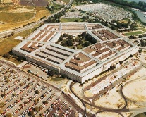 **Pentagon**

1. The halls of the Pentagon are 17.5 miles in total length
2. The pentagon houses offices for the Army, Navy, Air Force and Marine Corps, also the Secretary of Defense
3. It is actually located in Arlington, VA but has a DC zip code
4. It is 29 acres- one of the largest office buildings in the world
5. Three times the volume of the Empire State building.
6. There are 16 parking lots that accommodate 8,770 cars
7. It was built by the US Army engineers between 1941 and 1943.
8. It has 131 stairways, 4,200 clocks and 691 water fountains
9. Different colored granite indicates where 9-11 plane hit
10. Benches in front represent those killed on 9-11
    1. Benches that face towards building represent those killed on the plane
    2. Benches facing away from the building represent those killed in the building.

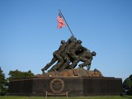 **Iwo Jima Memorial**

1. Is actually the U. S. Marine’s Memorial (often called the Iwo Jima Memorial)
2. The memorial is 32 feet tall
3. The flagpole is 60 feet long
4. President Eisenhower dedicated the memorial in 1951
5. President Kennedy decreed that a flag fly on the memorial 24 hours a day.
6. The base is made of granite and the statues of bronze
7. Of the 6 original flag raisers, only 3 survived the war
8. 5 Marines and one Navy corpsman
9. Iwo Jima is considered one of the deadliest battles of all time.
10. **Trip leader notes:** 
    1. **Not good for restrooms, (just porta potties)**
    2. **Very dangerous and uneven walks and steps.**

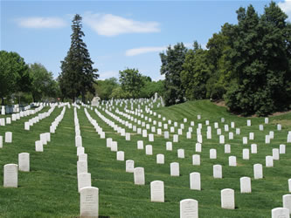 **Arlington Cemetery**

**Arlington House/ Custis Lee Mansion**

1. Built in 1802
2. Belonged to Lee family. Lee left in 1861 to command Confederacy and never returned.
3. Union Army confiscated the property during the civil war.
4. To upset the Lees, the Union started burying Union soldiers on the property.
5. Pvt. William Christman was the first soldier buried here.
6. One of Lee’s slaves, James Parks, helped bury the dead and is buried there as well. He is the only person who lived on the property to be buried there
7. After the war, the Lee family sued the government to get the property back and won and later sold the property back to the government for $150,000.

**The Women in Military Service for America Memorial,** located at the Ceremonial Entrance to Arlington National Cemetery, is a unique, living memorial honoring all military women - past, present and future - and is the only major national memorial honoring women who have served in our nation's defense during all eras and in all services. Work on the Memorial was in progress for about 11 years and it was dedicated October 18, 1997. To date approximately 2.5-3million women have served in US Armed Forces.

**Arlington Cemetery**

1. cemetery spans 624 acres
2. More than 300,000 people are buried in Arlington
3. There are approximately 4 million visitors each year
4. Only military cemetery to hold soldiers from every US war. Veterans from all the nation’s wars are buried here from the American Revolution through Iraq and Afghanistan
5. Three WW2 enemy combatants are buried in Arlington, died in US and Geneva convention required proper burial
6. There are approximately 6900 burials each year, about 28 per day
7. President Kennedy, Robert and Ted Kennedy and President Taft are buried there
8. Audie Murphy is buried here, one of the most decorated soldiers of WW Two
9. Glen Miller is buried in the cemetery- a US army major and famous band leader
10. Omar Bradley and the remains of the space shuttle Challenger are buried here also.
11. Any honorably discharged veteran is eligible to be buried and there are some special exceptions for non-veterans such as spouses, children and dignitaries.
12. Memorial Day - "Flags-in"
    1. Each year for the past 40+ years, the 3rd U.S. Infantry (The Old Guard) has honored America's fallen heroes by placing American flags before the gravestones and niches of service members buried at both Arlington National Cemetery and the U.S. Soldier's and Airmen's Home National Cemetery just prior to Memorial Day weekend.
    2. This tradition, known as "flags in," has been conducted annually since The Old Guard was designated as the Army's official ceremonial unit in 1948. Every available soldier in the 3rd U.S. Infantry participates.
    3. During an approximately three-hour period, the soldiers place flags in front of more than 265,000 graves. The flags are placed one boot length from the center of the base of the headstone. Old Guard soldiers remain in the cemetery throughout the weekend, ensuring that a flag remains at each gravestone.
    4. American flags are also placed at the graves of each of the four unknown service men interred at the Tomb of the Unknowns, by the Tomb Sentinels. All flags are removed after Memorial Day before each cemetery is opened to the public.
13. Sea Bee Memorial - The official memorial for the U.S. Navy Seabees/Civil Engineer Corps honors past, present and future Navy Seabees.  (located along Memorial Dr between the cemetery entrance and the roundabout before the river).
14. **Trip leader notes:**
    1. **There are restrooms, but there are steps involved**
    2. **All Vets should take a wheelchair as that ensures them “front row” viewing of the changing ceremony**

**The Tomb of the Unknowns –**

1. Has remains of WWII and Korea inside and until 1998 Vietnam, when DNA was used to identify the soldier, and his remains were removed.
2. Guarded by Company E of the 3rd U.S. Infantry known as “The Old Guard” 24 hours a day, 365 days a year in any weather and has been since 1937.
3. The Guard is changed every 30 minutes during the summer (April 1 to Sep 30) and every hour during the winter. During the hours the cemetery is closed, the guard is changed every 2 hours.

**Changing of the Guard:**

1. The Relief Commander appears to announce the changing of the guard.
2. The new sentinel leaves the quarters and unlocks the bolt of their rifle to signal the start of the ceremony.
3. The Relief Commander walks out, salutes the tomb and then faces the crowd and asks them to stand and remain silent during the ceremony.
4. Ceremony is not for show, they are actually inspecting rifle and uniform
5. Once the inspection is complete, the Commander and new sentinel walk to join the sentinel being relieved. All there salute the tomb.
6. Drill includes 21 steps and 2-21 second pauses flowed by 21 steps in the opposite direction alluding to a 21 gun salute. This is repeated until the sentinel is relieved.
7. The sentinel always carries their rifle on the shoulder away from the tomb to signal they are ready to defend against any threat.
8. When not walking, the guards clean their weapon, study cemetery history and help the others in their relief prepare.

**The Old Guard:**

1. Guards must be in superb physical condition, between 5’10” (5’8” for females) and 6’4” and have proportionate weight and build.
2. Each volunteer is interviewed and undergoes a two week trial to determine their capability to train as tomb guard. They memorize 7 pages of Arlington history and it must be recited exactly to earn a “walk”.
3. If the soldier passes the trial, they begin formal training which includes learning the location of nearly 300 veterans buried in Arlington. They learn the guard changing ceremony and the manual of arms.
4. The sentinel will be tested to earn the silver Tomb Guard Identification badge which is temporary. After serving honorably for nine months, the badge is made permanent and can be worn the rest of their military career. This is one of the rarest badges soldiers can wear. Only the astronaut badge is rarer.
5. This service is known as “walking the mat”
6. The sentinels are arranged in 3 reliefs according to height. They serve 24 hours shifts alternating off and on and have 4 days off after the third day on.
7. Each Relief has a 24 hour rotational work day. Ideally, four qualified Sentinels, one Relief Commander (RC), one Assistant Relief Commander (ARC), and several Sentinels in training comprise the Relief. The daily walk schedule is made by the RC or ARC and is dependent on the number of Sentinels who are proficient enough to guard the Tomb in front of the public. Generally, the Sentinel will do several walks back to back and then be done for the day. However, in extreme cases, Sentinels have been known to go back-to-back (every other walk) for the entire shift.
8. There have been four females who have earned the Tomb badge.
9. Typically a sentinel serves 18 months; however there is no set time.
10. The shoes are specially made with very thick soles to keep the heat and cold from their feet. There are metal heel plates that extend to the top of the shoe in order to make the loud click as they come to a halt. There are no wrinkles, folds or lint on the uniform. Guards dress for duty in front of a full-length mirror.

**The Sentinels Creed:**

**My dedication to this sacred duty is total and wholehearted. In the responsibility bestowed on me never will I falter. And with dignity and perseverance my standard will remain perfection. Through the years of diligence and praise and the discomfort of the elements, I will walk my tour in humble reverence to the best of my ability. It is he who commands the respect I protect. His bravery that made us so proud. Surrounded by well meaning crowds by day alone in the thoughtful peace of night, this soldier will in honored glory rest under my eternal vigilance.**

The Third Infantry Regiment at Fort Myer has the responsibility for providing ceremonial units and honor guards for state occasions, White House social functions, public celebrations and interments at Arlington National Cemetery and standing a very formal sentry watch at the Tomb of the Unknowns. They guard the tomb 24/7 regardless of weather.

**The tomb**

* consists of seven pieces of rectangular marble

1. Carved on the East side (the front of the Tomb, which faces Washington, D.C.) is a composite of three figures, commemorative of the spirit of the Allies of World War I.
2. In the center of the panel stands Victory (female).
3. On the right side, a male figure symbolizes Valor.
4. On the left side stands Peace, with her palm branch to reward the devotion and sacrifice that went with courage to make the cause of righteousness triumphant.
5. The north and south sides are divided into three panels by Doric pilasters. In each panel is an inverted wreath.
6. On the west, or rear, panel (facing the Amphitheater) is inscribed: HERE RESTS IN HONORED GLORY AN AMERICAN SOLDIER KNOWN BUT TO GOD

* The first Tomb of the Unknown Soldier was a sub base and a base or plinth. It was slightly smaller than the present base. This was torn away when the present Tomb was started Aug. 27, 1931. The Tomb was completed and the area opened to the public at 9:15 a.m. April 9, 1932, without any ceremony.
* Cost of the Tomb: $48,000 Sculptor: Thomas Hudson Jones Architect: Lorimer Rich Contractors: Hagerman & Harris, New York City
* The marble for the Tomb of the Unknowns was furnished by the Vermont Marble Company of Danby, Vt. The marble is the finest and whitest of American marble, quarried from the Yule Marble Quarry located near Marble, Colorado and is called Yule Marble. The Marble for the Lincoln memorial and other famous buildings was also quarried there.

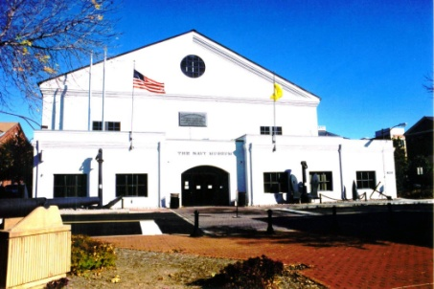 **The National Museum of the U.S. Navy**

* The U.S. Navy Museum was established in 1961 and opened to the public in 1963. As one of 15 Navy museums throughout the country, it is the only one that presents an overview of [U. S. naval history](https://en.wikipedia.org/wiki/History_of_the_United_States_Navy).
* It is located inside the Washington Navy Yard
* Permanent and temporary exhibitions commemorate the Navy's [wartime](https://en.wikipedia.org/wiki/War) heroes and [battles](https://en.wikipedia.org/wiki/Battle) as well as its [peacetime](https://en.wikipedia.org/wiki/Peace) contributions in exploration, [diplomacy](https://en.wikipedia.org/wiki/Diplomacy), [space flight](https://en.wikipedia.org/wiki/Space_flight), [navigation](https://en.wikipedia.org/wiki/Navigation) and [humanitarian](https://en.wikipedia.org/wiki/Humanitarian) service.
* Known for 40 years as the flagship museum of the U.S. Navy, The U.S. Navy Museum celebrates a legacy of educating the public. In the tradition of its predecessors on the Washington Navy Yard beginning in 1865, the current museum features a collection that dates from 1800.
* The museum's collection moved twice before Admiral Arleigh Burke established the current museum, Building 76, in 1963 to create an American [naval history museum](https://en.wikipedia.org/wiki/Maritime_museum) comparable to those in Europe. The U.S. Navy Museum continues to embody Burke's vision of sharing the Navy's history and traditions with the world.
* Permanent exhibits include (in building 67):
  + **Dive! Dive! U.S. Navy Submarines**
  + **The American Revolution and the French Alliance**
  + **The Forgotten Wars of the Nineteenth Century**
  + **Civil War**
  + **Spanish-American War**
  + **Polar Exploration**
  + **Navigation**
  + **U.S. Navy in World War I**
  + **In Harm's Way, The Navy in World War II**
    - The Atlantic Theater. This exhibit details convoy protection, the capture of [U-505](https://en.wikipedia.org/wiki/German_submarine_U-505), the breaking of the [German Enigma code](https://en.wikipedia.org/wiki/Enigma_machine), and the role of the [Merchant Marine](https://en.wikipedia.org/wiki/Merchant_Marine), as well as weapons and equipment used by both sides of the war for Europe. A wide variety of cannon, rifles and sidearms are on display along with a high-altitude flying suit, the diving log of U-505 and the [XAF Radar Receiver](https://en.wikipedia.org/wiki/XAF_Radar) from the battleship [USS New York (BB-34)](https://en.wikipedia.org/wiki/USS_New_York_(BB-34)).
    - The Home Front. Featuring a replica storefront and a small theater showing film from the World War II period, the home front exhibit is decorated with patriotic posters, aircraft-identification models, and personal items. The role of [WAVES](https://en.wikipedia.org/wiki/WAVES) is detailed in the exhibit.
    - The Pacific Theater. The area dedicated to the war in the Pacific dominates the World War II section of the museum, featuring a full-size replica of the bridge of the destroyer [USS Fletcher](https://en.wikipedia.org/wiki/USS_Fletcher_(DD-445)), four gun batteries, an [FG-1D Corsair](https://en.wikipedia.org/wiki/F4U_Corsair), a Japanese [MXY7 Ohka](https://en.wikipedia.org/wiki/Ohka) kamikaze aircraft, two atomic bomb casings, and models of the carrier [USS Leyte (CV-32)](https://en.wikipedia.org/wiki/USS_Leyte_(CV-32)) and battleship [USS Missouri (BB-63)](https://en.wikipedia.org/wiki/USS_Missouri_(BB-63)), each around twenty feet in length.
  + **Korea 1950–53: The Navy in the Forgotten War**
    - Uniforms and equipment, along with videos and other artifacts, bring the often-ignored Korean War into focus. Captured Soviet weapons, models of aircraft and warships and even a chunk of the Inchon seawall are on display.
  + **Cold War Gallery** (in building 70 across the street)
    - The Cold War Gallery will give visitors the chance to see up close what it was like to prepare for and execute high-stakes missions from our aircraft carriers, to stand beside actual weaponry used by both sides in the conflict, and to understand the fascinating strategies and tactics of brinksmanship that defined the era.

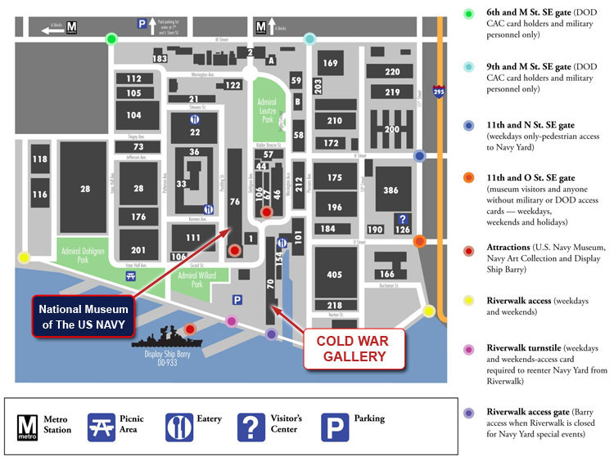

**Bus leader notes: great restrooms here**

**There are 2 buildings; 76 and 70, please make sure everyone is aware**

**More about the Washington Navy Yard:**

* The Washington Navy Yard is the oldest U.S. Navy shore facility. Founded in 1799, on land set aside by George Washington, the Navy Yard first served as a shipbuilding facility.
* During WWI, the Yard housed manufacturing facilities which produced various guns used in the war. Presently, the Navy Yard is home to a variety of activities.
* Navy District Washington functions as the military coordinator for most of the Navy units in the Washington, Northern Virginia and Maryland areas. The Navy Yard has been designated a National Historical Landmark by the National Park Service and features the Navy Museum, the homeport for Navy History.

**-------------------------------------------------------------------------------------------------------------------**

***TWELVE TRIVIAL AND ODD WWII FACTS***

**1.**  **The first German serviceman killed in WW II was killed by the Japanese (China, 1937), The first American serviceman killed, was killed by the Russians (Finland 1940); The highest ranking, American killed was Lt Gen Lesley McNair, killed while in the US Army Air Corps.**  
  
**2.** **The youngest US serviceman was 12 year old: Calvin Graham, USN. He was wounded and given a Dishonorable Discharge for lying about his age.  His benefits were later restored by act of Congress.**  
  
**3.**   **At the time of Pearl Harbor, the top US Navy command was called CINCUS (pronounced “sink us”); The shoulder patch of the US Army's 45th. Infantry division was the swastika.  Hitler's private train was named “Amerika”.  All three were soon changed for PR purposes.**  
  
**4.**   **More US servicemen died in the Air Corps than the Marine Corps. While completing the required 30 missions, an airman's chance of being killed was 71%.**  
  
**5.**  **Generally speaking, there was no such thing as an average fighter pilot. You were either an ace or a target.  For instance, Japanese Ace, Hiroyoshi Nishizawa shot down over 80 planes. He died while a passenger on a cargo plane.**   
  
**6.**  **It was a common practice on fighter planes to load every 5th round with a tracer round to aid in aiming. This was a big mistake.  Tracers had different Ballistics so (at long range) if your tracers were hitting the target 80% of your rounds were missing.  Worse yet tracers instantly told your enemy he was under fire and from which direction.  Worst of all was the practice of loading a string of tracers at the end of the belt to tell you that you were out of ammo. This was definitely not something you wanted to tell the enemy. Units that stopped using tracers saw their success rate nearly double and their loss rate go down.**  
  
**7.**  **When allied armies reached the Rhine, the first thing men did was pee in it.  This was pretty universal from the lowest private to Winston Churchill (who made a big show of it) and Gen. Patton (who had himself photographed in the act).**   
  
**8.**  **German ME-264 bombers were capable of bombing New York City, but they decided it wasn't worth the effort.**  
  
**9.**  **German submarine U-120 was sunk by a malfunctioning toilet.**  
  
**10.** **Among the first 'Germans' captured at Normandy were several Koreans. They had been forced to fight for the Japanese Army until they were captured by the Russians and forced to fight for the Russian Army until they were captured by the Germans and forced to fight for the German Army until they were captured by the US Army.**  
  
**11.** **Following a massive naval bombardment, 35,000 United States and Canadian troops stormed ashore at Kiska, in the Aleutian Islands.  21 troops were killed in the assault on the island.9/11/2019 It could have been worse if there had actually been any Japanese on the island.**   
  
**12.** **The last marine killed in WW2 was killed by a can of spam.  He was on the ground as a POW in Japan when rescue flights dropping food and supplies came over, the package came apart in the air and a stray can of spam hit him and killed him.**