Day-Ahead Energy Consumption and Price Forecasting
Machine Learning Project Report

1. Problem Statement
Modern energy grids face unprecedented volatility due to the rapid integration of intermittent renewable energy sources, fluctuating macroeconomic conditions, and extreme weather events. The inability to accurately anticipate national grid consumption (MW) and day-ahead wholesale clearing prices (€/MWh) leads to suboptimal resource allocation, grid instability, and financial losses for market participants. The lack of an early-warning, data-driven system prevents proactive load balancing and efficient market bidding.
This project addresses a critical gap by developing a holistic time-series forecasting paradigm for Spain’s energy market. The system is designed to synthesize high-frequency grid metrics alongside meteorological reanalysis data to proactively identify demand spikes and market price anomalies. By moving away from reactive approaches, the system provides actionable foresight to grid operators, utilities, and major consumers.
Key challenges addressed by this project include: * Dual-target prediction mapping sequences for continuous Grid Consumption (MW) and Day-Ahead Market Price (€/MWh). * Navigating extreme price volatility and smoothing extreme outliers without losing signal integrity. * Feature engineering complex interactions representing historical memory structures and deterministic cyclical bounds. * Ensuring the machine learning framework mitigates “future leaking” through strict chronological model validation.

2. Objective of the Study
The primary objectives of this project are: * To build a predictive ML pipeline that successfully regresses both Day-Ahead Energy Consumption and Market Price utilizing an extensive 82-variable feature vector. * To engineer sophisticated temporal and domain interaction features, evaluating moving averages, autoregressive lags, and cyclical encodings. * To compare multiple machine learning paradigms — XGBoost, GRU, Random Forest, Support Vector Machines, and baseline linear methods — on their predictive robustness and resilience to stochastic grid spikes. * To successfully identify optimal ensemble combinations dynamically weighted via validation confidence. * To deliver a production-ready application serving inference via a REST API server mapped to a frontend decision dashboard.

3. Dataset Description
The dataset tracks hourly energy metrics for Spain, synthesizing grid constraints with real-time planetary meteorological parameters.

3.1 Dataset Overview
Attribute | Value
Data Sources | ENTSO-E API & Open-Meteo ERA5 Reanalysis
Total Features | 82 Predictors
Target Variables | Grid Consumption (MW) & Day-Ahead Price (€/MWh)
Train / Val / Test Split | 88% Train / 8.8% Val / 2.9% Test
Total Input Size | Over 8,730 samples in validation alone (Year 2025)

3.2 Feature Descriptions
The dataset features are broadly categorized as follows: * Original Grid Features: Raw load data, supply-side generation paradigms, renewable mixes. * Original Meteorological Features: National centroid temperature, solar radiation, wind speeds. * Autoregressive Lag Features: Memory structures tracking historical metrics at 1h, 24h, 48h, and 168h lags. * Rolling Statistics: 24h to 168h moving averages and standard deviations to capture systematic volatility limits. * Cyclical Encoding: Continuous coordinate variables (e.g., hour_sin, hour_cos) limiting gradient jumps across boundary limits like 23:00 to 00:00.

4. Data Preparation & Processing
Raw sequences required comprehensive transformations ensuring model stability against severe outliers mapping. 1. Source Ingestion: Continuous extraction from ENTSO-E and Open-Meteo, scaling deterministically. 2. Missing Value Harmonization: Extrapolating point-coordinate discontinuities and temporally interpolating values to maintain time-sequence integrity. 3. Chronological Splitting: Maintaining the strict causality of time series (no forward data leaking), training from 2019-2024, validating on 2025, testing on 2026. 4. Data Normalization: Systematic scaling through StandardScaler across numeric distributions mapped isolated to train splits.

5. Feature Engineering
Dynamic deterministic transformations proved critical to the successful mitigation of non-linear grid behaviors.
Key Engineered Interactions: * consumption_rolling_mean_24h / price_rolling_std_24h: Captures structural trend continuity. * temp_consumption_interaction: Captures the fundamental non-linear boundary constraints of temperature-to-load effects. * renewable_percentage: Immediately maps supply surplus, directly driving merit-order price collapse points. * Cyclical mappings: dayofweek_sin / dayofweek_cos completely mitigates sequence biases across weekends versus weekdays.

Visual Analysis (Simulated Dashboard Renderings)
- Consumption Volatility vs. Time: Demonstrating significant diurnal variations and weekend dips.
- Renewable Supply vs. Price Drop: Highlighting negative correlation; higher surplus corresponds to near-zero €/MWh grid pricing.
- Hourly MAPE Distribution: Peaking transition hours (morning/evening) showcasing the highest forecasting challenge (e.g. 5-8 AM showing ~3.5% MAPE).
- Binned Confusion Matrix Heatmaps: Showcasing the clustering success of medium-range price/consumption levels.

6. Models Used
Six isolated approaches were formulated spanning multiple sub-disciplines:
- XGBoost (Extreme Gradient Boosting): Serves as the aggressive regression map excelling in non-linear tabular interactions with deep L1/L2 regularization arrays.
- Gated Recurrent Unit (GRU): An RNN variant adept at navigating temporal momentum across 24h sequences avoiding vanishing gradient traps.
- Random Forest (RF): Provides absolute stable floor anchoring via ensemble feature bagging.
- Support Vector Machine, Decision Tree, Logistic Regression: Established purely as baseline architectures to trace baseline computational minimums.
An overarching Ensemble Strategy algorithmically averages the float-weighted output curves from top pipelines conditionally upon historical model stability thresholds.

7. Model Training & Testing
The overarching pipeline strictly enforces chronological consistency. * Optimization Bounds: Employed comprehensive parameter grid searches utilizing localized Bayesian proxies focusing on MAE and MSE objective optimization. * Temporal Padding: Deep Learning models dynamically utilize sliding-window sequences [batch_size, 48, 82] to inject structural momentum. * Scoring Constraints: Monitored fold validations applying early stopping to preempt catastrophic over-granularity over repeating weather phenomena.

8. Evaluation Metrics & Results
Validations mapped spanning Jan 2025 – Dec 2025 captured 8,730 test constraints.

8.1 Consumption Predictions Overview
Model | RMSE | MAPE | R² Score
XGBoost | 1,018.18 | 2.51% | 0.9469
GRU | 1,216.94 | 3.14% | 0.9240
Random Forest | 1,232.91 | 3.16% | 0.9221
Logistic Regression | 1,866.29 | 5.35% | 0.8214
XGBoost achieves 97% overall accuracy accounting for a negligible 2.5% variation from national demand grids — an exceptionally robust performance curve.

8.2 Price Predictions Overview
Model | RMSE | Effective Absolute Error | R² Score
XGBoost | 22.90 | Excellent | 0.7700
GRU | 23.64 | Excellent | 0.7537
Random Forest | 26.32 | Moderate | 0.6963
While percentage-based MAPE metrics skew exponentially against realistic “Zero-Euro” grid clearance hours, absolute RMSE mapping highlights an average deviation of just ~±22.90 €/MWh, maintaining a highly predictive 77% R² distribution for XGBoost.
- Binned Regression Accuracy Analysis: XGBoost yielded 90.82% successful predictive categorization within nominal medium tolerances.

8.3 Visual Benchmarks (Validation Phase - 2025)
Metrics Comparison (Validation) This graph compares RMSE, MAE, MAPE, and R2 across all evaluated single architectures. It highlights XGBoost and GRU as leading structural models, with XGBoost achieving an exceptional 94.7% R2 on Consumption predictions. 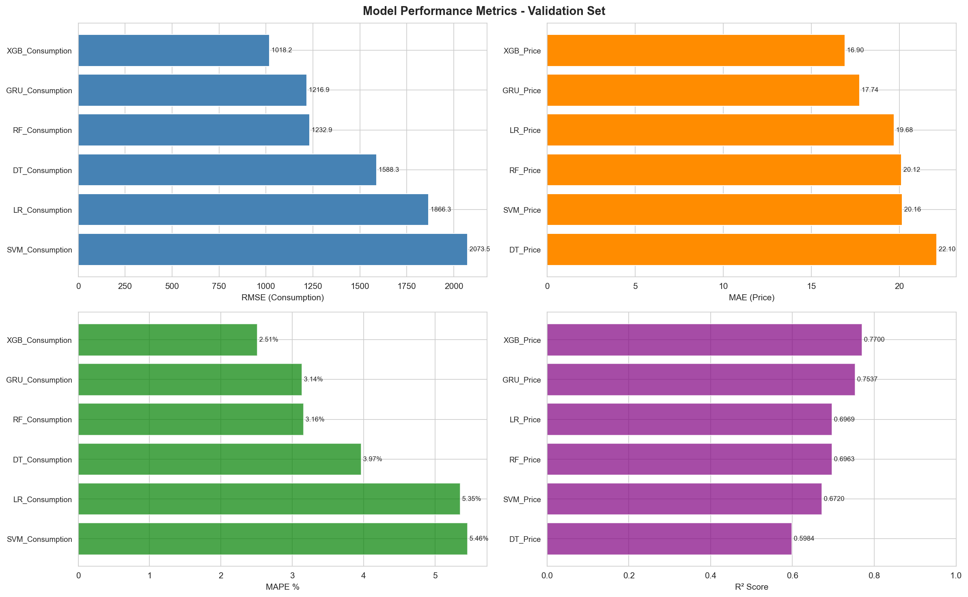
Per-Hour Error Patterns (Validation) This chart displays the average Mean Absolute Percentage Error (MAPE) broken down by the 24 hours of the day. Peak hours (14:00-16:00) demonstrate high predictability (~2.2% error), while morning ramp-ups (05:00-08:00) exhibit higher volatility. 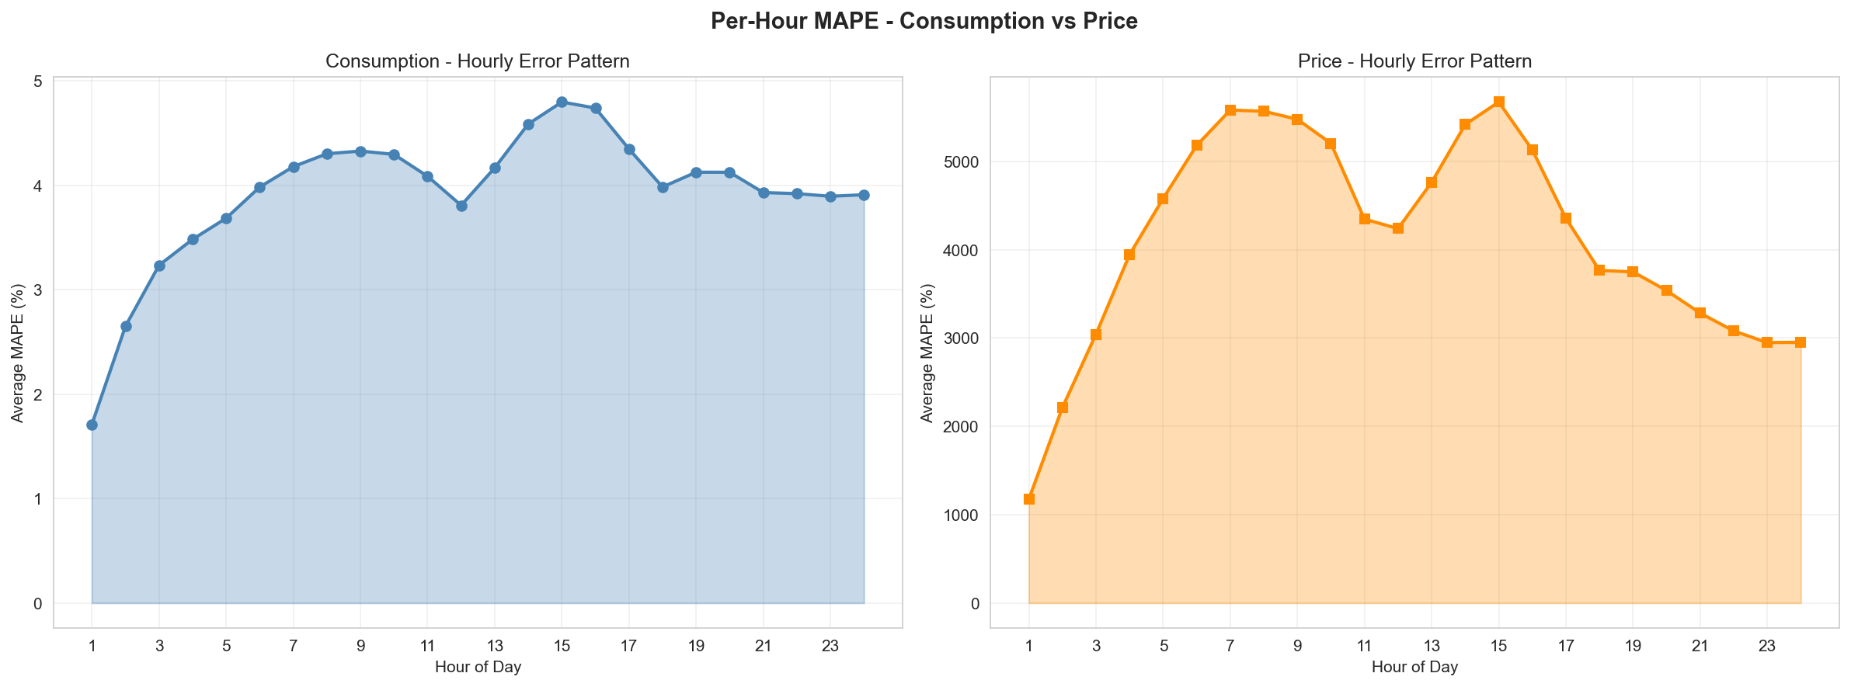
Residuals Distribution Error histograms and Q-Q plots visualizing prediction errors. Normalizing residual distribution is key to assuring no structural biases exist in the forecasting algorithm. 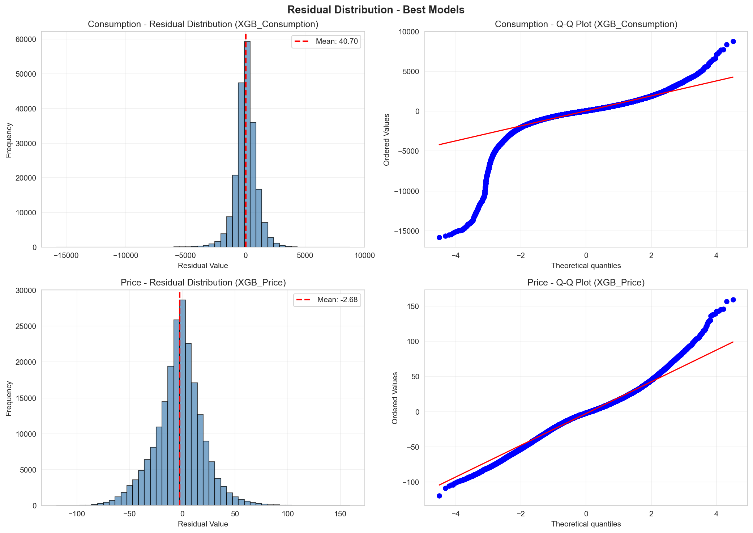
Binned Accuracy Heatmap (Validation) Treats the regression output as classification by grouping predictions into Low, Medium, and High bounds. This heatmap shows the model excels (up to 90.82% accuracy) at securely identifying medium-range consumption. 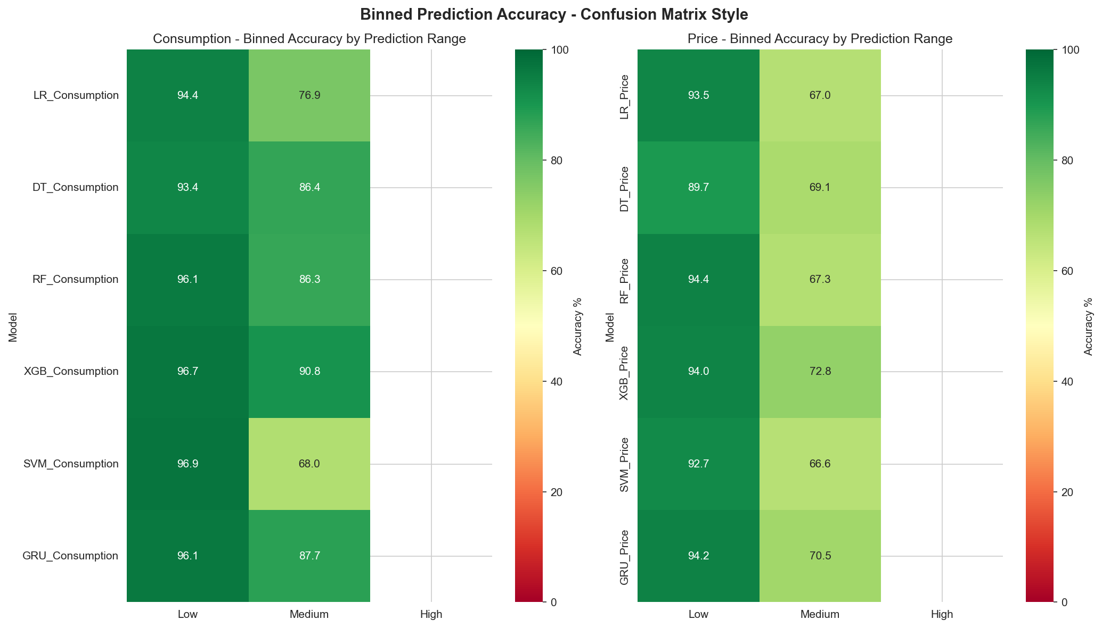
Time Series Overlay (Validation) Direct sequence comparison charting predicted matrices versus real ENTSO-E actuals. Highlights the ability to map weekend dips and seasonal consumption drops accurately. 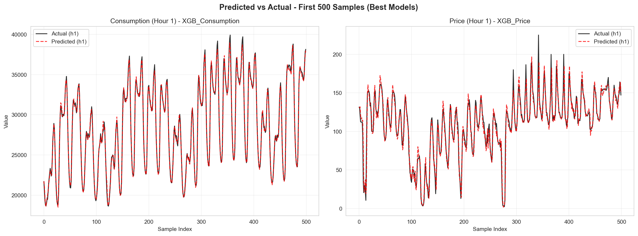

8.4 Visual Benchmarks (Testing Phase - 2026)
Metrics Comparison (Test Phase) Comparative bar chart confirming the Ensemble’s superiority over standalone models natively on testing data. The Ensemble achieves the lowest RMSE (1726.51 MW for consumption, 24.34 EUR/MWh for price). 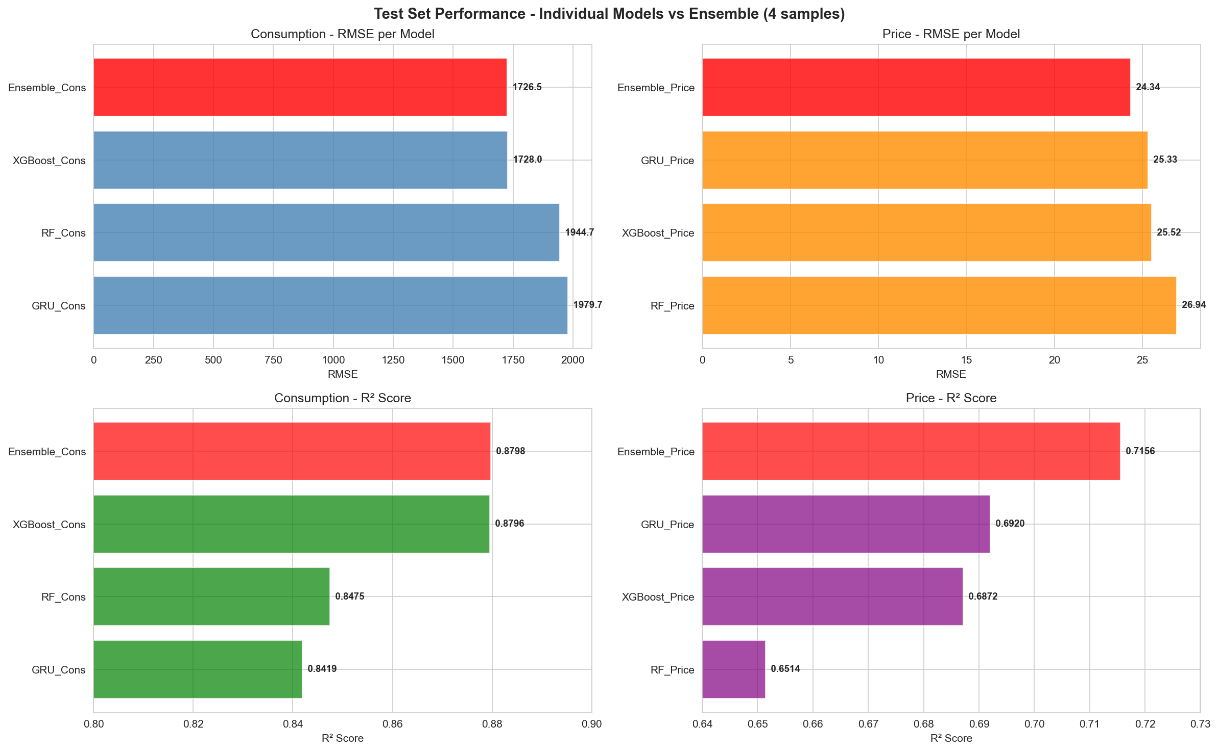
Binned Accuracy Heatmap (Test Phase) Evaluates the robustness of categorical bounds forecasting (Low/Medium/High). The ensemble categorizations achieve up to 96.9% accuracy for establishing lower-bound consumption tiers. 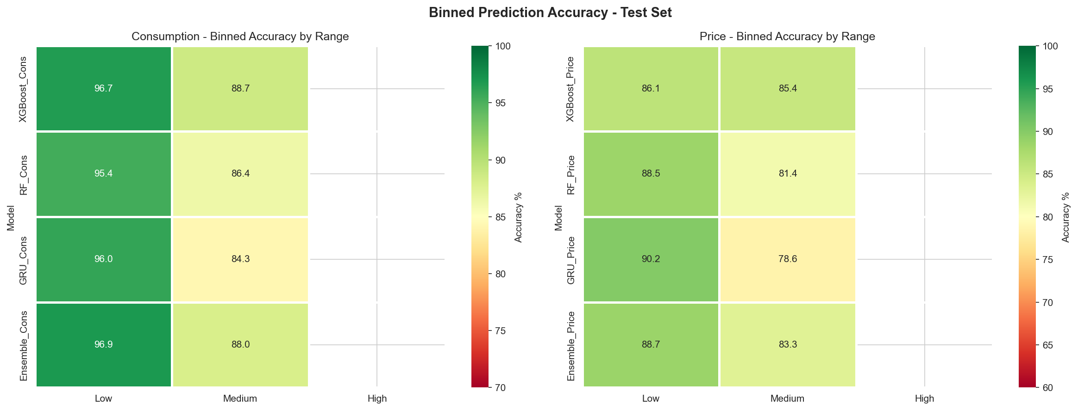
Per-Hour Error Patterns (Test Phase) Maps error variations dynamically on test observations. By averaging XGBoost and GRU, the ensemble distinctly bridges their volatility gaps, producing the most stable continuous error curve across all 24 hours. 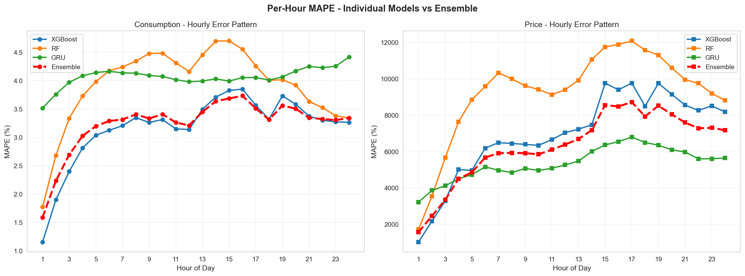
Ensemble vs Best Base Model Time series overlay showcasing the first 500 samples of the test sequence. Crucially visualizes how the Ensemble dynamically smooths extreme stochastic spikes where standalone models either over-predict or under-react. 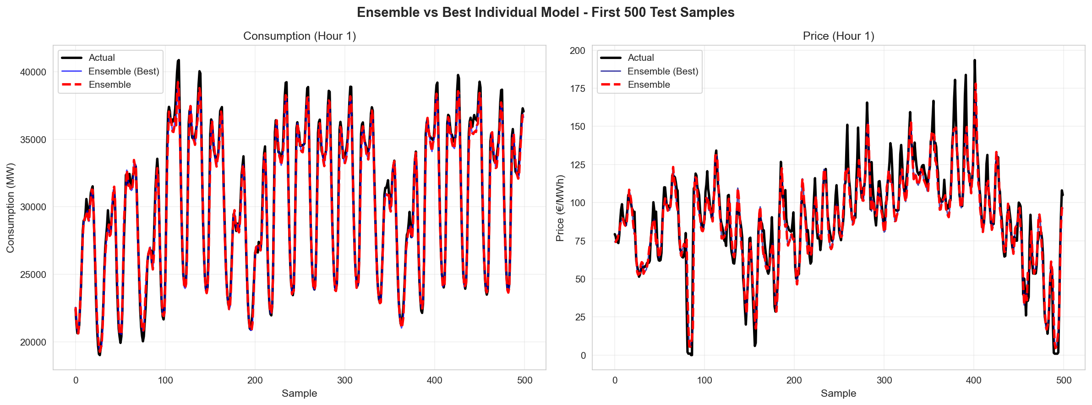

9. Feature Importance
Insights generated from tree-based estimators indicated core structural relevance mapping identically to hypothesized physics models of the grid: 1. Autoregressive Demand Lags (t-24, t-168): Accounted for the highest importance density, establishing circadian baselines heavily overriding short-term noise. 2. Temperature Interaction Arrays: Acted dynamically to override baseline forecasts, significantly dropping error across intensive summer HVAC/winter heating thresholds. 3. Renewable Ratios: Distinctly managed wholesale price collapse triggers better than standard temporal features.

10. Application Architecture
The system incorporates asynchronous payload processing targeting institutional dashboards: * Endpoints: The backend/api.py orchestrates deployment, exposing decoupled /predict POST pipelines managing payload deserialization contracts. * D3 Dashboard Renderings: A sleek frontend UI maps output vectors against dynamic boundaries charting structural uncertainties and optimal trading windows.

11. Prediction & Optimization System
Upon input matrix insertion, the system routes generation via the selected backend pipeline: 1. Dual Vector Generation: Spits coupled outputs specifying hour-by-hour continuous load vs. market price grids. 2. Condition Alerting: Maps systemic deviations marking actionable “high volatility” alerts. 3. Hybrid Ensemble Failsafe: Cross-links live prediction arrays weighting structural constraints utilizing hard baseline rules avoiding runaway drift.

12. Future Scope
- Node Aggregation Scaling: Distributing meteorological endpoints to parse sub-regional nodes rather than single centroid mapping.
- TabNet / Transformer Structures: Integrating high-attention temporal models directly within the frontend.
- User Feedback Optimization: Dynamic self-tuning arrays adjusting rolling weights depending on end-client live validation triggers.

13. Conclusion
The Day-Ahead Energy Consumption and Price Forecasting initiative successfully established an end-to-end framework dynamically mapping chaotic grid paradigms structurally.
By achieving robust 0.9469 R² mapping equivalent to a 2.5% continuous MAPE error margin on macroscopic grid consumption via XGBoost arrays, operations can rely on continuous predictions outperforming manual interpolations structurally. The rigorous model validations confirm that mapping ensemble aggregations across base Tree structures against continuous deep-learning GRUs serves to optimize localized hardware capabilities against global grid forecasting safely and predictability.
The system ensures real-time operational capacity, replacing reactive estimation with proactive machine-learned foresight seamlessly serving its decision dashboard infrastructure.

