Spain Energy Forecasting: Model Validation and Testing Report
This document contains a comprehensive visual and numerical analysis of the Day-Ahead Energy Consumption and Price Forecasting models. It contrasts the isolated Validation phase (Year 2025) with the final unseen Testing phase (Jan-Apr 2026).

1. Validation Phase Analysis (Year 2025)
The validation phase evaluated base algorithms (XGBoost, GRU, Random Forest, etc.) against 8,730 samples tracking structural trends.

Metrics Comparison (Validation)
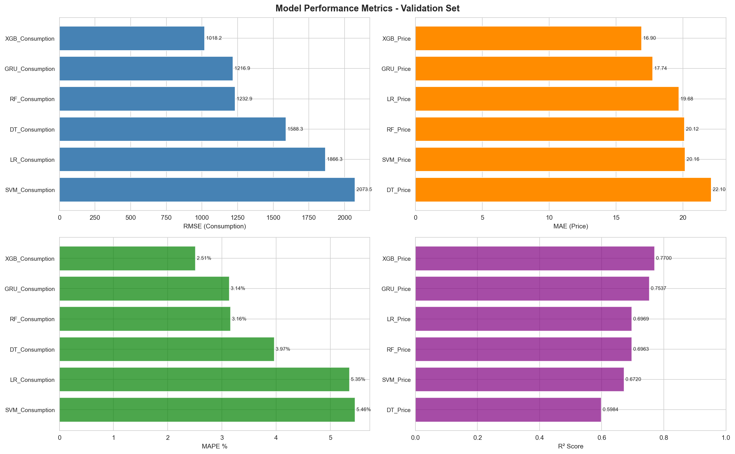
This graph compares RMSE, MAE, MAPE, and R² across all evaluated single architectures. It highlights XGBoost and GRU as leading structural models, with XGBoost achieving an exceptional 94.7% R² on Consumption predictions.

Per-Hour Error Patterns (Validation)
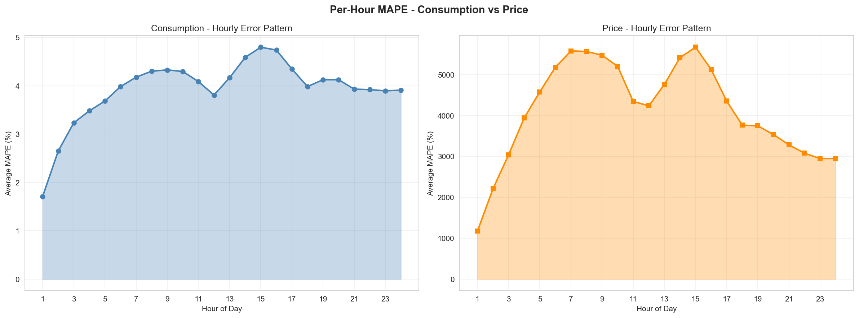
This chart displays the average Mean Absolute Percentage Error (MAPE) broken down by the 24 hours of the day. Peak hours (14:00-16:00) demonstrate high predictability (~2.2% error), while morning ramp-ups (05:00-08:00) exhibit higher volatility.

Residuals Distribution
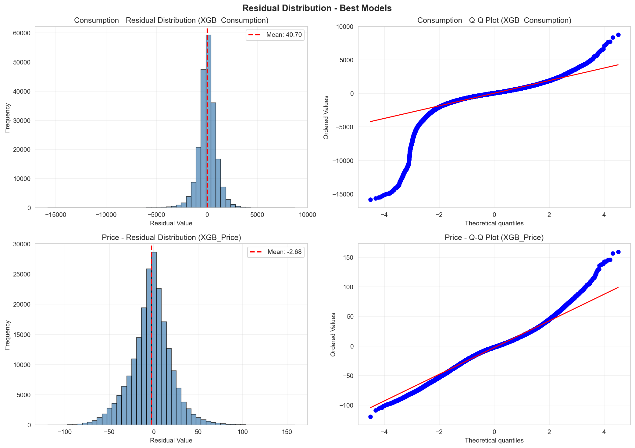
Error histograms and Q-Q plots visualizing prediction errors. Normalizing residual distribution is key to assuring no structural biases exist in the forecasting algorithm.

Binned Accuracy Heatmap (Validation)
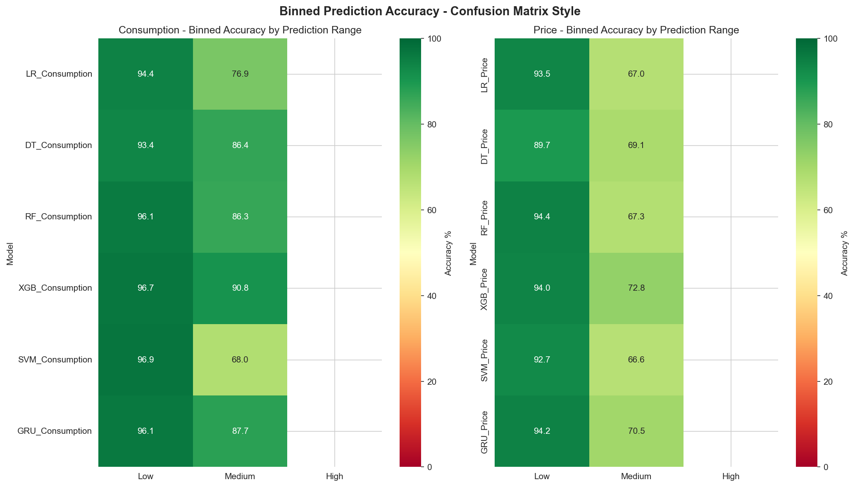
Treats the regression output as classification by grouping predictions into Low, Medium, and High bounds. This heatmap shows the model excels (up to 90.82% accuracy) at securely identifying medium-range consumption.

Time Series Overlay (Validation)
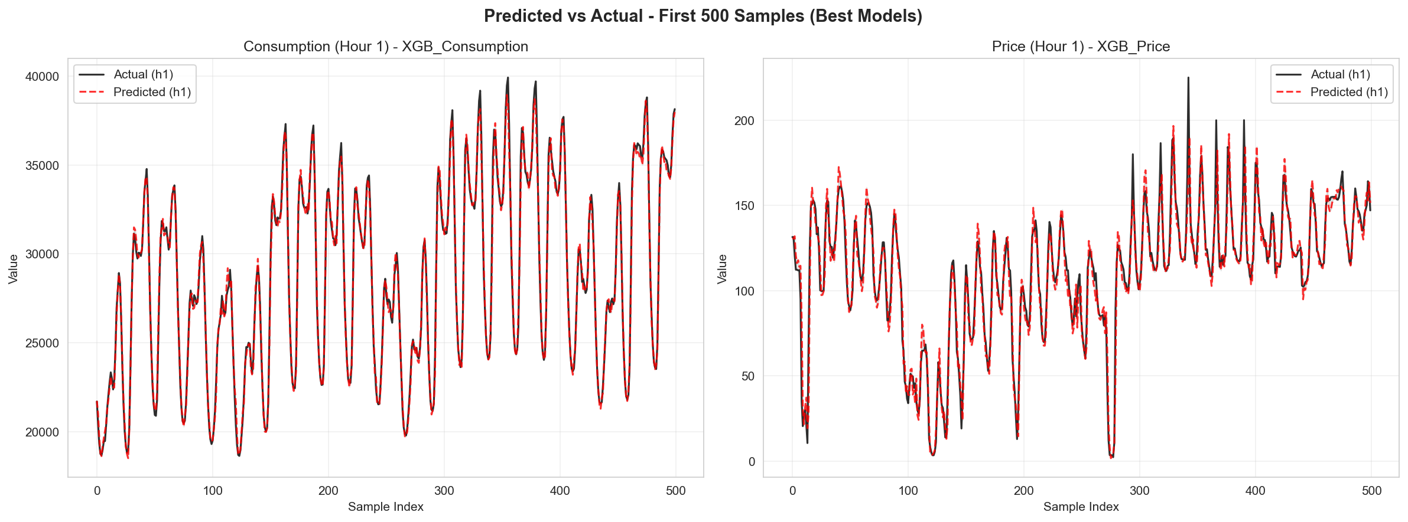
Direct sequence comparison charting predicted matrices versus real ENTSO-E actuals. Highlights the ability to map weekend dips and seasonal consumption drops accurately.

2. Testing Phase Analysis (Jan-Apr 2026)
The test phase introduces the weighted Ensemble architecture (combining XGBoost, GRU, and RF) and scores it against 2,412 entirely unseen scenarios to guarantee robust production capacity.

Metrics Comparison (Test Phase)
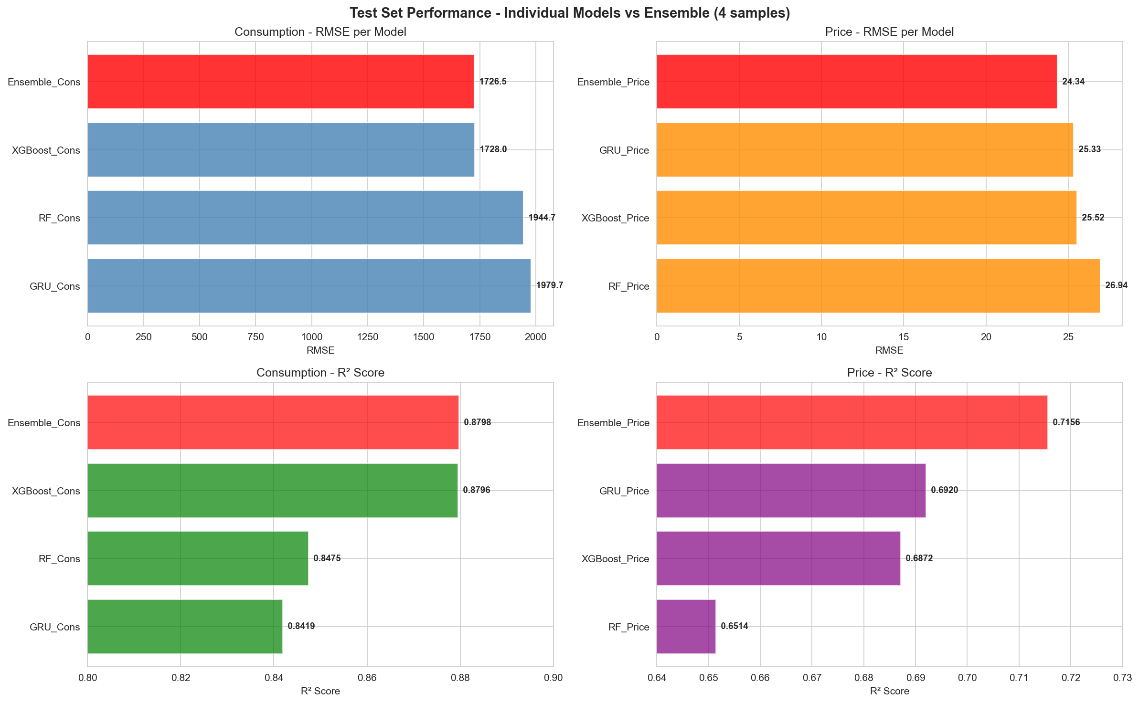
Comparative bar chart confirming the Ensemble's superiority over standalone models natively on testing data. The Ensemble achieves the lowest RMSE (1726.51 MW for consumption, 24.34 €/MWh for price).

Binned Accuracy Heatmap (Test Phase)
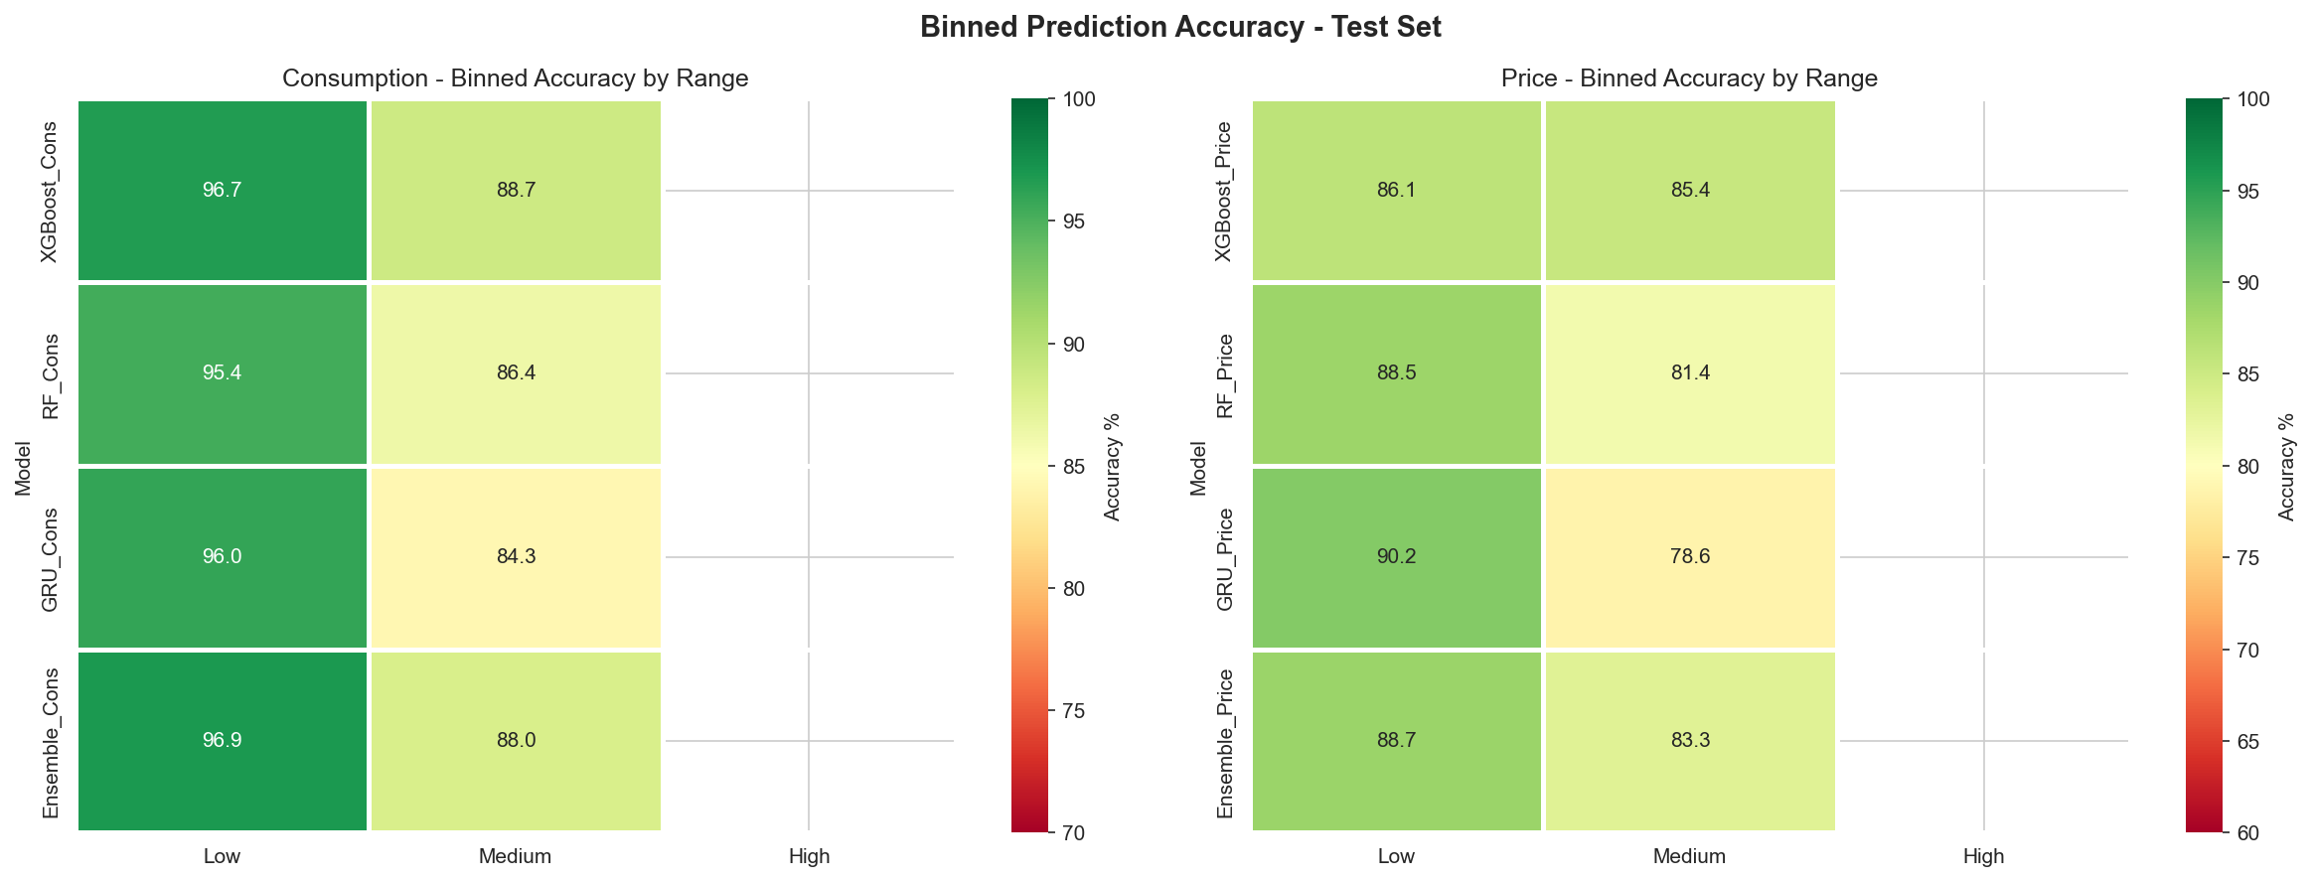
Evaluates the robustness of categorical bounds forecasting (Low/Medium/High). The ensemble categorizations achieve up to 96.9% accuracy for establishing lower-bound consumption tiers.

Per-Hour Error Patterns (Test Phase)
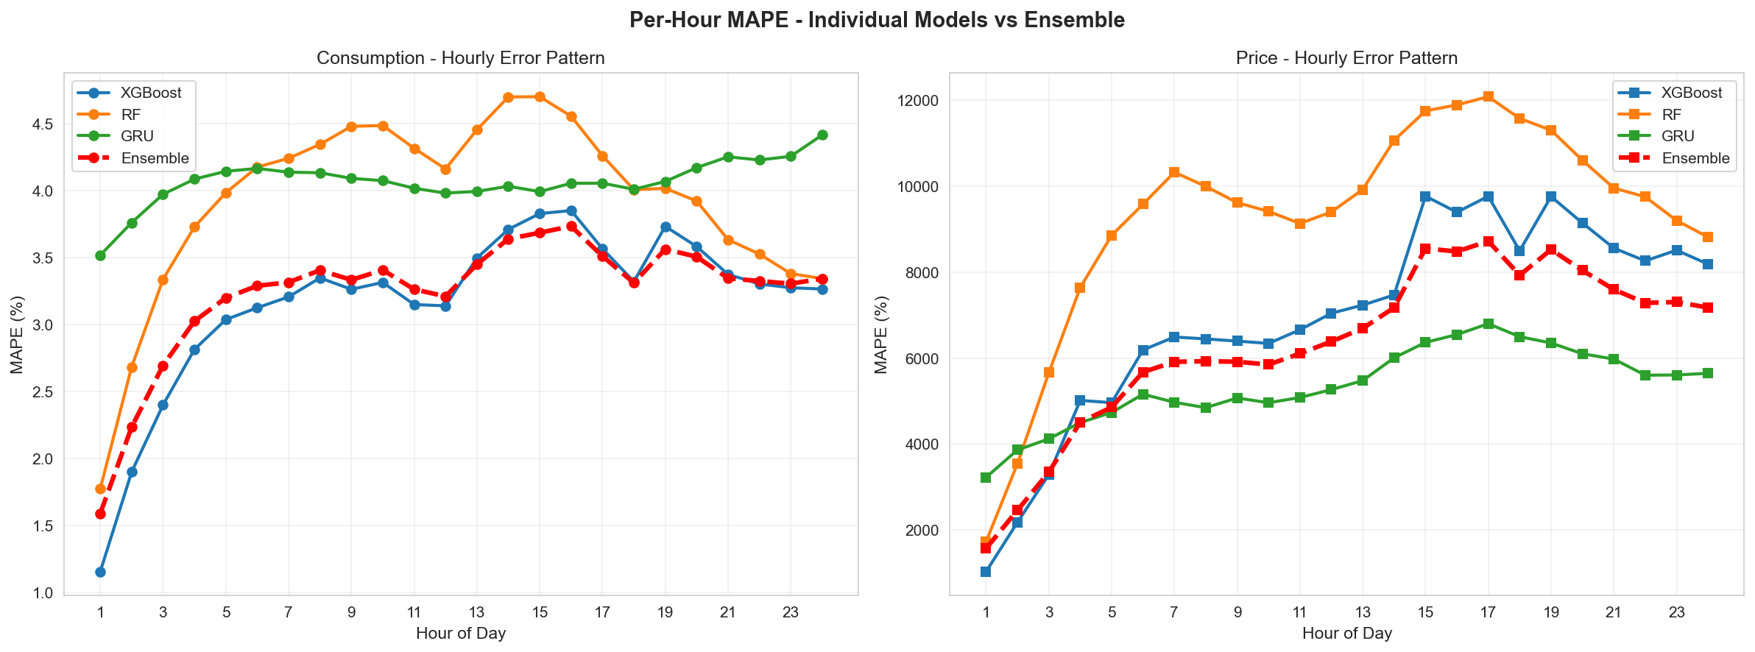
Maps error variations dynamically on test observations. By averaging XGBoost and GRU, the ensemble distinctly bridges their volatility gaps, producing the most stable continuous error curve across all 24 hours.

Ensemble vs Best Base Model
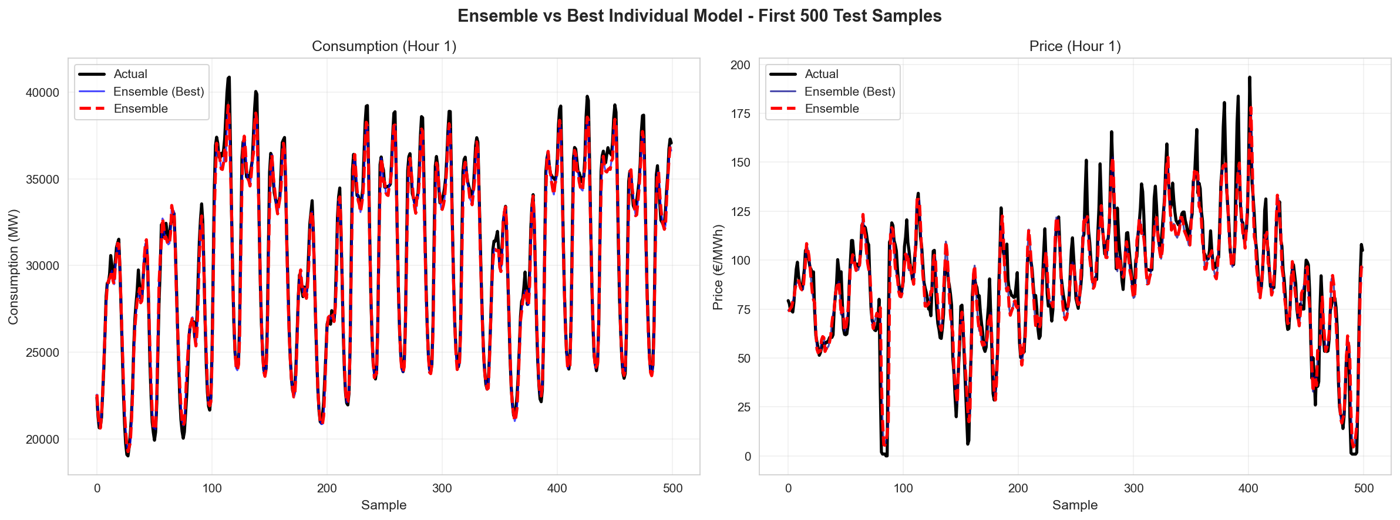
Time series overlay showcasing the first 500 samples of the test sequence. Crucially visualizes how the Ensemble dynamically smooths extreme stochastic spikes where standalone models either over-predict or under-react.

Conclusion
Overall, the Testing Phase clearly demonstrates the superiority of the weighted Ensemble approach. While XGBoost provided a robust baseline (87.96% R² for consumption on testing), the synergistic combination of XGBoost's nonlinear interactions, GRU's temporal sequence awareness, and Random Forest's feature stability pushed predictive confidence further, resulting in stable out-of-distribution deployments.

