How to make a high quality sound recording

Introduction
If you want to help translate Schoolsplay, you can help by making .po files.
But you can also help by recording numbers and the alphabet in your language.
To have optimal sound quality, please follow this guideline.

Preparing the environment
First, make sure you are in a quiet room with little or no background noise.
Next you need a microphone, just try what you have at your house:
- some laptops have this onboard
- you can maybe use your VOIP headset
- you can try with a real microphone
Just try to find something that suits you.
Make sure your microphone input is not muted!
Next up is the program to do the recording.
Every OS has a built in program for audio recording, however I would recommend Audacity.
It's easy to use and free (GPL) and it runs on the same platforms as Schoolsplay.

Make the recording
Open Audacity and press the red record button, it starts recording immediately.
Don't say anything for 3 seconds: we will use this silence for noise measurement later on.
Now say the translation you have to say and press the stop button.
You may get something like this:
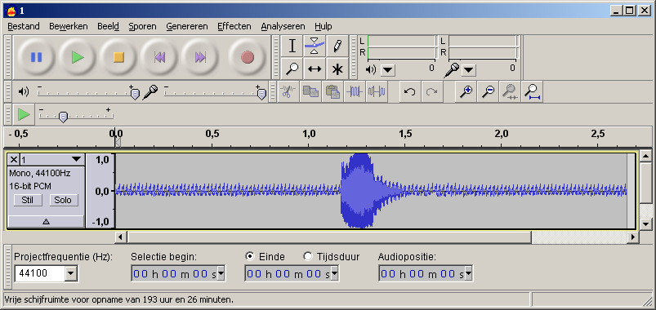
A small explanation about the sound file you see above:
The blue 'blub' going from 1,0 to -1,0 is your speech. This is OK.
However, the sinusoidal curve before and after is noise.
Here you were recording silence, and still there is something.
If it were completely silent, you would see nothing except the 0,0 line.
We will try to remove this noise.
Pressing Space bar, starts and stops playback.
If it doesn't sound good, try changing your distance from the microphone, this may help a lot.

Improve the recording
Since you are probably not in a real recording studio, your sound may not be that good.
No problem, we will try to improve it now.
If you have a lot of background noise, select a part of the noise (the first 3 seconds) with your mouse.
(Left click on the beginning of the noise, drag to the right and release)
Go to Effects - Noise Removal - Step 1 and click the Get Noise Profile button.
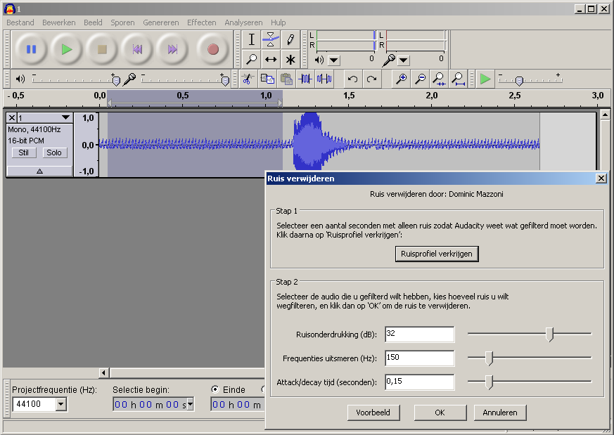
Since you selected a few seconds of noise, Audacity now recognises the typical background noise.
Now select your complete track (Ctrl+A) and go again to Effects - Noise Removal but now to Step 2.
You can get a preview of the sound with noise removed.
If it doesn't sound good enough, you can try to improve with the sliders.
Usually the default setting is good enough, so click OK.
Now select the actual translation instead of the complete track.
Play that again, to check if it sound good.
If so, go to File - Export Selection (as ogg) and export to a .ogg file with appropriate name.
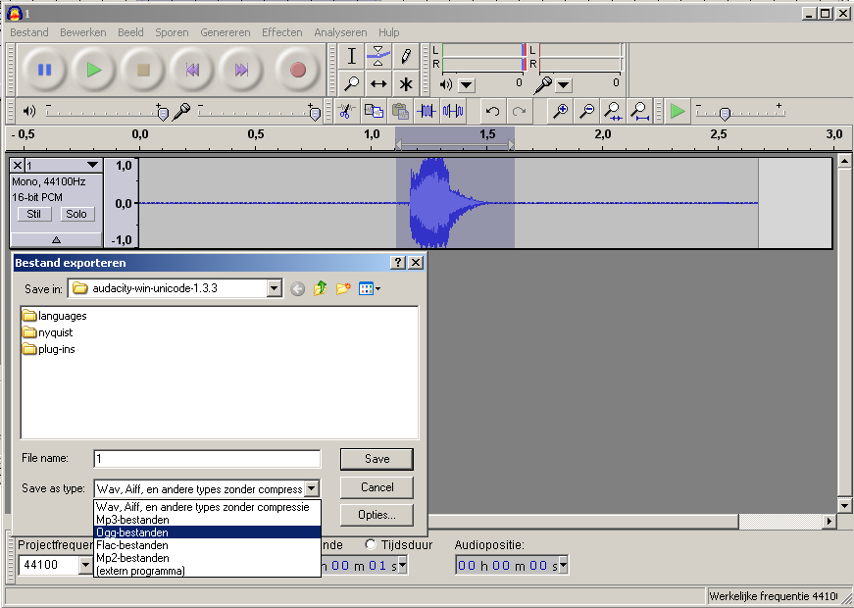
Voila, you made your first recording for Schoolsplay, thanks!

