Printer Settings (For Cura, IIIP printers)

# First off, Machine settings:

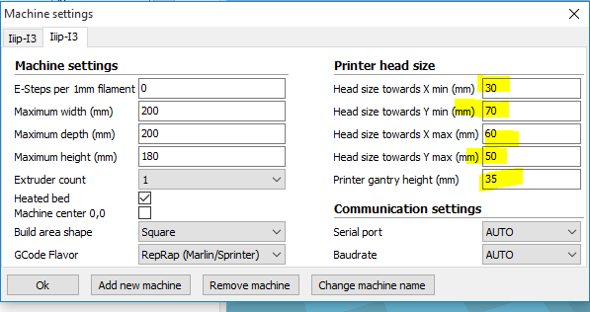

Set the highlighted speeds, Click OK.

# Basic settings

To access the basic settings, you must go to the expert tab and switch the settings to full settings. 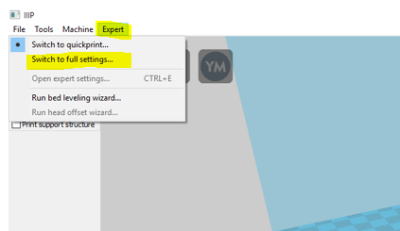

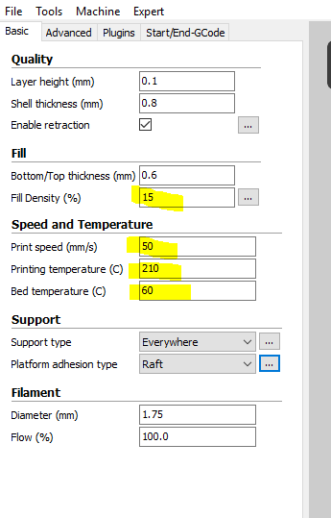

Change Fill density. 10 – 20 will work. (20 very strong, 10 is strong enough)

Change Print speed: This will slow down the print head, but it will be more likely to bond well between layers.

Change the Printing Temp to 210, and the Bed Temp to 60.

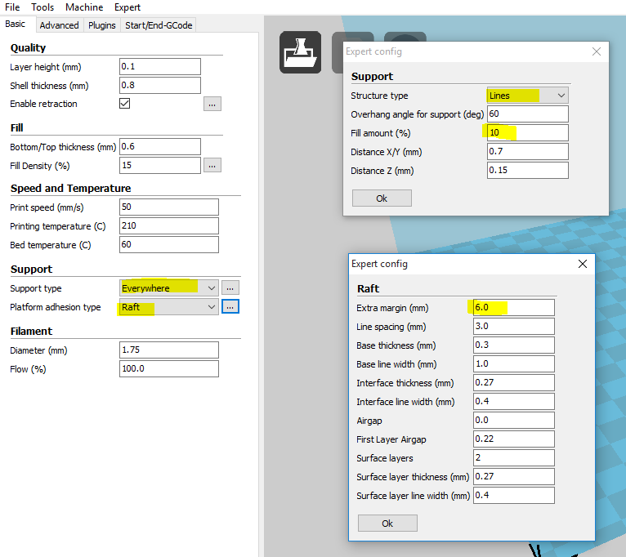

Make sure you have a platform: Raft is standard. A 5 – 6 mm raft (click the 3 dots advanced settings) is generally sufficient for most objects. If you have an unusually tall object you might consider a larger raft.

If you have an object that is not vertically supported down to the bed, you will need to select support type. I recommend everywhere and using lines with a 10% amount of fill.

# Advanced Settings

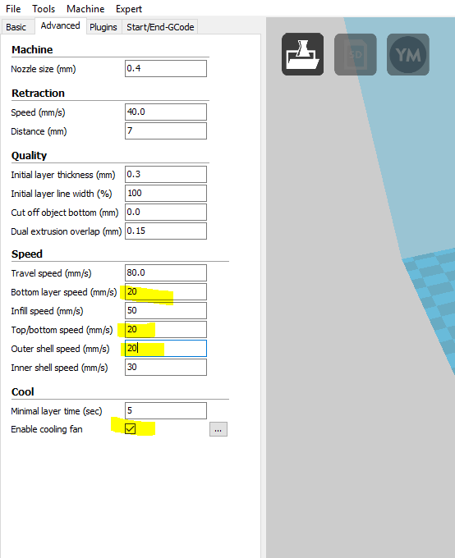

Change your settings to match.

# When saving:

Save a gcode file to an SD card to print out the object.

Save a copy of the model that is the same name to the SD card as well. This way if something goes wrong I can manipulate your model to hopefully print it.