# IT 230 Coding Activity Submission Template

Submit your work on the coding activities for Modules One, Two, Three, Four, and Six in this document. In addition to this document, you should submit a ZIP file containing all your Visual Studio project files and source code that can be run in Visual Studio on a different computer.

For each coding activity, complete the following steps:

* Download and rename this document to meet the file naming conventions requested in the assignment instructions.
* Fill in the required information below by replacing the bracketed text with the relevant information.
* Submit this document and your ZIP file for grading and feedback. Your ZIP file should follow the same naming conventions.

Document your work in the coding activity by completing each of the following items:

1. Provide a screenshot of the output that resulted from running your program successfully in Visual Studio. See the coding assignment instructions for an example of what should be included in the screenshot. Your screenshot must include the following elements:
   1. Your last name as the first printed text on the screen
   2. Verification that the program is fully functioning and data results are accurate for the given problem

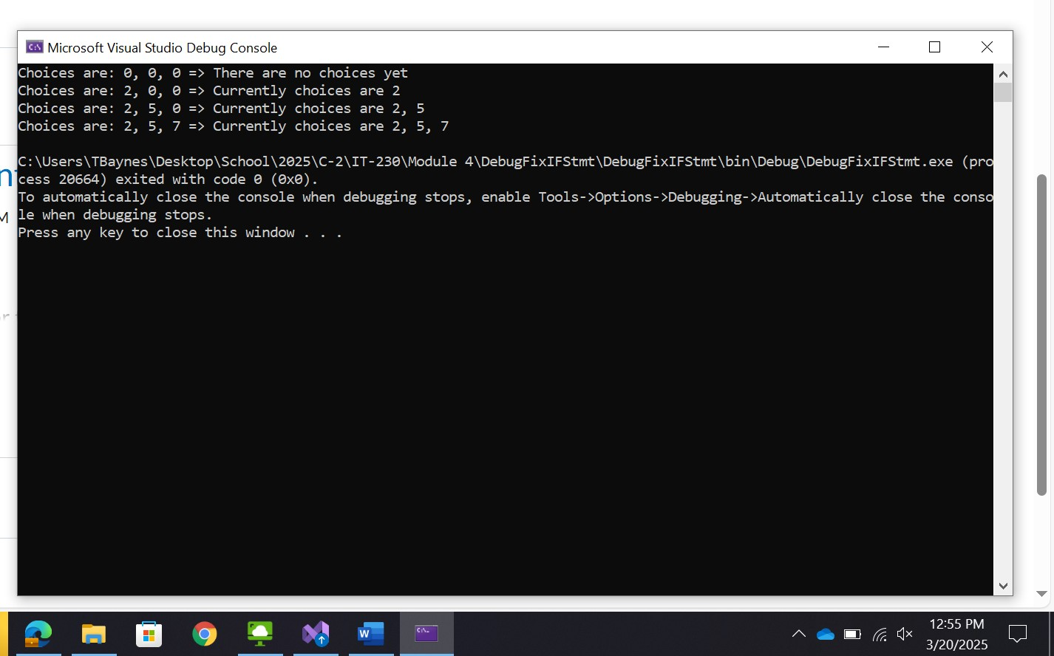

1. Copy and paste the source code text you wrote for this assignment from the *.cs file into the space below. Only providing the *.cs files or a screenshot does not meet the requirements for this part of the assignment. Code should be logically organized. It should also follow proper syntax and conventions noted in the Coding Activity Guidelines and Rubric.

using System;

using System.Collections.Generic;

using System.Linq;

using System.Text;

using System.Threading.Tasks;

namespace DebugFixIFStmt

{

class Program

{

static void Main(string[] args)

{

(new Program()).run();

}

void run()

{

int firstChoice = 0, secondChoice = 0, thirdChoice = 0;

//System.Console.WriteLine("Teacher's Copy"); This was left in here but probably shouldn't be?

firstChoice = 0; secondChoice = 0; thirdChoice = 0;

WriteCurrentChoices(firstChoice, secondChoice, thirdChoice);

firstChoice = 2; secondChoice = 0; thirdChoice = 0;

WriteCurrentChoices(firstChoice, secondChoice, thirdChoice);

firstChoice = 2; secondChoice = 5; thirdChoice = 0;

WriteCurrentChoices(firstChoice, secondChoice, thirdChoice);

firstChoice = 2; secondChoice = 5; thirdChoice = 7;

WriteCurrentChoices(firstChoice, secondChoice, thirdChoice);

}

void WriteCurrentChoices(int firstChoice, int secondChoice, int thirdChoice)

{

if (firstChoice == 0)//changed to firstChoice as it skipped it

Console.WriteLine("Choices are: {0}, {1}, {2} => There are no choices yet", firstChoice, secondChoice, thirdChoice);

else if (secondChoice == 0)//had too few =

Console.WriteLine("Choices are: {0}, {1}, {2} => Currently choices are {0}", firstChoice, secondChoice, thirdChoice, firstChoice);

else if (thirdChoice == 0)//Had an extra =

Console.WriteLine("Choices are: {0}, {1}, {2} => Currently choices are {0}, {1}", firstChoice, secondChoice, thirdChoice, firstChoice, secondChoice);

else if(thirdChoice != 0 )//Changed to greater than, otherwise it will be the same as the previous bit. This would mean the choice is never seen as the final choice needs to be greater than 0.

Console.WriteLine("Choices are: {0}, {1}, {2} => Currently choices are {0}, {1}, {2}",

firstChoice, secondChoice, thirdChoice, firstChoice, secondChoice, thirdChoice);

}

}

}

1. Show that you understand the task by explaining the design of your program in the space below. Include the process and steps you took to write your code. Explain how you arrived at the solution to the problem and completed the activity.

The program is set up to display choices in the form of numbers that are strings. The method “void run()” establishes the statements that define the variables of firstChoice, secondChoice, thirdChoice. These are numbers but are not integers as classified by the “void” return type.

The first line of this establishes the variables as integers with int but this is null as the return type is void.

From there, the run() method changes those variables and after each step, executes the function WriteCurrentChoices. Later, WriteCurrentChoices is defined as a return type “void” with parameters of int for the three choice variables. Within this method, we have our if/else if statements. If the firstChoice variable comes back as 0 (via ==), then the statement “Choices are: {0}, {1}, {2} => There are no choices yet.” is printed where {0,1,2} represents the given choices from the parameters at the end: Choices are: {0}, {1}, {2} => There are no choices yet", firstChoice, secondChoice, thirdChoice);”

The same is repeated for the next two statements but instead it simply looks for 0 in the ascending choices.

Finally, if thirdChoice is anything other than 0, then the last prompt is printed out with all three choices being made. This can be accomplished with the > operator or, more thoroughly, != operator as this enables a negative number to exist.

Finding the errors was quick this time around. But my method was to read through the instructions and what the program is attempting to do. This streamlined my brain and I was already thinking about how this could be accomplished while waiting for my laptop’s lengthy load times.

1. Reflect on your learning experience and what you learned from completing the activity.

I feel like I learned more about how to read someone else’s code. That is a skill that is absolutely needed. As a programmer, I will be spending as much time fixing errors in someone else's code rather than creating it all by scratch.