Name: Ty Chhenglong

ID: e20191217

Department: GIC-C

**Result of TP01 Internet Programing**

**Exercise01:** Basic Layout

**Exercise02:** Centering a “div” in a container with position property

**Exercise03:** Centering a “div” in a container with display-flex property

**Exercise04:** Column and Row with display-flex property

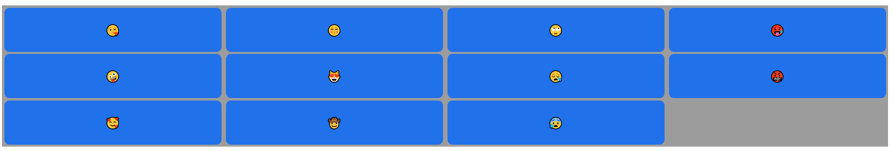

**Exercise05:** Column and Row with display-grid property

**Exercise06:** Responsive with “@media only screen” property

**Exercise07:** Responsive with “clamp” property

**Exercise08: Animation**

**Exercise09:** Scrollable Content

**Exercise10:** Scrollable Content

**Exercise11:** Scrollable Content

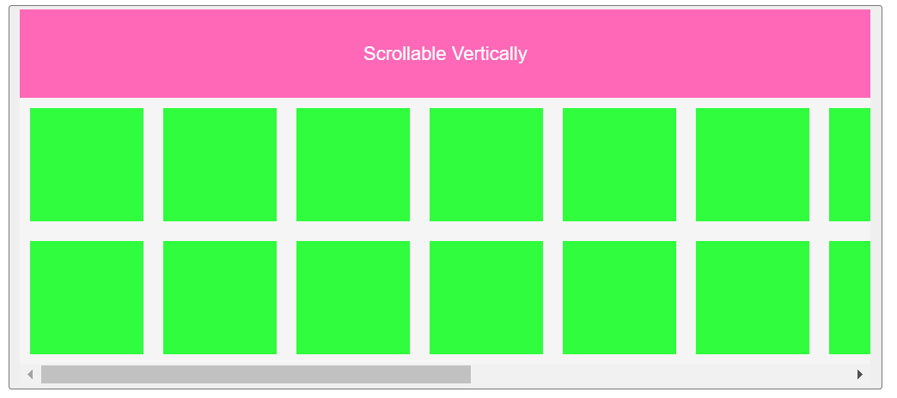

**Exercise12:** Scrollable Content

