Name: Ty Chhenglong

ID: e20191217

Department: GIC-C

**Result TP04 Internet Programing**

**Exercise01:** Design following UI to have 3 tabs.

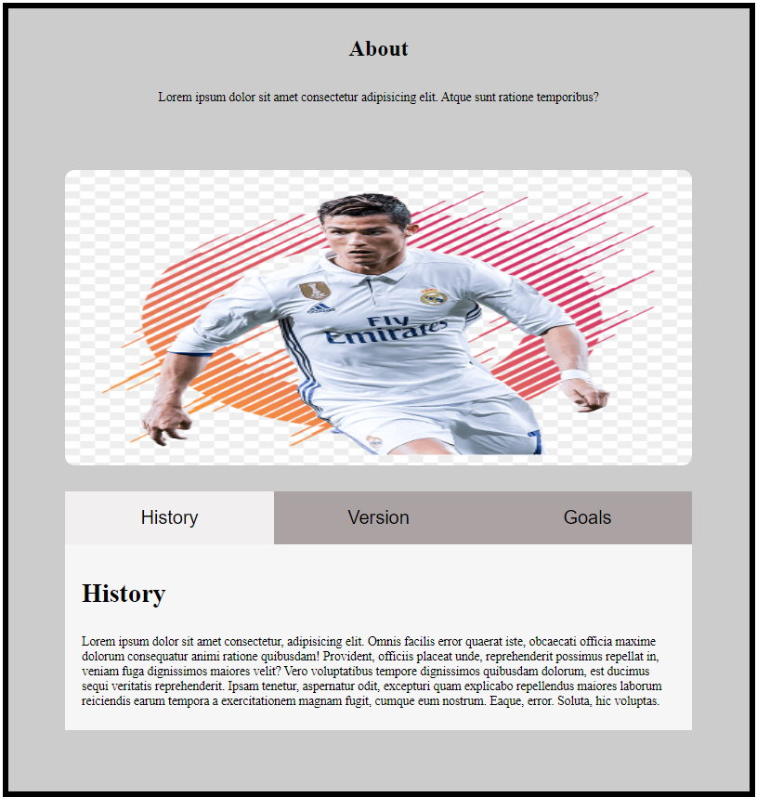

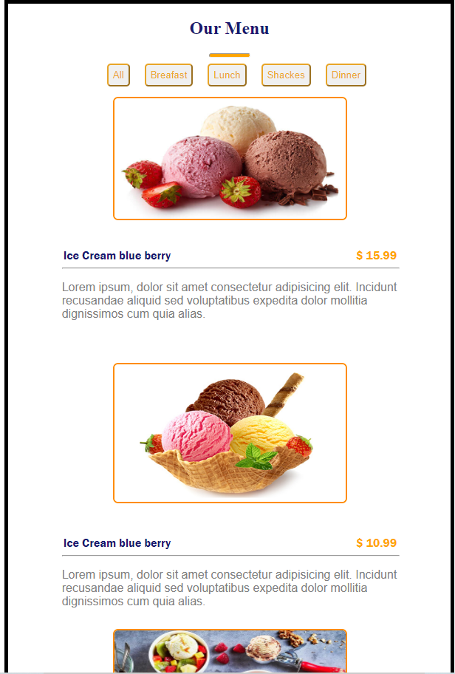**Exercise02:** Design following responsive UI as following

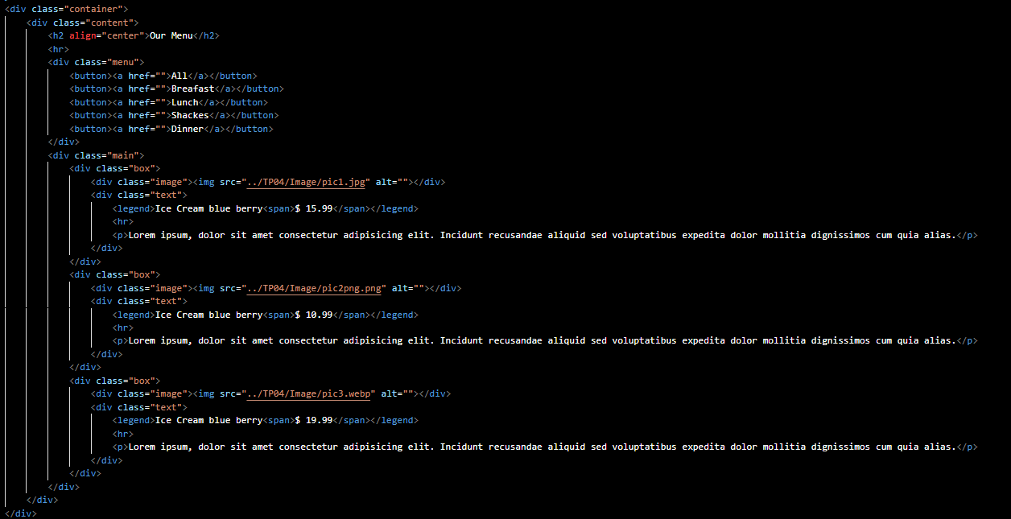**Exercise3:** Build a number counter app with Class/Object concept and local storage

**Exercise4:** Build a color generator app with Class/Object concept with local storage

**Exercise5:** Build a navigation bar to support both wide and mobile screen

**Exercise6:** Build an app with a slide bar

