Name: Ty Chhenglong

ID: e20191217

Group: GIC-C

**Result TP05 Internet Programming**

**Exercise01:** Create a web app to random activity for suggesting activity to a boring person. Use Fetch function in JavaScript to request the data from the server.

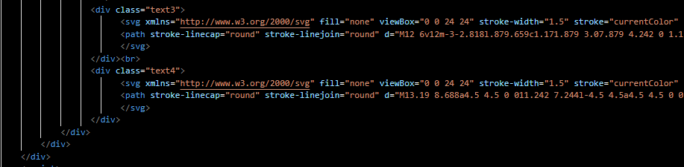

**Exercise02:** Create a web app to guess a person’s gender by providing a person’s name. Use Fetch function in JavaScript to request the data from the server

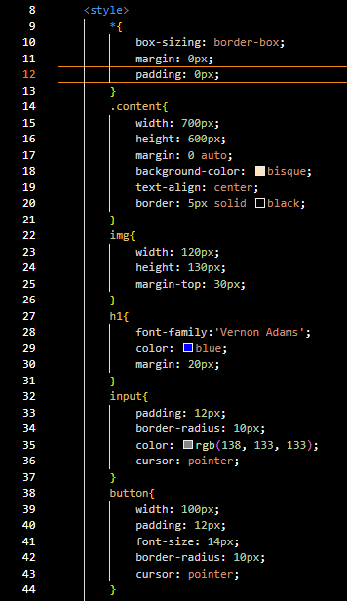

**Exercise03:** Create a web app to guess a person’s nationality by providing a person’s name. Use Fetch function in JavaScript to request the data from the server.

**Exercise04:** Create a web app to display a list of university of a country. Use Fetchfunction in JavaScript to request the data from the server.

**Eercise05:** Apply fetch function to our previous book app.



