**Project 1: Familiarity with UNIX/Linux**

Duc Vo & Ty Gehrke

Grand Canyon University

CST-315: Operating Systems Lecture and Lab

Professor Citro

1/21/2024

# 

# Team Members

* Ty Gehrke
* Duc Vo

# Project Description

In Project 1, we are tasked with gaining familiarity with UNIX/Linux by exploring various features of the operating system on your computer. Firstly, we will be choosing five features and explaining what would happen. Additionally, we are expected to demonstrate readiness to write and run C++ programs in a Linux or UNIX environment. This involves creating a simple HelloWorld.cpp file using a UNIX/Linux text editor (vi) and compiling it. The project also includes testing and validating the results, creating a local Git repository, and committing specific directories/files to a remote Git repository. This project aims to assess your understanding of UNIX/Linux features and your ability to work with C programs in a Linux or UNIX environment.

# 5 Operating Systems Features

## ls

* 1. Ls is a command in Linux that shows all the files in the current folder. The OS would need to scan the contents of the folder and print out the names of the files to the terminal. It would also need to check what kind of file it is, as some files, like output files, and printed out with green text.



## vi

* 1. explanation

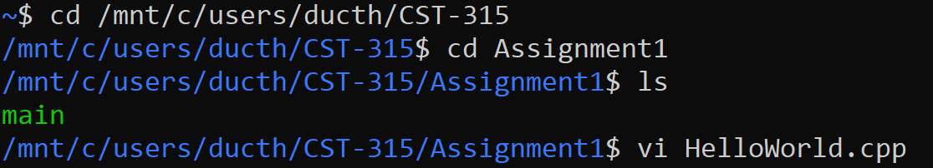

## cd

* 1. Cd is a Linux command that moves the terminal to a certain folder. This is done by putting the file path after cd, or the folder name if it is inside the current folder. The OS does this by reading the path and checking all the paths inside the current folder, or inside the system, to find the folder to move to. Cd ~ can be used to move the terminal back to the home.

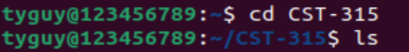

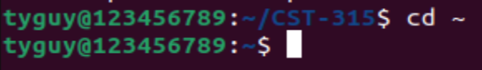

## who

* 1. The ‘who’ command can be used to find the current users of the systems, along with additional information related to that user. It can be used with various extra options:
* -u gives idle time
* -b gives the last system boot time
* -q shows the users name only
* -r displays the run level

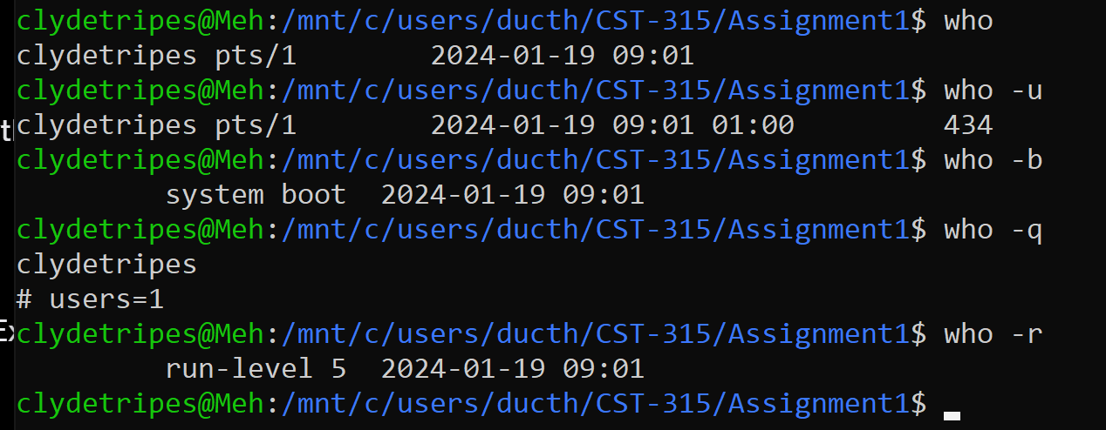

## open

* 1. Open is a linux command that opens a file of the specified name in the folder that the terminal is in. The OS would need to be able to take the string after the word open and check all the files in the current folder to see if their name matches that string. It would then need to start a process to fetch that file and start the default program to open the file with.

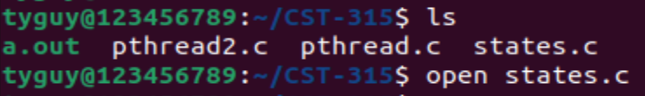

# Linux Download

# The version of linux installed was 22.04.3, and installed in a virtual machine.

# 

# Running Program

We will be running a simple “HelloWorld.cpp” file where we will be printing the word “Hello World” onto the console

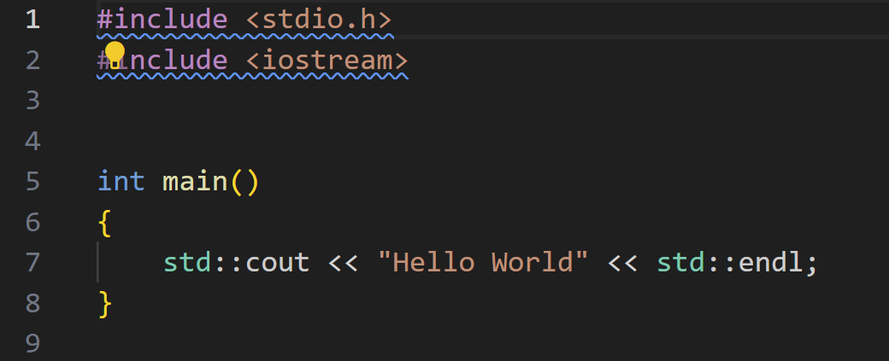

We use VisualCode to edit this code. This can also be done in the Linux Terminal using

Linux Text Editor “vi” as we have mentioned above



This will open the Text editors as follows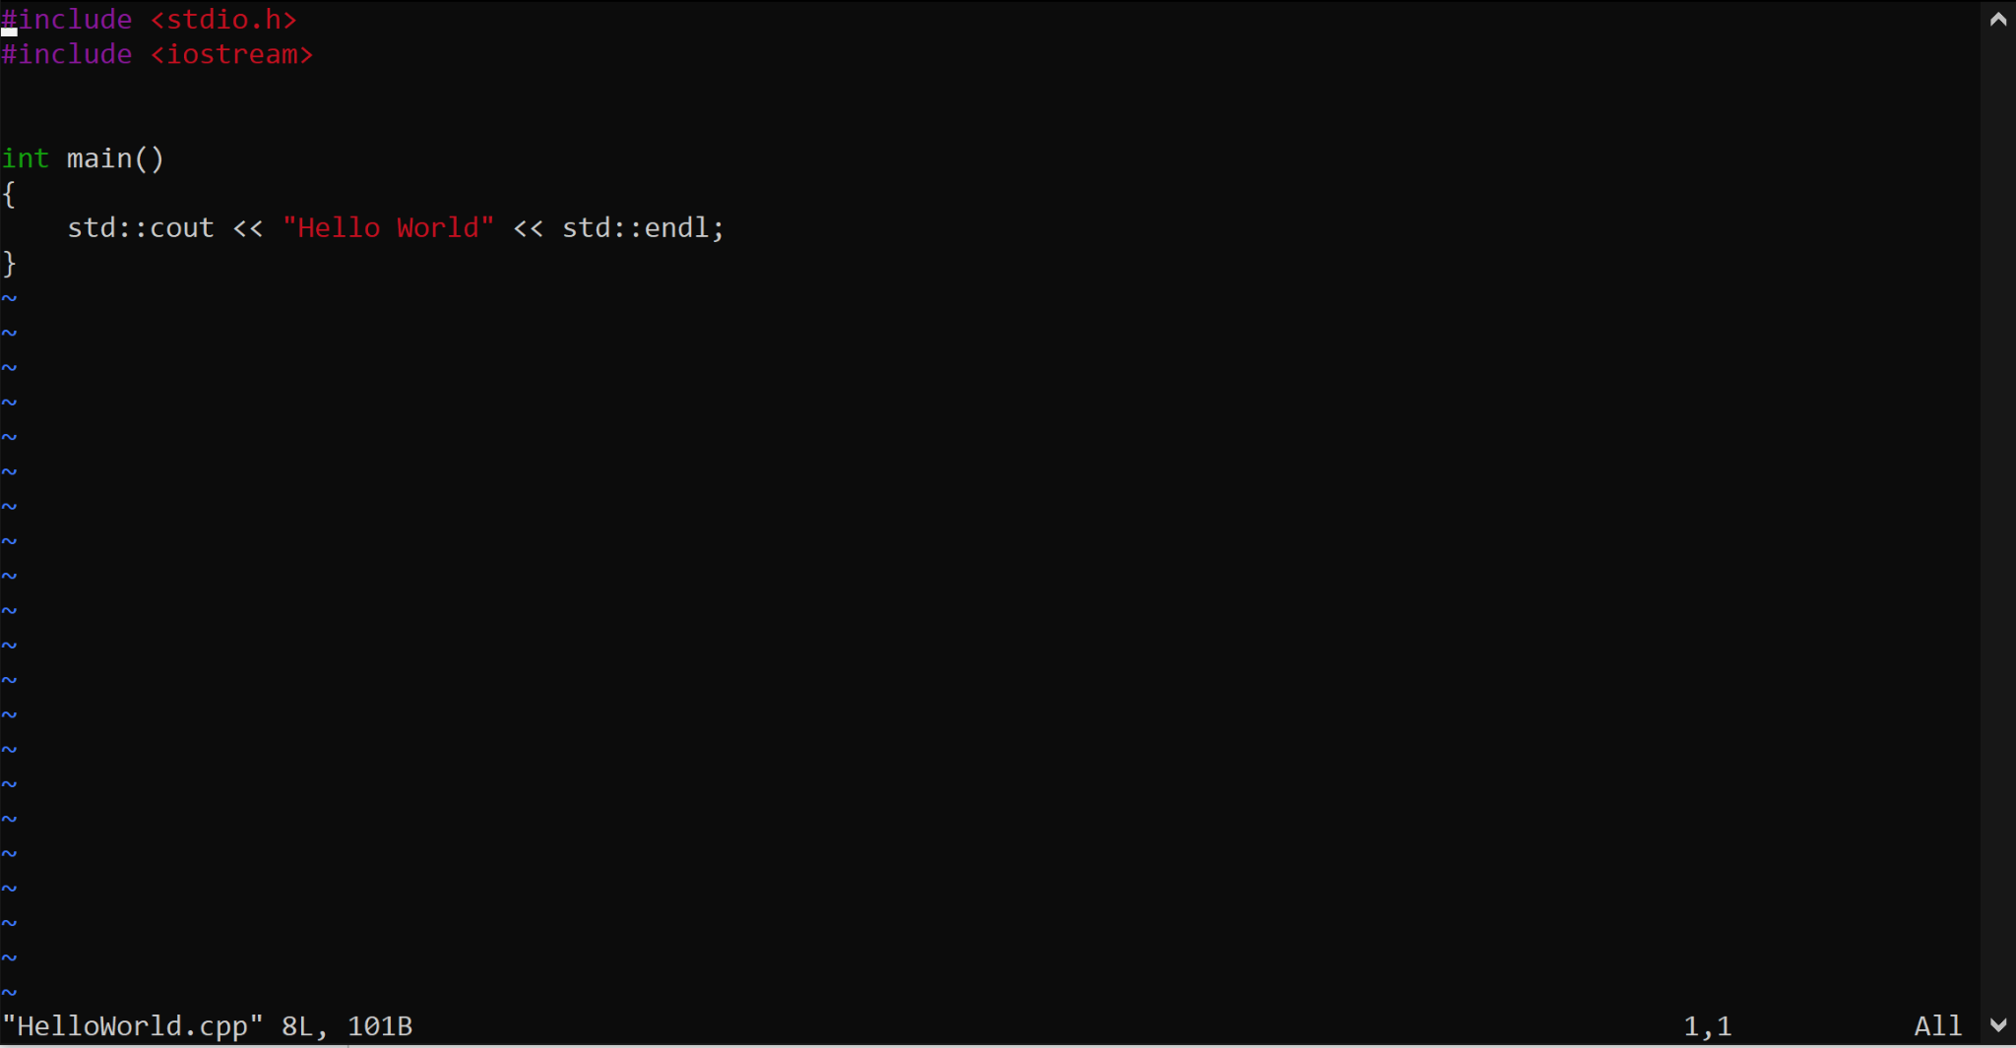

When done, we can then hit the “Esc” key to exit the edit mode, and then:

* ‘i’ to go back to edit
* ‘:wq’ to save and exit
* ‘:q!’ to exit without save

Afterwards, we can run our executables using the command lines below



# 

# Git Set Up

We have set up the Git repository with all of the necessary files and created the ‘Assingment1’ folder accordingly

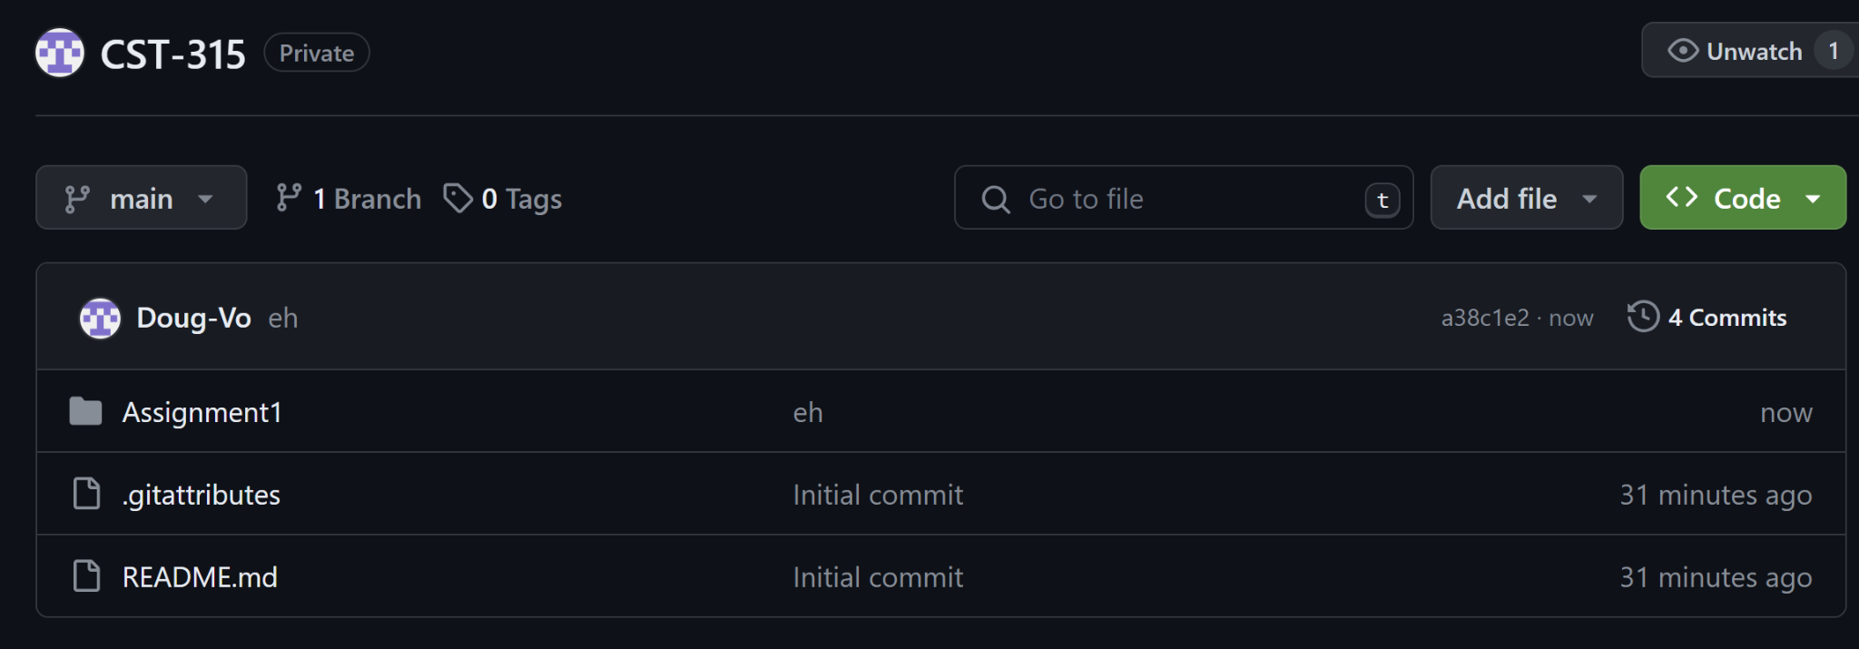

# 

# References

“The Linux Command Line for Beginners.” *Ubuntu*, Canonical Ltd., ubuntu.com/tutorials/command-line-for-beginners?ref=vegastack.com. Accessed 19 Jan. 2024.