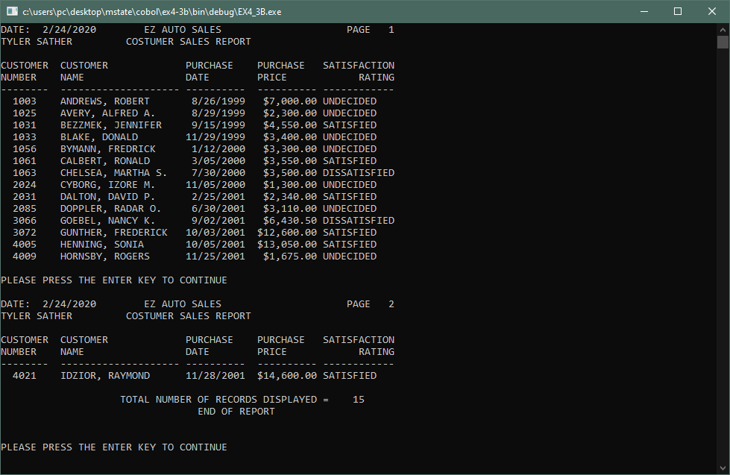

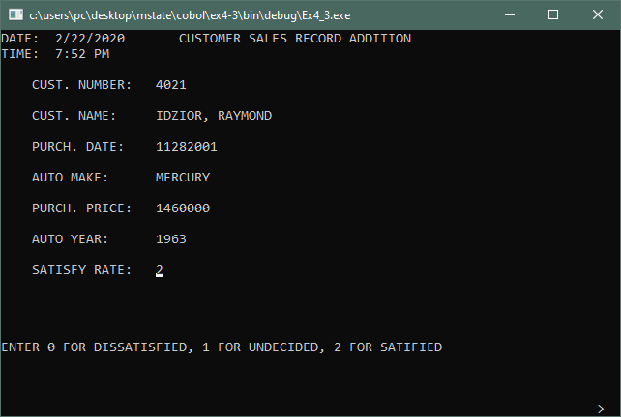

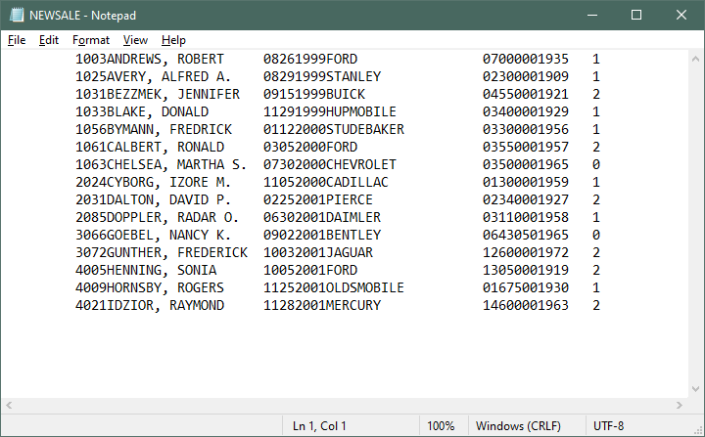

IDENTIFICATION DIVISION.

************************

PROGRAM-ID. EX4-3A.

AUTHOR. Tyler Sather.

INSTALLATION. MState.

DATE-WRITTEN. February 18, 2020.

DATE-COMPILED.

*****************************************************************

* PROGRAM NARRATIVE

*

* THIS PROGRAM ACCEPTS INPUT FOR THE CREATION OF A SEQUENTIAL

* CUSTOMER SALES FILE FOR EZ AUTO. INPUT IS VERIFIED AS IT IS

* ENTERED AND BAD DATA MUST BE RE ENTERED. VALID DATA IS

* WRITTEN TO THE SALES FILE.

*

*

*

* INPUT: TERMINAL KEYBOARD

*

* OUTPUT: NEWSALE.DAT - SALES FILE

*

*****************************************************************

ENVIRONMENT DIVISION.

*********************

INPUT-OUTPUT SECTION.

*********************

FILE-CONTROL.

SELECT NEW-SALES-FILE

ASSIGN TO

"C:\Users\PC\Desktop\Mstate\COBOL\Ex4-3\NEWSALE.DAT"

ORGANIZATION IS LINE SEQUENTIAL.

/

DATA DIVISION.

**************

FILE SECTION.

*************

*****************************************************************

* INPUT FILE CUSTOMER FILE

*

*****************************************************************

FD NEW-SALES-FILE.

01 SALES-RECORD.

02 PIC X(9).

02 SR-CUSTOMER-NUMBER PIC X(4).

02 SR-CUSTOMER-NAME PIC X(20).

02 SR-PURCHASE-DATE-ALPHA PIC X(8).

02 SR-PURCHASE-DATE REDEFINES

SR-PURCHASE-DATE-ALPHA PIC 9(8).

02 SR-AUTO-MAKE PIC X(20).

02 SR-PURCHASE-PRICE-ALPHA PIC X(7).

02 SR-PURCHASE-PRICE REDEFINES

SR-PURCHASE-PRICE-ALPHA PIC 9(5)V99.

02 SR-AUTO-YEAR-ALPHA PIC X(4).

02 SR-AUTO-YEAR REDEFINES

SR-AUTO-YEAR-ALPHA PIC 9(4).

02 PIC XXX.

02 SR-SATIFACTION-RATING PIC X.

88 DISSATIFIED VALUE "0".

88 UNDECIDED VALUE "1".

88 SATISFIED VALUE "2".

/

WORKING-STORAGE SECTION.

************************

******************************************************************

* *

* SWITCHES *

* *

******************************************************************

01 SWITCHES.

02 SW-ENTER-ANOTHER-RECORD PIC X.

88 MORE-RECORDS VALUE "Y" "y".

88 NO-MORE-RECORDS VALUE "N" "n".

02 SW-VALID-ENTRY PIC X.

88 VALID-ENTRY VALUE "Y".

******************************************************************

* *

* ACCUMULATORS *

* *

******************************************************************

01 ACCUMULATORS.

02 AC-RECORD-COUNT PIC 9(5).

/

******************************************************************

* *

* WORK AREA FIELDS *

* *

******************************************************************

01 WORK-AREA.

02 WA-TODAYS-DATE-TIME.

03 WA-TODAYS-DATE.

04 WA-TODAYS-YEAR PIC 9(4).

04 WA-TODAYS-MONTH PIC 99.

04 WA-TODAYS-DAY PIC 99.

03 WA-TODAYS-TIME.

04 WA-TODAYS-HOURS PIC 99.

04 WA-TODAYS-MINUTES PIC 99.

03 PIC X(9).

02 WA-DATE.

03 WA-MONTH PIC 99.

03 WA-DAY PIC 99.

03 WA-YEAR PIC 9(4).

02 WA-RUN-DATE

REDEFINES WA-DATE PIC 9(8).

02 WA-AM-PM PIC XX.

02 WA-UNDERS PIC X(20) VALUE ALL "_".

02 WA-ERROR-MESSAGE PIC X(80).

02 WA-COUNT-DISPLAY PIC ZZZZ9.

02 WA-BLANK-LINE PIC X(80) VALUE ALL SPACES.

/

SCREEN SECTION.

*****************

******************************************************************

* *

* INITIAL SCREEN FOR THE CUSTOMER SALES ADDITION PROGRAM *

* *

******************************************************************

01 SALES-INPUT-SCREEN.

02 BLANK SCREEN.

02 LINE 1 COLUMN 1 VALUE "DATE: ".

02 COLUMN 7 PIC Z9/99/9999 FROM WA-RUN-DATE.

02 COLUMN 24 VALUE

"CUSTOMER SALES RECORD ADDITION".

02 LINE 2 COLUMN 1 VALUE "TIME: ".

02 COLUMN 7 PIC Z9 FROM WA-TODAYS-HOURS.

02 COLUMN 9 VALUE ":".

02 COLUMN 10 PIC XX FROM WA-TODAYS-MINUTES.

02 COLUMN 13 PIC XX FROM WA-AM-PM.

02 LINE 4 COLUMN 5 VALUE "CUST. NUMBER:".

02 COLUMN 21 VALUE "0000".

02 LINE 6 COLUMN 5 VALUE "CUST. NAME:".

02 COLUMN 21 PIC X(20) FROM WA-UNDERS.

02 LINE 8 COLUMN 5 VALUE "PURCH. DATE:".

02 COLUMN 21 VALUE "00000000".

02 LINE 10 COLUMN 5 VALUE "AUTO MAKE:".

02 COLUMN 21 PIC X(20) FROM WA-UNDERS.

02 LINE 12 COLUMN 5 VALUE "PURCH. PRICE:".

02 COLUMN 21 VALUE "0000000".

02 LINE 14 COLUMN 5 VALUE "AUTO YEAR:".

02 COLUMN 21 VALUE "0000".

02 LINE 16 COLUMN 5 VALUE "SATISFY RATE:".

02 COLUMN 21 VALUE "0".

/

PROCEDURE DIVISION.

*******************

******************************************************************

* *

* MAIN-PROGRAM. THIS IS THE MAIN PARAGRAPH OF THIS PROGRAM *

* *

******************************************************************

MAIN-PROGRAM.

PERFORM A-100-INITIALIZATION.

PERFORM B-100-PROCESS-FILE.

PERFORM C-100-WRAP-UP.

STOP RUN.

******************************************************************

* *

* HOUSEKEEPING PARAGRAPH *

* *

******************************************************************

A-100-INITIALIZATION.

MOVE ZERO TO AC-RECORD-COUNT.

MOVE FUNCTION CURRENT-DATE TO WA-TODAYS-DATE-TIME.

MOVE WA-TODAYS-MONTH TO WA-MONTH.

MOVE WA-TODAYS-DAY TO WA-DAY.

MOVE WA-TODAYS-YEAR TO WA-YEAR.

EVALUATE TRUE

WHEN WA-TODAYS-HOURS = 00

MOVE "AM" TO WA-AM-PM

MOVE 12 TO WA-TODAYS-HOURS

WHEN WA-TODAYS-HOURS < 12

MOVE "AM" TO WA-AM-PM

WHEN WA-TODAYS-HOURS = 12

MOVE "PM" TO WA-AM-PM

WHEN WA-TODAYS-HOURS > 12

MOVE "PM" TO WA-AM-PM

SUBTRACT 12 FROM WA-TODAYS-HOURS.

OPEN OUTPUT NEW-SALES-FILE.

/

******************************************************************

* *

* FILE PROCESSING CONTROL PARAGRAPH *

* *

******************************************************************

B-100-PROCESS-FILE.

PERFORM B-200-ENTER-RECORDS

UNTIL NO-MORE-RECORDS.

MOVE AC-RECORD-COUNT TO WA-COUNT-DISPLAY.

DISPLAY WA-COUNT-DISPLAY LINE 21 COLUMN 6 WITH BLANK LINE.

DISPLAY " RECORDS HAVE BEEN WRITTEN!" LINE 21 COLUMN 12.

/

******************************************************************

* *

* DISPLAY HEADINGS AND DETAIL LINES *

* *

******************************************************************

B-200-ENTER-RECORDS.

INITIALIZE SALES-RECORD.

DISPLAY SALES-INPUT-SCREEN.

MOVE "N" TO SW-VALID-ENTRY.

PERFORM B-300-ACCEPT-CUST-NUMBER

UNTIL VALID-ENTRY.

DISPLAY WA-BLANK-LINE LINE 21 COLUMN 1.

MOVE "N" TO SW-VALID-ENTRY.

PERFORM B-310-ACCEPT-CUST-NAME

UNTIL VALID-ENTRY.

DISPLAY WA-BLANK-LINE LINE 21 COLUMN 1.

MOVE "N" TO SW-VALID-ENTRY.

PERFORM B-320-ACCEPT-PURCH-DATE

UNTIL VALID-ENTRY.

DISPLAY WA-BLANK-LINE LINE 21 COLUMN 1.

DISPLAY WA-BLANK-LINE LINE 22 COLUMN 1.

DISPLAY WA-BLANK-LINE LINE 23 COLUMN 1.

DISPLAY WA-BLANK-LINE LINE 24 COLUMN 1.

DISPLAY WA-BLANK-LINE LINE 25 COLUMN 1.

MOVE "N" TO SW-VALID-ENTRY.

PERFORM B-330-ACCEPT-AUTO-MAKE

UNTIL VALID-ENTRY.

DISPLAY WA-BLANK-LINE LINE 21 COLUMN 1.

DISPLAY WA-BLANK-LINE LINE 22 COLUMN 1.

DISPLAY WA-BLANK-LINE LINE 23 COLUMN 1.

DISPLAY WA-BLANK-LINE LINE 24 COLUMN 1.

DISPLAY WA-BLANK-LINE LINE 25 COLUMN 1.

MOVE "N" TO SW-VALID-ENTRY.

PERFORM B-340-ACCEPT-PURCH-PRICE

UNTIL VALID-ENTRY.

DISPLAY WA-BLANK-LINE LINE 21 COLUMN 1.

DISPLAY WA-BLANK-LINE LINE 22 COLUMN 1.

DISPLAY WA-BLANK-LINE LINE 23 COLUMN 1.

DISPLAY WA-BLANK-LINE LINE 24 COLUMN 1.

DISPLAY WA-BLANK-LINE LINE 25 COLUMN 1.

MOVE "N" TO SW-VALID-ENTRY.

PERFORM B-350-ACCEPT-AUTO-YEAR

UNTIL VALID-ENTRY.

DISPLAY WA-BLANK-LINE LINE 21 COLUMN 1.

DISPLAY WA-BLANK-LINE LINE 22 COLUMN 1.

DISPLAY WA-BLANK-LINE LINE 23 COLUMN 1.

DISPLAY WA-BLANK-LINE LINE 24 COLUMN 1.

DISPLAY WA-BLANK-LINE LINE 25 COLUMN 1.

MOVE "N" TO SW-VALID-ENTRY.

PERFORM B-360-ACCEPT-SATIFY-RATE

UNTIL VALID-ENTRY.

WRITE SALES-RECORD.

ADD 1 TO AC-RECORD-COUNT.

DISPLAY "RECORD "

LINE 21 COLUMN 10 WITH BLANK SCREEN.

DISPLAY SR-CUSTOMER-NUMBER " HAS BEEN ADDED TO THE FILE".

DISPLAY "DO YOU WISH TO ENTER ANOTHER RECORD? Y/N"

LINE 23 COLUMN 10.

MOVE SPACES TO SW-ENTER-ANOTHER-RECORD.

PERFORM UNTIL MORE-RECORDS OR NO-MORE-RECORDS

ACCEPT SW-ENTER-ANOTHER-RECORD LINE 23 COLUMN 52

IF NOT MORE-RECORDS AND NOT NO-MORE-RECORDS

DISPLAY "YOU MUST ENTER Y OR N !!" LINE 24 COLUMN 10

END-IF

END-PERFORM.

/

******************************************************************

* *

* ACCEPT CUSTOMER NUMBER PARAGRAPH *

* *

******************************************************************

B-300-ACCEPT-CUST-NUMBER.

DISPLAY

"ENTER THE CUSTOMERS NUMBER - NUMERIC AND NOT ALL ZEROS"

LINE 21 COLUMN 1.

ACCEPT SR-CUSTOMER-NUMBER LINE 4 COLUMN 21.

IF SR-CUSTOMER-NUMBER NOT NUMERIC

MOVE "CUSTOMER NUMBER NOT NUMERIC - RE-ENTER" TO

WA-ERROR-MESSAGE

ELSE

IF SR-CUSTOMER-NUMBER = ZERO

MOVE "NUMBER = ZERO - RE-ENTER" TO WA-ERROR-MESSAGE

ELSE

MOVE "Y" TO SW-VALID-ENTRY.

DISPLAY WA-ERROR-MESSAGE LINE 21 COLUMN 1 with WA-BLANK-LINE.

/

******************************************************************

* *

* ACCEPT CUSTOMER NAME PARAGRAPH *

* *

******************************************************************

B-310-ACCEPT-CUST-NAME.

DISPLAY "ENTER THE CUSTOMERS NAME - NOT ALL SPACES"

LINE 21 COLUMN 1.

ACCEPT SR-CUSTOMER-NAME LINE 6 COLUMN 21.

IF SR-CUSTOMER-NAME = SPACES

MOVE "CUSTOMER NAME MISSING - RE-ENTER" TO

WA-ERROR-MESSAGE

ELSE

MOVE "Y" TO SW-VALID-ENTRY.

DISPLAY WA-ERROR-MESSAGE LINE 21 COLUMN 1 with WA-BLANK-LINE.

/

******************************************************************

* *

* ACCEPT PURCHASE DATE PARAGRAPH *

* *

******************************************************************

B-320-ACCEPT-PURCH-DATE.

DISPLAY "ENTER THE PURCHASE DATE - MMDDYYYY FORMAT"

LINE 21 COLUMN 1.

DISPLAY " ".

DISPLAY " WHERE MM = 01 - 12".

DISPLAY " DD = 01 - 31".

DISPLAY " YYYY = UNDER 2020".

ACCEPT SR-PURCHASE-DATE-ALPHA LINE 8 COLUMN 21.

IF SR-PURCHASE-DATE-ALPHA NOT NUMERIC

MOVE "PURCHASE DATE NOT NUMERIC - RE-ENTER" TO

WA-ERROR-MESSAGE

ELSE

IF SR-PURCHASE-DATE (1:2) < "01" OR > "12"

MOVE "MM MUST BE 01 - 12 - RE-ENTER"

TO WA-ERROR-MESSAGE

ELSE

IF SR-PURCHASE-DATE (3:2) < "01" OR > "31"

MOVE "DD MUST BE 01 - 31 - RE-ENTER" TO

WA-ERROR-MESSAGE

ELSE

IF SR-PURCHASE-DATE (5:4) >= "2020"

MOVE "YYYY OVER 2020 - RE-ENTER"

TO WA-ERROR-MESSAGE

ELSE

MOVE "Y" TO SW-VALID-ENTRY.

DISPLAY WA-ERROR-MESSAGE LINE 21 COLUMN 1 with WA-BLANK-LINE.

/

******************************************************************

* *

* ACCEPT AUTO MAKE PARAGRAPH *

* *

******************************************************************

B-330-ACCEPT-AUTO-MAKE.

DISPLAY "ENTER THE AUTOMOBILES MAKE - NOT ALL SPACES"

LINE 21 COLUMN 1.

ACCEPT SR-AUTO-MAKE LINE 10 COLUMN 21.

IF SR-AUTO-MAKE = SPACES

MOVE "AUTOMOBILE MAKE MISSING - RE-ENTER" TO

WA-ERROR-MESSAGE

ELSE

MOVE "Y" TO SW-VALID-ENTRY.

DISPLAY WA-ERROR-MESSAGE LINE 21 COLUMN 1 with WA-BLANK-LINE.

/

******************************************************************

* *

* ACCEPT PURCHASE PRICE PARAGRAPH *

* *

******************************************************************

B-340-ACCEPT-PURCH-PRICE.

DISPLAY "ENTER THE PURCHASE PRICE - NUMERIC AND POSTIVE"

LINE 21 COLUMN 1.

ACCEPT SR-PURCHASE-PRICE-ALPHA LINE 12 COLUMN 21.

IF SR-PURCHASE-PRICE-ALPHA NOT NUMERIC

MOVE "PURCHASE PRICE NOT NUMERIC - RE-ENTER" TO

WA-ERROR-MESSAGE

ELSE

IF SR-PURCHASE-PRICE < 0

MOVE "PURCHASE PRICE NOT POSITIVE - RE-ENTER"

TO WA-ERROR-MESSAGE

ELSE

MOVE "Y" TO SW-VALID-ENTRY.

DISPLAY WA-ERROR-MESSAGE LINE 21 COLUMN 1 with WA-BLANK-LINE.

/

******************************************************************

* *

* ACCEPT AUTO YEAR PARAGRAPH *

* *

******************************************************************

B-350-ACCEPT-AUTO-YEAR.

DISPLAY

"ENTER THE AUTOMOBILE YEAR - NUMERIC AND 1900 - 2020"

LINE 21 COLUMN 1.

ACCEPT SR-AUTO-YEAR-ALPHA LINE 14 COLUMN 21.

IF SR-AUTO-YEAR-ALPHA NOT NUMERIC

MOVE "AUTOMOBILE YEAR NOT NUMERIC - RE-ENTER" TO

WA-ERROR-MESSAGE

ELSE

IF SR-AUTO-YEAR <= 1900

MOVE "AUTOMOBILE YEAR MUST BE OVER 1900 - RE-ENTER"

TO WA-ERROR-MESSAGE

ELSE

MOVE "Y" TO SW-VALID-ENTRY.

DISPLAY WA-ERROR-MESSAGE LINE 22 COLUMN 1 with WA-BLANK-LINE.

/

******************************************************************

* *

* ACCEPT SATIFACTION RATE PARAGRAPH *

* *

******************************************************************

B-360-ACCEPT-SATIFY-RATE.

DISPLAY

"ENTER 0 FOR DISSATISFIED, 1 FOR UNDECIDED, 2 FOR SATIFIED"

LINE 21 COLUMN 1.

ACCEPT SR-SATIFACTION-RATING LINE 16 COLUMN 21.

IF SR-SATIFACTION-RATING NOT = "0" AND

SR-SATIFACTION-RATING NOT = "1" AND

SR-SATIFACTION-RATING NOT = "2"

MOVE "SATIFACTION RATE INVALID - RE-ENTER" TO

WA-ERROR-MESSAGE

ELSE

MOVE "Y" TO SW-VALID-ENTRY.

DISPLAY WA-ERROR-MESSAGE LINE 22 COLUMN 1 WITH WA-BLANK-LINE.

/

******************************************************************

* *

* END OF JOB PARAGRAPH *

* *

******************************************************************

C-100-WRAP-UP.

CLOSE NEW-SALES-FILE.

DISPLAY "CUSTOMER SALES RECORD ADDITION PROGRAM HAS TERMINATED"

LINE 21 COLUMN 10 WITH BLANK LINE.

******************************************************************

* END OF PROGRAM *

******************************************************************

/

*************************************************************************************

IDENTIFICATION DIVISION.

************************

PROGRAM-ID. EX4-3B.

AUTHOR. Tyler Sather.

INSTALLATION. MState.

DATE-WRITTEN. February 18, 2020.

DATE-COMPILED.

*****************************************************************

* PROGRAM NARRATIVE

*

* THIS PROGRAM READS ALL RECORDS IN THE

* CUSTOMER SALES FILE FOR EZ AUTO. AND DISPLAYS A DETAIL LINE

* CONTAINING CUSTOMER NUMBER, CUSTOMER NAME, PURCHASE DATE,

* MAKE, PURCH PR, YEAR, SATIFACTION RATING. WILL ALSO MAKE A

* REPORT FILE OF THE INFORMATION.

*

*

* INPUT: NEWSALE.DAT

*

* OUTPUT: SCREEN,

*

*****************************************************************

ENVIRONMENT DIVISION.

*********************

INPUT-OUTPUT SECTION.

*********************

FILE-CONTROL.

SELECT SALES-FILE

ASSIGN TO

"C:\Users\PC\Desktop\Mstate\COBOL\EX4-3B\NEWSALE.DAT"

ORGANIZATION IS LINE SEQUENTIAL

ACCESS IS SEQUENTIAL.

SELECT REPORT-FILE

ASSIGN TO

"C:\Users\PC\Desktop\Mstate\COBOL\EX4-3B\NEWSALE.PRT".

/

DATA DIVISION.

**************

FILE SECTION.

*************

*****************************************************************

* INPUT FILE SALES FILE

*

*****************************************************************

FD SALES-FILE.

01 SALES-RECORD.

02 PIC X(9).

02 SR-CUSTOMER-NUMBER PIC X(4).

02 SR-CUSTOMER-NAME PIC X(20).

02 SR-PURCHASE-DATE PIC 9(8).

02 SR-AUTO-MAKE PIC X(20).

02 SR-PURCHASE-PRICE PIC 9(5)V99.

02 SR-AUTO-YEAR PIC 9(4).

02 PIC XXX.

02 SR-SATISFACTION-RATING PIC X.

88 DISSATIFIED VALUE "0".

88 UNDECIDED VALUE "1".

88 SATISFIED VALUE "2".

/

******************************************************************

* REPORT-FILE *

******************************************************************

FD REPORT-FILE.

01 REPORT-LINE-OUT PIC X(84).

/

WORKING-STORAGE SECTION.

************************

******************************************************************

* *

* SWITCHES *

* *

******************************************************************

01 SWITCHES.

02 SW-END-OF-FILE PIC X.

88 END-OF-FILE VALUE "Y".

******************************************************************

* *

* ACCUMULATORS *

* *

******************************************************************

01 ACCUMULATORS.

02 AC-LINE-COUNT PIC 999.

02 AC-PAGE-COUNT PIC 999.

02 AC-RECORD-COUNT PIC 9(5).

/

******************************************************************

* *

* WORK AREA FIELDS *

* *

******************************************************************

01 WORK-AREA.

02 WA-TODAYS-DATE-TIME.

03 WA-TODAYS-DATE.

04 WA-TODAYS-YEAR PIC 9(4).

04 WA-TODAYS-MONTH PIC 99.

04 WA-TODAYS-DAY PIC 99.

03 WA-TODAYS-TIME.

04 WA-TODAYS-HOURS PIC 99.

04 WA-TODAYS-MINUTES PIC 99.

03 PIC X(9).

02 WA-DATE.

03 WA-MONTH PIC 99.

03 WA-DAY PIC 99.

03 WA-YEAR PIC 9(4).

02 WA-RUN-DATE

REDEFINES WA-DATE PIC 9(8).

02 WA-AM-PM PIC XX.

02 WA-SCREEN-HOLD PIC X.

02 WA-BLANK-LINE PIC X(80) VALUE ALL SPACES.

02 WA-SATISFACTION-RATING PIC X(12).

/

******************************************************************

* *

* REPORT HEADINGS FOR THE COSTUMER REPORT *

* *

******************************************************************

01 REPORT-HEADING.

02 RH-LINE-1.

03 PIC X(6) VALUE "DATE: ".

03 RH-RUN-DATE PIC Z9/99/9999.

03 PIC X(8) VALUE SPACES.

03 PIC X(13) VALUE "EZ AUTO SALES".

03 PIC X(21) VALUE SPACES.

03 PIC X(5) VALUE "PAGE ".

03 RH-PAGE-COUNT PIC ZZ9.

02 RH-LINE-2.

03 PIC X(12) VALUE "TYLER SATHER".

03 PIC X(9) VALUE SPACES.

03 PIC X(25) VALUE "COSTUMER SALES REPORT".

02 RH-LINE-3.

03 PIC X(8) VALUE "CUSTOMER".

03 PIC XX VALUE SPACES.

03 PIC X(8) VALUE "CUSTOMER".

03 PIC X(13) VALUE SPACES.

03 PIC X(8) VALUE "PURCHASE".

03 PIC X(4) VALUE SPACES.

03 PIC X(8) VALUE "PURCHASE".

03 PIC XXX VALUE SPACES.

03 PIC X(12) VALUE "SATISFACTION".

02 RH-LINE-4.

03 PIC X(6) VALUE "NUMBER".

03 PIC XXXX VALUE SPACES.

03 PIC X(4) VALUE "NAME".

03 PIC X(17) VALUE SPACES.

03 PIC X(4) VALUE "DATE".

03 PIC X(8) VALUE SPACES.

03 PIC X(5) VALUE "PRICE".

03 PIC X(12) VALUE SPACES.

03 PIC X(6) VALUE "RATING".

02 RH-LINE-5.

03 PIC X(8) VALUE ALL "-".

03 PIC XX VALUE SPACES.

03 PIC X(20) VALUE ALL "-".

03 PIC X VALUE SPACES.

03 PIC X(10) VALUE ALL "-".

03 PIC XX VALUE SPACES.

03 PIC X(10) VALUE ALL "-".

03 PIC X VALUE SPACES.

03 PIC X(12) VALUE ALL "-".

/

******************************************************************

* *

* DETAIL LINE FOR THE INVENTORY ITEM LIST REPORT *

* *

******************************************************************

01 DETAIL-LINE.

02 PIC XX VALUE SPACES.

02 DL-CUSTOMER-NUMBER PIC X(4).

02 PIC XXXX VALUE SPACES.

02 DL-CUSTOMER-NAME PIC X(20).

02 PIC X VALUE SPACES.

02 DL-PURCHASE-DATE PIC Z9/99/9999.

02 PIC XX VALUE SPACES.

02 DL-PURCHASE-PRICE PIC $$$,$$9.99.

02 PIC X VALUE SPACES.

02 WA-SATISFACTION-RATING PIC X(12).

/

******************************************************************

* *

* SUMMARY LINES FOR THE INVENTORY ITEM LIST REPORT *

* *

******************************************************************

01 SUMMARY-LINES.

02 SL-LINE-1.

03 PIC X(20) VALUE SPACES.

03 PIC X(36) VALUE "TOTAL NUMBER OF RECORDS DISPLAYED = ".

03 SL-RECORD-COUNT PIC ZZZZ9.

02 SL-LINE-2.

03 PIC X(33) VALUE SPACES.

03 PIC X(13) VALUE "END OF REPORT".

/

PROCEDURE DIVISION.

*******************

******************************************************************

* *

* MAIN-PROGRAM. THIS IS THE MAIN PARAGRAPH OF THIS PROGRAM *

* *

******************************************************************

MAIN-PROGRAM.

PERFORM A-100-INITIALIZATION.

PERFORM B-100-PROCESS-FILE.

PERFORM C-100-WRAP-UP.

STOP RUN.

******************************************************************

* *

* HOUSEKEEPING PARAGRAPH *

* *

******************************************************************

A-100-INITIALIZATION.

MOVE ZERO TO AC-PAGE-COUNT

AC-LINE-COUNT

AC-RECORD-COUNT.

MOVE FUNCTION CURRENT-DATE TO WA-TODAYS-DATE-TIME.

MOVE WA-TODAYS-MONTH TO WA-MONTH.

MOVE WA-TODAYS-DAY TO WA-DAY.

MOVE WA-TODAYS-YEAR TO WA-YEAR.

MOVE WA-RUN-DATE TO RH-RUN-DATE.

OPEN INPUT SALES-FILE

OUTPUT REPORT-FILE.

/

******************************************************************

* *

* FILE PROCESSING CONTROL PARAGRAPH *

* *

******************************************************************

B-100-PROCESS-FILE.

MOVE "N" TO SW-END-OF-FILE.

READ SALES-FILE

AT END

MOVE "Y" TO SW-END-OF-FILE.

PERFORM B-200-PROCESS-RECORD

UNTIL END-OF-FILE.

MOVE AC-RECORD-COUNT TO SL-RECORD-COUNT.

DISPLAY " ".

DISPLAY SL-LINE-1.

WRITE REPORT-LINE-OUT FROM SL-LINE-1

AFTER ADVANCING 2 LINES.

DISPLAY SL-LINE-2.

WRITE REPORT-LINE-OUT FROM SL-LINE-2

AFTER ADVANCING 1 LINE.

/

******************************************************************

* *

* DISPLAY HEADINGS AND DETAIL LINES *

* *

******************************************************************

B-200-PROCESS-RECORD.

IF AC-LINE-COUNT = 0

PERFORM B-300-DISPLAY-HEADINGS.

IF DISSATIFIED

MOVE "DISSATISFIED" TO WA-SATISFACTION-RATING OF DETAIL-LINE.

IF UNDECIDED

MOVE "UNDECIDED" TO WA-SATISFACTION-RATING OF DETAIL-LINE.

IF SATISFIED

MOVE "SATISFIED" TO WA-SATISFACTION-RATING OF DETAIL-LINE.

MOVE SR-CUSTOMER-NUMBER TO DL-CUSTOMER-NUMBER.

MOVE SR-CUSTOMER-NAME TO DL-CUSTOMER-NAME.

MOVE SR-PURCHASE-DATE TO DL-PURCHASE-DATE.

MOVE SR-PURCHASE-PRICE TO DL-PURCHASE-PRICE.

DISPLAY DETAIL-LINE.

WRITE REPORT-LINE-OUT FROM DETAIL-LINE

AFTER ADVANCING 1 LINE.

ADD 1 TO AC-LINE-COUNT.

ADD 1 TO AC-RECORD-COUNT.

IF AC-LINE-COUNT > 20

DISPLAY " "

DISPLAY "PLEASE PRESS THE ENTER KEY TO CONTINUE"

ACCEPT WA-SCREEN-HOLD

MOVE ZERO TO AC-LINE-COUNT.

READ SALES-FILE

AT END

MOVE "Y" TO SW-END-OF-FILE.

/

******************************************************************

* *

* HEADER PARAGRAPH *

* *

******************************************************************

B-300-DISPLAY-HEADINGS.

ADD 1 TO AC-PAGE-COUNT.

MOVE AC-PAGE-COUNT TO RH-PAGE-COUNT.

DISPLAY RH-LINE-1.

WRITE REPORT-LINE-OUT FROM RH-LINE-1

AFTER ADVANCING 2 LINES.

DISPLAY RH-LINE-2.

WRITE REPORT-LINE-OUT FROM RH-LINE-2

AFTER ADVANCING 1 LINE.

DISPLAY " ".

DISPLAY RH-LINE-3.

WRITE REPORT-LINE-OUT FROM RH-LINE-3

AFTER ADVANCING 2 LINE.

DISPLAY RH-LINE-4.

WRITE REPORT-LINE-OUT FROM RH-LINE-4

AFTER ADVANCING 1 LINES.

DISPLAY RH-LINE-5.

WRITE REPORT-LINE-OUT FROM RH-LINE-5

AFTER ADVANCING 1 LINES.

MOVE 7 TO AC-LINE-COUNT.

/

******************************************************************

* *

* END OF JOB PARAGRAPH *

* *

******************************************************************

C-100-WRAP-UP.

CLOSE SALES-FILE

REPORT-FILE.

DISPLAY " ".

DISPLAY " ".

DISPLAY "PLEASE PRESS THE ENTER KEY TO CONTINUE".

ACCEPT WA-SCREEN-HOLD.

DISPLAY " ".

DISPLAY "COSTUMER RECORD REPORT PROGRAM TERMINATED".

DISPLAY " ".

******************************************************************

* END OF PROGRAM *

******************************************************************

/