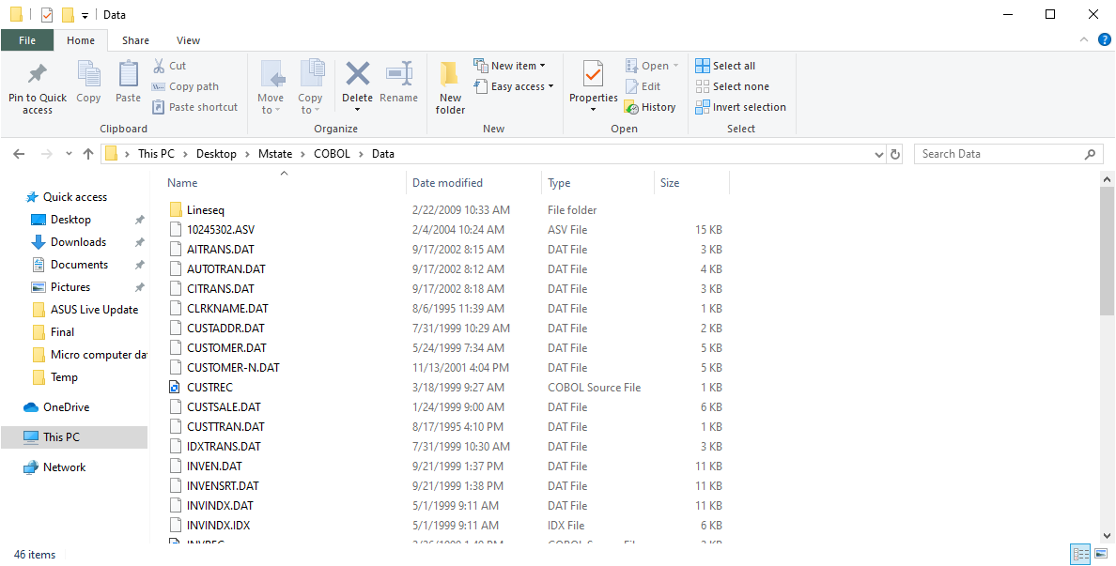

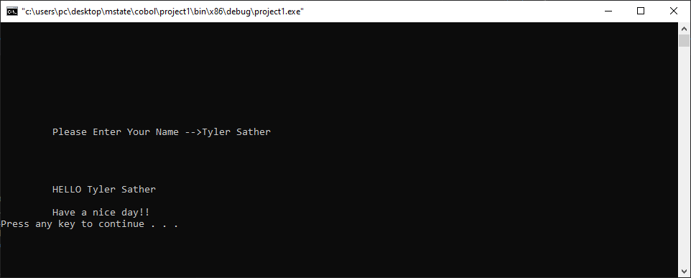

identification division.

program-id. Program1.

environment division.

configuration section.

data division.

working-storage section.

01 wa-name pic x(15).

procedure division.

main-program.

display "Please Enter Your Name -->" line 10 column 10.

accept wa-name line 10 column 36.

display "HELLO" line 15 column 10.

display wa-name line 15 column 16.

display "Have a nice day!!" line 17 column 10.

display " " line 18 column 9.

goback.

end program Program1.